

Wachemo University

College of Engineering and Technology

Department of Software Engineering

Project Title: Smart Home

Group members

Name

ID No

Habtamu Bitew ……………………………….………………………………………..1303901

Amare Yigzaw ……………………………………………………………………….…1304757

Ermias Bezabih ………………………………………………………………..………1305583

Ayele Asefa ………………………………………………………………………..….1402402

Alemayehu Demssie …………………………………………………………………..1402400

Betelhem Adane …………………………………………………………………..…..1304757

Bezawit abuwa ………………………………………………………….………...…..1305583

Tewodros Abebe ……………………………………………………….………..……1402402

Zekarias Meseret ………………………………………………..……………...……..1303901

Saron Mesfin …………………………………………………………………...…..…1304757

Submitted To : Mr.Mesay Aschalew.

Submission Date : 10/07/2016 E.C

Table Contents

1 Introduction 3

2 Statement of the project 3

3 Objective of the project 3

3.1 General Objective 3

3.2 Specific Objective 4

4. Scope of the project 4

5. Requirement specification of the project 4

6. Design of the project 5

6.1 Semantic view (PCB)

6.2 Circuit view

6.3 System Use case

6.4 Activity diagram

7.0 Development and test 8

8.0 Deployment 8

9.0 Maintenance 10

10.0 Conclusion 10
1. Introduction:

The rise of technology has ushered in the era of "smart homes," offering homeowners enhanced convenience, efficiency, and security. Traditional manual operations for tasks like lighting and security are replaced by automated systems utilizing microcontrollers, sensors, and communication protocols. Arduino, with its versatility and affordability, is an ideal platform for developing these systems. Smart home projects have gained traction, allowing customization and innovation. Our project aims to leverage Arduino-based smart home automation to enhance comfort, convenience, and security while promoting energy efficiency and sustainability.

2. Project Statement:

Our smart home automation project utilizes Arduino microcontrollers to develop an innovative solution for enhancing homeowners' quality of life. By integrating sensors for environmental monitoring and user activity detection, along with actuators for controlling household systems, the project aims to offer convenience, efficiency, and security through automated control. Additionally, it explores Arduino's potential in promoting energy efficiency and sustainable living practices. The project provides an affordable and customizable platform, empowering homeowners to transform their houses into intelligent living spaces tailored to their needs.

3.Objective

3.1 General Objective

The primary objective of the project is to design, develop, and implement a smart home automation system using Arduino microcontrollers, sensors, actuators, and communication modules.

3.2 Specific Objective

Automation: To automate various aspects of home management including lighting control, temperature regulation, security monitoring, and energy management. This will reduce the reliance on manual intervention and enhance the efficiency of household tasks.

1

User-Friendly Interface: To create a user-friendly interface that allows for intuitive control and monitoring of the smart home automation system. The interface will provide real-time feedback on device status and enable users to easily manage.

Integration: To integrate sensors for environmental monitoring and user activity detection, as well as actuators for controlling lights, appliances, and security devices. This will create a comprehensive system that responds intelligently to changes in the home environment and user preferences.

Energy Efficiency: To optimize energy consumption by implementing smart energy management strategies adaptive control. This will reduce energy waste and contribute to environmental sustainability.

Security Enhancement: To enhance home security through automated monitoring. This will improve the safety and protection of the home and its occupants.

4. Significance of the Project

The smart home automation project offers significant benefits for homeowners, society, and the environment:

Convenience and Comfort: Automating routine tasks enhances convenience and creates a more relaxed living environment.

Energy Efficiency: Optimizing energy consumption reduces utility costs and contributes to environmental sustainability.

Enhanced Security: Automated security systems improve home safety by detecting and responding to threats in real-time.

5. Scope of the project

Lighting Control: Automate lights to turn on/off based on time of day and presence detection.

Temperature Regulation: Maintain a comfortable environment based on temperature readings.

Security Systems: Implement basic security measures using sensors.

2

Data Monitoring: Collect and monitor sensor data (temperature, sound, light) for analysis and potential actions.

6. Requirement specification of the project

Project Overview: Create a home automation system using Arduino.

- Control and monitor home environment. Functional Requirements:

- Temperature Monitoring: Measure and display temperature.

  - Provide real-time readings via a user interface.

- Lighting Control: Automate based on time or sensors.

- Security System:

  - Implement door sensors using keypad password and card scanner (RFID).

  - Door control.

Non-Functional Requirements:

- Reliability: Operate reliably under various conditions.

- User Interface: Intuitive interface for easy interaction.

  - Informative feedback.

- Security: Strong measures to protect data.

  - Authentication.

- Performance: Optimize response times and resource usage.

Constraints:

- Hardware Limitations: Work within Arduino's capabilities.

- Power Supply: Ensure stable power.

- Budget: 1110 birr.

3
6. Design of the project

6.1 Semantic View (PCB)
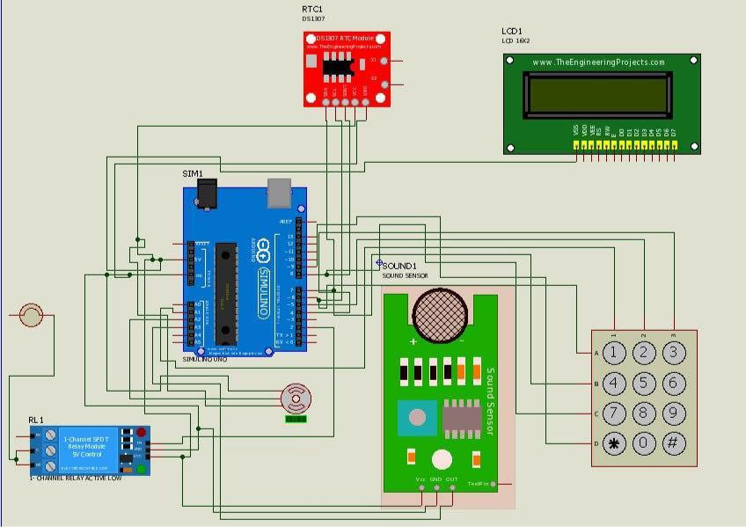

6.2 Circuit View
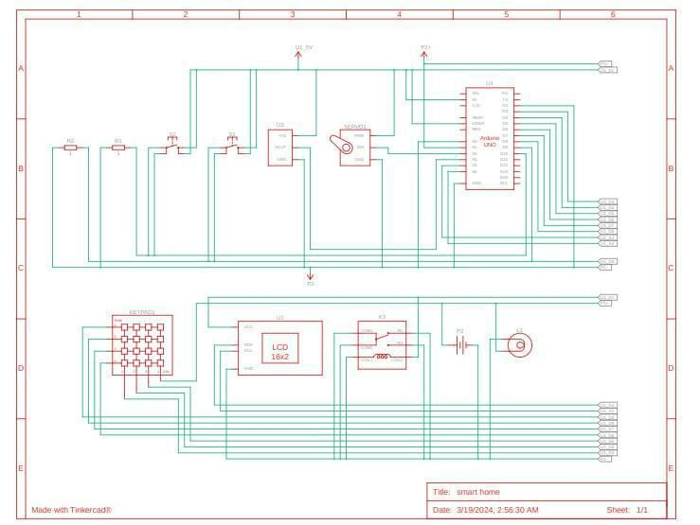

4
6.3 System Use Case
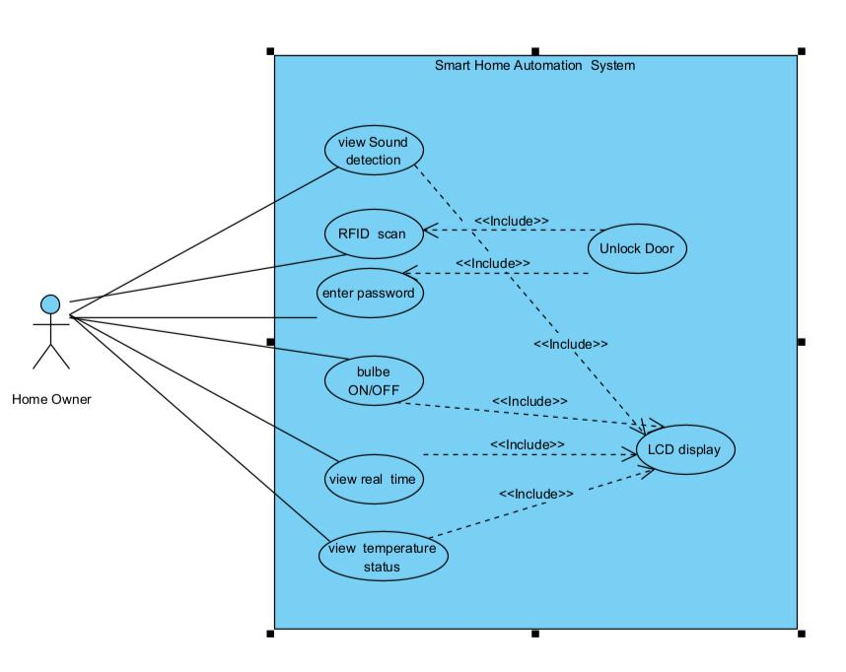

5
6.4 Activity diagram
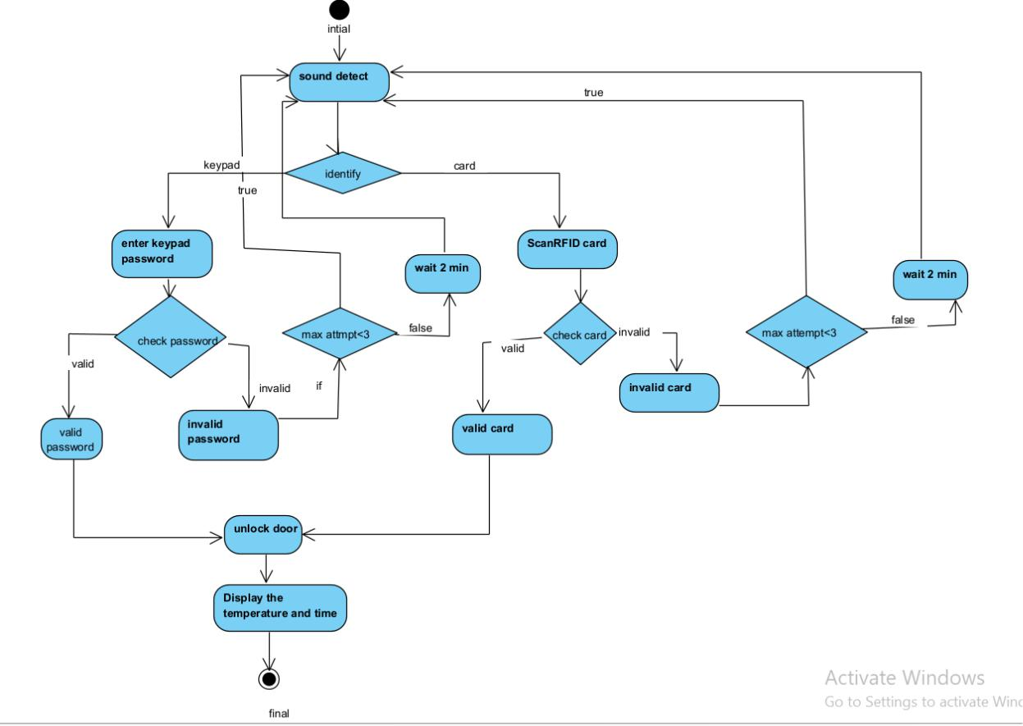

7.Deployment

Arduino Board: Arduino microcontroller board as the brain of your smart home system. Popular options include Arduino Uno, Arduino Nano, or Arduino Mega. Sensors and Modules:

- Temperature Sensor: To monitor environmental conditions.

- Sound Sensor: To measure sound levels for automation purposes.

- Relay Module: For controlling bulb.

Actuators:

Motor: For automating doors.

6
Power Supply:

- DC Power Adapter: To provide power to the bulb and connected components. Miscellaneous Components:

- Jumper Wires: For prototyping and connecting components.

- LCD Display: For visual feedback and user interaction.
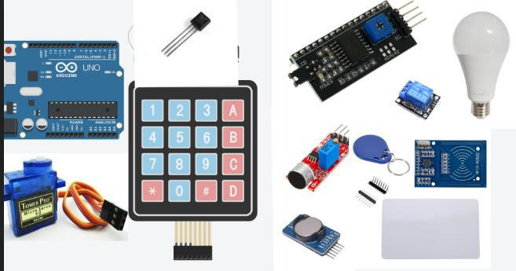

Arduino IDE: Essential for coding and uploading to Arduino boards. Downloaded from Arduino's official website.

Arduino Libraries: Download sensor libraries from GitHub for specific sensors.

Device Drivers: Install USB drivers if needed for our Arduino board.

Serial Monitor Software: Useful for debugging; Arduino's built-in or third-party tools.

Deployment Steps:

Assembly: Step-by-step hardware assembly instructions with visuals if available.

7

Installation: Detailed process for uploading software to the Arduino board, including library installation.

Power Up: Instructions for connecting power sources safely.

Verification: Guidance on checking indicators, sensor readings, or accessing the system post-deployment.

8.Testing

Test Procedures:

1. Functional Testing

Test Case 1: Temperature Sensor Reading

Description: Ensure the temperature sensor accurately measures ambient temperature.

Procedure:

- Place sensor in a controlled environment.

- Power on Arduino and wait for sensor initialization.

- Read temperature using Arduino IDE Serial Monitor.

- Compare measured and expected temperatures.

- Expected Outcome: Measured temperature closely matches the expected with minimal error.

Test Case 2: Sound Detection

Description: Confirm sound sensor detects sound within its range.

Procedure:

- Place sensor where sound is expected.

- Power on Arduino and wait for sensor initialization.

- Trigger sound and observe sound sensor output.

- Expected Outcome: Sound sensor detects sound.

8
Test Case 3: Unauthorized Access

- Result: The system effectively prevented unauthorized access attempts and responded appropriately to security threats.

- Deviation: No deviations from expected outcomes were observed.

Troubleshooting

- Issue: Delayed Response Times

- Solution: Optimize code efficiency and reduce processing overhead to improve response times.

- Issue: Actuator Malfunction

- Solution: Check hardware connections and ensure proper power supply to actuators. Replace malfunctioning components if necessary.

9.Maintenance

Routine Maintenance Tasks:

Outline routine tasks such as checking hardware connections, cleaning sensors, verifying power sources, and updating software/firmware.

Maintenance Schedule:

Recommend a schedule for users to stay proactive, including weekly, monthly, and yearly tasks, reminders for updates, and preventative measures.

Software Updates:

Explain how to perform software updates, emphasizing precautions, verification steps, and testing procedures post-update.

Hardware Upgrades:

Offer guidance on upgrading hardware components, including compatible options, installation instructions, and compatibility considerations.

9
Documentation Updates:

Highlight the importance of keeping documentation current, encouraging users to contribute by reporting issues and suggesting improvements.

User Support:

Provide resources for users to seek additional assistance, including online forums, technical support contact information, and FAQs.

Conclusion:

Summarize the significance of maintenance in ensuring the project's long-term success, urging users to prioritize maintenance tasks for maximum reliability and lifespan.

Conclusion

The testing process confirmed the overall reliability and functionality of the smart home Arduino project. While minor deviations and issues were encountered, they were addressed through troubleshooting measures. Moving forward, continuous monitoring and optimization will be necessary to maintain optimal performance and address any emerging challenges.

10

