FinMan
An AI-assisted personal finance tracker built on MongoDB

Project report · NoSQL Database · Semester 5
Submitted by
Avyukt Gupta 2427010161
Ujjawal Chaudhary 2427010084
Soham Phulwaria 2427010107

October 2026

Contents
Contents 2
1. Problem identification 4
1.1 Problem statement 4
1.2 Real-world relevance 4
1.3 Objectives 4
1.4 Scope 4
2. NoSQL database selection 6
2.1 Why MongoDB 6
2.2 Compared with a relational database 6
2.3 Compared with other NoSQL databases 6
2.4 MongoDB features used 7
3. Database design and data modeling 8
3.1 Collections 8
3.2 One field, three shapes: the details sub-document 8
3.3 Denormalising the category name 9
3.4 Dates, time zones and money 9
3.5 Access patterns and indexes 9
3.6 Scalability 9
4. NoSQL database implementation and CRUD 11
4.1 REST API 11
4.2 Create 11
4.3 Read 11
4.4 Update and delete 12
4.5 Persistence 12
5. Advanced features and query optimisation 14
5.1 Aggregation pipelines 14
5.2 Index evidence 14
5.3 Partial unique index for duplicate messages 15
5.4 Multi-document transaction: renaming a category 16
5.5 TTL index: self-cleaning AI logs 17
6. Application integration 18
6.1 Architecture 18
6.2 AI parsing pipeline 18
6.3 Screens 18
6.4 Error handling and user experience 22
7. Testing, security and data validation 23
7.1 Input validation 23
7.2 Authentication and access control 23
7.3 Other protections 23
7.4 Automated tests 23
7.5 Manual checks 24
8. Demonstration, viva and documentation 26
8.1 How to run 26
8.2 Demo script (about six minutes) 26
8.3 Viva questions 26
8.4 Limitations and future work 27
8.5 Plagiarism report 27
Appendix A: Environment variables 28
Appendix B: Project structure 28

Right-click the table above and choose Update Field if page numbers are missing.

1. Problem identification

1.1 Problem statement
Most spending in India now happens through UPI, cards and food-delivery apps, and every payment produces a text message or notification. The record of what someone spent already exists, but it is scattered across hundreds of SMS messages in formats that differ from bank to bank. Writing each payment into a spreadsheet by hand is slow enough that most people stop after a week, so they end each month without knowing where the money went.
FinMan turns those messages into structured records. The user pastes a bank SMS or uploads a photo of a bill, a language model extracts the amount, merchant, date, category and payment details, the user confirms or corrects each field, and the record is stored in MongoDB. Charts then show spending by day and by category.

1.2 Real-world relevance
- UPI handled more than 18 billion transactions a month in 2025 (NPCI). Each one triggers an SMS from the bank, so the input data is already in every user's phone.
- Bank messages are semi-structured: amount, account, reference and date are present, but word order, date format and wording vary between banks. That variation is what makes a rules-only parser brittle and an AI parser useful.
- The data is naturally document-shaped. A UPI payment carries a UPI reference and payee address, a card payment carries the last four digits, and a restaurant bill carries line items and tax. One table cannot hold all three without many empty columns.

1.3 Objectives
- Store every transaction as a MongoDB document whose shape can vary by payment type.
- Let users create, view, edit and delete transactions through a web interface and a REST API.
- Extract transactions from pasted SMS text and bill photos with a hosted language model, and keep working when the model is unavailable.
- Answer analytics questions (spend per day, per category, per month) with MongoDB aggregation pipelines served by indexes.
- Prevent the same SMS being saved twice, validate every input, and protect the data behind a login.
- Demonstrate MongoDB-specific features: compound and partial indexes, $lookup, $facet, a multi-document transaction and a TTL index.

1.4 Scope
In scope | Out of scope
Single account with email and password login | Multiple users sharing one deployment (design notes in section 8.4)
Indian rupee amounts and IST dates | Multi-currency and other time zones
Paste SMS text, upload bill photos or text files, manual entry | Reading SMS directly from the phone
Daily, category and monthly analytics; CSV and JSON export | Budgets, alerts and forecasting
Responsive web app for laptop and phone browsers | Native Android or iOS apps

2. NoSQL database selection

2.1 Why MongoDB
MongoDB is a document database: each record is a JSON-like document (stored as BSON) inside a collection, and documents in one collection do not need identical fields. The table maps FinMan's requirements to the MongoDB feature that meets them.
Requirement | How MongoDB meets it
Payment details differ by type (UPI, card, bill) | A details sub-document holds whatever keys that payment has. No schema migration is needed to add a new type.
Bill line items are a list | Arrays are a native type: details.items is an array of { name, qty, price } objects.
The AI returns JSON | Parsed output maps straight onto a document. No object-relational mapping layer is needed.
Charts need grouping by day and category | The aggregation framework ($match, $group, $lookup, $facet) runs inside the database.
Day boundaries must follow Indian time | $dateToString accepts timezone: "Asia/Kolkata", so grouping by IST day happens on the server.
The same SMS must not be saved twice | A unique index with a partial filter applies only to documents that have a hash.
Old AI parse logs should disappear on their own | A TTL index deletes documents 30 days after createdAt.
Free hosting for a student project | MongoDB Atlas M0 is free, is a three-node replica set, and runs in Mumbai (ap-south-1).

2.2 Compared with a relational database
Concern | Relational (e.g. MySQL) | MongoDB (FinMan)
Varying payment details | Many nullable columns, or one table per payment type joined back to transactions | One details object whose keys depend on the type
Bill line items | A separate bill_items table and a join | An embedded array inside the transaction
Showing a transaction list with category names | Join to categories on every read | Category name copied into each transaction; no join to read
Schema changes | ALTER TABLE and migrations | New optional fields need no migration; validation lives in the app (Mongoose + zod)
Multi-row consistency | ACID transactions | Single-document writes are atomic; multi-document transactions are used where two collections change together (section 5.4)

A relational design would work, but it would spend effort fighting the data's shape. The cost of MongoDB here is that consistency between collections becomes the application's job, which section 5.4 handles with a transaction.

2.3 Compared with other NoSQL databases
Database | Model | Why not chosen for FinMan
Redis | Key-value, in memory | Built for caching and counters. Ad-hoc filters and aggregations over history would need hand-built secondary structures.
Cassandra | Wide-column | Designed for very high write volume across many nodes. Tables are designed per query, and grouping by arbitrary fields is limited. One user's finances do not need that write scale.
Neo4j | Graph | Strong for relationships between entities. FinMan's data is a list of independent records, not a network.
Firestore | Document, managed | Close fit, but aggregation is limited to count, sum and average, and joins such as $lookup are not available.

2.4 MongoDB features used
- Flexible documents with an embedded sub-document (details) and embedded arrays (details.items).
- Four secondary indexes on transactions, including two compound indexes and one partial unique index.
- Aggregation pipelines with $match, $group, $project, $lookup, $facet, $sort, $limit, $count, $dateToString and $round.
- A multi-document ACID transaction (session.withTransaction) across categories and transactions.
- A TTL index on the parselogs collection.
- explain("executionStats") and index hiding to prove what the indexes do.

3. Database design and data modeling

3.1 Collections
FinMan uses four collections in one database named finman. Figure 1 shows each collection's fields and types and how they relate.
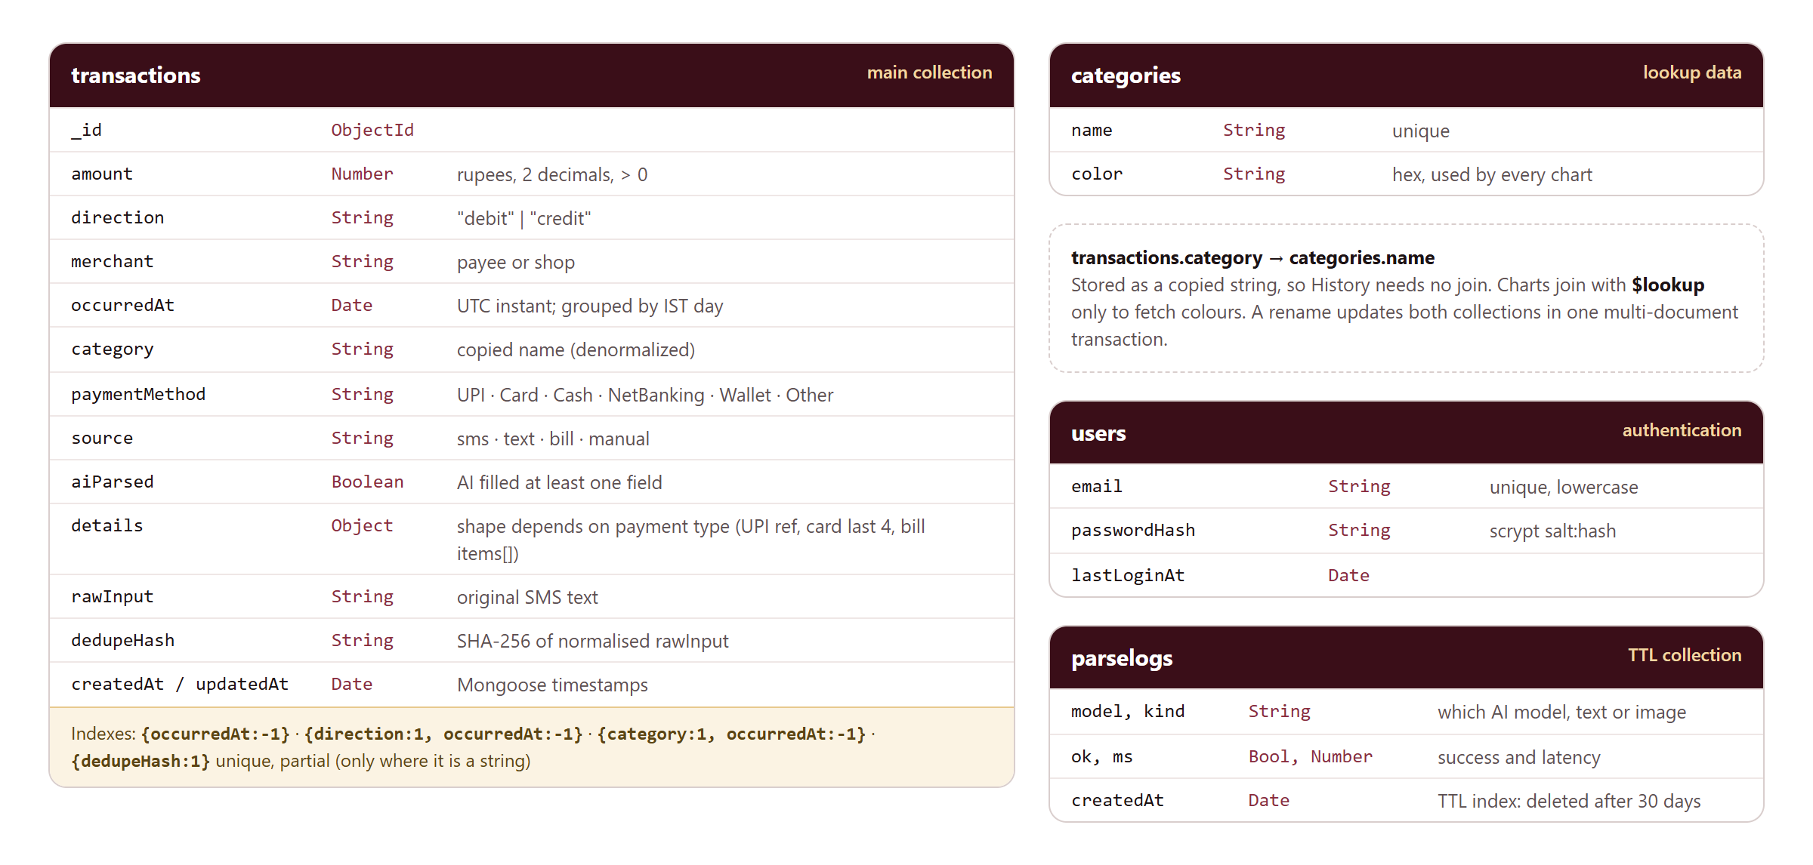
Figure 1: Collections, field types, indexes and the one cross-collection link
Collection | Purpose | Typical size
transactions | One document per payment or receipt | Grows by tens per day per user
categories | Category names and chart colours (12 seeded) | Small, rarely changes
users | Login email and scrypt password hash | One document
parselogs | One row per AI parse: model, success, latency | Bounded by the 30-day TTL

3.2 One field, three shapes: the details sub-document
The details field is where the document model earns its place. Its keys depend on how the payment was made. All three documents below live in the same collection.
// UPI payment from an SMS
{ amount: 850, merchant: "Swiggy", paymentMethod: "UPI", source: "sms",
details: { upiRef: "523614789012", vpa: "swiggy@icici", accountLast4: "4521" } }

// Credit card spend
{ amount: 2499, merchant: "Amazon Pay India", paymentMethod: "Card", source: "sms",
details: { cardLast4: "9087", bank: "XYZ Bank", cardType: "credit" } }

// Restaurant bill photo
{ amount: 429, merchant: "Swiggy", paymentMethod: "Other", source: "bill",
details: { invoiceNumber: "18273645", subtotal: 380, tax: 19, fileName: "IMG_0012.jpg",
items: [ { name: "Paneer Butter Masala", qty: 1, price: 260 },
{ name: "Garlic Naan", qty: 2, price: 120 } ] } }
In a relational schema these would need either about ten mostly empty columns or three extra tables. Here the common fields (amount, date, category) are typed and validated by Mongoose, and details is declared as Schema.Types.Mixed so it can take any shape the payment type needs.

3.3 Denormalising the category name
Each transaction stores the category as a plain string (category: "Food") instead of a reference to the category's _id. This is deliberate:
- Reads are cheap. The History list, filters and CSV export need the name and nothing else, so they never join.
- Colours are joined only where needed. The category chart uses $lookup once per category group, not once per transaction.
- The cost is renaming. Changing "Rent" to "Housing" must update every transaction that copied the old name. FinMan does that inside a multi-document transaction (section 5.4), so both collections change together or not at all.
Renames are rare and reads happen on every page load, so the trade favours copying the name.

3.4 Dates, time zones and money
- occurredAt is a real BSON Date. The original design used separate date and time strings, which cannot be range-queried or grouped by day.
- MongoDB stores UTC. Every analytics query converts to Indian Standard Time on the server: ranges are built as IST midnights (2026-10-05 becomes [04 Oct 18:30Z, 05 Oct 18:30Z)), and grouping uses $dateToString with timezone: "Asia/Kolkata". A payment at 00:30 IST therefore counts on the correct day. Section 7.4 tests this boundary.
- Amounts are rupees stored as a Number and rounded to two decimals on input (12.345 is saved as 12.35).
- direction separates money out (debit) from money in (credit), so salary credits and refunds never inflate spending totals.

3.5 Access patterns and indexes
Indexes were chosen from the queries the app actually runs, following MongoDB's Equality, Sort, Range rule: fields matched by equality come first, then the sort or range field.
Query the app runs | Index | Why this order
History list, newest first | { occurredAt: -1 } | Matches the sort, so the first page comes straight off the index
Charts: debits in a date range | { direction: 1, occurredAt: -1 } | Equality on direction, then range on occurredAt
History filtered by category | { category: 1, occurredAt: -1 } | Equality on category, then sort by date
Duplicate SMS check on insert | { dedupeHash: 1 } unique, partial | Only documents with a hash are indexed, so manual entries never collide
Category lookup by name | { name: 1 } unique on categories | Enforces unique names and serves $lookup
Expire old parse logs | { createdAt: 1 } TTL 30 days | MongoDB deletes rows in the background

3.6 Scalability
- Each transaction is small (under 1 KB) and self-contained, so reads never fan out to other documents.
- Every frequent query is served by an index, so response time depends on the size of the result, not the size of the collection (measured in section 5.2).
- The TTL index keeps parselogs bounded without a cleanup job.
- For many users, every document would gain a userId field placed first in every compound index (for example { userId: 1, occurredAt: -1 }). { userId: 1, occurredAt: 1 } would then be a natural shard key: it keeps one user's data together for range queries and spreads different users across shards.

4. NoSQL database implementation and CRUD

4.1 REST API
The backend is Node.js 24 with Express 5 and Mongoose 9, written in TypeScript. Every route except health and login requires a signed-in session.
Method | Path | Purpose | Success / errors
POST | /api/auth/login | Sign in, set session cookie | 200 / 400, 401, 429
POST | /api/auth/logout | Clear session | 204
GET | /api/auth/me | Current user | 200 / 401
POST | /api/entries | Create a transaction | 201 / 400, 409
GET | /api/entries | List with filters and pages | 200 / 400
GET | /api/entries/:id | Read one | 200 / 400, 404
PUT | /api/entries/:id | Replace one | 200 / 400, 404
DELETE | /api/entries/:id | Delete one | 204 / 400, 404
GET POST | /api/categories | List with usage counts, create | 200, 201 / 400, 409
PATCH | /api/categories/:name | Rename or recolour (transaction) | 200 / 400, 404, 409
DELETE | /api/categories/:name | Delete if unused | 204 / 404, 409
POST | /api/parse | AI-parse pasted text | 200 / 400, 429
POST | /api/parse/file | AI-parse a bill photo or .txt | 200 / 400
GET | /api/analytics/daily | Spend per IST day | 200 / 400
GET | /api/analytics/categories | Spend per category with colours | 200 / 400
GET | /api/analytics/summary | Month view in one $facet query | 200 / 400
GET | /api/analytics/parser | AI success rate and latency | 200
GET | /api/export/csv, /json | Download all or a date range | 200 / 400

4.2 Create
- The body is validated with a zod schema: amount positive and at most ₹1 crore, date not in the future, enums for direction, payment method and source.
- The category must exist in the categories collection, otherwise 400.
- If the entry came from an SMS, the text is normalised (trimmed, whitespace collapsed, lowercased) and hashed with SHA-256 into dedupeHash.
- Transaction.create() inserts the document. If the hash already exists, MongoDB raises duplicate key error 11000, which the error handler returns as 409 "This transaction was already saved".

4.3 Read
The list endpoint builds a filter from optional query parameters: an IST date range on occurredAt, an exact category, and a case-insensitive search on merchant or description. Search text is regex-escaped first, so input such as ( cannot break the query. The page of results and the total count run in parallel:
const [items, total] = await Promise.all([
Transaction.find(filter).sort({ occurredAt: -1, _id: -1 })
.skip((page - 1) * limit).limit(limit).lean(),
Transaction.countDocuments(filter),
]);
The _id tiebreaker keeps pages stable when two entries share a timestamp. .lean() returns plain objects, which skips building Mongoose documents for read-only data.

4.4 Update and delete
- PUT validates the full body again and calls findByIdAndUpdate(id, data, { new: true, runValidators: true }). Mongoose skips schema validators on updates unless runValidators is set.
- DELETE uses findByIdAndDelete. A missing document returns 404; a malformed id fails Mongoose's cast and returns 400.

4.5 Persistence
In production the data lives in MongoDB Atlas (an M0 cluster, which is a three-node replica set). For offline development and as a backup for the live demo, npm run db:local starts a one-node replica set on port 27017 that stores its data on disk in backend/.localdb, so records survive restarts. Both are replica sets, which multi-document transactions require.
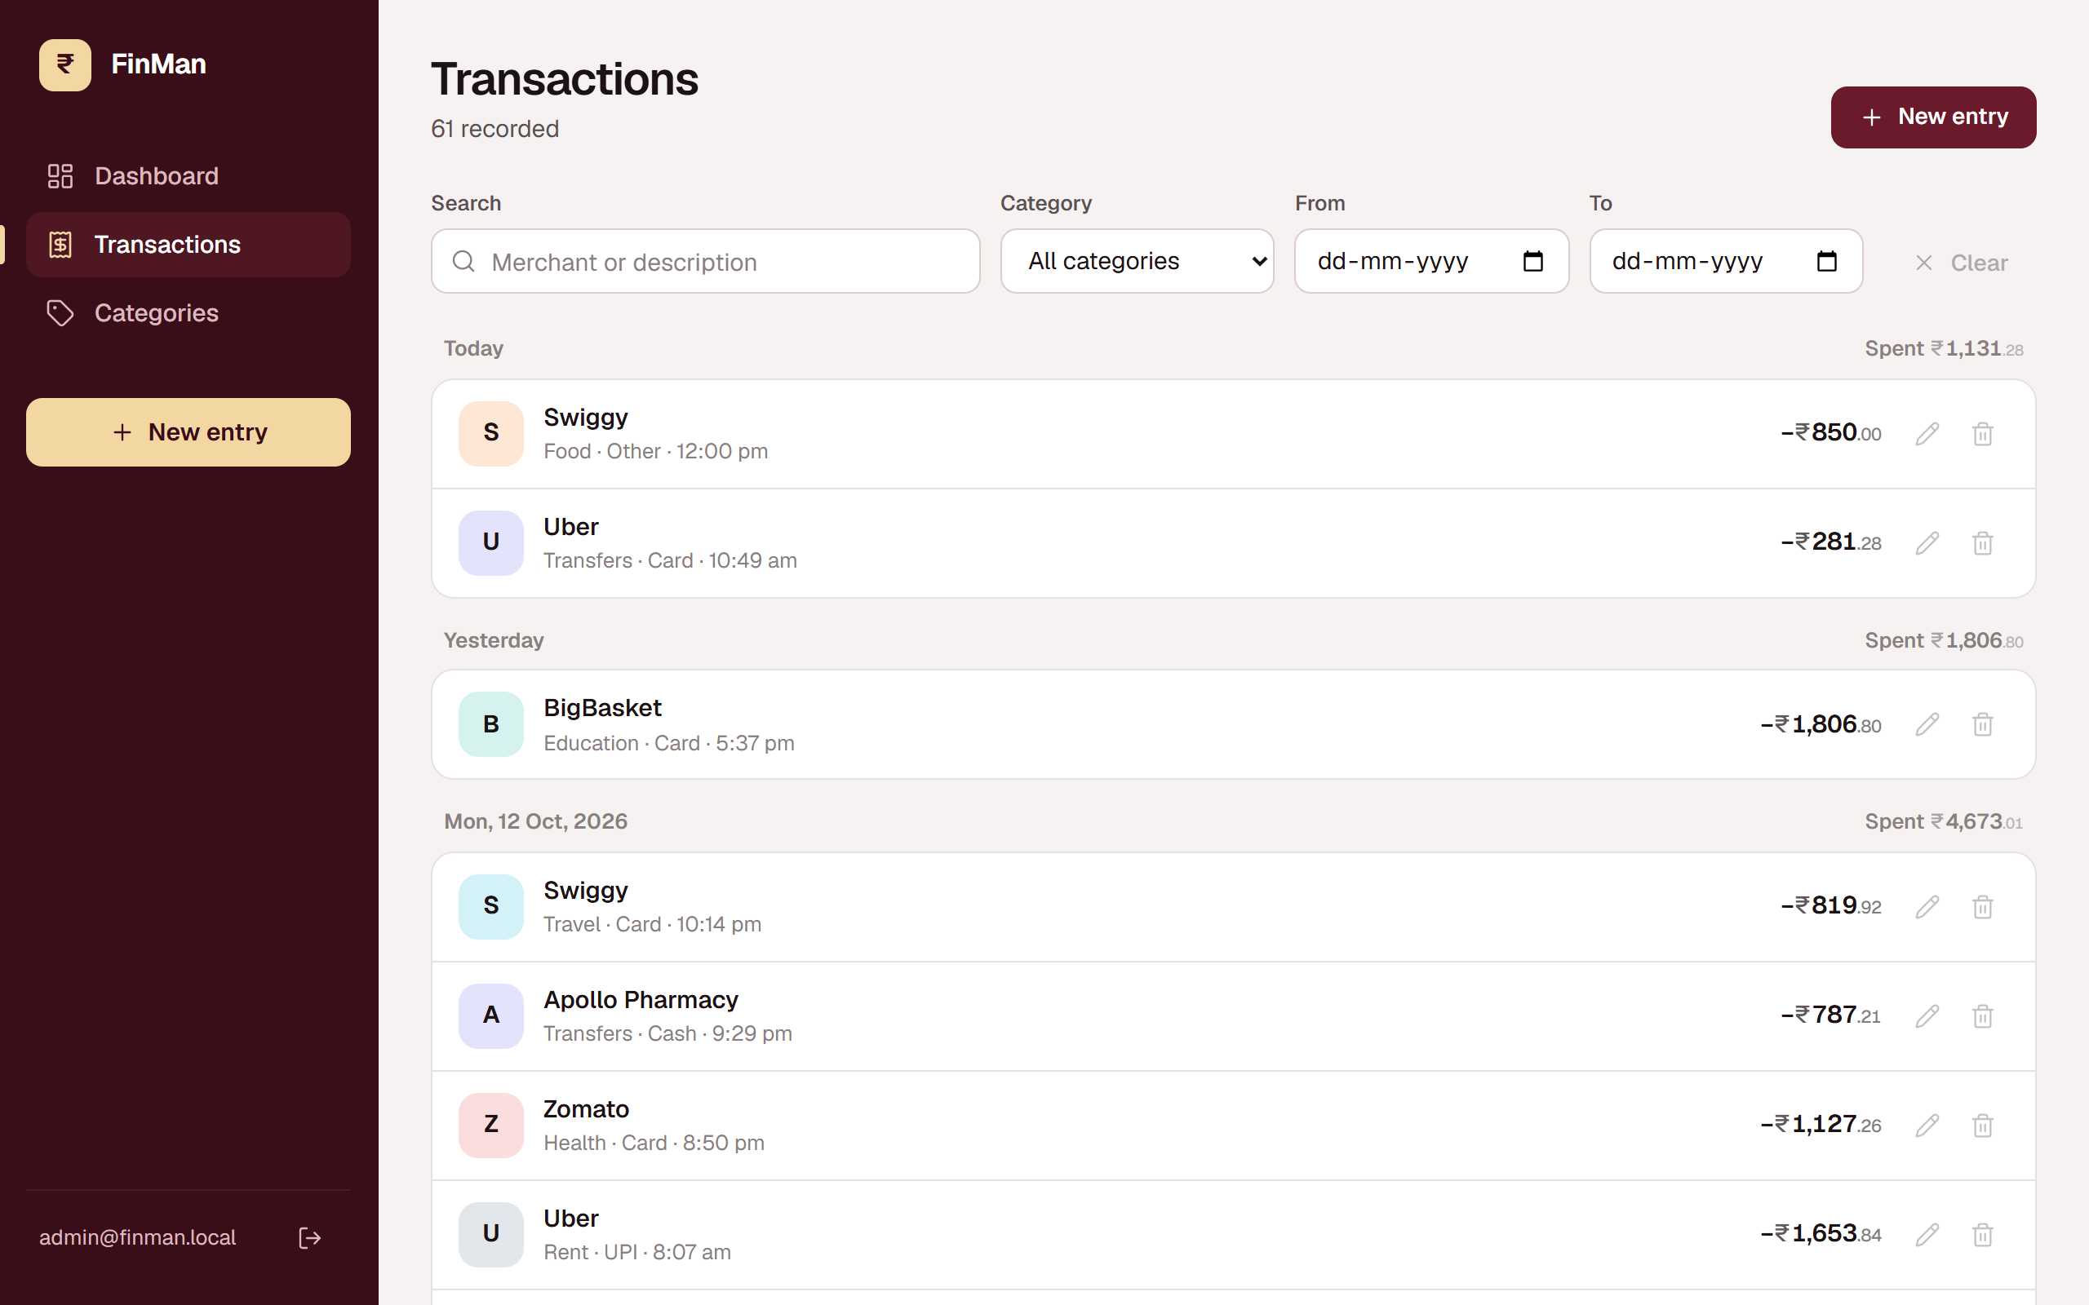
Figure 2: Transactions screen. Entries are grouped by IST day, with filters kept in the URL
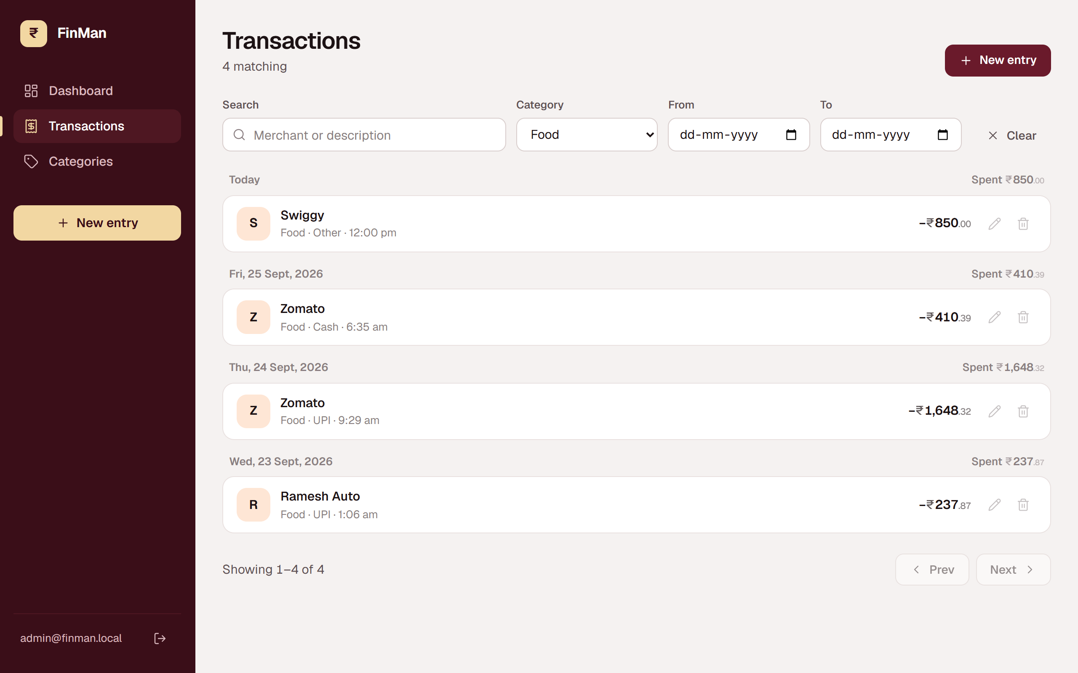
Figure 3: The same list filtered to one category (served by the { category, occurredAt } index)

5. Advanced features and query optimisation

5.1 Aggregation pipelines

Spending per IST day
Transaction.aggregate([
{ $match: { direction: 'debit', occurredAt: { $gte: start, $lt: end } } },
{ $group: {
_id: { $dateToString: { format: '%Y-%m-%d', date: '$occurredAt', timezone: 'Asia/Kolkata' } },
total: { $sum: '$amount' }, count: { $sum: 1 } } },
{ $project: { _id: 0, day: '$_id', total: { $round: ['$total', 2] }, count: 1 } },
]);
Days with no spending are filled in with zero afterwards, so the chart shows gaps as empty bars instead of skipping dates.

Spending per category, joined to colours with $lookup
{ $group: { _id: '$category', total: { $sum: '$amount' }, count: { $sum: 1 } } },
{ $lookup: { from: 'categories', localField: '_id', foreignField: 'name', as: 'cat' } },
{ $project: { _id: 0, category: '$_id', count: 1, total: { $round: ['$total', 2] },
color: { $ifNull: [{ $first: '$cat.color' }, '#9ca3af'] } } },
{ $sort: { total: -1 } }
Grouping happens before the join, so $lookup runs once per category (about 12 times), not once per transaction. A deleted category falls back to grey instead of breaking the chart.

The month view in one query with $facet
The dashboard's month card needs five different answers. $facet runs five sub-pipelines over the same $match, so all of them come back in one round trip:
{ $match: { occurredAt: { $gte: start, $lt: end } } },
{ $facet: {
totals: [ { $group: { _id: '$direction', total: { $sum: '$amount' } } } ],
byMethod: [ debits, { $group: { _id: '$paymentMethod', ... } },
{ $sort: { total: -1 } } ],
topMerchants: [ debits, { $group: { _id: '$merchant', ... } },
{ $sort: { total: -1 } }, { $limit: 5 } ],
largest: [ debits, { $sort: { amount: -1 } }, { $limit: 1 } ],
aiParsed: [ { $match: { aiParsed: true } }, { $count: 'count' } ],
} }
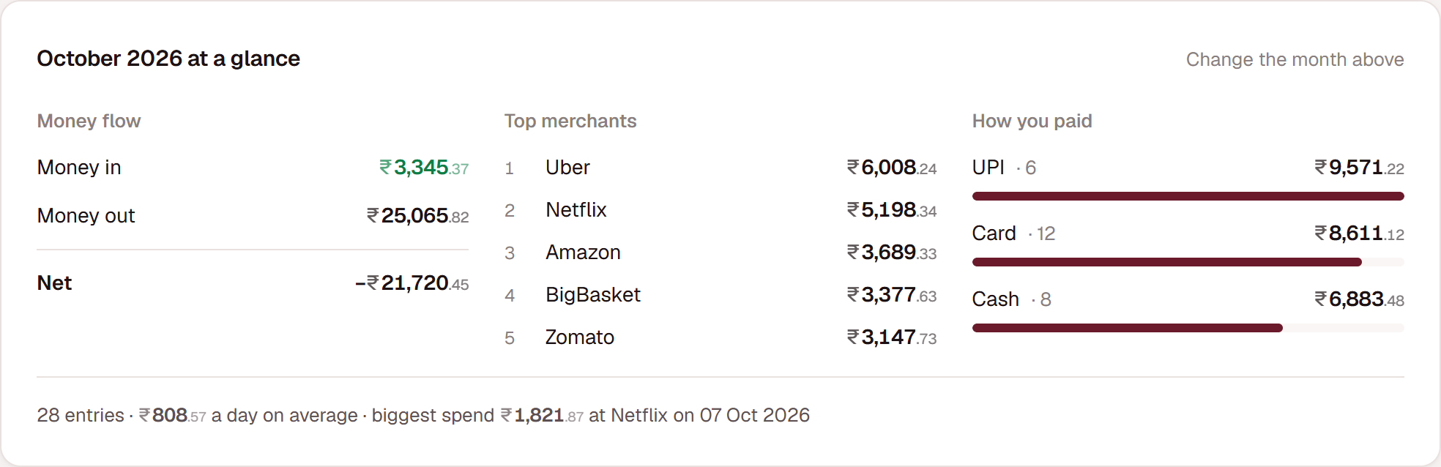
Figure 4: The month card rendered from the single $facet result

5.2 Index evidence
npm run explain -- 5000 seeds a separate database with 5,000 transactions, runs two real app queries with explain("executionStats"), then removes the matching index (and hides the others) and runs them again. The output from this run:
5000 transactions in finman_explain

History: one category, newest first, page 1
┌───────────────┬──────────────────────────┬───────────┬──────────────┬──────────────┬────┐
│ (index) │ stages │ nReturned │ keysExamined │ docsExamined │ ms │
├───────────────┼──────────────────────────┼───────────┼──────────────┼──────────────┼────┤
│ with index │ 'LIMIT > FETCH > IXSCAN' │ 20 │ 20 │ 20 │ 0 │
│ without index │ 'SORT > COLLSCAN' │ 20 │ 0 │ 5000 │ 21 │
└───────────────┴──────────────────────────┴───────────┴──────────────┴──────────────┴────┘
Analytics $match: debits in the last 30 days
┌───────────────┬──────────────────┬───────────┬──────────────┬──────────────┬────┐
│ (index) │ stages │ nReturned │ keysExamined │ docsExamined │ ms │
├───────────────┼──────────────────┼───────────┼──────────────┼──────────────┼────┤
│ with index │ 'FETCH > IXSCAN' │ 369 │ 369 │ 369 │ 2 │
│ without index │ 'COLLSCAN' │ 369 │ 0 │ 5000 │ 3 │
└───────────────┴──────────────────┴───────────┴──────────────┴──────────────┴────┘
- History query: with the index MongoDB read exactly the 20 documents it returned and did no in-memory sort. Without it, it read all 5,000 and sorted them in memory.
- Analytics range: with the index, documents examined equals documents returned (369). Without it, every document is examined. The gap grows linearly with the collection.
An integration test (section 7.4) also asserts that the analytics filter is planned as an IXSCAN on direction_1_occurredAt_-1, so a future change that breaks the index fails the build.

5.3 Partial unique index for duplicate messages
transactionSchema.index(
{ dedupeHash: 1 },
{ unique: true, partialFilterExpression: { dedupeHash: { $type: 'string' } } },
);
Only documents with a string hash are indexed. Manual entries have no hash and are left out, so two identical manual entries are allowed while the same bank SMS can only be saved once. A plain sparse index would treat an explicit null as a value and start rejecting manual entries.
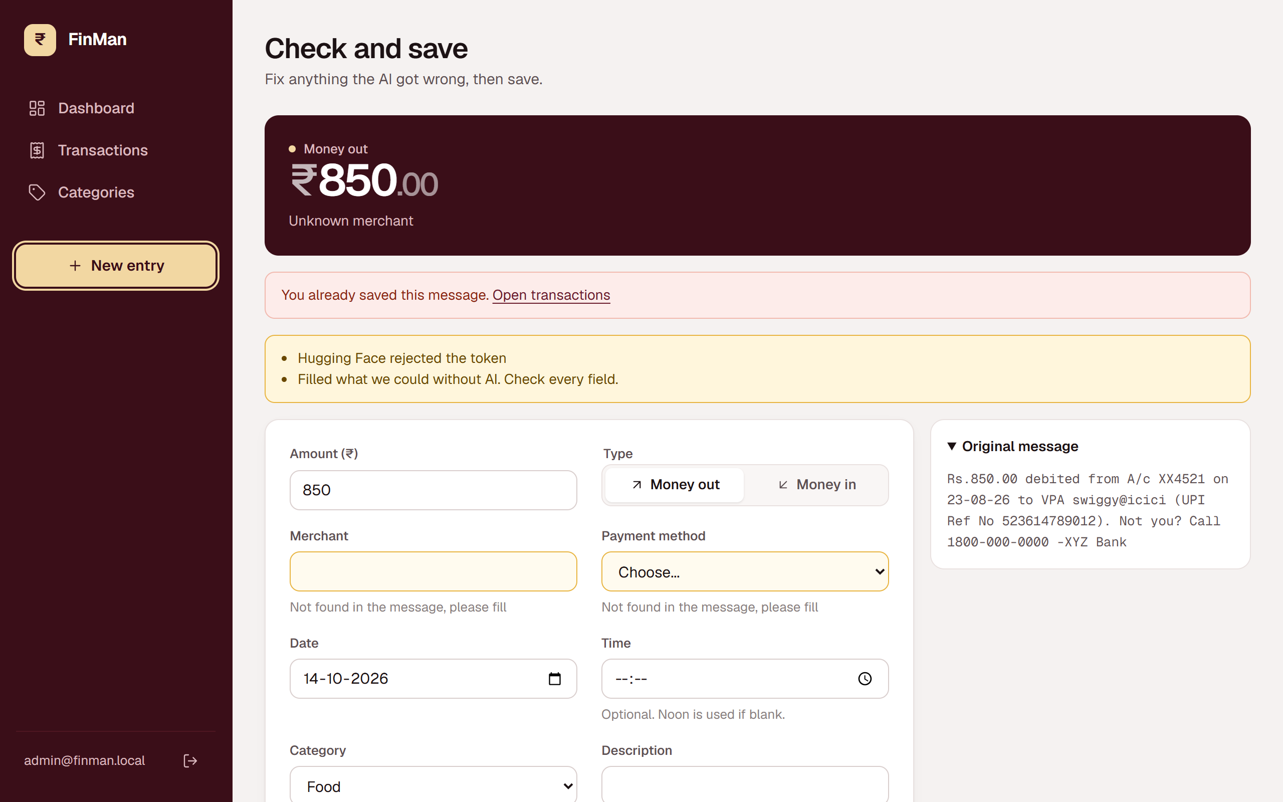
Figure 5: Saving the same SMS a second time. MongoDB rejects the insert and the app explains why

5.4 Multi-document transaction: renaming a category
Because the category name is copied into transactions (section 3.3), a rename changes two collections. Both writes run inside one transaction:
const session = await mongoose.startSession();
await session.withTransaction(async () => {
const cat = await Category.findOne({ name: oldName }).session(session);
if (!cat) throw new HttpError(404, 'Category not found');
if (await Category.exists({ name: newName }).session(session))
throw new HttpError(409, 'A category with that name already exists');
await Transaction.updateMany({ category: oldName }, { $set: { category: newName } }, { session });
cat.name = newName;
await cat.save({ session });
});
If any step throws, MongoDB rolls back every write made in the session. The test suite checks this: a rename that collides with an existing name returns 409 and leaves both collections exactly as they were.
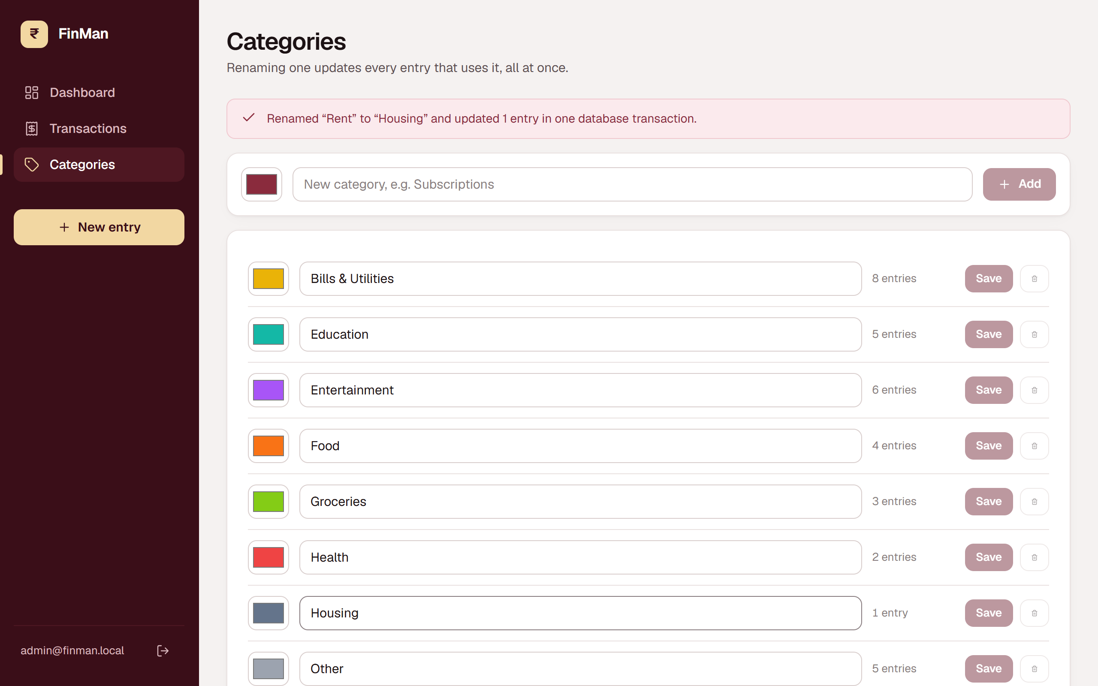
Figure 6: Renaming "Rent" to "Housing" through the Categories screen

5.5 TTL index: self-cleaning AI logs
parseLogSchema.index({ createdAt: 1 }, { expireAfterSeconds: 30 * 86_400 });
Every AI parse writes one small document (model, text or image, success, milliseconds). MongoDB's TTL monitor deletes each one 30 days after createdAt, so the log never needs a cleanup job and never grows without limit. GET /api/analytics/parser aggregates it into a success rate and average latency per model, shown on the Add entry screen.

6. Application integration

6.1 Architecture
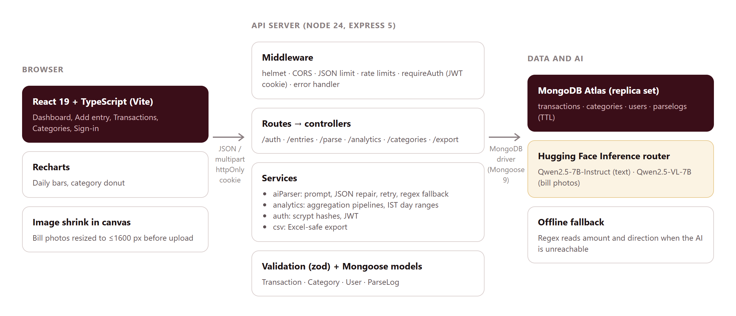
Figure 7: System architecture
The React frontend (Vite, TypeScript, React Router, Recharts) talks only to the Express API. In development Vite proxies /api to port 4000, so the browser sees one origin and the session cookie is first-party. The Hugging Face token lives only on the server; the browser never sees it.

6.2 AI parsing pipeline
- The server builds a prompt containing the exact JSON shape, the parsing rules (Indian day-month-year dates, "debited" means debit) and the current category list read from MongoDB. One worked example is included as a previous turn, which usually helps smaller models follow the format.
- The Hugging Face router is called with temperature: 0 and a 30-second timeout.
- The first { to last } of the reply is extracted, which strips code fences and chatty text.
- A lenient zod schema validates each field separately, so one bad field (say, a date in the wrong format) becomes null instead of discarding the whole answer. Categories the model invents are dropped.
- If the reply is not valid JSON, the model is shown its reply and asked once more.
- If the AI is down, out of credits or still wrong, a regular expression extracts the amount and direction, and the response carries a warning. The endpoint still returns 200, so the user can always finish the entry by hand.
- The user reviews every field. Fields the AI filled are tagged "AI", and fields it could not find are highlighted.

6.3 Screens
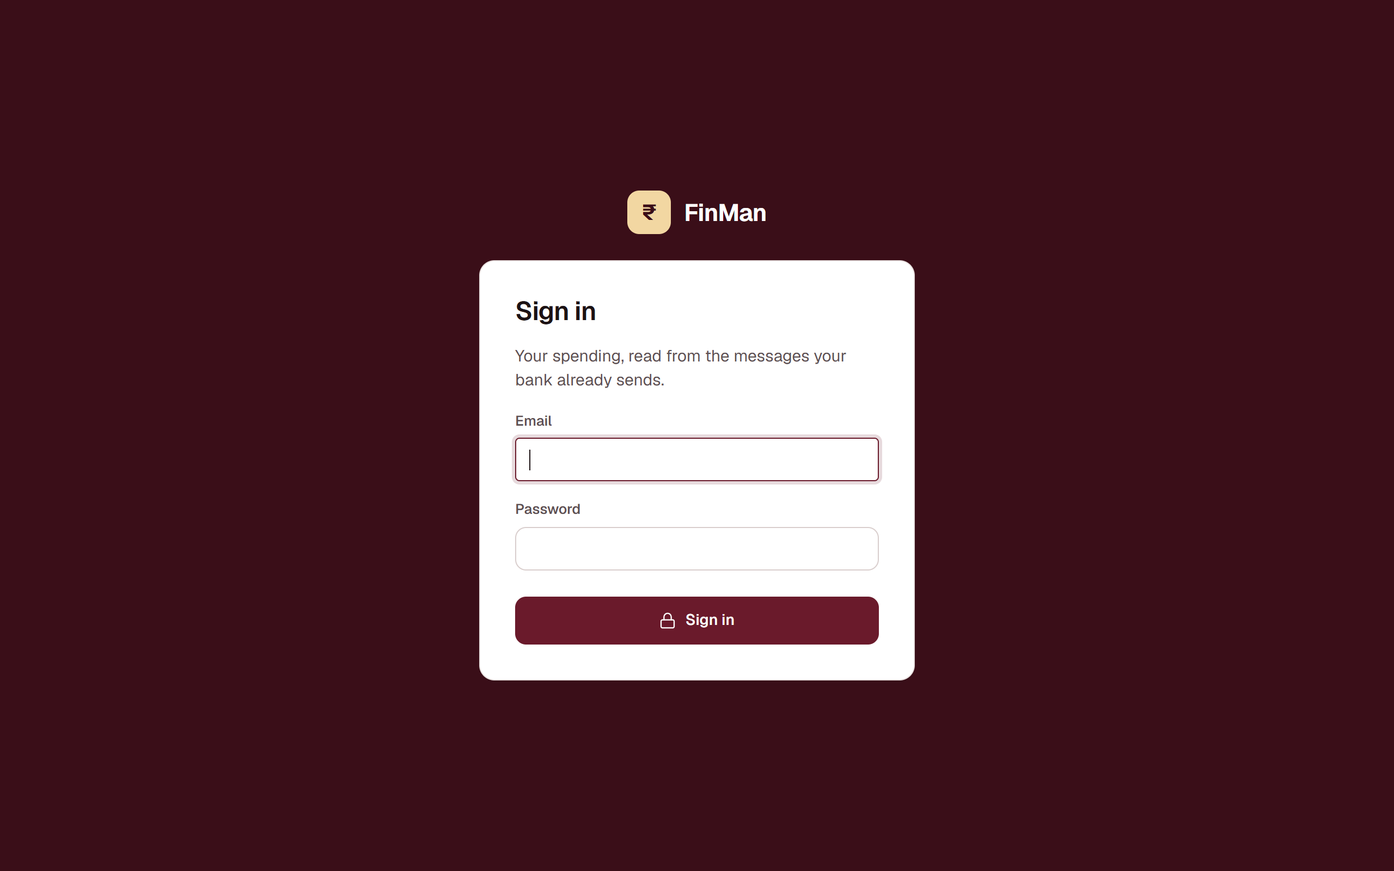
Figure 8: Sign-in
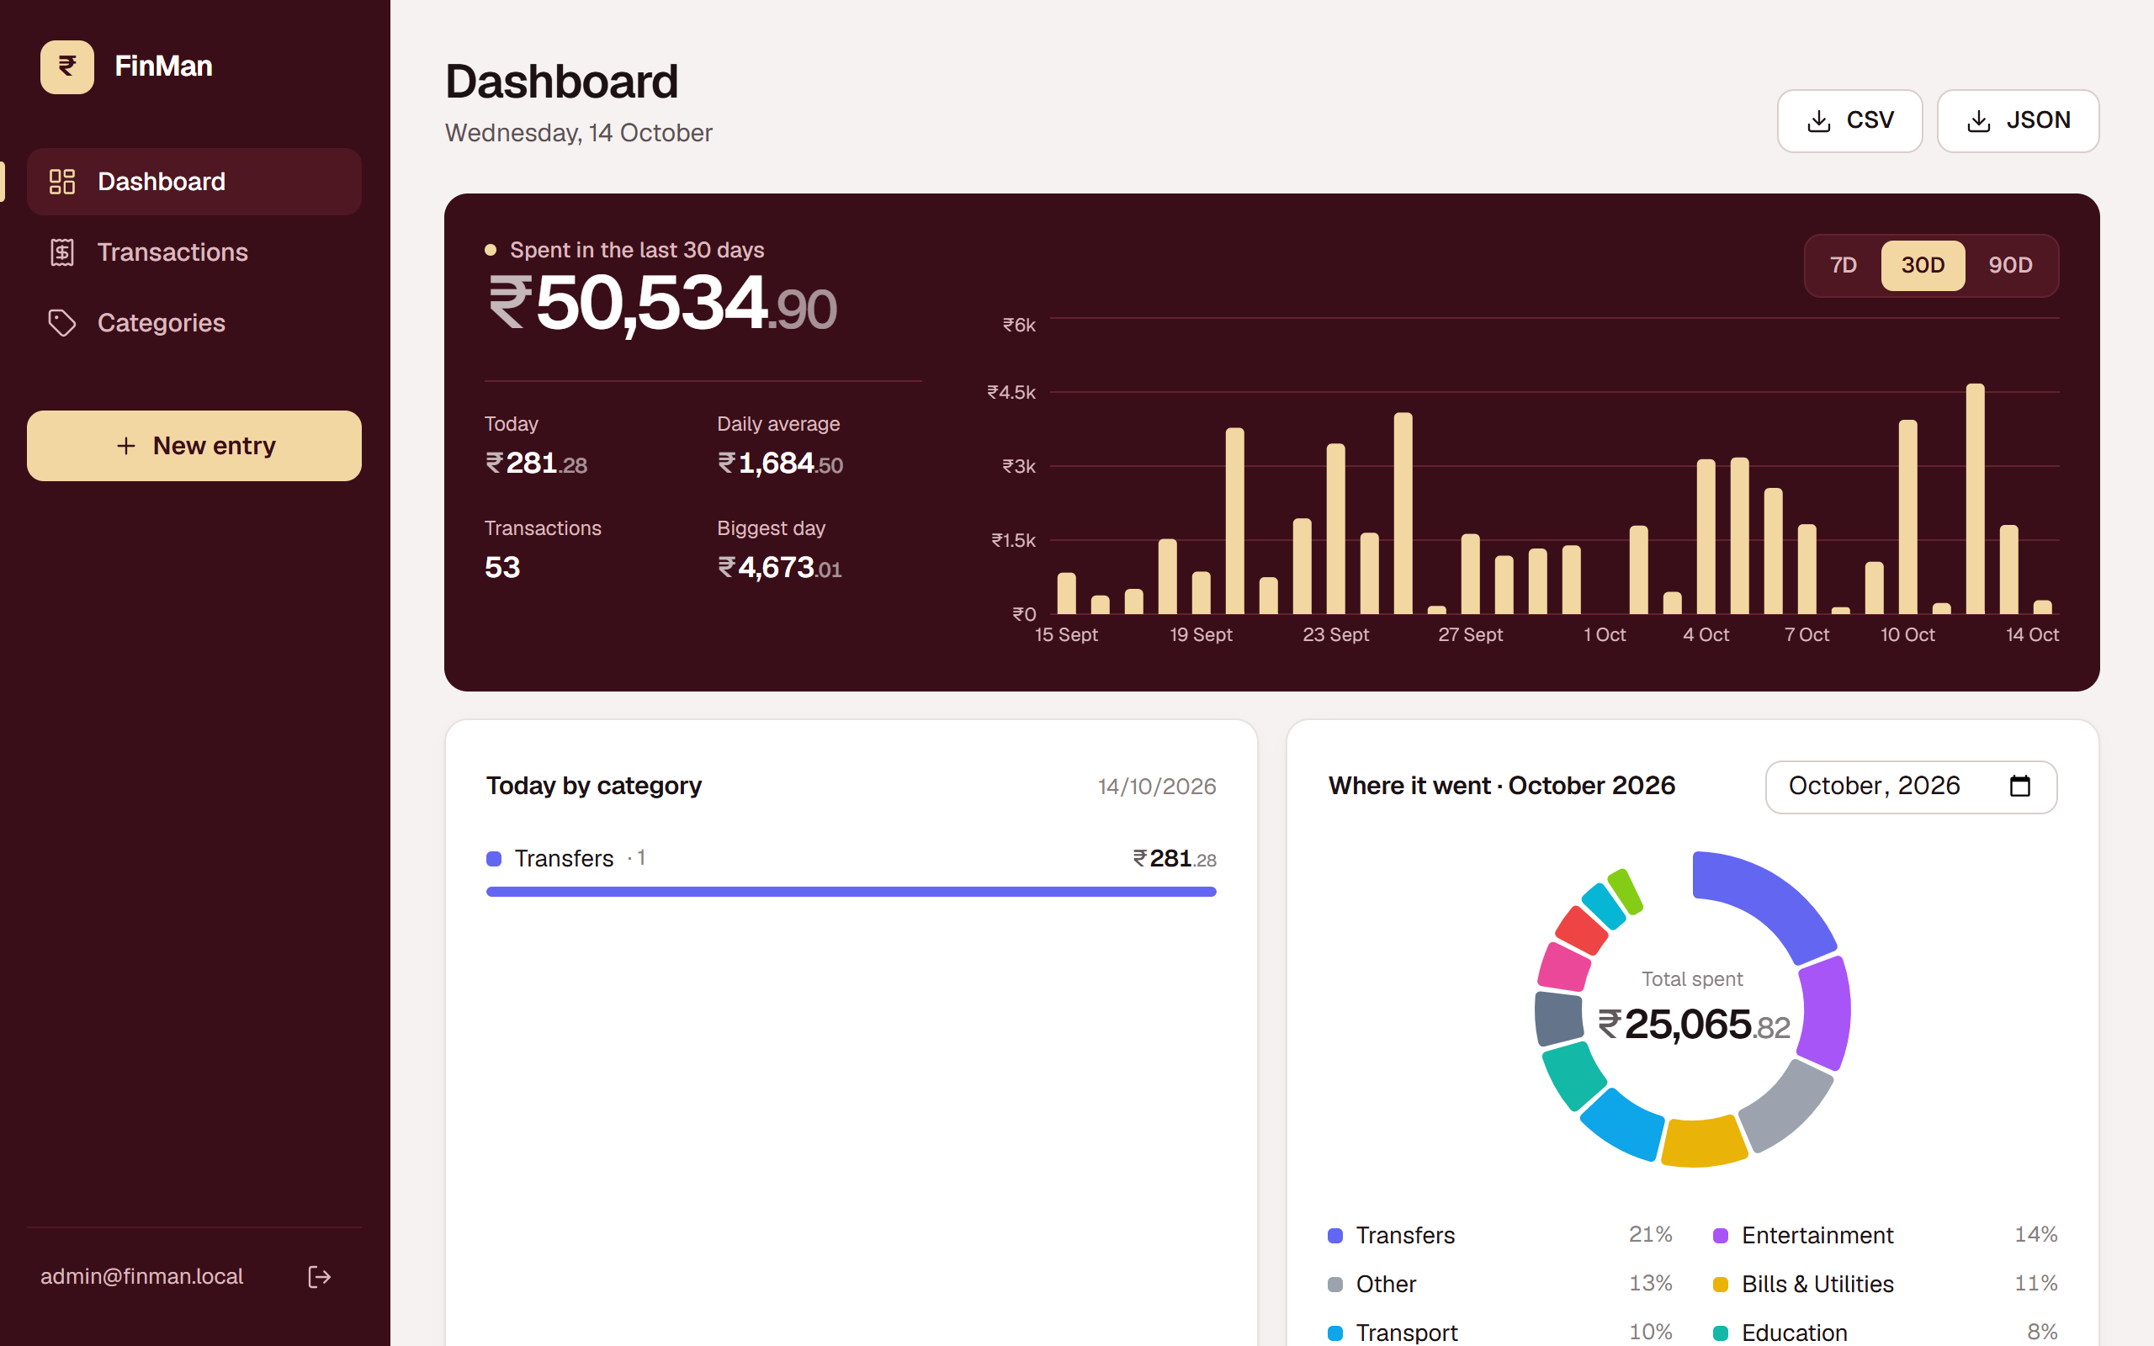
Figure 9: Dashboard: 30-day statement panel and chart, today by category, month donut
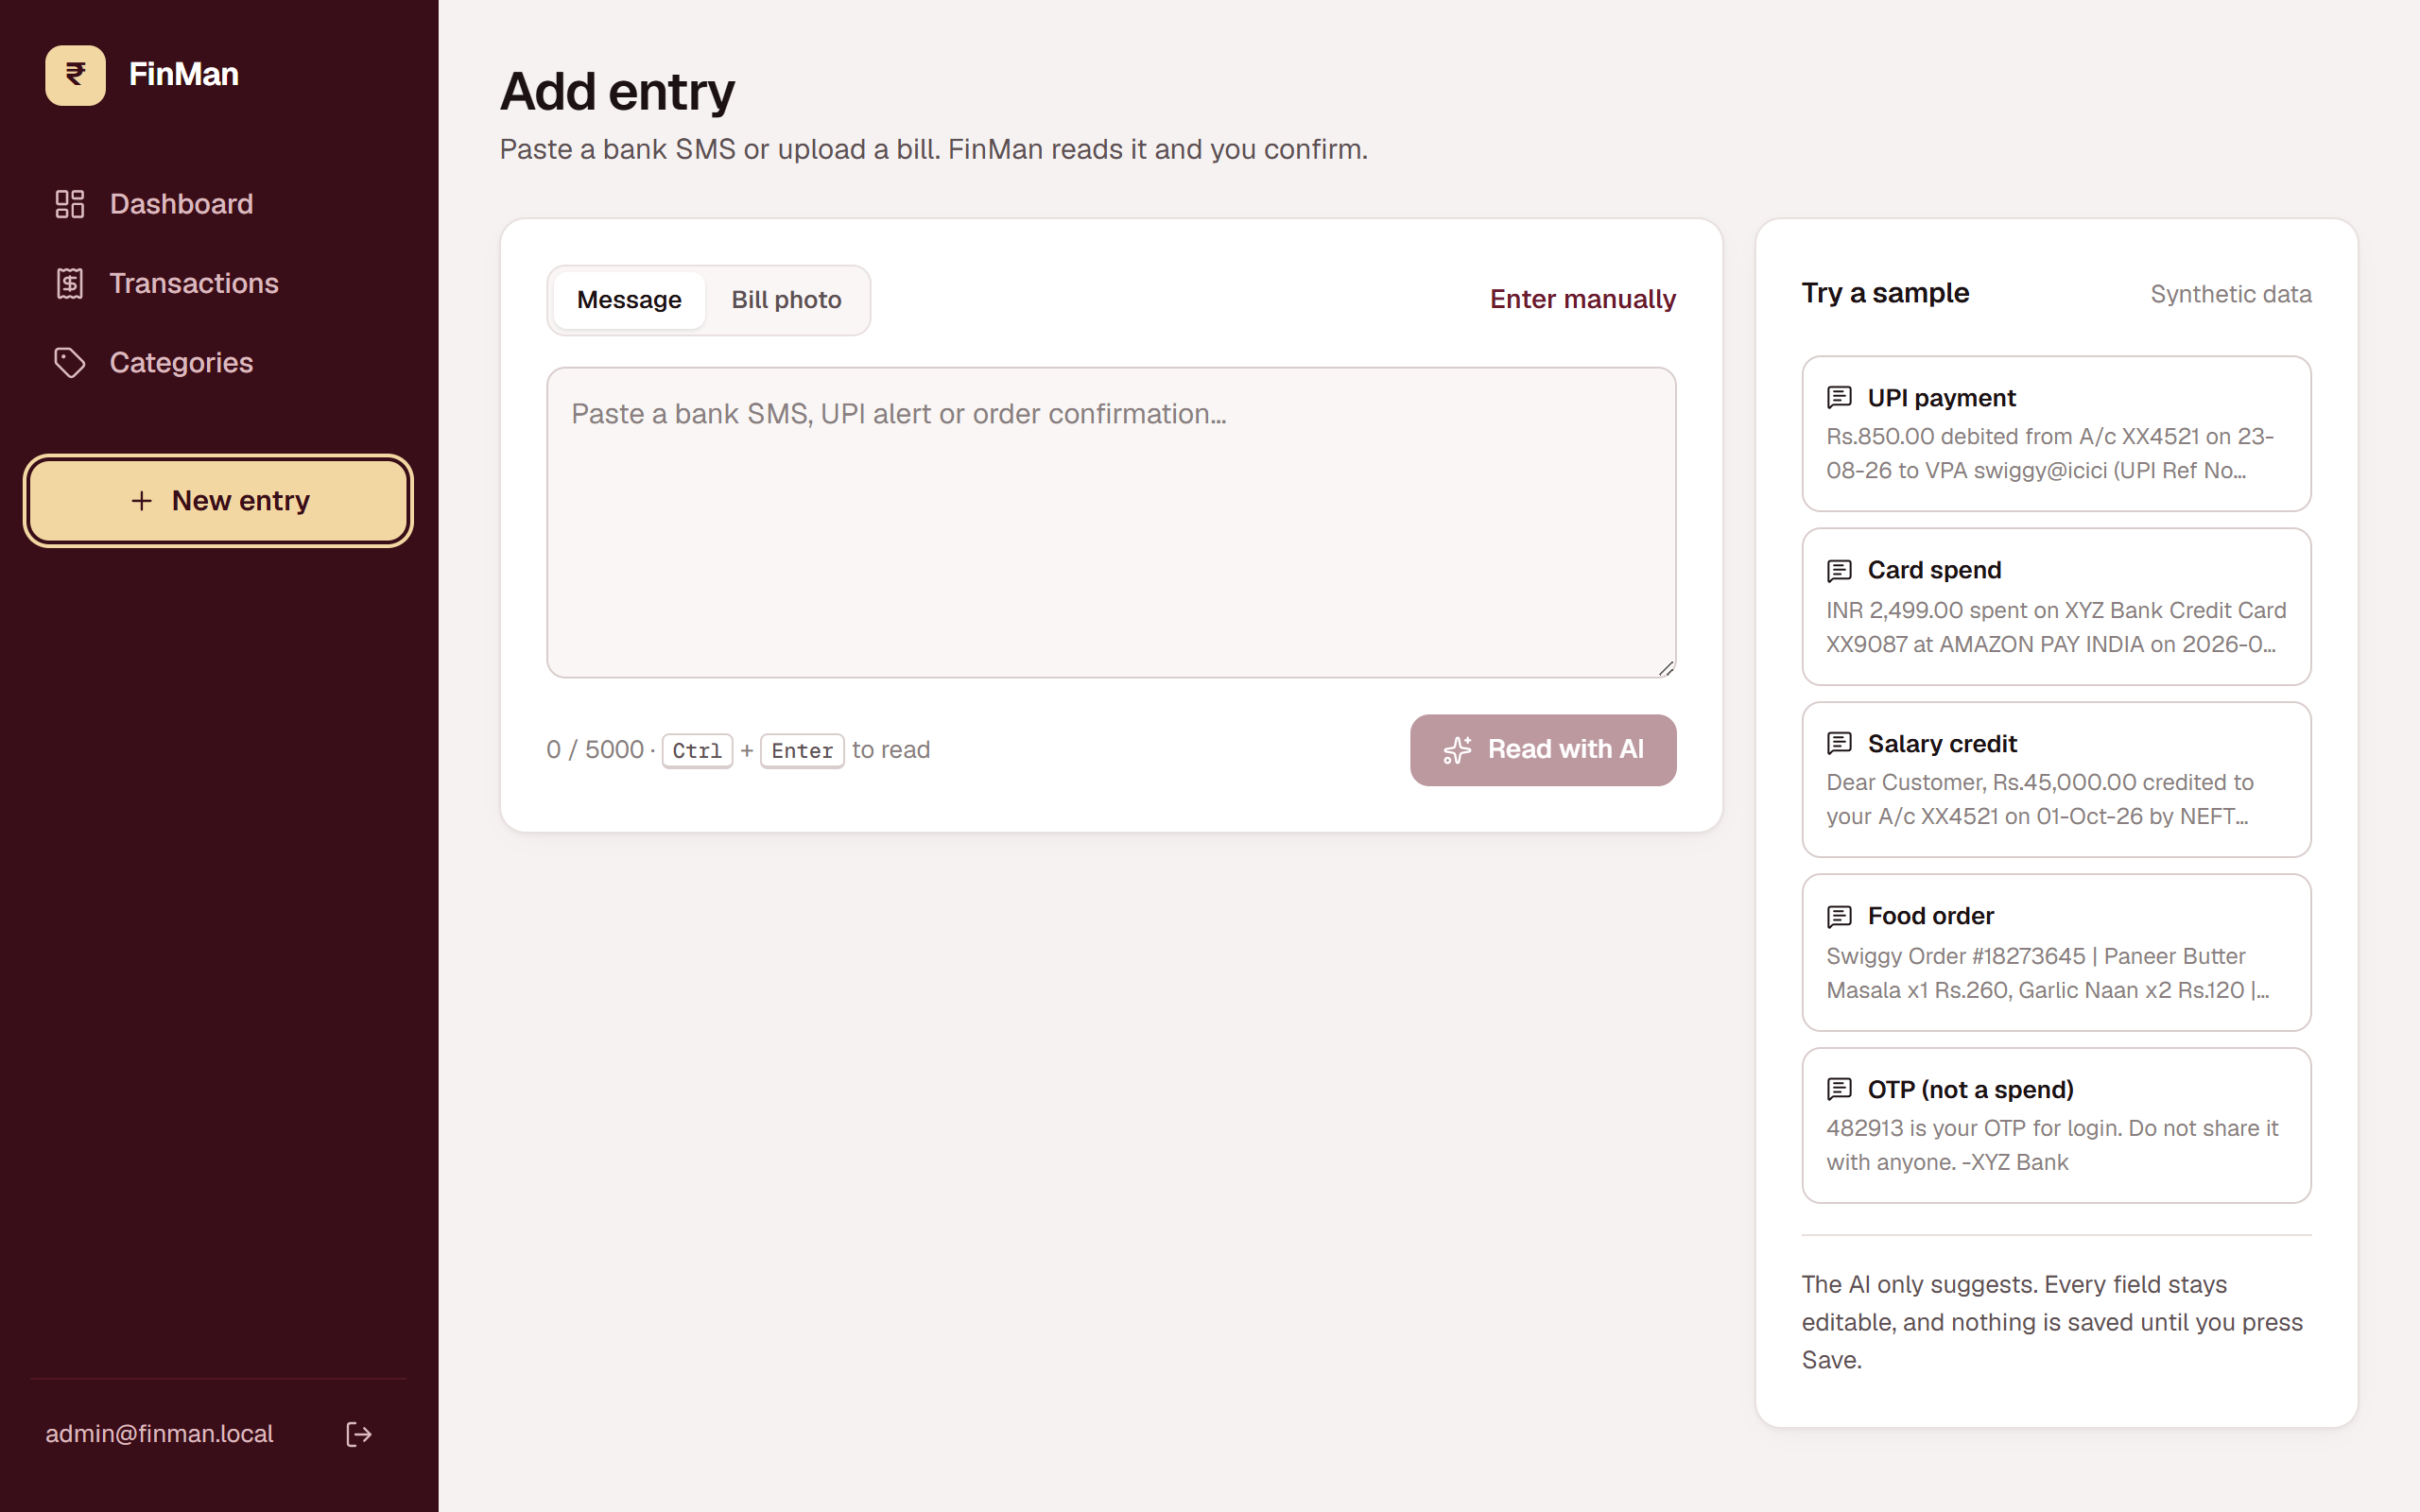
Figure 10: Add entry, with sample messages for the demo
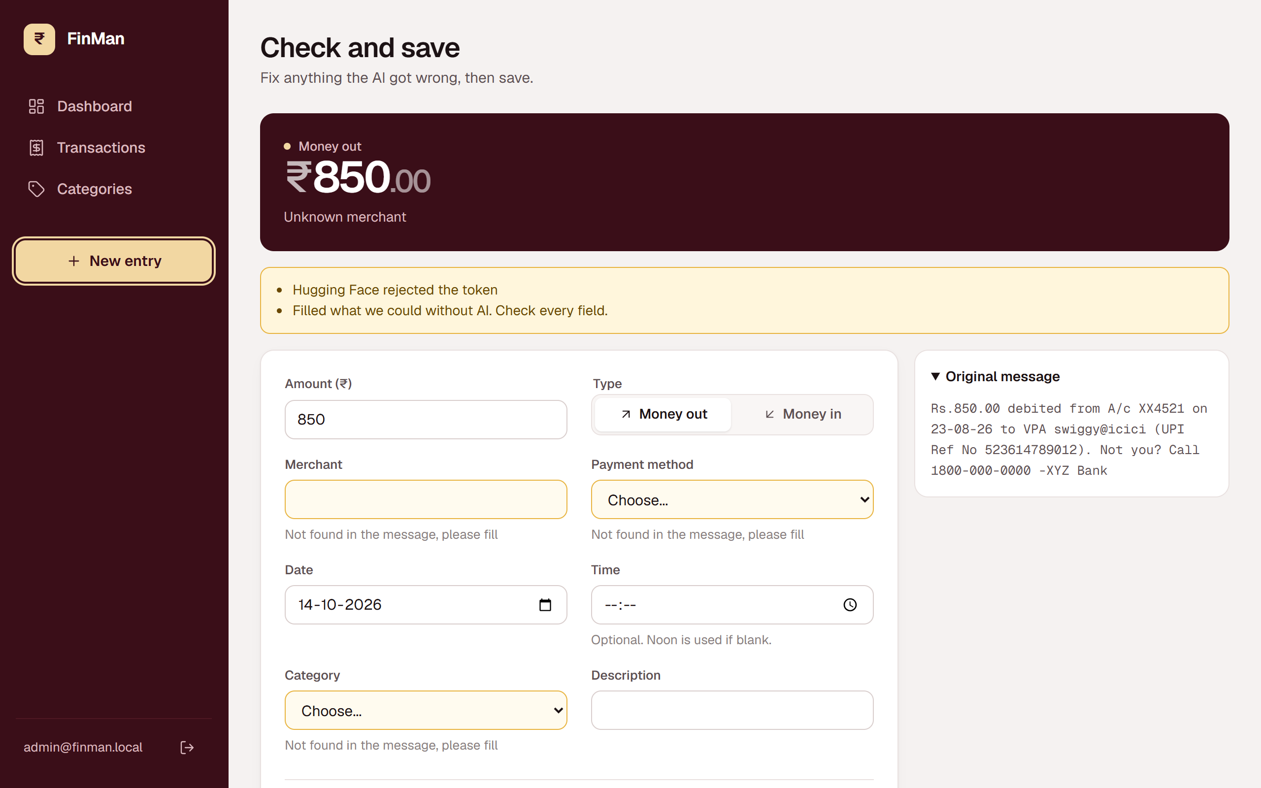
Figure 11: Review screen in fallback mode. With no valid AI token the regex still found ₹850 and the app flags the fields to fill
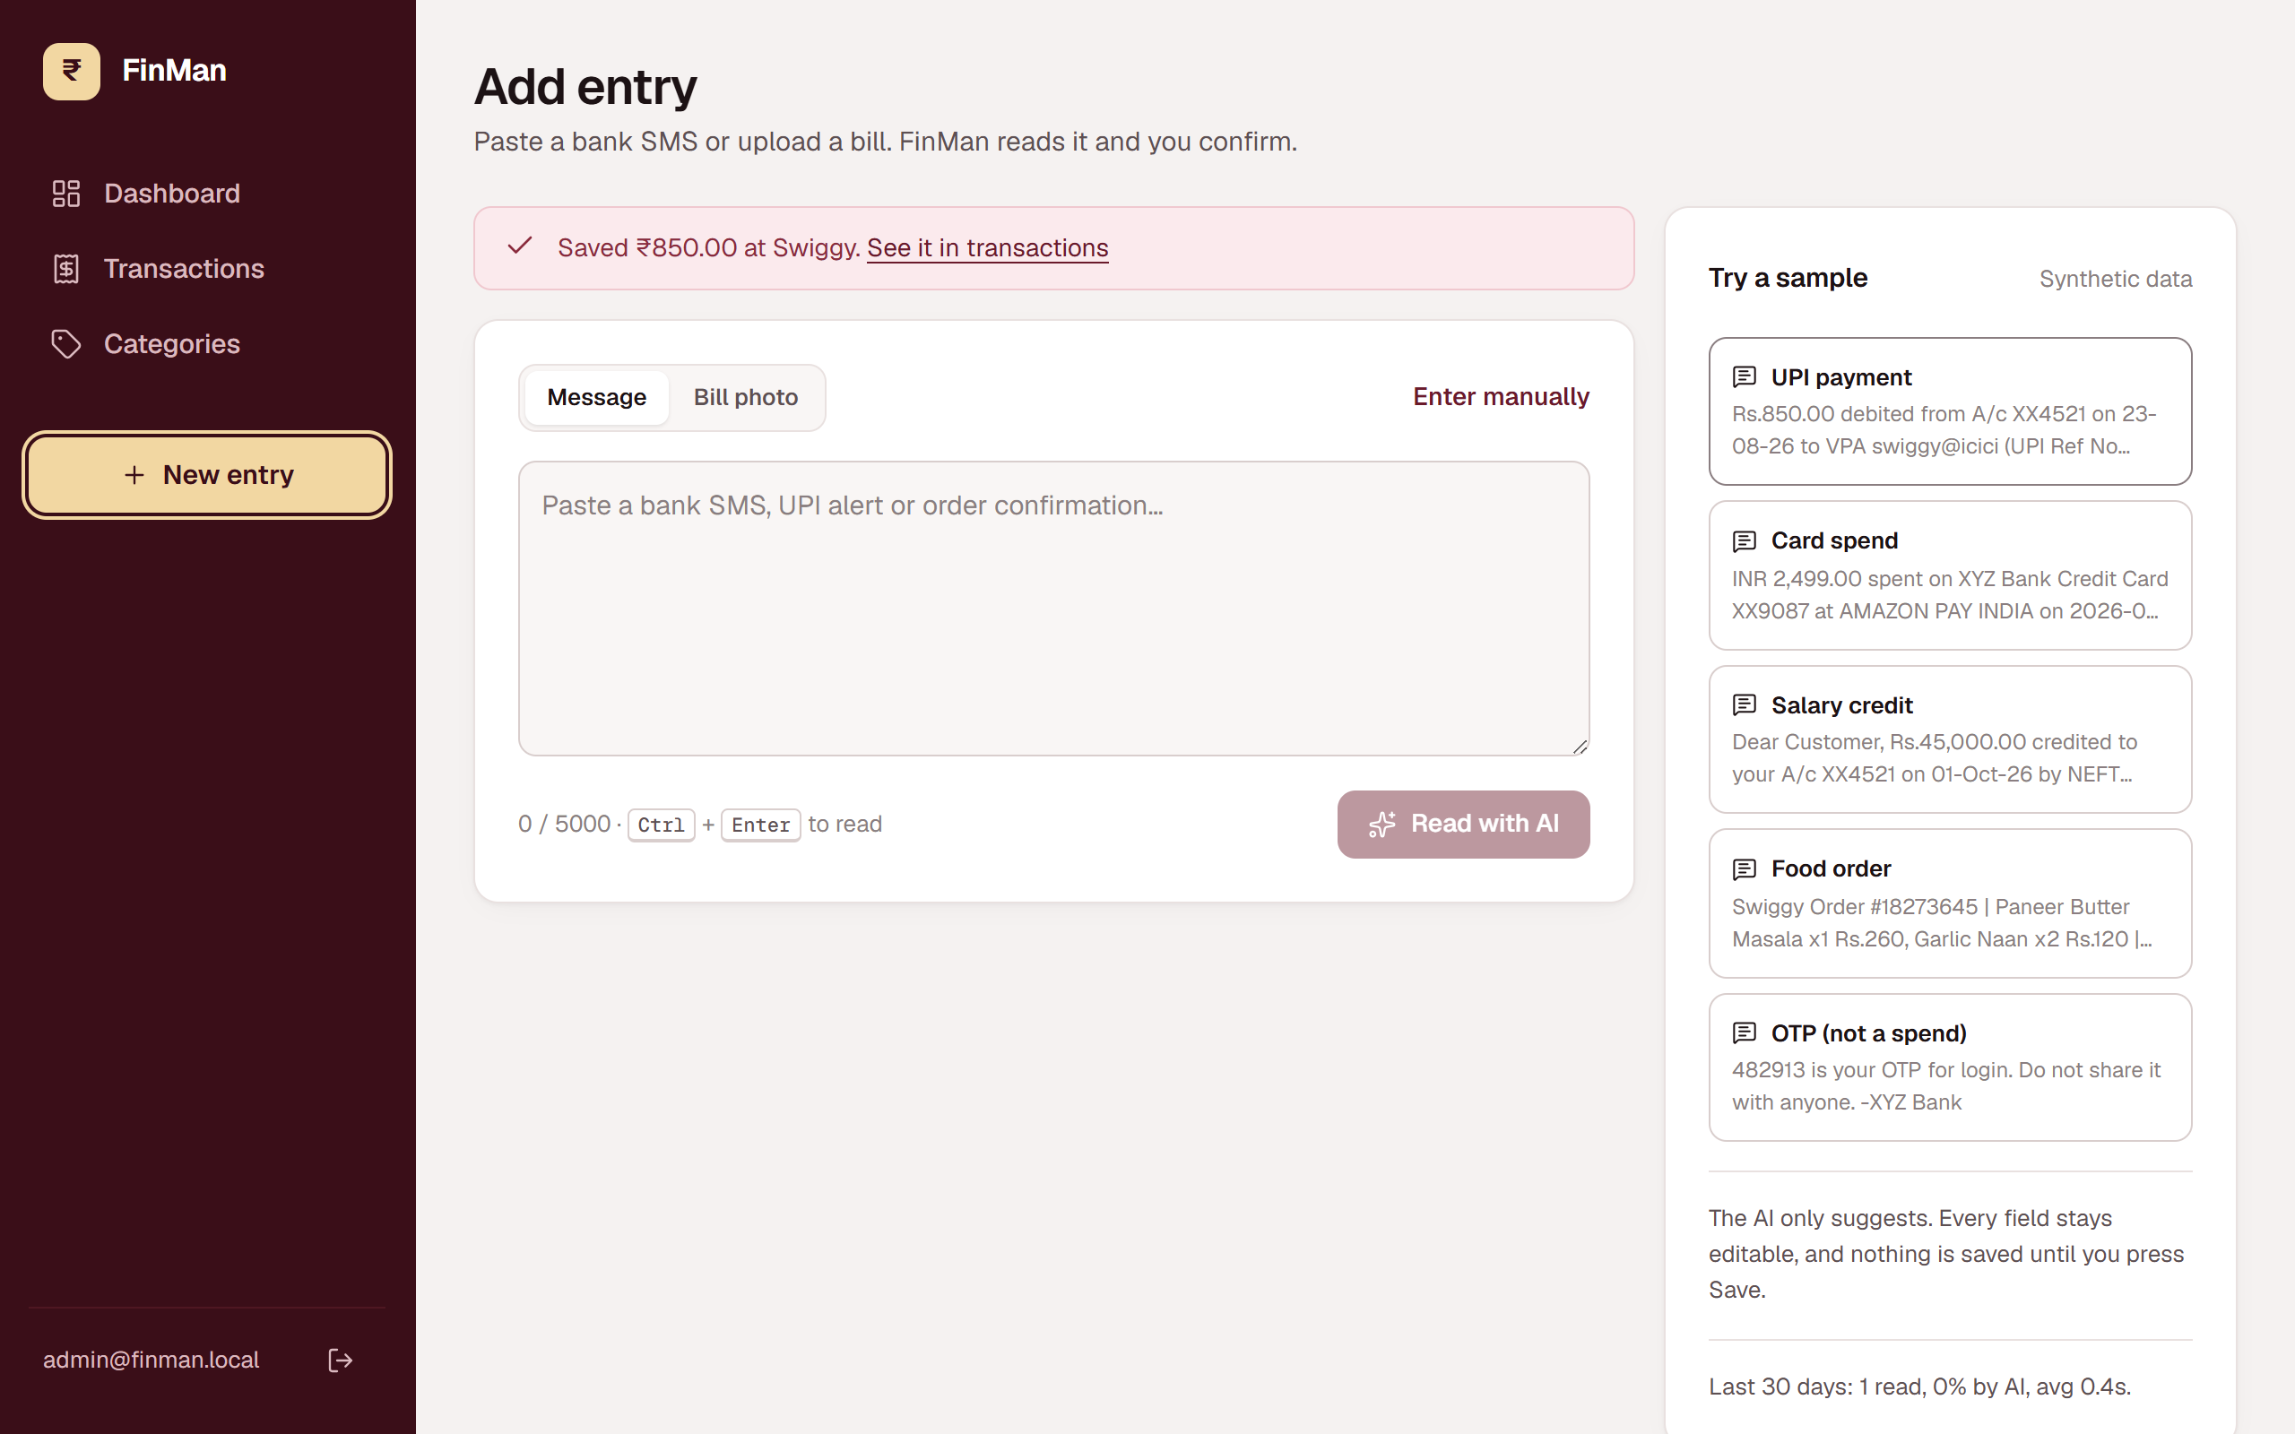
Figure 12: Saved confirmation
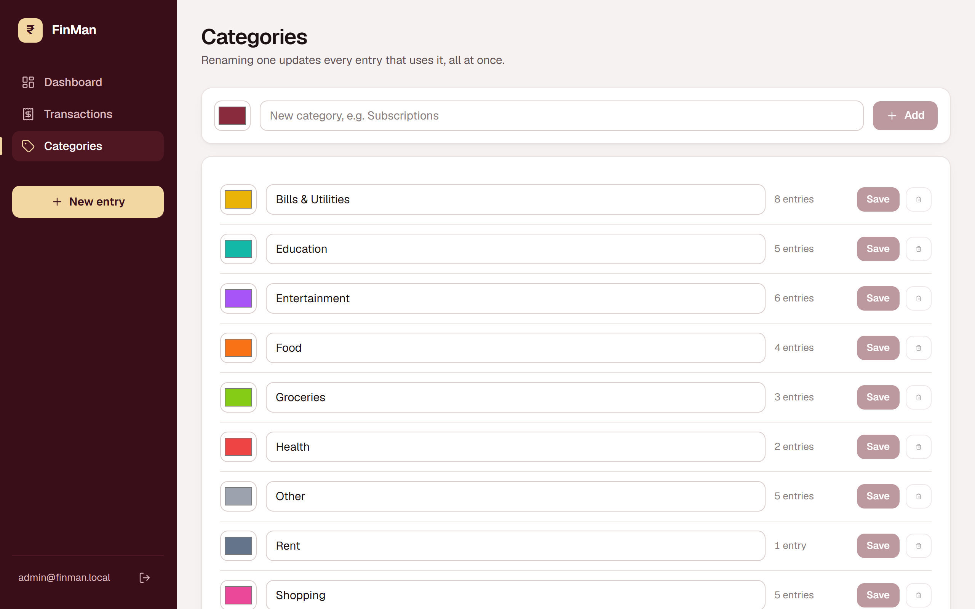
Figure 13: Categories with usage counts. Delete is disabled for categories in use
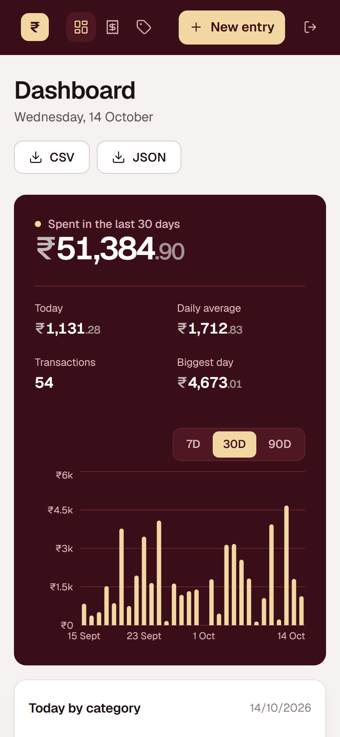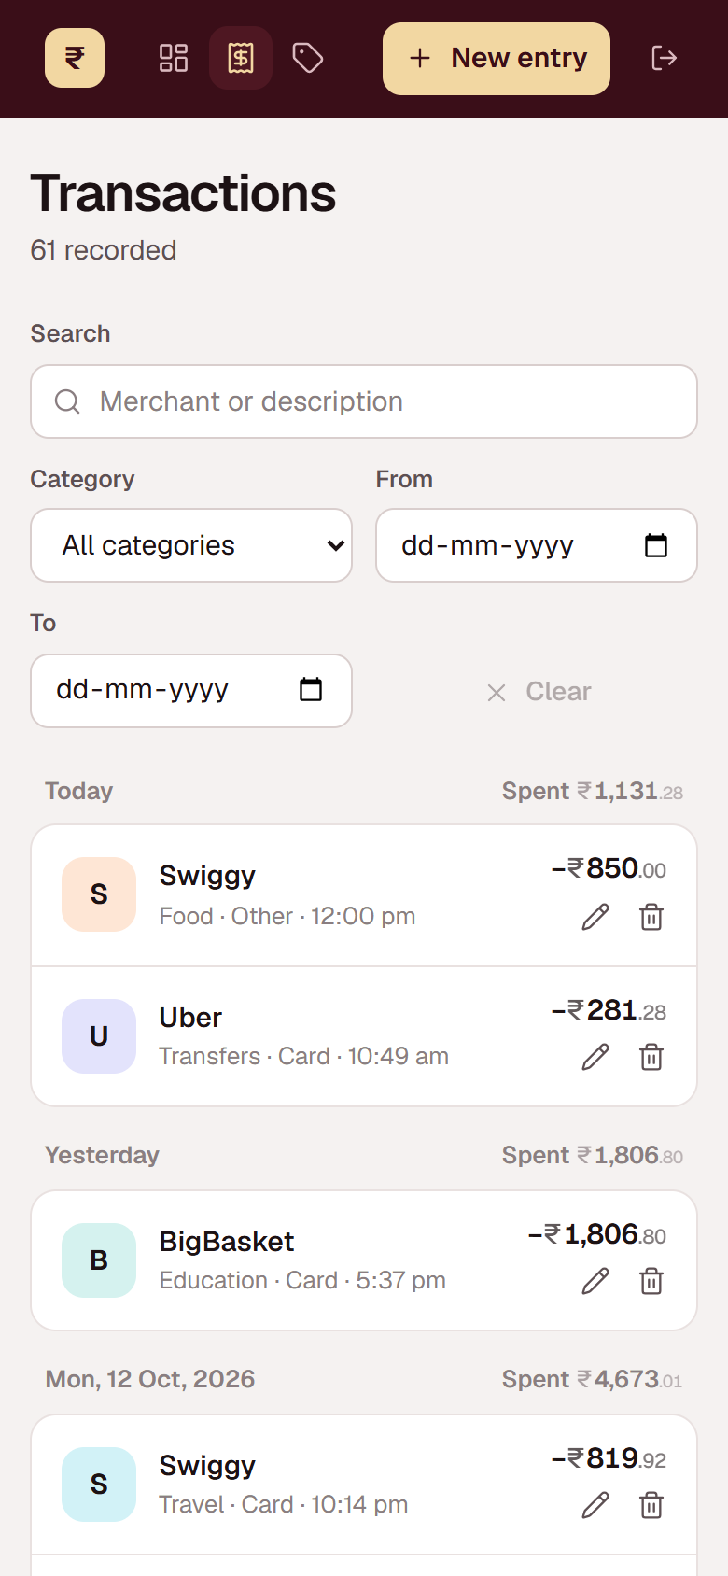
Figure 14: The same app at phone width (390 px)

6.4 Error handling and user experience
- Every API error has the same shape, { error: { message } }, and the frontend shows that message as written.
- Each dashboard panel loads separately and has its own loading, error-with-retry and empty states, so one failed request never blanks the page.
- Buttons that send requests are disabled while in flight, which prevents double saves.
- Filters and page number on the Transactions screen live in the URL, so refresh and the back button keep the view.
- If the backend is down, every screen says "Can't reach the server. Is the backend running?" instead of failing silently.
- An expired session anywhere returns the user to the sign-in screen.

7. Testing, security and data validation

7.1 Input validation
Validation happens in three layers, so bad data is stopped as early as possible and nothing invalid reaches the database:
Layer | What it checks
Browser form | Required fields, amount above 0, no future dates, focus moves to the first invalid field
API (zod) | Types, ranges, enums, string lengths, date format, hex colours, email format. Invalid input returns 400 with the field-level issues
Database (Mongoose) | Schema types, min: 0.01 on amount, enums, required fields, unique and partial unique indexes

7.2 Authentication and access control
- Passwords are hashed with scrypt and a random 16-byte salt (Node's built-in crypto), and compared with timingSafeEqual.
- Login returns a JWT signed with a server secret (12-hour expiry), stored in an httpOnly, SameSite=Lax cookie that page scripts cannot read. It is marked Secure in production.
- A requireAuth middleware guards every route except health and login. A missing, tampered or expired token returns 401.
- The login error is the same for an unknown email and a wrong password, so the endpoint does not reveal which accounts exist.

7.3 Other protections
Risk | Protection
Password guessing | Rate limit: 10 login attempts per 15 minutes per IP
Draining AI credits | Rate limit: 20 parse requests per minute
Common web attacks | helmet security headers (CSP, HSTS, nosniff, frame-ancestors)
Regex injection in search | Search text is escaped before building the regex
Spreadsheet formula injection | CSV cells starting with = + - @ are prefixed with an apostrophe
Prompt injection in an SMS | The prompt tells the model the message is data; the output is validated and only ever a suggestion the user confirms
Leaked secrets | Tokens and passwords live in .env, which is git-ignored; only .env.example with empty values is committed
Oversized uploads | 5 MB limit and an allow-list of file types

7.4 Automated tests
The backend has 36 automated tests run with Node's built-in test runner. 36 of 36 pass (output saved in docs/test-results.txt). The integration tests start a throwaway MongoDB replica set in memory, run the real Express app against it, and fake the Hugging Face API, so they never spend inference credits.
Suite | Tests | What is checked
Unit | 5 | JSON extraction from chatty replies, lenient field validation, CSV escaping, IST day range, regex fallback
Authentication | 4 | 401 without a session, wrong password, httpOnly cookie, tampered token
Entries CRUD | 5 | Create with rounding and persistence, list with filters, search and regex escaping, update with validation, delete, 400 vs 404
Input validation | 5 | Negative and zero amounts, future date, unknown category, invalid payment method
Duplicate detection | 2 | Same SMS with different spacing or case gives 409; manual entries never collide
Analytics | 5 | IST day boundaries at 23:59 and 00:01, credits excluded, category totals equal daily totals, $facet summary values, index used (IXSCAN)
Category transaction | 3 | Rename updates both collections; a colliding rename rolls back fully; in-use categories cannot be deleted
AI parser | 6 | Good reply, invented category dropped, retry then fallback, rejected token, OTP rejected, TTL index present and log written
Export | 1 | Byte-order mark, header row, formula escaping, download filename

✔ authentication
✔ entries CRUD
✔ input validation
✔ duplicate detection (partial unique index)
✔ analytics aggregations
✔ category rename (multi-document transaction)
✔ AI parser
✔ export
✔ extractJson handles code fences and trailing prose
✔ aiResult keeps good fields when one is bad
✔ csvCell escapes quotes, commas and formulas
✔ istDayRange covers exactly one IST day
✔ regexFallback finds amount and direction
ℹ tests 36
ℹ pass 36
ℹ fail 0

7.5 Manual checks
These checks were done by hand in the browser. Rows marked "before the demo" need a real Hugging Face token, Excel, or a fresh database, and should be ticked off on the demo machine.
Area | Check | Evidence
AI offline | Invalid token: warning shown, amount still filled from the SMS | Figure 11
Duplicate | Same SMS saved twice is refused with a clear message | Figure 5
Category rename | Rename shows how many entries moved | Figure 6
Phone width | 390 px wide: no sideways scrolling | Figure 14
Session | After sign-out the app returns to the sign-in screen | Figure 8
AI parsing | All five sample messages with a real Hugging Face token | Before the demo
Charts | An empty month and a 90-day range render without errors | Before the demo
Export | CSV opens in Excel with ₹ symbols and commas intact | Before the demo

8. Demonstration, viva and documentation

8.1 How to run
# 1. database: Atlas, or a local on-disk replica set
cd backend
npm install
npm run db:local # leave running, or put an Atlas URI in .env

# 2. data and login user (reads ADMIN_EMAIL / ADMIN_PASSWORD from .env)
npm run seed -- --demo

# 3. API on :4000
npm run dev

# 4. web app on :5173
cd ../frontend
npm install
npm run dev

# tests and index evidence
cd ../backend
npm test
npm run explain -- 5000

8.2 Demo script (about six minutes)
- Sign in with the demo account (demo@gmail.com / demo123). Show that the API returns 401 without the session cookie.
- Dashboard: the 30-day statement panel, switch between 7, 30 and 90 days, the category donut and the month card.
- Add entry: pick the UPI sample, read it with AI, point out the AI tags and the highlighted missing fields, save.
- Paste the same message again to show the duplicate rejected by the partial unique index.
- Pick the OTP sample to show it recognised as not a transaction.
- Transactions: filter by Food, edit an amount, delete an entry, refresh to show the filters survive.
- Categories: rename Rent to Housing and show the transaction count updated in one transaction.
- Export CSV and open it in Excel.
- Terminal: run npm run explain -- 5000 to show IXSCAN against COLLSCAN, then npm test.
- Compass or Atlas: show three documents with different details shapes, the indexes tab, and the TTL index on parselogs.
Backup plan: Atlas and Hugging Face both need internet. npm run db:local keeps the database working offline, and the regex fallback keeps entry working without the AI.

8.3 Viva questions
Question | Short answer
Why MongoDB instead of SQL? | Payment details vary by type and bills have line-item arrays. One flexible details field replaces several nullable columns or extra tables, and the aggregation framework covers the analytics.
Why copy the category name into each transaction? | Reads are frequent and renames are rare. Copying avoids a join on every list and export. Renames are handled atomically with a transaction.
Why is the index { direction, occurredAt } in that order? | Equality, Sort, Range: direction is matched by equality, occurredAt by range, so equality goes first and the range scan stays contiguous.
Why a partial index instead of sparse? | Sparse skips only missing fields; an explicit null would still be indexed and collide. The partial filter indexes only string hashes.
What happens if the AI returns garbage? | Extract the JSON object, validate each field separately, retry once, then fall back to a regex for the amount. The user always reviews before saving.
How are time zones handled? | Dates are stored as UTC instants. Queries build IST-midnight boundaries and group with timezone Asia/Kolkata, so day totals follow Indian time.
Why does the transaction need a replica set? | MongoDB implements multi-document transactions on replica sets (using the oplog). Atlas is a replica set; locally a one-node replica set is used.
How would you support many users? | Add userId to every document, put it first in every compound index, filter every query by it, and shard on { userId, occurredAt } if needed.

8.4 Limitations and future work
- One account per deployment. Multi-user support needs userId scoping as described above.
- AI accuracy depends on the model chosen. A second worked example per message type and a comparison across models using the parse log would improve it.
- PDF bills with a text layer could be read with a PDF text extractor; scanned PDFs still need a photo.
- Monthly budgets with alerts, and change streams to push new entries to an open dashboard in real time.

8.5 Plagiarism report
[Attach the plagiarism report generated by the institute's tool here before submission.]

Appendix A: Environment variables
Variable | Purpose
MONGODB_URI | Atlas connection string, or mongodb://127.0.0.1:27017/?replicaSet=rs0 for the local database
MONGODB_DB | Database name (default finman)
HF_TOKEN | Hugging Face token with Inference Providers permission
HF_MODEL | Text model, e.g. Qwen/Qwen2.5-7B-Instruct
HF_VISION_MODEL | Vision model for bill photos, e.g. Qwen/Qwen2.5-VL-7B-Instruct
JWT_SECRET | At least 32 random characters for signing session tokens
ADMIN_EMAIL, ADMIN_PASSWORD | The login the seed script creates or updates
DEMO_EMAIL, DEMO_PASSWORD | Optional second login for the demo (demo@gmail.com / demo123 on the demo machine only)
CORS_ORIGIN | Frontend origin when not using the Vite proxy

Appendix B: Project structure
finman/
├─ backend/src/
│ ├─ app.ts, server.ts Express app and start-up
│ ├─ config/ env validation, MongoDB connection
│ ├─ models/ Transaction, Category, User, ParseLog
│ ├─ routes/, controllers/ HTTP layer
│ ├─ services/ aiParser, analytics, auth, csv
│ ├─ middleware/ auth guard, error handler
│ ├─ validation/ zod schemas
│ ├─ scripts/ seed, localdb, explain
│ └─ tests/ core.test.ts, api.test.ts
├─ frontend/src/
│ ├─ pages/ Dashboard, AddEntry, History, EditEntry, Categories, Login
│ ├─ components/ EntryForm, ParseInput, TransactionList, charts/, ...
│ └─ api.ts, types.ts, format.ts, index.css
├─ samples/sms.txt synthetic test messages
├─ docs/ this report, screenshots, test and explain output
└─ api.http REST Client requests

