**STUDY:**

***PREDICTING VESSEL EXPECTED TIME OF ARRIVAL (ETA) USING MACHINE LEARNING***

**Data** is from AIS Observation: GPS and SATELLITE feed from global vessel monitoring center (GVVMC)

Used to avoid collision among ships and is mandatory for cargo ships of 300GrossTon or more and for every passenger ships. Sends data like position, heading and speed for every 10 to 15mins. My company receives around 90% of all shipping lines AIS data that includes vessel movement data of other carriers.

**Model used:** Regression using random forest (xgboost) and gradient boosted machine (GBM)

**Results:** Training Set vs Testing Set (568 recs and 142 recs) from **Ningbo to Shanghai in 2014 to 2015**

Current Transit time: **Avg: 32hrs** Min: 10hrs Max: 83hrs (3.5days);

Current speed: **Avg 7 nm/hr** Min: 2 nm/hr Max: 17nm/hr

Biggest cargo ship: 300m x 40m 75k GT Smallest cargo ship: 146m x 22m 10k GT

Going to **Shanghai is busy because 56% of the time,** shiphas 4 or more stops (speed=0)

ETA average: Predicted: **32hrs** (STDEV: 15hrs) Between 8hrs and 57hrs (2.4days) at 80% Conf Interval

Current ETA average: **24hrs** (STDEV: 19hrs)

(MSE: Mean square error): Predicted: **15%** vs Current: **42%**

(MA: mean absolute distance from actual): Predicted: **5hrs vs** Current: **11 hrs**

Accuracy or ETA is within +/-4hrs: Predicted: **63%** vsCurrent: **37%**

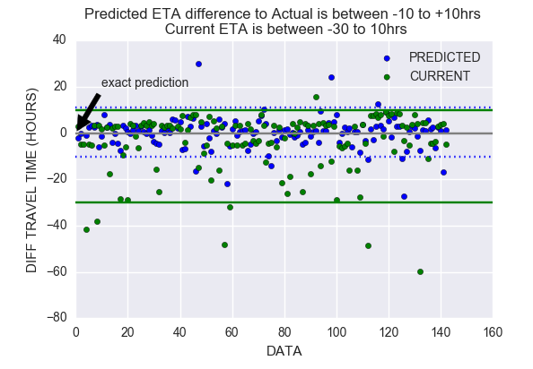

Ship route in red are those with delays or stops while in green are without delay.

Insight: Faster route uses the open seas while slower route is using a route near islands

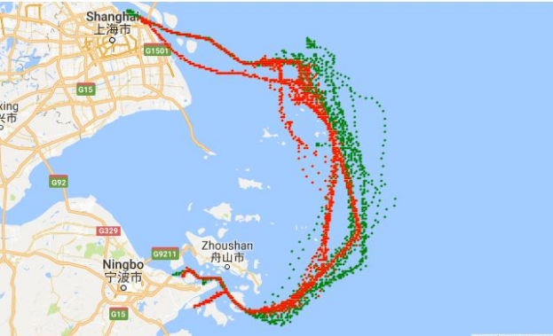

Low positive correlation: width of ship and draught, length of ship and draught

Highly negative correlation: travel time and speed, number of stops and speed

Very low correlation: travel time and sailing date (month, week number or day of the week)

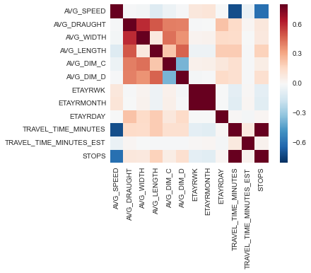

Without delay, travel time is about 10 hours from Ningbo to Shanghai. With 4hrs or more delays, ships are stopping between 5th or 10th hour before approaching Shanghai terminal.

