ICT167 Assignment 1- Change Calculation Program

<Hiba Anis Ur Rehman Zubairi>

<34779757>

27/06/2024

File names: “changeC.java” & “Client.java”(main)

The purpose of the program is to store a list of data entries either input by the user or from a predefined test cases method and make different calculations based on the menu option chosen by the user such as to calculate change for a specific person.

1. Requirements:

- Take user input to create atleast 10 entries of customers, storing their names and currency amounts in a changeC array.
- Validate to check for duplicate names
- Validate to check for amounts which are not a multiple of 5.Display menu to the user and prompt the user to choose one of the available options.
- The menu will contain the options to calculate change in higher value currency note denominations, find the smallest and largest amount, calculate total denomination and total amount of all entries.
- A method should be created for storing harcoded test cases so that the testing is made easier for the tutor.

2. Assumptions:

- User will input different names each time
- User will input currency note amounts that are a multiple of 5 only.
- User will input only positive integers for currency note amounts.
- The program has a fixed size array changes to store upto 100 entries only
- User will follow when prompted to enter a a required input for further running of the program.
- The program assumes a fixed list of denominations (5,10,20,50,100,200,500,100)

3. User guide:

Compilation and execution

- Open your installed version of IDE, (I used Netbeans IDE version 8.2)
- Make sure you have installed JDK 8
- Go to File > New Project
- Add two class files changeC.java and client.java
- Compile the files
- Run the client.java class
- Follow the prompts shown on the console with instructions to process the code
- Enter name and currecny or use hardcoded test cases to test the menu
- Enter 6 from the menu to exit the program.

4. Algorithm (client)

High-Level Algorithm (client.java):

1. Declare an array to store changeC objects/records entered
2. Declare a counter to store the number of records entered.
Input:
3. Prompt the user to enter the data
4. Validate if the entered data is valid and meets the requirements
5. Store the data in the array.
6. Ask the user if it wants to add more data.
Output:
7. Display a menu with choices for calculating and displaying various amounts.
8. Manage user choices for every option:
9. Display change in higher value note denominations for a particular person entered by user
10. Calculate change for the name with the smallest and largest amount.
11. Calculate sum of all currency notes denominations.
12. Calculate total amount of all entered amounts in the array.
13. terminate the program.

Low-level algorithm(Pseudocode):

DECLARE change : ARRAY[1:50] OF ChangeC

DECLARE numPersons : INTEGER

numPersons=:0

Input:

PROCEDURE enterData() returns void

DECLARE enterMore: BOOLEAN
Set enterMore to true
WHILE entermore is true
CALL validateData()
enterMore =: addData()
END WHILE
ENDPROCEDURE

PROCEDURE validateData() returns void
PRINT “Please enter the name of the person”
GET name

IF nameExists(name: string) is true THEN
PRINT “Name is already present”
RETURN
ENDIF

PRINT “Please enter the currency value for the persom”
GET amount

IF amount % 5!= 0 THEN
PRINT “Enter the amount in multiples of 5 only!”
RETURN
ENDIF

ENDPROCEDURE

PROCEDURE addData(scanner : Scanner) returns BOOLEAN
PRINT “Do you want to add more person(Y/N)”
GET reply from user
RETURN response “Y”

ENDPROCEDURE

PROCEDURE menu() returns void
DECALRE choice: int
SET choice to 0

WHILE choice is not equal to 6
CALL displayMenu()
GET choice from the user
CALL menuChoice(choice: int, scanner: Scanner)
ENDWHILE

ENDPROCEDURE

PROCEDURE menuDisplay () returns void
PRINT “Enter a specific name and display change"
PRINT “Find name with the smallest amount and display change"
PRINT “Find name with the largest amount and display change"
PRINT “Calculate total number of currency notes for each denomination"
PRINT “Calculate total amount for each denomination"
PRINT ”Exit the program”
ENDPROCEDURE

PROCEDURE menuChoice(choice: int, scanner: Scanner) returns void

CASE OF choice
CASE 1: CALL displayChangeForAPerson()
CASE 2: CALL displayChange(findSmallest())
CASE 3: CALL displayChange(findLargest())
CASE 4: CALL totalDenomination()
CASE 5: CALL totalAmount()
CASE 6: PRINT “EXIT”
OTHERWISE : PRINT “invalid input”
ENDCASE

ENDPROCEDURE

PRCODURE displayChangeForAPerson() returns void
PRINT “ enter name: ”
GET name from the user

DECLARE change =: findChange(name : string)

IF change != null THEN
displayChange(change : changeC)
ELSE
PRINT “ NAME NOR FOUND”
ENDIF

ENDPROCEDURE

PROCEDURE findChange(name : string) returns changeC
FOR int index from 0 to numPersons
IF change[index].getName() = name THEN
RETURN change[index]
ENDIF
NEXT index
ENDFOR
RETURN null

ENDPROCEDURE

PROCEDURE validateDenomination(change : changeC, denomaintion : int) returns void
DECLARE count : int
SET count =: change.getDenomination(denomination : int)

IF count > 0 THEN
PRINT “denomintaion, count”
ENDIF

ENDPROCEDURE

PROCEDURE displayChange(change : changeC) returns void
PRINT “ Customer: , name, change”
CALL validateDenomination (change : changeC , 1000)
CALL validateDenomination (change : changeC , 500)
CALL validateDenomination (change : changeC , 200)
CALL validateDenomination (change : changeC , 100)
CALL validateDenomination (change : changeC , 50)
CALL validateDenomination (change : changeC , 20)
CALL validateDenomination (change : changeC , 10)
CALL validateDenomination (change : changeC , 5)

ENDPROCEDURE

PROCEDURE findSmallest() returns changeC
DECLARE smallest : changeC
SET smallest =: change[0]

FOR int index from 0 to numPersons
IF change[index].getAmount() < smallest THEN
Smallest =: change[index]
ENDIF
NEXT index
ENDFOR
RETURN smallest
ENDPROCEDURE

PROCEDURE findSmallest() returns changeC
DECLARE largest : changeC
SET largest =: change[0]

FOR int index from 0 to numPersons
IF change[index].getAmount() > largest THEN
largest =: change[index]
ENDIF
NEXT index
ENDFOR
RETURN largest

ENDPROCEDURE

PROCEDURE findLargest() returns changeC
DECLARE smallest : changeC
SET smallest =: change[0]

FOR int index from 0 to numPersons
IF change[index].getAmount() < smallest THEN
Smallest =: change[index]
ENDIF
NEXT index
ENDFOR
RETURN smallest

ENDPROCEDURE

PROCEDURE totalDenomaintion() returns void
DECLARE total5, total10, total20, total50, total100, total200, total500, total1000 : INTEGER
SET total5, total10, total20, total50, total100, total200, total500, total1000 =: 0

FOR int index from 0 to numPersons
SET total5 =: total5 + change[index].getDenomination(5)
SET total10 =: total10 + change[index].getDenomination(10)
SET total20 =: total20 + change[index].getDenomination(20)
SET total50 =: total50 + change[index].getDenomination(50)
SET total100 =: total100 + change[index].getDenomination(100)
SET total200 =: total200 + change[index].getDenomination(200)
SET total500 =: total500 + change[index].getDenomination(500)
SET total1000 =: total1000 + change[index].getDenomination(1000)
NEXT index
ENDFOR

PRINT “Total of aed5 notes, Total of aed10 notes, Total of aed20 notes, Total of aed50 notes, Total of aed200 notes, Total of aed500 notes, Total of aed1000 notes”

ENDPROCEDURE

PROCEDURE calculateTotalAmount() returns int
DECLARE total : INTEGER
SET total =: 0

FOR int index from 0 to numPersons
Total =: total + change[index].getAmount()
NEXT index
ENDFOR
RETURN total

ENDPROCEDURE

PROCEDURE totalAmount() returns void

PRNT “Total amount: ”

ENDPROCEDURE

Structure chart (client.java):

scanner
name


choice
scanner


change
denomination


UML (changeC.java):

ChangeC
- name: string
- amount: int
- aed5: int
- aed10: int
- aed20: int
- aed50: int
- aed100: int
- aed200: int
- aed500: int
- aed1000: int

+ changeC()
+ changeC(string, int)
+ getName(): string
+ setName(string): void
+ getAmount(): int
+ setAmount(int): void
+ getDenomination(): int
- calculateChange (): void

6. O-O design principles useed:

1. The Open/Closed Principle says a class should be open for extension but closed for modification. This principle is implemented in changeC class.
In my program, the changeC class calculates and stores the breakdown of a given amount into higher valued denominations. For example, if you want to add new denomination or change how the change is calculated, you can add new methods without modifying the existing one.

public class changeC {
public void calculateChangeForNewCurrency(int amount) {
} }

2. Information hiding restricts access to an object's implementation details, In my program, private variables are declared to ensure internal details of the changeC class are hidden from other classes

private String name;
private int amount;
private int aed5, aed10, aed20, aed50, aed100, aed200, aed500, aed1000;

3. Encapsulation is the bundling of data and methods that act on that data within a single class. It also involves restricting direct access to an object's elements, which is a means of information hiding.
In my program, the changeC class encapsulates the person's name, amount, and denomination counts, with methods to use it.

public class changeC {
// Private variable
private String name;
// Methods to operate on the it
public void setName(String name) {
this.name = name;
}
public String getName(){
return name;
}

4. Pre-conditions are conditions that must be true before a method is executed, and post-conditions are conditions that must be true after the method is executed. For example, the pre-condition for the setAmount() method is that the amount should be a multiple of 5. The post-condition is that the amount should be stored in the array of changeC objects

//pre-condition
if (amount % 5 != 0) {
System.out.println("Please enter the amount in multiple of 5 only!");
return;
}
//post-condition
change[numofRecords] = new changeC(name, amount);
numofRecords++

5. Private variables are used to restrict access to the inner state of an object. for example, all variables in the changeC class are private to ensure they are not accessible from outside the class.

private String name;
private int amount;
private int aed5, aed10, aed20, aed50, aed100, aed200, aed500, aed1000

6. Constructors are special methods used to initialize objects. for example The changeC class has a default constructor and a parameterized constructor

//default constructor
public changeC(){
this.name = "";
this.amount = 0;
this.aed5 = this.aed10 = this.aed20 = this.aed50 = this.aed100 = this.aed200 = this.aed500 = this.aed1000 = 0;
}
//parameterized consturctor
public changeC( String name, int amount){
this.name = name;
this.amount = amount;
calculateChange();
}

7. Accessors (getters) and mutators (setters) are methods used to retrieve and modify the values of private variables for example they are used to access and modify the name and amount variables:

public String getName(){
return name;
}
public void setName(String name){
this.name = name;
}

public int getAmount(){
return amount;
}
public void setAmount(int amount){
this.amount = amount;
calculateChange();
}

8. Helper methods are private methods used to perform joint tasks that are utilized internally by other methods. for example the calculateChange method in changeC class is a private helper method that calculates the denominations based on the amount entered. It is called internally by changeC whenever the amount is updated to ensure that the denominations are recalculated with the correct ouput.

Helper Methods are private methods that help the public methods of a class, to achieve encapsulation by breaking down complex functions into simpler parts.

public changeC( String name, int amount){
this.name = name;
this.amount = amount;
calculateChange();
}
public void setAmount(int amount){
this.amount = amount;
calculateChange();
}

7. limitations:

- My program only validates if the amount input is a multiple of 5. other validations can are not included, such as checking for negative values or decimal numbers.
- My program does not offer the user the option to edit the existing records once it is entered or to remove an existing record.
- The array size is set to 50, which might not be enough for storing large number of records.
- My program demands a precise name to find a record. It does not support case-insensitive names.
- My program assumes the user will input valid data types only for a variable. It does not handle possibilities where the input is of an incorrect type such as if an integer is input instead of a name

8. Testing:

Test table 1: desk check
Test id | Test description/justification – what is the test for and why this particular test. | Actual data for this test | Expected output | Actual desk check result when desk check is carried out | Desk check outcome – Pass/Fail
1 | Test to validate data input for amount as it should be a multiple of 5 only | Name: SUHA  Amount: 404 | Enter the amount in multiples of 5 only | Please enter amount in multiple of 5 only | Pass
2 | Test to validate no duplicate names are stored | Name: MAHAM  Amount:940 | This name already exists!  Please enter the name of the person | The name already exists Please enter the name of the person | Pass
3 | Test to check if correct change denominations are displayed for a specific person when user choses menu option 1 | Name: HIBA | HIBA 1230 aed  1 1000aed note  1 200aed note  1 20aed note  1 10aed note | 1000aed: 1  200aed: 1  20aed: 1  10aed: 1 | Pass
4 | Test to check for invalid input when menu 1 is chosen and a non-existing name is entered | Name: SAHER | Name doesnt exist | Name Not Found | Pass
5 | Test to check if change for the smallest amount is displayed in correct denominations | Enter 2 from menu display | SALEHA 120 aed  1 100aed note  1 20aed note | 100aed: 1  20aed: 1 | Pass
6 | Test to check if change for the largest amount is displayed in correct denominations when menu option 3 is chosen | Menu optin 3 | HIBA 1230 aed  1 1000aed note  1 200aed note  1 20aed note  1 10aed note | 1000aed: 1  200aed: 1  20aed: 1  10aed: 1 | Pass
7 | Test to check if a denomination which is 0 is being displayed | Name: AFIA  Amount: 440 | AFIA 440 aed  2 200aed note  2 20aed note | 200aed: 2  20aed : 2 | Pass
8 | Test if the sum of each denomination is calculated correctly when the menu option 4 is selected | Menu uption 4 | 2 aed5 notes  2 aed10 notes  9 aed20 notes  2 aed50 notes  2 aed100 notes  10 aed200 notes 4 aed500 notes  2 aed1000 notes | 1000aed: 2  500aed:4  200aed: 10  100aed: 2  50aed: 2  20aed : 9  10aed: 2  5aed: 2 | Pass
9 | Test to check if the total amount of all records entered is calculated correctly after chosing menu option 5 | Menu option 5 | 6510 aed | Total: 6510 aed | Pass
10 | Test to check if an integer is entere instead of a name after chosing menu option 1 | Name: 4 | NULL | NULL | Pass
11 | Test to check if a character is entered when the user is asked to choose a menu option | Enter H from menu display | NULL | NULL | Pass
12 | Test to check if name is entered in lowercase letters | Chose menu option 1 and enter leen | Name doesnt exit | Name is not found | Pass
13 | Test to check the result when 0 is entered after the menu is displayed to the yser | Enter 0 when menu is displayed | Not a valid input | Invalid input | Pass
14 | Test to check if n is entered in lowercase when asked if the user wants to add more data | Enter n when asked to enter more data | Menu will be displayed | Menu is displayed | Pass

Test table: program output
Test id | Test description/justification – what is the test for and why this particular test. | Actual data for this test | Expected output | Actual program output when test is carried out | Test run outcome – Pass/Fail
1 | Test to validate data input for amount as it should be a multiple of 5 only | Name: SUHA  Amount: 404 | Enter the amount in multiples of 5 only | Please enter the amount in multiple of 5 only!  Do you want to enter another person (Y/N): | Pass
2 | Test to validate no duplicate names are stored | Name: MAHAM  Amount:940 | This name already exists!  Please enter the name of the person | The name is already present  Do you want to enter another person (Y/N): | Pass
3 | Test to check if correct change denominations are displayed for a specific person when user choses menu option 1 | Name: HIBA | HIBA 1230 aed  1 1000aed note  1 200aed note  1 20aed note  1 10aed note | Customer:  HIBA 1230 Dirhams  1000 dirhams: 1  200 dirhams: 1  20 dirhams: 1  10 dirhams: 1 | Pass
4 | Test to check for invalid input when menu 1 is chosen and a non-existing name is entered | Name: SAHER | Name doesnt exist | Name: SAHER  Not found | Pass
5 | Test to check if change for the smallest amount is displayed in correct denominations | Enter 2 from menu display | SALEHA 120 aed  1 100aed note  1 20aed note | Customer:  SALEHA 120 Dirhams  100 dirhams: 1  20 dirhams: 1 | Pass
6 | Test to check if change for the largest amount is displayed in correct denominations when menu option 3 is chosen | Menu option 3 | HIBA 1230 aed  1 1000aed note  1 200aed note  1 20aed note  1 10aed note | Customer:  HIBA 1230 Dirhams  1000 dirhams: 1  200 dirhams: 1  20 dirhams: 1  10 dirhams: 1 | Pass
7 | Test to check if a denomination which is 0 is being displayed after chosing menu option 1 | Enter menu choice 1  Name: AFIA | AFIA 440 aed  2 200aed note  2 20aed note | Customer:  AFIA 440 Dirhams  200 dirhams: 2  20 dirhams: 2 | Pass
8 | Test if the sum of each denomination is calculated correctly when the menu option 4 is selected | Menu uption 4 | 2 aed5 notes  2 aed10 notes  9 aed20 notes  2 aed50 notes  2 aed100 notes  10 aed200 notes 4 aed500 notes  2 aed1000 notes | Total AED 5 notes: 2  Total AED 10 notes: 2  Total AED 20 notes: 9  Total AED 50 notes: 2  Total AED 100 notes: 2  Total AED 200 notes: 10  Total AED 500 notes: 4  Total AED 1000 notes: 2 | Pass
9 | Test to check if the total amount of all records entered is calculated correctly after chosing menu option 5 | Menu option 5 | 6510 aed | Total amount: 6510 dirhams | Pass
10 | Test to check if an integer is enterde instead of a name after chosing menu option 1 | Name: 4 | NULL | Name: 4  Not found | Fail
11 | Test to check if a character is entered when the user is asked to choose a menu option | Enter H from menu display | NULL | Name: H  Not found | Fail
12 | Test to check if name is entered in lowercase letters | Chose menu option 1 and enter leen | Name doesnt exit | Name: leen  Not found | Pass
13 | Test to check the result when 0 is entered after the menu is displayed to the yser | Enter 0 when menu is displayed | Not a valid input | Invalid input, try again! | Pass
14 | Test to check if n is entered in lowercase when asked if the user wants to add more data | Enter n when asked to enter more data | Menu will be displayed | 1. Enter a name and display change to be given for each denomination.  2. Find the name with the smallest amount and display change to be given for each denomination.  3. Find the name with the largest amount and display change to be given for each denomination.  4. Calculate and display the total number of currency notes for each denomination.  5. Calculate and display the total amount for the sum of all denominations.  6. Exit.  Choose an option: | Pass

TEST ID 1:
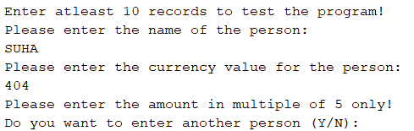

TEST ID 2:
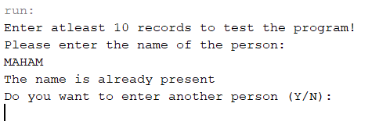
TEST ID 3:
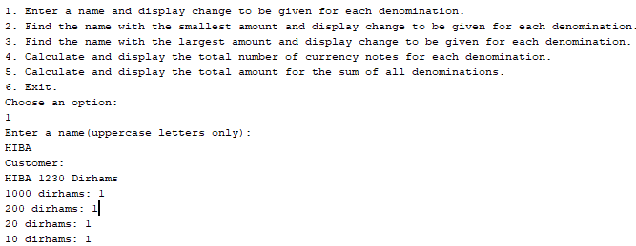
TEST ID 4:
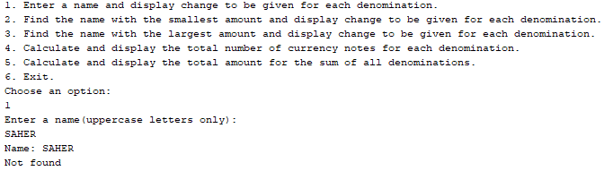

TEST ID 5:
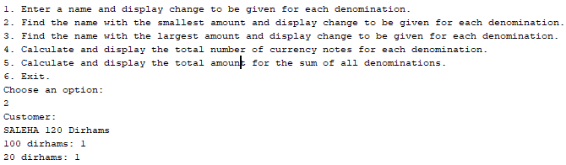
TEST ID 6:
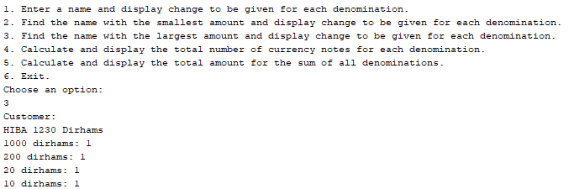
TEST ID 7:
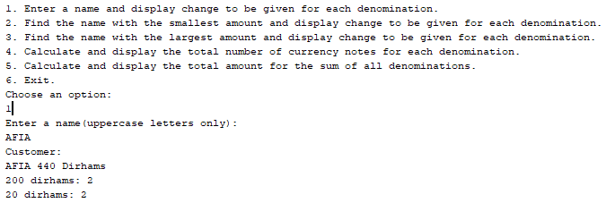

TEST ID 8:
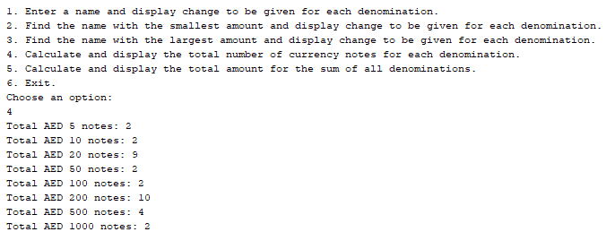
TEST ID 9:
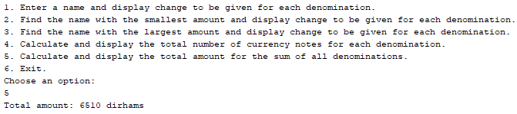
TEST ID 10:
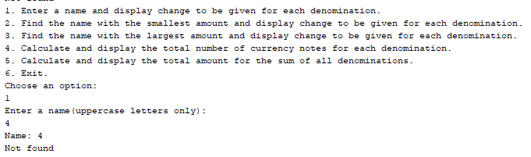

TEST ID 11:
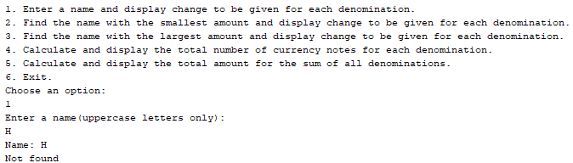
TEST ID 12:
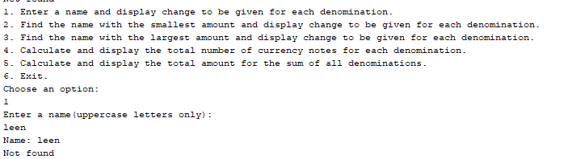
TEST ID 13:
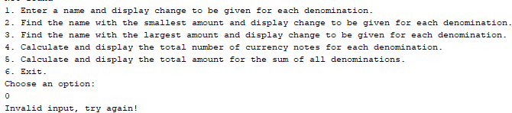

TEST ID 14:
