Topic Modeling With Bert On Omicron Tweets Dataset

MACHINE LEARNING ASSIGNMENT
DATE: 22/07/2025

Topic Modelling with BertTopic, LDA & K-means

Introduction:
With the rise of global health situations like the COVID-19 pandemic, public panels have exploded around social media like Twitter. This project uses machine learning and natural language processing to study about 2,600 tweets from December 2021, on talks surrounding the Omicron variant. Using numerous topic modelling techniques including BERTopic, LDA, and K-Means the study aimed to extract and crack dominant themes embedded in the data which was done successfully.
(Figure 1) below shows the working flow of topic extraction from the Omicron tweet dataset, controlling the logical pipeline from raw data to final understandings. The strategy starts with pre-processing steps—such as stop word removal, lemmatization, and stemming ensuring textual consistency. Feature extraction follows, using both word embeddings and TF-IDF to stress semantic meaning. This altered data is then fit into topic modelling algorithms, like UMAP and LDA, which identify latent structures and recurrent topics. Next, clustering via K-Means joins similar topic distributions, leading to the abstraction of coherent final topics. This framework delivers an overview of the plan built to discover patterns in public discourse relating the Omicron variant.
Likewise, this analysis compares three topic modeling techniques; BERTopic, Latent Dirichlet Allocation (LDA), and K-Means clustering to assess their efficacy in finding influential topics from noisy, short-text Twitter data. Such analyses are essential to determine ways best suited for text like tweets, where word co-occurrence patterns may be sparse and depend on context[1].

Figure 1: Diagram of planned BERT-LDA based topic modeling framework
Pre-processing:
The dataset was fetched from Kaggle’s “Omicron Tweets”, forming over 8,000 tweets. To ensure relevance, the following actions were done on the dataset:
- Filtered to December 2021 tweets to assure temporal relevance by capturing text during the peak of Omicron-related conversations.
- Removed duplicates and null values in the text column to eradicate noise and confirm the dataset has only meaningful text.
- Dropped columns irrelevant to content study to simplify the dataset and focus solely on features that contribute to textual topic modelling.
- Twitter text was converted into lowercase following the removal of URL links, emojis, non-ASCII, mentions, hashtags, punctuations and numbers for better consistency.
Valuable topic modelling starts with high-quality data. Tweets are noisy, short, and contain slang, emojis, and links. To organize tweets for modelling, textual data was converted into numerical forms via:
- TF-IDF helped classic models like K-Means and LDA determine meaningful topics based on term worth. BoW-based TF-IDF vectors were provided to K-Means and LDA, allowing topic clusters to be formed based on word frequency patterns. While useful for traditional models, BoW lacks contextual nuance.
- SentenceTransformer (all-mpnet-base-v2) was used to develop contextual embeddings that grasp semantic meaning, which is vital for short text like tweets.

Table 1: Justification for choosing BERTopic, LDA and K-means
Model | Coherence Score | Strengths | Limitations
BERTopic | 0.8643 | Context-aware clustering using BERT embeddings, brilliant semantic accuracy | Delicate to embedding quality and needs tuning
LDA | 0.5415 | Captures global term distribution, interpretable with salience plots | Struggles with short text, repeated term recurrence
K-Means | 0.6728 | Fast, scalable standard using TF-IDF, interpretable clusters | Disregards context: topic margins can blur without deep semantic insights

The n-gram range was extended from unigrams to bigrams (1 to 2), permitting key phrases such as "vaccination rate" to appear as an alternative of disjointed terms like "vac-cination". The number of topics was also reduced to 5. This decision was made by studying the following figures:
After early BERTopic modelling, the Intertopic Distance Map (see Figure 2) revealed overlapping clusters topics that were semantically alike. This proposed that the model was taking repetitive topics across several clusters.
The Topic Distribution Chart (see Figure 3) reveals that a single leading topic reported for 71% of the tweets, while sparse topics shaped only a minority. This authorised that five topics were enough to capture the major descriptions while cleaning out noise.
Hierarchical clustering (see Figure 4) was displayed after topic modelling. The visualization exposed several topic pairs with close proximity such as "vaccine_vaccination_vacci..." demonstrating redundancy in topic handling.
As seen in Figure 5, all topics show a clear awareness of high-weighted terms for example, Topic 0 is dominated by vaccine-related keywords like "vaccine," "vaccinated," and "booster", whereas Topic 1 emphases on geopolitical talk with words like "ban," "african," and "country." This visualization supports the use of bigrams, which captured rich phrases such as “vaccination rate” and “travel ban”, improving interpretability.
Additionally, the sharp drop-off in word scores (see Figure 5) after the first few terms across all topics emphasised redundancy, making it obvious that several topics were covering alike themes.
Dropping the number of topics to 5 eradicated semantic intersection, gave the best stability between coherence score, interpretability, and thematic simplicity. All these visualizations justify this decision, making the topics simpler to understand and decreasing vagueness in phrase structure. Topic reduction and n-gram updates provided transparency, which is important when working with short, informal text like tweets.
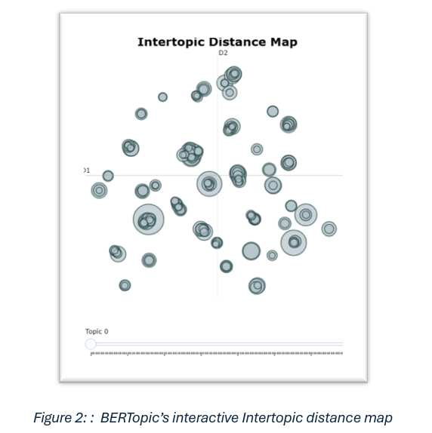.

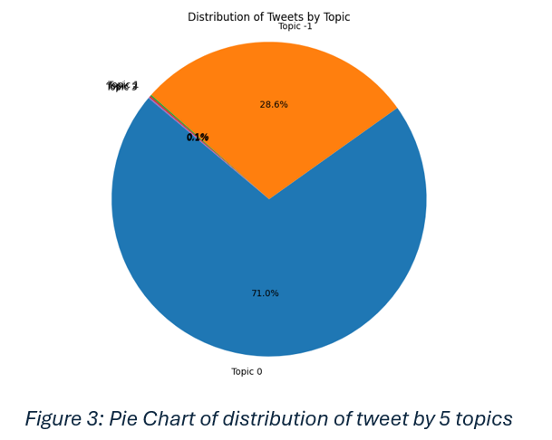

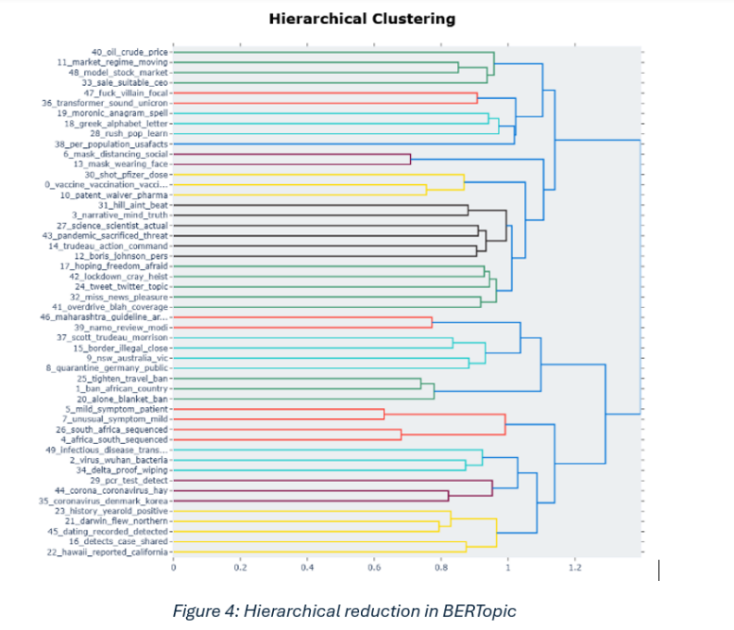
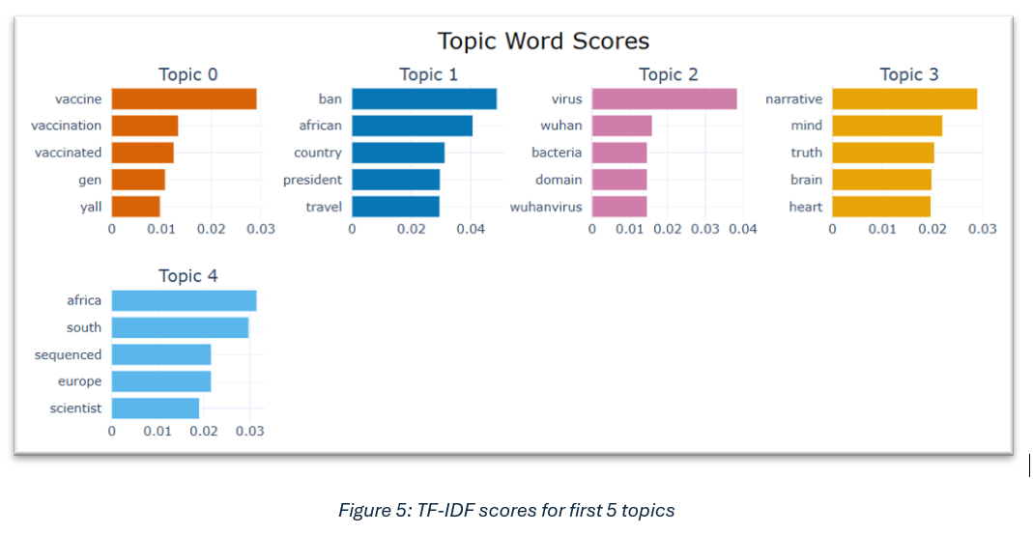
All analyses were run in Python, making use of libraries like BERTopic[8], SentenceTransformers, HDBSCAN, UMAP, scikit-learn, and gensim for LDA, alongside matplotlib and seaborn for visualizations.
BERTopic:
- Embedding model: 'all-mpnet-base-v2' chosen for high semantic accuracy.
- UMAP Parameters: Adjusted for close split in reduced dimensions (n_components=2, min_dist=0.0).
- HDBSCAN Clustering: Facilitated dynamic, noise topic partition.
Prevalent topic (71% of tweets in Figure ) Centered on vaccine discourse stressed over terms like vaccination, booster, and access. Other clusters grasped travel limitations, virus origin disputes.
Outliers (Topic -1) represent tweets with poor semantic alignment expected in noisy Twitter data. Increased importance of outliers reflects the inconsistent nature of Twitter data. The fusion of BERTopic with embedding models gave outstanding results. By allowing for contextual nuance and noise filtering, the method beat LDA and K-Means in catching coherent themes.
The word cloud (See Figure 6) after applying BERTopic summarises the central themes mined from the tweet corpus. The words that stand out include omicron, variant, vaccine, and covid in stressing the focus on pandemic discussions, and extra keywords like country, South Africa, and case, which point to geographical settings.

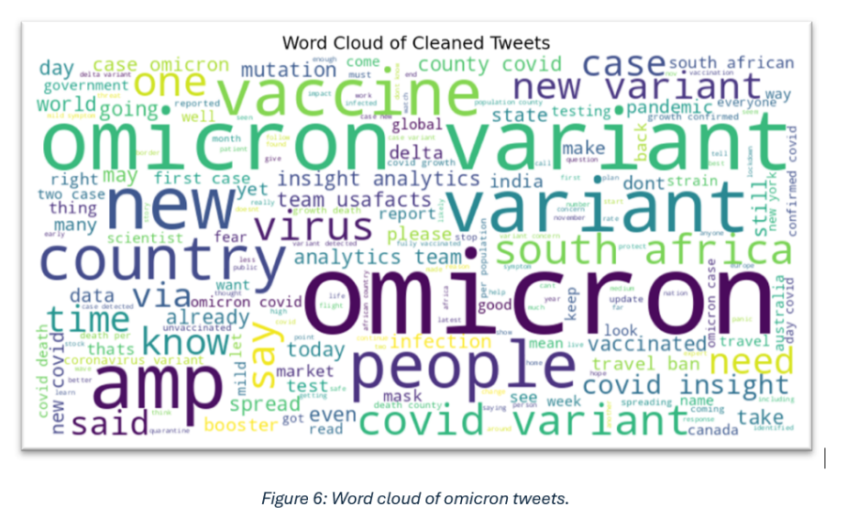

LDA
Although LDA managed to capture some patterns such as travel-related concerns and vaccine mentions, the boundaries between topics were less clear. The semantic differences between the four identified topics are fuzzy, as evidenced by the overlapping topic circles in the Intertopic Distance Map (see Figure 7). This lack of variance suggests that LDA had difficulty identifying unique themes in the brief, unstructured tweet data.
With respect to prevalent terms, on the right the Top 30 Most Salient Terms plot shows words that are repetitively stated on different topics, such as covid, variant, omicron, and case. Despite as much informativeness in these words, occurrence that is extremely high throughout the clusters overweight topic enlightening worth. The negligeable topic distribution (bottom right) also indicates that the topics are not steadily represented, and there is no strong or interpretable topic that stands out. These observations reflects the model’s limitations with sparse text.
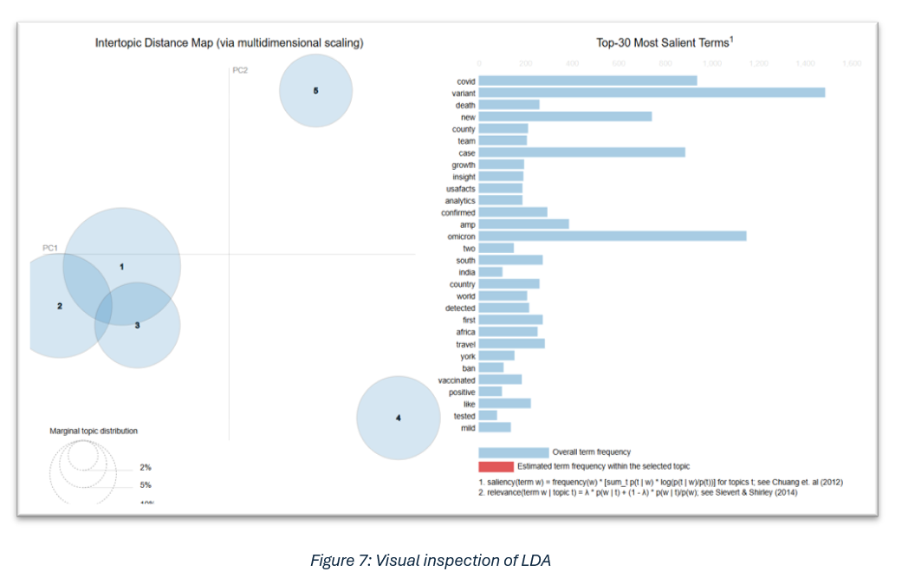

K-Means
The pre-processed tweets were compressed into a set of TF-IDF vectors using K-Means clustering, a distance-based method. It is fast compared to other techniques which is why it was used as a baseline for comparison.
K-Means clustering was visualized using PCA (see Figure 8). With 67.7% of the dataset coverage, Cluster 0, represented by the densest region of blue points, dominates the plot and suggests a general topic that is probably focused on terms related to Omicron and Covid. Smaller clusters, like Cluster 1 (red), are isolated and indicate a specific theme related to restrictions on international travel, which is reinforced by keywords like "travel," "africa," "border," and "ban." More momentous overlap is seen in other clusters, such as those in pink and cyan, which represent semantic nearness and common vocabulary across topics like public view and booster shots.
Top TF-IDF terms for each cluster provided pure insight into cluster themes. K-Means gave interpretable clusters that aligned with BERTopic’s themes. PCA visualization revealed one isolated cluster, while other clusters overlapped. TF-IDF was short of depth but provided dissimilarity.

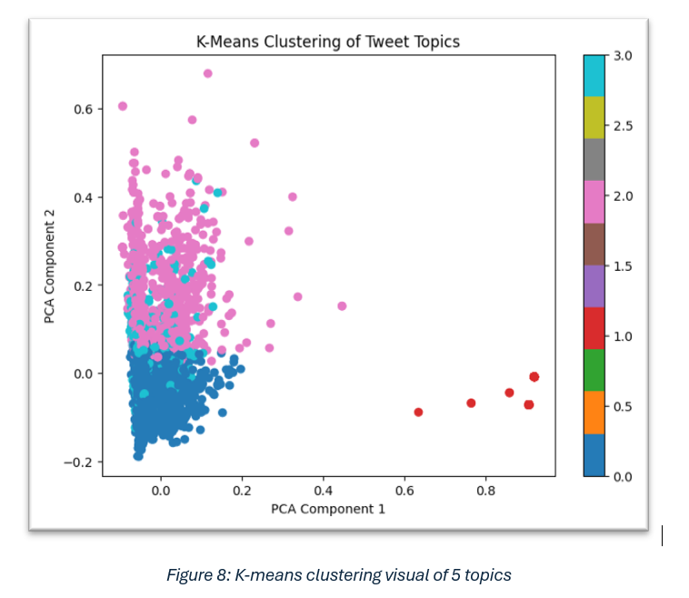
The PCA scatter plot (see Figure 9) shows a more context-aware clustering, where tweets are grouped based on semantic richness rather than simple word frequency. Each cluster coloured represents distinct topics inferred from BERT-generated sentence embeddings. Unlike TF-IDF-based clustering, this approach captures more profound connections among tweets by regarding the purpose behind phrases rather than their surface-level format.
This supports that using BERT not only pointed out the thematic granularity of clusters but also went well with the refined topics marked through BERTopic. This evidence indicates that semantic intellect improves clustering accuracy, particularly with short-text data like tweets.
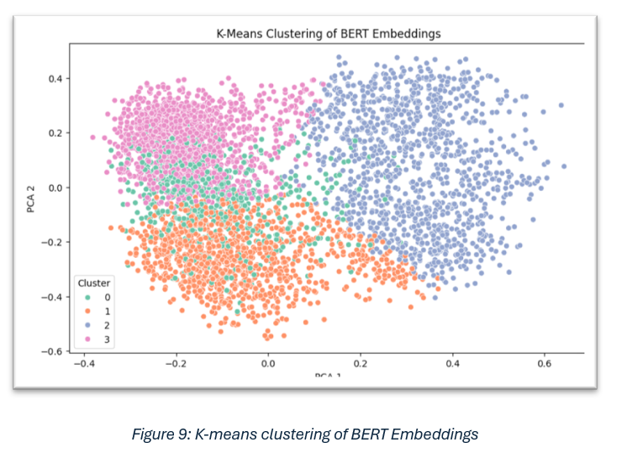

Evaluation:
To evaluate the quality and interpretability of the topics generated, quantitative and qualitative evaluation techniques were used.
Quantitatively, the coherence score was utilized to estimate how semantically meaningful and different the topics were. BERTopic held the highest coherence score (see Table 1). This supports prior studies on BERTopic’s prominent performance on short and noisy social media data[1][3][4].
Qualitatively, the topics were assessed by reviewing the most salient terms, intertopic distance maps, and cluster visualizations. BERTopic generated well-separated, semantically coherent clusters with tiniest redundancy[6]. Its word cloud and topic distribution charts showed topics, such as vaccine talks, travel restrictions, and geopolitical controversies, which correspond to dialogues taking place during that time.
LDA, showed overlapping topics and suffered from vague boundaries, consistent with its usual limitations on short texts where word frequencies are sparse[2]. Likewise, K-Means showed interpretable clusters but failed to catch more in-depth semantic relations[5], as seen from the overlap and lack of contextual nuance in its PCA visualization. In conclusion, this proved that BERTopic was the most influential method for this dataset.
Conclusion:
This analysis shows the effect of contextual NLP and unsupervised modelling in understanding public sentiment. Through chosen preprocessing steps, embedding models, and topic refinement, prevalent talks about the Omicron variant were extracted and interpreted. BERTopic proved valuable in learning short-text data, showing insights that could help researchers track viral trends. K-Means gave an insightful baseline, while LDA showed average performance with restraints on short texts. These results stress the importance of embedding-based models for social media analysis and offer further exploration into mixed models and sentiment-aware topic modelling for forthcoming work.
Future work could focus on multilingual tweet analysis for wider cultural insight and integrate real-time topic search to observe emerging trends. This will enhance the interpretive control of topic modelling in high noise social media domains.

Refereences:
[1]
R. Egger and J. Yu, “A Topic Modeling Comparison Between LDA, NMF, Top2Vec, and BERTopic to Demystify Twitter Posts,” Frontiers in Sociology, vol. 7, May 2022, doi: https://doi.org/10.3389/fsoc.2022.886498.

[2]
A. Anwar, H. Ilyas, U. Yaqub, and S. Zaman, “Analyzing QAnon on Twitter in Context of US Elections 2020: Analysis of User Messages and Profiles Using VADER and BERT Topic modeling,” DG.O2021: The 22nd Annual International Conference on Digital Government Research, Jun. 2021, doi: https://doi.org/10.1145/3463677.3463718.

[3]
D. Murthy et al., “Categorizing E-cigarette-related tweets using BERT topic modeling,” Emerging Trends in Drugs, Addictions, and Health, vol. 4, p. 100160, Oct. 2024, doi: https://doi.org/10.1016/j.etdah.2024.100160.

[4]
A. Pachlore and V. Chakkarwar, “Opinion Mining and Tweet Analysis Using Topic Modeling by LDA with BERT and GLOVE Embedding.”

[5]
V. Sharifian-Attar, S. De, S. Jabbari, J. Li, H. J. Moss, and J. Johnson, “Analysing Longitudinal Social Science Questionnaires: Topic modelling with BERT-based Embeddings,” 2022 IEEE International Conference on Big Data (Big Data), Dec. 2022, doi: https://doi.org/10.1109/bigdata55660.2022.10020678.

[6]
S. Uthirapathy and D. Sandanam, “ScienceDirect Peer-review under responsibility of the scientific committee of the International Conference on Machine Learning and Data Engineering-NC-ND license (https://creativecommons.org/licenses/by-nc-nd/4.0) Peer-review under responsibility of the scientific committee of the International Conference on Machine Learning and Data Engineering ScienceDirect Topic Modelling and Opinion Analysis On Climate Change Twitter Data Using LDA And BERT Model,” 2023, doi: https://doi.org/10.1016/j.procs.2023.01.071.

[7]
L. George and P. Sumathy, “An integrated clustering and BERT framework for improved topic modeling,” International Journal of Information Technology, vol. 15, no. 4, pp. 2187–2195, Apr. 2023, doi: https://doi.org/10.1007/s41870-023-01268-w.

[8]
M. Grootendorst, “BERTopic: Neural topic modeling with a class-based TF-IDF procedure,” arXiv:2203.05794 [cs], Mar. 2022, doi: https://doi.org/10.48550/arXiv.2203.05794.

[9]
Q. Wang and B. Ma, “Enhancing BERTopic with Pre-Clustered Knowledge: Reducing Feature Sparsity in Short Text Topic Modeling,” Journal of Data Analysis and Information Processing, vol. 12, no. 04, pp. 597–611, 2024, doi: https://doi.org/10.4236/jdaip.2024.124032.

