**Which Users Allows To Use RDP ?**

In this article, we will see how to add or remove Remote Desktop users in Windows 10. This will allow them to make connections to the target computer over the Remote Desktop protocol. By default, only members of the Administrators group (e.g. administrative accounts) have access to RDP

Now, you can configure user permissions.

1. Press Win + R hotkeys on the keyboard. The Run dialog will appear on the screen, type the following into the text box and press Enter:

SystemPropertiesAdvanced

[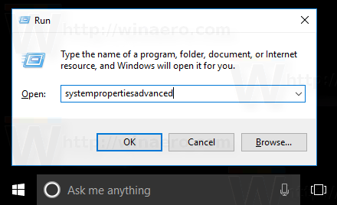](https://winaero.com/blog/wp-content/uploads/2017/03/system-properties-advanced-in-the-Run-dialog.png)

1. Advanced System Properties will open.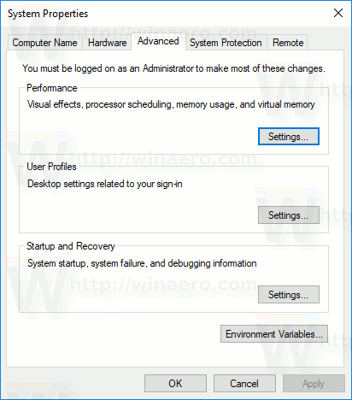
2. Go to the Remote tab. There, click on the button *Select Users*.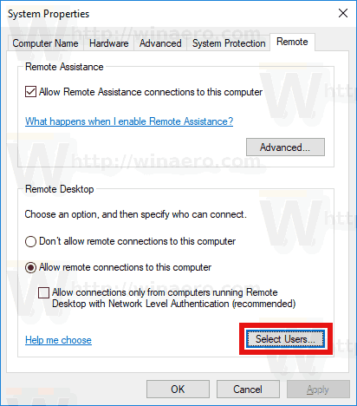
3. The following dialog will open. Click on the *Add* button.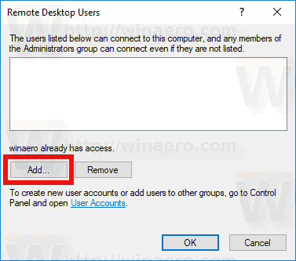
4. The *Select Users* dialog will appear. There, type the desired user name to add or click on the *Advanced* button to select the user from the list. To populate the list, click on the Find now button in Advanced mode.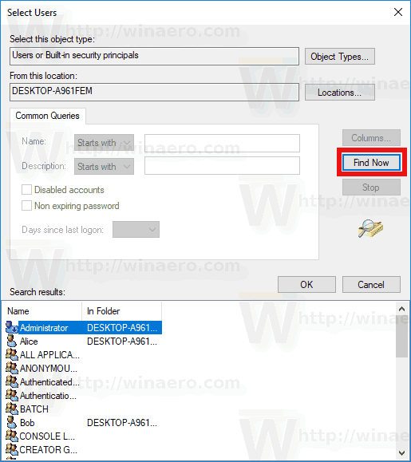
5. Select the desired user in the list and click OK.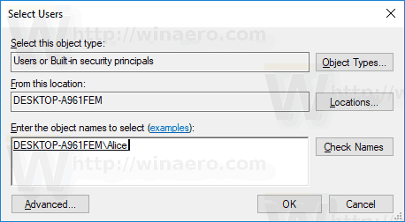
6. Click OK once again to add the user.

You are done.

**Contents**  [hide](https://winaero.com/add-remote-desktop-users-windows-10/)

[Alternative ways to add Remote Desktop users in Windows 10](https://winaero.com/add-remote-desktop-users-windows-10/#Alternative_ways_to_add_Remote_Desktop_users_in_Windows_10)

[You can use Local Users and Groups snap-in](https://winaero.com/add-remote-desktop-users-windows-10/#You_can_use_Local_Users_and_Groups_snap-in)

[You can the net.exe console tool](https://winaero.com/add-remote-desktop-users-windows-10/#You_can_the_netexe_console_tool)

**Alternative ways to add Remote Desktop users in Windows 10**

There are two more ways to add or remove Remote Desktop users in Windows 10.

**You can use Local Users and Groups snap-in**

You can use Local Users and Groups snap-in if your [Windows edition](https://winaero.com/blog/find-windows-10-edition-installed/) comes with this app.

1. Press Win + R shortcut keys on your keyboard and type the following in the run box:

lusrmgr.msc

[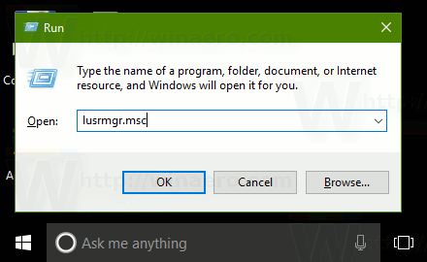](https://winaero.com/blog/wp-content/uploads/2017/01/Windows-10-run-lusrmgr-msc.png)This will open the Local Users and Groups app.

1. Click on Groups on the left.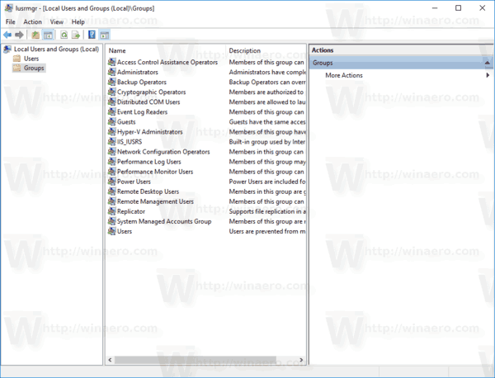
2. Double-click "Remote Desktop Users" in the list of groups.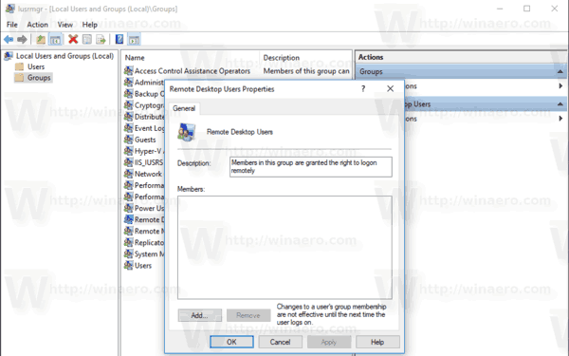
3. Click the Add button to add one or more users.

You are done.

**You can the net.exe console tool**

1. Open an elevated command prompt.
2. Type the following command:

net localgroup "Remote Desktop Users" "UserName" /add

Replace the "UserName" portion with the actual user account name you want to add to Remote Desktop users.  
In my case, the command looks as follows:

net localgroup "Remote Desktop Users" "Alice" /add

1. To remove a user from the "Remote Desktop Users", substitute the /add argument in the command above with the /delete switch, as follows:

net localgroup "Remote Desktop Users" "Alice" /delete

See the following screenshot.