Memory Reconstruction: Experiments 1 & 2
2026-03-26

Correlation between avoidance learning and memory accuracy

All trials
Across both experiments, we tested whether participants who more strongly avoided the stones-only position in Part 1 (higher pstones avoidance, i.e. lower values) showed better reconstruction accuracy in Part 2.
In Experiment 1, the correlation between pstones and overall memory accuracy was $t\left(98\right)=0.86$, $p=.390$. In Experiment 2, it was $t\left(93\right)=1.10$, $p=.276$. Across both experiments combined, $t\left(193\right)=1.37$, $p=.173$.

Trials on which participants chose the stones-only position
In Experiment 1, the correlation between pstones and memory accuracy on stones-only trials was $t\left(97\right)=6.93$, $p<.001$. In Experiment 2, it was $t\left(92\right)=5.55$, $p<.001$. Across both experiments combined, $t\left(191\right)=8.73$, $p<.001$.

Trials on which participants chose one of the other two positions
In Experiment 1, the correlation between pstones and memory accuracy on non-stones trials was $t\left(98\right)=0.16$, $p=.872$. In Experiment 2, it was $t\left(93\right)=0.20$, $p=.844$. Across both experiments combined, $t\left(193\right)=0.20$, $p=.842$.

Difference in memory accuracy between explicit and implicit learners

All trials
In Experiment 1, memory accuracy was 0.66 for explicit learners and 0.65 for implicit learners ($t\left(29.87\right)=0.31$, $p=.757$). In Experiment 2, these figures were 0.63 and 0.66 ($t\left(59.70\right)=-1.07$, $p=.289$). Across both experiments combined, $t\left(82.83\right)=-0.50$, $p=.616$.

Trials on which participants chose the stones-only position
Explicit learners showed lower memory accuracy on stones-only trials than implicit learners. In Experiment 1, memory accuracy was 0.40 for explicit learners and 0.59 for implicit learners ($t\left(24.20\right)=-2.44$, $p=.022$). In Experiment 2, these figures were 0.34 and 0.64 ($t\left(40.50\right)=-5.25$, $p<.001$). Combined: $t\left(60.56\right)=-5.22$, $p<.001$.

Trials on which participants chose one of the other two positions
In Experiment 1, memory accuracy was 0.70 for explicit learners and 0.67 for implicit learners ($t\left(32.81\right)=0.77$, $p=.447$). In Experiment 2, these figures were 0.67 and 0.66 ($t\left(46.22\right)=0.37$, $p=.715$). Combined: $t\left(79.69\right)=0.78$, $p=.439$.
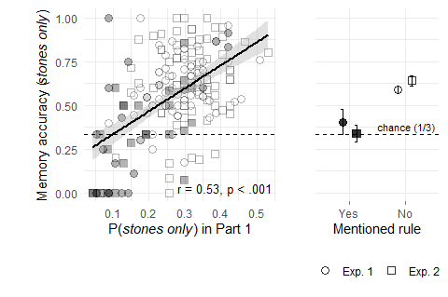
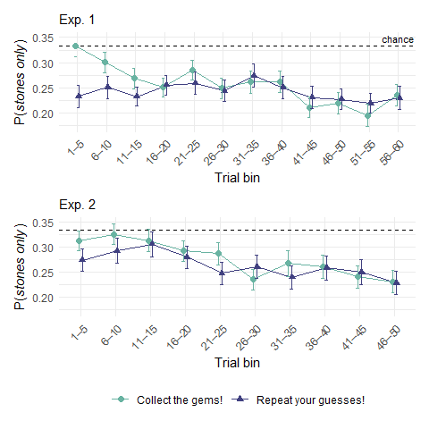
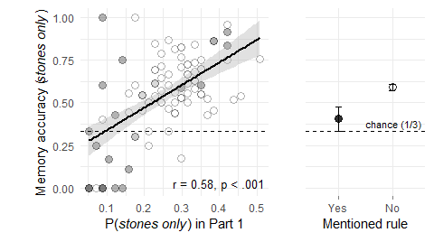
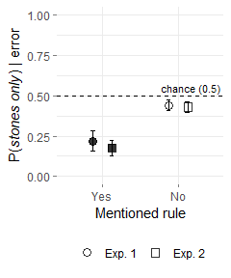
Participants varied in their ability to notice the hidden rule, measured as the probability of touching the stones only position in part 1. We asked whether this variability predicted memory accuracy in part 2, specifically for memory-inconsistent decisions (that is, selections of the stones only position). If participants use their learned policy to reconstruct past decisions, those participants who successfully learned the hidden rule should have worse memory for decisions that are incongruent with their current, learned policy. This is what we found. Across both experiments, poor rule learning in part 1 was positively correlated with memory accuracy for rule-inconsistent decisions in part 2 (Exp. 1: r = 0.58, < .001; Exp. 2: r = 0.50, < .001). This effect was selective to rule-inconsistent decisions: we observed no correlation between rule learning and memory for rule-consistent decisions (Exp. 1: r = 0.02, .872; Exp. 2: r = 0.02, .844; pooled: r = 0.01, .842). Furthermore, when asked at the end of the experiment if they noticed a regularity in the location of gems, a subset of 22 participants in Exp. 1 and 25 participants in Exp. 2 mentioned the position of boxes. These “explicit learners” had significantly worse memory for their rule-inconsistent decisions than did other participants (Exp. 1: 0.40 vs. 0.59, $t\left(24.20\right)=-2.44$, $p=.022$; Exp. 2: 0.34 vs. 0.64, $t\left(40.50\right)=-5.25$, $p<.001$). Again, this effect was selective for memory for rule-inconsistent actions. No group differences were observed for memory-consistent actions (Exp. 1: 0.70 vs. 0.67, $t\left(32.81\right)=0.77$, $p=.447$; Exp. 2: 0.67 vs. 0.66, $t\left(46.22\right)=0.37$, $p=.715$; pooled: $t\left(79.69\right)=0.78$, $p=.439$).
So far, we mostly focused on the effects of outcome and rule knowledge on the accuracy of memory for past decisions, showing that participants better remember their successful guesses than their unsuccessful ones. In the following, we zero in on the effects of outcome and rule knowledge not on the proportion of errors, but on the types of errors participants make. As a first test we focused on a subset of trials in which participants failed to remember that they had made a correct choice (that is, chose the box containing gems) in part 1. In these trials, participants had chosen the box of gems in part 1 and in part 2 either selected the stones only box or the box that sometimes (but not in this trial) contained gems (see Fig. 6A). This test deconfounds the bias against the stones only box from a bias to be correct or from a memory for originally biased actions. Given that different participants had different numbers of error trials, we fitted a mixed effects logistic regression model with a random intercept for participant. In Experiment 1, the estimated probability of selecting the stones only option in the specified subset of trials was 0.37, significantly below the chance level of 0.5 (β = -0.54, SE = 0.12, z = -4.36, p < .001). This effect was solely driven by participants who mentioned the rule (p(stones only | error) = 0.12; β = -2.04, SE = 0.49, z = -4.13, p < .001), and was not evident among participants who did not mention the rule (p(stones only | error) = 0.44; β = -0.23, SE = 0.09, z = -2.50, p .013). This was replicated in Experiment 2, where the estimated probability of selecting the stones only box was 0.34 (β = -0.68, SE = 0.15, z = -4.53, p < .001), again driven solely by those who explicitly mentioned the rule (p(stones only | error) = 0.09; β = -2.29, SE = 0.64, z = -3.59, p < .001), but not among those who did not (p(stones only | error) = 0.42; β = -0.30, SE = 0.13, z = -2.30, p .021). These results show a robust and systematic avoidance of the stones only box in errors controlling for reward, which we interpret to be a bias rooted in (faulty) model-based memory reconstruction: participants avoided choosing the option which they believed they would not have chosen, given what they currently know (but did not necessarily know back then).

