APPENDIX 2

(to the Services Agreement No: ____________)

TECHNICAL PROPOSAL

**INTEGRATION SERVICE HSBC TO FPT.iHRP**

Contents

1. OVERVIEW 2

1.1 Purpose & Scope 2

1.2 Reference 2

1.3 Definitions, Acronyms and Abbreviations 3

2. System Architecture 3

2.1 Integrated modal 3

2.1 Integrated flow 3

3. Function specification 4

3.1 iFile payment for Local rule 4

3.1.1 Structure File 4

3.1.2 Example Content 4

3.1.3 File Header 4

3.1.4 Batch Header 5

3.1.5 Second Party Details 6

3.2 iFile payment for Expat rule 6

3.2.1 Structure File 6

3.2.1 Example Content 7

3.2.1 File Header 7

3.2.2 Batch Header 7

3.2.2 Second Party Details 8

Document Changing History

|  |  |  |  |
| --- | --- | --- | --- |
| Version | Change Date | Changed Detail | Written by |
| 1.0 | 2018.02.28 | Init Release | Ngoc. Le Dung |
| 1.1 |  |  |  |
| 1.2 |  |  |  |

# 1. OVERVIEW

## 1.1 Purpose & Scope

This document describes overview of the architecture and design integrated system iHRP – Service HSBC.

The scope of this document includes developing the integrated system for the following function components:

* File template payment HSBC for local employee
* File template payment HSBC for expat employee
* Encrypt file template payment of HSBC

This document is used for following roles:

* System designer
* Programmer
* Tester
* Deployment member

## 1.2 Reference

|  |  |  |
| --- | --- | --- |
| # | Document | Source |
| 1 | Internal_iFile for Vietnam_ACH_2014.xls |  |
| 2 | Internal_iFile for Vietnam_PP_HSBC_Vietnam_2017.xls |  |
| 3 | HSBCnet File Upload E2E encryption - Customer Guide V1.5.doc |  |

## 1.3 Definitions, Acronyms and Abbreviations

|  |  |  |
| --- | --- | --- |
| # | Definitions, Acronyms and Abbreviations | Description |
| 1 | iHRP | Payroll System of BAT Vietnam |
| 2 | DB | Database |

# 2. System Architecture

## 2.1 Integrated modal

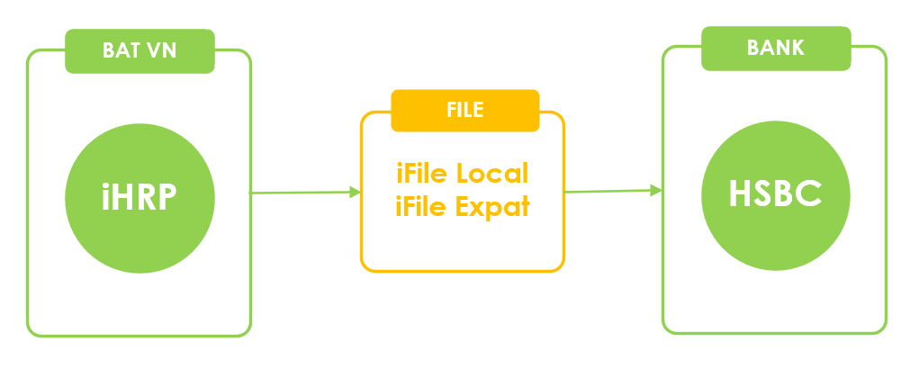

## 2.1 Integrated flow

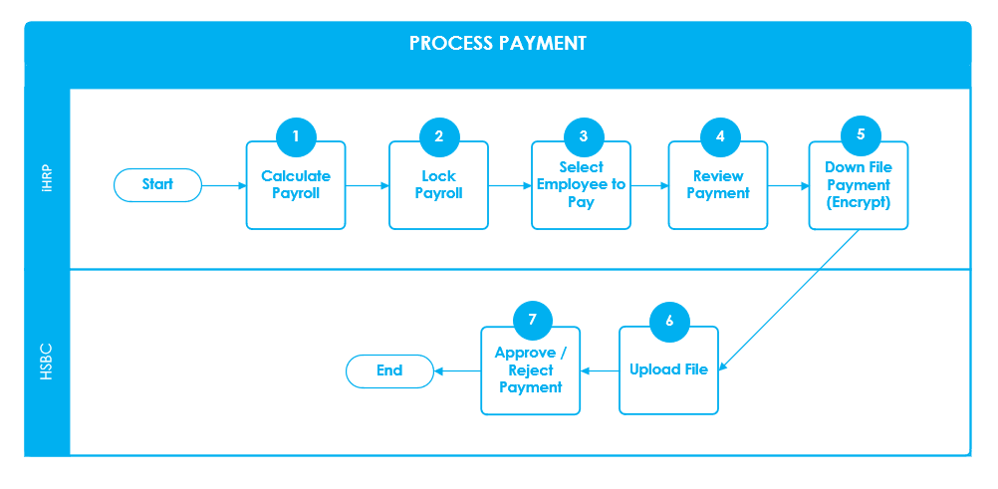

|  |  |  |  |
| --- | --- | --- | --- |
| # | Step | System | Description |
| 1 | Calculate Payroll | iHRP | Create data for payroll table |
| 2 | Lock Payroll | iHRP | Confirm data for payroll |
| 3 | Select employee to pay | iHRP | HR team **pickup list employee** to pay.  User can **create many list** payment |
| 4 | Review Payment | iHRP | HR team review data payment |
| 5 | Download File (with encrypt) | iHRP | HR team click button Create File Payment to **download file payment.** |
| 5 | Upload File | HSBC | HR team upload file payment |
| 6 | Approve Reject payment | HSBC | User approve or reject the payment |

# 3. Function specification

## 3.1 iFile payment for Local rule

### 3.1.1 Structure File

|  |  |  |
| --- | --- | --- |
| # | Row name | Sample |
| 1 | Header File | IFH,IFILE,… |
| 2 | Batch Header | BATHDR,ACH-CR,… |
| 3 | Second Party Details | SPECPTY,… |
| 4 | Second Party Details | SPECPTY,… |
| 5 | Second Party Details | SPECPTY,… |
| … | ……… | SPECPTY,… |
| N | Second Party Details | SPECPTY,… |

### 3.1.2 Example Content

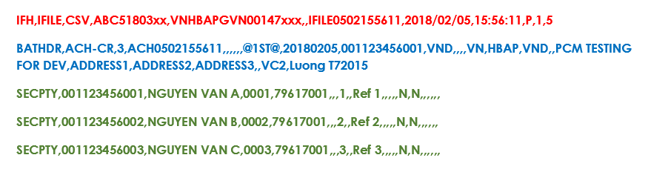

### 3.1.3 File Header



|  |  |  |  |  |  |
| --- | --- | --- | --- | --- | --- |
| # | Inbound fields in i-File | M/O | Length | Description | Sample Data |
| 1 | Record Type | M | 16x | **Fixed** "IFH" | “IFH” |
| 2 | File Format | M | 16x | **Fixed** "IFILE" | “IFILE” |
| 3 | File Type | M | 16x | **Fixed** "CSV" | “CSV” |
| 4 | Hexagon Customer ID | M | 11x | Customer ID provided by HSBC | “ABC12345001” |
| 5 | HSBCnet ID | M | 18x | Customer ID provided by HSBC | “GBHBEUGB1018036407” |
| 6 | File Reference | M | 35x | Unique for each file  (retention for 3 months) | “IFILE20180321152730” |
| 7 | File Creation Date | M | 10x | Format: “CCYY/MM/DD” | “2018/03/21” |
| 8 | File Creation Time | M | 8x | Format: “HH:MM:SS” | “15:15:57” |
| 9 | Authorization Type | M | 1x | **Fixed** | “P” |
| 10 | File Version | M | 3n | **Fixed** | “1” |
| 11 | Record Count | M | 7n | Total Count | “300” |

### 3.1.4 Batch Header



|  |  |  |  |  |  |
| --- | --- | --- | --- | --- | --- |
| # | Inbound fields in i-File | M/O | Length | Description | Sample Data |
| 1 | Record Type | M | 16x | **Fixed** | “BATHDR” |
| 2 | Instruction Type | M | 16x | **Fixed** | “ACH-CR” |
| 3 | Total number of instructions in batch | M | 7n | Max 2000 | Total number of current batch |
| 4 | Batch Reference | O | 35x | Payment batch number | “ACH0502155611” |
| 5 | Filler |  | 35x | Blank |  |
| 6 | Filler |  | 35x | Blank |  |
| 7 | Filler |  | 35x | Blank |  |
| 8 | Filler |  | 35x | Blank |  |
| 9 | Filler |  | 35x | Blank |  |
| 10 | Constant Eye Catcher | M | 5x | **Fixed** | “@1ST@” |
| 11 | Value Date (YYYYMMDD) | C | 8n | Must be a working day of VN | “20180321” |
| 12 | First Party Account | M | 35n | Debit Account | “001061688001” |
| 13 | Transaction Currency | M | 3x | Transaction Currency | “VND” |
| 14 | Transaction Amount | O | 20n | Blank |  |
| 15 | Template Mode | N | 1x | Blank |  |
| 16 | Batch Template ID | N | 16x | Blank |  |
| 17 | First Party Account (Country Code) | M | 2x | Country Code | “VN” |
| 18 | First Party Account (Institution Code) | M | 4x | **Fixed** | “HBAP” |
| 19 | First Party Account (Currency) | M | 3x | Currency of Debit Account | “VND” |
| 20 | Payment Amount in Debit account currency | O | 20n | Blank |  |
| 21 | First Party Name | M | 120x | Company Name | “British American Tobacco Vietnam” |
| 22 | First Party Info Line 1 | O | 35x | Blank |  |
| 23 | First Party Info Line 2 | O | 35x | Blank |  |
| 24 | First Party Info Line 3 | O | 35x | Blank |  |
| 25 | First Party Info Line 4 | O | 35x | Blank |  |
| 26 | Payment Code | S | 30x | Payment set code  (provided by HSBC) | “VC1” |
| 27 | Reference Line 1 | M | 16x | Payment Reference No. (must be unique), max to 16 bytes | “Salary 05-2018” |
| 28 | Reference Line 2 | O | 35x | Blank |  |

### 3.1.5 Second Party Details

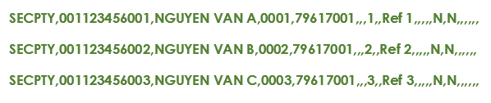

|  |  |  |  |  |  |
| --- | --- | --- | --- | --- | --- |
| # | Inbound fields in i-File | M/O | Length | Description | Sample Data |
| 1 | Record Type | M | 16x | **Fixed** | "SECPTY" |
| 2 | Second Party Account Number | M | 35n | Beneficiary account number | “001123456001” |
| 3 | Second Party Name | M | 35x | Beneficiary account name | “NGUYEN VAN AN” |
| 4 | Second Party Identifier | M | 35x | Employee code in BAT Vietnam | “00477” |
| 5 | Bene Bank Number / ID | S | 9n | Local Bank code of Vietnam | “79617001” |
| 6 | Bene Branch Number | S | 4n | Blank |  |
| 7 | Transaction Code | S | 6x | Blank |  |
| 8 | 2nd party Transaction Amount | M | 14n | Transaction amount (no comma) e.g. 1000.00 | “12000000” |
| 9 | Entry Value Date (YYYYMMDD) | O | 8n | Blank |  |
| 10 | Second Party Reference | O | 60x | Blank |  |
| 11 | Information Line 1 | S | 35x | Blank |  |
| 12 | Information Line 2 | S | 35x | Blank |  |
| 13 | Information Line 3 | S | 35x | Blank |  |
| 14 | Information Line 4 | O | 35x | Blank |  |
| 15 | Advice Indicator | S | 1x | **Fixed** | “N” |
| 16 | WHT Indicator | N | 1x | **Fixed** | “N” |
| 17 | Filler |  | 35 | Blank |  |
| 18 | Filler |  | 35 | Blank |  |
| 19 | Filler |  | 35 | Blank |  |
| 20 | Filler |  | 35 | Blank |  |
| 21 | Filler |  | 35 | Blank |  |

## 3.2 iFile payment for Expat rule

### 3.2.1 Structure File

|  |  |  |
| --- | --- | --- |
| # | Row name | Sample |
| 1 | Header File | IFH,IFILE,… |
| 2 | Batch Header | BATHDR,LTR,… |
| 3 | Second Party Detail | SPECPTY,… |
| 4 | Batch Header | BATHDR,LTR,… |
| 5 | Second Party Detail | SPECPTY,… |
| .. | ……… | … |
| N-1 | Batch Header | BATHDR,LTR,… |
| N | Second Party Detail | SPECPTY,… |

### 3.2.1 Example Content

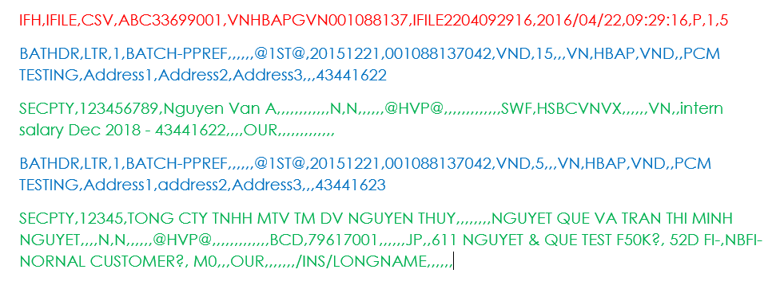

### 3.2.1 File Header



|  |  |  |  |  |  |
| --- | --- | --- | --- | --- | --- |
| # | Inbound fields in i-File | M/O | Length | Description | Sample Data |
| 1 | Record Type | M | 16x | **Fixed** | “IFH” |
| 2 | File Format | M | 16x | **Fixed** | “IFILE” |
| 3 | File Type | M | 16x | **Fixed** | “CSV” |
| 4 | Hexagon ABC Customer ID | M | 11x | Customer ID provided by HSBC | “ABC12345001” |
| 5 | HSBCnet ID | M | 18x | Customer ID provided by HSBC | “GBHBEUGB1018036407” |
| 6 | File Reference | M | 35x | Unique for each file  (retention for 3 months) | “IFILE20180321152730” |
| 7 | File Creation Date | M | 10x | Format: “CCYY/MM/DD” | “2018/03/21” |
| 8 | File Creation Time | M | 8x | Format: “HH:MM:SS” | “15:15:57” |
| 9 | Authorization Type | M | 1x | **Fixed** | “P” |
| 10 | File Version | M | 3n | **Fixed** | “1” |
| 11 | Record Count | M | 7n | Total Row | “30” |

### 3.2.2 Batch Header



|  |  |  |  |  |  |
| --- | --- | --- | --- | --- | --- |
| # | Inbound fields in i-File | M/O | Length | Description | Sample Data |
| 1 | Record Type | M | 16x | **Fixed** | “BATHDR” |
| 2 | Instruction Type | M | 16x | **Fixed** | “LTR” |
| 3 | Total number of instructions in batch | M | 7n | Max 2000 | Total number of current batch |
| 4 | Batch Reference | N | 35x | Referent batch | “BATCH-PPREF” |
| 5 | Filler |  | 35x | Blank |  |
| 6 | Filler |  | 35x | Blank |  |
| 7 | Filler |  | 35x | Blank |  |
| 8 | Filler |  | 35x | Blank |  |
| 9 | Filler |  | 35x | Blank |  |
| 10 | Constant Eye Catcher | M | 5x | **Fixed** | “@1ST@” |
| 11 | Value Date (YYYYMMDD) | C | 8n | Must be a working day of VN | “20180321” |
| 12 | First Party Account | M | 35n | Debit Account | “001088137042” |
| 13 | Transaction Currency | M | 3x | Transaction Currency | “VND” |
| 14 | Transaction Amount | C | 20n | Transaction Amount | “200000000” |
| 15 | Template Mode | O | 1x | Blank |  |
| 16 | Batch Template ID | O | 16x | Blank |  |
| 17 | First Party Account (Country Code) | M | 2x | Country Code | “VN” |
| 18 | First Party Account (Institution Code) | M | 4x | **Fixed** | “HBAP” |
| 19 | First Party Account Currency | O | 3x | Currency Debit Account | “VND” |
| 20 | Payment Amount in Debit account currency | C | 20n | Blank |  |
| 21 | First Party Name | M | 120x | Company Name | Company Name |
| 22 | First Party Info Line 1 | O | 35x | Address 1 | “Address 1” |
| 23 | First Party Info Line 2 | O | 35x | Address 2 | “Address 2” |
| 24 | First Party Info Line 3 | O | 35x | Address 3 | “Address 3” |
| 25 | First Party Info Line 4 | O | 35x | Blank |  |
| 26 | Payment Code | S | 30x | Blank |  |
| 27 | **Reference Line 1** | **M** | **16x** | Must be unique in file (max 16 bytes) | “43441622” |
| 28 | Reference Line 2 | O | 35x | Blank |  |
| 29 | Ordering Party Account / ID | O | 35x | Blank |  |

### 3.2.2 Second Party Details



|  |  |  |  |  |  |
| --- | --- | --- | --- | --- | --- |
| # | Inbound fields in i-File | M/O | Length | Description | Sample Data |
| 1 | Record Type | M | 16x | **Fixed** | "SECPTY" |
| 2 | Second Party Account Number | M | 35n | Beneficiary account number | “001123456001” |
| 3 | Second Party Name | M | 70x | Beneficiary account name | “NGUYEN VAN A” |
| 4 | Second Party Identifier | S | 35x | Blank |  |
| 5 | Bene Bank Number / ID | S | 9n | Blank |  |
| 6 | Bene Branch Number | S | 4n | Blank |  |
| 7 | Transaction Code | S | 6x | Blank |  |
| 8 | 2nd party Transaction Amount | C | 14n | Blank |  |
| 9 | Entry Value Date (YYYYMMDD) | C | 8n | Blank |  |
| 10 | Second Party Reference | S | 60x | Blank |  |
| 11 | Information Line 1 | S | 35x | Information Line 1 |  |
| 12 | Information Line 2 | S | 35x | Blank |  |
| 13 | Information Line 3 | S | 35x | Blank |  |
| 14 | Information Line 4 | O | 35x | Blank |  |
| 15 | Advice Indicator | M | 1x | **Fixed** | “N” |
| 16 | WHT Indicator | M | 1x | **Fixed** | “N” |
| 17 | Filler | N | 35 | Blank |  |
| 18 | Filler | N | 35 | Blank |  |
| 19 | Filler | N | 35 | Blank |  |
| 20 | Filler | N | 35 | Blank |  |
| 21 | Filler | N | 35 | Blank |  |
| 22 | Constant Eye Catcher | M | 5n | **Fixed** | “@HVP@” |
| 23 | First Party Reference [for Batch PP only] | C | 35x | Blank |  |
| 24 | Payment Currency [for Batch PP only] | C | 3x | Blank |  |
| 25 | Template ID | N | 16x | Blank |  |
| 26 | Exchange Rate | N | 12x | Blank |  |
| 27 | Intermediary Institution Bank ID/SWIFT Address Code | O | 3x | Blank |  |
| 28 | Intermediary Institution Bank Name | O | 35x | Blank |  |
| 29 | Intermediary Institution Bank Address Line 1 | O | 35x | Blank |  |
| 30 | Intermediary Institution Bank Address Line 2 | O | 35x | Blank |  |
| 31 | Intermediary Institution Bank Address Line 3 | O | 35x | Blank |  |
| 32 | Intermediary Institution Bank Address Line 4 | N | 35x | Blank |  |
| 33 | Intermediary Institution Bank ID/SWIFT Address | O | 35x | Blank |  |
| 34 | Intermediary Institution Account Number | O | 34x | Blank |  |
| 35 | Bene Bank ID/SWIFT Address Code | C | 3x | Swift code: “SWF”  Bank code: “BCD” | “SWF” or “BCD“ |
| 36 | Bene Bank ID/SWIFT Address | C | 34x | Swift address | “HSBCVNVX” |
| 37 | Bene Bank Name | C | 35x | Blank |  |
| 38 | Bene Bank Address Line 1 | C | 35x | Blank |  |
| 39 | Bene Bank Address Line 2 | C | 35x | Blank |  |
| 40 | Bene Bank Address Line 3 | C | 35x | Blank |  |
| 41 | Bene Bank Address Line 4 | N | 35x | Blank |  |
| 42 | Bene Bank Country | M | 2x | Country code ISO 3166  e.g. VN, SG, HK,… | “VN” |
| 43 | Beneficiary CHIPS UID | O | 6x | Blank |  |
| 44 | Payment Details Line 1 | O | 35x | Payment Description (Tax payment details, payment invoice to vendor, etc) | “Intern salary May 2018 - 43441622” |
| 45 | Payment Details Line 2 | O | 35x | Blank |  |
| 46 | Payment Details Line 3 | O | 35x | Blank |  |
| 47 | Payment Details Line 4 | O | 35x | Blank |  |
| 48 | Details of charges | M | 3x | **Fixed** | “OUR” |
| 49 | Sender Charges | N | 15x | Blank |  |
| 50 | Charges Account | N | 34x | Blank |  |
| 51 | Instruction Code Line 1 | O | 35x | Blank |  |
| 52 | Instruction Code Line 2 | O | 35x | Blank |  |
| 53 | Instruction Code Line 3 | O | 35x | Blank |  |
| 54 | Instruction Code Line 4 | O | 35x | Blank |  |
| 55 | Bank to Bank info Line 1 | C | 35x | Bank to Bank info Line 1 |  |
| 56 | Bank to Bank info Line 2 | C | 35x | Blank |  |
| 57 | Bank to Bank info Line 3 | C | 35x | Blank |  |
| 58 | Bank to Bank info Line 4 | O | 35x | Blank |  |
| 59 | Bank to Bank info Line 5 | O | 35x | Blank |  |
| 60 | Bank to Bank info Line 6 | O | 35x | Blank |  |
| 61 | 1st Exchange Contract Number | O | 12x | Blank |  |
| 62 | 1st Exchange Contract Amount | O | 15x | Blank |  |
| 63 | 2nd Exchange Contract Number | O | 12x | Blank |  |
| 64 | 2nd Exchange Contract Amount | O | 15x | Blank |  |
| 65 | Regulatory Reporting Line 1 | O | 35x | Blank |  |
| 66 | Regulatory Reporting Line 2 | O | 35x | Blank |  |
| 67 | Regulatory Reporting Line 3 | O | 35x | Blank |  |
| 68 | Advise By | O | 1x | Blank |  |
| 69 | Advise By Number | O | 20x | Blank |  |
| 70 | Intermediary Bank Country | O | 2 | Blank |  |