Reinforcement Schedules: An Open Source Visual Interface for Operant Chambers
Precise control and recording of experimental events have long been central to the experimental analysis of behavior. In Latin America, constraints on access to commercial equipment have fostered the development of low-cost, flexible, and pedagogically oriented experimental systems. The present paper introduces an open-source application for controlling and recording operant procedures across laboratory preparations (e.g., rat operant chambers). The software preserves the hardware requirements and communication protocol of previously described low-cost Arduino based systems while incorporating a graphical user interface that allows users to configure, execute, and monitor experimental sessions through point-and-click interactions. Experimental procedures are organized following the logic of multiple schedules arranged in discrete temporal components, each defined by duration, and optional reinforcement contingencies, stimuli, response feedback, or delay parameters. Experimental events are recorded at the millisecond level in a raw data file, complemented by a summary file for rapid post-session inspection. By reducing the need for direct code manipulation, the software lowers the entry barrier to experimental control in low-income contexts. The software is intended to support both research and instruction, facilitating the training of new behavior analysts and promoting replicable experimental practices in laboratories with diverse levels of technical expertise. To illustrate the practical use of the system, the paper includes a brief demonstration experiment with representative data.
Keywords: low-cost experimental equipment, visual basic, open-source software, Arduino, rats

Automation and precise control of experimental events have been a defining feature of research in the experimental analysis of behavior since its inception. Starting with early electromechanical arrangements, to contemporary web-based and virtual reality systems, the evolution of experimental apparatus has closely paralleled advances in available technology, shaping not only how data are collected but also the kinds of questions that can be addressed (Escobar, 2014; Lattal, 2008). Although Skinner’s introduction of the operant conditioning chamber represented a major technological innovation (Skinner, 1956), the subsequent automation of behavioral recording led to the consolidation of specialized and standardized software and hardware systems. Over time, these systems became the normative infrastructure for controlling experimental events, shaping not only how data were collected but also how experiments themselves were designed and implemented. While desirable from a scientific perspective, this standardization also brought unintended consequences, for instance, in the US, the market has concentrated in the hands of a small number of providers. This has limited technological diversity and increased the costs of experimental equipment, resulting in economic barriers for laboratories with restricted resources.
However, across this history, the development of experimental technology has not been confined to a single geographic or institutional center but has emerged from diverse research contexts in response to local scientific, educational, and economic conditions (Malott, 2004). Particularly in Latin America, behavior-analytic laboratory-based research has developed under circumstances that have encouraged methodological creativity (e.g. Gómez-Fuentes, 2014; Ribes-Iñesta, 1968; Todorov, 2006). Limited access to foreign commercial equipment has motivated the design of custom-made experimental systems that prioritize flexibility and pedagogical value. These developments constitute substantive contributions to the field, demonstrating how core principles of experimental control can be implemented through innovative and context-sensitive technological solutions.
A clear example of this approach is the Arduino–Visual Basic interface described by Escobar and Pérez-Herrera (2015), which showed that inexpensive microcontroller boards could be reliably used to control and record events by the millisecond in custom made operant conditioning chambers. This framework was further supported through the design of fully functional operant chambers built from 3D-printed and laser-cut components, thereby preserving an open-source philosophy (Ávila-Chauvet & Pedroza-Cabrera, 2013; Escobar, et al., 2022). Visual Basic was adopted as the primary programming environment for experimental control due to its graphical orientation, compatibility with earlier software used in operant research, and relatively shallow learning curve. Although Visual Basic is more accessible than lower-level programming languages, programming experimental procedures still require users to write, modify, and debug code. Acquiring these skills demands substantial time, technical training, and sustained resources that not all students or laboratories can afford. Consequently, access to flexible and customizable experimental technologies becomes not only a technical issue but also a matter of academic and economic privilege, further shaping who can innovate and under what conditions within behavioral science.
In practice, these requirements impose a barrier for undergraduate students or researchers without explicit training in programming. In many Latin American psychology programs, students rarely have formal exposure to computer programming, which means that existing code can often be used only in a “run-as-is” manner. While this approach allows students to execute predefined tasks by simply starting a session, even minor modifications to the procedure, such as changing schedule parameters, could require direct interaction with the source code. At this point, technical difficulties frequently arise, and instructional activities may shift away from conceptual and experimental considerations towards troubleshooting programming issues.
This context underscores the need to develop accessible, user-friendly, and open-access programs that allow students and early career researchers to design and run basic experiments without requiring extensive programming expertise. Such tools would facilitate laboratory work by keeping the focus on experimental logic, data interpretation, and scientific reasoning, while reducing the technical load associated with software development. This paper introduces Reinforcement Schedules (apologies for the lack of a more creative name), an application developed as a direct extension of the Arduino–Visual Basic interface described previously.
It is conceived as a graphical control layer built on top of the aforementioned interface, it organizes experimental contingencies, session structure, and data recording through a visual, component-based interface, lowering the technical barrier to experimental control while preserving the temporal resolution, event fidelity, and functional requirements characteristic of operant research with animal models. The software prioritizes accessibility and ease of use, allowing students and researchers to implement basic experimental procedures without requiring programming skills. This paper describes the logic underlying the operation of the application, detailing how experimental contingencies are structured and executed within the program. Additionally, an empirical demonstration is presented to validate the software by reproducing key behavioral outcomes from previously published procedures commonly implemented with commercial control systems, using figures derived from the session record, including resurgence measures based on within-session transitions.
The Reinforcement Schedules Application
Reinforcement Schedules is a Windows Forms Application that preserves the same hardware requirements and communication protocol as the Arduino–Visual Basic interface by Escobar and Perez-Herrera (2015), while adding a graphical user interface that allows the users to configure, execute, and monitor experimental sessions through point-and-click interactions. Experimental components, schedules of reinforcement, stimulus conditions, response feedback, reinforcement delays, and session termination criteria can be defined without writing code, while the underlying Visual Basic engine remains accessible for modification by advanced users.
Broadly, the program organizes experimental procedures as multiple schedules arranged in discrete temporal components. Each component can be defined by either a fixed duration or a reinforcer-based termination criterion, and they can be repeated sequentially or arranged in a randomized order. Sessions do not include an independent maximum-duration parameter. Instead, total session length is determined by the duration and number of programmed components. A session terminates when the full sequence of components has been completed or when a predefined event-based criterion within components is met, whichever occurs first. For instance, a 30-min continuous reinforcement session can be programmed as a single component lasting 30 min under a fixed ratio 1 schedule on either of the levers (see Section B on Figure 1 ).
The program is distributed as open-source software under the GNU General Public License version 3 (GPL-3.0). This license allows users to use, study, modify, and redistribute the software for research, educational, or other purposes, provided that any redistributed or modified versions preserve the same license and include the corresponding source code. This licensing scheme is intended to promote transparency, reproducibility, and collaborative development within the behavior-analytic community. The software source code is freely available at: “https://github.com/anonymous-author3/ReinforcementSchedules”. In the sections that follow, we describe the prerequisites, structure, functionality, and data output of Reinforcement Schedules in detail, situating it as a technological contribution that reflects and extends the region’s ongoing engagement with experimental analysis of behavior.
Prerequisites
Reinforcement Schedules runs on a standard personal computer with a Windows operating system, as it is developed in Visual Basic and communicates with the experimental hardware via a USB serial connection. No specialized or high-performance hardware is required. The software has been tested on standard laboratory and classroom computers equipped with a basic processor, 4 GB of RAM, and an available USB port. Under these conditions, a single computer can reliably run two and, in some cases, three simultaneous instances of the software without performance issues; however, additional instances may be feasible depending on available system resources. In addition to the computer, an Arduino-compatible microcontroller board configured with a sketch is required to interface with the operant conditioning chamber (see Escobar et al., 2022).
The software is configured “out of the box” for a standard operant conditioning chamber commonly used in teaching and research laboratories in Latin America, consisting of two response levers with stimulus lights mounted above each lever and a centered food magazine equipped with a photobeam sensor on the front panel. A buzzer and a houselight are mounted on the rear panel, and reinforcement is delivered via a feeder or pump (see Escobar et al., 2022). The program also supports simpler configurations involving fewer devices, as unused inputs and outputs can be left unassigned during setup without affecting program execution. It should be noted that the software is not species-specific and can be used with other experimental preparations provided that the required input/output signals are available through the corresponding hardware interface (i.e., the operanda and sensors appropriate for the target species); similarly, with appropriate hardware interfacing (e.g., voltage-level matching and input/output mapping), the software can control commercially available laboratory equipment.
The Set-Up Form
The Set-Up Form serves as the main configuration interface of Reinforcement Schedules and is the first screen presented to the user when the program is launched (see Figure 1). This form is designed to guide users through the minimum set of parameters required to define and begin an experimental session, while preventing common configuration errors prior to execution.
At the top of the form (see Section A), users specify basic session identifiers, including subject name and session number. These identifiers are used to label all data files generated during the session, ensuring traceability across repeated runs and facilitating later data organization. Users also select the appropriate serial communication port to establish connection with the Arduino-compatible microcontroller that interfaces with the operant conditioning chamber. Figure 1 shows a view of the Set-Up From.
Figure 1.
The Set-Up Form
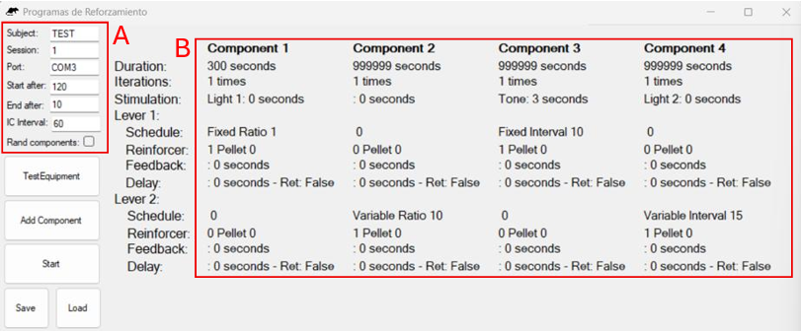
Note. In this instance, the form is configured for a session with four sequential components. Section A shows session-level fields (e.g., subject identifier, session number, port assignment, start delay/blackout, and intercomponent interval). Section B shows component-level parameters specified for each component, including duration/iterations, correlated stimulation, and lever-specific schedule arrangements (schedule type, reinforcer, feedback, and delay settings). For this example, Component 1 ends after 300 s, and the rest of the components end once 15 reinforcers are recorded or when 999999 s have elapsed, whichever occurs first.

The form also provides controls for defining global session parameters that apply across all components (Figure 1, Section A). These fields include subject and session identifiers and the port assignment used for equipment communication, as well as timing parameters that determine when the session effectively begins and ends. The start after interval specifies the period between initiating the session (clicking Start) and the onset of the first component (i.e., a blackout), allowing acclimation to the chamber prior to data collection. The intercomponent interval (ICI) specifies the duration of the pause between consecutive components. Finally, the optional end after interval specifies a period following completion of the final component during which all outputs remain inactive. All timing parameters are specified in seconds. Together, these settings allow users to standardize transitions between components and control pre and post session conditions independently of the experimental contingencies.
Components are arranged to run sequentially by default, but the Set-Up Form also includes a Rand components checkbox (see Section A, Figure 1), which if selected, randomizes the order in which programmed components are presented. When this option is enabled, the program constructs an internal list that contains each component identifier repeated according to its programmed number of iterations. At the start of each component, the program selects one item from this list at random, assigns it as the next active component, and then removes it from the list. This approach guarantees that (a) all programmed components are presented exactly as many times as specified, and (b) the session ends only after the list has been exhausted (i.e., after the full programmed sequence has been completed). In addition, the randomization routine includes a safeguard against excessive immediate repetition (i.e., it avoids selecting the same component if doing so would produce three identical components in a row). The generated sequence is evaluated to ensure that it does not contain three identical components in a row; if such a pattern is detected, the sequence is reshuffled until the restriction is satisfied or a predefined maximum number of attempts (500) is reached.
A central function of the Set-Up Form is the creation and organization of experimental components. Users may add components through direct interaction with the interface, with each component configured independently using the Component Form described below. Once defined, components can be arranged to run sequentially or presented in a randomized order by selecting the corresponding option. The number of components displayed simultaneously in the preview area is limited to four, as this configuration fits comfortably within a standard monitor resolution and facilitates visual inspection of the programmed sequence (see Figure 1, section B). This limit reflects an interface design choice rather than a structural constraint of the software, and the underlying architecture allows the number of components to be extended as needed through straightforward modifications to the code. In practice, most experimental procedures implemented with the system have required only two or three components within a single session (see Demonstration Experiment below), making this design sufficient for typical teaching and research applications.
The Set-Up Form also includes options for saving and loading complete experimental configurations. Entire programs (e.g., macros), including all component definitions and global parameters, can be stored as external text files and reloaded in future sessions. This feature supports replication across sessions, sharing of procedures between users, and rapid reconfiguration of experiments in teaching settings. Although these files are typically generated and loaded through the interface, advanced users may modify them directly to adjust program structure, provided that the expected format is preserved. Figure 2 shows an example session configuration file.
Figure 2.
Annotated session configuration file.
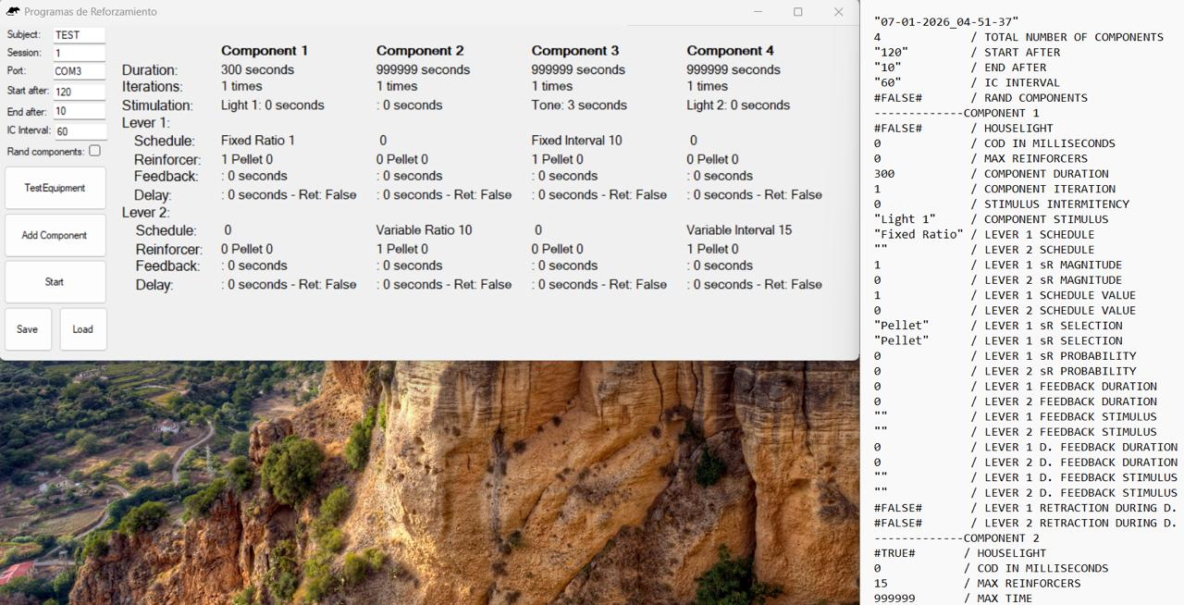
Note. The figure shows an example of the plain-text session configuration file generated by the program, with annotations added to indicate the meaning of each stored value (global session parameters followed by component-specific parameters). In this annotated example, a forward slash (/) and dashed separators (-) are used to label parameters and mark component blocks for readability; IC=Inter Component; COD=Change Over Delay; D.=Delay. Configuration files saved by the program do not include these comments..

Once configuration is complete, sessions are initiated from the Set-Up Form, at which point control is transferred to the main execution interface and data recording begins automatically. Before initiating a session, users may access the Test Equipment Form directly from the Set-Up interface to verify proper operation of all inputs and outputs. In the following section we will describe this form.
The Test Equipment Form
The Test Equipment Form provides a diagnostic and maintenance interface intended to verify the correct operation of the operant conditioning chamber prior to experimental sessions. Although this form can be used to demonstrate the basic functioning of the apparatus, its primary purpose is to support routine equipment checks and troubleshooting before data collection begins. For this reason, users are encouraged to run it before initiating any experimental session. When the form is launched, the software establishes serial communication with the Arduino-compatible microcontroller and begins monitoring all configured inputs in real time. Responses detected from the chamber, including lever presses and magazine photobeam interruptions, are displayed immediately within the interface, allowing users to confirm that sensors are functioning properly and that response detection is reliable. Figure 3 shows a view of the Test Equipment Form.
Figure 3.
Test Equipment Form
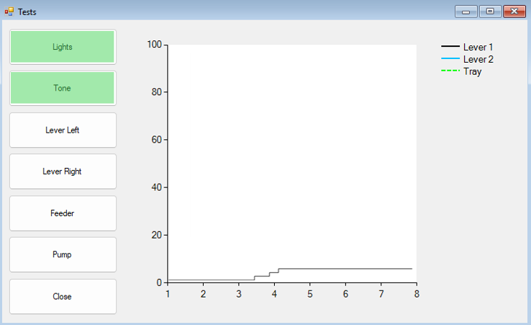
Note. The form provides manual activation of chamber devices (e.g., lights, tone, levers, feeder, pump) to verify equipment functionality prior to running a session. Activated controls are highlighted to indicate testing progress.

In addition to monitoring inputs, the form allows users to manually activate and deactivate available outputs through dedicated on-screen controls. These outputs include houselight and stimulus lights, auditory stimuli, lever extension and retraction, and reinforcement delivery mechanisms (e.g., 45-mg grain pellets or liquid). Each control sends a corresponding command to the microcontroller, enabling users to test individual devices independently of any programmed contingencies. This feature is particularly useful for identifying wiring issues, malfunctioning components, or misconfigured devices before running an experimental procedure. To facilitate rapid visual feedback, the interface updates its display dynamically as inputs are detected and outputs are activated. For example, response indicators change state when a lever is pressed or when the magazine photobeam is interrupted, providing an intuitive confirmation that physical events in the chamber are being correctly registered by the software. This design allows users with minimal technical experience to assess equipment status without inspecting raw serial data. This form does not record data to session files and does not engage any reinforcement schedules or component logic. Its function is mainly diagnostic and aimed to reduce the likelihood of session failures due to hardware issues.
The Component Form
The Component Form is the core configuration interface of Reinforcement Schedules and defines the experimental logic of each component within a multiple schedule. Figure 4 shows the standard view of the Component Form. By configuring components independently, users can construct complex experimental procedures without writing or modifying source code. Each component is defined either by a fixed duration (in seconds) or by a reinforcer-based termination criterion and by a specified number of iterations, which determines how many times the component is presented within a session. Component duration determines the temporal structure of the session, as total session length is derived from the combined durations of all programmed components.
Section A of the Component Form (see Figure 4) defines the component-level parameters that determine how each component is presented and terminated and which stimuli are correlated with its occurrence. Components may be terminated either by a fixed duration (in seconds) or by a reinforcer-based termination criterion specified as the maximum number of reinforcers available within the component, and an iterations field specifies how many times the component is repeated when the programmed sequence is executed; thus, total session length is derived from the number of components, their termination criteria, and their iterations. Section A also provides controls for component-correlated stimulation and changeover constraints: users select the stimulus to be active during the component (stimulus lights above the levers, a tone, or the houselight) and may specify stimulus intermittency by entering an on/off cycle duration, with a value of zero arranging continuous activation for the duration of the component. Finally, a changeover delay (COD) field constrains reinforcer availability following switches between response options, supporting the arrangement of standard operant procedures within a fixed component-based session structure.
Figure 4.
The Component Form
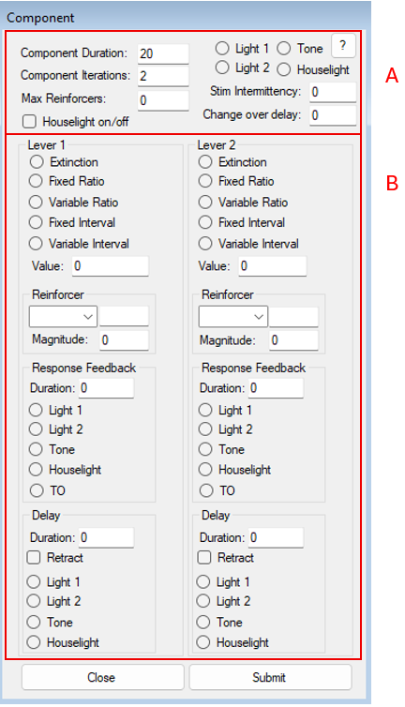
Note. Section A shows component-level parameters, including duration, iterations, maximum reinforcers (reinforcer-based termination), component-correlated stimulation (including intermittency), and the changeover delay (COD). Section B shows lever-specific contingency fields (schedule type and value, reinforcer selection and magnitude, response feedback, and delay/retraction options). If no schedule is specified for a lever, extinction is programmed by default.

Within each component, independent schedules of reinforcement can be assigned to each response lever (see Figure 4, Section B). The program includes both fixed and variable interval and ratio schedules, as well as extinction. Schedule parameters are specified numerically through the interface in the Value box. For variable schedules, reinforcement criteria are generated according to a modern version of Hantula’s (1991) BASIC implementation of Fleshler & Hoffmans’ (1962) iterative equation.
The Component Form also allows users to configure the type and magnitude of reinforcers delivered following a qualifying response. Reinforcement may be delivered in the form of food pellets, liquid reinforcers, or mixed arrangements in which the type of reinforcer delivered varies across reinforcement opportunities. When a mixed option is selected, users can specify the probability with which each reinforcer type is delivered following a qualifying response. Reinforcer magnitude and delivery duration can be defined independently for each response lever, allowing asymmetric reinforcement arrangements within the same component. A reinforcer magnitude of 1 corresponds to a single delivery event, such as the release of one food pellet or a single activation of the liquid pump producing 0.1 ml of fluid. When higher magnitudes are specified, the software issues the corresponding delivery command multiple times in succession, resulting in repeated pellet deliveries or multiple pump activations within the same reinforcement event.
Contingencies can be further customized through response feedback and delay parameters. The form allows users to define immediate feedback following a response (e.g., brief stimulus changes) as well as delayed reinforcement arrangements. Delays may be configured as signaled or unsignaled, depending on whether stimulation is presented during the delay interval. In addition, users may specify whether response levers remain extended or are retracted during delays, allowing for fine-grained control over response availability across experimental conditions.
Main Form
The Main Form is the execution and monitoring window of the software. Once a session is initiated from the Set-Up form, control is transferred to the Main Form, where programmed components are executed sequentially and all experimental events are recorded automatically. This form is designed primarily for real-time monitoring rather than configuration, allowing users to observe session progress without interacting with underlying parameters. Figure 5 shows an example view of the Main Form. During execution, the form displays the currently active component and updates its status as components begin and end. Visual indicators reflect component transitions, stimulus activation, and reinforcement delivery, providing a continuous overview of the ongoing procedure. This arrangement allows users to verify that the programmed events occur as intended while minimizing the need for manual intervention.
This form includes a cumulative display of responses across components. Response counts for each lever are plotted continuously as the session progresses, allowing rapid visual assessment of response patterns and changes across experimental conditions. This display rescues the logic of cumulative recording originally developed by Skinner (1957), in which the temporal organization of responding is made immediately visible as behavior unfolds. Although the graphical display is intended primarily for monitoring and does not replace post-session analyses based on recorded event files, it has demonstrated substantial pedagogical value in our laboratories. In teaching settings, this real-time visualization allows students to directly observe characteristic response patterns associated with different learning histories and reinforcement schedules, facilitating the interpretation of basic learning phenomena as they emerge during the session.

Figure 5.
The Main Form
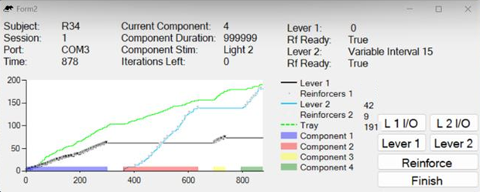
Note. The form displays session identifiers (subject, session, port, elapsed time) and the active component (component number, programmed duration, correlated stimulus, and iterations remaining). The cumulative record plots responses on each lever and magazine entries (see tray), with component segments indicated along the x-axis. The “Rf ready” fields indicate whether a reinforcer is currently available under interval schedules (i.e., whether the timing requirement has elapsed and the next response will produce delivery).

Under standard operation, the Main Form does not require user input during execution. However, the interface also includes a set of manual control buttons designed to facilitate specific experimental and instructional situations. These controls allow users to extend or retract response levers, simulate responses, and deliver reinforcers on demand. Such features are particularly useful during equipment demonstrations, or when testing contingencies dynamically during a test session. Manual reinforcement delivery can be used to guide responding during early shaping phases, while simulated responses can support classroom demonstrations of schedule effects without requiring live responding from the subject or physically pressing the lever inside the chamber.
At session termination, either after completion of all programmed components or upon reaching a predefined event-based criterion, the form initiates shutdown procedures. All outputs are deactivated, final data are written to disk, and a summary file is generated to provide a concise overview of session performance. In addition, a static image of the response plot displayed during the session is saved automatically for documentation and quick reference. In addition, the form includes a control to terminate a session manually before completion of all programmed components. This option is intended for situations in which experimental conditions must be interrupted due to unforeseen events, such as equipment malfunction or subject-related issues. When a session is terminated manually, the software performs standard shutdown procedures saving all data recorded up to that point.
The Data Files
During session execution, the program generates two data files, one containing a raw continuous, event-level record of the experimental session, and one with a summary of session events. Data logging begins at session onset and proceeds without interruption until the session ends. Figure 6 shows an overview of both data files.

Figure 6.
Raw and summary data files
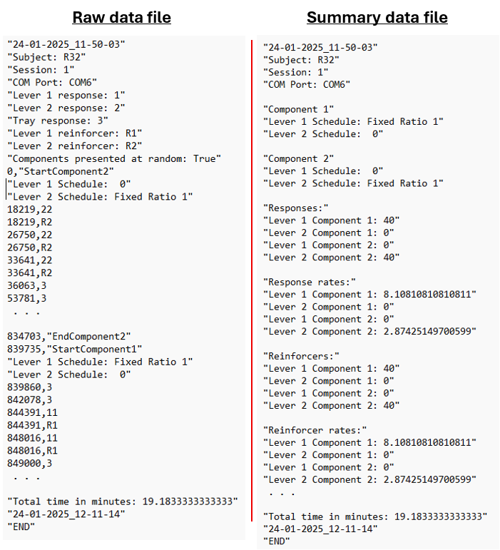
Note. The program writes two plain-text (.txt) outputs per session. The raw data file (left) contains a continuous time-stamped event record, including event codes for responses, reinforcer deliveries, delays, and component transitions. The summary file (right) lists the programmed component parameters and session-level summaries (e.g., response rates, reinforcers, and total session time). Files can be saved to any user-specified directory; storing files in a synchronized folder may facilitate backup and access across devices.

On the raw data file, each entry consists of a timestamp indicating elapsed time since session start and an event code specifying the nature of the recorded event. Event codes may be customized by advanced users through minor modifications to the software; however, a standardized default coding scheme is provided to ensure immediate usability and consistency across laboratories. Under this default scheme, each response emitted on the left and right levers is recorded using distinct numeric codes (e.g., code “11” for responses on component 1 and lever 1, and code “21” for responses on component 2 and lever 1), while interruptions of the food magazine photobeam are recorded using a separate code. Reinforcement deliveries are logged according to both reinforcer type and delivery event, allowing pellet and liquid deliveries to be distinguished in the event stream. Component boundaries are explicitly identified using start and end codes, making it possible to reconstruct the temporal organization of the session directly from the raw data. Additional event codes are used to record stimulus activations and deactivations, intercomponent intervals, and responses emitted during programmed reinforcement delays. Together, these conventions produce a detailed and interpretable event log while preserving flexibility for laboratories that adopt alternative coding schemes.
In addition to the raw data file, the software generates a summary file at the end of each session. The summary file provides an aggregated overview of session performance, including total response counts, reinforcement deliveries, and basic measures computed separately for each programmed component. This file is designed to support rapid inspection of session outcomes when continuous monitoring was not possible or when a quick assessment of session integrity is required. The summary file is not intended to replace detailed analyses based on the raw data. Instead, it functions as a convenience tool that allows users to verify that components were executed as programmed, that responses and reinforcers occurred as expected, and that the session progressed without obvious anomalies. In teaching settings, the summary file can also serve as a useful aid for immediate discussion of session outcomes before more detailed analyses are conducted.
Demonstration Experiment
The purpose of the demonstration experiment was not to evaluate resurgence as a behavioral phenomenon per se, but to functionally validate the capacity of the interface to execute sequential, multi-component operant sessions requiring precise control over stimulus transitions, reinforcement contingencies, and event timing. Resurgence preparations were selected because they impose stringent demands on experimental control, including component-specific stimulus correlations, rapid schedule transitions, and continuous event-level recording suitable for within-session analyses.
The experiment was run by undergraduate psychology students as part of their thesis-related laboratory work, under standard supervision conditions. The procedure integrates two published preparations: the worsening-transition arrangement used by Yensen et al. (2022) and the component-specific stimulus-combination used by Madrigal et al. (2024), including assessment of resurgence when the alternative response is placed in extinction during the test component. Validation was based on whether the resulting event record supported standard within-session measures of target responding across the transition into the test component and the proportion of sessions meeting an operational resurgence criterion.
Method
Subjects
Four, 120-day-old female Wistar rats served as subjects. Rats were group-housed in standard polycarbonate cages with environmental enrichment (e.g., nesting material and shelters) in a colony room maintained under a 12:12-hr light–dark cycle, at a mean temperature of 24 °C and approximately 40% relative humidity. Throughout the experiment, rats were maintained at approximately 85% of their free-feeding body weights via controlled daily feeding, with water continuously available in the home cage. All experimental procedures were reviewed and approved by the institution’s ethical committee and were conducted in accordance with national and international guidelines for the care and use of laboratory animals.

Apparatus
Sessions were conducted in a custom-built operant conditioning chamber fabricated using 3D-printed components in a configuration like that described by Escobar et al. (2022). The chamber was equipped with two levers positioned on the front panel (left and right) and a food magazine connected to a pellet dispenser that delivered 45-mg grain pellets (Bio-Serv). Visual stimulation was provided by a houselight placed on the opposite panel to that of the levers; auditory stimulation was provided by a tone generator that, when active, produced an intermittent cycle (3 s on/3 s off) at 60dB. All experimental events were controlled by the developed interface (i.e., Reinforcement Schedules), which arranged contingencies and stored a continuous time-stamped event stream including lever presses, pellet deliveries, stimulus state changes, lever insertion events, and component boundaries.
Procedure
Each session consisted of three sequential components arranged within a single session and separated by no intercomponent interval. Three discriminative stimuli were used to correlate each component within a session. Stimulus A was the intermittent tone programmed as a repeating 3-s on/3-s off cycle, stimulus B was illumination of the houselight, and stimulus C was no programmed stimulus change. Across conditions, the component–stimulus arrangement was varied by permuting the order of A, B, and C across the three components using four stimulus orders (ABC, ACB, BAC, and BCA). These stimulus orders were exchanged across conditions and across sessions such that the worsening manipulation in the test component was not uniquely associated with a single stimulus arrangement. For each subject, one lever was designated as the target response and the other as the alternative response, with lever assignment counterbalanced across subjects.
At the start of each session, both levers were retracted and the chamber remained in blackout for 120 s. Following this interval, Component 1 began with insertion of the target lever. During Component 1, food deliveries were arranged according to a variable-interval (VI) 30-s schedule for responding on the target lever. Component 1 remained in effect until 15 food deliveries occurred. Component 2 began immediately upon completion of Component 1 and was signaled by the programmed component-specific stimulus arrangement. The alternative lever was inserted at the onset of Component 2. During Component 2, food deliveries were arranged according to a VI 30-s schedule for responding on the alternative lever, and the component terminated after 15 food deliveries occurred. Target responding was not programmed to produce food deliveries during Component 2. A 6-s changeover delay (COD) was in effect during Components 2 and 3 to constrain rapid switching between levers. Under the COD, a food delivery could not be obtained for responding on a lever until 6 s had elapsed since the most recent response on the other lever.
Component 3 served as the test component and implemented the worsening manipulation. Across conditions, food deliveries for alternative responding in Component 3 were arranged according to a FI 30-s schedule, a FI 50-s schedule, a FI 100-s schedule, or extinction. Target responding remained on extinction during Component 3. Because a reinforcer-based termination criterion cannot be applied under extinction, Component 3 was terminated by elapsed time and lasted 15 min in all conditions.
Four conditions were evaluated, defined by the schedule arranged for alternative responding in Component 3 (FI 30 s, FI 50 s, FI 100 s, or extinction). Each condition comprised six sessions per subject. Subjects were exposed to one condition per day, with the condition changing daily until six exposures to each condition were completed.
Data analysis and measures
Primary analyses focused on target responding immediately before and immediately after the transition into the test component. For each session, the number of target responses was calculated during the last 5 min of Component 2 and during the first 5 min of Component 3. Resurgence was scored for a given session when the number of target responses during the first 5 min of Component 3 exceeded the number of target responses during the last 5 min of Component 2. For each subject and condition, the proportion of sessions meeting the resurgence criterion was summarized as the percentage of sessions with resurgence, using six sessions as the denominator.
Results and Discussion
Figure 7 shows the number of target responses during the last 5 min of Component 2 (closed bars) and the first 5 min of Component 3 (open bars) across the six sessions conducted under each worsening condition. Across subjects and conditions, target responding during the last five minutes of Component 2 was often low, whereas target responding commonly increased immediately following the transition into Component 3, producing repeated instances of resurgence.
Figure 7
Session-by-session target responding and resurgence across worsening conditions.
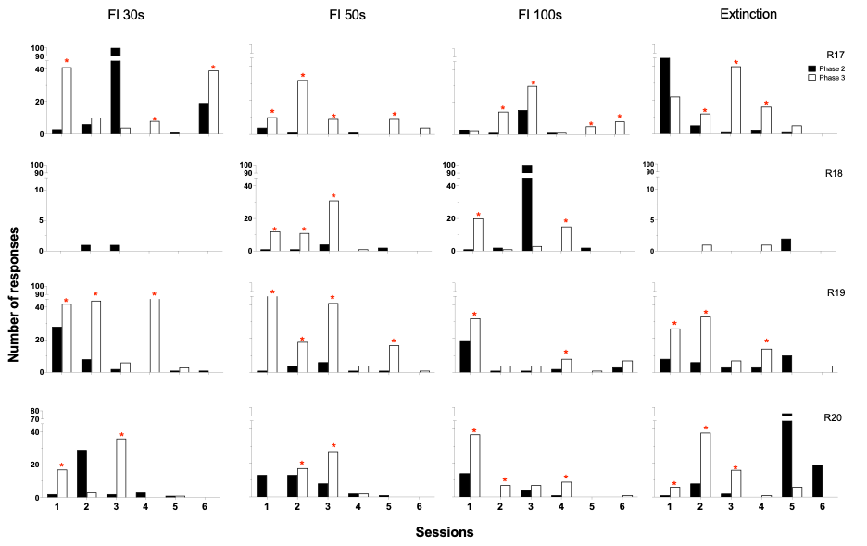
Note. Number of target responses during the last 5 min of Component 2 (closed bars) and the first 5 min of Component 3 (open bars) across the six sessions conducted in each condition (FI 30 s, FI 50 s, FI 100 s, and extinction) for each subject (R17–R20). Asterisks indicate sessions that met the operational resurgence criterion (target responses in the first 5 min of Component 3 exceeded target responses in the last 5 min of Component 2). Note y-axis breaks.

Table 1 summarizes these outcomes as the percentage of sessions meeting the resurgence criterion and shows that, for three of four subjects (R17, R19, and R20), resurgence occurred in every programmed test arrangement at least once; R18 showed fewer sessions with resurgence. These outcomes are consistent with the patterns reported in prior resurgence preparations that were used as the basis for the present demonstration. Specifically, the repeated observation of resurgence across FI and extinction tests is consistent with the schedule-transition worsening arrangement described by Yensen et al. (2022), and the occurrence of resurgence under multiple component-specific stimulus orders is consistent with the logic of varying stimulus combinations across components emphasized by Madrigal et al. (2024).
Table 1
Percentage of session with resurgence by condition.
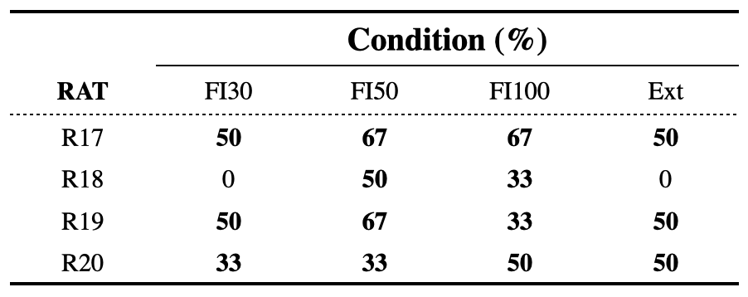
Note. Percentage of sessions in which resurgence was observed for each subject in each condition (FI 30 s, FI 50 s, FI 100 s, and extinction). Percentages are based on six sessions per condition. Resurgence was scored when target responses in the first 5 min of Component 3 exceeded target responses in the last 5 min of Component 2.

Conclusions
The present paper introduced an open-source application designed to support operant research and instruction through a graphical, component-based interface built on a low-cost Arduino–Visual Basic architecture. During the demonstration, programmed reinforcer deliveries (or their absence under extinction) occurred as arranged in Components 1–3. Behavioral effects were recorded while the interface executed sequential component transitions, enforced component-specific stimulus states (including 3-s on/3-s off auditory cycling and no programmed stimulus change), applied a COD in Components 2 and 3, and implemented mixed component termination criteria (reinforcer-based termination in Components 1–2 and time-based termination in Component 3). The behavioral outcomes and their derivation from a continuous time-stamped event record, support the conclusion that the 3D-printed chamber arrangement (Escobar et al., 2022) coupled with the current interface, is sufficient to reproduce a standard resurgence result that was previously demonstrated using commercial control systems.
It should be noted that the present application is not intended to replace commercial experimental control systems, but to provide a functionally comparable alternative for laboratories in which access to such systems is limited by economic or infrastructural constraints. Rather than prioritizing feature parity with proprietary platforms, the design emphasizes flexibility, accessibility and transparency. In this sense, Reinforcement Schedules aligns with a tradition in the experimental analysis of behavior that values functional control and replicability over technological exclusivity.
Despite its demonstrated utility, the current implementation of Reinforcement Schedules has identifiable limitations. The interface is optimized for discrete-response operant preparations and does not natively support more complex arrangements such as chained schedules, closed-loop adaptive or progressive procedures, or concurrent choice programs with more than two response options. These constraints reflect deliberate design decisions oriented toward accessibility and pedagogical use, and they delineate clear directions for future development, whether by the authors or by anyone interested in contributing to the public repository.
In summary, the present work demonstrates that a low-cost, open-source, visually configurable interface can support both instruction and research in the experimental analysis of behavior without sacrificing experimental rigor. The successful implementation of a standard resurgence preparation provides concrete evidence that the system can reproduce established behavioral effects using component-based logic. We hope that distribution of this software contributes to ongoing efforts to democratize access to experimental control technology, promote replicable practices, and support the training of new behavior analysts in contexts with diverse levels of technical and economic resources.

References
Ávila-Chauvet, L., & Pedroza Cabrera, F. J. (2013). REPRAP y Rhinoceros® en el diseño y construcción de equipo experimental. Revista Mexicana de Análisis de la Conducta, 39(3), 65-72.
Escobar, R. (2014). From relays to microcontrollers: The adoption of technology in operant research. Mexican Journal of Behavior Analysis, 40 (2), 127–153. https://doi.org/10.5514/rmac.v40.i2.63673.
Escobar, R., Gutiérrez, B., & Benavides, R. (2022). 3D-printed operant chambers for rats: Design, assembly, and innovations. Behavioural Processes, 199, 1-11. https://doi.org/10.1016/j.beproc.2022.104647
Escobar, R., & Pérez-Herrera, C. A. (2015). Low-cost USB interface for operant research using Arduino and Visual Basic. Journal of the Experimental Analysis of Behavior, 103(2), 427–435. https://doi.org/10.1002/jeab.135
Fleshler, M., & Hoffman, H. S. (1962). A progression for generating variable-interval schedules. Journal of the Experimental Analysis of Behavior, 5(4), 529–530. https://doi.org/10.1901/jeab.1962.5-529
Gómez-Fuentes, D. (2014). Los inicios: El conductismo en la Universidad Veracruzana. In R. Pérez Almonacid & D. Gómez-Fuentes (Eds.), Emilio Ribes Iñesta: Una historia de proyectos institucionales de identidad disciplinar e innovación educativa (pp. 21–109). Universidad Veracruzana.
Hantula D. A. (1991). A simple BASIC program to generate values for variable-interval schedules of reinforcement. Journal of Applied Behavior Analysis, 24(4), 799–801. https://doi.org/10.1901/jaba.1991.24-799
Lattal, K. A. (2008). JEAB at 50: Coevolution of research and technology. Journal of the Experimental Analysis of Behavior, 89(1), 129–135.
https://doi.org/10.1901/jeab.2008.89-129
Malott, M. E. (2004). Toward the globalization of behavior analysis. The Behavior Analyst, 27(1), 25-32. https://doi.org/10.1007/BF03392087
Ribes-Inesta, E. (1968). Psychology in Mexico. American Psychologist, 23(8), 565–566. https://doi.org/10.1037/h0026432
Todorov, J. C. (2006). Behavior analysis in Brazil. Avances en Psicología Latinoamericana, 24, 29-36.

