Reinforcement Schedules: An Open-Source Visual Interface for Component-Based Operant Procedures
Precise control and recording of experimental events are central requirements in operant research, but many laboratories and teaching programs need tools that are transparent, modifiable, and less costly than commercial control systems. The present paper describes Reinforcement Schedules, an open-source Windows application for configuring, executing, monitoring, and recording component-based operant procedures through a graphical interface. The program extends the Arduino-Visual Basic architecture described in prior low-cost systems by moving routine schedule construction from source-code editing to a visual workflow. Users can define simple, multiple, mixed, and concurrent arrangements across as many as six operandum inputs, assign fixed- and variable-ratio or interval schedules to each input, arrange component-specific stimuli, schedule response feedback and reinforcement delays, randomize component order when appropriate, and save complete session configurations for later reuse. The application communicates with Arduino-compatible firmware through a simple serial protocol: the firmware must report the state of the configured digital inputs and interpret symbolic commands sent by the Visual Basic program to activate or deactivate outputs. A reference sketch supporting six inputs, four stimulus lights, houselight, tone, pellet delivery, and pump control is included with the software. The demonstration experiment illustrates how the system can execute a multi-component resurgence preparation requiring sequential transitions, stimulus changes, changeover delays, and continuous event-level recording. The manuscript emphasizes implementation requirements, data outputs, and the functional contribution of a graphical control layer for reproducible open-source operant research.
Keywords: low-cost experimental equipment, visual basic, open-source software, Arduino, rats

Automation and precise control of experimental events have been defining features of the experimental analysis of behavior since its early electromechanical arrangements. Contemporary operant research depends on the ability to arrange contingencies, change stimulus conditions, and record events with enough temporal resolution to reconstruct what occurred during a session. Commercial systems provide this functionality, but their cost, proprietary structure, and dependence on specialized hardware can limit access, modification, and training.
Open-source and low-cost technologies have therefore become an important complement to commercial systems. Microcontrollers, 3D printing, laser cutting, and user-modifiable software make it possible to build experimental arrangements that are transparent and adaptable while preserving the core requirements of operant research. This approach is especially valuable in teaching laboratories and laboratories with limited equipment budgets, but its relevance is methodological rather than only regional: a useful system should be implementable, inspectable, and modifiable by independent users.
The Arduino-Visual Basic interface described by Escobar and Perez-Herrera (2015) showed that inexpensive Arduino boards could serve as a reliable USB interface between a Windows computer and an operant chamber. Later work extended this open-source infrastructure to 3D-printed chambers for rats and provided detailed hardware designs and example programs (Escobar et al., 2022). Those systems established the feasibility of the hardware architecture, including Arduino-based input and output control, serial communication, and Visual Basic programs for arranging simple or concurrent schedules.
A remaining barrier is that procedural flexibility often still depends on editing or duplicating source code. Even when the hardware is inexpensive, users who want to change from one schedule arrangement to another, combine procedures across successive components, or prepare variants for teaching exercises may need to understand how the program represents events, timers, schedules, and outputs. For students and researchers without programming experience, that requirement can shift attention away from experimental design and data interpretation toward debugging.
The present project addresses that barrier by adding a graphical, component-based control layer to the existing Arduino-Visual Basic tradition. Reinforcement Schedules allows users to define components, assign contingencies to multiple operandum inputs, arrange stimuli and delays, save configurations, test equipment, execute sessions, and inspect data files without modifying the source code for routine procedures.
The contribution is not a replacement for the previously described hardware or firmware approach. Instead, it is a higher-level interface for configuring a wider class of operant procedures within that architecture. This distinction is important: the Arduino remains an input/output interface, whereas the Visual Basic application implements the experimental logic, session structure, schedule progression, event logging, and graphical monitoring. The demonstration experiment was selected to show that the program can execute a procedure with successive components, stimulus-specific transitions, changeover-delay constraints, and a raw event stream suitable for reconstructing within-session behavior.

The Reinforcement Schedules Application
Reinforcement Schedules is a Windows Forms application developed in Visual Basic for use with Arduino-compatible microcontroller interfaces. The program preserves the general division of labor of prior Arduino-Visual Basic systems: the Arduino firmware reads physical inputs and activates outputs, whereas the Visual Basic application arranges contingencies, manages session structure, records data, and provides a graphical interface for users. The current version differs from earlier example programs by allowing routine procedures to be configured through forms rather than by editing code.
Broadly, the program organizes procedures as one or more temporal components. Within each component, users can define duration or reinforcer-based termination criteria, number of iterations, component-correlated stimulation, changeover delays, feedback events, reinforcement delays, and independent schedules for each configured operandum. Components may be presented sequentially or, when selected, in a randomized order that preserves the programmed number of presentations. This architecture supports simple schedules, multiple schedules with successive stimulus-correlated components, mixed arrangements in which component order is not signaled, and concurrent arrangements involving more than one available operandum.
The program is distributed as open-source software under the GNU General Public License version 3 (GPL-3.0). The repository includes the Visual Basic source code, the compiled application, and a reference Arduino sketch compatible with the serial communication protocol used by the program. Users may use, study, modify, and redistribute the software, provided that redistributed or modified versions preserve the same license and include the corresponding source code. The software source code is freely available at: https://github.com/anonymous-author3/ReinforcementSchedules.
Table 1. Summary of the main functional differences between previously described Arduino-Visual Basic examples and the present graphical interface.
Feature | Previously described Arduino-Visual Basic examples | Reinforcement Schedules
Primary user workflow | Users selected or modified specific Visual Basic programs for simple or two-response concurrent schedules. | Users configure complete sessions through graphical forms and save/load reusable configuration files.
Procedural scope | Simple schedules and two-operanda concurrent schedules were emphasized. | Simple, multiple, mixed, and concurrent arrangements can be programmed within a component-based session structure.
Operandum inputs | Example programs focused on one or two responses. | The current architecture supports up to six configured inputs, each with independent schedule, feedback, delay, and reinforcer settings.
Session structure | Procedures were tied more closely to a specific program file. | Users can combine up to ten components, repeat components, randomize component order, and mix time- and reinforcer-based termination criteria.
Data output | Programs recorded real-time data for the implemented schedule. | The program writes a continuous time-stamped event file and a summary file suitable for rapid inspection and post-session reconstruction.

Prerequisites
Reinforcement Schedules runs on a standard Windows computer and communicates with the experimental hardware through a USB serial connection. No specialized computer hardware is required. The software has been tested on standard laboratory and classroom computers with a basic processor, 4 GB of RAM, and an available USB port. A single computer can run more than one instance of the application when separate microcontrollers and chambers are assigned to separate serial ports, although the number of simultaneous sessions depends on available system resources.
The software is configured by default for an operant chamber with multiple digital inputs, stimulus lights, a houselight, an auditory stimulus, and pellet or liquid reinforcement devices. Unused inputs and outputs can be left unassigned, and the software is not species-specific. Any preparation can be used if its response devices and output devices can be represented as digital input states and output commands understood by the microcontroller interface.

Firmware compatibility and reference sketch
Reinforcement Schedules does not require a unique Arduino sketch, but the firmware must satisfy a small set of communication requirements. First, it must continuously read the physical input lines used for responses or sensors and transmit their states to the computer through the serial port in a stable order. Second, it must listen for single-character or otherwise unambiguous symbolic commands sent by the Visual Basic application. Third, it must translate those commands into output changes, such as turning lights on or off, sounding a tone, inserting or retracting response devices, operating a feeder, or activating a pump. Finally, it must return all relevant outputs to a safe inactive state when instructed or when a session ends.
The repository includes a reference sketch, newProgram2026_6inputs_4lights.ino, that implements this protocol for six digital inputs and a set of commonly used chamber outputs. In that sketch, response inputs are read with internal pull-up resistors and reported over serial communication at 9600 baud. The sketch accepts symbolic commands for houselight control, auditory stimulation, four stimulus lights, six actuator outputs associated with operandum devices, pellet delivery through a stepper-driven feeder, pump activation, and a global all-off command. Users may modify pin assignments or output routines to match their own chamber wiring, as long as the order of reported inputs and the symbolic commands expected by the Visual Basic program remain consistent.
This firmware is included to provide a complete, independently implementable pathway from the graphical application to the chamber hardware. At the same time, the firmware is best understood as a reference implementation of an input/output interface rather than as the main contribution of the present paper. Detailed discussions of Arduino-based operant interfaces, relay control, and 3D-printed chamber hardware are available in the prior descriptions of the platform (Escobar & Perez-Herrera, 2015; Escobar et al., 2022).

Implementation workflow
A typical session is prepared in five steps. The user first connects the chamber to the Arduino-compatible interface and selects the corresponding serial port. Second, the user opens the Test Equipment Form to verify that each input is detected and that each output operates as expected. Third, the user defines one or more components in the Component Form, assigning schedules, stimuli, feedback, delay parameters, and termination criteria. Fourth, the user reviews the full session in the Set-Up Form, where subject and session identifiers, global timing parameters, component order, and saved configuration files are managed. Fifth, the user starts the session and monitors ongoing behavior in the Main Form while the program writes raw and summary data files.
Describing the workflow in this order separates the experimental logic from the execution interface. The Component Form defines what can happen within a component; the Set-Up Form assembles those components into a session; the Main Form executes the programmed sequence and records what occurred.

The Component Form
The Component Form is the core configuration interface of Reinforcement Schedules because it defines the experimental logic of each component before those components are assembled into a session. Figure 1 shows the standard view of the Component Form. By configuring components independently, users can construct procedures involving simple, multiple, mixed, or concurrent arrangements without writing or modifying source code.
Section A of the Component Form (see Figure 1) defines component-level parameters: component name, duration, number of iterations, maximum number of reinforcers, component-correlated stimulation, intermittency of lights or tone, houselight state, and changeover delay (COD). Components may terminate after a fixed duration or after a programmed number of reinforcers. Because this termination rule is stored at the component level, the same session can combine acquisition, transition, and test components with different stopping criteria.
Figure 1.
The Component Form
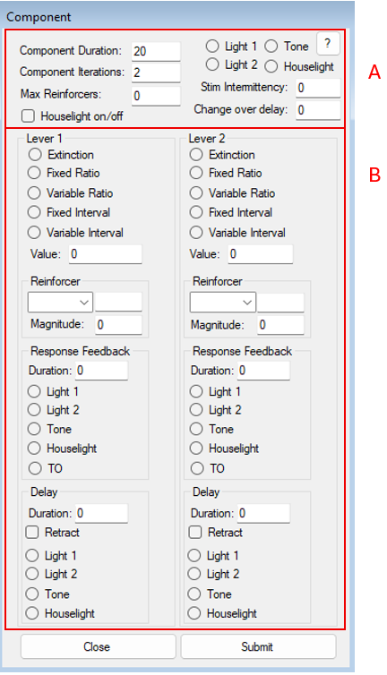
Note. Section A shows component-level parameters, including duration, iterations, maximum reinforcers (reinforcer-based termination), component-correlated stimulation (including intermittency), and the changeover delay (COD). Section B shows lever-specific contingency fields (schedule type and value, reinforcer selection and magnitude, response feedback, and delay/retraction options). If no schedule is specified for a lever, extinction is programmed by default.

Within each component, schedules can be assigned independently to each configured input (see Figure 1, Section B). The program includes extinction, fixed-ratio, variable-ratio, fixed-interval, and variable-interval schedules. If no schedule is specified for an input, extinction is programmed by default. Variable schedules are generated using a modern implementation of Hantula's (1991) BASIC adaptation of the Fleshler and Hoffman (1962) progression.
The Component Form also allows users to configure reinforcer type, reinforcer magnitude, and probabilistic mixed-reinforcer arrangements. Reinforcement may involve pellet delivery, liquid delivery, or mixtures in which each reinforcer type occurs with a user-specified probability. Magnitude and delivery duration can be specified separately for each input, allowing asymmetric reinforcement arrangements within the same component.
Contingencies can be further customized through response feedback and delay parameters. Users may program brief feedback following responses, signaled or unsignaled reinforcement delays, and lever or operandum retraction during delays. These options are important for recurrence and relapse preparations, including resurgence, renewal, reinstatement, and other procedures in which successive components, stimulus changes, worsening transitions, extinction tests, or differential reinforcement histories must be arranged within and across sessions.

The Set-Up Form
The Set-Up Form serves as the main configuration interface of Reinforcement Schedules and is the first screen presented to the user when the program is launched (see Figure 2). This form is designed to guide users through the minimum set of parameters required to define and begin an experimental session, while preventing common configuration errors prior to execution.
At the top of the form (see Section A), users specify basic session identifiers, including subject name and session number. These identifiers are used to label all data files generated during the session, ensuring traceability across repeated runs and facilitating later data organization. Users also select the appropriate serial communication port to establish connection with the Arduino-compatible microcontroller that interfaces with the operant conditioning chamber. Figure 2 shows a view of the Set-Up From.
Figure 2.
The Set-Up Form
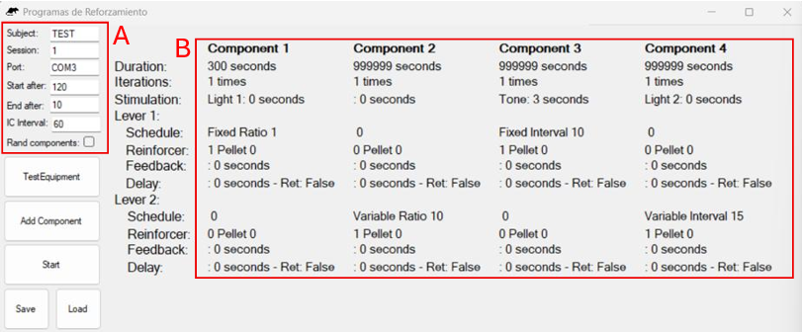
Note. In this instance, the form is configured for a session with four sequential components. Section A shows session-level fields (e.g., subject identifier, session number, port assignment, start delay/blackout, and intercomponent interval). Section B shows component-level parameters specified for each component, including duration/iterations, correlated stimulation, and lever-specific schedule arrangements (schedule type, reinforcer, feedback, and delay settings). For this example, Component 1 ends after 300 s, and the rest of the components end once 15 reinforcers are recorded or when 999999 s have elapsed, whichever occurs first.

The form also provides controls for defining global session parameters that apply across all components (Figure 2, Section A). These fields include subject and session identifiers and the port assignment used for equipment communication, as well as timing parameters that determine when the session effectively begins and ends. The start after interval specifies the period between initiating the session (clicking Start) and the onset of the first component (i.e., a blackout), allowing acclimation to the chamber prior to data collection. The intercomponent interval (ICI) specifies the duration of the pause between consecutive components. Finally, the optional end after interval specifies a period following completion of the final component during which all outputs remain inactive. All timing parameters are specified in seconds. Together, these settings allow users to standardize transitions between components and control pre and post session conditions independently of the experimental contingencies.
Components are arranged to run sequentially by default, but the Set-Up Form also includes a Rand components checkbox (see Section A, Figure 2), which if selected, randomizes the order in which programmed components are presented. When this option is enabled, the program constructs an internal list that contains each component identifier repeated according to its programmed number of iterations. At the start of each component, the program selects one item from this list at random, assigns it as the next active component, and then removes it from the list. This approach guarantees that (a) all programmed components are presented exactly as many times as specified, and (b) the session ends only after the list has been exhausted (i.e., after the full programmed sequence has been completed). In addition, the randomization routine includes a safeguard against excessive immediate repetition (i.e., it avoids selecting the same component if doing so would produce three identical components in a row). The generated sequence is evaluated to ensure that it does not contain three identical components in a row; if such a pattern is detected, the sequence is reshuffled until the restriction is satisfied or a predefined maximum number of attempts (500) is reached.
A central function of the Set-Up Form is the creation and organization of experimental components. Users may add components through direct interaction with the interface, with each component configured independently using the Component Form described above. Once defined, components can be arranged to run sequentially or presented in a randomized order by selecting the corresponding option. The number of components displayed simultaneously in the preview area is limited to four, as this configuration fits comfortably within a standard monitor resolution and facilitates visual inspection of the programmed sequence (see Figure 2, section B). This limit reflects an interface design choice rather than a structural constraint of the software, and the underlying architecture allows the number of components to be extended as needed through straightforward modifications to the code. In practice, most experimental procedures implemented with the system have required only two or three components within a single session (see Demonstration Experiment below), making this design sufficient for typical teaching and research applications.
The Set-Up Form also includes options for saving and loading complete experimental configurations. Entire programs (e.g., macros), including all component definitions and global parameters, can be stored as external text files and reloaded in future sessions. This feature supports replication across sessions, sharing of procedures between users, and rapid reconfiguration of experiments in teaching settings. Although these files are typically generated and loaded through the interface, advanced users may modify them directly to adjust program structure, provided that the expected format is preserved. Figure 3 shows an example session configuration file.
Figure 3.
Annotated session configuration file.
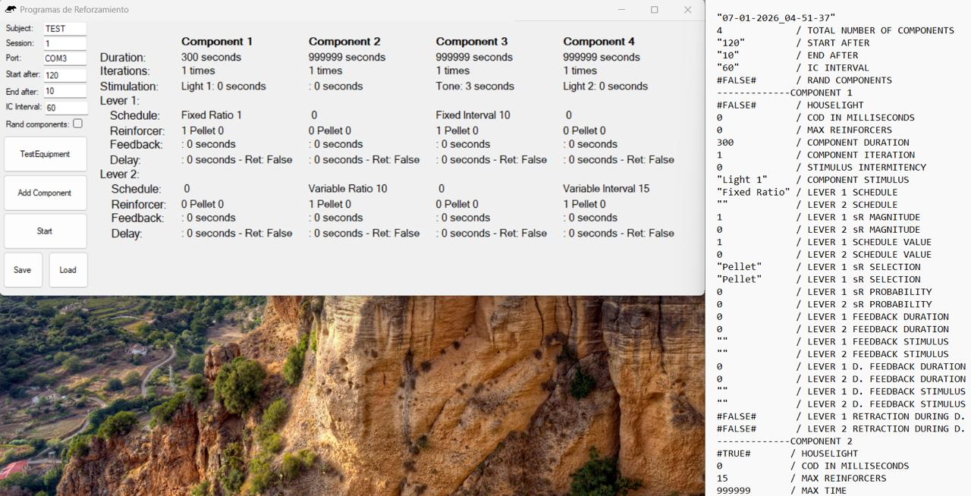
Note. The figure shows an example of the plain-text session configuration file generated by the program, with annotations added to indicate the meaning of each stored value (global session parameters followed by component-specific parameters). In this annotated example, a forward slash (/) and dashed separators (-) are used to label parameters and mark component blocks for readability; IC=Inter Component; COD=Change Over Delay; D.=Delay. Configuration files saved by the program do not include these comments.

Once configuration is complete, sessions are initiated from the Set-Up Form, at which point control is transferred to the main execution interface and data recording begins automatically. Before initiating a session, users may access the Test Equipment Form directly from the Set-Up interface to verify proper operation of all inputs and outputs. In the following section we will describe this form.

The Test Equipment Form
The Test Equipment Form provides a diagnostic and maintenance interface intended to verify the correct operation of the operant conditioning chamber prior to experimental sessions. Although this form can be used to demonstrate the basic functioning of the apparatus, its primary purpose is to support routine equipment checks and troubleshooting before data collection begins. For this reason, users are encouraged to run it before initiating any experimental session. When the form is launched, the software establishes serial communication with the Arduino-compatible microcontroller and begins monitoring all configured inputs in real time. Responses detected from the chamber, including lever presses and magazine photobeam interruptions, are displayed immediately within the interface, allowing users to confirm that sensors are functioning properly and that response detection is reliable. Figure 4 shows a view of the Test Equipment Form.
Figure 4.
Test Equipment Form
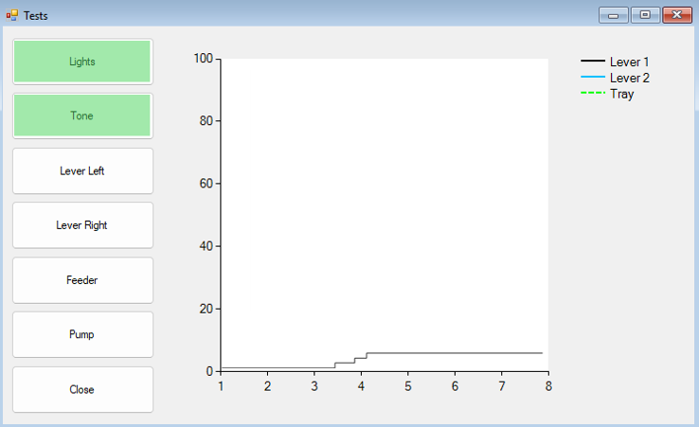
Note. The form provides manual activation of chamber devices (e.g., lights, tone, levers, feeder, pump) to verify equipment functionality prior to running a session. Activated controls are highlighted to indicate testing progress.

In addition to monitoring inputs, the form allows users to manually activate and deactivate available outputs through dedicated on-screen controls. These outputs include houselight and stimulus lights, auditory stimuli, lever extension and retraction, and reinforcement delivery mechanisms (e.g., 45-mg grain pellets or liquid). Each control sends a corresponding command to the microcontroller, enabling users to test individual devices independently of any programmed contingencies. This feature is particularly useful for identifying wiring issues, malfunctioning components, or misconfigured devices before running an experimental procedure. To facilitate rapid visual feedback, the interface updates its display dynamically as inputs are detected and outputs are activated. For example, response indicators change state when a lever is pressed or when the magazine photobeam is interrupted, providing an intuitive confirmation that physical events in the chamber are being correctly registered by the software. This design allows users with minimal technical experience to assess equipment status without inspecting raw serial data. This form does not record data to session files and does not engage any reinforcement schedules or component logic. Its function is mainly diagnostic and aimed to reduce the likelihood of session failures due to hardware issues.

Main Form
The Main Form is the execution and monitoring window of the software. Once a session is initiated from the Set-Up form, control is transferred to the Main Form, where programmed components are executed sequentially and all experimental events are recorded automatically. This form is designed primarily for real-time monitoring rather than configuration, allowing users to observe session progress without interacting with underlying parameters. Figure 5 shows an example view of the Main Form. During execution, the form displays the currently active component and updates its status as components begin and end. Visual indicators reflect component transitions, stimulus activation, and reinforcement delivery, providing a continuous overview of the ongoing procedure. This arrangement allows users to verify that the programmed events occur as intended while minimizing the need for manual intervention.
This form includes a cumulative display of responses across components. Response counts for each lever are plotted continuously as the session progresses, allowing rapid visual assessment of response patterns and changes across experimental conditions. This display rescues the logic of cumulative recording originally developed by Skinner (1957), in which the temporal organization of responding is made immediately visible as behavior unfolds. Although the graphical display is intended primarily for monitoring and does not replace post-session analyses based on recorded event files, it has demonstrated substantial pedagogical value in our laboratories. In teaching settings, this real-time visualization allows students to directly observe characteristic response patterns associated with different learning histories and reinforcement schedules, facilitating the interpretation of basic learning phenomena as they emerge during the session.

Figure 5.
The Main Form
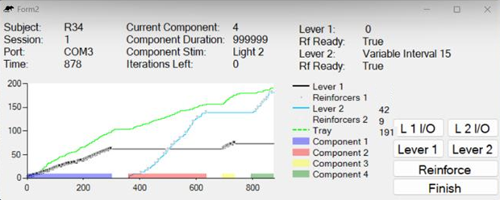
Note. The form displays session identifiers (subject, session, port, elapsed time) and the active component (component number, programmed duration, correlated stimulus, and iterations remaining). The cumulative record plots responses on each lever and magazine entries (see tray), with component segments indicated along the x-axis. The “Rf ready” fields indicate whether a reinforcer is currently available under interval schedules (i.e., whether the timing requirement has elapsed and the next response will produce delivery).

Under standard operation, the Main Form does not require user input during execution. However, the interface also includes a set of manual control buttons designed to facilitate specific experimental and instructional situations. These controls allow users to extend or retract response levers, simulate responses, and deliver reinforcers on demand. Such features are particularly useful during equipment demonstrations, or when testing contingencies dynamically during a test session. Manual reinforcement delivery can be used to guide responding during early shaping phases, while simulated responses can support classroom demonstrations of schedule effects without requiring live responding from the subject or physically pressing the lever inside the chamber.
At session termination, either after completion of all programmed components or upon reaching a predefined event-based criterion, the form initiates shutdown procedures. All outputs are deactivated, final data are written to disk, and a summary file is generated to provide a concise overview of session performance. In addition, a static image of the response plot displayed during the session is saved automatically for documentation and quick reference. In addition, the form includes a control to terminate a session manually before completion of all programmed components. This option is intended for situations in which experimental conditions must be interrupted due to unforeseen events, such as equipment malfunction or subject-related issues. When a session is terminated manually, the software performs standard shutdown procedures saving all data recorded up to that point.

The Data Files
During session execution, the program generates two data files: a raw continuous event-level record and a session summary file. Data logging begins at session onset and proceeds until the session ends. The raw file is the primary record for reproducible analysis because each line contains elapsed time and an event code, allowing the session to be reconstructed independently of the on-screen display.

Figure 6.
Raw and summary data files
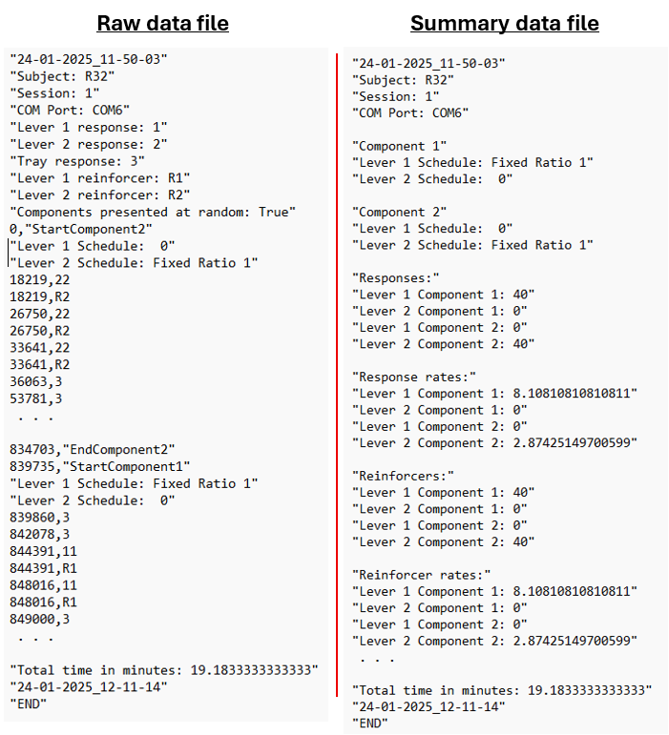
Note. The program writes two plain-text (.txt) outputs per session. The raw data file (left) contains a continuous time-stamped event record, including event codes for responses, reinforcer deliveries, delays, and component transitions. The summary file (right) lists the programmed component parameters and session-level summaries (e.g., response rates, reinforcers, and total session time). Files can be saved to any user-specified directory; storing files in a synchronized folder may facilitate backup and access across devices.

In the raw data file, response events, reinforcer deliveries, stimulus changes, delay events, component starts and ends, and other programmed events are identified by event codes. Because component boundaries and stimulus changes are explicitly recorded, users can reconstruct cumulative records, response-rate changes around transitions, obtained reinforcer timing, responses during delays, and other moment-to-moment measures directly from the event stream. This design makes the graphical display a monitoring aid rather than the sole source of evidence.
The summary file provides an aggregated overview of session performance, including response counts, reinforcer deliveries, component-level measures, and total session time. It is intended for rapid inspection, teaching, and routine session checks. Detailed analyses should be based on the raw event file, particularly when the goal is to verify temporal relations among responses, stimuli, component transitions, and reinforcer deliveries.

Demonstration Experiment
The purpose of the demonstration experiment was to evaluate whether the interface could execute and record a multi-component operant procedure requiring coordinated stimulus transitions, schedule changes, changeover-delay constraints, and continuous event-level recording. The experiment should therefore be read as a functional validation of the software workflow rather than as a new test of resurgence as a behavioral phenomenon.
The procedure integrated features of published resurgence preparations, including worsening transitions and component-specific stimulus arrangements. Such preparations are useful software demonstrations because they require a session to change contingencies across successive components while preserving a record that can be analyzed around the transition into the test component.

Method

Subjects
Four, 120-day-old female Wistar rats served as subjects. Rats were group-housed in standard polycarbonate cages with environmental enrichment (e.g., nesting material and shelters) in a colony room maintained under a 12:12-hr light–dark cycle, at a mean temperature of 24 °C and approximately 40% relative humidity. Throughout the experiment, rats were maintained at approximately 85% of their free-feeding body weights via controlled daily feeding, with water continuously available in the home cage. All experimental procedures were reviewed and approved by the institution’s ethical committee and were conducted in accordance with national and international guidelines for the care and use of laboratory animals.

Apparatus
Sessions were conducted in a custom-built operant conditioning chamber fabricated using 3D-printed components in a configuration like that described by Escobar et al. (2022). The chamber was equipped with two levers positioned on the front panel (left and right) and a food magazine connected to a pellet dispenser that delivered 45-mg grain pellets (Bio-Serv). Visual stimulation was provided by a houselight placed on the opposite panel to that of the levers; auditory stimulation was provided by a tone generator that, when active, produced an intermittent cycle (3 s on/3 s off) at 60dB. All experimental events were controlled by the developed interface (i.e., Reinforcement Schedules), which arranged contingencies and stored a continuous time-stamped event stream including lever presses, pellet deliveries, stimulus state changes, lever insertion events, and component boundaries.

Procedure
Each session consisted of three sequential components arranged within a single session and separated by no intercomponent interval. Three discriminative stimuli were used to correlate each component within a session. Stimulus A was the intermittent tone programmed as a repeating 3-s on/3-s off cycle, stimulus B was illumination of the houselight, and stimulus C was no programmed stimulus change. Across conditions, the component–stimulus arrangement was varied by permuting the order of A, B, and C across the three components using four stimulus orders (ABC, ACB, BAC, and BCA). These stimulus orders were exchanged across conditions and across sessions such that the worsening manipulation in the test component was not uniquely associated with a single stimulus arrangement. For each subject, one lever was designated as the target response and the other as the alternative response, with lever assignment counterbalanced across subjects.
At the start of each session, both levers were retracted and the chamber remained in blackout for 120 s. Following this interval, Component 1 began with insertion of the target lever. During Component 1, food deliveries were arranged according to a variable-interval (VI) 30-s schedule for responding on the target lever. Component 1 remained in effect until 15 food deliveries occurred. Component 2 began immediately upon completion of Component 1 and was signaled by the programmed component-specific stimulus arrangement. The alternative lever was inserted at the onset of Component 2. During Component 2, food deliveries were arranged according to a VI 30-s schedule for responding on the alternative lever, and the component terminated after 15 food deliveries occurred. Target responding was not programmed to produce food deliveries during Component 2. A 6-s changeover delay (COD) was in effect during Components 2 and 3 to constrain rapid switching between levers. Under the COD, a food delivery could not be obtained for responding on a lever until 6 s had elapsed since the most recent response on the other lever.
Component 3 served as the test component and implemented the worsening manipulation. Across conditions, food deliveries for alternative responding in Component 3 were arranged according to a FI 30-s schedule, a FI 50-s schedule, a FI 100-s schedule, or extinction. Target responding remained on extinction during Component 3. Because a reinforcer-based termination criterion cannot be applied under extinction, Component 3 was terminated by elapsed time and lasted 15 min in all conditions.
Four conditions were evaluated, defined by the schedule arranged for alternative responding in Component 3 (FI 30 s, FI 50 s, FI 100 s, or extinction). Each condition comprised six sessions per subject. Subjects were exposed to one condition per day, with the condition changing daily until six exposures to each condition were completed.

Data analysis and measures
Primary analyses focused on target responding immediately before and immediately after the transition into the test component. For each session, the number of target responses was calculated during the last 5 min of Component 2 and during the first 5 min of Component 3. Resurgence was scored for a given session when the number of target responses during the first 5 min of Component 3 exceeded the number of target responses during the last 5 min of Component 2. For each subject and condition, the proportion of sessions meeting the resurgence criterion was summarized as the percentage of sessions with resurgence, using six sessions as the denominator.

Results and Discussion
Figure 7 shows the number of target responses during the last 5 min of Component 2 (closed bars) and the first 5 min of Component 3 (open bars) across the six sessions conducted under each worsening condition. Across subjects and conditions, target responding during the last five minutes of Component 2 was often low, whereas target responding commonly increased immediately following the transition into Component 3, producing repeated instances of resurgence.
Figure 7
Session-by-session target responding and resurgence across worsening conditions.
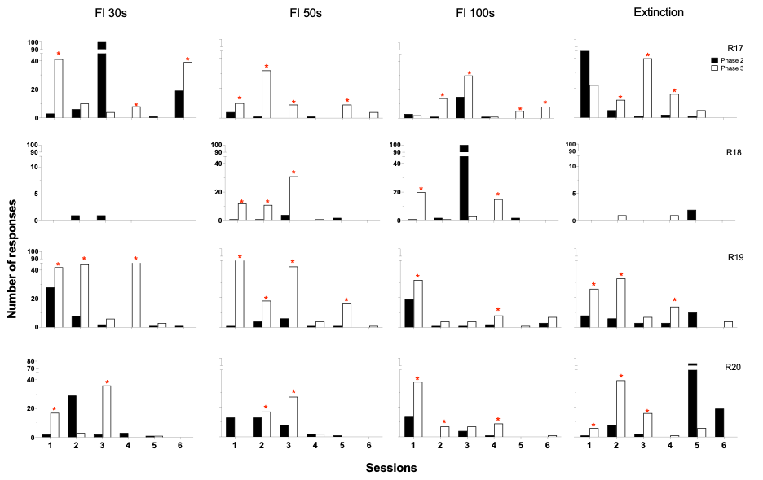
Note. Number of target responses during the last 5 min of Component 2 (closed bars) and the first 5 min of Component 3 (open bars) across the six sessions conducted in each condition (FI 30 s, FI 50 s, FI 100 s, and extinction) for each subject (R17–R20). Asterisks indicate sessions that met the operational resurgence criterion (target responses in the first 5 min of Component 3 exceeded target responses in the last 5 min of Component 2). Note y-axis breaks.

Table 2 summarizes these outcomes as the percentage of sessions meeting the resurgence criterion and shows that, for three of four subjects (R17, R19, and R20), resurgence occurred in every programmed test arrangement at least once; R18 showed fewer sessions with resurgence. These outcomes are consistent with the patterns reported in prior resurgence preparations that were used as the basis for the present demonstration. Specifically, the repeated observation of resurgence across FI and extinction tests is consistent with the schedule-transition worsening arrangement described by Yensen et al. (2022), and the occurrence of resurgence under multiple component-specific stimulus orders is consistent with the logic of varying stimulus combinations across components emphasized by Madrigal et al. (2024).
Table 2
Percentage of session with resurgence by condition.
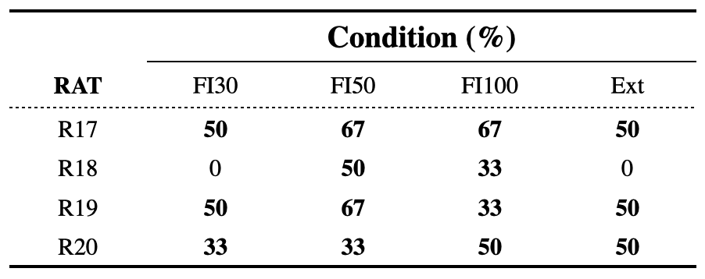
Note. Percentage of sessions in which resurgence was observed for each subject in each condition (FI 30 s, FI 50 s, FI 100 s, and extinction). Percentages are based on six sessions per condition. Resurgence was scored when target responses in the first 5 min of Component 3 exceeded target responses in the last 5 min of Component 2.

Conclusions
The present paper introduced Reinforcement Schedules, an open-source graphical interface for arranging component-based operant procedures with Arduino-compatible hardware. The current version provides a complete implementation pathway that includes the Visual Basic application, a reference Arduino sketch, saved configuration files, equipment testing, session execution, and raw event-level data output. Its central contribution is a visual control layer that allows users to build procedures that previously would have required direct code editing.
The application is not intended to replace commercial experimental control systems or to duplicate the hardware-focused contribution of earlier Arduino-based platforms. Rather, it provides a transparent and modifiable alternative for users who need to configure a wider range of procedures while preserving access to the underlying source code. The system is especially useful for teaching and for laboratories that require adaptable procedures but cannot depend on proprietary software.
The current implementation has limitations. It remains optimized for discrete-response operant preparations and for procedures that can be represented as components with scheduled inputs, outputs, delays, and termination criteria. More complex closed-loop adaptive procedures, progressive algorithms, or arrangements requiring continuous analog measurement would require additional development. The present version also depends on accurate hardware wiring and firmware-command compatibility; therefore, users should verify each chamber with the Test Equipment Form before collecting data.
In summary, Reinforcement Schedules extends prior low-cost Arduino-Visual Basic systems by making component-based schedule construction available through a graphical interface. By supporting simple, multiple, mixed, and concurrent arrangements across as many as six inputs, saving reusable configurations, and producing raw event files suitable for independent reconstruction, the program provides a practical open-source platform for operant research and instruction.

References
Ávila-Chauvet, L., & Pedroza Cabrera, F. J. (2013). REPRAP y Rhinoceros® en el diseño y construcción de equipo experimental. Revista Mexicana de Análisis de la Conducta, 39(3), 65-72.
Escobar, R. (2014). From relays to microcontrollers: The adoption of technology in operant research. Mexican Journal of Behavior Analysis, 40 (2), 127–153. https://doi.org/10.5514/rmac.v40.i2.63673.
Escobar, R., Gutiérrez, B., & Benavides, R. (2022). 3D-printed operant chambers for rats: Design, assembly, and innovations. Behavioural Processes, 199, 1-11. https://doi.org/10.1016/j.beproc.2022.104647
Escobar, R., & Pérez-Herrera, C. A. (2015). Low-cost USB interface for operant research using Arduino and Visual Basic. Journal of the Experimental Analysis of Behavior, 103(2), 427–435. https://doi.org/10.1002/jeab.135
Fleshler, M., & Hoffman, H. S. (1962). A progression for generating variable-interval schedules. Journal of the Experimental Analysis of Behavior, 5(4), 529–530. https://doi.org/10.1901/jeab.1962.5-529
Gómez-Fuentes, D. (2014). Los inicios: El conductismo en la Universidad Veracruzana. In R. Pérez Almonacid & D. Gómez-Fuentes (Eds.), Emilio Ribes Iñesta: Una historia de proyectos institucionales de identidad disciplinar e innovación educativa (pp. 21–109). Universidad Veracruzana.
Hantula D. A. (1991). A simple BASIC program to generate values for variable-interval schedules of reinforcement. Journal of Applied Behavior Analysis, 24(4), 799–801. https://doi.org/10.1901/jaba.1991.24-799
Lattal, K. A. (2008). JEAB at 50: Coevolution of research and technology. Journal of the Experimental Analysis of Behavior, 89(1), 129–135.
https://doi.org/10.1901/jeab.2008.89-129
Malott, M. E. (2004). Toward the globalization of behavior analysis. The Behavior Analyst, 27(1), 25-32. https://doi.org/10.1007/BF03392087
Ribes-Inesta, E. (1968). Psychology in Mexico. American Psychologist, 23(8), 565–566. https://doi.org/10.1037/h0026432
Todorov, J. C. (2006). Behavior analysis in Brazil. Avances en Psicología Latinoamericana, 24, 29-36.

