Multiple view geometry

Assignment #3

Due date: 2014. 06. 12

3D Reconstruction

20134736 Tran Duc Nhan

1. Introduction

In this assignment, we will implement program to reconstruct the 3D structure based on Stratified method. The method includes 4 steps: fundamental matrix estimation, projective reconstruction, affine reconstruction and metric reconstruction.

1. Procedure
2. Fundamental matrix estimation:

For the fundamental matrix estimation step, we used the 8-normalized points algorithm. The points are manually selected by hand from 2 images. In order to provide better result, we collect more than 8 points( around 30-35 points), and using the above algorithm. The summary of algorithm can be explained:



The matrix A represent for the equation we need to solve f, and using SVD for getting solution. For the constrains of rank(F)=2, we takes only 2 largest singular values of A, and then take the f solution. This part is programmed in eightpoint.m file.

1. Projective reconstruction:

Based on the projective ambiguity, we can recover the 2 camera matrices from the fundamental matrix. One of the pair matrices is : P=[I | 0] and P’ =[[e’]xF, e’] where e’ is epipole in the second image. In order to reconstruct the 3D points, we need to follow triangulation method.

From the 2 equation:



we have:



with:

Solving X with SVD method, we will get the 3D point of the pair 2D points (x,x’) in 2 images. This part is programmed in compute2Pmatrix_tran.m and triangulate.m files.

1. Affine reconstruction:

In order to have affine reconstruction, we need to find 4*4 H_affine matrix that map old 3D points to new 3D that has the affine characteristic. The affine matrix transformation can be calculated in the form of :



,where  is the plane at infinity in 3D dimension. We can measure  using 3 non-colinear vanishing points in the 2D image, triangulate into 3D, and calculate plane pass through these 3 points. Then affine reconstruction matrix can be measured. This part is programmed in affine_reconstructioin.m file.

1. Metric reconstruction:

For metric reconstruction, we need to measure IAC. Since IAC is symmetry matrix, which has 6 d.o.f and can be written as: , and with scale condition, 5 equations is enough to solve w. Five constrains to solve IAC can be taken from vanishing points and vanishing lines with orthogonal direction. In my case, what I used can be listed below:

* Find vanishing line l( from 2 vanishing points) and a vanishing point v that corresponds to a line perpendicular to the plane correspond to vanishing line l. Then we have equation:

, which imposed 2 constrains.

* Find 3 pairs of vanishing points that correspond to pair of orthogonal lines, each pair imposed 1 constrains from equation: , then total we have 3 constrains.

Solving w from A.h_w=0 where A is 5*6 matrix, and h_w=[a,b,c,d,e,f]T using SVD. Then we can solve metric reconstruction matrix as: calculate A from:

, where M is 3*3 matrix and can be chose from one of 2 camera matrix P or P’, and using Cholesky factorization to find H:  .

This part is programmed in metric.m file.

Other support file includes:

-skew: caltulate skew matrix from a vector 3*1.

-vanishing_point: calculate vanishing point from 2 lines

-plotedge: plot edge between 3 points in 3D.

- displayEpipolarF: adopted toolbox for displaying epipolar line in order to check our fundamental matrix calculation is correct.

1. Result:
2. Fundamental matrix estimation:

We used these matching points for our fundamental matrix estimation. The points was manually selected by hand:

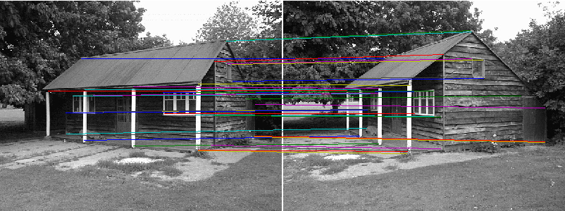

Then running fundamental matrix estimation, we have:

F =

0.0000 0.0000 -0.0004

0.0000 -0.0000 -0.0051

-0.0004 0.0048 0.1304

Using displayEpipolarF we can check our estimation is correct or not:

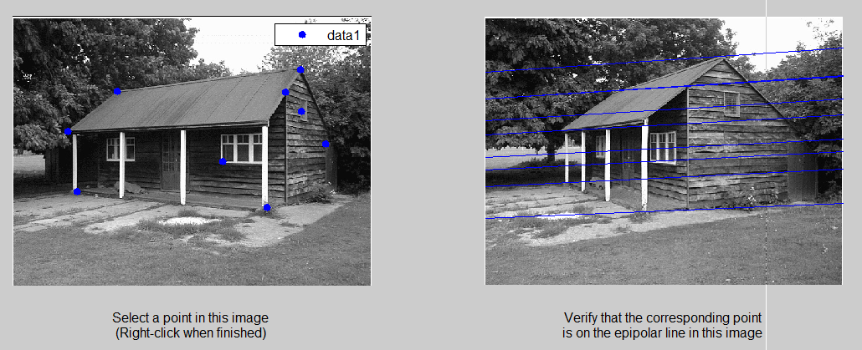

As we can see, the points on the left that correspond to epipolar lines on the right also pass through the matching point, which mean our fundamental matrix estimation is reasonable. Also we can see that the epipole on the right image is out-side of image.

1. Projective reconstruction:

Using above method, we can get the result of 3D projective reconstruction. We draw 3D points using plotedge function to visualize our result in 3D:

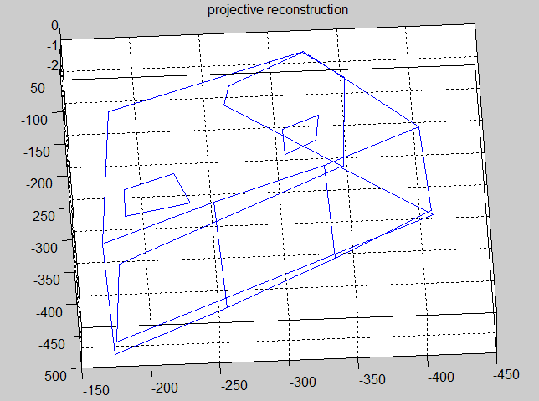

We can see that the house has shape of 3D and maintain projective, but cannot have affine information (such as 2 windows that have edge are not parallel). Therefore, affine and metric reconstruction is needed.

1. Affine reconstruction:

For affine reconstruction, we used the following 3 pairs of vanishing points:

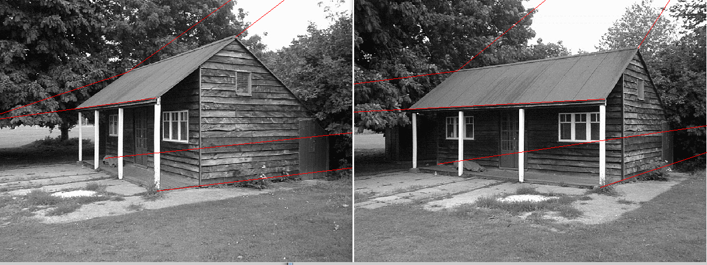

Then using the above method, we can recover the affine transform matrix. Then the result of affine reconstruction can be seen as:

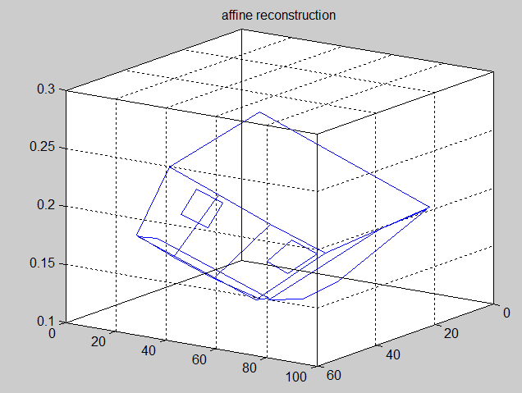

Now we can see that the affine information is recovered.

1. Metric reconstruction:

The plane and line and pairs of lines mentioned in above algorithm can be chosen as follow

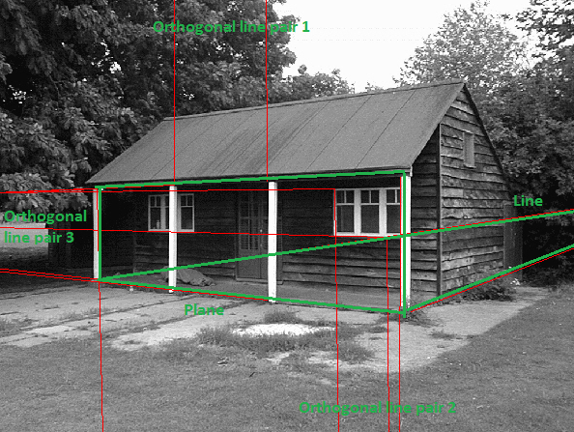

Then the result of metric reconstruction can be showed as:

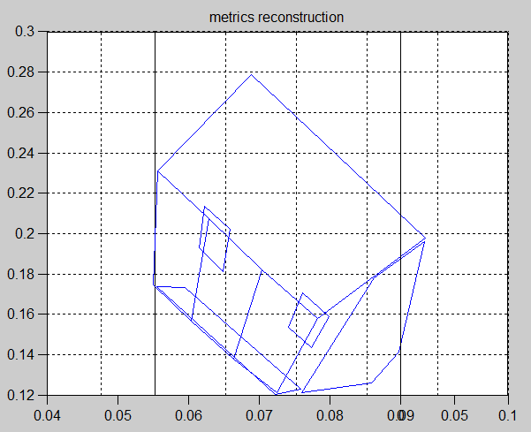 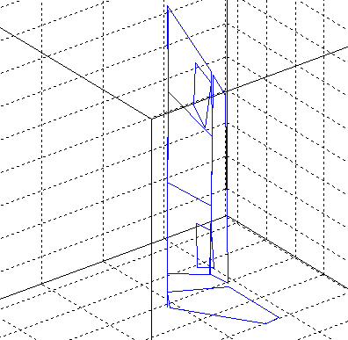

Now we can see that the metric information is reconstructed. We can also try another input of line pair and plane-line relation. However, this is not 100% percent perfect result due to error and approximation.

1. Conclusion:

In this assignment, we implement 4 steps of Stratified reconstruction. Of course we can improve performance by using sophisticated method mention in lecture. That could be used for our future purpose.