% 首先需要在故录查看的软件里把1sec长度的数据导成csv

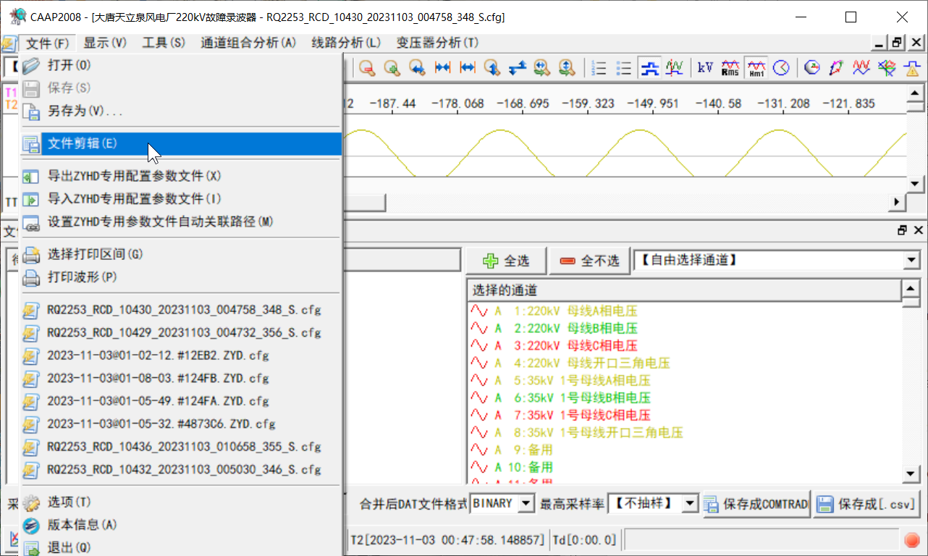

%% verion 2.1 revised by Yamin

% This version, read csv as input, you have to specify the column of Uabc

% and Iabc

close all;clc

%% User define zone

%MatUrl就是导出的csv的路径

MatUrl = 'D:\Travail\RE\HIL\[Routine] MMC-HVDC\20230411_ZhongDu\02-Data\Recorder\jishancun\2023-04-11@09-48-36.369500.csv';

% Define which column you select as Uabc and Iabc

% 这里定义电压、电流所在的列数，软件里左侧这个序号就是，比如这个就填USabcIdx = 1:3，电流也是一样

USabcIdx = 3:5;

ISabcIdx = 28:30;

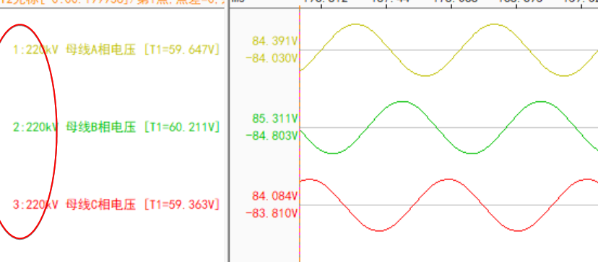

% which freq do you want to focus on

% 这里填需要计算哪些频率，可以多写几个，长度可变

WHICH_FREQ = [43, 50, 57];

% Sampling frequency, must consist with CSV

% SAMPLE_FREQ，填故录数据的采样频率，这里要看你选的故录哪一段，故录采样率是会变的，不要让这1sec的csv数据包含不同的采样率

SAMPLE_FREQ = 2e3;

T_SPAN = 1; % signal real time span for selected window

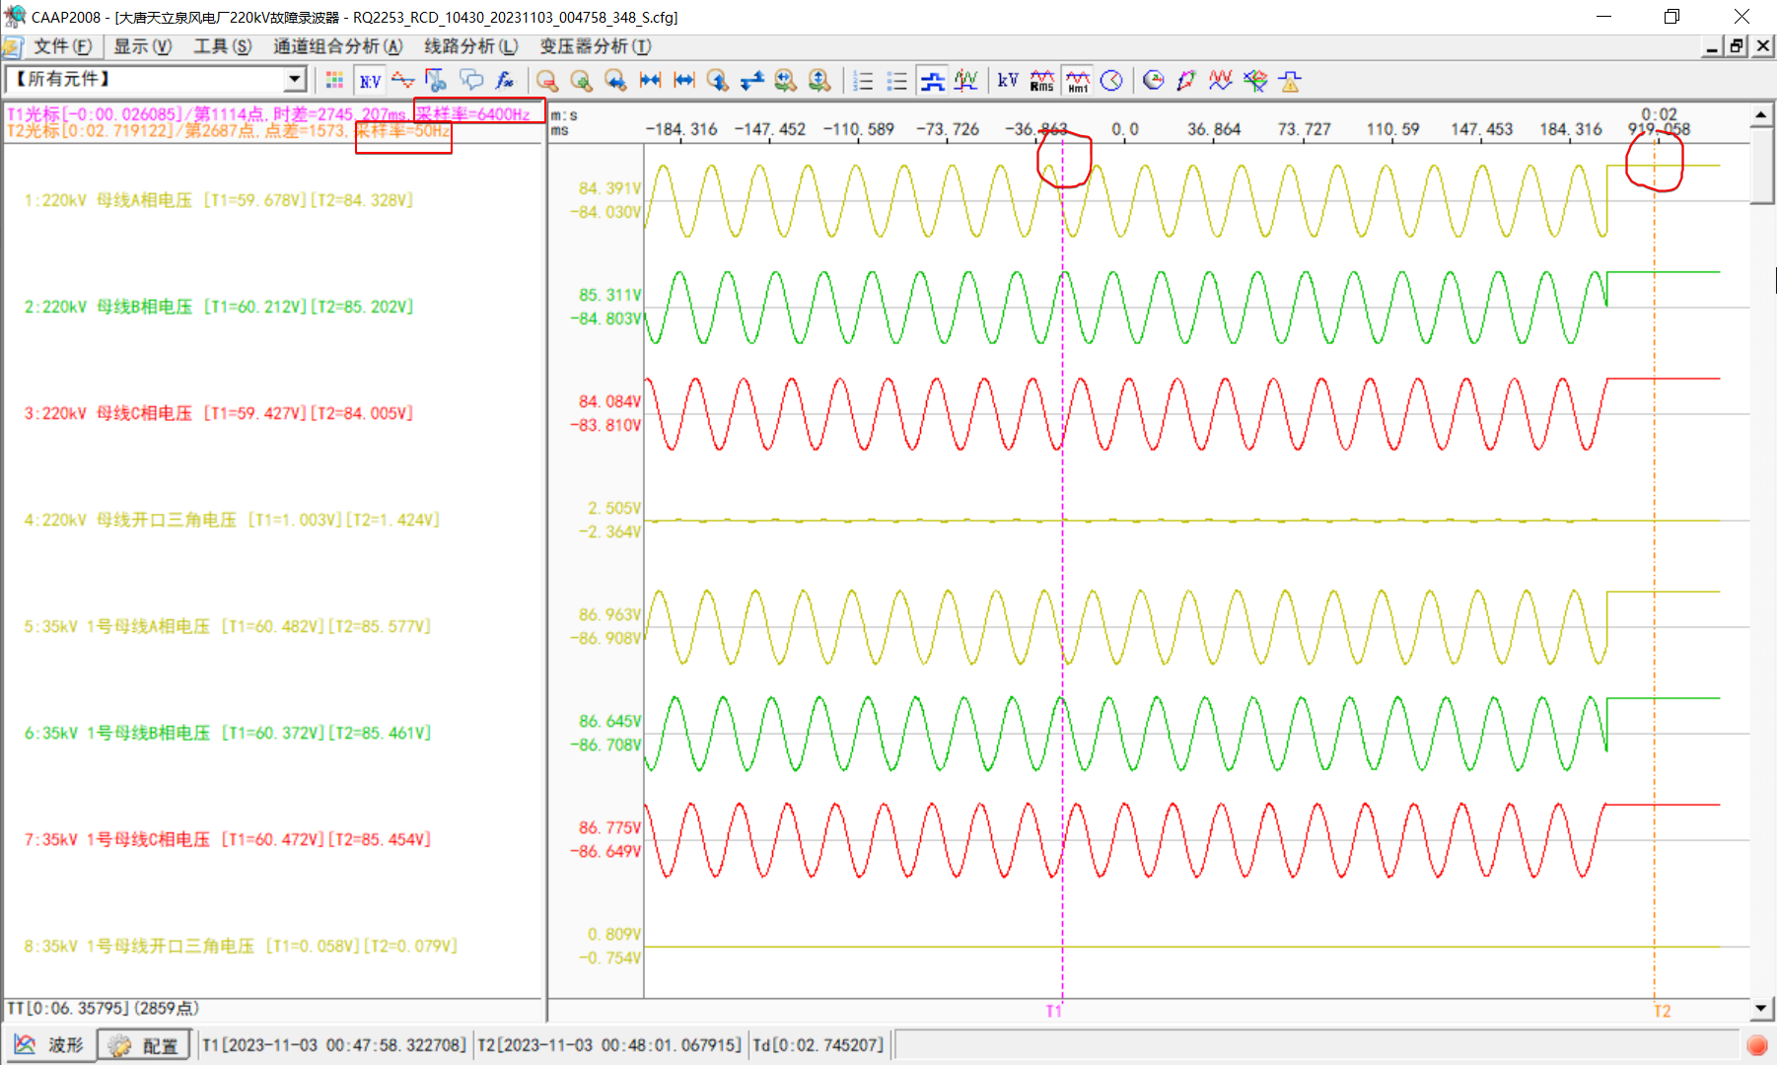

RawData = table2array(readtable(MatUrl));

USabc = RawData(:, USabcIdx);

ISabc = RawData(:, ISabcIdx);

%% Don't touch the following code unless you know what are you doing

f_MagAngle2Imag = @(arg_mag, arg_angle) arg_mag .* exp(1i .* arg_angle);

% 1: Voltage only, 2: Current only, 3: Impedance computing

% 工作模式：1：只计算电压FFT；2：只计算电流FFT；3：计算阻抗和功率

WORKING_MODE = 3;

% 剩下的就没什么了，运行完之后会出图，具体数据看在这两个变量里。具体Mag是幅值，Arg是相角，依此类推

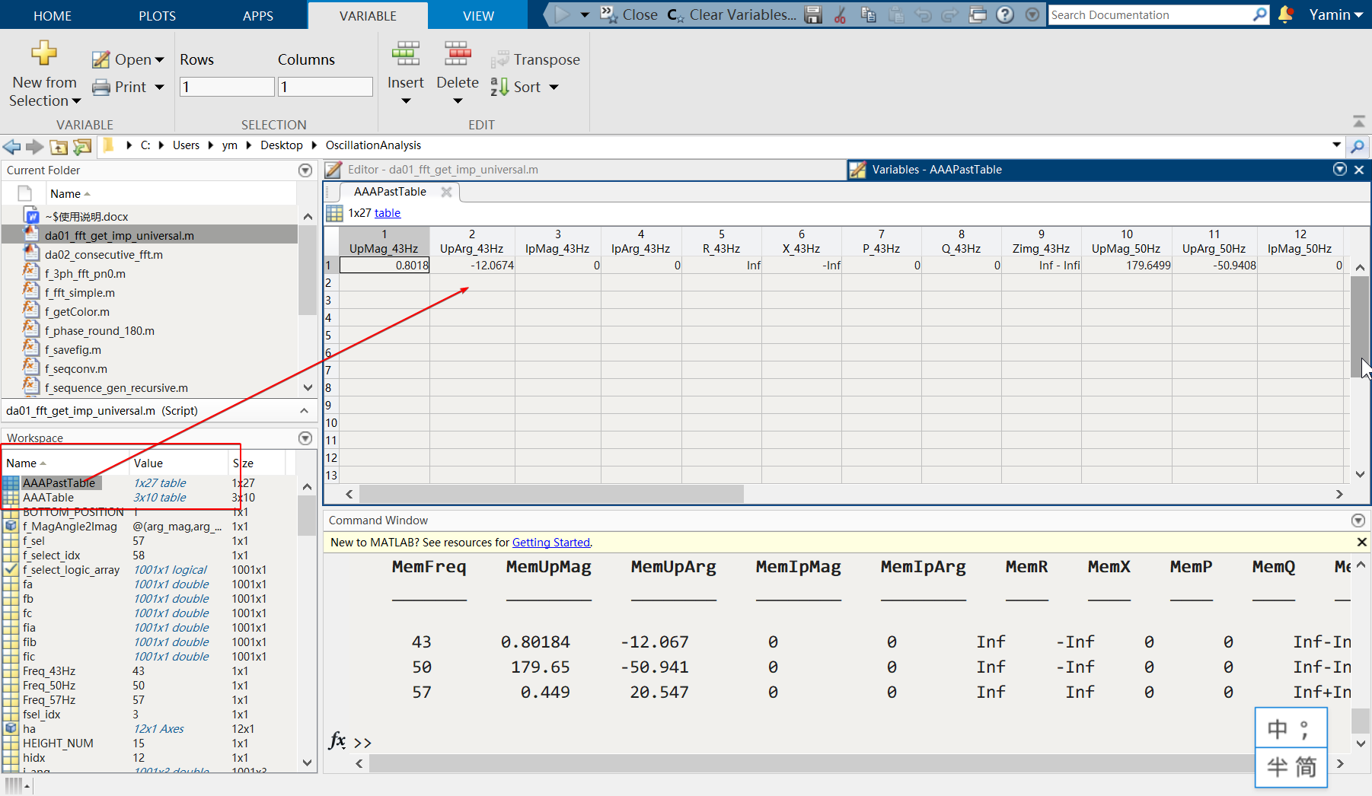

%% Your data input here

uabc_iabc = [USabc, ISabc];

RAW_DATA = uabc_iabc;

SAMPLE_TIME = 1/SAMPLE_FREQ;

[RAW_DATA_RNum, RAW_DATA_CNum] = size(RAW_DATA);

assert(RAW_DATA_CNum == 6, 'Please make sure that your signal is n-by-6 matrix')

%% generate fake time array

t_array = 0:SAMPLE_TIME:(RAW_DATA_RNum-1)*SAMPLE_TIME;

t_array = t_array';

uabc = RAW_DATA(:, 1:3);

iabc = RAW_DATA(:, 4:6);

L = T_SPAN * SAMPLE_FREQ; % lenght of signal

N = L; % number of signal

scan = [t_array, uabc, iabc];

Uas = uabc(:, 1);

Ubs = uabc(:, 2);

Ucs = uabc(:, 3);

Ias = iabc(:, 1);

Ibs = iabc(:, 2);

Ics = iabc(:, 3);

[fa, umag_a, uang_a] = f_fft_simple(Uas, SAMPLE_FREQ, N);

[fb, umag_b, uang_b] = f_fft_simple(Ubs, SAMPLE_FREQ, N);

[fc, umag_c, uang_c] = f_fft_simple(Ucs, SAMPLE_FREQ, N);

[fia, imag_a, iang_a] = f_fft_simple(Ias, SAMPLE_FREQ, N);

[fib, imag_b, iang_b] = f_fft_simple(Ibs, SAMPLE_FREQ, N);

[fic, imag_c, iang_c] = f_fft_simple(Ics, SAMPLE_FREQ, N);

u_mag = [umag_a, umag_b, umag_c];

% u_ang = [uang_a, uang_b, uang_c];

u_ang = [uang_a, uang_b, uang_c] + pi/2;

i_mag = [imag_a, imag_b, imag_c];

% i_ang = [iang_a, iang_b, iang_c];

i_ang = [iang_a, iang_b, iang_c] + pi/2;

%% convert fft result from mag/angle to complex

u_complex_array = f_MagAngle2Imag(u_mag, u_ang);

i_complex_array = f_MagAngle2Imag(i_mag, i_ang);

%% convert fft result from ABC complex form to positive-negative-zero form

u_pn0_array = f_seqconv(u_complex_array');

u_pn0_array = u_pn0_array';

i_pn0_array = f_seqconv(i_complex_array');

i_pn0_array = i_pn0_array';

z_pn0_array = u_pn0_array ./ i_pn0_array;

u_pn0_mag = abs(u_pn0_array);

u_pn0_ang = angle(u_pn0_array);

i_pn0_mag = abs(i_pn0_array);

i_pn0_ang = angle(i_pn0_array);

z_pn0_mag = abs(z_pn0_array);

z_pn0_ang = angle(z_pn0_array);

MemFreq = [];

MemUpMag = [];

MemUpArg = [];

MemIpMag = [];

MemIpArg = [];

MemR = [];

MemX = [];

MemP = [];

MemQ = [];

MemZimg = [];

AAAPastTable = table();

for fsel_idx = 1:length(WHICH_FREQ)

%% Select specific freq value

f_sel = WHICH_FREQ(fsel_idx);

fprintf('FFT抽取%6.2f (Hz)频率，原始数据采样频率%i (Hz), 时间长度为%6.2f (sec)\n', ...

f_sel, SAMPLE_FREQ, T_SPAN)

f_select_logic_array = fa == f_sel;

f_select_idx = find(f_select_logic_array);

u_mag_sel = u_mag(f_select_idx, :);

u_ang_sel = u_ang(f_select_idx, :);

i_mag_sel = i_mag(f_select_idx, :);

i_ang_sel = i_ang(f_select_idx, :);

z_pn0_sel = z_pn0_array(f_select_idx, :);

u_pn0_mag_sel = u_pn0_mag(f_select_idx, :);

u_pn0_ang_sel = u_pn0_ang(f_select_idx, :);

i_pn0_mag_sel = i_pn0_mag(f_select_idx, :);

i_pn0_ang_sel = i_pn0_ang(f_select_idx, :);

z_pn0_mag_sel = abs(z_pn0_sel);

z_pn0_ang_sel = angle(z_pn0_sel);

Pp = 1.5*u_pn0_mag_sel(1)*i_pn0_mag_sel(1)*cos(u_pn0_ang_sel(1) - i_pn0_ang_sel(1));

Qp = 1.5*u_pn0_mag_sel(1)*i_pn0_mag_sel(1)*sin(u_pn0_ang_sel(1) - i_pn0_ang_sel(1));

%% Data store zone

MemFreq = [MemFreq; f_sel];

MemUpMag = [MemUpMag; u_pn0_mag_sel(1)];

MemUpArg = [MemUpArg; u_pn0_ang_sel(1)*180/pi];

MemIpMag = [MemIpMag; i_pn0_mag_sel(1)];

MemIpArg = [MemIpArg; i_pn0_ang_sel(1)*180/pi];

MemR = [MemR; real(z_pn0_sel(1))];

MemX = [MemX; imag(z_pn0_sel(1))];

MemP = [MemP; Pp];

MemQ = [MemQ; Qp];

MemZimg = [MemZimg; z_pn0_sel(1)];

%%

eval(strcat('Freq_', num2str(f_sel), 'Hz = f_sel'))

eval(strcat('UpMag_', num2str(f_sel), 'Hz = u_pn0_mag_sel(1);'))

eval(strcat('UpArg_', num2str(f_sel), 'Hz = u_pn0_ang_sel(1)*180/pi;'))

eval(strcat('IpMag_', num2str(f_sel), 'Hz = i_pn0_mag_sel(1);'))

eval(strcat('IpArg_', num2str(f_sel), 'Hz = i_pn0_ang_sel(1)*180/pi;'))

eval(strcat('R_', num2str(f_sel), 'Hz = real(z_pn0_sel(1));'))

eval(strcat('X_', num2str(f_sel), 'Hz = imag(z_pn0_sel(1));'))

eval(strcat('P_', num2str(f_sel), 'Hz = Pp;'))

eval(strcat('Q_', num2str(f_sel), 'Hz = Qp;'))

eval(strcat('Zimg_', num2str(f_sel), 'Hz = z_pn0_sel(1);'))

% eval(strcat("AAAPastTable = addvars(AAAPastTable, ", 'Freq_', num2str(f_sel), 'Hz);') )

eval(strcat("AAAPastTable = addvars(AAAPastTable, ", 'UpMag_', num2str(f_sel), 'Hz);') )

eval(strcat("AAAPastTable = addvars(AAAPastTable, ", 'UpArg_', num2str(f_sel), 'Hz);') )

eval(strcat("AAAPastTable = addvars(AAAPastTable, ", 'IpMag_', num2str(f_sel), 'Hz);') )

eval(strcat("AAAPastTable = addvars(AAAPastTable, ", 'IpArg_', num2str(f_sel), 'Hz);') )

eval(strcat("AAAPastTable = addvars(AAAPastTable, ", 'R_', num2str(f_sel), 'Hz);') )

eval(strcat("AAAPastTable = addvars(AAAPastTable, ", 'X_', num2str(f_sel), 'Hz);') )

eval(strcat("AAAPastTable = addvars(AAAPastTable, ", 'P_', num2str(f_sel), 'Hz);') )

eval(strcat("AAAPastTable = addvars(AAAPastTable, ", 'Q_', num2str(f_sel), 'Hz);') )

eval(strcat("AAAPastTable = addvars(AAAPastTable, ", 'Zimg_', num2str(f_sel), 'Hz);') )

%% Print out zone

disp("----- Sequence Result: Positive Negative Zero ------")

fprintf("Up mag, angle(degree): %f, %f\n", u_pn0_mag_sel(1), u_pn0_ang_sel(1)*180/pi)

fprintf("Ip mag, angle(degree): %f, %f\n", i_pn0_mag_sel(1), i_pn0_ang_sel(1)*180/pi)

fprintf("P = %f, Q = %f\n", Pp, Qp)

fprintf("Zp complex: %s\n", num2str(z_pn0_sel(1)))

end

AAATable = table(MemFreq, MemUpMag, MemUpArg, MemIpMag, MemIpArg, ...

MemR, MemX, MemP, MemQ, MemZimg)

% disp("-------")

% fprintf("Zp mag, angle(degree): %f, %f\n", z_pn0_mag_sel(1), z_pn0_ang_sel(1)*180/pi)

% fprintf("Un mag, angle(degree): %f, %f\n", u_pn0_mag_sel(2), u_pn0_ang_sel(2)*180/pi)

% fprintf("In mag, angle(degree): %f, %f\n", i_pn0_mag_sel(2), i_pn0_ang_sel(2)*180/pi)

% fprintf("Zn mag, angle(degree): %f, %f\n", z_pn0_sel(2), z_pn0_sel(2)*180/pi)

% fprintf("Zn complex: %s\n", num2str(z_pn0_sel(2)))

%

% fprintf("U0 mag, angle(degree): %f, %f\n", u_pn0_mag_sel(3), u_pn0_ang_sel(3)*180/pi)

% fprintf("I0 mag, angle(degree): %f, %f\n", i_pn0_mag_sel(3), i_pn0_ang_sel(3)*180/pi)

% fprintf("Z0 mag, angle(degree): %f, %f\n", z_pn0_sel(3), z_pn0_sel(2)*180/pi)

% fprintf("Z0 complex: %s\n", num2str(z_pn0_sel(3)))

% convert ABC to positive-negative-zero sequence

%% Figure plot zone

LEFT_POSITION = 5;

BOTTOM_POSITION = 1;

WIDTH_NUM = 12;

HEIGHT_NUM = 15;

POSITION_SET = [LEFT_POSITION, BOTTOM_POSITION, WIDTH_NUM, HEIGHT_NUM];

% Plot Voltage

figure;

subplot(3, 1, 1)

plot(fa, umag_a, 'LineWidth', 1.5)

xlabel('频率 (Hz)')

ylabel('U (kV)')

title('Ua')

grid on

set(gca, 'XLim', [0, 100])

subplot(3, 1, 2)

plot(fb, umag_b, 'LineWidth', 1.5)

xlabel('频率 (Hz)')

ylabel('U (kV)')

title('Ub')

grid on

set(gca, 'XLim', [0, 100])

subplot(3, 1, 3)

plot(fc, umag_c, 'LineWidth', 1.5)

xlabel('频率 (Hz)')

ylabel('U (kV)')

title('Uc')

grid on

set(gca, 'XLim', [0, 100])

set(gcf,'unit','centimeters','position', POSITION_SET)

% Plot Current

figure

subplot(3, 1, 1)

plot(fia, imag_a, 'LineWidth', 1.5)

xlabel('频率 (Hz)')

ylabel('I (kA)')

title('Ia')

grid on

set(gca, 'XLim', [0, 100])

subplot(3, 1, 2)

plot(fib, imag_b, 'LineWidth', 1.5)

xlabel('频率 (Hz)')

ylabel('I (kA)')

title('Ib')

grid on

set(gca, 'XLim', [0, 100])

subplot(3, 1, 3)

plot(fic, imag_c, 'LineWidth', 1.5)

xlabel('频率 (Hz)')

ylabel('I (kA)')

title('Ic')

grid on

set(gca, 'XLim', [0, 100])

set(gcf,'unit','centimeters','position', POSITION_SET)

% figure;

%

% subplot(2, 6, 1)

% plot(fa, u_pn0_mag(:, 1))

% title('U Pos mag')

% subplot(2, 6, 2)

% plot(fa, u_pn0_ang(:, 1)*180/pi)

% title('U Pos phase')

%

% subplot(2, 6, 3)

% plot(fa, u_pn0_mag(:, 2))

% title('U Neg mag')

% subplot(2, 6, 4)

% plot(fa, u_pn0_ang(:, 2)*180/pi)

% title('U Neg phase')

%

% subplot(2, 6, 5)

% plot(fa, i_pn0_mag(:, 1))

% title('I Pos mag')

% subplot(2, 6, 6)

% plot(fa, i_pn0_ang(:, 1)*180/pi)

% title('I Pos phase')

%

% subplot(2, 6, 7)

% plot(fa, i_pn0_mag(:, 2))

% title('I Neg mag')

% subplot(2, 6, 8)

% plot(fa, i_pn0_ang(:, 2)*180/pi)

% title('I Neg phase')

%

% subplot(2, 6, 9)

% plot(fa, i_pn0_mag(:, 1))

% title('Z Pos mag')

% subplot(2, 6, 10)

% plot(fa, i_pn0_ang(:, 1)*180/pi)

% title('Z Pos phase')

%

% subplot(2, 6, 11)

% plot(fa, i_pn0_mag(:, 2))

% title('Z Neg mag')

% subplot(2, 6, 12)

% plot(fa, i_pn0_ang(:, 2)*180/pi)

% title('Z Neg phase')

% set(gcf, "Position", [20, 20, 18, 6])

XLIM = [0, 100];

SUBPLOT_FONT_SIZE = 10;

figure

[ha, pos] = tight_subplot(4, 3, [0.06, 0.04], [0.03, 0.03], [0.04, 0.01]);

set(gcf,'unit','centimeters','position',[0.5, 1, 45, 20])

axes(ha(1))

title('test')

for hidx = 1:12

axes(ha(hidx))

switch hidx

%% positive

case 1

plot(fa, u_pn0_mag(:, 1))

grid on

title('U Pos Mag')

set(gca,'XLim', XLIM, 'fontname', 'times new roman', 'fontsize', SUBPLOT_FONT_SIZE)

case 4

plot(fa, u_pn0_ang(:, 1)*180/pi)

grid on

title('U Pos Phase')

set(gca,'XLim', XLIM, 'fontname', 'times new roman', 'fontsize', SUBPLOT_FONT_SIZE)

case 7

plot(fa, i_pn0_mag(:, 1))

grid on

title('I Pos Mag')

set(gca,'XLim', XLIM, 'fontname', 'times new roman', 'fontsize', SUBPLOT_FONT_SIZE)

case 10

plot(fa, i_pn0_ang(:, 1)*180/pi)

grid on

title('I Pos Phase')

set(gca,'XLim', XLIM, 'fontname', 'times new roman', 'fontsize', SUBPLOT_FONT_SIZE)

%% negative

case 2

plot(fa, u_pn0_mag(:, 2))

grid on

title('U Neg Mag')

set(gca,'XLim', XLIM, 'fontname', 'times new roman', 'fontsize', SUBPLOT_FONT_SIZE)

case 5

plot(fa, u_pn0_ang(:, 2)*180/pi)

grid on

title('U Neg Phase')

set(gca,'XLim', XLIM, 'fontname', 'times new roman', 'fontsize', SUBPLOT_FONT_SIZE)

case 8

plot(fa, i_pn0_mag(:, 2))

grid on

title('I Neg Mag')

set(gca,'XLim', XLIM, 'fontname', 'times new roman', 'fontsize', SUBPLOT_FONT_SIZE)

case 11

plot(fa, i_pn0_ang(:, 2)*180/pi)

grid on

title('I Neg Phase')

set(gca,'XLim', XLIM, 'fontname', 'times new roman', 'fontsize', SUBPLOT_FONT_SIZE)

case 3

plot(fa, z_pn0_mag(:, 1))

grid on

title('Z Pos Mag')

set(gca,'XLim', XLIM, 'fontname', 'times new roman', 'fontsize', SUBPLOT_FONT_SIZE)

case 6

plot(fa, z_pn0_ang(:, 1)*180/pi)

grid on

title('Z Pos Phase')

set(gca,'XLim', XLIM, 'fontname', 'times new roman', 'fontsize', SUBPLOT_FONT_SIZE)

case 9

plot(fa, z_pn0_mag(:, 2))

grid on

title('Z Neg Mag')

set(gca,'XLim', XLIM, 'fontname', 'times new roman', 'fontsize', SUBPLOT_FONT_SIZE)

case 12

plot(fa, z_pn0_ang(:, 2)*180/pi)

grid on

title('Z Neg Phase')

set(gca,'XLim', XLIM, 'fontname', 'times new roman', 'fontsize', SUBPLOT_FONT_SIZE)

otherwise

disp('wrong')

end

end