Table of Contents

TASK 3: Website Testing 2

1) W3C Validator 2

a) Home Page: 2

b) Rising Desk Page: 3

c) Health Benefits Page: 4

d) Contact Us Page 5

# TASK 3: Website Testing

## W3C Validator

### Home Page:

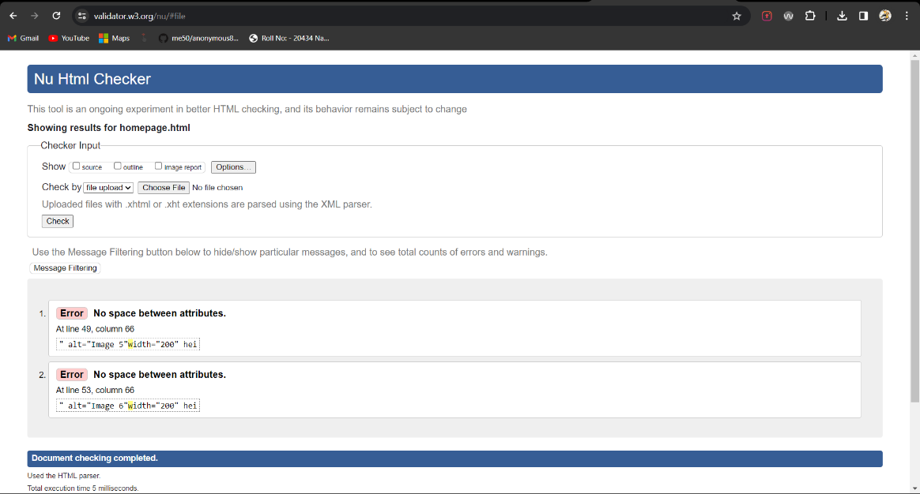

Fig 3.1: Home Page Validation

In my homepage.html I got the error that there was no spacing between the attributes on line 49 and line 53.

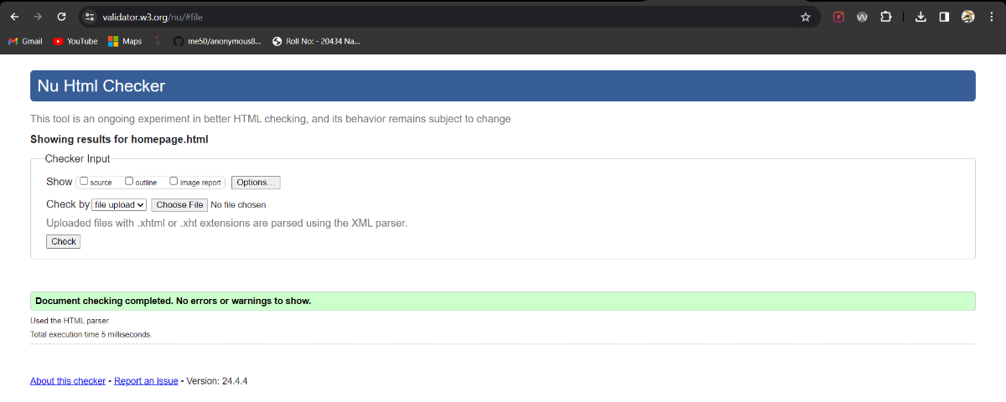

Fig 3.2: Home Page Validation

I solved the error by putting space between the attributes on line 49 and line 53.

### Rising Desk Page:

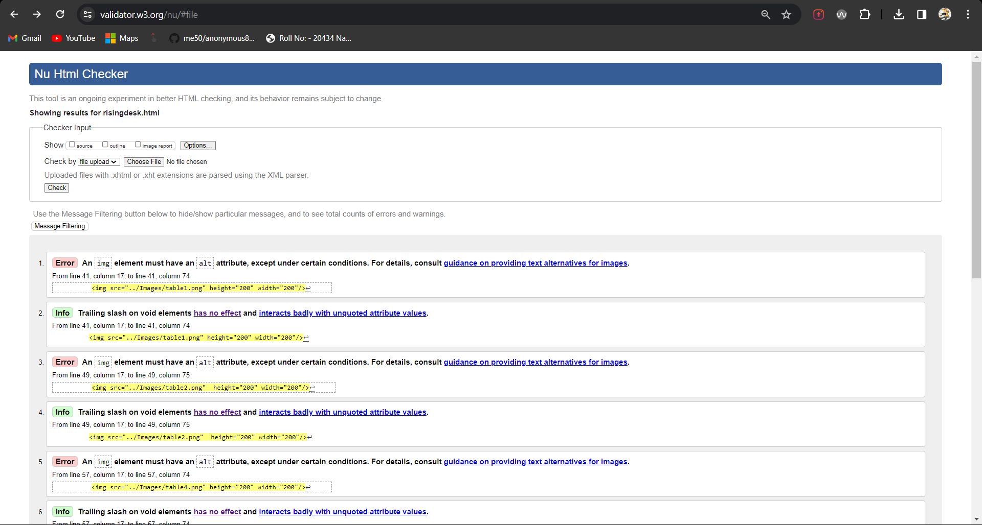

In my risingdesk.html I was getting the error that I didn’t use ‘alt’ attribute in the <img> tags, and I was using a slash on void elements.

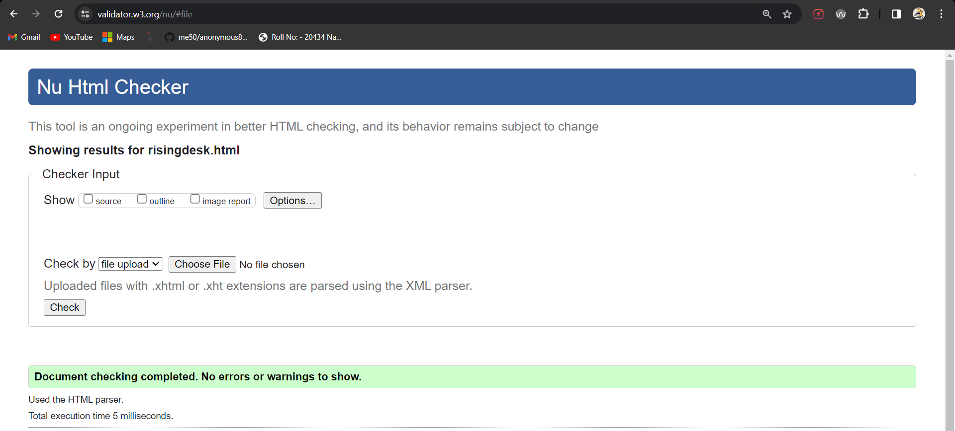

I solved the error by added ‘alt’ attribute to the <img> tags and removing the slash from void elements.

### Health Benefits Page:

In my health-benefits.html I was getting the error that the ‘frameborder’ attribute on the <iframe> element is obsolete.

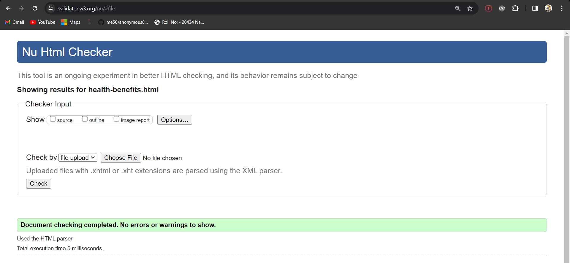

I solved the error by removing the ‘frameborder’ tag from the <iframe> element.

### Contact Us Page

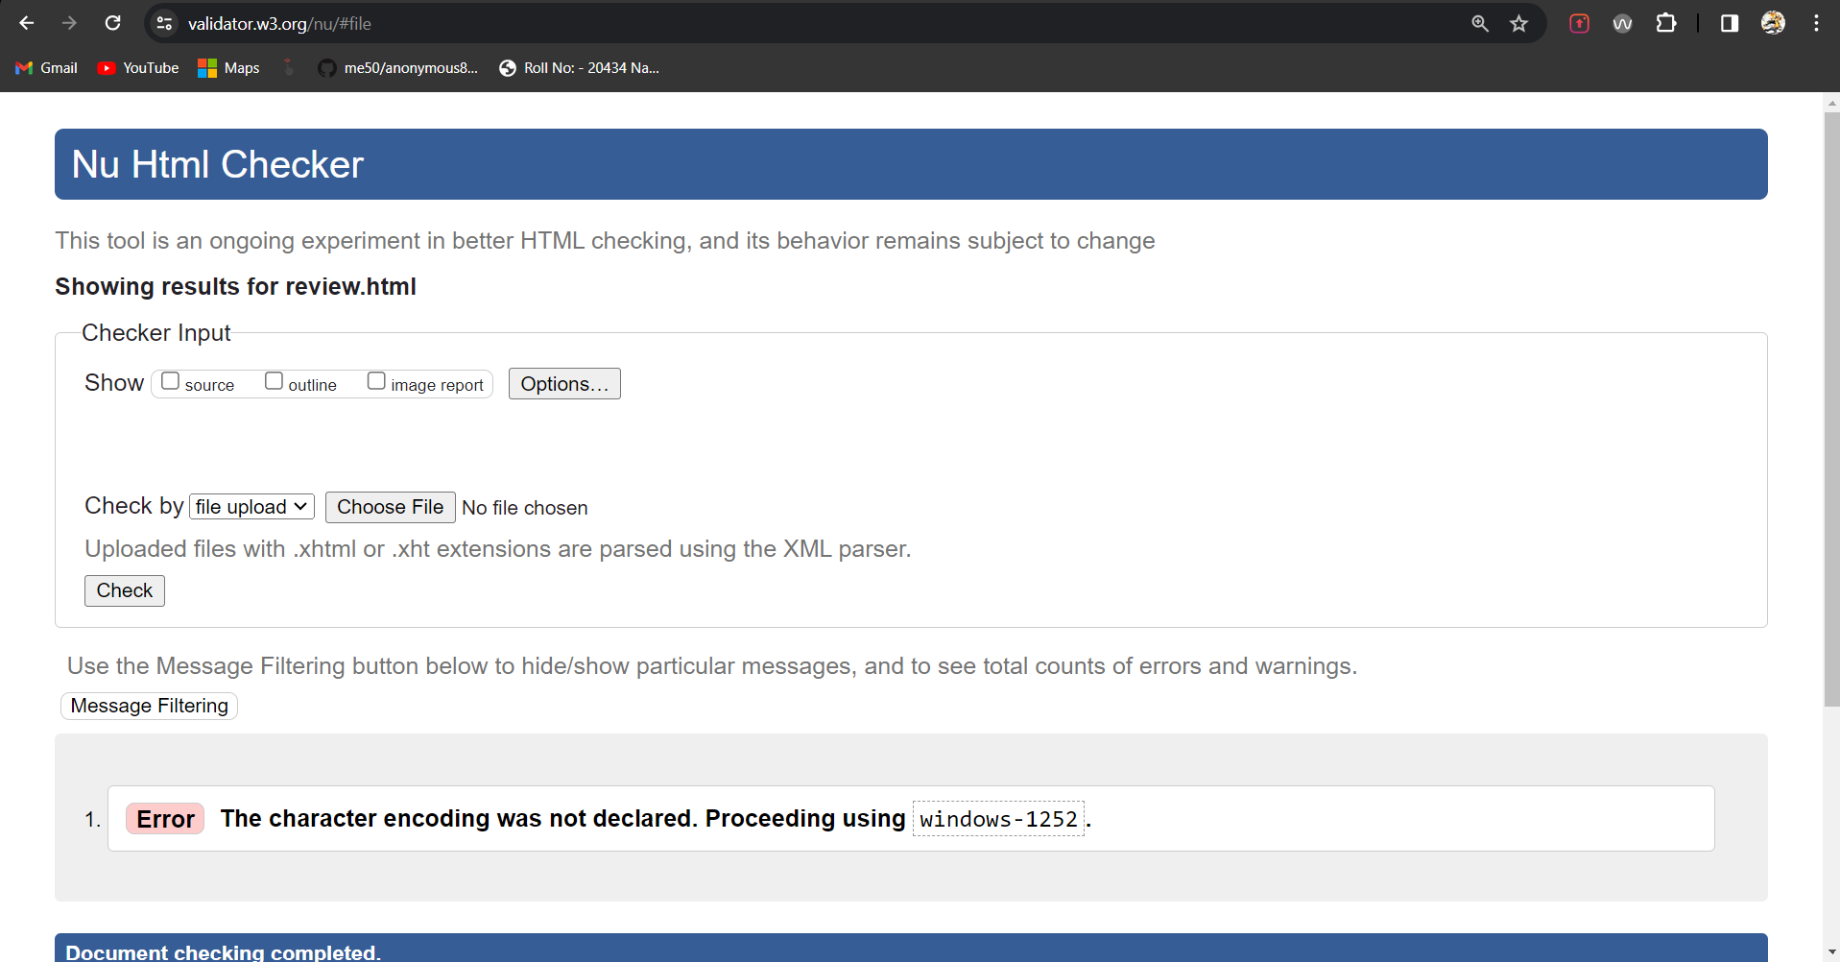

In my review.html page I was getting the error that I haven’t declared the character encoding.

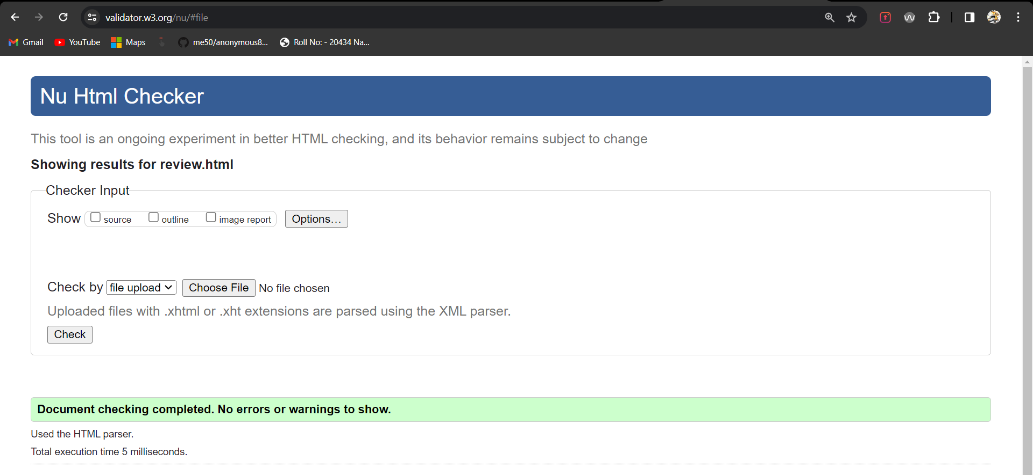

I solved this problem by declaring the character set as ‘UTF-8’.

### Basket Page

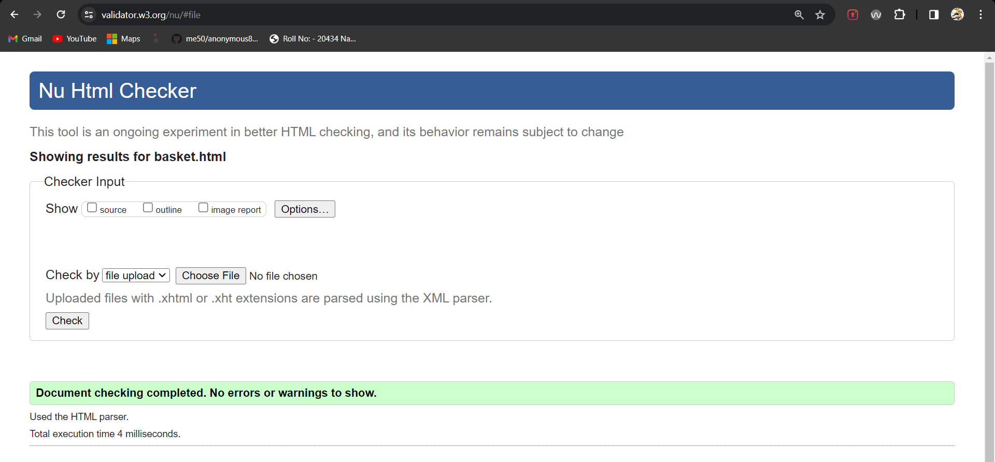

I did not get any error on my basket.html page.