Statistics of drug-related deaths in 2020 and earlier years, broken down by age, sex, substances implicated in the death, underlying cause of death and NHS Board and Council areas.



Drug

-

related deaths in Scotland

in 20

20

Published

on

30

July

20

2

1

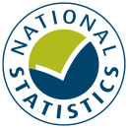

## Main Points

* {{Q1}}
* {{Q2}}
* {{Q3}}
* {{Q4}}
* {{Q5}}
* {{Q6}}