Gates — spells 144–146
Registry entries (godot/assets/gates/registry.json) beside each spell’s vignette. Entries with identical text are merged under their names.
Registry names and descriptions | Vignette (with horizontal bottom text for 144 and 146)
Spell 144
Room 1  First room / First room keeper  A god kneels inside the first room, holding two knives, under a roof of blades and two cobras. He is the keeper of its door, "overthrowing the multitude of the forms."  Man-headed god  A man-headed god stands before the first room. The room has two attendants, its watcher, "Smet", and its herald, "Sahatu-Kheru, the utterer of imprecations"; which of them he is, is not known.  Hawk-headed god  A hawk-headed god stands before the first room. The room has two attendants, its watcher, "Smet", and its herald, "Sahatu-Kheru, the utterer of imprecations"; which of them he is, is not known. | 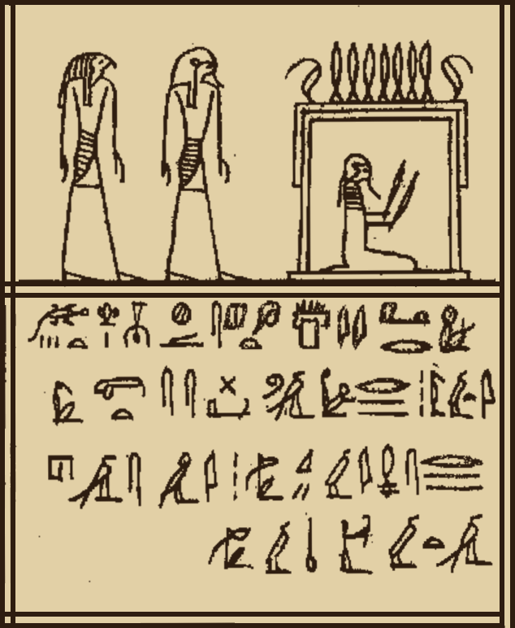
Room 2  Second room / Second room keeper  A crocodile-headed god kneels inside the second room, holding two knives, under a roof of blades and two cobras. He is the keeper of its door, "Toun-ha."  Ram-headed god  A ram-headed god stands before the second room. The room has two attendants, its watcher, "Skati", and its herald, "Ashu"; which of them he is, is not known.  Bull-headed god  A bull-headed god stands before the second room. The room has two attendants, its watcher, "Skati", and its herald, "Ashu"; which of them he is, is not known. | 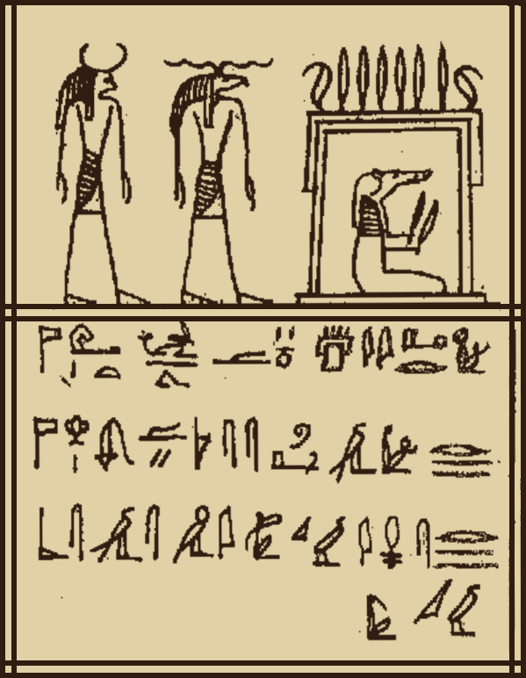
Room 3  Third room / Third room keeper  A god with a scarab for a head kneels inside the third room, holding two knives, under a roof of blades and two cobras. He is the keeper of its door, "eating the excrement of the one who reaches it."  Ram-headed god  A ram-headed god stands before the third room. The room has two attendants, its watcher, "the one with a Vigilant Face", and its herald, "Usaaau"; which of them he is, is not known.  Man-headed god  A man-headed god stands before the third room. The room has two attendants, its watcher, "the one with a Vigilant Face", and its herald, "Usaaau"; which of them he is, is not known. | 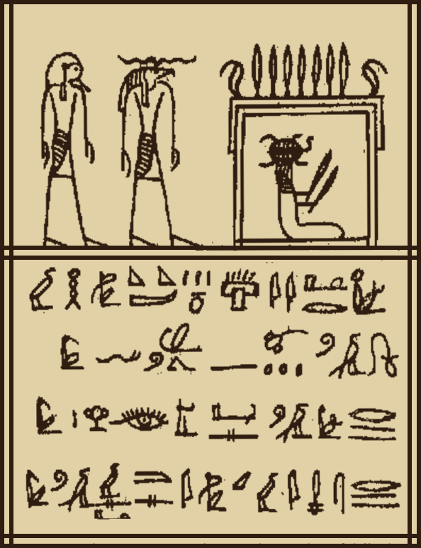
Room 4  Fourth room / Fourth room keeper  A dog-headed god kneels inside the fourth room, holding two knives, under a roof of blades and two cobras. He is the keeper of its door, "repelling the multitudes of words."  Ram-headed god  A ram-headed god stands before the fourth room. The room has two attendants, its watcher, "the one with a Vigilant Heart", and its herald, "Aa-her-Khesef-ati, great to repel the crocodile"; which of them he is, is not known.  Man-headed god  A man-headed god stands before the fourth room. The room has two attendants, its watcher, "the one with a Vigilant Heart", and its herald, "Aa-her-Khesef-ati, great to repel the crocodile"; which of them he is, is not known. | 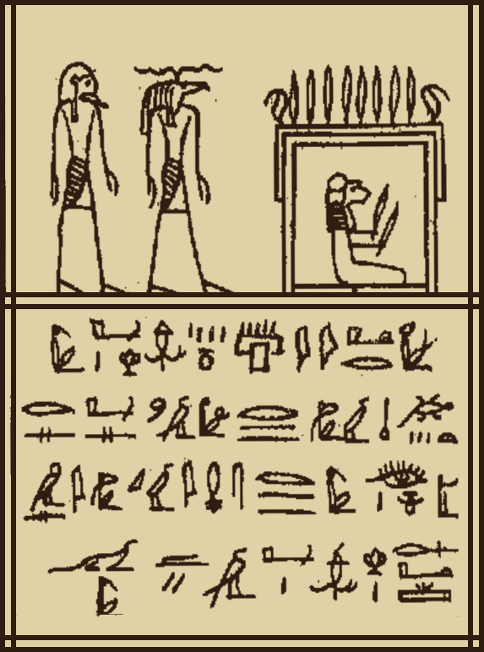
Room 5  Fifth room / Fifth room keeper  A god with a round, front-facing head kneels inside the fifth room, holding two knives, under a roof of blades and two cobras. He is the keeper of its door, "living upon reptiles."  Ram-headed god  A ram-headed god stands before the fifth room. The room has two attendants, its watcher, "Usheb", and its herald, "Nebet-hi-Kehabu-at"; which of them he is, is not known.  Bull-headed god  A bull-headed god stands before the fifth room. The room has two attendants, its watcher, "Usheb", and its herald, "Nebet-hi-Kehabu-at"; which of them he is, is not known. | 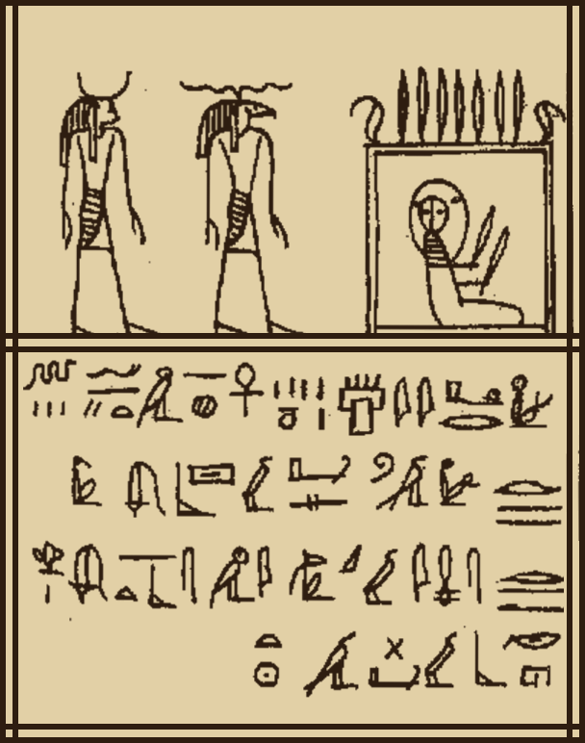
Room 6  Sixth room / Sixth room keeper  A monkey-headed god sits inside the sixth room, holding two knives, under a roof of blades and two cobras. He is the keeper of its door, "An-Ketitau-Kehabu-Kheru."  Ram-headed god  A ram-headed god stands before the sixth room. The room has two attendants, its watcher, "An-hi", and its herald, "the one who strikes for the keeper of Heaven"; which of them he is, is not known.  Hawk-headed god  A hawk-headed god stands before the sixth room. The room has two attendants, its watcher, "An-hi", and its herald, "the one who strikes for the keeper of Heaven"; which of them he is, is not known. | 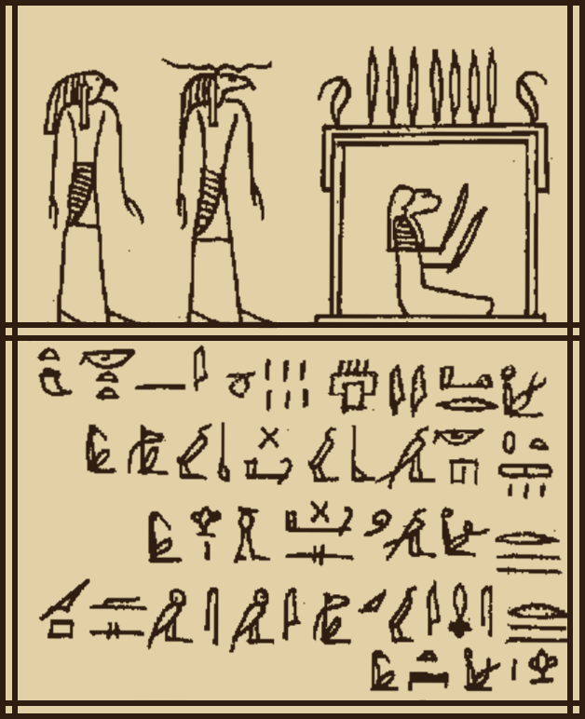
Room 7  Seventh room / Seventh room keeper  A god with a cobra for a head kneels inside the seventh room, holding two knives, under a roof of blades and two cobras. He is the keeper of its door, "Mates-sen, their executioner."  Ram-headed god / Ram-headed god  A ram-headed god stands before the seventh room. The room has two attendants, its watcher, "the Great by his word", and its herald, "the Expeller of the overthrower"; which of them he is, is not known. | 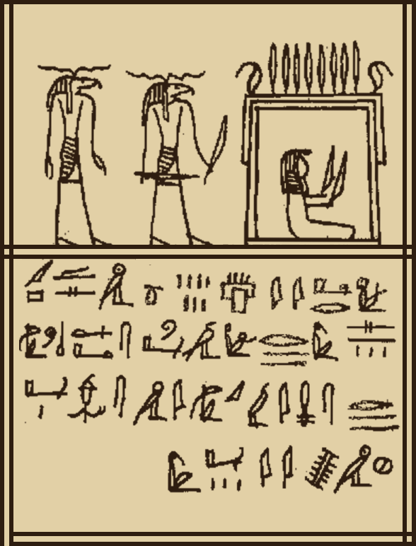
Spell 145
Pylon 1  First pylon  The first pylon of the Field of Reeds, a tall gate crowned with blades. Its name begins "The mistress, terrible and great, the dominating wall."  Hawk-headed god  A hawk-headed god keeps the first pylon, a knife in one hand and a blade raised in the other.  The deceased adoring  The deceased raises his hands before the first pylon. He knows its name and the name of its keeper, and is told: "Go through, thou art pure." | 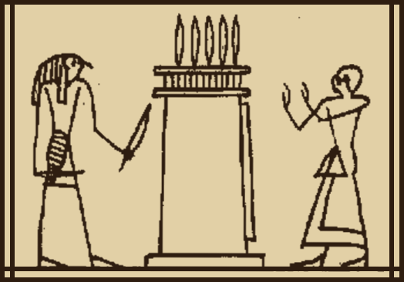
Pylon 2  Second pylon  The second pylon of the Field of Reeds, a tall gate crowned with blades. Its name begins "Inspiring veneration to the earth by thy flanks."  God with two cobras  A god with two cobras in place of a head keeps the second pylon, a knife in one hand and a blade raised in the other. Davis names him "Ra's offspring."  The deceased adoring  The deceased raises his hands before the second pylon. He knows its name and the name of its keeper, and is told: "Go through, thou art pure." | 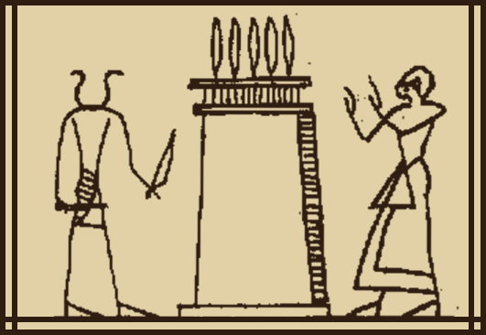
Pylon 3  Third pylon  The third pylon of the Field of Reeds, a tall gate crowned with blades. Its name begins "Present of the day of the starting of the bark for Abydos."  Ram-headed god  A ram-headed god keeps the third pylon, a knife in one hand and a blade raised in the other. Davis names him "Fig-tree."  The deceased adoring  The deceased raises his hands before the third pylon. He knows its name and the name of its keeper, and is told: "Go through, thou art pure." | 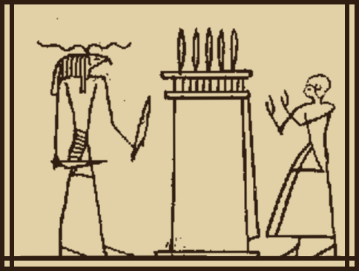
Pylon 4  Fourth pylon  The fourth pylon of the Field of Reeds, a tall gate crowned with blades. Its name begins "The presiding over the executions of the mistress ruling the earth."  Ram-headed god  A ram-headed god keeps the fourth pylon, a knife in one hand and a blade raised in the other. Davis names him "the Immolator of cattle."  The deceased adoring  The deceased raises his hands before the fourth pylon. He knows its name and the name of its keeper, and is told: "Go through, thou art pure." | 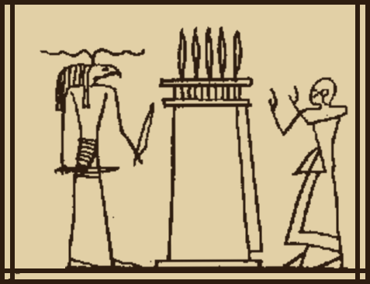
Pylon 5  Fifth pylon  The fifth pylon of the Field of Reeds, a tall gate crowned with blades. Its name begins "The one whom beseeches he who does not enter through her at first."  Foreign-looking god  A god with a man's head of foreign type, his hair standing up keeps the fifth pylon, a knife in one hand and a blade raised in the other. Davis names him "He who puts the foes to flight."  The deceased adoring  The deceased raises his hands before the fifth pylon. He knows its name and the name of its keeper, and is told: "Go through, thou art pure." | 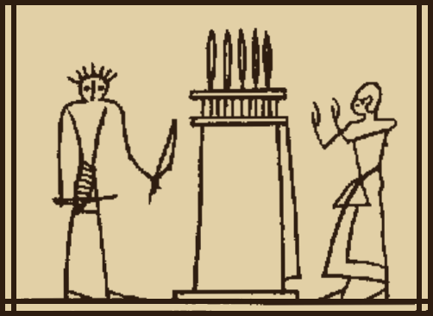
Pylon 6  Sixth pylon  The sixth pylon of the Field of Reeds, a tall gate crowned with blades. Its name begins "The master of the roarings whose neither height nor width are known."  Hawk-headed god  A hawk-headed god keeps the sixth pylon, a knife in one hand and a blade raised in the other. Davis names him "the Gatherer."  The deceased adoring  The deceased raises his hands before the sixth pylon. He knows its name and the name of its keeper, and is told: "Go through, thou art pure." | 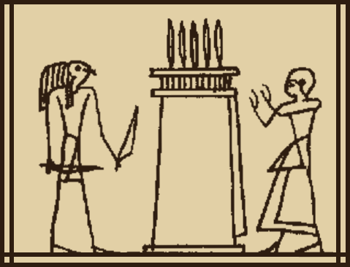
Pylon 7  Seventh pylon  The seventh pylon of the Field of Reeds, a tall gate crowned with blades. Its name begins "The cloud enveloping the suffering, the one grieving over the one she loves."  Jackal-headed god  A jackal-headed god keeps the seventh pylon, a knife in one hand and a blade raised in the other. Davis names him "Neith."  The deceased adoring  The deceased raises his hands before the seventh pylon. He knows its name and the name of its keeper, and is told: "Go through, thou art pure." | 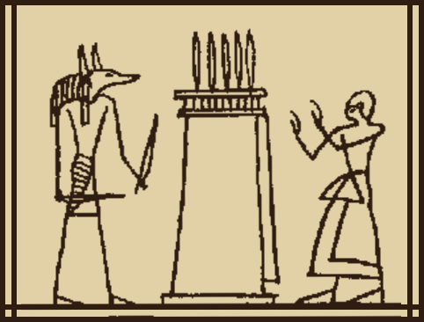
Pylon 8  Eighth pylon  The eighth pylon of the Field of Reeds, a tall gate crowned with blades. Its name begins "The one who belongs to her mistress, the Strong."  God with two cobras  A god with two cobras in place of a head keeps the eighth pylon, a knife in one hand and a blade raised in the other. Davis names him "Djeses."  The deceased adoring  The deceased raises his hands before the eighth pylon. He knows its name and the name of its keeper, and is told: "Go through, thou art pure." | 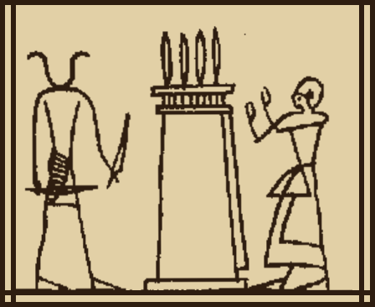
Pylon 9  Ninth pylon  The ninth pylon of the Field of Reeds, a tall gate crowned with blades. Its name begins "The fire and the flame which are not extinguished."  Jackal-headed god  A jackal-headed god keeps the ninth pylon, a knife in one hand and a blade raised in the other. Davis names him "Terror, the master of his roarings, the protector of his body."  The deceased adoring  The deceased raises his hands before the ninth pylon. He knows its name and the name of its keeper, and is told: "Go through, thou art pure." | 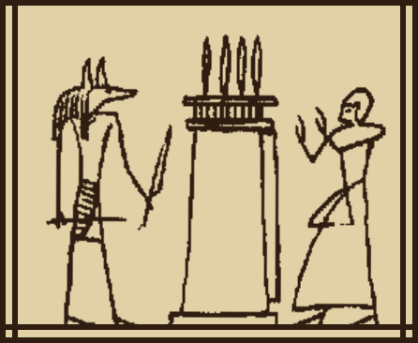
Pylon 10  Tenth pylon  The tenth pylon of the Field of Reeds, a tall gate crowned with blades. Its name begins "Height of the gates, the exciter of the clamors of those who dread his approaching."  Man-headed god  A man-headed, bearded god keeps the tenth pylon, a knife in one hand and a blade raised in the other. Davis names him "the Great one who locks up."  The deceased adoring  The deceased raises his hands before the tenth pylon. He knows its name and the name of its keeper, and is told: "Go through, thou art pure." | 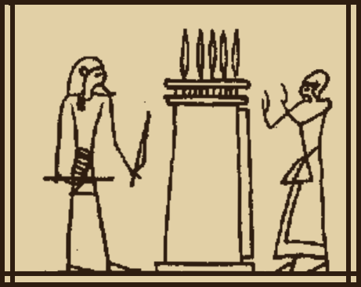
Pylon 11  Eleventh pylon  The eleventh pylon of the Field of Reeds, a tall gate crowned with blades. Its name begins "Reiteration of the flame of immolation against the foes, the terror of every gate."  Lion-headed god  A lion-headed god keeps the eleventh pylon, a knife in one hand and a blade raised in the other.  The deceased adoring  The deceased raises his hands before the eleventh pylon. He knows its name and the name of its keeper, and is told: "Go through, thou art pure." | 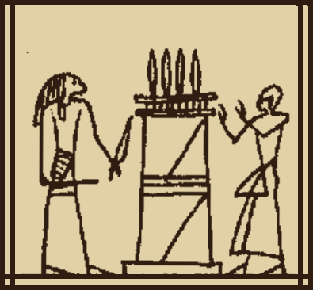
Pylon 12  Twelfth pylon  The twelfth pylon of the Field of Reeds, a tall gate crowned with blades. Its name begins "The one who goes around the earth and dispels those who come."  Cat-headed god  A cat-headed god keeps the twelfth pylon, a knife in one hand and a blade raised in the other.  The deceased adoring  The deceased raises his hands before the twelfth pylon. He knows its name and the name of its keeper, and is told: "Go through, thou art pure." | 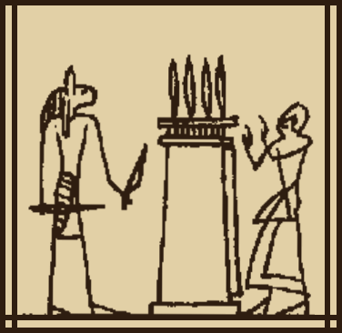
Pylon 13  Thirteenth pylon  The thirteenth pylon of the Field of Reeds, a tall gate crowned with blades. Its name begins "The one towing the gods, whose arms are in adoration of his face."  Hare-headed god  A hare-headed god keeps the thirteenth pylon, a knife in one hand and a blade raised in the other.  The deceased adoring  The deceased raises his hands before the thirteenth pylon. He knows its name and the name of its keeper, and is told: "Go through, thou art pure." | 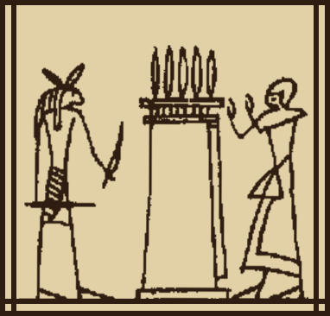
Pylon 14  Fourteenth pylon  The fourteenth pylon of the Field of Reeds, a tall gate crowned with blades. Its name begins "The chief of the spirits, Tesher in mourning, the goddess in tears going out by night."  Lion-headed god  A lion-headed god keeps the fourteenth pylon, a knife in one hand and a blade raised in the other.  The deceased adoring  The deceased raises his hands before the fourteenth pylon. He knows its name and the name of its keeper, and is told: "Go through, thou art pure." | 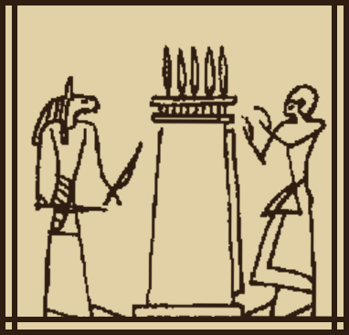
Pylon 15  Fifteenth pylon  The fifteenth pylon of the Field of Reeds, a tall gate crowned with blades. Its name begins "The lord of terror, slaughtering amidst blood."  Crocodile-headed god  A crocodile-headed god keeps the fifteenth pylon, a knife in one hand and a blade raised in the other.  The deceased adoring  The deceased raises his hands before the fifteenth pylon. He knows its name and the name of its keeper, and is told: "Go through, thou art pure." | 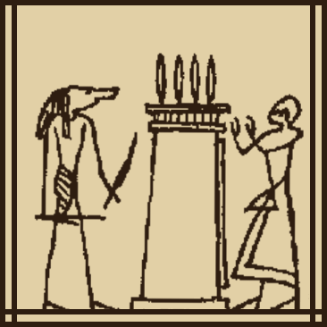
Pylon 16  Sixteenth pylon  The sixteenth pylon of the Field of Reeds, a tall gate crowned with blades. Its name begins "The lord of the veneration, the pursuing of the foes, the flame blazing when it appears."  Monkey-headed god  A monkey-headed god keeps the sixteenth pylon, a knife in one hand and a blade raised in the other.  The deceased adoring  The deceased raises his hands before the sixteenth pylon. He knows its name and the name of its keeper, and is told: "Go through, thou art pure." | 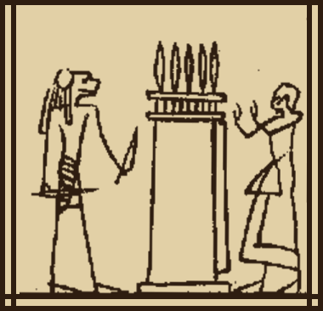
Pylon 17  Seventeenth pylon  The seventeenth pylon of the Field of Reeds, a tall gate crowned with blades. Its name begins "Greatness of the horizon, the lord of the blood."  Man-headed god  A man-headed, bearded god keeps the seventeenth pylon, a knife in one hand and a blade raised in the other.  The deceased adoring  The deceased raises his hands before the seventeenth pylon. He knows its name and the name of its keeper, and is told: "Go through, thou art pure." | 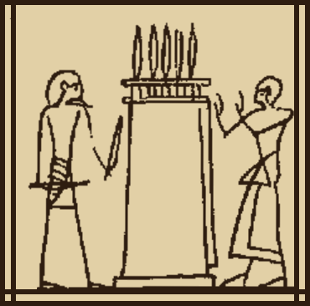
Pylon 18  Eighteenth pylon  The eighteenth pylon of the Field of Reeds, a tall gate crowned with blades. Its name begins "Love of the flame, the first of the devotees, the lord of the slaughtering-place."  Dog-headed god  A dog-headed god keeps the eighteenth pylon, a knife in one hand and a blade raised in the other.  The deceased adoring  The deceased raises his hands before the eighteenth pylon. He knows its name and the name of its keeper, and is told: "Go through, thou art pure." | 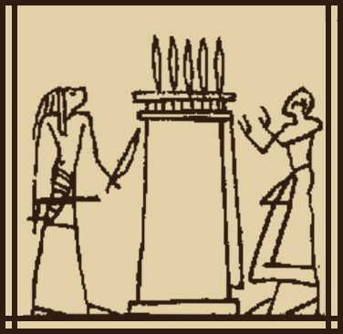
Pylon 19  Nineteenth pylon  The nineteenth pylon of the Field of Reeds, a tall gate crowned with blades. Its name begins "The one who prepares the light of duration, the mistress of the flame and of the writings of Thoth."  Ibis-headed god  An ibis-headed god keeps the nineteenth pylon, a knife in one hand and a blade raised in the other.  The deceased adoring  The deceased raises his hands before the nineteenth pylon. He knows its name and the name of its keeper, and is told: "Go through, thou art pure." | 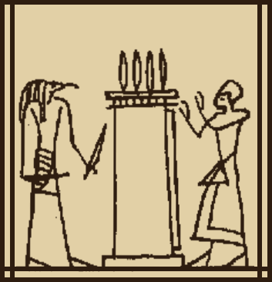
Pylon 20  Twentieth pylon  The twentieth pylon of the Field of Reeds, a tall gate crowned with blades. Its name begins "The one invoking his lord, the uraeus-field, the covering of the hidden."  Front-facing god  A god whose human face is shown from the front keeps the twentieth pylon, a knife in one hand and a blade raised in the other.  The deceased adoring  The deceased raises his hands before the twentieth pylon. He knows its name and the name of its keeper, and is told: "Go through, thou art pure." | 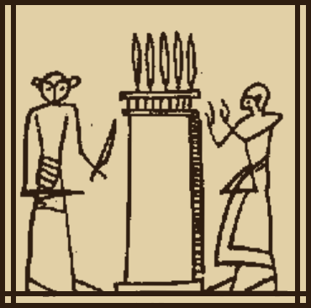
Pylon 21  Twenty-first pylon  The twenty-first pylon of the Field of Reeds, a tall gate crowned with blades. Its name begins "The sword hitting at the calling of its name, the god hiding his face."  Bes  Bes, the lion-maned dwarf god with a plumed crown, keeps the twenty-first pylon, a knife in one hand and a blade raised in the other. With him is his avenger, "the Devouring One."  The deceased adoring  The deceased raises his hands before the twenty-first pylon. He knows its name and the name of its keeper, and is told: "Go through, thou art pure." | 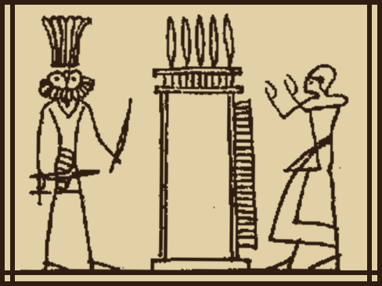
Spell 146
Portal 1  First portal / First portal guardian  The first portal of the House of Osiris, topped with a long snake. Inside crouches a crocodile-headed god, holding a knife. The portal is called "The mistress of the Terror, the height of walls." Its keeper is "Veneration." | 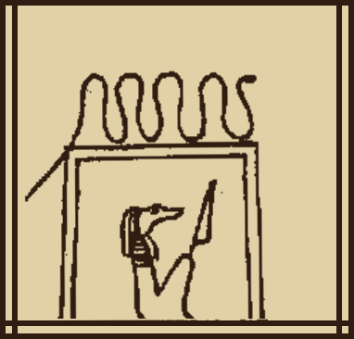
Portal 2  Second portal / Second portal guardian  The second portal of the House of Osiris, topped with an ankh among six vipers. Inside crouches a man-headed god with three vipers on his head, holding a knife. The portal is called "The Mistress of Heaven, the Regent of Earth." Its keeper is "Bringing forth of Ptah." | 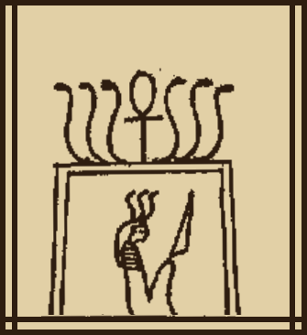
Portal 3  Third portal / Third portal guardian  The third portal of the House of Osiris, topped with a long snake. Inside crouches a monkey-headed god, holding a knife. The portal is called "The Mistress of the Altars, the Mistress of the Offerings." Its keeper is "the one who performs the unction." | 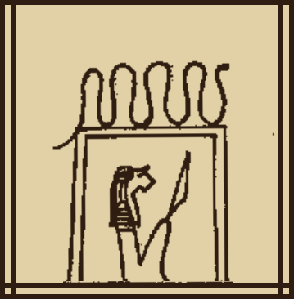
Portal 4  Fourth portal / Fourth portal guardian  The fourth portal of the House of Osiris, topped with a long snake. Inside crouches a bull-headed god, holding a knife. The portal is called "The one who is in possession of the Sword, the Regent of the Earth." Its keeper is "the one who strikes the cattle." | 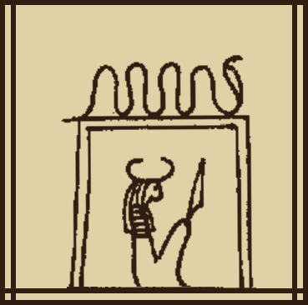
Portal 5  Fifth portal / Fifth portal guardian  The fifth portal of the House of Osiris, topped with a long snake. Inside crouches an ibis-headed god, holding a knife. The portal is called "The Flame, the Mistress of the Breaths for the Nostrils." Its keeper is "the one who puts the foes to flight." | 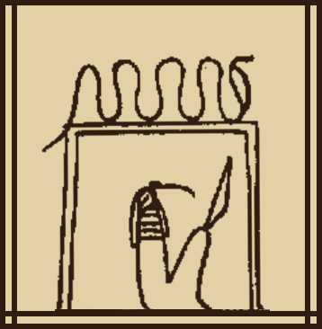
Portal 6  Sixth portal / Sixth portal guardian  The sixth portal of the House of Osiris, topped with six vipers. Inside crouches a god with a cobra for a head, holding a knife. The portal is called "The Mistress of the Prostrations." Its keeper is "the Gatherer." | 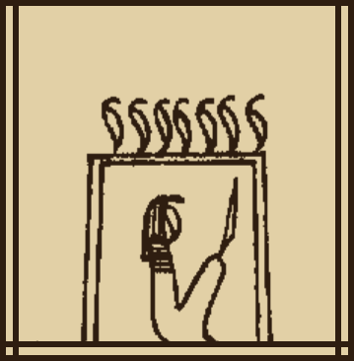
Portal 7  Seventh portal / Seventh portal guardian  The seventh portal of the House of Osiris, topped with a long snake. Inside crouches a man-headed god, holding a knife. The portal is called "The Cloud Enveloping the Fainting One." Its keeper is "Kenti." | 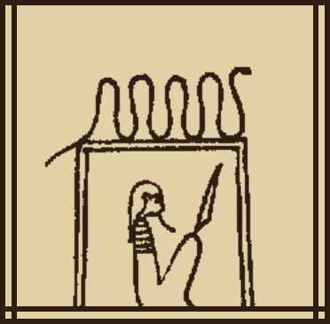
Portal 8  Eighth portal / Eighth portal guardian  The eighth portal of the House of Osiris, topped with a snake with a sun disc and horns. Inside crouches a man-headed god, holding a knife. The portal is called "The Blazing Flame which is not extinguished." Its keeper is "the one who protects his body." | 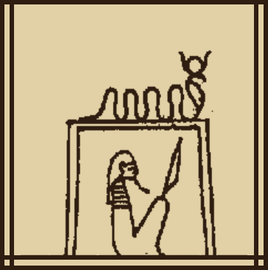
Portal 9  Ninth portal / Ninth portal guardian  The ninth portal of the House of Osiris, topped with a long snake. Inside crouches a hare-headed god, holding a knife. The portal is called "The One who is on the forehead of the Mistress of the Forces." Its keeper is "Djetes." | 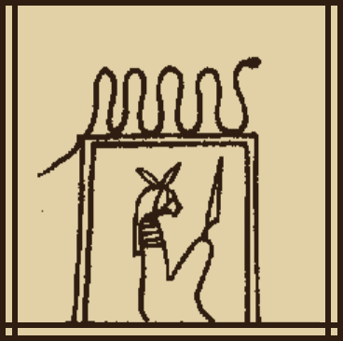
Portal 10  Tenth portal / Tenth portal guardian  The tenth portal of the House of Osiris, topped with a large snake. Inside crouches a man-headed god with two tall feathers and ram's horns, holding a knife. The portal is called "The One who makes longer the outcries." Its keeper is "the great one who locks up." | 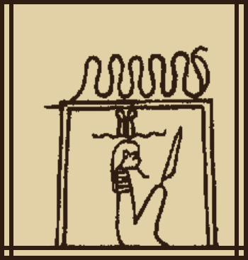
Portal 11  Eleventh portal / Eleventh portal guardian  The eleventh portal of the House of Osiris, topped with two cats. Inside crouches a monkey-headed god, holding a knife. The portal is called "The god of the Sword, the Flame Destroying the Foes, the Terror of every Gate." | 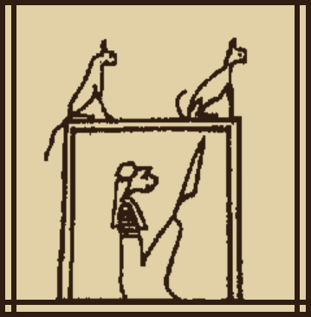
Portal 12  Twelfth portal / Twelfth portal guardian  The twelfth portal of the House of Osiris, topped with a large snake. Inside crouches a god with a cobra for a head, holding a knife. The portal is called "The one that the earth invokes, the Mistress of the Shades." | 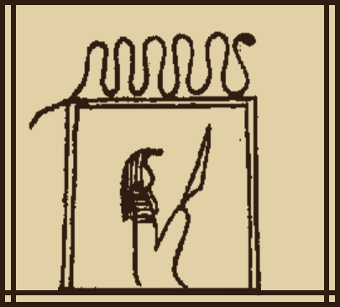
Portal 13  Thirteenth portal / Thirteenth portal guardian  The thirteenth portal of the House of Osiris, topped with two seated figures of the Nile god. Inside crouches a crocodile-headed god with an ostrich feather, holding a knife. The portal is called "The one who tows Isis." | 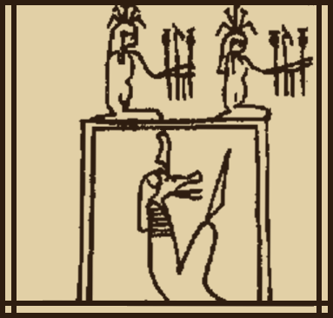
Portal 14  Fourteenth portal / Fourteenth portal guardian  The fourteenth portal of the House of Osiris, topped with a snake and a bull's head. Inside crouches a hawk-headed god, holding a knife. The portal is called "The Mistress of Terror, slaughtering amidst blood." | 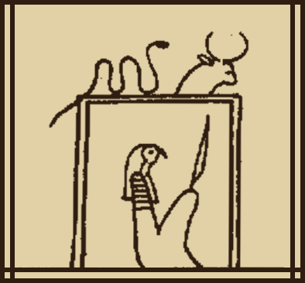
Portal 15  Fifteenth portal / Fifteenth portal guardian  The fifteenth portal of the House of Osiris, topped with a row of plumes. Inside crouches a man-headed god, holding a knife. The portal is called "The Red Soul in Mourning, investigator going out by night." | 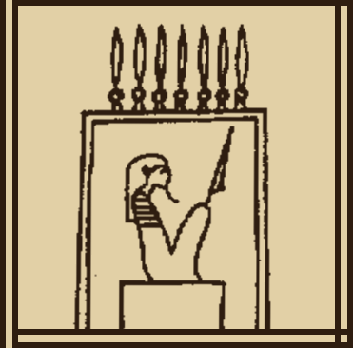
Spell 146 bottom text  The horizontal inscription under the whole run of portals, in one line, split into pieces and read right to left (first piece at the top). | 

