

DEPARTMENT OF SMART COMPUTING
Course lab assignment:
LAB REPORT
WEEK 3: DATA WRANGLING WITH PANDAS
SEOULCART: TURNING MESSY ORDERS INTO BUSINESS INSIGHT

Submitted by | : YOGI YOG BAHADUR
Student ID | : 2317427
Department | : SMART COMPUTING
Instructor | : SIMEON O.A., ASSISTANT PROFESSOR
Course | : DATA SCIENCE: FOUNDATIONS TO APPLICATIONS

Kyungdong University
[GOSEONG, South Korea]
[01, OCTOBER, 2026]

1. Introduction

1.1 Business problem
SeoulCart is an online retailer that ships electronics, home goods, fashion and beauty products to six Korean cities. The Head of Operations reported that the March to August order export was messy and that Finance could not reconcile the numbers. Before the September planning meeting, four questions needed answers:
- Which product categories and cities bring in the most revenue?
- How is monthly revenue trending?
- Who are the best customers, and which registered customers have never bought anything?
- Can the data actually be trusted?
This report documents how the raw export was inspected, cleaned, merged with the customer list, summarised and reshaped using Pandas, and presents the findings and three recommendations requested by the Head of Operations.

1.2 Data and tools
Two files were used. orders_raw.csv is the order export (312 rows, 8 columns: order_id, customer_id, order_date, category, product, unit_price, quantity, payment_method). customers.csv is the CRM customer list (60 rows, 4 columns: customer_id, customer_name, city, segment). The data is synthetic but reproduces problems found in real exports. The work was done in a Jupyter Notebook using Python 3, NumPy, Pandas and Matplotlib.

2. Methodology

2.1 Inspecting the raw data
Following the rule of looking before touching, both files were loaded and inspected with .shape, .info(), .isna().sum(), .duplicated().sum() and value_counts(). The inspection found the following problems:
- Duplicates: 12 fully duplicated rows, caused by double form submissions.
- Currency text in numbers: unit_price stored as text with the won sign and commas (for example ₩99,000).
- Dates as text: order_date stored as a string, so it cannot be sorted or grouped by month.
- Inconsistent labels: category appeared with different capitalisation and extra spaces instead of exactly four categories.
- Missing values: 15 missing quantities and 21 missing payment methods.
- Orphan orders: orders from customer 9999, who does not exist in the CRM.

2.2 Cleaning steps
Each cleaning decision was made per column, and the output was checked after every step.
Step | Action | Why
Duplicates | drop_duplicates() removed 12 rows (312 to 300) | Exact duplicates inflate every revenue total
Data types | Stripped ₩ and commas from unit_price, then astype(float); pd.to_datetime() on order_date | Numbers and dates must be real types to calculate, sort and filter
Text labels | str.strip().str.title() on category | Leaves exactly 4 categories instead of many spellings
Missing quantity | Filled with the median, converted to int | Numeric and only ~5% missing; the median is robust to outliers and keeps real orders
Missing payment | Filled with 'Unknown' | An honest placeholder rather than guessing a method
New columns | revenue = unit_price × quantity; month from order_date | These power the analysis

Key cleaning code:
orders = orders.drop_duplicates()
orders["unit_price"] = (orders["unit_price"]
.str.replace("\u20a9", "", regex=False)
.str.replace(",", "", regex=False).astype(float))
orders["order_date"] = pd.to_datetime(orders["order_date"])
orders["category"] = orders["category"].str.strip().str.title()
orders["quantity"] = orders["quantity"].fillna(orders["quantity"].median()).astype(int)
orders["payment_method"] = orders["payment_method"].fillna("Unknown")
orders["revenue"] = orders["unit_price"] * orders["quantity"]
orders["month"] = orders["order_date"].dt.strftime("%Y-%m")
A validation cell with assert statements then confirmed that there were no duplicated rows or missing values, unit_price was float64, order_date was a datetime column, and category had exactly four unique values.

2.3 Merging orders with customers
Orders contain only a customer_id, so the customer table was merged in to get city and segment. Two join types were compared, with row counts checked before and after:
Join | Rows
Orders before merge | 300
Inner join | 297
Left join (indicator=True) | 300

The inner join silently dropped 3 orders (customer 9999, total ₩618,000), which would have understated revenue. A left join keeps them, and indicator=True showed exactly which rows had no match. These orders were labelled 'Unknown' for city, segment and customer name, giving the final analysis-ready DataFrame of 300 rows and 13 columns.

3. Results
Total revenue across March to August is ₩53,904,000 from 300 orders.

3.1 Revenue by category
Category | Revenue (₩) | Average order (₩) | Orders
Fashion | 19,665,000 | 239,817 | 82
Home & Kitchen | 15,750,000 | 215,753 | 73
Electronics | 13,918,000 | 210,879 | 66
Beauty | 4,571,000 | 57,861 | 79

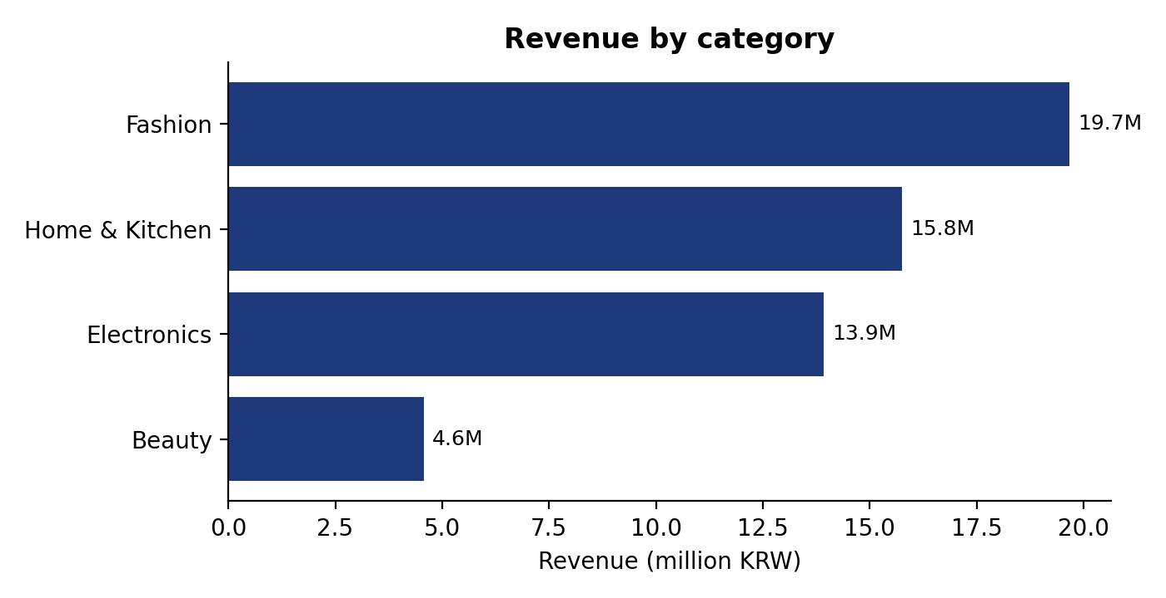
Figure 1: Revenue by category
Fashion is the largest category at about 36% of revenue. Beauty has almost as many orders as Fashion (79 versus 82) but the lowest revenue, because its average order is only about ₩58,000 compared with ₩210,000 to ₩240,000 in the other categories.

3.2 Revenue by city
City | Revenue (₩)
Seoul | 16,193,000
Busan | 11,175,000
Daegu | 9,372,000
Incheon | 7,658,000
Daejeon | 6,671,000
Gwangju | 2,217,000
Unknown (3 orphan orders) | 618,000

Seoul is the top city and Gwangju the lowest. The 3 orders from the customer missing in the CRM appear as city 'Unknown'.

3.3 Monthly trend
Month | Beauty | Electronics | Fashion | Home & Kitchen | Total
2026-03 | 956,000 | 1,576,000 | 3,318,000 | 2,352,000 | 8,202,000
2026-04 | 752,000 | 1,832,000 | 3,215,000 | 2,772,000 | 8,571,000
2026-05 | 725,000 | 2,807,000 | 4,273,000 | 1,371,000 | 9,176,000
2026-06 | 511,000 | 1,711,000 | 2,247,000 | 2,907,000 | 7,376,000
2026-07 | 733,000 | 4,323,000 | 3,855,000 | 2,838,000 | 11,749,000
2026-08 | 894,000 | 1,669,000 | 2,757,000 | 3,510,000 | 8,830,000

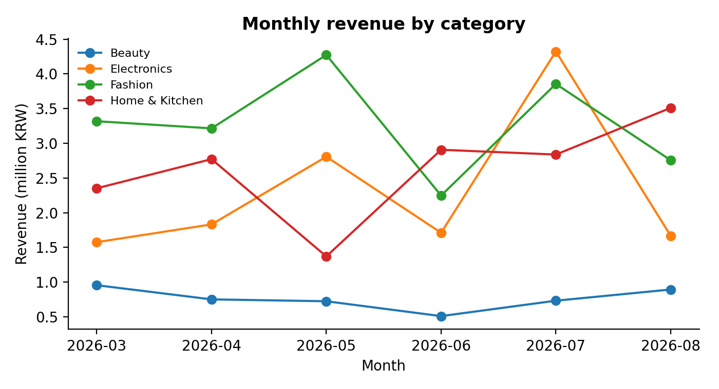
Figure 2: Monthly revenue by category (million KRW)
Revenue is uneven rather than steadily growing. June is the low point (₩7.4M) and July is the peak (₩11.7M). The July spike is driven by Electronics, which reached ₩4.3M against roughly ₩1.7M in a typical month.

3.4 Customers
Rank | Customer | Revenue (₩)
1 | Customer_16 | 2,922,000
2 | Customer_1 | 2,451,000
3 | Customer_7 | 2,168,000
4 | Customer_5 | 2,079,000
5 | Customer_20 | 1,816,000

Ten registered customers (IDs 1051 to 1060) have never placed an order; two of them (Customer_56 and Customer_57) are Premium. Seven orders worth ₩300,000 or more came from Premium customers.

3.5 Payment methods, segments and Premium reliance
Payment method | Revenue (₩) | Orders
KakaoPay | 17,594,000 | 102
Bank Transfer | 16,751,000 | 88
Card | 14,194,000 | 90
Unknown | 5,365,000 | 20

Segment | Average order (₩) | Orders
Regular | 183,476 | 248
Premium | 158,857 | 49
Unknown | 206,000 | 3

KakaoPay brings in the most revenue. Premium customers do not spend more per order than Regular customers (about ₩159,000 versus ₩183,000). A city-by-segment pivot table shows that Incheon relies most on Premium customers: about 68% of its revenue (₩5.2M of ₩7.7M) comes from them, compared with 10% or less in every other city.

4. Findings and Recommendations

4.1 Findings
- Revenue drivers: Total revenue is ₩53.9M. Fashion (₩19.7M), Home & Kitchen (₩15.8M) and Electronics (₩13.9M) generate almost all of it, while Beauty adds only ₩4.6M despite 79 orders. Seoul leads the cities at ₩16.2M and Gwangju is lowest at ₩2.2M.
- Monthly trend: Revenue dips in June (₩7.4M), peaks in July (₩11.7M) because of Electronics, and falls back to ₩8.8M in August.
- Customers: Customer_16 is the top customer (₩2.9M). Ten registered customers have never bought anything. Premium customers have a lower average order than Regular customers, and Incheon is the city most dependent on Premium customers.
- Data quality: The raw export could not be trusted as delivered: it had 12 duplicate orders, 15 missing quantities, 21 missing payment methods, text-formatted prices and dates, inconsistent category labels and 3 orders (₩618,000) from a customer missing in the CRM. After cleaning, the dataset is reliable, but ₩5.4M of revenue still has an Unknown payment method.

4.2 Recommendations
- Fix data capture at the source. Block double-submitted orders, make quantity and payment method required fields, use a fixed category list, and sync the CRM so every order has a valid customer. This removes the problems that made the export a mess.
- Activate dormant customers and review the Premium programme. Run a win-back or first-purchase campaign for the 10 registered customers who never ordered, and investigate why Premium customers spend less per order than Regular customers, especially outside Incheon.
- Plan September around what drives revenue. Prepare stock and promotions for Electronics ahead of peak periods such as July, keep promoting Fashion, and bundle low-priced Beauty items to raise the average order value.

4.3 Why the data can be trusted now
Every cleaning step is documented above and reproducible by running the notebook from top to bottom. The assert checks, the row-count comparison between join types, and the 300-row, 13-column output file orders_clean.csv give a clear audit trail.

5. Conclusion
The messy order export was turned into an analysis-ready dataset using duplicate removal, type conversion, label standardisation, targeted missing-value handling and a carefully audited left join. The cleaned data answers the Head of Operations' questions: revenue is concentrated in Fashion, Home & Kitchen and Electronics and in Seoul and Busan; monthly revenue is volatile with an Electronics-driven July peak; ten registered customers have never bought; and the original export needed substantial cleaning before it could be trusted. The cleaned file orders_clean.csv and the notebook Week3_Lab_YogiYogBahadur.ipynb are submitted via GitHub.

