- Write a Program to Find the ASCII Value of a Character
ch = 'A';
cout << "The ASCII value of " << ch << " is " << int(ch)

- Check Whether a Character is an Alphabet or Not
ch = 'a';
if (isalpha(ch)) {
cout <<”yes" ;
else
cout << “no”;
……………………………………………………………………………..
if ((ch >= 'A' && ch <= 'Z') || (ch >= 'a' && ch <= 'z'))
cout << “yes”;
else
cout << “no”;
- Find the Length of the String Without using strlen() Function
for (int i = 0; str[i] != '\0'; i++) {
length++;
}

- Write a Program to Toggle Each Character in a String
string str = "GeeksforGeeks";
for (int i = 0; str[i] != '\0'; i++) {
if (islower(str[i]))
str[i] = toupper(str[i]);
else if (isupper(str[i]))
str[i] = tolower(str[i]);
}

- Remove Spaces From a String
string remove_spaces(string str)
{
string result = "";
for (char c : str) {
if (c != ' ') {
result += c;
}
}
return result;
}

- Factorial of a Number
int fact = 1;
while (n > 1) {
fact *= n;
n--;
}
return fact;
……………………………………………………
unsigned long long factorial(int n) {
if (n == 0 || n == 1) return 1;
return n * factorial(n - 1);
}
NOTE: unsigned → Cannot store negative numbers. Only 0 and positive values.

- Find a Leap Year or Not
// leap year
if (year % 400 == 0)
return true;

// Not leap year
if (year % 100 == 0)
return false;

// leap year
if (year % 4 == 0)
return true;

- Check the Prime Number
bool isPrime(int n)
{
if (n <= 1)
return false;

// Check from 2 to n-1
for (int i = 2; i < n; i++) // we are not checking for no. divided by 1 and itself i < n
{ // so if we get any factor other than 1 and itself => not prime
if (n % i == 0)
return false;
}
return true;
}
………………………………………….
bool isPrime(int n) {
if (n <= 1) return false; // 1 and below are not prime
for (int i = 2; i * i <= n; i++) { // check till sqrt(n)
if (n % i == 0)
return false;
}
return true;
}

- Program to Check Palindrome
bool isPalindrome(int n) {
int original = n;
int reversed = 0;

while (n > 0) {
int rem = n % 10;
reversed = reversed * 10 + rem;
n /= 10;
}

return original == reversed;
}

………………………………………………………………………
bool isPalindrome(string str) {
int start = 0, end = str.length() - 1;
while (start < end) {
if (str[start] != str[end])
return false;
start++;
end--;
}
return true;
}
NOTE: Palindrome → Mirror → reads same forward/backward
Armstrong → Arithmetic sum of powers → sum of digitsⁿ = number
An anagram is a word or phrase made by rearranging the letters of another word or phrase.
Example: listen → silent

- Check Whether a Number is an Armstrong Number or Not

Examples
Number | Digits | Calculation | Armstrong?
153 | 3 | 1³ + 5³ + 3³ = 153 | ✅ Yes
9474 | 4 | 9⁴ + 4⁴ + 7⁴ + 4⁴ = 9474 | ✅ Yes

3 digit no.
while (n > 0) {
int rem = n % 10;
ans = (ans) + (rem * rem * rem);
n = n / 10;
}
……………………………………………………………………..
bool isArmstrong(int n) {
int original = n, sum = 0;
int count = log10(n) + 1; // number of digits
while (n > 0) {
int digit = n % 10;
sum += pow(digit, count);
n /= 10;
}
return sum == original;
}

- Nth Term of the Fibonacci Series
int fib(int n)
{
int first = 0, second = 1, ans = 0;
if (n == 0)
return first;
for (int i = 2; i <= n; i++) {
ans = first + second;
first = second;
second = ans;
}
return ans;
}
…………………………………………………………………
long long fibonacci(int n) {
if (n == 0) return 0;
if (n == 1) return 1;
return fibonacci(n-1) + fibonacci(n-2);
}
………………………………………………………………………….
long long fib(int n, vector<long long>& dp) {
if (n == 0) return 0;
if (n == 1) return 1;
if (dp[n] != -1) return dp[n];
return dp[n] = fib(n-1, dp) + fib(n-2, dp);
}

int main() {
int n;
cin >> n;
vector<long long> dp(n+1, -1);
for (int i = 0; i < n; i++)
cout << fib(i, dp) << " ";
cout << endl;
}
Time complexity: O(n)
Space complexity: O(n)

- Calculate the Greatest Common Divisor/Factor of Two Numbers
1️⃣ What is Greatest Common Divisor (GCD)?
The largest positive number that divides both numbers exactly .

2️⃣ Example
- GCD of 12 and 18
Divisors of 12 → 1, 2, 3, 4, 6, 12
Divisors of 18 → 1, 2, 3, 6, 9, 18
✅ Common divisors: 1, 2, 3, 6
👉 Greatest = 6
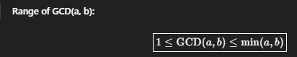
int gcd(int a, int b)
{
int result = min(a, b);
while (result > 0)
{
if (a % result == 0 && b % result == 0) {
break;
}
result--;
}

return result;
}
…………………………………………
Euclidean Algorithm(Most Optimized)
GCD(a , b)=GCD(b , a%b)
int gcd(int a, int b) {
while (b != 0) {
int r = a % b;
a = b;
b = r;
}
return a;
}
……………………………………
long long gcd(long long a, long long b) {
if (b == 0)
return a;
return gcd(b, a % b); // not space optimized O(log min(a,b))
}
NOTE: Keep replacing (a, b) with (b, a % b) until b becomes 0.”
Brute-force GCD → O(min(a,b))
Euclidean Algorithm → O(log(min(a,b)))
GCD of 3 no. gcd(gcd(a, b), c);
GCD of 4 no. gcd(gcd(gcd(a, b), c), d);

- Lowest Common Multiple (LCM) of Two Numbers
LCM of 4 and 6
Multiples of 4 → 4, 8, 12, 16, …
Multiples of 6 → 6, 12, 18, …
✅ Smallest common multiple = 12
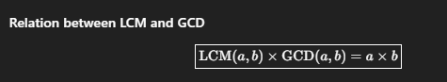
int lcm(int a, int b) {
return (a / gcd(a, b)) * b; // divide first to avoid overflow (keep in long long)
}

Lcm of 3 no. int result = lcm(lcm(a, b), c);
………………………………………………………………
long long lcmBrute(long long a, long long b) {
long long maxNum = max(a, b);
long long lcm = maxNum;

while (true) {
if (lcm % a == 0 && lcm % b == 0)
return lcm;
lcm++;
}
}

- Finding the Roots of a Quadratic Equation
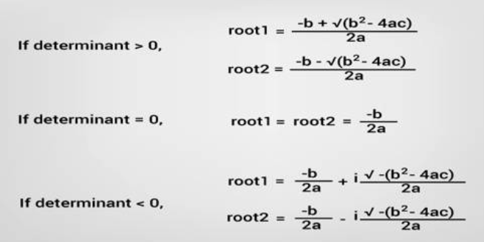
Find D as we have a,b,c and use formula

- Second Smallest Element in an Array in one pass
void print2Smallest(int arr[], int n)
{
int first, second;

if (n < 2) {
cout << " Invalid Input ";
return;
}

first = second = INT_MAX;
for (int i = 0; i < n; i++) {
if (arr[i] < first) {
second = first;
first = arr[i];
}
else if (arr[i] < second && arr[i] != first)
second = arr[i];
}
if (second == INT_MAX)
cout << "There is no second smallest element";
else
cout << " Second smallest element is " << second;
}

#3rd Max in one Pass
void print3Smallest(int arr[], int n) {
if (n < 3) {
cout << "Array must have at least 3 elements" << endl;
return;
}

int first = INT_MAX, second = INT_MAX, third = INT_MAX;

for (int i = 0; i < n; i++) {
if (arr[i] < first) {
third = second;
second = first;
first = arr[i];
} else if (arr[i] < second && arr[i] != first) {
third = second;
second = arr[i];
} else if (arr[i] < third && arr[i] != first && arr[i] != second) {
third = arr[i];
}
}
if (third == INT_MAX)
cout << "There is no third smallest element" << endl;
else
cout << "Third smallest element is " << third << endl;
}

- Check if Two Strings are Anagram or Not
bool areAnagrams(string str1, string str2) {
if (str1.length() != str2.length())
return false;

sort(str1.begin(), str1.end());
sort(str2.begin(), str2.end());

return str1 == str2;
}

Without sorting
bool areAnagramsOptimized(string s1, string s2) {
if (s1.length() != s2.length()) return false;

int count[26] = {0}; // assuming lowercase letters

for (int i = 0; i < s1.length(); i++) {
count[s1[i] - 'a']++;
count[s2[i] - 'a']--;
}

for (int i = 0; i < 26; i++)
if (count[i] != 0)
return false;

return true;
}

- Write a Program to Print a Diamond Pattern
*
***
*****
*******
*****
***
*
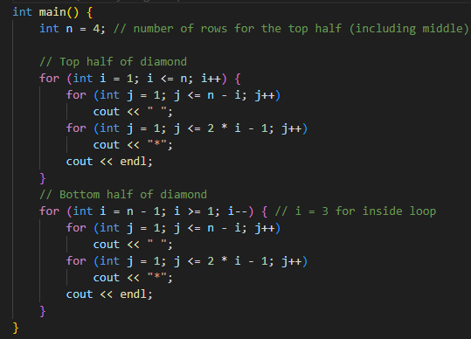

- *
***
*****
*******
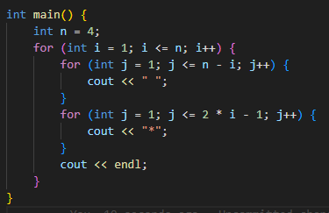

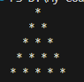
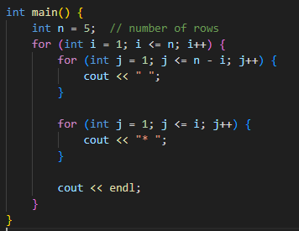

- Count the Sum of Numbers in a String
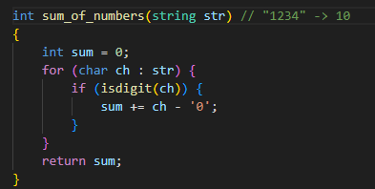

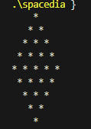
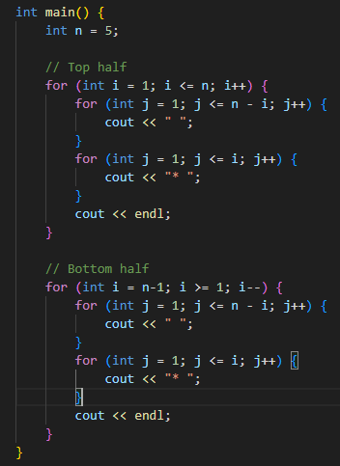
- Count String length using recursion
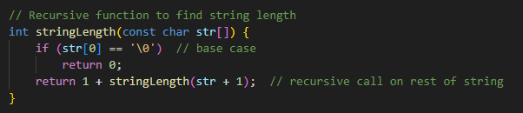

- Print All Natural Numbers up to N Without Using a Semi-Colon
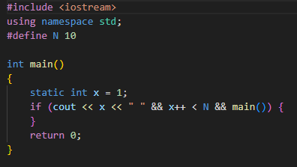
- Print Hello World without Semicolon
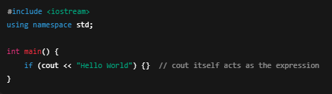
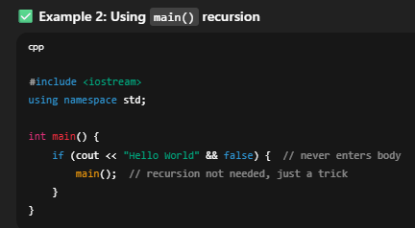
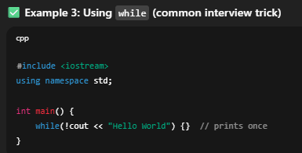
- Swap 2 number
