- What is the difference between == and === in JavaScript?
== (loose equality)
- Compares values only
- Performs type coercion (JavaScript tries to convert data types to match)
5 == "5" // true , even though one is a string and the other is a number, JS converts the string to a number.
0 == false // true
null == undefined // true

=== (strict equality)
- Compares both value AND type
- No type coercion
5 === "5" // false
0 === false // false
null === undefined // false

- Is JavaScript compiled or interpreted?
Traditionally, JavaScript was considered an interpreted language because code was executed line by line by the browser.
Modern JavaScript engines (like V8 in Chrome, SpiderMonkey in Firefox) actually compile JavaScript to machine code at runtime using Just-In-Time (JIT) compilation.
JavaScript is an interpreted language that uses Just-In-Time (JIT) compilation in modern engines.

- JavaScript vs Java
Feature | Java | JavaScript
Type | Programming language (general-purpose, compiled) | Scripting language (interpreted, runs in browser)
Execution | Compiled into bytecode → runs on JVM (Java Virtual Machine) | Interpreted or JIT-compiled → runs in browser or Node.js
Syntax | Strongly typed (you must declare variable types) | Loosely/dynamically typed (types inferred at runtime)
Usage | Desktop apps, Android apps, backend servers | Web development (frontend & backend with Node.js), interactive websites
Concurrency | Multi-threading supported | Single-threaded (event-driven, uses async callbacks/promises)

- How many ways an HTML element can be accessed in JavaScript code?
There are four possible ways to access HTML elements in JavaScript which are:
- getElementById() Method: It is used to get the element by its id name.
- getElementsByClass() Method: It is used to get all the elements that have the given classname.
- getElementsByTagName() Method: It is used to get all the elements that have the given tag name.
- querySelector() Method: This function takes CSS style selector and returns the first selected element.

- What’s the difference between var, let, and const .
Feature | var | let | const
Scope | Function | Block | Block
Hoisting | Yes (initialized undefined) | Yes (temporal dead zone) | Yes (temporal dead zone)
Re-declaration | ✅ Allowed | ❌ Not allowed | ❌ Not allowed
Re-assignment | ✅ Allowed | ✅ Allowed | ❌ Not allowed (except object properties)

- What is the Temporal Dead Zone?
// TDZ example
console.log(x); // ReferenceError (x in TDZ)
let x = 10;
console.log(y); // undefined (var is initialized at hoist time)
var y = 10;
It is the time period , During this period:
- The variable exists in memory but is not yet initialized.
- Accessing it before the declaration will throw a ReferenceError.
- Only let and const have a TDZ. var does not, because var is hoisted and initialized as undefined.

- What is a Variable Scope in JavaScript?
- Global Scope:
- Local Scope
- Function Scope:
- Block Scope:

- What the difference between Lexical and Dynamic Scoping?

- ECMAScript 2025 (ES2025)?
Enhanced ways to work with iterators and sets, direct JSON module imports, and improvements to regular expressions and promises
- What is the use of isNaN, and how is it different from Number.isNaN?
1️⃣ isNaN()
- Purpose: Checks if a value is “Not a Number”.
- Important: isNaN() first converts the value to a number and then checks if it’s NaN.
- Consequence: This can give surprising results.
Example:
isNaN("hello"); // true → "hello" is converted to number → NaN
isNaN("123"); // false → "123" is converted to 123
isNaN(42); // false → 42 is a number
isNaN(NaN); // true
✅ So isNaN() is more “coercive”, because it converts the value first.
2️⃣ Number.isNaN()
- Purpose: Checks if a value is exactly NaN, without converting it.
- Safer and more predictable than isNaN().
Example:
Number.isNaN("hello"); // false → no conversion, "hello" is not NaN
Number.isNaN(123); // false
Number.isNaN(NaN); // true
Number.isNaN("123"); // false
✅ Only returns true if the value is actually the special NaN value.
- Output
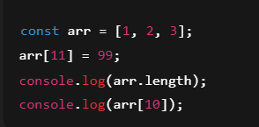
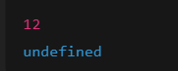
- Why is typeof null === "object"?
typeof null === "object" is a historical bug in JavaScript. null is a primitive, but early JS represented it in memory like an object, and typeof never got fixed for backward compatibility.
const value = null;

console.log(value === null); // → true
console.log(typeof value); // → "object"

  - value === null ✅ confirms it is null.
  - typeof value returning "object" is just a JavaScript quirk/bug from the early days.
- What are "truthy" and "falsy" values in JavaScript
Truthy: A value that evaluates to true in a boolean context.
Falsy: A value that evaluates to false in a boolean context.
JavaScript automatically converts values to boolean when needed (like in if statements, while, logical operators, etc.).

Falsy Values
There are exactly 8 falsy values in JavaScript:
Value | Example
false | if (false) → not executed
0 | if (0) → not executed
-0 | if (-0) → not executed
0n | BigInt zero: if (0n) → not executed
"" | empty string: if ("") → not executed
null | if (null) → not executed
undefined | if (undefined) → not executed
NaN | if (NaN) → not executed
Everything else is truthy.

- What are undeclared and undefined variables?
Undefined: It occurs when a variable is declare but not assign any value. Undefined is not a keyword.
Undeclared: It occurs when we try to access any variable which is not initialize or declare earlier using the var or const keyword.

- Output
console.log(null ?? 'default');
console.log(undefined ?? 'default');
console.log(false ?? 'default');
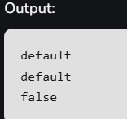

- Null
Different from undefined:
- undefined → variable exists but has no assigned value yet.
- null → variable is intentionally empty.
null is a primitive value that represents “no value” or “empty”. It’s a way to intentionally indicate that a variable does not point to any object or meaningful data.

- How to delete property-specific values?
In JavaScript, you cannot delete just the value of a property while keeping the property itself using delete. The delete keyword removes the entire property from the object.
If your goal is to “remove the value” but keep the property, you have to set the value to null or undefined.
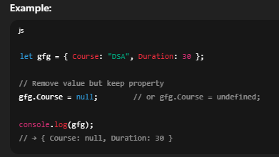
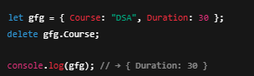

- What are template literals and when do you use them?
Support string interpolation (inserting variables or expressions directly into the string).
Can include expressions and function calls inside ${}.
Example:
const message = `Hello, my name is ${name} and I am ${age} years old.`;

- Output
For primitives (number, string, boolean), == compares values and === compares values & type.
For objects/arrays/functions, == and === both compare references, not the actual content.
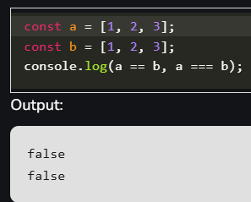

- Can closures leak memory?
Yes — closures can potentially cause memory leaks in JavaScript, but it depends on how they are used. Let me explain carefully.

1️⃣ What is a closure?
A closure happens when a function remembers variables from its outer scope, even after that outer function has finished executing:
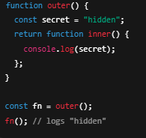
A closure keeps references to its outer variables. If you unintentionally retain closures longer than necessary, the memory for those outer variables cannot be garbage-collected.
JavaScript closures capture variables from their outer scope, but if not managed properly, they can sometimes lead to memory leaks.
Memory Leak Possibility: Closures can leak memory when they unintentionally keep references to variables or objects that are no longer needed. This prevents the garbage collector fro5 freeing that memory.

- Does JavaScript allow multiple inheritance?
No, JavaScript does not support multiple inheritance in the traditional sense like C++ or Python, where a class can directly inherit from more than one class.
How inheritance works in JavaScript
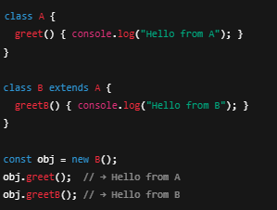

- Is JavaScript statically typed or dynamically typed?
JavaScript is dynamically typed because we don’t have to tell JavaScript what kind of data (number, text, true/false, etc.) a variable will hold when you create it. The type is decided automatically when the program runs.

- What is the 'this' keyword in JavaScript?
- What are Timers in JavaScript?
Timers are functions that schedule code to run after a certain delay or repeatedly at intervals.
JavaScript provides two main types of timers:
- setTimeout() – runs a function once after a delay.
- setInterval() – runs a function repeatedly at a specified interval.
- clearTimeout() / clearInterval() – cancel the scheduled execution.
- Output
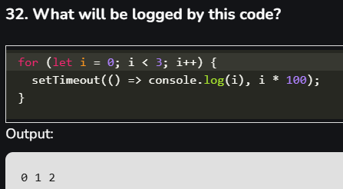

- What is the difference between ViewState and SessionState?
Feature | ViewState | SessionState
Purpose | Maintains state of controls on a single web page across postbacks. | Maintains user-specific data across multiple pages during a user session.
Scope | Page-level (specific to the page where it is used). | Application-level for a single user (available across all pages in the session).
Storage Location | Stored in a hidden field on the page itself (encoded and sent to the client). | Stored on the server (InProc, StateServer, or SQLServer).
Lifetime | Exists only during the current page’s postbacks. | Exists for the duration of the user session (default 20 minutes of inactivity).
Accessibility | Only accessible to the page that created it. | Accessible across all pages in the same session.
Performance | Can increase page size because data is sent back and forth between client and server. | Uses server memory, so large amounts of data can affect server performance.
Security | Data can be seen or tampered with by the client if not encrypted. | More secure since data is stored on the server.
Use Case | Retaining control values like TextBox input, selected items in DropDownList during postbacks. | Storing user-specific information, like login info, shopping cart, or preferences, across multiple pages.

- How to submit a form using JavaScript?
You can use document.form[0].submit() method to submit the form in JavaScript.
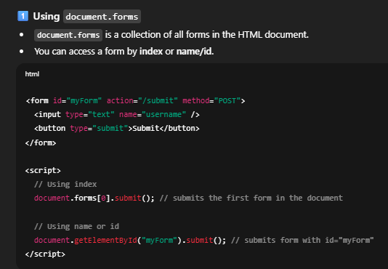
- What is a higher-order function in JavaScript?
A higher-order function in JavaScript is a function that either takes one or more functions as arguments, returns a function, or both.
Key Characteristics
- Accepts functions as arguments
- Returns a function as a result
- Can do both simultaneously
Example:
setInterval , setTimeout

- What is the difference between call() and apply() methods ?
Feature | call() | apply()
Arguments | Passed individually | Passed as an array
Use case | When you know the number of arguments | When you have arguments in an array or dynamically
Functionality | Same as apply, just different syntax | Same as call, just different syntax
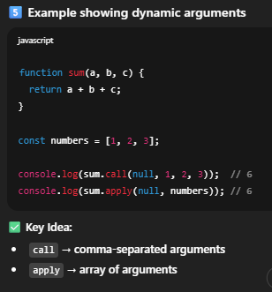
- Is JavaScript single-threaded or multi-threaded
- What is lexical scope in JavaScript?

- Explain how to read and write a file using JavaScript?
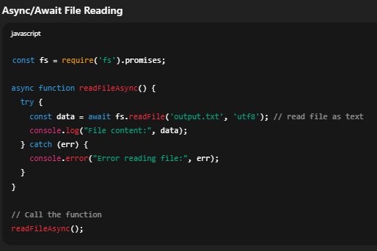
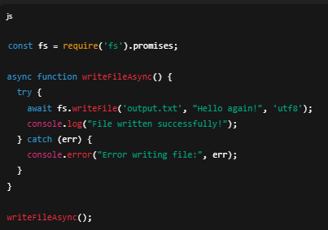
- What is called Variable typing in JavaScript?
The variable typing is the type of variable used to store a number and using that same variable to assign a “string”.
Geeks = 42;
Geeks = "GeeksforGeeks"

- What is the ‘Strict’ mode in JavaScript and how can it be enabled?
Strict mode in JavaScript is a feature that enables a stricter set of rules for writing JavaScript code.
It helps in catching common errors, prevents unsafe actions, and improves overall code quality.
It can be enabled by adding "use strict"; at the beginning of a script or function.
Example
1️⃣ Prevents undeclared variables
"use strict";
x = 5; // Error
2️⃣ Disallows duplicate parameter names
"use strict";
function sum(a, a) {} // Error
- What are the types of Pop up boxes available in JavaScript?
Popup Box | Purpose | Buttons | Return Value
Alert | Show message | OK | None
Confirm | Get confirmation | OK / Cancel | true / false
Prompt | Get user input | OK / Cancel | String / null
JavaScript provides three types of popup boxes: Alert, Confirm, and Prompt.
Alert displays a message, Confirm asks for user confirmation, and Prompt collects input from the user.

- Explain how to detect the operating system on the client machine?
To detect the operating system on the client machine, one can simply use navigator.appVersion or navigator.userAgent property.

Js coding question
https://www.geeksforgeeks.org/javascript/javascript-coding-questions-and-answers/

