- What is angular
Angular is a popular open-source web application framework used to build dynamic, single-page applications (SPAs). It is developed and maintained by Google.
🔹 Key Features of Angular
1. Component-Based Architecture
2. TypeScript-Based
3. Two-Way Data Binding
4. Routing
- What is bigger library or framework?
A framework is generally “bigger” than a library in terms of structure, control, and responsibility.
🔹 Simple Analogy
- Library = A toolbox 🧰
You pick tools when you need them.
- Framework = A house blueprint 🏠
It tells you how the whole structure should be built.
🔹 Biggest Difference in One Sentence
- Library → You call it.(react)
- Framework → It calls you.(angular)
A library is a collection of pre-written functions that I can call when needed.
A framework provides a complete structure for building an application and controls the overall flow of the program.
The main difference is Inversion of Control:
- In a library, I control the flow and call the library.
- In a framework, the framework controls the flow and calls my code.
In terms of scope, a framework is bigger and more opinionated, while a library is smaller and more flexible.

- Set Up
Issue faced:
Node version 25 and angular are not supporting
So I uninstall the node and install the nvm setup and I can not change the node version according to need
- nvm install 20
- nvm use 20.20.0
- npm i -g @angular/cli
- nvm list
- nvm use 20.20.0
- ng version
- ng serve (to run angular applications)
- ng new my-app
- ng generate component login // this will generate login component

- What is ng?
- ng is short for Angular.
- It’s used to create and manage Angular projects, generate components, services, modules, and run or build the application.

- What is CLI?
The Command Line Interface (CLI) is a text-based tool for interacting with a computer’s operating system using typed commands.

- What is Terminal?
- A terminal provides a console, which is a text-based interface where you type commands.
- It is not a graphical UI like buttons or windows—everything is typed.
- The terminal does not “do the work” itself; it just takes your typed commands and passes them to the CLI or operating system.

NOTE:
Terminal = where you type
CLI = tool that listens and acts
Command = specific instruction you give to the CLI

Commands vs CLI
- Command: A single instruction you type, like npm install or ng serve.
- CLI (Command-Line Interface): The program or tool that understands these commands and executes them.

- What is angular cli?
Angular CLI (Command Line Interface) is a tool you use in the terminal that understands your commands related to Angular and performs the required actions, like creating projects, generating components, running a development server, or building your app.

- What is Interpolation in Angular?
Interpolation is a way to display data from your component (TypeScript file) inside the HTML template.
Interpolation in Angular is a data binding technique that allows us to display component data in the template using double curly braces {{ }}.
It uses double curly braces:
{{ expression }}
Example:

📌 app.ts (component file)
export class AppComponent {
title = 'My Angular App';
}

📌 app.html (template file)
<h1>{{ title }}</h1>

👉 Output in browser:
My Angular App

Example:
<p>{{ 5 + 5 }}</p> <!-- 10 -->
<p>{{ title.toUpperCase() }}</p>

Limitation
1️⃣ Cannot use statements (like if, for)
❌
{{ if(age > 18) { return 'Adult'; } }}

2️⃣ Cannot use loops
❌
{{ for(let i = 0; i < 5; i++) {} }}

3️⃣ Cannot handle events
❌
<button>{{ saveData() }}</button>

Component flow
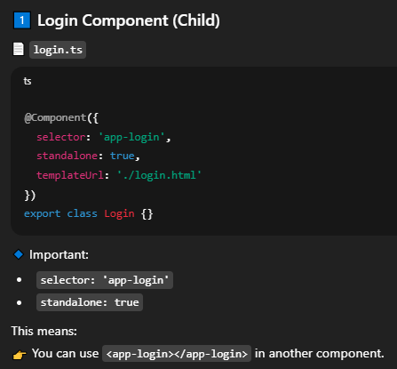
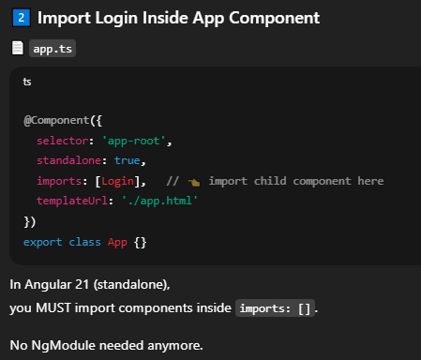
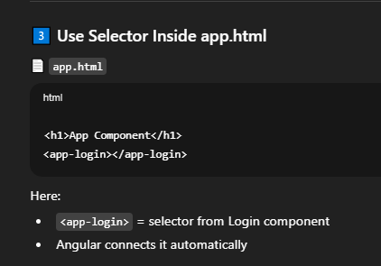
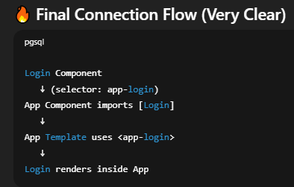

- Use of this
When we call a function inside another function in a class we use it.
Example:
export class App {
alertCalled(){
alert('alert called');
this.otherFunction();// use of this keyword to call other function in same
class
}
otherFunction(){
console.log('other function called');
}
}
We Write all the functions inside .ts file.
See difference between variable and property.
we cannot write variable inside class directly, we have to write it inside the method
if I write let name = ‘john’; // this will through an error.
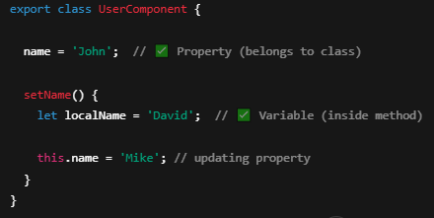
Type define
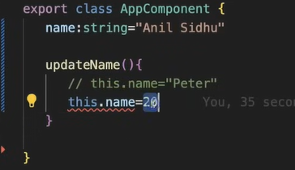
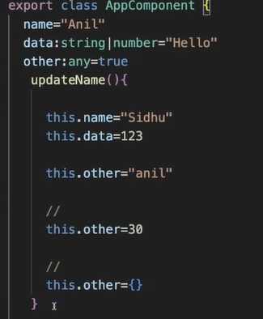
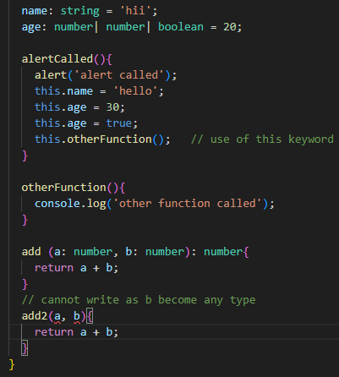
Counter app
Flow
Counter component
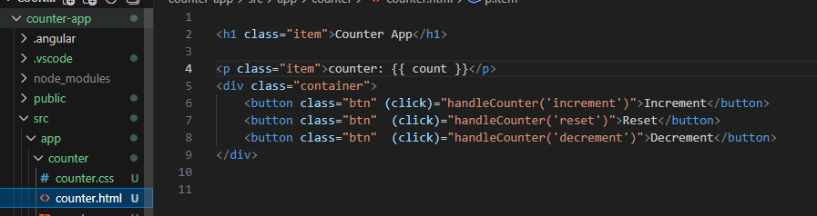
Then function is defined in counter.ts
export class Counter {
count:number = 0;

// handle using 3 function
increment(){
this.count= this.count + 1
}
decrement(){
this.count--;
}
reset(){
this.count = 0;
}
// ................................................................
// handle using one function
handleCounter(arglelo:string){
if(arglelo === 'increment'){
this.count++;
}else if(arglelo === 'decrement'){
this.count--;
}else if(arglelo === 'reset'){
this.count = 0;
}
}

Now connect to app component
In app.ts
@Component({
selector: 'app-root',
imports: [RouterOutlet, Counter],// import counter
templateUrl: './app.html',
styleUrl: './app.css'
})

And in app.html
<app-counter></app-counter>

Keep remember this syntax: (click)="handleCounter('increment')"
- What Are Events in Angular? (Simple Meaning)
An event is something that happens in the browser.
Examples:
- Clicking a button
- Typing in an input box
- Submitting a form
- Moving the mouse
Angular lets us listen to events and run a function when they happen.
🔹 Basic Syntax in Angular
<button (click)="sayHello()">Click Me</button>
👉 (click) is the event
👉 sayHello() is the function

🔹 Example 2 – Input Event
HTML
<input type="text" (input)="handleInput($event.target.value)">
<p>You typed: {{ text }}</p>

TypeScript
text = '';
handleInput(value: string) {
this.text = value;
}

- What is $event?
$event is a special Angular keyword.
It gives information about the event.
Example:
<button (click)="show($event)">Click</button>
show(event: Event) {
console.log(event);
}

- Difference Between (input) and (change)?
(input) → triggers every time user types
(change) → triggers when user leaves input field

Example:
<h1>event works!</h1>

<!-- click event -->
<button
name="clickevent"
class="clicking"
(click)="handleClick($event)">click event</button>

<!-- mouseenter event -->
<div
style="height: 50px; background: #000;"
(mouseenter)="handleMouseEnter($event)">mouse event</div>

<!-- input event -->
<input
type="text"
(input)="handleInput($event.target.value)"
placeholder="Enter text here"
>

export class Event {

// click event handler
handleClick(event: MouseEvent){
console.log(event);
console.log(event.target);
console.log(event.type)
}

// mouse enter event handler
handleMouseEnter(event: MouseEvent){
console.log(event);
console.log(event.target);
console.log(event.type)
}

// input event handler
handleInput(value: string){
console.log(value);
}
}

- What is template reference variable in Angular.
A template reference variable is a way to give a name to an element, component, or directive inside your HTML template so you can access it within that same template.
It is created using the # symbol.
🔹 Basic Syntax
<input type="text" #myInput>
- #myInput creates a reference
- myInput now refers to that input DOM element
Example:
<!-- (input)="handleEmailInput($event.target.value)" i m not using this -->
<input
type="email"
placeholder="Enter your email"
value="{{email}}"
#emailInput
>

<button (click)="getEmail(emailInput.value)">get Email</button>
<button (click)="setEmail()">set Email</button>
<p>Your email: {{email}}</p>

Logic
getEmail(val: string){
console.log(val);
this.email = val;
}

setEmail(){
this.email="abc@gmail.com";
}

- Styles
For global style in angular.json
"styles": [
"src/styles.css"
]
If we change the file name "src/theme.css" now theme becomes the global style

How to style inside .ts file
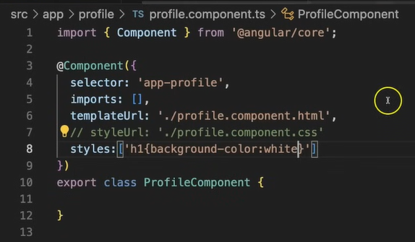

Using more than one global css in angular
In Angular.json add this
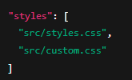
We can use multiple css using styleUrls in .ts file
styleUrls: ['./example.component.css', './example-custom.css']
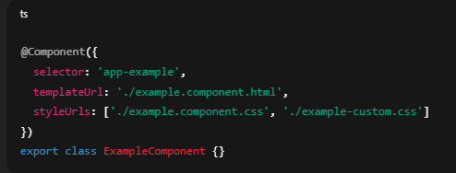

- Conditional Statements
✅ 1️⃣ IF – ELSE Example (@if)
🔹 TypeScript (component.ts)
status = 'success';

🔹 HTML (component.html)
@if (status === 'success') {
<p style="color: green;">Success Message</p>

} @else if (status === 'error') {
<p style="color: red;">Error Message</p>

} @else {
<p style="color: gray;">Unknown Status</p>
}

✅ 2️⃣ SWITCH Example (@switch)
🔹 TypeScript
role = 'admin';

🔹 HTML
@switch (role) {

@case ('admin') {
<p>Welcome Admin</p>
}

@case ('user') {
<p>Welcome User</p>
}

@default {
<p>Welcome Guest</p>
}

}

🎯 Very Simple Real Example
<input type="number" (input)="num = +$event.target.value">

@switch (num) {

@case (1) {
<div style="background:red; width:100px; height:100px;"></div>
}

@case (2) {
<div style="background:green; width:100px; height:100px;"></div>
}

@default {
<div style="background:gray; width:100px; height:100px;"></div>
}
- Loops in angular
🚀 2️⃣ @for (New Angular Control Flow – Angular 17+)
In newer Angular versions, @for is introduced as a modern replacement for *ngFor.
✅ Example
@for (user of users; track user.id) {
<li>{{ user.name }}</li>
}
With index:
@for (user of users; let i = $index) {
<p>{{ i }} - {{ user }}</p>
}
👉 @for is:
- Cleaner
- More readable
- Better performance
- Works great with Signals

- What is Singal
A Signal is a reactive state container that automatically updates the UI when its value changes.
When we say “Signal is a reactive state” in Angular, it means:
It stores a value and automatically reacts when that value changes.

Creating a Signal
import { signal } from '@angular/core';
count = signal(0);

Reading a signal
count(); // 0

Updating a signal
count.set(5);

Updating using previous value
count.update(value => value + 1);

You read a signal by calling it like a function → count()
Note:
Normal properties don’t update inside effect() because Angular only tracks signals for reactivity, not plain class variables.
Without Computed Signal
export class WithoutComputedSignal {

x = 11;
y = 22;

summ = this.x + this.y;

calculate(){
console.log(this.summ);
this.x = 200;
console.log(this.summ);
// the value of summ will not be updated,
// it will still be 33, because it is not a computed signal,
// it is just a regular variable
}
}
With Computed Signal
export class ComputedSignals {

x = signal(11);
y = signal(22);

// computed signal
sum = computed(() => this.x() + this.y());

ComputedSignalscalculate(){
console.log(this.sum());
this.x.set(33);
console.log(this.sum()); // updated
}

// we cannot directly set/update the value of a computed signal, it is read-only
// this.sum.set(44); // not allowed
// we can change the value of x and y, and the sum will be automatically updated
// that is by changing the values of dependent signals, the computed signal will be automatically updated
Computed Signal
Definition:
A read-only signal that derives its value from other signals.
Features:
- Cannot be updated manually
- Automatically recalculates when dependencies change

3️⃣ Effect Signal
Definition:
A function that runs side effects automatically whenever signals it depends on change.
Features:
- Doesn’t store a value
- Used for logging, API calls, DOM updates
- Automatically re-runs when dependent signals change
Types of signal summery
Type | Writable Signal | Computed Signal | Effect
Can update manually | ✅ | ❌ | ❌
Stores value | ✅ | ✅ (derived) | ❌
Reacts automatically | ✅ triggers dependents | ✅ recalculates | ✅ runs side effects
Example | count = signal(0) | sum = computed(() => x() + y()) | effect(() => console.log(count()))

Loops, index, odd, even, last, first
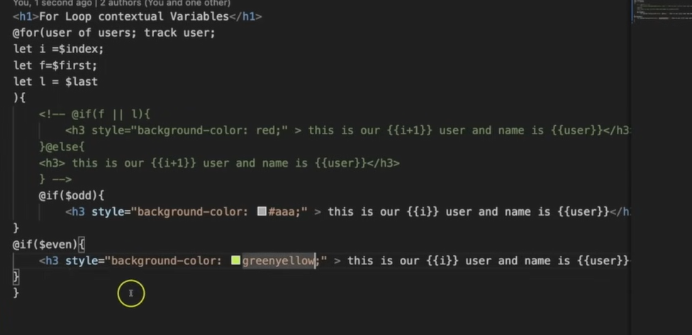
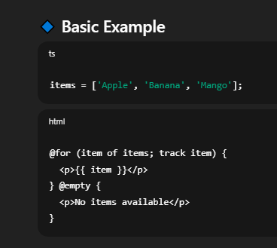
🔹 Available Contextual Variables
Variable | Meaning
$index | Current item index (0, 1, 2...)
$count | Total number of items
$first | true if first item
$last | true if last item
$even | true if index is even
$odd | true if index is odd

Two way Binding
Two-way data binding in Angular allows synchronization between the component (TypeScript) and the template (HTML).
When the data in the component changes → the view updates.
When the user updates the view → the component updates automatically.
How It Works?
Step 1
Import formModule and define a property(I define name )
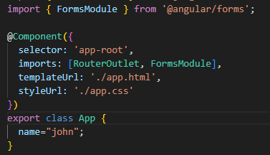
Step 2
[(ngModel)] = “name”
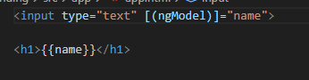

✅ ngModel
ngModel is a directive used for two-way data binding in Angular forms.
🔹 What ngModel Does
It connects:
- The input field (HTML)
- The component property (TypeScript)
So when one changes → the other updates automatically.

Directives
In Angular, directives are instructions in the template that tell Angular how to render or modify the DOM.

3️⃣ Attribute Directives
These change the appearance or behavior of an element but do NOT remove it.

✅ ngClass
<div [ngClass]="{ 'active': isActive }"></div>
Adds or removes CSS classes.

✅ ngStyle
<div [ngStyle]="{ color: isActive ? 'green' : 'red' }"></div>
Changes inline styles.

✅ ngModel (from FormsModule)
<input [(ngModel)]="task">
Creates two-way data binding.

3️⃣ Attribute Directives
These change the appearance or behavior of an element but do NOT remove it.

✅ ngClass
<div [ngClass]="{ 'active': isActive }"></div>
Adds or removes CSS classes.

✅ ngStyle
<div [ngStyle]="{ color: isActive ? 'green' : 'red' }"></div>
Changes inline styles.

✅ ngModel (from FormsModule)
<input [(ngModel)]="task">
Creates two-way data binding.

🔹 Angular 17+ New Syntax
You’re using:
@for(tasks of listOfItems; track tasks)
This is the new control flow syntax (Angular 17+), replacing *ngFor.
Equivalent to:
<li *ngFor="let tasks of listOfItems; trackBy: trackFn">

