OOPS
- What is OOPS
OOP (Object-Oriented Programming) is a programming paradigm based on the concept of objects.
- An object is a real-world entity (like Car, Student, Employee).
- An object contains:
  - Data (attributes / properties)
  - Functions (methods / behavior)
👉 OOP makes programs more modular, reusable, and easier to maintain.

- Difference between Procedural and OOP
Feature | C | C++
Programming Paradigm | Procedural (POP) | Object-Oriented (OOP) + Procedural
Approach | Function-oriented  top-down approach. | Object-oriented (class + object)  bottom-up approach.
Data Security | Low – data is globally accessible | High – data hiding using access modifiers
Access Specifiers | ❌ Not available | ✔ public, private, protected
Classes & Objects | ❌ Not supported | ✔ Fully supported
Encapsulation  Inheritance  Polymorphism  Abstraction | ❌ No | ✔ Yes
Function Overloading | ❌ No | ✔ Yes
Operator Overloading | ❌ No | ✔ Yes
Exception Handling | ❌ No | ✔ try–catch–throw
Standard Input/Output | printf(), scanf() | cout, cin
Memory Allocation | malloc, calloc, free | new, delete
File Handling | FILE* and stdio | fstream (more advanced)
Namespace Concept | ❌ No | ✔ Yes (namespace std)
Inline Functions | ❌ No | ✔ Yes
Low-Level Programming | Better for system-level code | Supports low-level + high-level OOP
Speed | Slightly faster (less abstraction) | Slightly slower (OOP overhead)
Use Case | OS, embedded systems, kernel | GUI apps, games, real-world modeling, competitive coding
Style | C = "Procedure → Function → Data"  e.g., FORTRAN, Pascal | C++ = "Object → Class → Data + Functions together"  e.g., java, python

Top-Down(C): Start with main problem → break into functions.
Bottom-Up(C++): Create small classes/objects → combine to build system.

- What is Class and Object?
- Class: A class is a blueprint for creating objects that defines data member and member functions.
- Class is a user-defined data type.
- Class does NOT occupy memory until an object is created.
- Object: An object is a real-world instance of a class. Its a Real world Entity.

❓ When is memory allocated?
👉 When an object is created, because objects hold actual data.

- Main Difference between Class and Struct.
“In C, struct cannot have functions.
In C++, struct can have functions — same as class — only default access differs.” struct is public and class is private.
Otherwise, both support functions, inheritance, constructors, etc.”

- Four Pillars of OOP
1. Encapsulation
- Wrapping data and methods into a single unit (class).
- Encapsulation means binding data and functions together and restricting direct access using access modifiers.
- Example
class Bank {
private:
int balance; // hidden data
public:
void deposit(int amount) {
balance += amount;
}
int getBalance() {
return balance;
}
};
class Bank {
private:
int balance; // hidden data

public:
void deposit(int amount) {
balance += amount;
}

int getBalance() {
return balance;
}
};

2. Abstraction
- Hiding implementation details and showing only necessary features.
- Achieved using abstract classes or interfaces (in C++ → pure virtual functions).
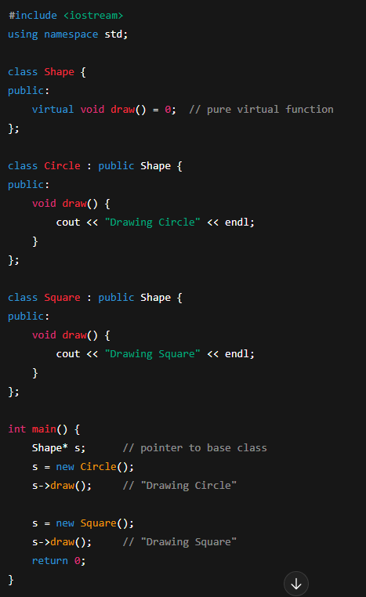

Abstract Class
A class that contains at least one pure virtual function.
Pure Virtual Function
A function declared but not defined in the base class:
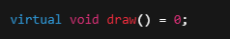

3. Inheritance
- Acquiring properties and behaviors of a parent class into a child class.
- Promotes reusability.
- To reuse code, reduce duplication, and support runtime polymorphism.
Type | Meaning
Single | One base → one derived
Multilevel | Base → Derived → Sub-derived
Multiple | Two or more bases → one derived
Hierarchical | One base → many derived classes
Hybrid | Combination (typically multiple + multilevel)

1. Single inheritance
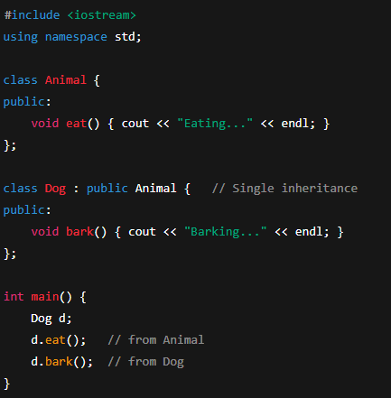

2. Multiple Inheritance
👉 One derived class inherits from more than one base class
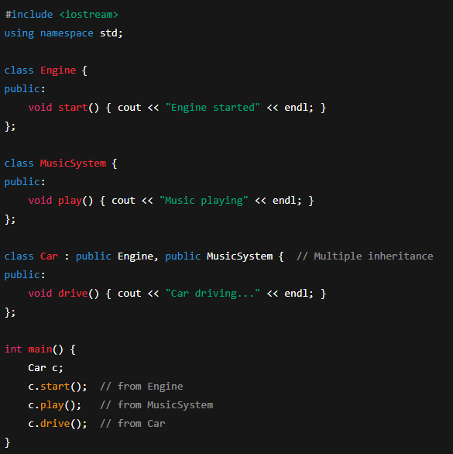

⚠ Problem: Diamond Problem may occur with multiple inheritance

3. Multilevel Inheritance
👉 A chain of inheritance (grandparent → parent → child).
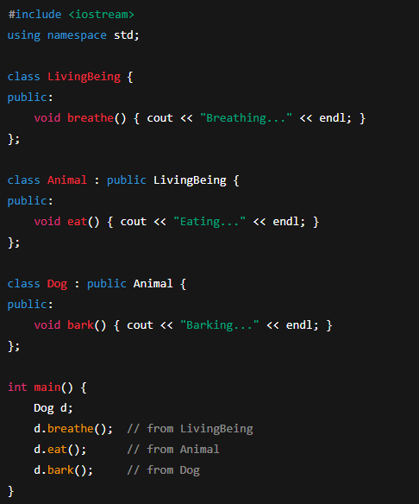

4. Hierarchical Inheritance
👉 Multiple derived classes inherit from one base class.
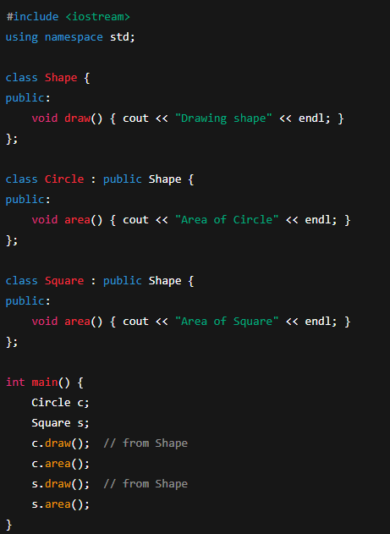
5. Hybrid Inheritance
👉 Combination of two or more types of inheritance.
Example: Diamond Problem (Multiple + Multilevel). 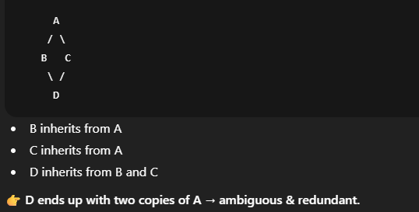
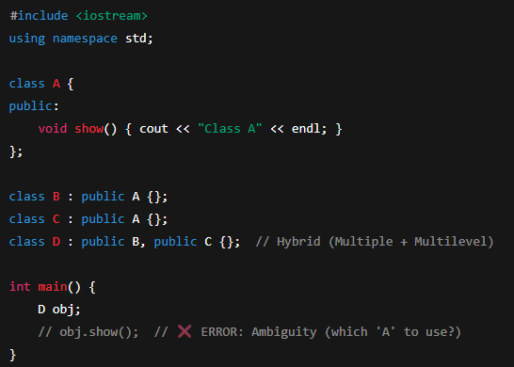
⚠ This causes ambiguity because D inherits A through both B and C.
So D has show method via A as well as via B.
👉 Solution: use virtual inheritance
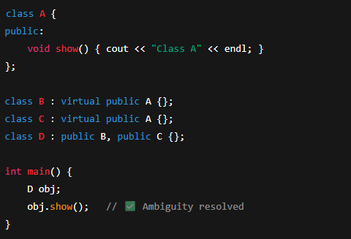
“The diamond problem occurs when multiple inheritance creates two copies of the same base class.
It is solved using virtual inheritance which ensures only one shared copy of the base class.”

Ambiguity Problem in C++
Ambiguity occurs in multiple inheritance when the compiler cannot decide which parent class’s member to use.
This happens when two or more base classes contain functions or variables with the same name.
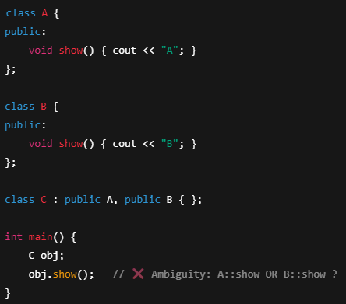
⭐ How to Solve Ambiguity
1️ Use scope resolution
obj.A::show();
obj.B::show();
Note: 👉 Simple name clash → use scope resolution.
👉 Not a diamond problem.
The derived class ends up with two copies of the base class. Use virtual

4. Polymorphism
- Same function name, different forms/behavior.
- Two types:
  - Compile-time (Function/Operator Overloading)
  - Run-time (Function Overriding via virtual functions)
- Example 1: (Compile-time Polymorphism)
Function overloading
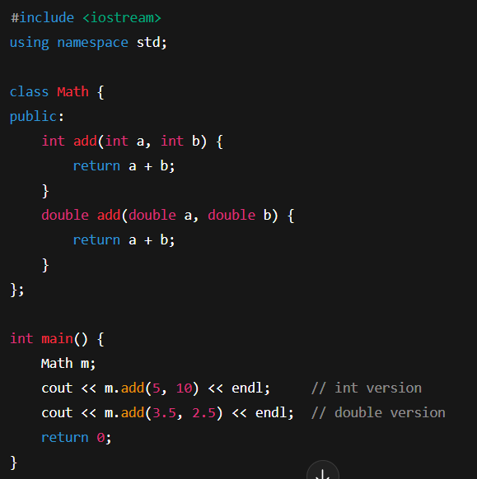
Operator Overloading(Runtime Polymorphism)
In C++, operators (+, -, *, ==, etc.) are just special functions with symbols as names.
Note: Templates (also resolved at compile time)

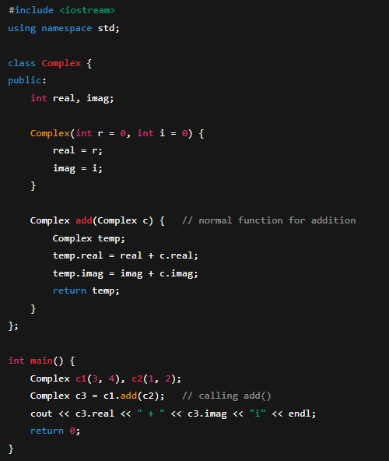
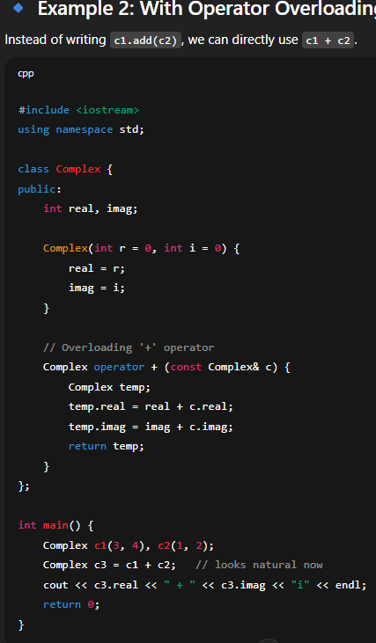
Without Operator Overloading
Suppose you want to add two complex numbers.
Works fine, but syntax is c1.add(c2), which is not very natural.
Key Points
- You can overload most operators (+, -, *, /, ==, [], (), ++, etc.).
- Some operators cannot be overloaded in C++:
  - :: (scope resolution)
  - . (dot operator)
  - .* (pointer-to-member)
  - sizeof
  - ?: (ternary operator)

(runtime Time)Function Overriding with Virtual Functions
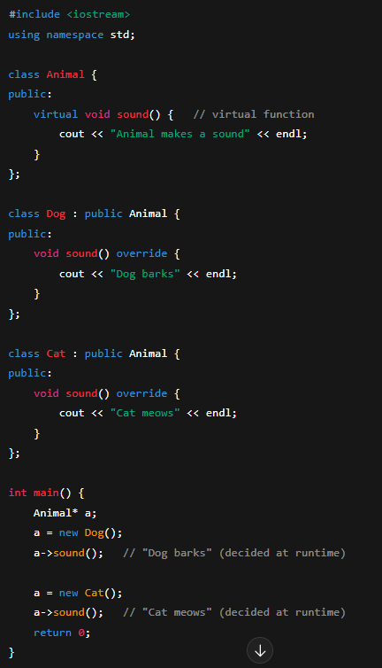

Feature | Compile-Time Polymorphism | Run-Time Polymorphism
Binding Time | Early Binding (at compile time)  Static Polymorphism(trick: CSE)  The decision of which function to call is made at compile time. | Late Binding (at runtime)  Dynamic Polymorphism  The decision of which function to call is made at runtime.
Achieved By | Function Overloading, Operator Overloading | Function Overriding (with virtual functions)
Inheritance | Not required | Required
Flexibility | Less flexible (fixed at compile time) | More flexible (decided at runtime)
Performance | Faster (no runtime overhead) | Slightly slower (due to virtual table lookup)
Example | int add(int a, int b) vs double add(double a, double b) | Animal* a = new Dog();  a->sound();

NOTE:
If they ask “Can a normal function be overridden?”, answer:
“No, only virtual functions can be overridden in C++. If you declare a normal function with the same name in the derived class, it results in function hiding, not overriding.”

⭐ Difference Between private and protected in C++
✅ 1. Accessibility
Access Specifier | Accessible Inside Same Class | Child Class | Outside Class
private | ✔ Yes | ❌ No | ❌ No
protected | ✔ Yes | ✔ Yes | ❌ No
Key difference:
- private cannot be accessed by derived classes
- protected can be accessed by derived classes
Private: Protected:
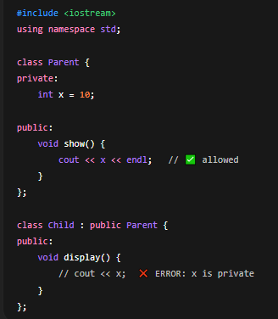
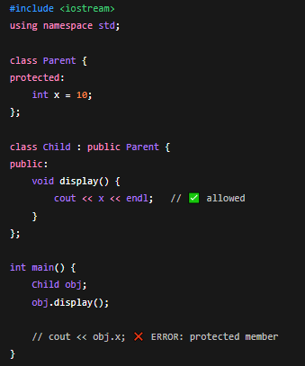
Inheritance
1️⃣ Public Inheritance
class Child : public Base
- Base public members → remains public in child
- Base protected members → remains protected in child
- Base private members → ❌ not accessible in child
2️⃣ Protected Inheritance
class Child : protected Base
- Base public members → becomes protected in child
- Base protected members → remains protected in child
- Base private members → ❌ not accessible in child
3️⃣ Private Inheritance
class Child : private Base
- Base public members → becomes private in child
- Base protected members → becomes private in child
- Base private members → ❌ not accessible in child

🤝 Friend Function in C++
A friend function is a function that is not a member of a class, but it can access the private and protected members of that class.
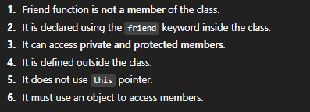
❓ Is friendship mutual?
No. If A is friend of B, B is not automatically friend of A.
❓ Is friendship inherited?
No. Friendship is not inherited.
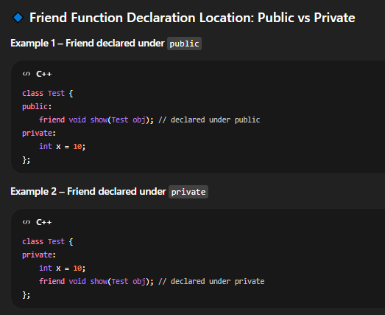
- Whether you declare a friend under public or private, it does not affect its access.
- It always has access to private and protected members.

Example:
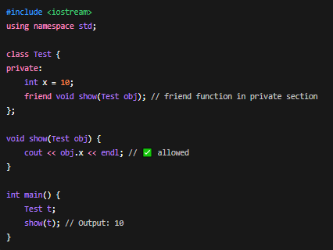

2️⃣ Friend Class
A friend class can access the private and protected members of another class.
Example:
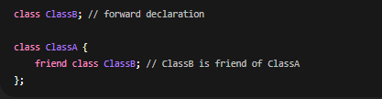
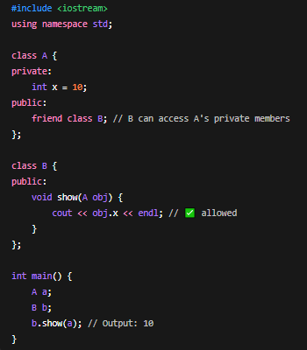

Static in cpp
Use Case | Behavior | How to Call / Access
Static Local Variable | Retains value across function calls | Directly by function name. No object needed. Example: counter();
Static Class Member (Variable) | Shared across all objects of the class | ClassName::memberName or object.memberName (preferred via class)
Static Member Function | Can access only static members, callable without object | ClassName::functionName()
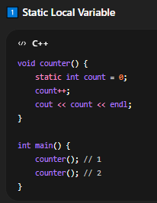
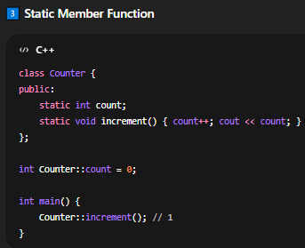
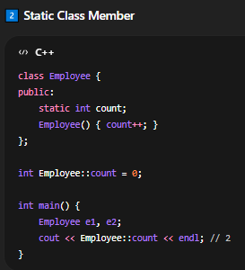

Copy Constructor in C++
A copy constructor is a special constructor in C++ used to initialize a new object as a copy of an existing object.
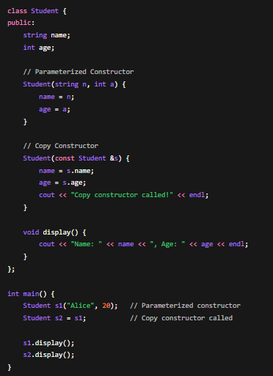
OutPut:
Copy constructor called!
Name: Alice, Age: 20
Name: Alice, Age: 20

Inline Function
Inline Function in C++ is a function where the compiler replaces the function call with the actual code of the function to reduce function call overhead.
Example:
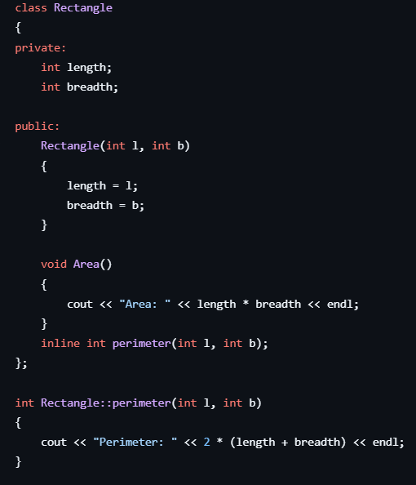
the code work without inline also.
Template in cpp
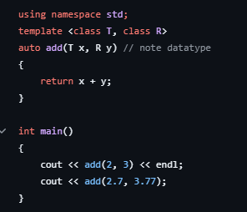
Destructor
A destructor is a special member function that is automatically called when an object is destroyed.
- Used to clean up resources (memory, files, etc.)
- Has the same name as the class but prefixed with ~
- No return type and no parameters
- Only one destructor per class
class Demo{
public:
Demo()
{
cout << "Constructor called" << endl;
}

~Demo()
{
cout << "Destructor called" << endl;
}
};

int main()
{
Demo d1;// Constructor runs here
// main() ends → d1 goes out of scope → Destructor runs here

cout << "End of main" << endl;

}

// output
// Constructor called
// End of main
// Destructor called

Pointer destructor
class Demo
{
public:
Demo()
{
cout << "Constructor called" << endl;
}

~Demo()
{
cout << "Destructor called" << endl;
}
};
int main()
{
Demo *p = new Demo();

delete p; // Destructor is called here (must call manually)
}

// Note that if we forget to call delete, the destructor will not be called, leading to a memory leak.
// we cannot overload the destructor like we do with constructors. Each class can have only one destructor.

