Typescript
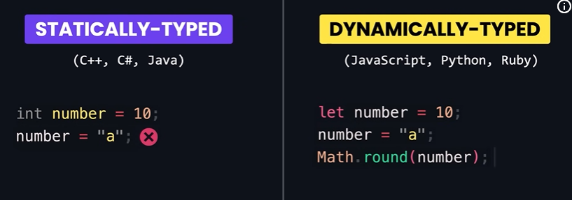
Typescript is JavaScript with Type Checking.
TypeScript is a strongly typed, transpiled superset of JavaScript developed by Microsoft.
It helps developers catch errors at compile time rather than runtime, making code more robust and maintainable.
Browser don’t understand typescript code so it transpiled into js
ts is superset of js as js all features + additional features.
2️⃣ Transpiled
- Transpilation is source-to-source conversion — converting code from one language (or version) to another at the same level.
- Example: TypeScript → JavaScript
  - Both are high-level languages, so TS is transpiled to JS.

How JavaScript Runs
- When you run JS in a browser or Node.js, a JavaScript engine (like V8 in Chrome/Node) converts JS into machine code at runtime.
  - This is called Just-In-Time (JIT) compilation.
- So JS eventually becomes machine code, but it’s done by the engine while running, not beforehand like C++ or Rust.
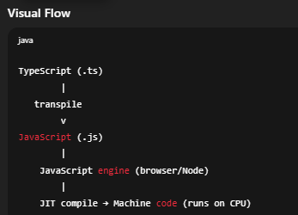
Difference between javascript and typescript.

Steps to configure and setup typescript
    - npm init -y
Command | Purpose
npm init -y | Create project config
package.json | What the project needs
npm i | Install what’s listed

    - ✔️ 1. Local (recommended for projects)
npm i -D typescript
✔️ 2. Global (optional convenience)
npm i -g typescript

for Local
-D (or -d) means
👉 --save-dev
👉 Install the package as a devDependency

    - What does npx tsc --init do?
👉 It creates a tsconfig.json file in your project.
That file is the TypeScript compiler configuration.
Uncomment these two
"rootDir": "./src",
"outDir": "./dist",

Then create two dir
Src for index.ts
And dist for js file
    - npx tsc
the js file will automatically created in dist

Feature | Type Inference | Type Annotation
Who provides type | TypeScript guesses | Developer writes it
Example | let age = 25; | let age: number;
Use case | Simple assignments | Complex cases / clarity

1️⃣ What is Type Narrowing?
Type Narrowing is when TypeScript figures out a more specific type from a broader type using checks or conditions.
- You start with a union type (or broad type)
- Then you narrow it down using if, typeof, instanceof, or custom checks
- After narrowing, TS knows the exact type and allows only the safe operations
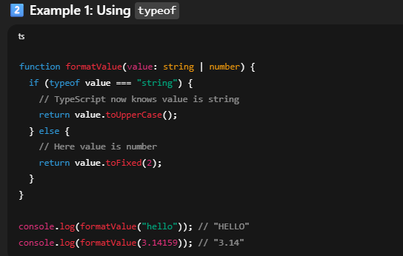
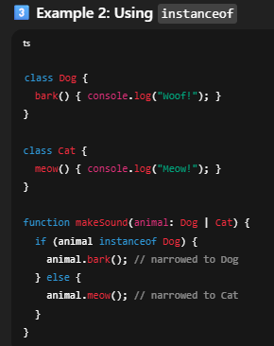

Difference between any and unknown?
