1. What is functional component?
A functional component is just a plain JavaScript function that returns JSX (the HTML-like code that describes what the UI should look like).
- State management: Functional components can use the useState Hook to manage state, so class components are no longer required for stateful logic.
- Lifecycle methods: Hooks like useEffect can replace lifecycle methods such as componentDidMount, componentDidUpdate, and componentWillUnmount.
Props in React allow functional components to receive data and behave dynamically.
2. What is react life cycle?
React lifecycle = different phases a component goes through from creation → update → removal.
1. Mounting Phase (Component is created)
👉 When component is added to the DOM for the first time.
Important methods:
- constructor() → initialize state
- render() → returns JSX (UI)
- componentDidMount() → API calls, subscriptions
📌 Shortcut to remember:
👉 “Create → Show → Fetch”

2. Updating Phase (State/Props change)
👉 Happens when data changes → component re-renders
Important methods:
- shouldComponentUpdate() → optimize performance
- render() → re-render UI
- componentDidUpdate() → run after update (API call, DOM update)
📌 Shortcut:
👉 “Change → Check → Update”

3. Unmounting Phase (Component removed)
👉 When component is removed from DOM
Important method:
- componentWillUnmount() → cleanup (timers, listeners)
📌 Shortcut:
👉 “Cleanup before leaving”
“Nowadays we use useEffect to handle lifecycle behavior in functional components.”
✔ It replaces:
- componentDidMount
- componentDidUpdate
- componentWillUnmount
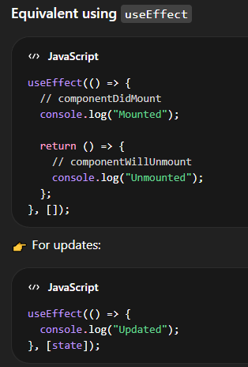
4. What are Hooks?
Hooks are functions in React that allow functional components to use state, lifecycle methods, and other features without writing classes.
5. What is useState hook
useState is a Hook used to create and manage state in functional components. “useState allows us to store and update data in a functional component.”
useState returns 2 things:
- Current state
- Function to update state
When state updates → component re-renders
👉 State can store ANY type of data
- number ✔
- string ✔
- array ✔
- object (JSON) ✔
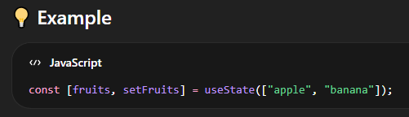
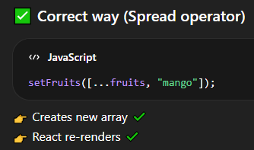
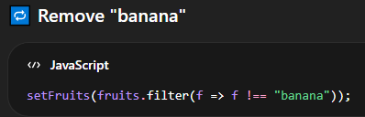
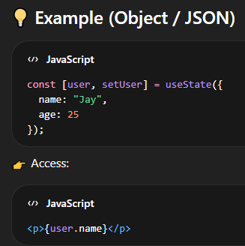
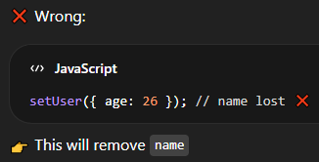
Age :26 will replace all data
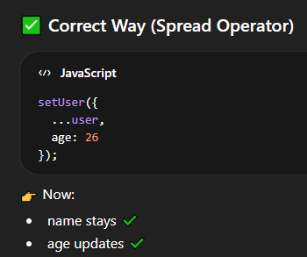
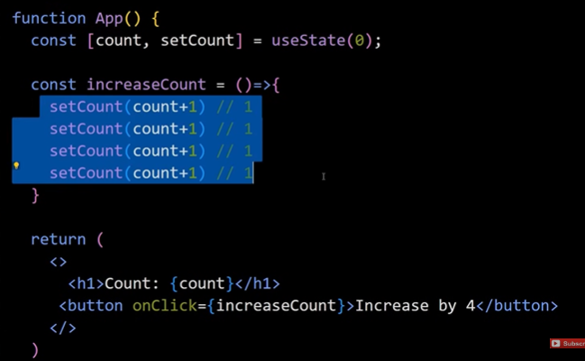
On click the count do not increase by 4
as count sets to 0 + 1 always
so we use
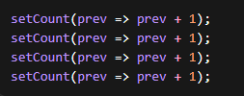
What is useEffect?
👉 useEffect is a Hook used to perform side effects in functional components.
“useEffect is used for handling side effects like API calls, timers, and lifecycle behavior in functional components.”
Syntax:
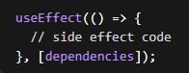
🎯 When is useEffect called?
👉 useEffect runs AFTER the component renders (after UI is shown).
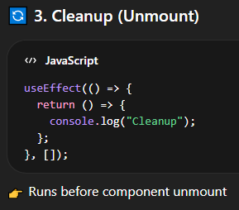
Dependency | Behavior
[] | Run once
[count] | Run on change
no array | Run every render 😵

What is useRef?
“useRef is used to persist values across renders and to directly access DOM elements without causing re-render.”
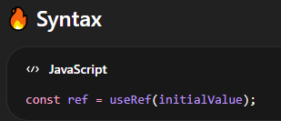
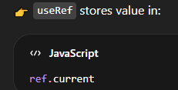

Accessing the DOM element
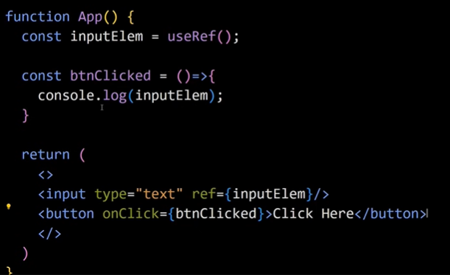
inputElem.current
if I want to select the para ele
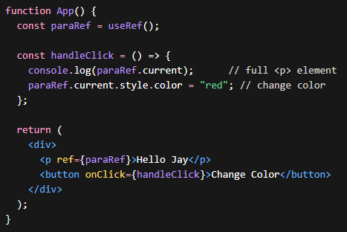
paraRef.current = real DOM element
👉 Works like document.getElementById but React way
Render happens initially, and re-render happens on state change, props change, or parent re-render.(not only iff state change as there is difference between state and props)

