- What are the possible ways to create objects in JavaScript.
  - Object Literals
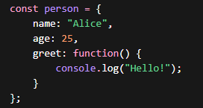

  - new Object() Syntax
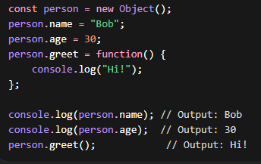

  - Constructor Functions
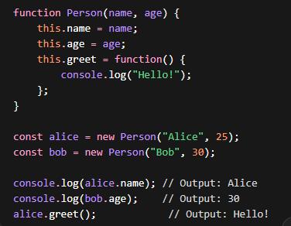 etc.

- Call, apply and bind method in js.
Call method
In JavaScript, the call() method is used to call a function with a specific this value(obj) and arguments passed individually.
Syntax
functionName.call(thisArg, arg1, arg2, ...)
- thisArg → the object you want this to refer to
- arg1, arg2... → a rguments passed to the function
Method | Arguments | Runs Immediately
call() | Separate | ✅ Yes
apply() | Array | ✅ Yes
bind() | Separate | ❌ No

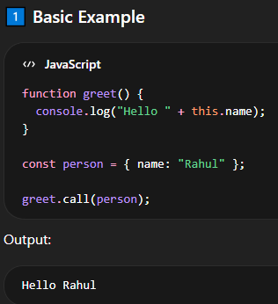
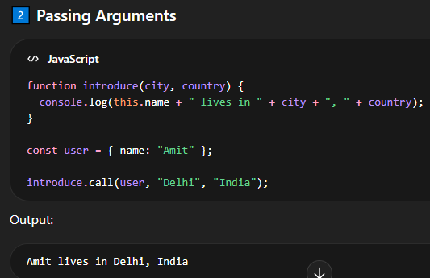
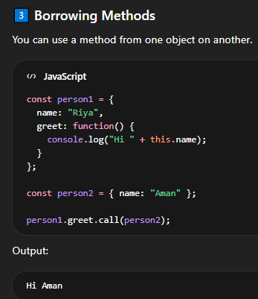
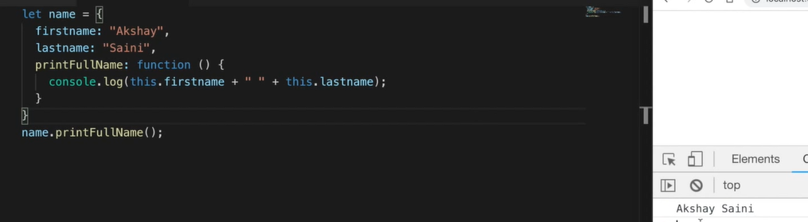
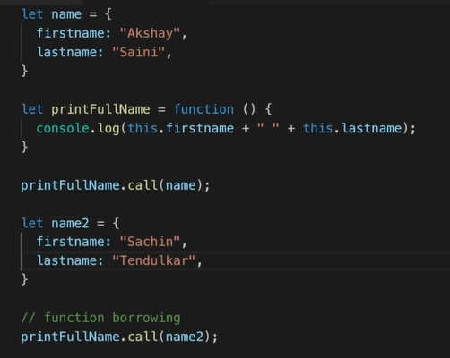


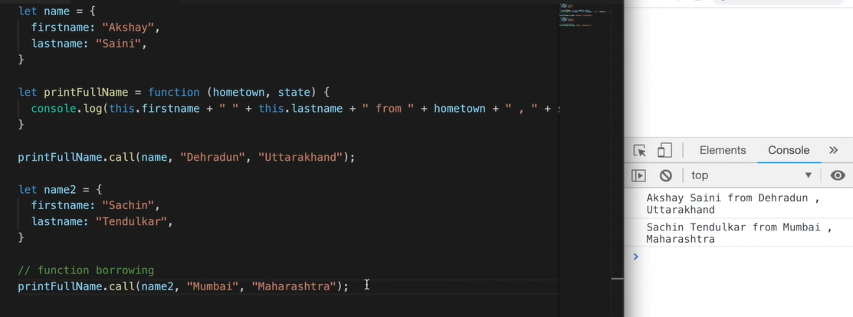

Apply and Bind Method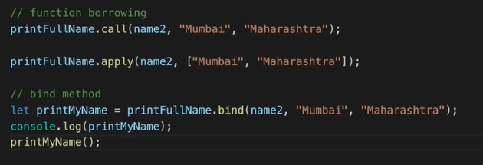
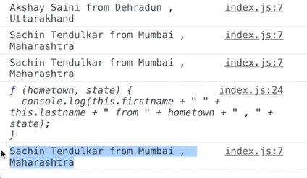
Feature | call() | apply() | bind()
Purpose | Calls a function with a specified this value | Calls a function with a specified this value | Creates a new function with this bound
Execution | Executes immediately | Executes immediately | Does not execute immediately
Arguments | Passed individually (comma separated) | Passed as an array | Passed individually
Return Value | Returns the function’s result | Returns the function’s result | Returns a new function
Use Case | When arguments are known separately | When arguments are in an array | When you need to call the function later with fixed this

What is Prototypes & Prototypal Inheritance in js?
Every JavaScript object has a hidden property called [[Prototype]] (often accessed with __proto__ or Object.getPrototypeOf()).
When you try to access a property:
- JavaScript first looks in the object itself.
- If it doesn’t find it, it looks in the object’s prototype.
- Then it looks in the prototype’s prototype, and so on.
This chain is called the Prototype Chain.
