Chess Board CSS Modification Assignment
This document explains the required CSS changes and includes screenshots from each major stage of the work. The final submitted HTML file is named final_chess_brick_wall.html.

1. left-offset class and wider board
I created a .left-offset CSS class with margin-left: 25px and applied it to the first cell of every row that starts with a dark cell. Since those rows now begin 25px farther to the right, I increased #chess-board from 400px to 425px so each shifted row still fits on one line. The result looks like alternating rows are staggered, almost like a brick pattern starting to form.
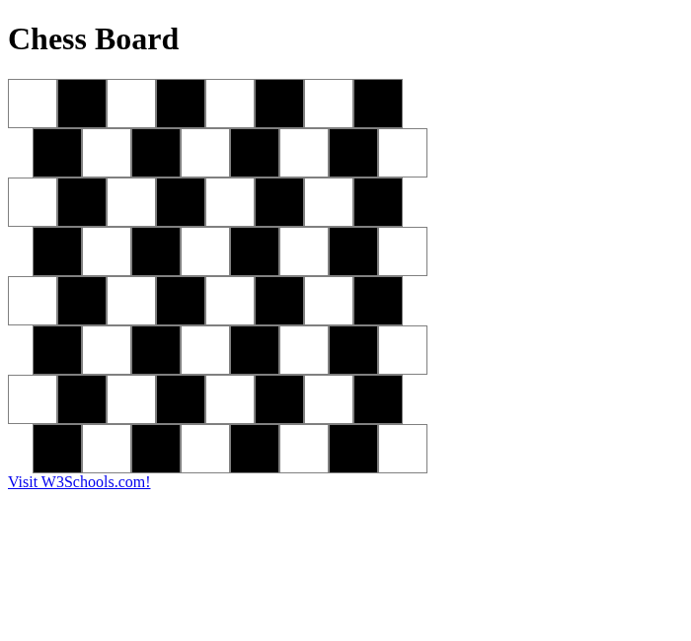
Screenshot: 1. left-offset class and wider board

2. Dark cells changed to yellow
I changed the .dark background color from black to yellow. The staggered layout stayed the same, but the board looks much brighter. The strange thing is that the original chess-board contrast is mostly gone: white and yellow are both light colors, so it no longer looks like a normal chess board.
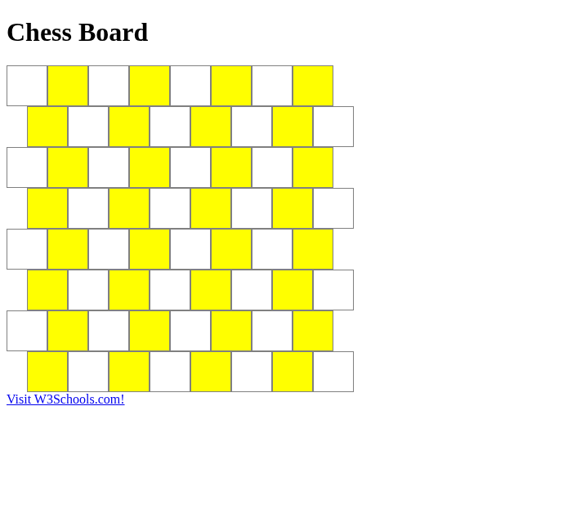
Screenshot: 2. Dark cells changed to yellow

3. Red and dark red colors from the video
The assignment asks for the red color at 10:00 and the dark red color 20 seconds later. I used the CSS named colors red for the light cells and darkred for the dark cells. This keeps the two cell types visible while changing the board into a red brick-like color scheme.
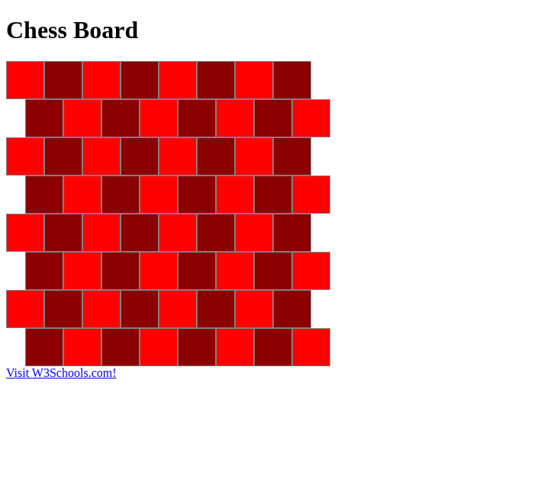
Screenshot: 3. Red and dark red colors from the video

4. half-width class instead of left-offset
I removed the .left-offset class completely and added a .half-width class with width: 25px. I placed a light half-width cell at the beginning of every row that starts with a dark cell, and at the end of every row that ends with a dark cell. This creates the same staggered visual effect without using margin-left.

5. Final brick wall styling
I reduced the cell height to 35px, added a 6px border-radius, and increased the border to 3px solid gray. The width and color properties stayed the same except for the required half-width cells. The final result looks less like a chess board and more like a brick wall because the rows are offset, the cells are shorter, and the rounded borders create brick-like gaps.
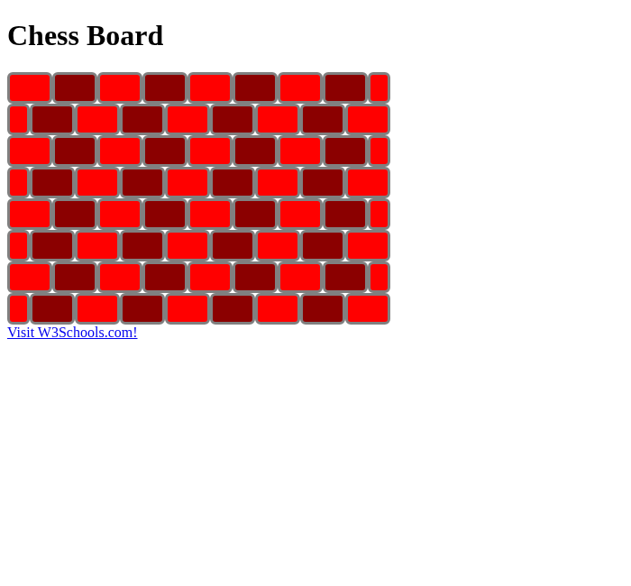
Screenshot: 5. Final brick wall styling

Final code summary
#chess-board width: 425px;
.cell height: 35px; width: 50px; border: 3px solid gray; border-radius: 6px;
.light background-color: red;
.dark background-color: darkred;
.half-width width: 25px;
Each row has eight normal cells plus one half-width light cell, either at the beginning or the end.

