Password is root.

\l – view all databases

\c <databasename> - connect to a different database

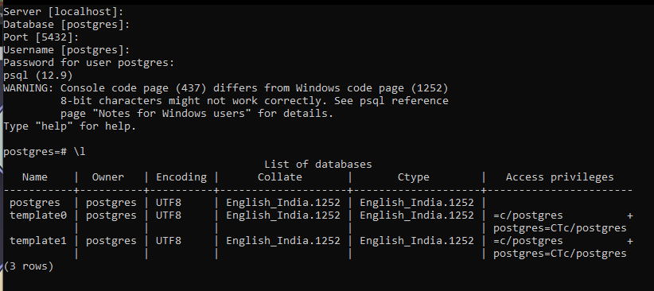

Creating database and switching

Create database <dbname>

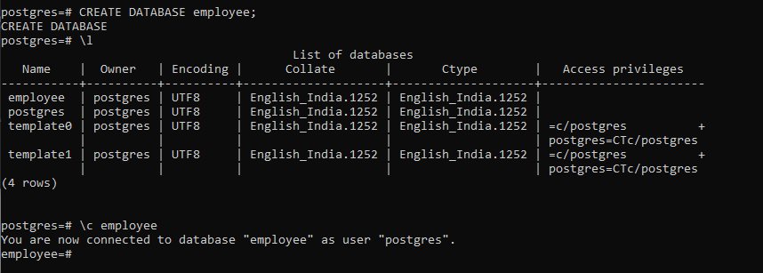

Drop database <databasename>



CREATE TABLE person(id int, name varchar(10), age int, salary int, doj date);

\d – List of tables

\d <tableName> - describes that table

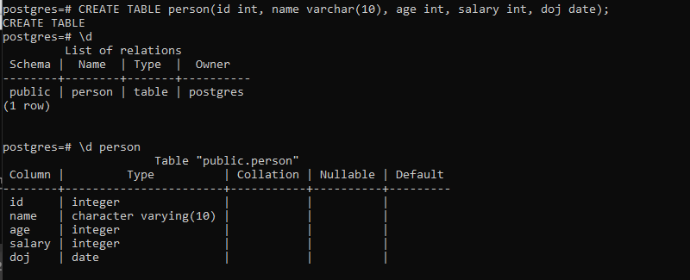

DROP TABLE <tableName> - To drop the table.

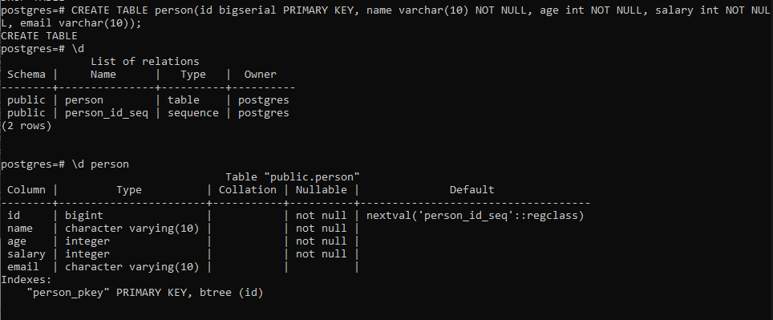

Inserting into the table

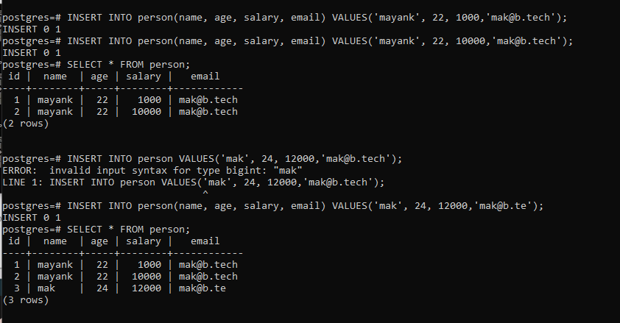

Updating a record

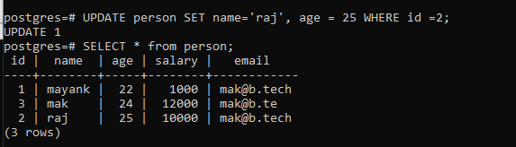

Employee database:

<http://www.cems.uwe.ac.uk/~pchatter/resources/html/emp_dept_data+schema.html>

Day -2

CREATING DATABASE and the employee table

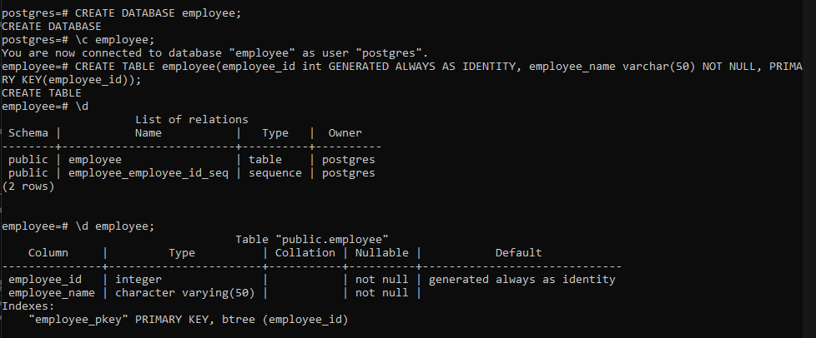

CREATING department table

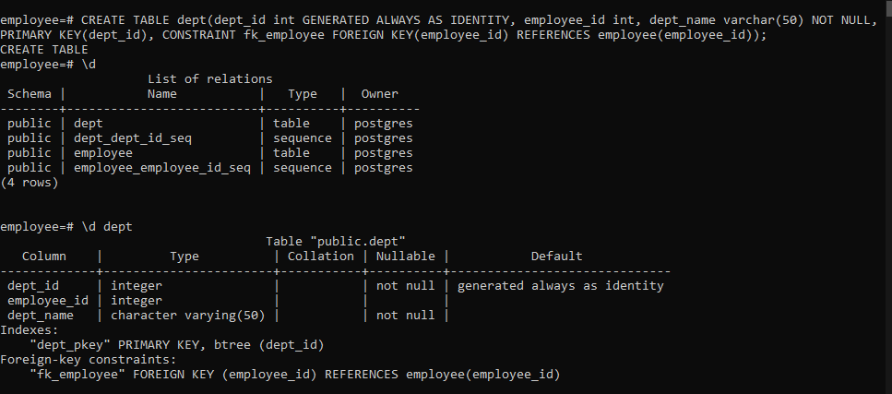

Inserting into employee

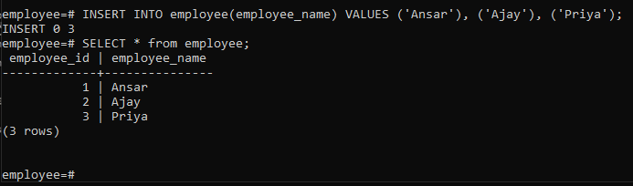

Inserting into dept table. Also note that inserting a employee_id that is not in employee table, gives us an error.

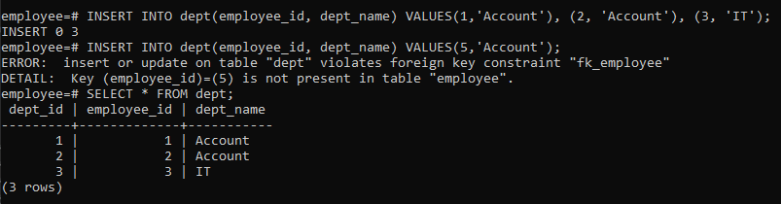

Inner join

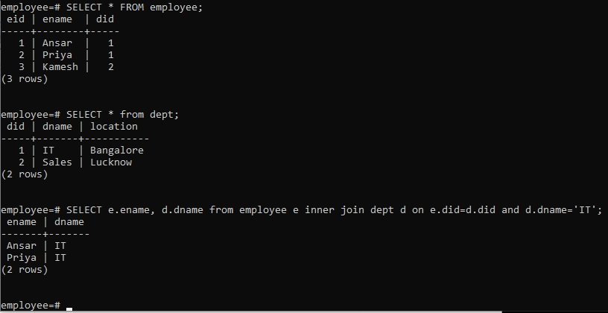

Advanced SQL commands:

Date and time commands:

1. SHOW TIMEZONE – Shows your current timezone
2. SELECT NOW() – Timestamp with timezone
3. SELECT TIMEOFDAY() – Same information as NOW() but in a better format.
4. SELECT CURRENT_TIME – Just the time with timezone.
5. SELECT CURRENT_DATE – Gives Current date.

Extracting information from a time based data type using:

1. EXTRACT() – Allows to extract a sub component of a date value.

SELECT EXTRACT(YEAR FROM payment_date) from payment; - outputs the year. You can extract year, month, quarter, week, day.

1. AGE() – Calculates and returns the current age given a timestamp.

SELECT AGE(payment_date) from payment;

1. TO_CHAR() – General function to convert data types to text. Useful for timestamp formatting.

SELECT TO_CHAR(payment_date, 'MM-YYYY') from payment;

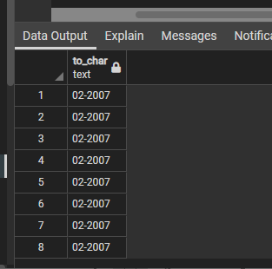

<https://www.postgresql.org/docs/9.5/functions-formatting.html> - all different formats.

Challenge 1

SELECT DISTINCT TO_CHAR(payment_date, 'Month') from payment;

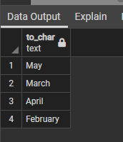

Challenge 2

SELECT COUNT(*) from payment where TO_CHAR(payment_date, 'DAY') = 'MONDAY ';

Or

SELECT COUNT(*) from payment WHERE EXTRACT(dow FROM payment_date) = 1;

Update account_job SET hiredate=account.created_on from account where account_job.user_id = account.user_id; - Update join