Students Performance Dashboard

Case Study Report
Report Date: December 7, 2025 | Academic Year: 2025–2026

Story 1 — Business Insights & Analysis

1. Case Study Title

Students Performance Analysis Dashboard

2. Objective of the Case Study

The objective of this case study is to evaluate and understand student academic performance across departments, semesters, and gender using various KPIs to support data-driven academic decisions.

3. Key KPIs / Metrics Analyzed

Metric | Value
Total Students | 500
Average Marks | 71.53
CGPA | 7.15
Internal Marks Total | 5,270
External Marks Total | 16,000
Gender Distribution | 52.8% Male, 47.2% Female
Departments | CSE, ECE, ME, CE

4. Insights Observed

1. ECE department records the highest average marks.

2. Mechanical Engineering (ME) holds the highest total score across all departments.

3. Student gender distribution is nearly balanced with males at 52.8% and females at 47.2%.

4. Semesters 1 and 2 show the strongest academic performance.

5. Semester 6 marks the lowest dip in average performance (69.2).

6. Final semester (8th) shows a major improvement (76.9).

7. CSE and CE departments show consistent but moderate average marks.

Visual Insights
Gender Distribution Chart:
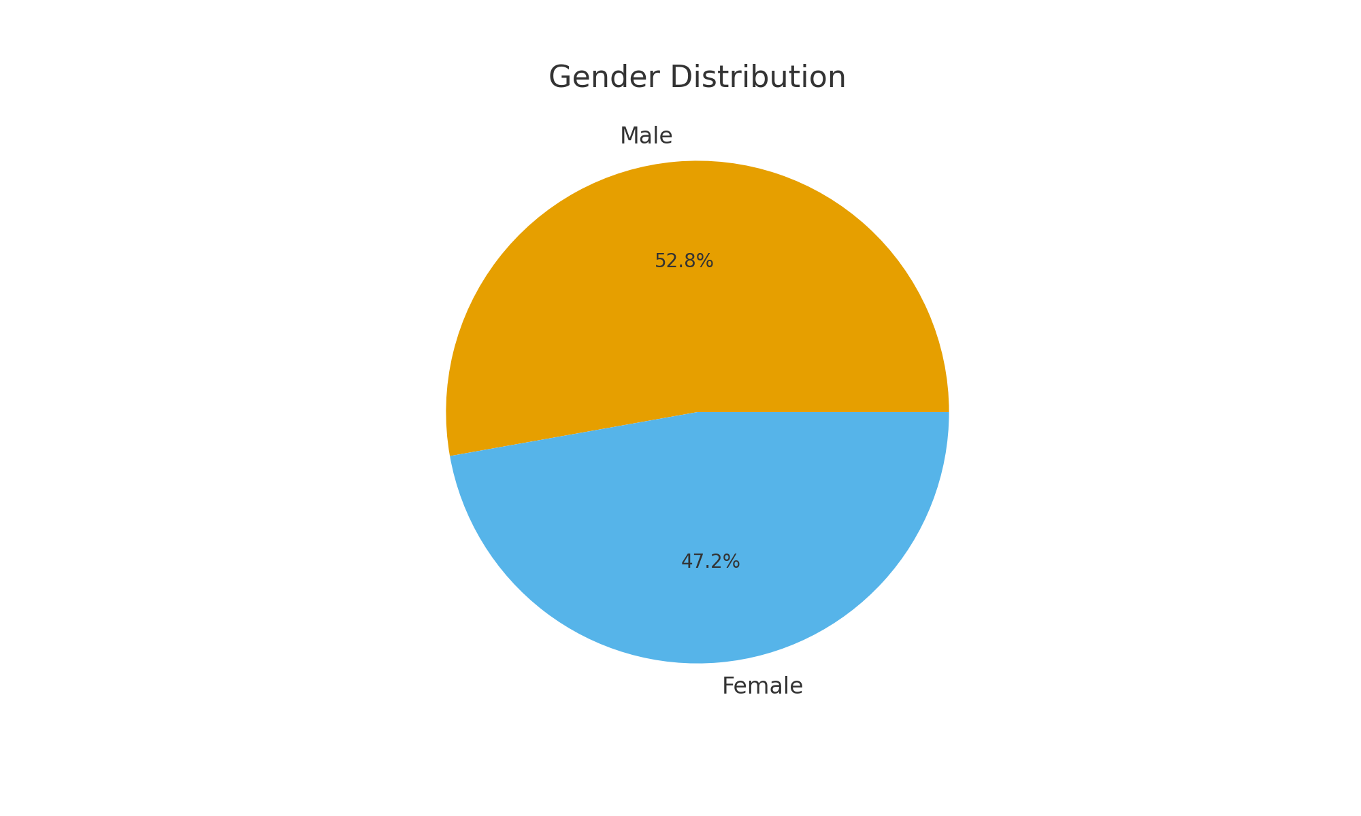
Department Average Marks:
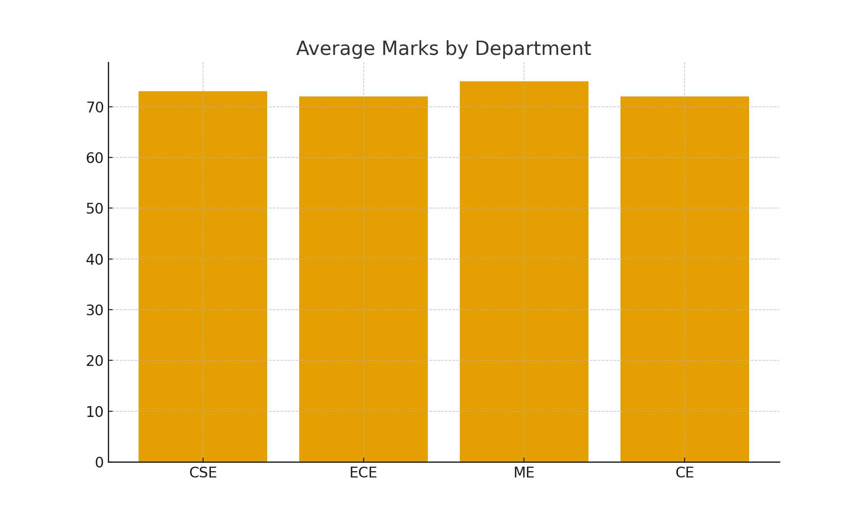

Story 2 — Technical Implementation Using Power BI

Power BI Desktop — Data Import & Setup
- Imported dataset of 500 students.
- Validated fields (StudentID, Dept, Semester, Marks, Gender, CGPA).
- Created KPI measure tables & dimension tables.

Power Query — Transformations Applied
- Removed duplicates
- Ensured proper data types
- Created custom columns (TotalMarks, PerformanceCategory)

Power Pivot — Data Modeling
Table Specifications:
Table Name | Type | Description
Student Performance | Fact | Contains 500 student records with marks, CGPA, and scores
Department | Dimension | Lists 4 departments: CSE, ECE, ME, CE
Semester | Dimension | Sequential list of 8 semesters

- Many-to-One relationships created
- Calculated fields added

4.Power View — Visualization Used
Visual Type | Where Used | Why Used (Purpose)
Card Visuals | KPI Summary Section | Displays key metrics (500 students, 5270 internal marks, 16K external marks, 71.53 avg, 7.15 CGPA) clearly and prominently
Bar Chart | Average Marks by Department | Compares performance across 4 departments side-by-side for easy departmental benchmark analysis
Bar Chart | Total Score by Department | Shows cumulative contribution by each department for resource and performance trending
Donut Chart | Total Students by Gender | Visualizes gender distribution (52.8% M, 47.2% F) as proportional representation
Line Chart | Average Marks by Semester | Tracks performance trends across 8 semesters, highlighting peaks (Semester 1,8) and dips (Semester 3)
Slicer Filter | Department Dropdown | Allows interactive filtering of all visuals by specific department for detailed department-level analysis

DAX Measures Created
- Total Students
- Average Marks
- Internal Marks Total
- External Marks Total
- CGPA Average
- Male Count
- Female Count

Final Insights Summary
- Balanced performance across departments.
- Semester 3 requires academic support.
- Strong final semester outcomes.
- Gender distribution balanced.
- Dashboard helps data-driven planning.

Conclusion
Key Dashboards Included:
- Dashboard 1 - Executive Summary: High-level KPI cards, departmental comparisons, gender distribution overview
- Dashboard 2 - Performance Analytics: Semester-wise trend analysis, detailed departmental breakdowns, interactive filters by department
Summary of Final Insights:
The Students Performance Dashboard successfully visualizes academic performance across 500 students, revealing consistent cross-departmental standards, strong initial performance, mid-course challenges requiring intervention (Semester 3), stabilization in middle semesters, and exceptional final semester excellence. The near-perfect gender balance (52.8% M, 47.2% F) validates inclusive practices. Overall CGPA of 7.15 demonstrates good academic standing. The dashboard enables data-driven decisions for curriculum optimization, targeted student support, and resource allocation to enhance institutional performance.
