ACE ENGINEERING COLLEGE

ONE-WEEK TECHNICAL PROJECT REPORT

Project Title: Personal Finance Tracker

Submitted by: Adithya Salaka
Roll Number: 24AG1A05B8
Branch and Year: Computer Science and Engineering, B.Tech. III Year I Semester
Academic Year: 2026

Project Duration: 15 October 2026 to 21 October 2026 (7 Days)
Project Guide / Mentor: Satish Bhaskar
Organization / Training Institute: ACE Engineering College

Submitted to the Department of Computer Science and Engineering

TABLE OF CONTENTS
1. Certificate
2. Acknowledgement
3. Abstract
4. Introduction
5. Objectives of the Project
6. Problem Statement and Scope
7. Tools and Technologies Used
8. System Design / Methodology
9. Day-Wise Progress Report
10. Implementation and Results
11. Learning Outcomes
12. Challenges Faced and Solutions
13. Conclusion and Future Scope
14. References
15. Appendices / Supporting Evidence
16. Mentor Evaluation Sheet

1. CERTIFICATE (FOR SIGNATURE)
This report records the Personal Finance Tracker project submitted by Adithya Salaka (Roll Number 24AG1A05B8), Computer Science and Engineering, B.Tech. III Year I Semester, ACE Engineering College, under the guidance of Satish Bhaskar. The reporting window supplied for this seven-day project is 15 October 2026 to 21 October 2026. The implementation commits currently preserved in the repository are dated 20 October 2026. This certificate is pending mentor and departmental verification.
Signature of Project Mentor: ____________________
Signature of Department Project Guide: ____________________
Date: ____________________ Place: ____________________

2. ACKNOWLEDGEMENT
I express my gratitude to ACE Engineering College and the Department of Computer Science and Engineering for the academic setting in which this Flutter lab project was completed. I thank project guide Satish Bhaskar for guidance and review, and my faculty and peers for their support during the project. I also acknowledge the Flutter, Dart, Provider, and Frankfurter documentation used while implementing and verifying the application.

3. ABSTRACT
This project implements a responsive Personal Finance Tracker as a Flutter and Dart application for recording income and expenses. Its purpose is to demonstrate how a mobile-oriented interface can combine form handling, shared state, financial summaries, navigation, and a small REST API exercise. The application is organized into Dashboard, Transactions, and Analytics screens. Users can add, edit, and delete entries; form validation requires a description and a positive amount with no more than two decimal places. Provider-backed FinanceController state calculates income, expenses, balance, and category totals using integer paise. The interface adapts its navigation and summary layout to viewport width, supports light and dark themes, and animates balance changes while respecting reduced-motion preferences. Analytics fetches a dated USD/INR reference rate from Frankfurter and provides loading, error, and retry states. Static analysis completed without issues and the automated suite passed 18 tests. Transactions are held in memory; sample values are illustrative, reset after restart, and are not connected to a bank.

4. INTRODUCTION
Personal finance applications turn a ledger of income and expenses into information that is easier to review. A useful tracker needs clear totals, consistent transaction editing, understandable categories, and layouts that work on narrow and wide screens. This project applies Flutter widgets, responsive constraints, Navigator named routes, and Provider state management to those needs. The dashboard summarizes the ledger, the transaction screen supports basic CRUD operations, and Analytics groups expenses by category. A public exchange-rate request is included as a separate API demonstration. The application is a lab prototype: entries are local in-memory data, and no banking or account service is involved.

5. OBJECTIVES OF THE PROJECT
The objective is to build and verify a responsive Flutter finance tracker that demonstrates the ten CS506PC lab experiments through a coherent application: Dart fundamentals; widget composition; responsive layouts; named routes; Provider state; reusable components and themes; validated transaction forms; accessible balance animation; REST API integration; and testing and debugging.

6. PROBLEM STATEMENT AND SCOPE
Problem statement: A basic income-and-expense ledger can be difficult to review when totals, transaction details, and category spending are shown separately or are not recalculated consistently.
Scope: The prototype provides an in-memory ledger, calculated dashboard totals, transaction add/edit/delete, category analytics, theme selection, responsive navigation, and a dated USD/INR reference rate. It does not provide authentication, persistent storage, budgets, bank connectivity, or a live trading quote.

7. TOOLS AND TECHNOLOGIES USED
Tool / Technology | Purpose | Version / Details
Flutter / Dart | Flutter UI, Dart logic and tests | Dart SDK constraint ^3.13.1; installed Flutter version not recorded
Provider | Shared ChangeNotifier application state | pubspec constraint ^6.1.5+1
intl | INR currency and date formatting | pubspec constraint ^0.20.3
fl_chart | Dashboard spending chart | pubspec constraint ^1.2.0
http | Frankfurter USD/INR request | pubspec constraint ^1.6.0
Flutter test / analyzer | Widget, controller and API checks | 18 tests passed; analyzer clean

8. SYSTEM DESIGN / METHODOLOGY
Requirements and existing code were reviewed first. Flutter screens and named routes were built around a Provider FinanceController and in-memory transaction model. Form and exchange-rate inputs are validated; dashboard and analytics values derive from shared state. Responsive layouts and service states were checked with Flutter analysis, tests, and web output captures.
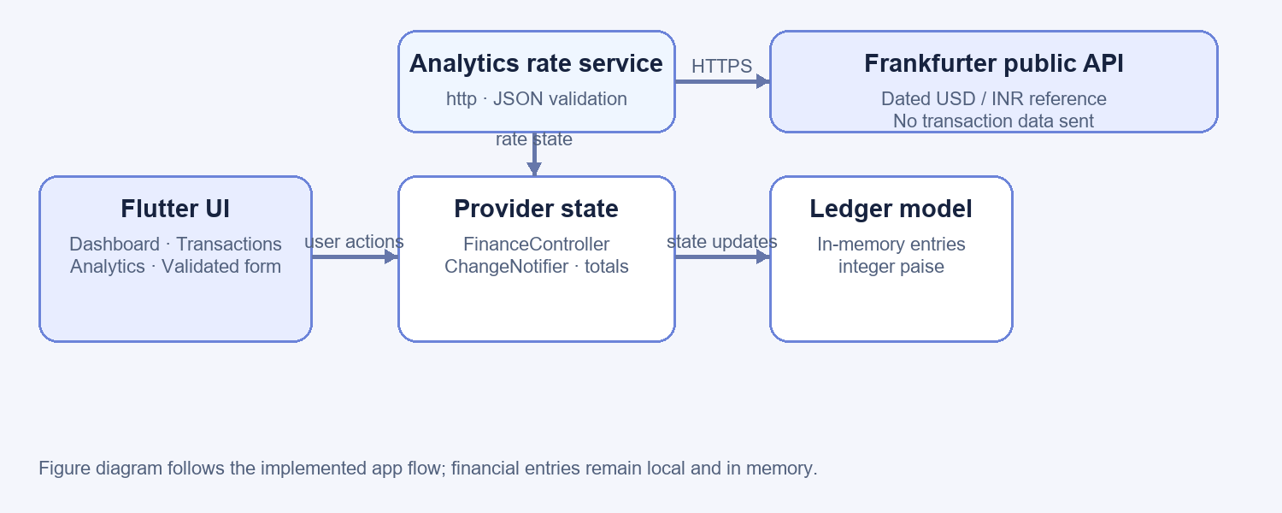
Figure 1. Application architecture and exchange-rate data flow.

9. DAY-WISE PROGRESS REPORT
Day | Activities Performed | Deliverables / Outcomes
Day 1 | Review the lab brief, existing repository, Dart types, collections and functions. | Requirements mapped; standalone Dart basics demonstration verified.
Day 2 | Build Flutter widgets, dashboard sections, reusable cards and local empty-state asset. | Dashboard and widget composition implemented.
Day 3 | Add responsive summary grids and navigation behavior for narrow and wide layouts. | Mobile and desktop layouts captured and checked for overflow.
Day 4 | Add named routes, transaction model and Provider-backed shared ledger state. | Dashboard, transactions and analytics read consistent calculated totals.
Day 5 | Implement add/edit/delete forms, validation, categories, dates and theme switching. | Transaction operations and theme changes covered by widget tests.
Day 6 | Add reduced-motion balance animation and the dated USD/INR REST integration. | API loading, success, failure and retry states; response validation tested.
Day 7 | Run final analysis and tests; record screenshots, README evidence and report results. | Analyzer clean; 18 tests pass; commits recorded on 20 Oct 2026.
Log note: Day 1–Day 7 are sequence labels for the user-supplied reporting window of 15–21 October 2026. Git history records the implementation commits on 20 October 2026; the repository does not assign separate commit dates to each day label.

10. IMPLEMENTATION AND RESULTS
The dashboard presents calculated net balance, income, expenses, recent activity, and a seven-day spending chart. Transactions can be added, edited, or deleted using a validated form. Named routes connect Dashboard, Transactions, Analytics, and the form; Provider refreshes the screens when ledger state changes. LayoutBuilder switches summary cards between one, two, and three columns, while app navigation changes from bottom bar to sidebar on wider screens. Light and dark themes share reusable widgets. AnimatedSwitcher transitions balance updates and honors the platform reduced-motion setting. Analytics groups expense totals and fetches a dated Frankfurter USD/INR reference rate. The API service validates the response and has loading, failure, timeout, and retry behavior. Sample transactions are clearly identified as demo data and are not persistent.
Result / Observation: Demo ledger totals are income ₹45,000.00, expenses ₹4,720.00, and net result ₹40,280.00. The captured API response on 20 October 2026 is 1 USD = ₹94.85 INR. Flutter analysis reported no issues; all 18 automated tests passed. Output screenshots and command logs are listed in the appendices.

11. LEARNING OUTCOMES
The project applies Dart types, collections, classes, and functions; composes Flutter layouts from reusable widgets; uses LayoutBuilder for responsive behavior; and connects named routes to Provider-backed state. It also practices input validation, safe integer-based currency arithmetic, theme management, reduced-motion animation, asynchronous HTTP handling, JSON validation, widget and controller tests, and reading analyzer output. The ten course lab experiments are demonstrated in one maintainable application.

12. CHALLENGES FACED AND SOLUTIONS
Challenge | Action / Solution | Outcome
Responsive card overflow | Use width breakpoints and adaptive summary columns. | Mobile and desktop widget layouts pass without overflow.
Consistent totals after edits | Centralize ledger updates in FinanceController; store paise as integers. | Dashboard, transaction list and analytics recalculate from shared state.
Unreliable or malformed API data | Apply an 8-second timeout, validate JSON fields, and expose retryable error states. | Success, HTTP failure, malformed response and retry paths are tested.

13. CONCLUSION AND FUTURE SCOPE
Conclusion: The project met its application goals by demonstrating transaction entry and editing, calculated summaries, analytics, responsive navigation, two themes, a guarded exchange-rate API request, animation, and automated verification. The saved Flutter analysis log is clean, and the complete test suite passed 18 tests. The screenshots show the running web app at mobile and desktop widths.
Future scope: Add persistent local storage, category and monthly budgets, search and export, and optional user authentication. Any bank integration would require a secure, consent-based design. The exchange-rate view can be extended with selectable currency pairs, caching, and explicit stale-data status.

14. REFERENCES
1. ACE Engineering College, CS506PC: UI Design–Flutter course plan, 2026 (provided course plan).
2. ACE Engineering College, Lab Manual Flutter 2026 (provided lab manual).
3. Flutter documentation, https://docs.flutter.dev/ (accessed 20 October 2026).
4. Dart documentation, https://dart.dev/guides (accessed 20 October 2026).
5. Provider package documentation, https://pub.dev/packages/provider (accessed 20 October 2026).
6. Frankfurter API, https://frankfurter.dev/ and https://api.frankfurter.dev/v2/rate/usd/inr (accessed 20 October 2026).
7. Project implementation and verification evidence: README.md, docs/evidence/, lib/, test/, and docs/screenshots/.

15. APPENDICES / SUPPORTING EVIDENCE
The following captures show the running Flutter web application. Supporting source and verification records are in README.md, docs/evidence/flutter-analyze-output.txt, docs/evidence/flutter-test-output.txt, and docs/evidence/usd-inr-api-response.json. Source examples include tool/dart_basics.dart and lib/features/.
Appendix A — Dashboard, desktop viewport (1242 × 761).
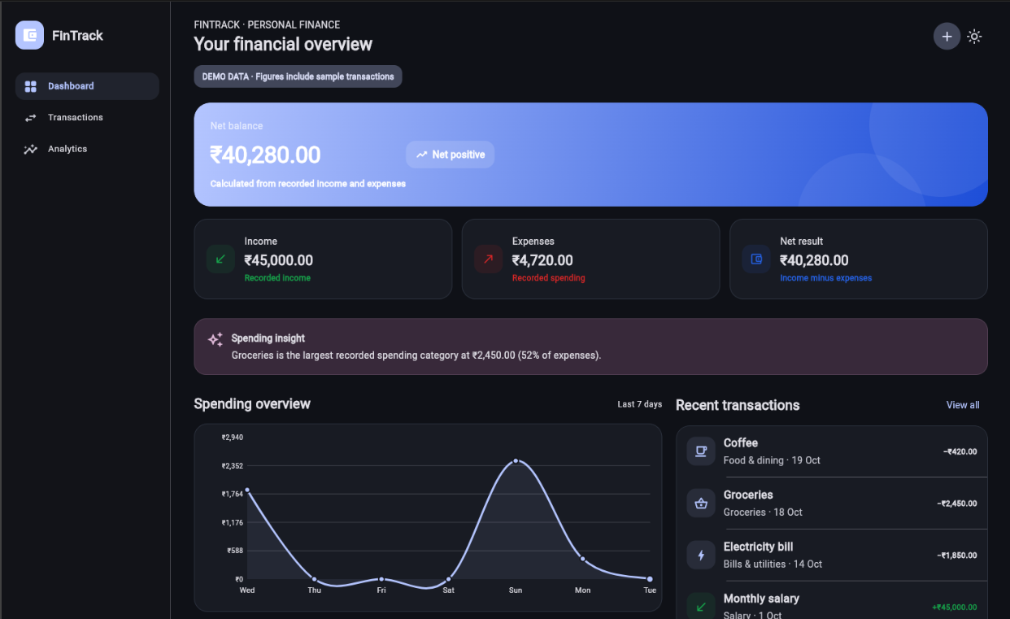
Appendix B — Dashboard, mobile viewport (360 × 695).
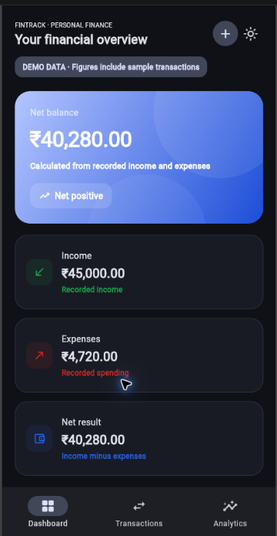
Appendix C — Analytics and dated USD/INR reference rate (1240 × 765).
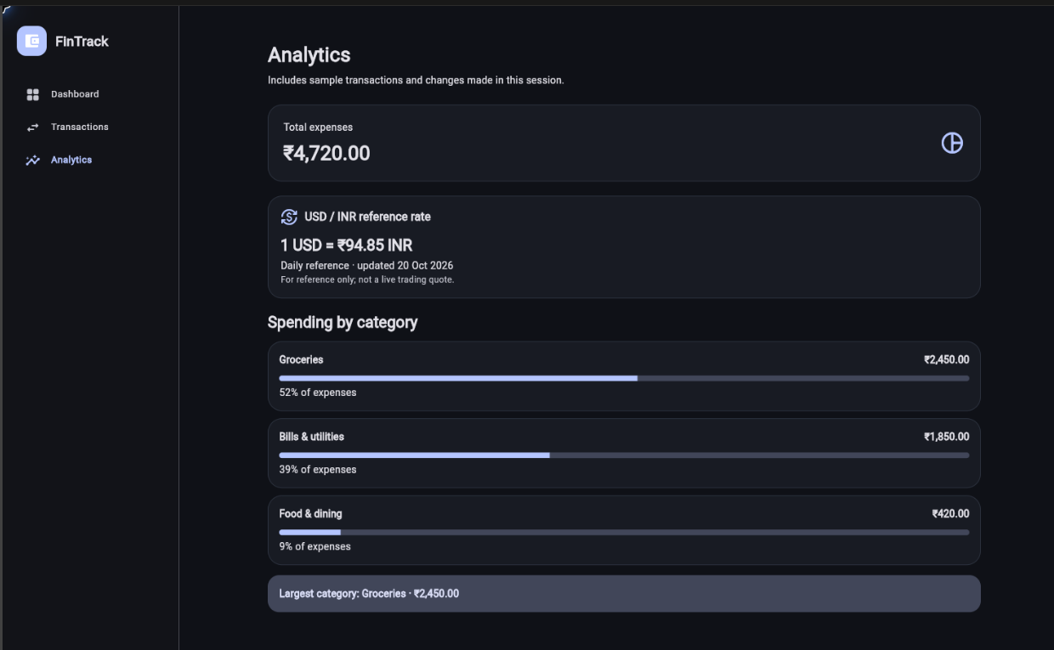

16. MENTOR EVALUATION SHEET (SUGGESTED)
Student Name: Adithya Salaka Roll Number: 24AG1A05B8
Project Title: Personal Finance Tracker
Mentor Name: Satish Bhaskar
Evaluation Criterion | Maximum Marks | Marks Awarded
Understanding of problem and objectives | 10
Technical knowledge and methodology | 20
Implementation / practical work | 25
Results and analysis | 15
Report quality and documentation | 15
Presentation and viva-voce | 15
Total | 100
Mentor Remarks: __________________________________________________________
________________________________________________________________________
Mentor Signature: ____________________ Date: ____________________

HoD SIGNATURE

