Synonym Mapping

HGNC -> (44242 rows × 54 columns)
- url = https://storage.googleapis.com/public-download-files/hgnc/tsv/tsv/hgnc_complete_set.txt
- columns : ['hgnc_id', 'symbol', 'name', 'locus_group', 'locus_type', 'status', 'location', 'location_sortable', 'alias_symbol', 'alias_name', 'prev_symbol', 'prev_name', 'gene_group', 'gene_group_id', 'date_approved_reserved', 'date_symbol_changed', 'date_name_changed', 'date_modified', 'entrez_id', 'ensembl_gene_id', 'vega_id', 'ucsc_id', 'ena', 'refseq_accession', 'ccds_id', 'uniprot_ids', 'pubmed_id', 'mgd_id', 'rgd_id', 'lsdb', 'cosmic', 'omim_id', 'mirbase', 'homeodb', 'snornabase', 'bioparadigms_slc', 'orphanet', 'pseudogene.org', 'horde_id', 'merops', 'imgt', 'iuphar', 'kznf_gene_catalog', 'mamit-trnadb', 'cd', 'lncrnadb', 'enzyme_id', 'intermediate_filament_db', 'rna_central_id', 'lncipedia', 'gtrnadb', 'agr', 'mane_select', 'gencc']
- 20294 row contains UniProt IDs, and only the values from the highlighted columns in this row are used. Constructed dictionary like{ name/synonym : [list of UniProt IDs]}
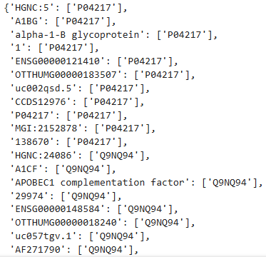
…..
UniProt -> 5375543 rows × 3 columns
- url = https://ftp.uniprot.org/pub/databases/uniprot/current_release/knowledgebase/idmapping/by_organism/HUMAN_9606_idmapping.dat.gz
- Columns: [‘UniProt_ID’, ‘Database_name’, ‘Identifier_synm’]
- Incuded Dataset_names : ['UniProt_ID', 'UniProtKB-ID', 'Gene_Name', 'GI', 'UniRef100', 'UniRef90', 'UniRef50', 'UniParc', 'EMBL', 'EMBL-CDS', 'NCBI_TaxID', 'CCDS', 'RefSeq', 'RefSeq_NT', 'PDB', 'EMDB', 'BioGRID', 'DIP', 'MINT', 'STRING', 'ChEMBL', 'DrugBank', 'BioMuta', 'DMDM', 'CPTAC', 'ProteomicsDB', 'DNASU', 'Ensembl', 'Ensembl_TRS', 'Ensembl_PRO', 'GeneID', 'KEGG', 'GeneCards', 'HGNC', 'MIM', 'neXtProt', 'OpenTargets', 'PharmGKB', 'VEuPathDB', 'eggNOG', 'GeneTree', 'HOGENOM', 'OMA', 'OrthoDB', 'TreeFam', 'Reactome', 'ChiTaRS', 'GeneWiki', 'GenomeRNAi', 'IDEAL', 'CRC64', 'TCDB', 'UCSC', 'Orphanet', 'Gene_Synonym', 'ComplexPortal', 'GeneReviews', 'BioCyc', 'SwissLipids', 'UniPathway', 'Gene_ORFName', 'DisProt', 'GuidetoPHARMACOLOGY', 'GlyConnect', 'MEROPS', 'ESTHER', 'Allergome', 'PeroxiBase', 'REBASE', 'PATRIC']
- Only the values from the highlighted columns in this row are used.
- As the final step, the two datasets are combined into a single dictionary(len: 575641) and saved as a file named uniprot_synonym_mapping.json.
Gene Name Matching Statistics:
Dataset | Total Number of Genes | Matched Genes | Multi Matches
breast | 16382 | 11998 | 172
ccRCC3 | 22928 | 14933 | 235
ccRCC4 | 23001 | 14937 | 237
coad | 21634 | 14874 | 230
pdac | 20032 | 14686 | 215
prostat | 27827 | 14806 | 233
AD | 55889 | 11511 | 156

