# Copy Quay Cert

# cd /quay/quay-rootCA

# scp rootCA.* root@10.251.0.51:/etc/pki/ca-trust/source/anchors

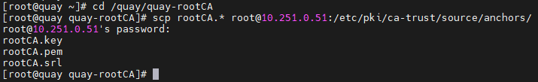

# update-ca-trust extract

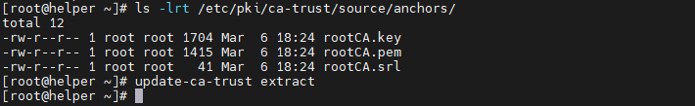

# Cài đặt packages

# mkdir /installer && cd /installer

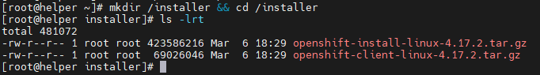

# tar -xvzf openshift-client-linux-4.17.2.tar.gz

# tar -xvzf openshift-install-linux-4.17.2.tar.gz

# mv oc kubectl openshift-install /usr/local/bin

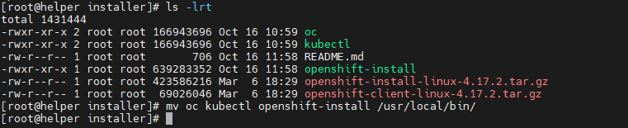

# rpm -ivh nmstate-2.2.39-1.el9_5.x86_64.rpm

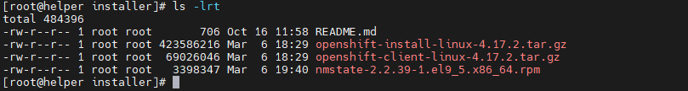

# SSH key

# ssh-add /root/.ssh/node_ssh_key

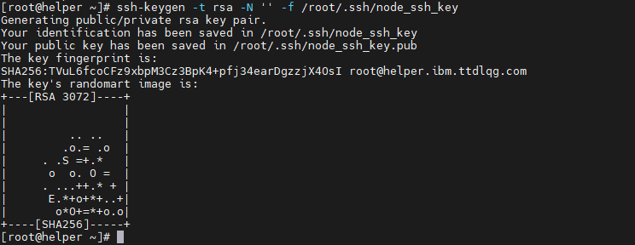

# ssh-add /root/.ssh/node_ssh_key

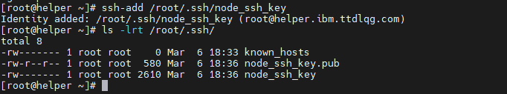

# Check DNS

# nslookup quay.ibm.ttdlqg.com

# nslookup helper.ibm.ttdlqg.com

# nslookup api.ibm.ttdlqg.com

# nslookup api-int.ibm.ttdlqg.com

# nslookup console-openshift-console.apps.ibm.ttdlqg.com

# nslookup master01.ibm.ttdlqg.com

# nslookup master02.ibm.ttdlqg.com

# nslookup master03.ibm.ttdlqg.com

# nslookup worker01.ibm.ttdlqg.com

# nslookup worker02.ibm.ttdlqg.com

# nslookup worker03.ibm.ttdlqg.com

# nslookup 10.251.0.10

# nslookup 10.251.0.51

# nslookup 10.251.0.52

# nslookup 10.251.0.55

# nslookup 10.251.0.56

# nslookup 10.251.0.57

# nslookup 10.251.0.58

# nslookup 10.251.0.59

# nslookup 10.251.0.60

# Tạo VM

Tạo các vm Master, Worker:

* Note lại MAC
* disk.EnableUUID = TRUE
* stealclock.enable = TRUE

Note lại cert của Quay

# cat /etc/pki/ca-trust/source/anchors/rootCA.pem

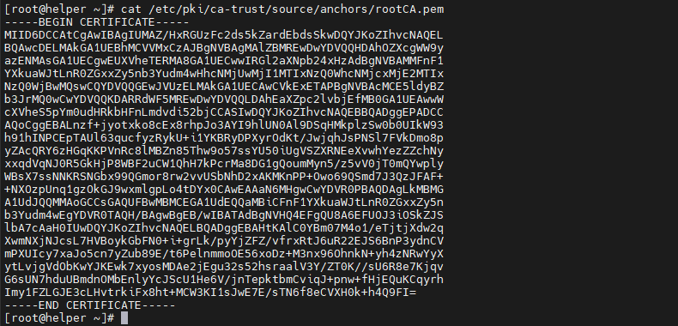

# Tạo file config

# mkdir /installer/cluster && cd /installer/cluster

# vi install-config.yaml

|  |
| --- |
| additionalTrustBundlePolicy: Proxyonly  apiVersion: v1  baseDomain: ttdlqg.com  compute:  - architecture: amd64    hyperthreading: Enabled    name: worker    replicas: 0  controlPlane:    architecture: amd64    hyperthreading: Enabled    name: master    replicas: 3  metadata:    creationTimestamp: null    name: ibm  networking:    clusterNetwork:    - cidr: 10.128.0.0/14      hostPrefix: 23    machineNetwork:    - cidr: 10.251.0.0/24    networkType: OVNKubernetes    serviceNetwork:    - 172.30.0.0/16  platform:    baremetal:      apiVIPs:      - 10.251.0.52      ingressVIPs:      - 10.251.0.53  publish: External  pullSecret: '{"auths":{"quay.ibm.ttdlqg.gov.vn:8443":{"auth":"aW5pdDpBZG1pbkAxMjM="}}}'  sshKey: |    ssh-rsa  root@helper.ibm.ttdlqg.com  additionalTrustBundle: |    -----BEGIN CERTIFICATE-----    MIID6DCCAtCgAwIBAgIUMAZ/HxRGUzFc2ds5kZardEbdsSkwDQYJKoZIhvcNAQEL    BQAwcDELMAkGA1UEBhMCVVMxCzAJBgNVBAgMAlZBMREwDwYDVQQHDAhOZXcgWW9y    azENMAsGA1UECgwEUXVheTERMA8GA1UECwwIRGl2aXNpb24xHzAdBgNVBAMMFnF1    YXkuaWJtLnR0ZGxxZy5nb3Yudm4wHhcNMjUwMjI1MTIxNzQ0WhcNMjcxMjE2MTIx    NzQ0WjBwMQswCQYDVQQGEwJVUzELMAkGA1UECAwCVkExETAPBgNVBAcMCE5ldyBZ    b3JrMQ0wCwYDVQQKDARRdWF5MREwDwYDVQQLDAhEaXZpc2lvbjEfMB0GA1UEAwwW    cXVheS5pYm0udHRkbHFnLmdvdi52bjCCASIwDQYJKoZIhvcNAQEBBQADggEPADCC    AQoCggEBALnzf+jyotxko8cEx8rhpJo3AYI9hlUN0Al9DSqHMkplzSw0b0UIkW93    h91hINPCEpTAUl63qucfyzRykU+i1YKBRyDPXyrOdKt/JwjqhJsPNSl7FVkDmo8p    yZAcQRY6zHGqKKPVnRc8lMBZn85Thw9o57ssYU50iUgVSZXRNEeXvwhYezZZchNy    xxqdVqNJ0R5GkHjP8WBF2uCW1QhH7kPcrMa8DG1gQoumMyn5/z5vV0jT0mQYwply    WBsX7ssNNKRSNGbx99QGmor8rw2vvUSbNhD2xAKMKnPP+Owo69QSmd7J3QzJFAF+    +NXOzpUnq1gzOkGJ9wxmlgpLo4tDYx0CAwEAAaN6MHgwCwYDVR0PBAQDAgLkMBMG    A1UdJQQMMAoGCCsGAQUFBwMBMCEGA1UdEQQaMBiCFnF1YXkuaWJtLnR0ZGxxZy5n    b3Yudm4wEgYDVR0TAQH/BAgwBgEB/wIBATAdBgNVHQ4EFgQU8A6EFUOJ3iOSkZJS    lbA7cAaH0IUwDQYJKoZIhvcNAQELBQADggEBAHtKAlC0YBm07M4o1/eTjtjXdw2q    XwmNXjNJcsL7HVBoykGbFN0+i+grLk/pyYjZFZ/vfrxRtJ6uR22EJS6BnP3ydnCV    mPXUIcy7xaJo5cn7yZub89E/t6PelnmmoOE56xoDz+M3nx96OhnkN+yh4zNRwYyX    ytLvjgVdObKwYJKEwk7xyosMDAe2jEgu32s52hsraalV3Y/ZT0K//sU6R8e7Kjqv    G6sUN7hduUBmdnOMbEnlyYcJScU1He6V/jnTepktbmCviqJ+pnw+fHjEQuKCqyrh    Imy1FZLGJE3cLHvtrkiFx8ht+MCW3KI1sJwE7E/sTN6f8eCVXH0k+h4Q9FI=    -----END CERTIFICATE-----  imageContentSources:  - mirrors:    - quay.ibm.ttdlqg.gov.vn:8443/ocp4/openshift417    source: quay.io/openshift-release-dev/ocp-release  - mirrors:    - quay.ibm.ttdlqg.gov.vn:8443/ocp4/openshift417    source: quay.io/openshift-release-dev/ocp-v4.0-art-dev |

# vi agent-config.yaml

|  |
| --- |
| apiVersion: v1alpha1  metadata:    name: ibm  rendezvousIP: 10.251.0.55  hosts:  # master 01 ------------------------------------    - hostname: master01.ibm.ttdlqg.com      interfaces:       - name: ens192         macAddress: 00:50:56:b5:59:06      networkConfig:        interfaces:          - name: ens192            type: ethernet            state: up            mac-address: 00:50:56:b5:59:06            ipv4:              enabled: true              address:                - ip: 10.251.0.55                  prefix-length: 24              dhcp: false        dns-resolver:          config:            server:              - 10.251.0.50        routes:          config:            - destination: 0.0.0.0/0              next-hop-address: 10.251.0.254              next-hop-interface: ens192  # master 02 ------------------------------------    - hostname: master02.ibm.ttdlqg.com      interfaces:       - name: ens192         macAddress: 00:50:56:b5:e6:88      networkConfig:        interfaces:          - name: ens192            type: ethernet            state: up            mac-address: 00:50:56:b5:e6:88            ipv4:              enabled: true              address:                - ip: 10.251.0.56                  prefix-length: 24              dhcp: false        dns-resolver:          config:            server:              - 10.251.0.50        routes:          config:            - destination: 0.0.0.0/0              next-hop-address: 10.251.0.254              next-hop-interface: ens192  # master 03 ------------------------------------    - hostname: master03.ibm.ttdlqg.com      interfaces:       - name: ens192         macAddress: 00:50:56:b5:e9:0b      networkConfig:        interfaces:          - name: ens192            type: ethernet            state: up            mac-address: 00:50:56:b5:e9:0b            ipv4:              enabled: true              address:                - ip: 10.251.0.57                  prefix-length: 24              dhcp: false        dns-resolver:          config:            server:              - 10.251.0.50        routes:          config:            - destination: 0.0.0.0/0              next-hop-address: 10.251.0.254              next-hop-interface: ens192 |



# Tạo & upload image

# openshift-install agent create image --dir /installer/cluster

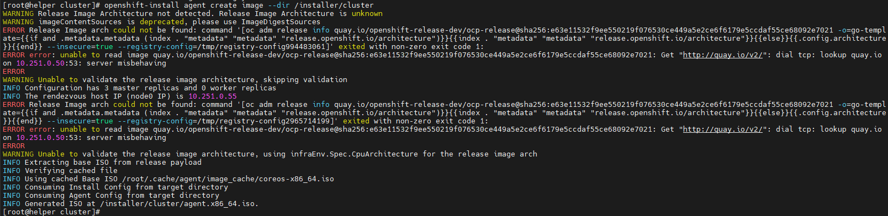

Upload iso file lên datastore

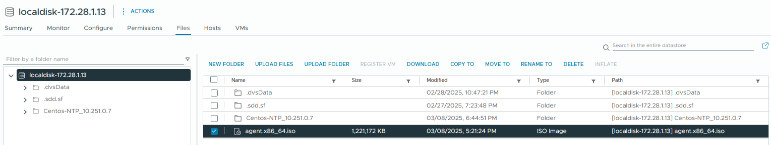

# Cài đặt cụm

Thực hiện start các vm

Check quá trình bootstrap host init

# openshift-install agent wait-for bootstrap-complete --log-level=info --dir /installer/cluster

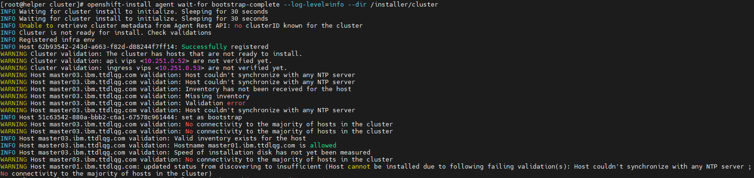

Mở new terminal

# openshift-install agent wait-for install-complete --dir /installer/cluster

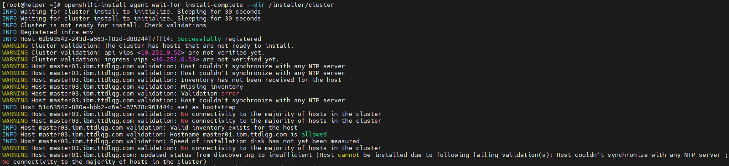

Cài đặt thành công

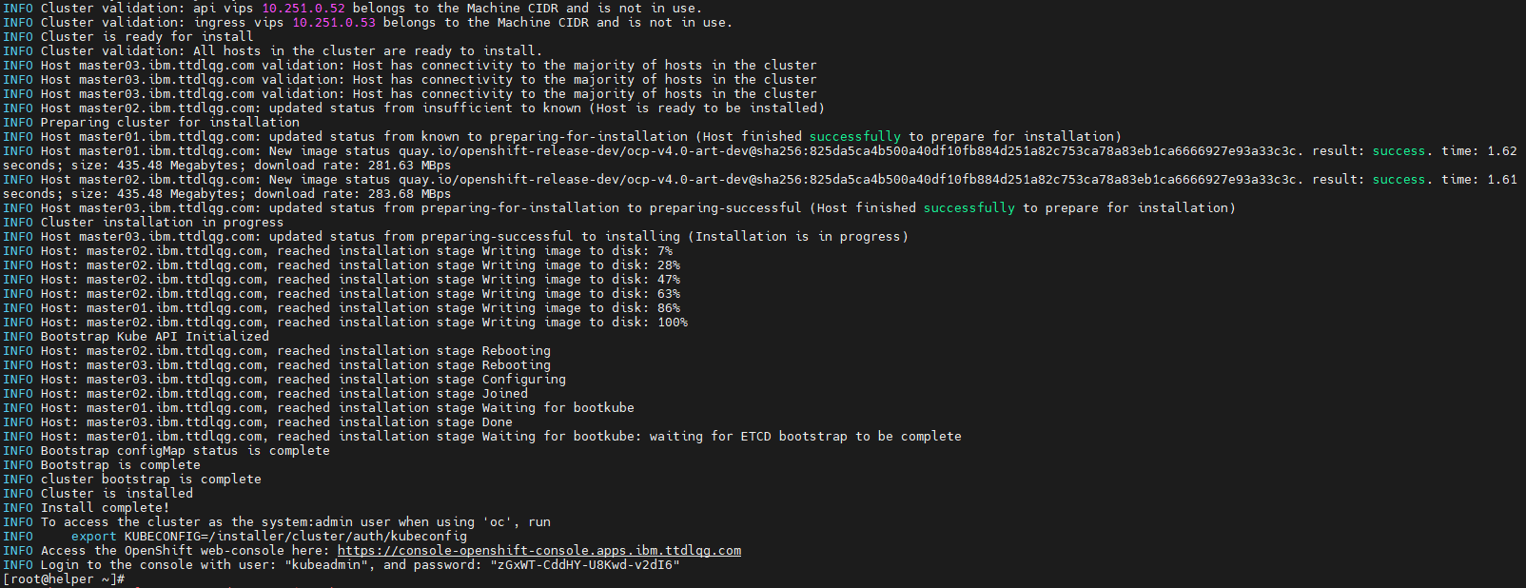

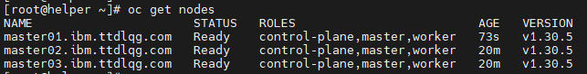

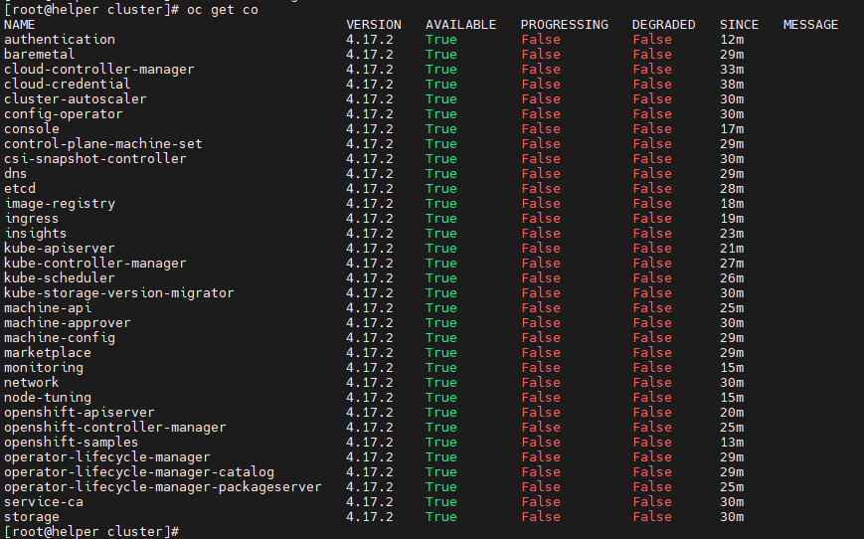

# export KUBECONFIG=/installer/cluster/auth/kubeconfig

https://console-openshift-console.apps.ibm.ttdlqg.com

"kubeadmin", "zGxWT-CddHY-U8Kwd-v2dI6"

