PROGRAM:
theBoard = {'7': ' ' , '8': ' ' , '9': ' ' ,
'4': ' ' , '5': ' ' , '6': ' ' ,
'1': ' ' , '2': ' ' , '3': ' ' }
board_keys = []
for key in theBoard:
board_keys.append(key)

''' We will have to print the updated board after every move in the game and
thus we will make a function in which we'll define the printBoard function
so that we can easily print the board everytime by calling this function. '''

def printBoard(board):
print(board['7'] + '|' + board['8'] + '|' + board['9'])
print('-+-+-')
print(board['4'] + '|' + board['5'] + '|' + board['6'])
print('-+-+-')
print(board['1'] + '|' + board['2'] + '|' + board['3'])

# Now we'll write the main function which has all the gameplay functionality.
def game():

turn = 'X'
count = 0
for i in range(10):
printBoard(theBoard)
print("It's your turn," + turn + ".Move to which place?")
move = input()

if theBoard[move] == ' ':
theBoard[move] = turn
count += 1
else:
print("That place is already filled.\nMove to which place?")
continue

# Now we will check if player X or O has won,for every move after 5 moves.
if count >= 5:
if theBoard['7'] == theBoard['8'] == theBoard['9'] != ' ': # across the top
printBoard(theBoard)
print("\nGame Over.\n")
print(" **** " +turn + " won. ****")
break
elif theBoard['4'] == theBoard['5'] == theBoard['6'] != ' ': # across the middle
printBoard(theBoard)
print("\nGame Over.\n")
print(" **** " +turn + " won. ****")
break
elif theBoard['1'] == theBoard['2'] == theBoard['3'] != ' ': # across the bottom
printBoard(theBoard)
print("\nGame Over.\n")
print(" **** " +turn + " won. ****")
break
elif theBoard['1'] == theBoard['4'] == theBoard['7'] != ' ': # down the left side
printBoard(theBoard)
print("\nGame Over.\n")
print(" **** " +turn + " won. ****")
break
elif theBoard['2'] == theBoard['5'] == theBoard['8'] != ' ': # down the middle
printBoard(theBoard)
print("\nGame Over.\n")
print(" **** " +turn + " won. ****")
break
elif theBoard['3'] == theBoard['6'] == theBoard['9'] != ' ': # down the right side
printBoard(theBoard)
print("\nGame Over.\n")
print(" **** " +turn + " won. ****")
break
elif theBoard['7'] == theBoard['5'] == theBoard['3'] != ' ': # diagonal
printBoard(theBoard)
print("\nGame Over.\n")
print(" **** " +turn + " won. ****")
break
elif theBoard['1'] == theBoard['5'] == theBoard['9'] != ' ': # diagonal
printBoard(theBoard)
print("\nGame Over.\n")
print(" **** " +turn + " won. ****")
break

# If neither X nor O wins and the board is full, we'll declare the result as 'tie'.
if count == 9:
print("\nGame Over.\n")
print("It's a Tie!!")

# Now we have to change the player after every move.
if turn =='X':
turn = 'O'
else:
turn = 'X'

# Now we will ask if player wants to restart the game or not.
restart = input("Do want to play Again?(y/n)")
if restart == "y" or restart == "Y":
for key in board_keys:
theBoard[key] = " "
game()

if __name__ == "__main__":
game()

OUTPUT:
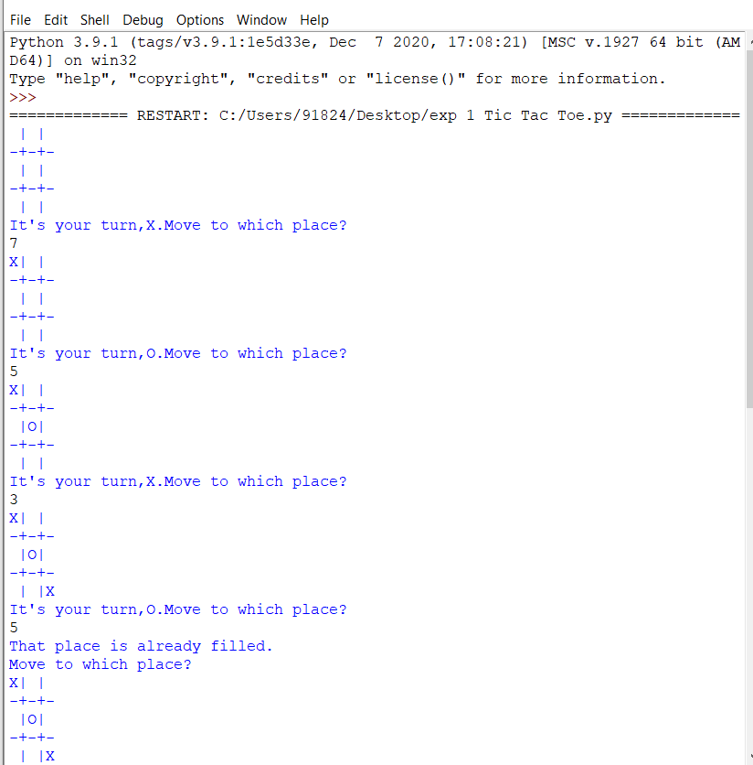

PROGRAM:
# Solves a randomized 8-puzzle using A* algorithm with plug-in heuristics

import random
import math

_goal_state = [[1,2,3],
[4,5,6],
[7,8,0]]

def index(item, seq):
"""Helper function that returns -1 for non-found index value of a seq"""

if item in seq:
return seq.index(item)
else:
return -1

class EightPuzzle:

def __init__(self):
# heuristic value
self._hval = 0
# search depth of current instance
self._depth = 0
# parent node in search path
self._parent = None
self.adj_matrix = []
for i in range(3):
self.adj_matrix.append(_goal_state[i][:])

def __eq__(self, other):
if self.__class__ != other.__class__:
return False
else:
return self.adj_matrix == other.adj_matrix

def __str__(self):
res = ''
for row in range(3):
res += ' '.join(map(str, self.adj_matrix[row]))
res += '\r\n'
return res

def _clone(self):
p = EightPuzzle()
for i in range(3):
p.adj_matrix[i] = self.adj_matrix[i][:]
return p

def _get_legal_moves(self):

"""Returns list of tuples with which the free space may be swapped"""
# get row and column of the empty piece
row, col = self.find(0)
free = []

# find which pieces can move there
if row > 0:
free.append((row - 1, col))
if col > 0:
free.append((row, col - 1))
if row < 2:
free.append((row + 1, col))
if col < 2:
free.append((row, col + 1))

return free

def _generate_moves(self):
free = self._get_legal_moves()
zero = self.find(0)

def swap_and_clone(a, b):
p = self._clone()
p.swap(a,b)
p._depth = self._depth + 1
p._parent = self
return p

return map(lambda pair: swap_and_clone(zero, pair), free)

def _generate_solution_path(self, path):
if self._parent == None:
return path
else:
path.append(self)
return self._parent._generate_solution_path(path)

def solve(self, h):
"""Performs A* search for goal state.h(puzzle) - heuristic function, returns an integer """

def is_solved(puzzle):
return puzzle.adj_matrix == _goal_state

openl = [self]
closedl = []
move_count = 0
while len(openl) > 0:
x = openl.pop(0)
move_count += 1
if (is_solved(x)):
if len(closedl) > 0:
return x._generate_solution_path([]), move_count
else:
return [x]

succ = x._generate_moves()
idx_open = idx_closed = -1
for move in succ:
# have we already seen this node?
idx_open = index(move, openl)
idx_closed = index(move, closedl)
hval = h(move)
fval = hval + move._depth

if idx_closed == -1 and idx_open == -1:
move._hval = hval
openl.append(move)
elif idx_open > -1:
copy = openl[idx_open]
if fval < copy._hval + copy._depth:
# copy move's values over existing
copy._hval = hval
copy._parent = move._parent
copy._depth = move._depth
elif idx_closed > -1:
copy = closedl[idx_closed]
if fval < copy._hval + copy._depth:
move._hval = hval
closedl.remove(copy)
openl.append(move)

closedl.append(x)
openl = sorted(openl, key=lambda p: p._hval + p._depth)

# if finished state not found, return failure
return [], 0

def shuffle(self, step_count):
for i in range(step_count):
row, col = self.find(0)
free = self._get_legal_moves()
target = random.choice(free)
self.swap((row, col), target)
row, col = target

def find(self, value):
"""returns the row, col coordinates of the specified value in the graph"""
if value < 0 or value > 8:
raise Exception("value out of range")

for row in range(3):
for col in range(3):
if self.adj_matrix[row][col] == value:
return row, col

def peek(self, row, col):
"""returns the value at the specified row and column"""
return self.adj_matrix[row][col]

def poke(self, row, col, value):
"""sets the value at the specified row and column"""
self.adj_matrix[row][col] = value

def swap(self, pos_a, pos_b):
"""swaps values at the specified coordinates"""
temp = self.peek(*pos_a)
self.poke(pos_a[0], pos_a[1], self.peek(*pos_b))
self.poke(pos_b[0], pos_b[1], temp)

def heur(puzzle, item_total_calc, total_calc):
"""
Heuristic template that provides the current and target position for each number and the
total function.

Parameters:
puzzle - the puzzle
item_total_calc - takes 4 parameters: current row, target row, current col, target col.
Returns int.
total_calc - takes 1 parameter, the sum of item_total_calc over all entries, and returns int.
This is the value of the heuristic function
"""
t = 0
for row in range(3):
for col in range(3):
val = puzzle.peek(row, col) - 1
target_col = val % 3
target_row = val / 3

# account for 0 as blank
if target_row < 0:
target_row = 2

t += item_total_calc(row, target_row, col, target_col)

return total_calc(t)

#some heuristic functions, the best being the standard manhattan distance in this case, as it comes
#closest to maximizing the estimated distance while still being admissible.

def h_manhattan(puzzle):
return heur(puzzle,
lambda r, tr, c, tc: abs(tr - r) + abs(tc - c),
lambda t : t)

def h_manhattan_lsq(puzzle):
return heur(puzzle,
lambda r, tr, c, tc: (abs(tr - r) + abs(tc - c))**2,
lambda t: math.sqrt(t))
def h_linear(puzzle):
return heur(puzzle,
lambda r, tr, c, tc: math.sqrt(math.sqrt((tr - r)**2 + (tc - c)**2)),
lambda t: t)

def h_linear_lsq(puzzle):
return heur(puzzle,
lambda r, tr, c, tc: (tr - r)**2 + (tc - c)**2,
lambda t: math.sqrt(t))

def h_default(puzzle):
return 0

def main():
p = EightPuzzle()
p.shuffle(20)
print p

path, count = p.solve(h_manhattan)
path.reverse()
for i in path:
print i

print "Solved with Manhattan distance exploring", count, "states"
path, count = p.solve(h_manhattan_lsq)
print "Solved with Manhattan least squares exploring", count, "states"
path, count = p.solve(h_linear)
print "Solved with linear distance exploring", count, "states"
path, count = p.solve(h_linear_lsq)
print "Solved with linear least squares exploring", count, "states"

# path, count = p.solve(heur_default)
# print "Solved with BFS-equivalent in", count, "moves"

if __name__ == "__main__":
main()

OUTPUT:

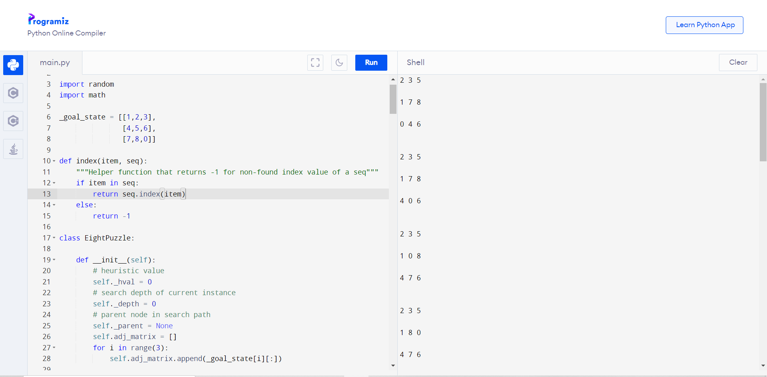

PROGRAM:
// CPP program for solving cryptographic puzzles
#include <bits/stdc++.h>
using namespace std;

// vector stores 1 corresponding to index
// number which is already assigned
// to any char, otherwise stores 0

vector<int> use(10);
// structure to store char and its corresponding integer
struct node
{
char c;
int v;
};
// function check for correct solution
int check(node* nodeArr, const int count, string s1, string s2, string s3)
{
int val1 = 0, val2 = 0, val3 = 0, m = 1, j, i;
// calculate number corresponding to first string
for (i = s1.length() - 1; i >= 0; i--)
{
char ch = s1[i];
for (j = 0; j < count; j++)
if (nodeArr[j].c == ch)
break;
val1 += m * nodeArr[j].v;
m *= 10;
}
m = 1;

// calculate number corresponding to second string
for (i = s2.length() - 1; i >= 0; i--)
{
char ch = s2[i];
for (j = 0; j < count; j++)
if (nodeArr[j].c == ch)
break;

val2 += m * nodeArr[j].v;
m *= 10;
}
m = 1;

// calculate number corresponding to third string
for (i = s3.length() - 1; i >= 0; i--)
{
char ch = s3[i];
for (j = 0; j < count; j++)
if (nodeArr[j].c == ch)
break;
val3 += m * nodeArr[j].v;
m *= 10;
}

// sum of first two number equal to third return true
if (val3 == (val1 + val2))
return 1;

// else return false
return 0;
}

// Recursive function to check solution for all permutations
bool permutation(const int count, node* nodeArr, int n,
string s1, string s2, string s3)
{
// Base case
if (n == count - 1)
{
// check for all numbers not used yet
for (int i = 0; i < 10; i++)
{

// if not used
if (use[i] == 0)
{
// assign char at index n integer i
nodeArr[n].v = i;
// if solution found
if (check(nodeArr, count, s1, s2, s3) == 1)
{
cout << "\nSolution found: ";
for (int j = 0; j < count; j++)
cout << " " << nodeArr[j].c << " = "
<< nodeArr[j].v;
return true;
}
}
}
return false;
}

for (int i = 0; i < 10; i++)
{
// if ith integer not used yet
if (use[i] == 0)
{
// assign char at index n integer i
nodeArr[n].v = i;
// mark it as not available for other char
use[i] = 1;
// call recursive function
if (permutation(count, nodeArr, n + 1, s1, s2, s3))
return true;
// backtrack for all other possible solutions
use[i] = 0;
}
}
return false;
}
bool solveCryptographic(string s1, string s2, string s3)
{
// count to store number of unique char
int count = 0;
// Length of all three strings
int l1 = s1.length();
int l2 = s2.length();
int l3 = s3.length();

// vector to store frequency of each char
vector<int> freq(26);
for (int i = 0; i < l1; i++)
++freq[s1[i] - 'A'];
for (int i = 0; i < l2; i++)
++freq[s2[i] - 'A'];
for (int i = 0; i < l3; i++)
++freq[s3[i] - 'A'];

// count number of unique char
for (int i = 0; i < 26; i++)
if (freq[i] > 0)
count++;

// solution not possible for count greater than 10
if (count > 10)
{
cout << "Invalid strings";
return 0;
}

// array of nodes
node nodeArr[count];

// store all unique char in nodeArr
for (int i = 0, j = 0; i < 26; i++)
{
if (freq[i] > 0)
{
nodeArr[j].c = char(i + 'A');
j++;
}
}
return permutation(count, nodeArr, 0, s1, s2, s3);
}

// Driver function
int main()
{
string s1 = "SEND";
string s2 = "MORE";
string s3 = "MONEY";

if (solveCryptographic(s1, s2, s3) == false)
cout << "No solution";
return 0;
}

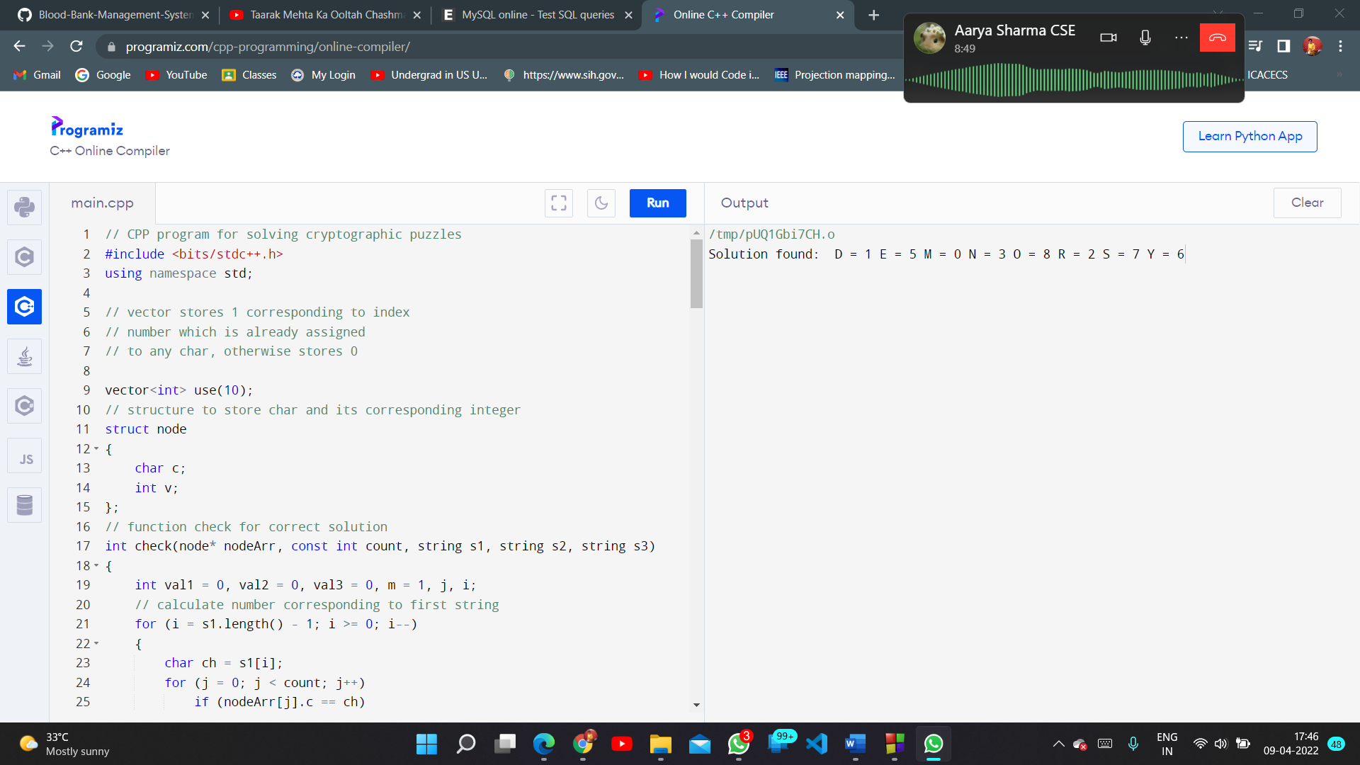
OUTPUT:

PROGRAM:
# DFS algorithm in Python
# DFS algorithm

def dfs(graph, start, visited=None):
if visited is None:
visited = set()
visited.add(start)

print(start)

for next in graph[start] - visited:
dfs(graph, next, visited)
return visited

graph = {'0': set(['1', '2']),
'1': set(['0', '3', '4']),
'2': set(['0']),
'3': set(['1']),
'4': set(['2', '3'])}

dfs(graph, '0')

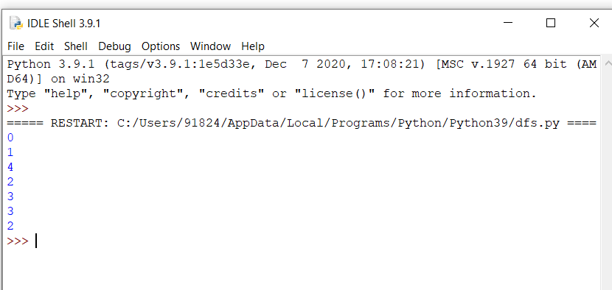
OUTPUT:

# BFS algorithm in Python
# BFS algorithm

import collections
def bfs(graph, root):
visited, queue = set(), collections.deque([root])
visited.add(root)

while queue:
# Dequeue a vertex from queue
vertex = queue.popleft()
print(str(vertex) + " ", end="")

# If not visited, mark it as visited, and
# enqueue it
for neighbour in graph[vertex]:
if neighbour not in visited:
visited.add(neighbour)
queue.append(neighbour)

if __name__ == '__main__':
graph = {0: [1, 2], 1: [2], 2: [3], 3: [1, 2]}
print("Following is Breadth First Traversal: ")
bfs(graph, 0)

OUTPUT:

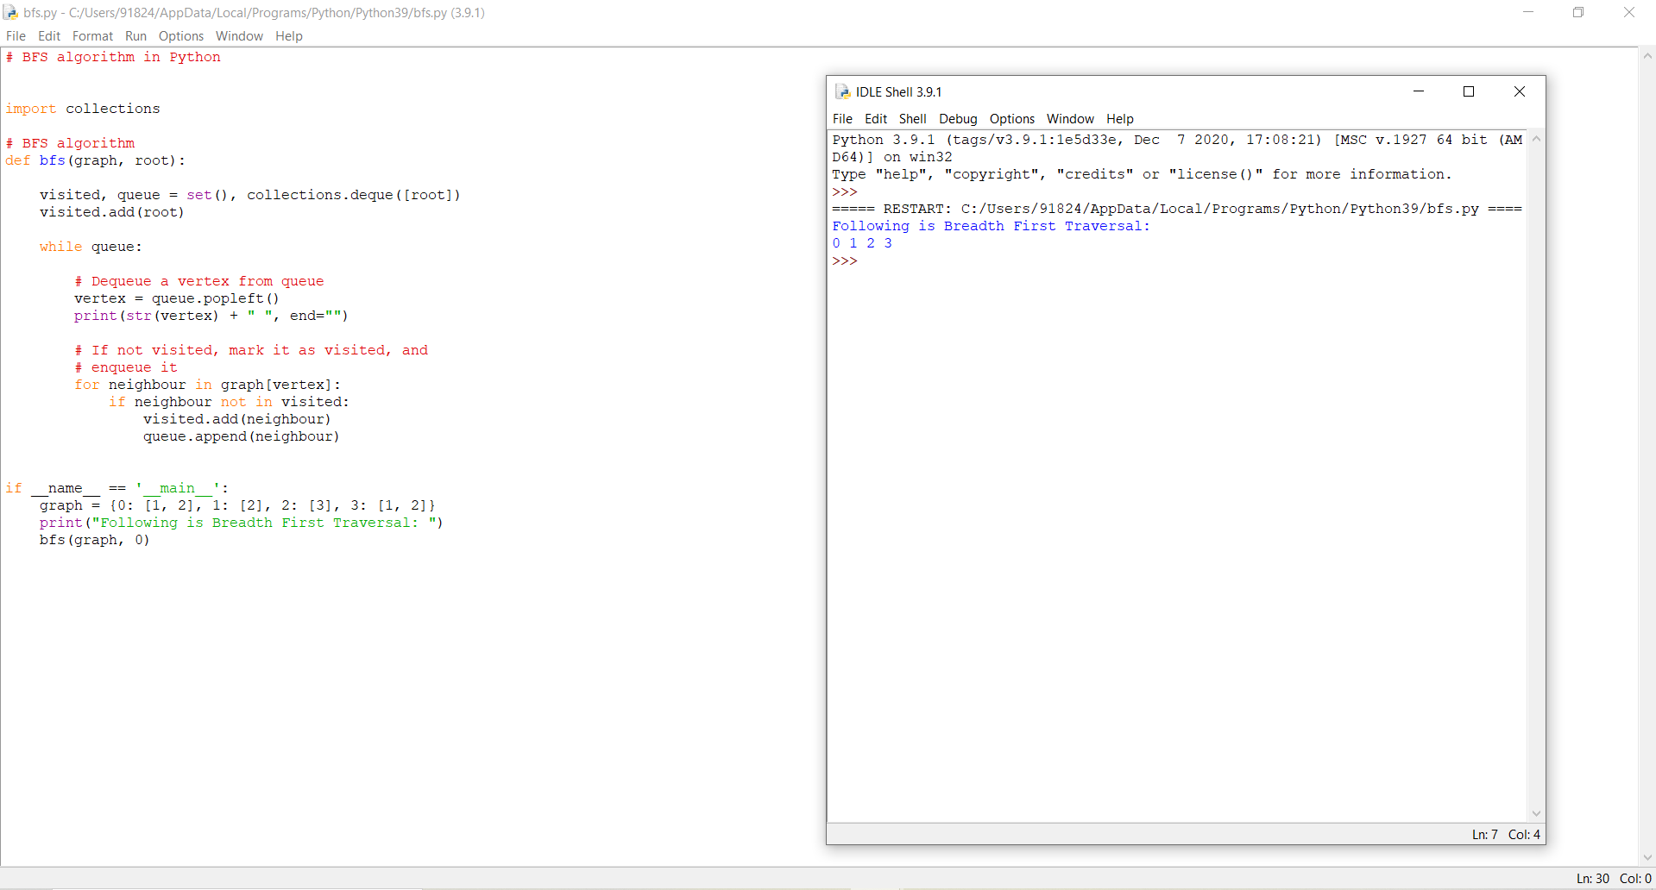

PROGRAM:

class Node():

"""A node class for A* Pathfinding"""

def __init__(self, parent=None, position=None):

self.parent = parent

self.position = position

self.g = 0

self.h = 0

self.f = 0

def __eq__(self, other):

return self.position == other.position

def astar(maze, start, end):

"""Returns a list of tuples as a path from the given start to the given end in the given maze"""

# Create start and end node

start_node = Node(None, start)

start_node.g = start_node.h = start_node.f = 0

end_node = Node(None, end)

end_node.g = end_node.h = end_node.f = 0

# Initialize both open and closed list

open_list = []

closed_list = []

# Add the start node

open_list.append(start_node)

# Loop until you find the end

while len(open_list) > 0:

# Get the current node

current_node = open_list[0]

current_index = 0

for index, item in enumerate(open_list):

if item.f < current_node.f:

current_node = item

current_index = index

# Pop current off open list, add to closed list

open_list.pop(current_index)

closed_list.append(current_node)

# Found the goal

if current_node == end_node:

path = []

current = current_node

while current is not None:

path.append(current.position)

current = current.parent

return path[::-1] # Return reversed path

# Generate children

children = []

for new_position in [(0, -1), (0, 1), (-1, 0), (1, 0), (-1, -1), (-1, 1), (1, -1), (1, 1)]: # Adjacent squares

# Get node position

node_position = (current_node.position[0] + new_position[0], current_node.position[1] + new_position[1])

# Make sure within range

if node_position[0] > (len(maze) - 1) or node_position[0] < 0 or node_position[1] > (len(maze[len(maze)-1]) -1) or node_position[1] < 0:

continue

# Make sure walkable terrain

if maze[node_position[0]][node_position[1]] != 0:

continue

# Create new node

new_node = Node(current_node, node_position)

# Append

children.append(new_node)

# Loop through children

for child in children:

# Child is on the closed list

for closed_child in closed_list:

if child == closed_child:

continue

# Create the f, g, and h values

child.g = current_node.g + 1

child.h = ((child.position[0] - end_node.position[0]) ** 2) + ((child.position[1] - end_node.position[1]) ** 2)

child.f = child.g + child.h

# Child is already in the open list

for open_node in open_list:

if child == open_node and child.g > open_node.g:

continue

# Add the child to the open list

open_list.append(child)

def main():

maze = [[0, 0, 0, 0, 1, 0, 0, 0, 0, 0],

[0, 0, 0, 0, 1, 0, 0, 0, 0, 0],

[0, 0, 0, 0, 1, 0, 0, 0, 0, 0],

[0, 0, 0, 0, 1, 0, 0, 0, 0, 0],

[0, 0, 0, 0, 1, 0, 0, 0, 0, 0],

[0, 0, 0, 0, 0, 0, 0, 0, 0, 0],

[0, 0, 0, 0, 1, 0, 0, 0, 0, 0],

[0, 0, 0, 0, 1, 0, 0, 0, 0, 0],

[0, 0, 0, 0, 1, 0, 0, 0, 0, 0],

[0, 0, 0, 0, 0, 0, 0, 0, 0, 0]]

start = (0, 0)

end = (7, 6)

path = astar(maze, start, end)

print(path)

if __name__ == '__main__':

main()

OUTPUT:

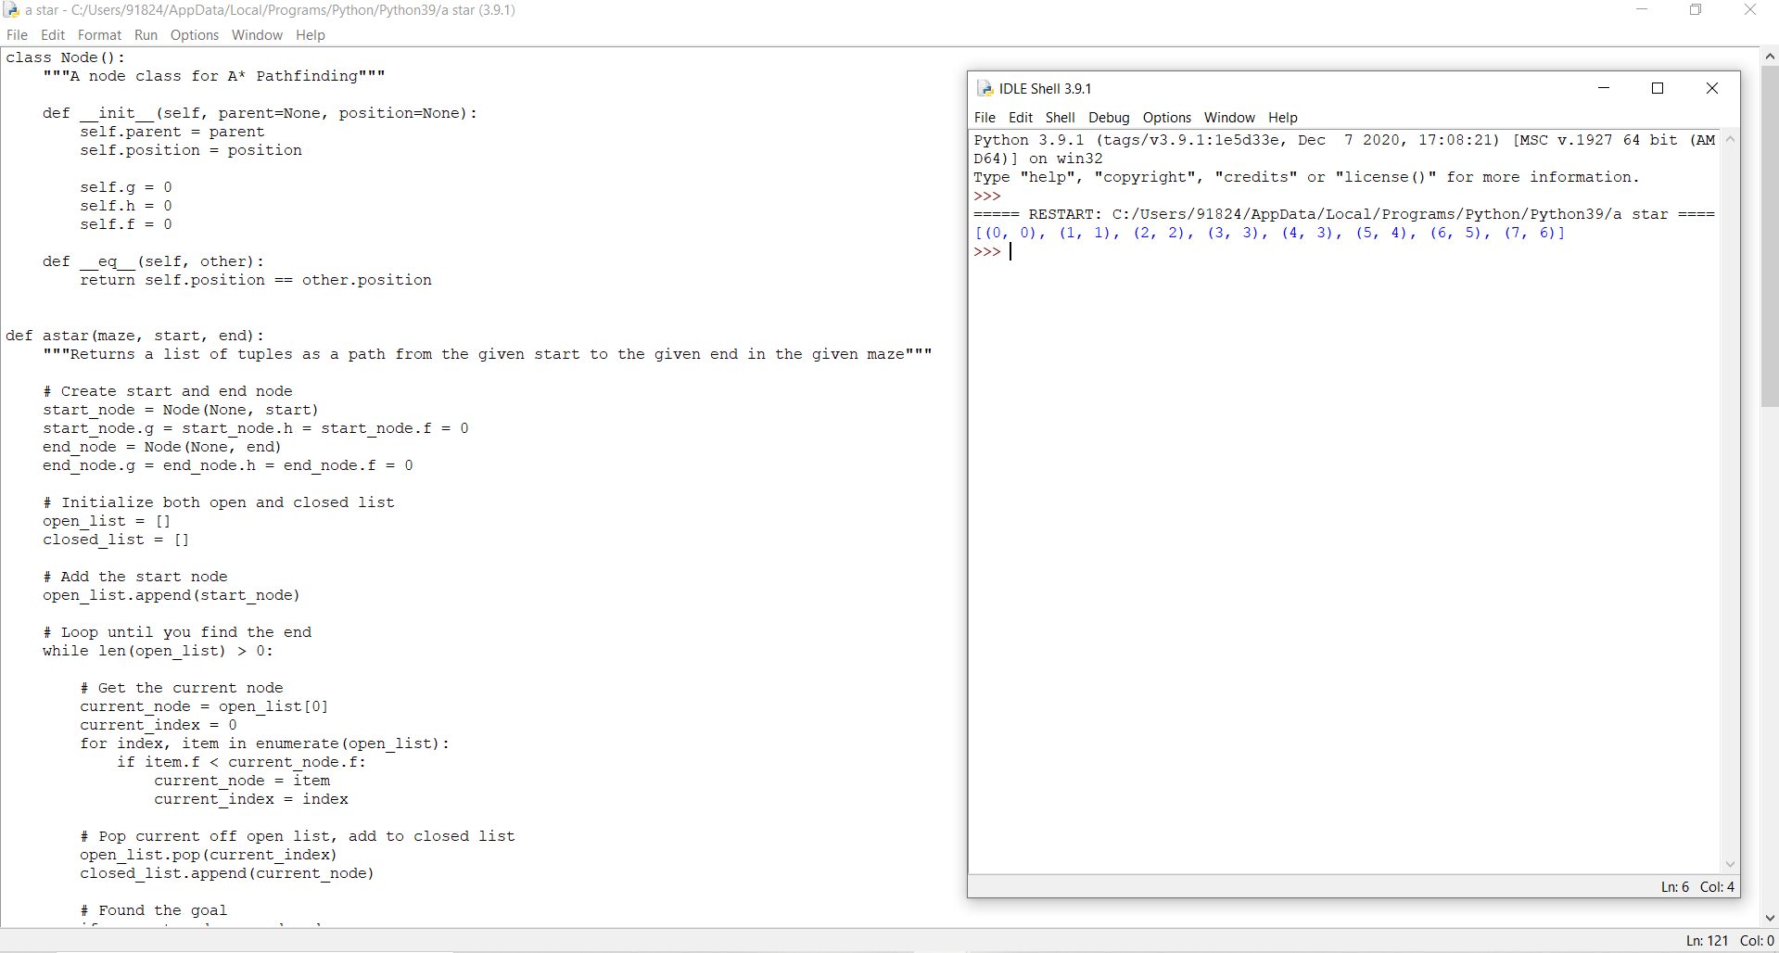

PROGRAM:
# Import libraries
import sys
import random
# This class represent a tic tac to game
class TicTacToeGame:
# Create a new game
def __init__(self, rows:int, columns:int, goal:int, max_depth:int=4):

# Create the game state
self.state = []
self.tiles = {}
self.inverted_tiles = {}
tile = 0
for y in range(rows):
row = []
for x in range(columns):
row += '.'
tile += 1
self.tiles[tile] = (y, x)
self.inverted_tiles[(y, x)] = tile
self.state.append(row)
# Set the number of noughts and crosses in a row that is needed to win the game
self.goal = goal
# Create vectors
self.vectors = [(1,0), (0,1), (1,1), (-1,1)] n

# Set lengths
self.rows = rows
self.columns = columns
self.max_row_index = rows - 1
self.max_columns_index = columns - 1
self.max_depth = max_depth
# Heuristics for cutoff
self.winning_positions = []
self.get_winning_positions()
# Set the starting player at random
#self.player = 'O'
self.player = random.choice(['X', 'O'])
# Get winning positions
def get_winning_positions(self):
# Loop the board
for y in range(self.rows):
for x in range(self.columns):
# Loop vectors
for vector in self.vectors:

# Get the start position
sy, sx = (y, x)
# Get vector deltas
dy, dx = vector
# Create a counter
counter = 0
# Loop until we are outside the board
positions = []
while True:
# Add the position
positions.append(self.inverted_tiles.get((sy, sx)))
# Check if we have a winning position
if (len(positions) == self.goal):
# Add winning positions
self.winning_positions.append(positions)
# Break out from the loop
break
# Update the position
sy += dy
sx += dx

# Check if the loop should terminate
if(sy < 0 or abs(sy) > self.max_row_index or sx < 0 or abs(sx) > self.max_columns_index):
break
# Play the game
def play(self):
# Variables
result = None
# Create an infinite loop
print('Starting board')
while True:
# Draw the state
self.print_state()
# Get a move from a player
if (self.player == 'X'): # AI
# Print AI move
print('Player X moving (AI) ...')
# Get the best move
max, py, px, depth = self.max(-sys.maxsize, sys.maxsize)
# Get a heuristic move at cutoff
print('Depth: {0}'.format(depth))
if(depth > self.max_depth):
py, px = self.get_best_move()
# Make a move
self.state[py][px] = 'X'
# Check if the game has ended, break out from the loop in that case
result = self.game_ended()
if(result != None):
break
# Change turn
self.player = 'O'
elif (self.player == 'O'): # Human player

# Print turn
print('Player O moving (Human) ...')
# Get a recommended move
min, py, px, depth = self.min(-sys.maxsize, sys.maxsize)
# Get a heuristic move at cutoff
print('Depth: {0}'.format(depth))
if(depth > self.max_depth):
py, px = self.get_best_move()
# Print a recommendation
print('Recommendation: {0}'.format(self.inverted_tiles.get((py, px))))
# Get input
number = int(input('Make a move (tile number): '))
tile = self.tiles.get(number)
# Check if the move is legal
if(tile != None):
# Make a move
py, px = tile
self.state[py][px] = 'O'
# Check if the game has ended, break out from the loop in that case
result = self.game_ended()
if(result != None):
break
# Change turn
self.player = 'X'
else:
print('Move is not legal, try again.')
# Print result
self.print_state()
print('Winner is player: {0}'.format(result))
# An evaluation function to get the best move based on heuristics
def get_best_move(self):
# Create an heuristic dictionary
heuristics = {}
# Get all empty cells
empty_cells = []
for y in range(self.rows):
for x in range(self.columns):
if (self.state[y][x] == '.'):
empty_cells.append((y, x))
# Loop empty positions
for empty in empty_cells:
# Get numbered position
number = self.inverted_tiles.get(empty)
# Loop winning positions
for win in self.winning_positions:
# Check if number is in a winning position
if(number in win):
# Calculate the number of X:s and O:s in the winning position
player_x = 0
player_o = 0
start_score = 1
for box in win:
# Get the position
y, x = self.tiles[box]
# Count X:s and O:s
if(self.state[y][x] == 'X'):
player_x += start_score if self.player == 'X' else start_score * 2
start_score *= 10
elif (self.state[y][x] == 'O'):
player_o += start_score if self.player == 'O' else start_score * 2
start_score *= 10
# Save heuristic
if(player_x == 0 or player_o == 0):
# Calculate a score
score = max(player_x, player_o) + start_score
# Update the score
if(heuristics.get(number) != None):
heuristics[number] += score
else:
heuristics[number] = score
# Get the best move from the heuristic dictionary
best_move = random.choice(empty_cells)
best_count = -sys.maxsize
for key, value in heuristics.items():
if(value > best_count):
best_move = self.tiles.get(key)
best_count = value
# Return the best move
return best_move
# Check if the game has ended
def game_ended(self) -> str:
# Check if a player has won
result = self.player_has_won()
if(result != None):
return result
# Check if the board is full
for y in range(self.rows):
for x in range(self.columns):
if (self.state[y][x] == '.'):
return None
# Return a tie
return 'It is a tie!'

# Check if a player has won
def player_has_won(self) -> str:

# Loop the board
for y in range(self.rows):
for x in range(self.columns):
# Loop vectors
for vector in self.vectors:
# Get the start position
sy, sx = (y, x)
# Get vector deltas
dy, dx = vector
# Create counters
steps = 0
player_x = 0
player_o = 0
# Loop until we are outside the board or have moved the number of steps in the goal
while steps < self.goal:
# Add steps
steps += 1
# Check if a player has a piece in the tile
if(self.state[sy][sx] == 'X'):
player_x += 1
elif(self.state[sy][sx] == 'O'):
player_o += 1
# Update the position
sy += dy
sx += dx

# Check if the loop should terminate
if(sy < 0 or abs(sy) > self.max_row_index or sx < 0 or abs(sx) > self.max_columns_index):
break
# Check if we have a winner
if(player_x >= self.goal):
return 'X'
elif(player_o >= self.goal):
return 'O'
# Return None if no winner is found
return None
# Get a min value (O)
def min(self, alpha:int=-sys.maxsize, beta:int=sys.maxsize, depth:int=0):

# Variables
min_value = sys.maxsize
by = None
bx = None

# Check if the game has ended
result = self.game_ended()
if(result != None):
if result == 'X':
return 1, 0, 0, depth
elif result == 'O':
return -1, 0, 0, depth
elif result == 'It is a tie!':
return 0, 0, 0, depth
elif(depth > self.max_depth):
return 0, 0, 0, depth
# Loop the board
for y in range(self.rows):
for x in range(self.columns):
# Check if the tile is empty
if (self.state[y][x] == '.'):
# Make a move
self.state[y][x] = 'O'
# Get max value
max, max_y, max_x, depth = self.max(alpha, beta, depth + 1)

# Set min value to max value if it is lower than curren min value
if (max < min_value):
min_value = max
by = y
bx = x

# Reset the tile
self.state[y][x] = '.'
# Do an alpha test
if (min_value <= alpha):
return min_value, bx, by, depth
# Do a beta test
if (min_value < beta):
beta = min_value
# Return min value
return min_value, by, bx, depth
# Get max value (X)
def max(self, alpha:int=-sys.maxsize, beta:int=sys.maxsize, depth:int=0):
# Variables
max_value = -sys.maxsize
by = None
bx = None
# Check if the game has ended
result = self.game_ended()
if(result != None):
if result == 'X':
return 1, 0, 0, depth
elif result == 'O':
return -1, 0, 0, depth
elif result == 'It is a tie!':
return 0, 0, 0, depth
elif(depth > self.max_depth):
return 0, 0, 0, depth
# Loop the board
for y in range(self.rows):
for x in range(self.columns):
# Check if the current tile is empty
if (self.state[y][x] == '.'):

# Add a piece to the board
self.state[y][x] = 'X'
# Set max value to min value if min value is greater than current max value
min, min_y, min_x, depth = self.min(alpha, beta, depth + 1)
# Adjust the max value
if (min > max_value):
max_value = min
by = y
bx = x
# Reset the tile
self.state[y][x] = '.'
# Do a beta test
if (max_value >= beta):
return max_value, bx, by, depth
# Do an alpha test
if (max_value > alpha):
alpha = max_value
# Return max value
return max_value, by, bx, depth
# Print the current game state
def print_state(self):
for y in range(self.rows):
print('| ', end='')
for x in range(self.columns):
if (self.state[y][x] != '.'):
print(' {0} | '.format(self.state[y][x]), end='')
else:
digit = str(self.inverted_tiles.get((y,x))) if len(str(self.inverted_tiles.get((y,x)))) > 1 else ' ' + str(self.inverted_tiles.get((y,x)))
print('{0} | '.format(digit), end='')
print()
print()
# The main entry point for this module
def main():
# Create a game
#game = TicTacToeGame(7, 6, 4, 1000)
game = TicTacToeGame(3, 3, 3, 1000)
# Play the game
game.play()
# Tell python to run main method
if __name__ == "__main__": main()

OUTPUT:

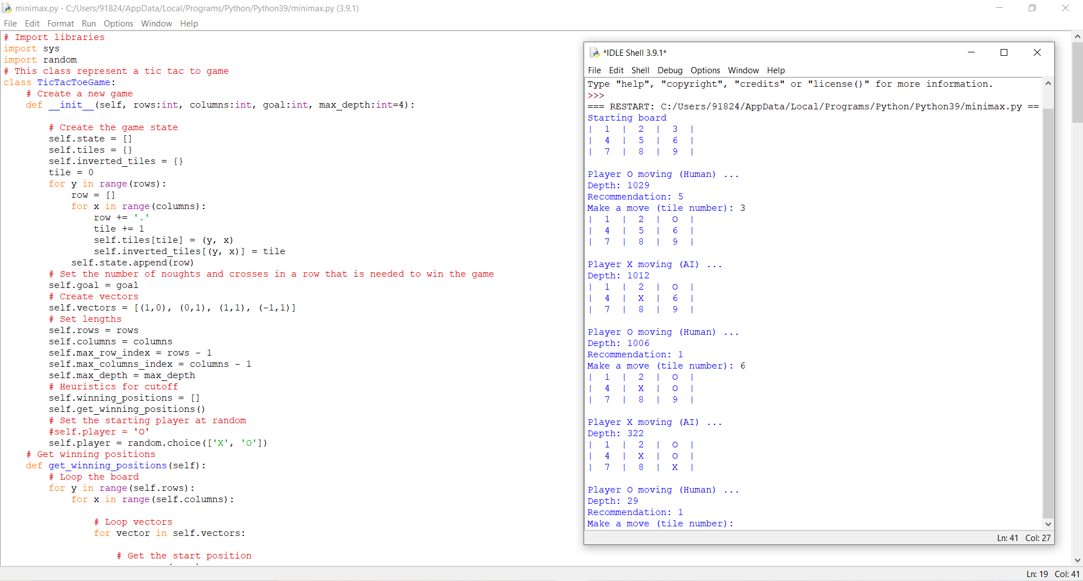

PROGRAM:
def get_index_comma(string):
"""
Return index of commas in string
"""

index_list = list()
# Count open parentheses
par_count = 0

for i in range(len(string)):
if string[i] == ',' and par_count == 0:
index_list.append(i)
elif string[i] == '(':
par_count += 1
elif string[i] == ')':
par_count -= 1

return index_list

def is_variable(expr):
"""
Check if expression is variable
"""

for i in expr:
if i == '(':
return False

return True

def process_expression(expr):
"""
input: - expression:
'Q(a, g(x, b), f(y))'
return: - predicate symbol:
Q
- list of arguments
['a', 'g(x, b)', 'f(y)']
"""
# Remove space in expression
expr = expr.replace(' ', '')

# Find the first index == '('
index = None
for i in range(len(expr)):
if expr[i] == '(':
index = i
break

# Return predicate symbol and remove predicate symbol in expression
predicate_symbol = expr[:index]
expr = expr.replace(predicate_symbol, '')

# Remove '(' in the first index and ')' in the last index
expr = expr[1:len(expr) - 1]

# List of arguments
arg_list = list()

# Split string with commas, return list of arguments
indices = get_index_comma(expr)

if len(indices) == 0:
arg_list.append(expr)
else:
arg_list.append(expr[:indices[0]])
for i, j in zip(indices, indices[1:]):
arg_list.append(expr[i + 1:j])
arg_list.append(expr[indices[len(indices) - 1] + 1:])

return predicate_symbol, arg_list

def get_arg_list(expr):
"""
input: expression:
'Q(a, g(x, b), f(y))'
return: full list of arguments:
['a', 'x', 'b', 'y']
"""

_, arg_list = process_expression(expr)

flag = True
while flag:
flag = False

for i in arg_list:
if not is_variable(i):
flag = True
_, tmp = process_expression(i)
for j in tmp:
if j not in arg_list:
arg_list.append(j)
arg_list.remove(i)

return arg_list

def check_occurs(var, expr):
"""
Check if var occurs in expr
"""

arg_list = get_arg_list(expr)
if var in arg_list:
return True

return False

def unify(expr1, expr2):
"""
Unification Algorithm

Step 1: If Ψ1 or Ψ2 is a variable or constant, then:
a, If Ψ1 or Ψ2 are identical, then return NULL.
b, Else if Ψ1 is a variable:
- then if Ψ1 occurs in Ψ2, then return False
- Else return (Ψ2 / Ψ1)
c, Else if Ψ2 is a variable:
- then if Ψ2 occurs in Ψ1, then return False
- Else return (Ψ1 / Ψ2)
d, Else return False

Step 2: If the initial Predicate symbol in Ψ1 and Ψ2 are not same, then return False.

Step 3: IF Ψ1 and Ψ2 have a different number of arguments, then return False.

Step 4: Create Substitution list.
Step 5: For i=1 to the number of elements in Ψ1
a, Call Unify function with the ith element of Ψ1 and ith element of Ψ2, and put the result into S.
b, If S = False then returns False
c, If S ≠ Null then append to Substitution list

Step 6: Return Substitution list.
"""

# Step 1:
if is_variable(expr1) and is_variable(expr2):
if expr1 == expr2:
return 'Null'
else:
return False
elif is_variable(expr1) and not is_variable(expr2):
if check_occurs(expr1, expr2):
return False
else:
tmp = str(expr2) + '/' + str(expr1)
return tmp
elif not is_variable(expr1) and is_variable(expr2):
if check_occurs(expr2, expr1):
return False
else:
tmp = str(expr1) + '/' + str(expr2)
return tmp
else:
predicate_symbol_1, arg_list_1 = process_expression(expr1)
predicate_symbol_2, arg_list_2 = process_expression(expr2)

# Step 2
if predicate_symbol_1 != predicate_symbol_2:
return False
# Step 3
elif len(arg_list_1) != len(arg_list_2):
return False
else:
# Step 4: Create substitution list
sub_list = list()

# Step 5:
for i in range(len(arg_list_1)):
tmp = unify(arg_list_1[i], arg_list_2[i])

if not tmp:
return False
elif tmp == 'Null':
pass
else:
if type(tmp) == list:
for j in tmp:
sub_list.append(j)
else:
sub_list.append(tmp)
# Step 6
return sub_list

if __name__ == '__main__':
# Data 1
f1 = 'p(b(A), X, f(g(Z)))'
f2 = 'p(Z, f(Y), f(Y))'

# Data 2
# f1 = 'Q(a, g(x, a), f(y))'
# f2 = 'Q(a, g(f(b), a), x)'

# Data 3
# f1 = 'Q(a, g(x, a, d), f(y))'
# f2 = 'Q(a, g(f(b), a), x)'

result = unify(f1, f2)
if not result:
print('Unification failed!')
else:
print('Unification successfully!')
print(result)

OUTPUT:

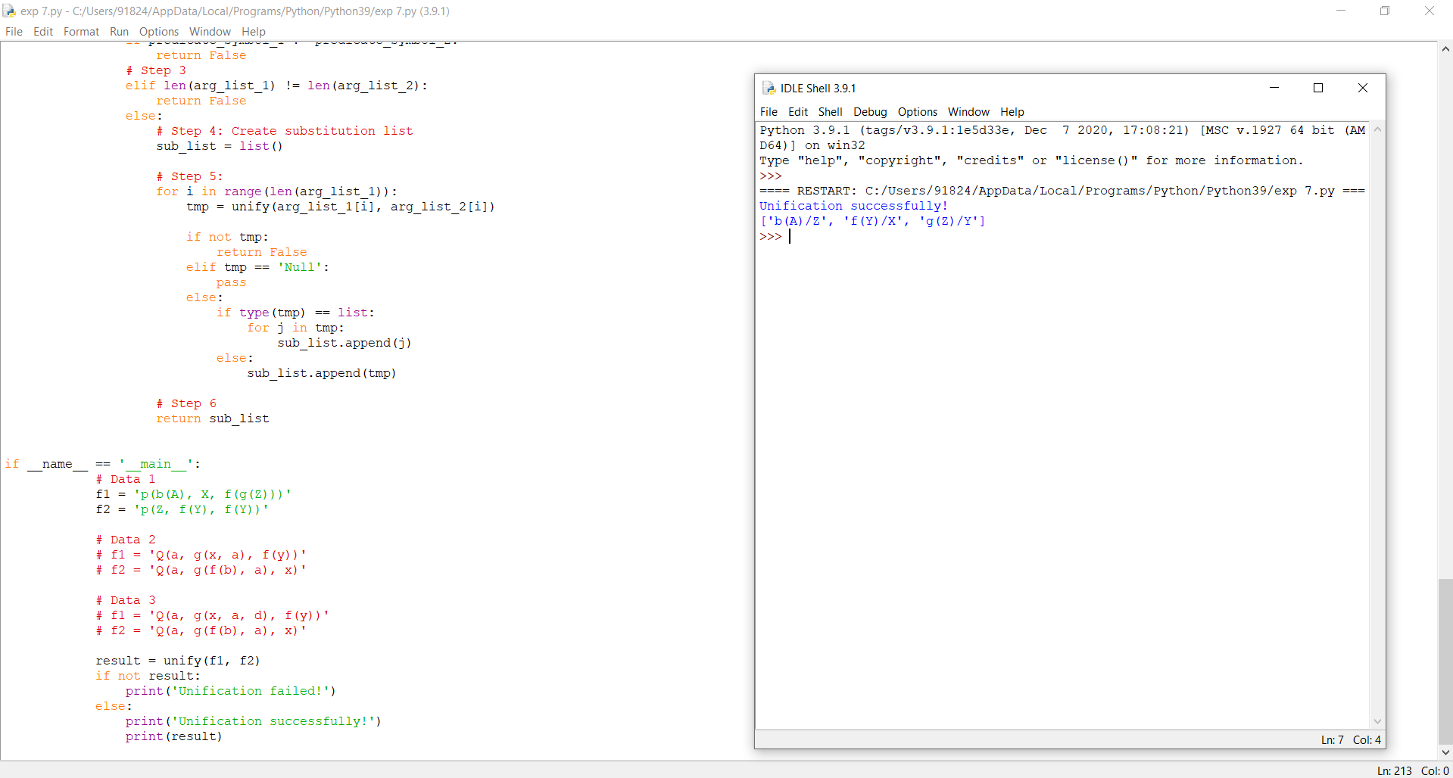

PROGRAM:
#include <stdio.h>
#define SIZE 9

//sudoku problem
int matrix[9][9] = {
{5,3,0,0,7,0,0,0,0},
{6,0,0,1,9,5,0,0,0},
{0,9,8,0,0,0,0,6,0},
{8,0,0,0,6,0,0,0,3},
{4,0,0,8,0,3,0,0,1},
{7,0,0,0,2,0,0,0,6},
{0,6,0,0,0,0,2,8,0},
{0,0,0,4,1,9,0,0,5},
{0,0,0,0,8,0,0,7,9}
};

//function to print sudoku
void print_sudoku()
{
int i,j;
for(i=0;i<SIZE;i++)
{
for(j=0;j<SIZE;j++)
{
printf("%d\t",matrix[i][j]);
}
printf("\n\n");
}
}

//function to check if all cells are assigned or not
//if there is any unassigned cell
//then this function will change the values of
//row and col accordingly
int number_unassigned(int *row, int *col)
{
int num_unassign = 0;
int i,j;
for(i=0;i<SIZE;i++)
{
for(j=0;j<SIZE;j++)
{
//cell is unassigned
if(matrix[i][j] == 0)
{
//changing the values of row and col
*row = i;
*col = j;
//there is one or more unassigned cells
num_unassign = 1;
return num_unassign;
}
}
}
return num_unassign;
}

//function to check if we can put a
//value in a paticular cell or not
int is_safe(int n, int r, int c)
{
int i,j;
//checking in row
for(i=0;i<SIZE;i++)
{
//there is a cell with same value
if(matrix[r][i] == n)
return 0;
}
//checking column
for(i=0;i<SIZE;i++)
{
//there is a cell with the value equal to i
if(matrix[i][c] == n)
return 0;
}
//checking sub matrix
int row_start = (r/3)*3;
int col_start = (c/3)*3;
for(i=row_start;i<row_start+3;i++)
{
for(j=col_start;j<col_start+3;j++)
{
if(matrix[i][j]==n)
return 0;
}
}
return 1;
}

//function to solve sudoku
//using backtracking
int solve_sudoku()
{
int row;
int col;
//if all cells are assigned then the sudoku is already solved
//pass by reference because number_unassigned will change the values of row and col
if(number_unassigned(&row, &col) == 0)
return 1;
int n,i;
//number between 1 to 9
for(i=1;i<=SIZE;i++)
{
//if we can assign i to the cell or not
//the cell is matrix[row][col]
if(is_safe(i, row, col))
{
matrix[row][col] = i;
//backtracking
if(solve_sudoku())
return 1;
//if we can't proceed with this solution
//reassign the cell
matrix[row][col]=0;
}
}
return 0;
}

int main()
{
if (solve_sudoku())
print_sudoku();
else
printf("No solution\n");
return 0;
}

OUTPUT:

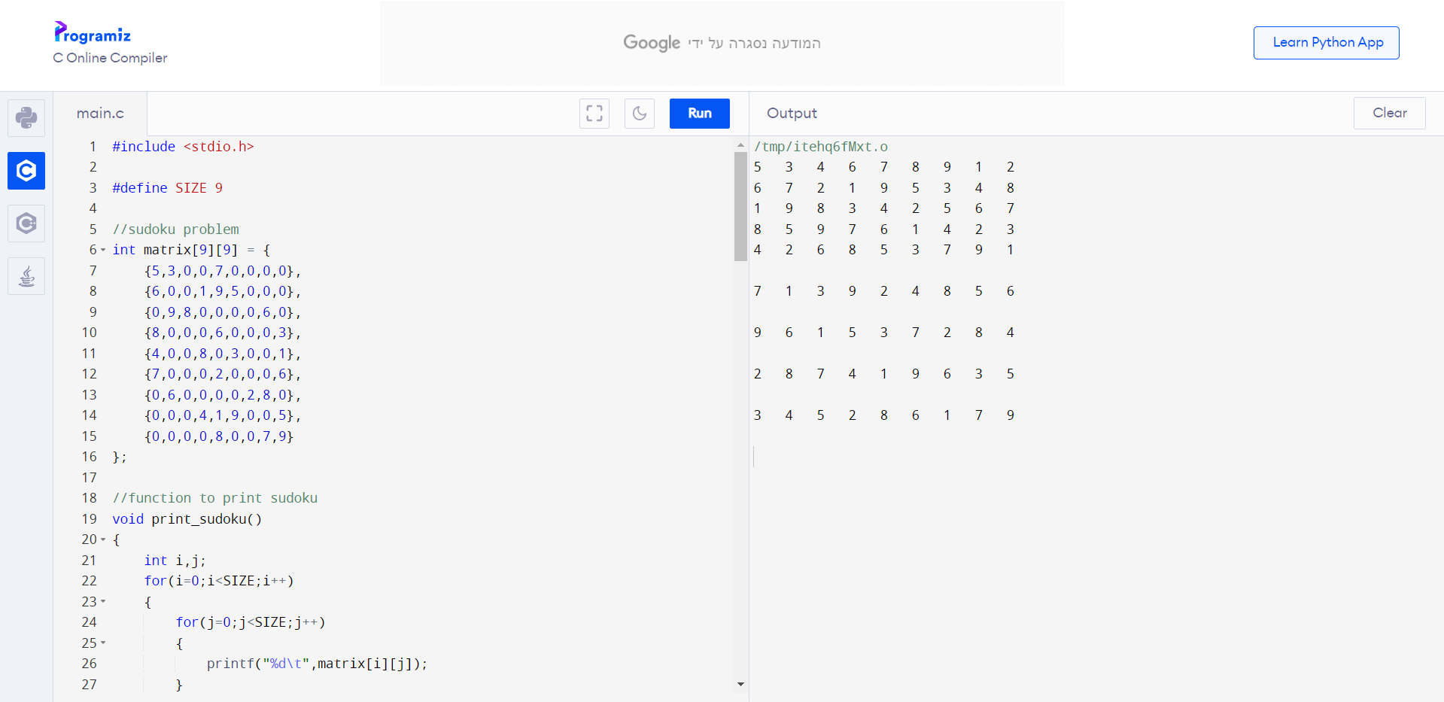

PROGRAM:
# prediction
y_pred_without_dropout = model_without_dropout.predict(x_test)
y_pred_with_dropout = model_with_dropout.predict(x_test)

# plotting
fig, ax = plt.subplots(1,1,figsize=(10,5))
ax.scatter(x_train, y_train, s=10, label='train data')
ax.plot(x_test, x_test, ls='--', label='test data', color='green')
ax.plot(x_test, y_pred_without_dropout, label='predicted ANN - R2 {:.2f}'.format(r2_score(x_test, y_pred_without_dropout)), color='red')
ax.plot(x_test, y_pred_with_dropout, label='predicted ANN Dropout - R2 {:.2f}'.format(r2_score(x_test, y_pred_with_dropout)), color='black')
ax.set_xlabel('x')
ax.set_ylabel('y')
ax.legend()
ax.set_title('test data');

OUTPUT:

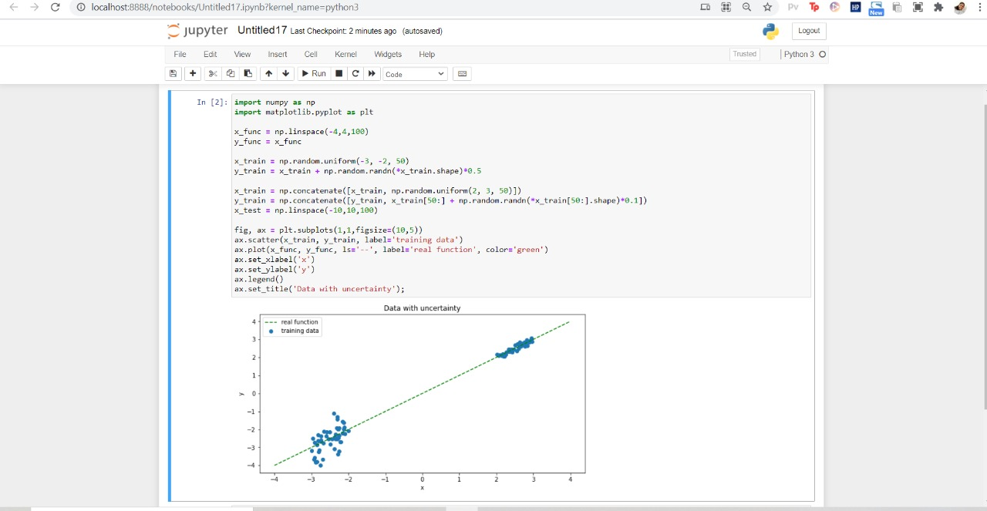

PROGRAM:
#Base Classes
#PREDICATE - ON, ONTABLE, CLEAR, HOLDING, ARMEMPTY

class PREDICATE:
def __str__(self):
pass
def __repr__(self):
pass
def __eq__(self, other) :
pass
def __hash__(self):
pass
def get_action(self, world_state):
pass

#OPERATIONS - Stack, Unstack, Pickup, Putdown
class Operation:
def __str__(self):
pass
def __repr__(self):
pass
def __eq__(self, other) :
pass
def precondition(self):
pass
def delete(self):
pass
def add(self):
pass

class ON(PREDICATE):
def __init__(self, X, Y):
self.X = X
self.Y = Y

def __str__(self):
return "ON({X},{Y})".format(X=self.X,Y=self.Y)

def __repr__(self):
return self.__str__()

def __eq__(self, other) :
return self.__dict__ == other.__dict__ and self.__class__ == other.__class__

def __hash__(self):
return hash(str(self))

def get_action(self, world_state):
return StackOp(self.X,self.Y)

class ONTABLE(PREDICATE):
def __init__(self, X):
self.X = X
def __str__(self):
return "ONTABLE({X})".format(X=self.X)

def __repr__(self):
return self.__str__()

def __eq__(self, other) :
return self.__dict__ == other.__dict__ and self.__class__ == other.__class__

def __hash__(self):
return hash(str(self))

def get_action(self, world_state):
return PutdownOp(self.X)

class CLEAR(PREDICATE):
def __init__(self, X):
self.X = X

def __str__(self):
return "CLEAR({X})".format(X=self.X)
self.X = X

def __repr__(self):
return self.__str__()

def __eq__(self, other) :
return self.__dict__ == other.__dict__ and self.__class__ == other.__class__

def __hash__(self):
return hash(str(self))

def get_action(self, world_state):
for predicate in world_state:
#If Block is on another block, unstack
if isinstance(predicate,ON) and predicate.Y==self.X:
return UnstackOp(predicate.X, predicate.Y)
return None

class HOLDING(PREDICATE):
def __init__(self, X):
self.X = X

def __str__(self):
return "HOLDING({X})".format(X=self.X)

def __repr__(self):
return self.__str__()

def __eq__(self, other) :
return self.__dict__ == other.__dict__ and self.__class__ == other.__class__

def __hash__(self):
return hash(str(self))
def get_action(self, world_state):
X = self.X
#If block is on table, pick up
if ONTABLE(X) in world_state:
return PickupOp(X)
#If block is on another block, unstack
else:
for predicate in world_state:
if isinstance(predicate,ON) and predicate.X==X:
return UnstackOp(X,predicate.Y)

class ARMEMPTY(PREDICATE):
def __init__(self):
pass

def __str__(self):
return "ARMEMPTY"

def __repr__(self):
return self.__str__()

def __eq__(self, other) :
return self.__dict__ == other.__dict__ and self.__class__ == other.__class__

def __hash__(self):
return hash(str(self))

def get_action(self, world_state=[]):
for predicate in world_state:
if isinstance(predicate,HOLDING):
return PutdownOp(predicate.X)
return None

class StackOp(Operation):
def __init__(self, X, Y):
self.X = X
self.Y = Y

def __str__(self):
return "STACK({X},{Y})".format(X=self.X,Y=self.Y)

def __repr__(self):
return self.__str__()

def __eq__(self, other) :
return self.__dict__ == other.__dict__ and self.__class__ == other.__class__

def precondition(self):
return [ CLEAR(self.Y) , HOLDING(self.X) ]

def delete(self):
return [ CLEAR(self.Y) , HOLDING(self.X) ]
def add(self):
return [ ARMEMPTY() , ON(self.X,self.Y) ]

class UnstackOp(Operation):
def __init__(self, X, Y):
self.X = X
self.Y = Y

def __str__(self):
return "UNSTACK({X},{Y})".format(X=self.X,Y=self.Y)

def __repr__(self):
return self.__str__()

def __eq__(self, other) :
return self.__dict__ == other.__dict__ and self.__class__ == other.__class__

def precondition(self):
return [ ARMEMPTY() , ON(self.X,self.Y) , CLEAR(self.X) ]

def delete(self):
return [ ARMEMPTY() , ON(self.X,self.Y) ]

def add(self):
return [ CLEAR(self.Y) , HOLDING(self.X) ]

class PickupOp(Operation):
def __init__(self, X):
self.X = X

def __str__(self):
return "PICKUP({X})".format(X=self.X)

def __repr__(self):
return self.__str__()

def __eq__(self, other) :
return self.__dict__ == other.__dict__ and self.__class__ == other.__class__

def precondition(self):
return [ CLEAR(self.X) , ONTABLE(self.X) , ARMEMPTY() ]

def delete(self):
return [ ARMEMPTY() , ONTABLE(self.X) ]

def add(self):
return [ HOLDING(self.X) ]

class PutdownOp(Operation):
def __init__(self, X):
self.X = X

def __str__(self):
return "PUTDOWN({X})".format(X=self.X)

def __repr__(self):
return self.__str__()

def __eq__(self, other) :
return self.__dict__ == other.__dict__ and self.__class__ == other.__class__

def precondition(self):
return [ HOLDING(self.X) ]

def delete(self):
return [ HOLDING(self.X) ]

def add(self):
return [ ARMEMPTY() , ONTABLE(self.X) ]

def isPredicate(obj):
predicates = [ON, ONTABLE, CLEAR, HOLDING, ARMEMPTY]
for predicate in predicates:
if isinstance(obj,predicate):
return True
return False

def isOperation(obj):
operations = [StackOp, UnstackOp, PickupOp, PutdownOp]
for operation in operations:
if isinstance(obj,operation):
return True
return False

def arm_status(world_state):
for predicate in world_state:
if isinstance(predicate, HOLDING):
return predicate
return ARMEMPTY()

class GoalStackPlanner:
def __init__(self, initial_state, goal_state):
self.initial_state = initial_state
self.goal_state = goal_state

def get_steps(self):
#Store Steps
steps = []
#Program Stack
stack = []
#World State/Knowledge Base
world_state = self.initial_state.copy()

#Initially push the goal_state as compound goal onto the stack
stack.append(self.goal_state.copy())

#Repeat until the stack is empty
while len(stack)!=0:
#Get the top of the stack
stack_top = stack[-1]

#If Stack Top is Compound Goal, push its unsatisfied goals onto stack
if type(stack_top) is list:
compound_goal = stack.pop()
for goal in compound_goal:
if goal not in world_state:
stack.append(goal)

#If Stack Top is an action
elif isOperation(stack_top):

#Peek the operation
operation = stack[-1]

all_preconditions_satisfied = True

#Check if any precondition is unsatisfied and push it onto program stack
for predicate in operation.delete():
if predicate not in world_state:
all_preconditions_satisfied = False
stack.append(predicate)
#If all preconditions are satisfied, pop operation from stack and execute it
if all_preconditions_satisfied:

stack.pop()
steps.append(operation)

for predicate in operation.delete():
world_state.remove(predicate)
for predicate in operation.add():
world_state.append(predicate)

#If Stack Top is a single satisfied goal
elif stack_top in world_state:
stack.pop()

#If Stack Top is a single unsatisfied goal
else:
unsatisfied_goal = stack.pop()

#Replace Unsatisfied Goal with an action that can complete it
action = unsatisfied_goal.get_action(world_state)

stack.append(action)

#Push Precondition on the stack
for predicate in action.precondition():
if predicate not in world_state:
stack.append(predicate)

return steps

if __name__ == '__main__':
initial_state = [
ON('B','A'),
ONTABLE('A'),ONTABLE('C'),ONTABLE('D'),
CLEAR('B'),CLEAR('C'),CLEAR('D'),
ARMEMPTY()
]

goal_state = [
ON('B','D'),ON('C','A'),
ONTABLE('D'),ONTABLE('A'),
CLEAR('B'),CLEAR('C'),
ARMEMPTY()
]

goal_stack = GoalStackPlanner(initial_state=initial_state, goal_state=goal_state)
steps = goal_stack.get_steps()
print(steps)

OUTPUT:

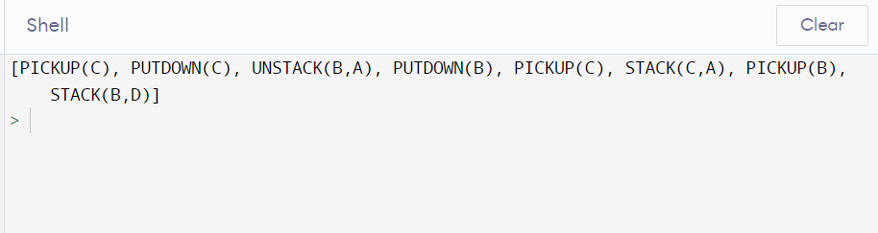

PROGRAM:
import numpy as np
import matplotlib.pyplot as plt

import pandas as pd
import seaborn as sns

%matplotlib inline
from sklearn.datasets import load_boston
boston_dataset = load_boston()
boston = pd.DataFrame(boston_dataset.data, columns=boston_dataset.feature_names)
boston.head()
boston['MEDV'] = boston_dataset.target
boston.isnull().sum()
sns.set(rc={'figure.figsize':(11.7,8.27)})
sns.distplot(boston['MEDV'], bins=30)
plt.show()
correlation_matrix = boston.corr().round(2)
# annot = True to print the values inside the square
sns.heatmap(data=correlation_matrix, annot=True)
plt.figure(figsize=(20, 5))

features = ['LSTAT', 'RM']
target = boston['MEDV']

for i, col in enumerate(features):
plt.subplot(1, len(features) , i+1)
x = boston[col]
y = target
plt.scatter(x, y, marker='o')
plt.title(col)
plt.xlabel(col)
plt.ylabel('MEDV')

OUTPUT:

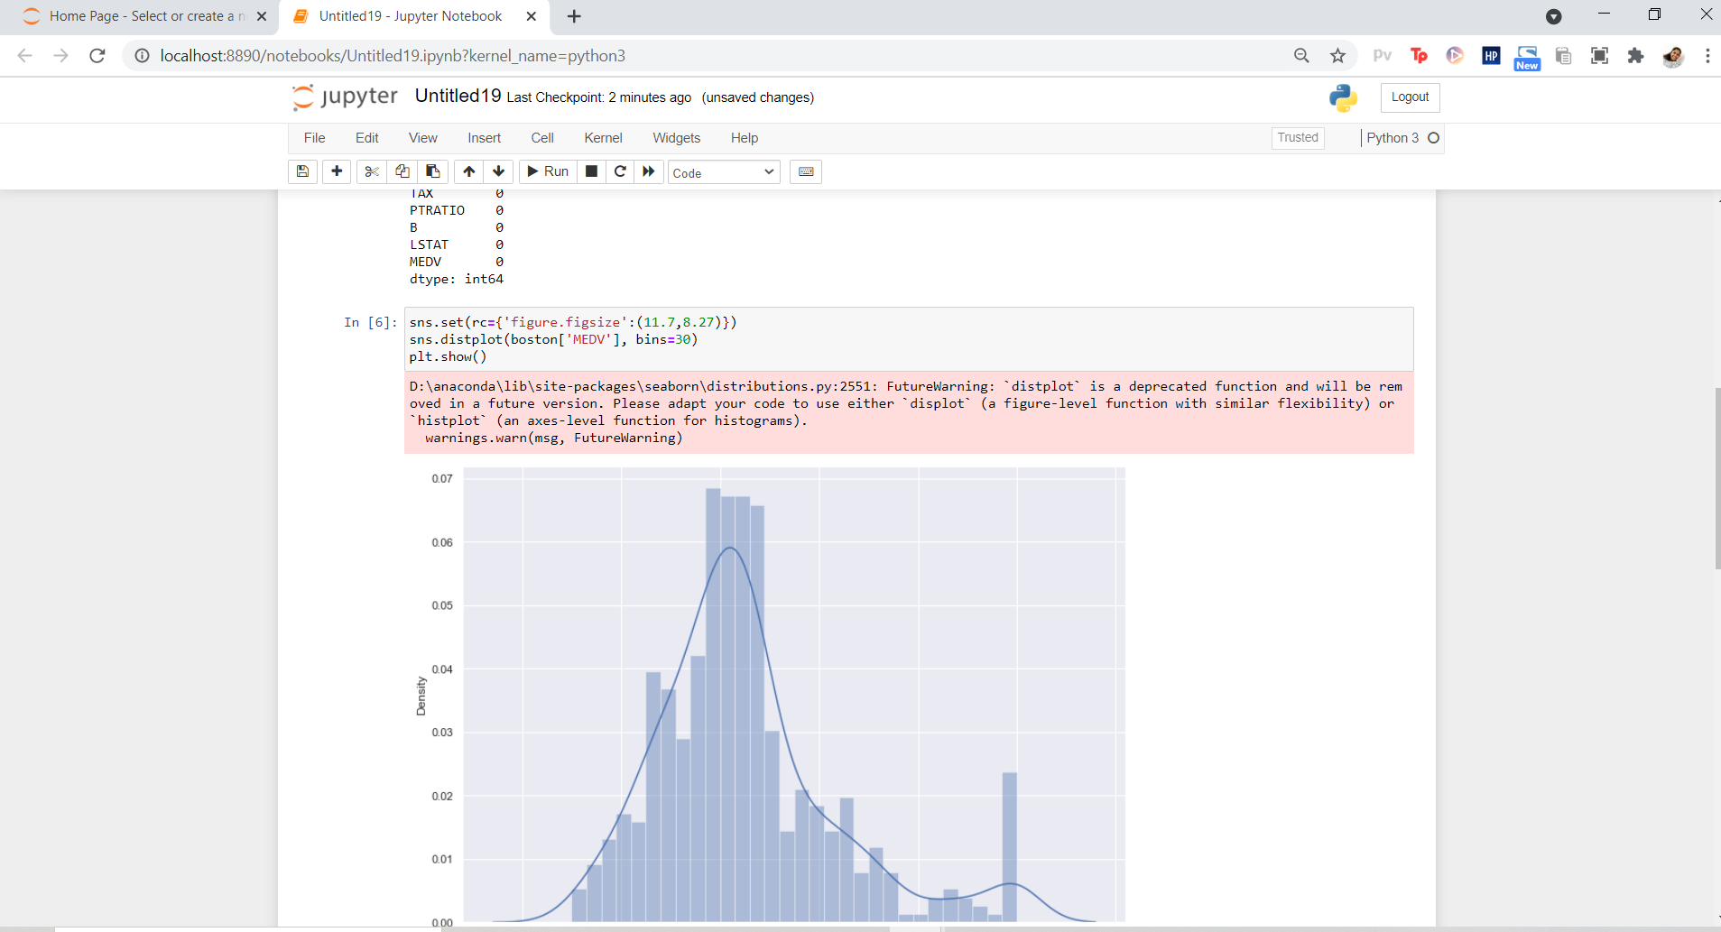

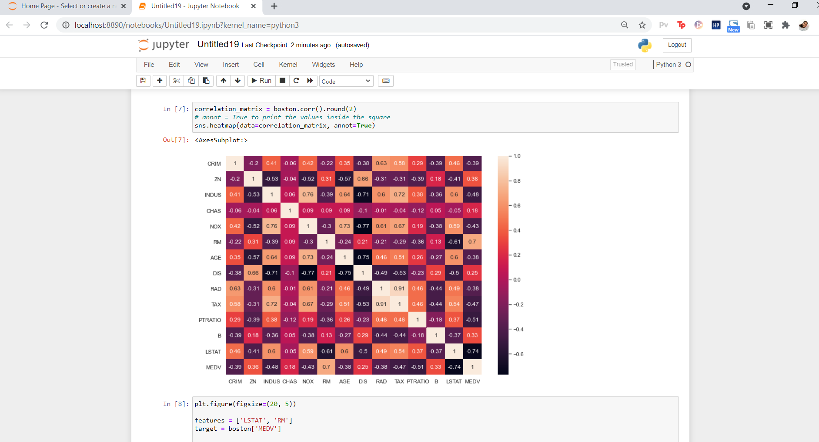

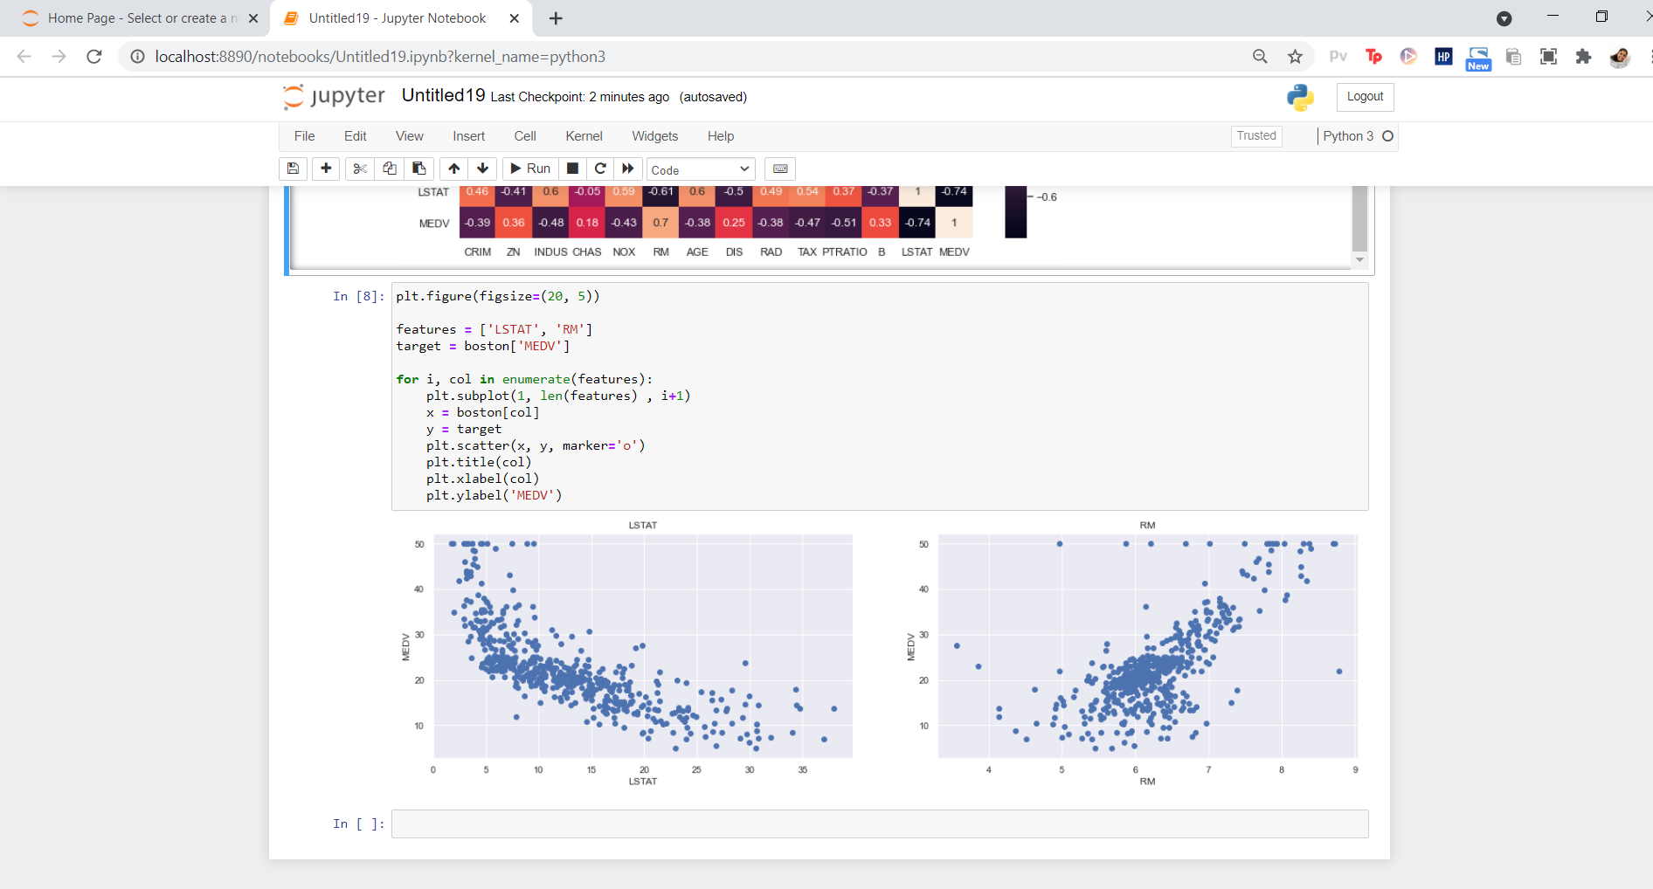

PROGRAM:

# Load libraries
from sklearn.ensemble import AdaBoostClassifier
from sklearn import datasets
# Import train_test_split function
from sklearn.model_selection import train_test_split
#Import scikit-learn metrics module for accuracy calculation
from sklearn import metrics
# Load data
iris = datasets.load_iris()
X = iris.data
y = iris.target
# Split dataset into training set and test set
X_train, X_test, y_train, y_test = train_test_split(X, y, test_size=0.3) # 70% training and 30% test
# Create adaboost classifer object
abc = AdaBoostClassifier(n_estimators=50,
learning_rate=1)
# Train Adaboost Classifer
model = abc.fit(X_train, y_train)

#Predict the response for test dataset
y_pred = model.predict(X_test)
# Model Accuracy, how often is the classifier correct?
print("Accuracy:",metrics.accuracy_score(y_test, y_pred))
# Load libraries
from sklearn.ensemble import AdaBoostClassifier
# Import Support Vector Classifier
from sklearn.svm import SVC
#Import scikit-learn metrics module for accuracy calculation
from sklearn import metrics
svc=SVC(probability=True, kernel='linear')

# Create adaboost classifer object
abc =AdaBoostClassifier(n_estimators=50, base_estimator=svc,learning_rate=1)

# Train Adaboost Classifer
model = abc.fit(X_train, y_train)

#Predict the response for test dataset
y_pred = model.predict(X_test)
# Model Accuracy, how often is the classifier correct?
print("Accuracy:",metrics.accuracy_score(y_test, y_pred))

OUTPUT:
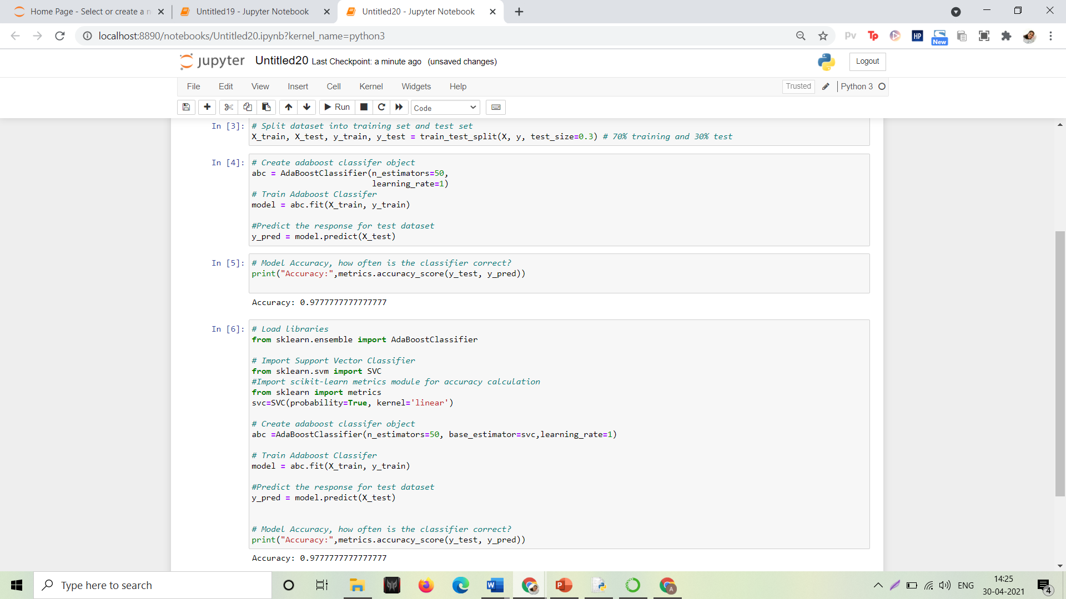

PROGRAM:
# import the necessary libraries
import nltk
import string
import re

1. Text Lowercase:
def text_lowercase(text):
return text.lower()
input_str = "Hey, did you know that the summer break is coming? Amazing right !! It's only 5 more days !!"
text_lowercase (input_str)

OUTPUT:
Input: “Hey, did you know that the summer break is coming? Amazing right!! It’s only 5 more days!!”
Output: “hey, did you know that the summer break is coming? amazing right!! it’s only 5 more days!!”

2. Remove numbers:
# Remove numbers
def remove_numbers(text):
result = re.sub(r'\d+', '', text)
return result
input_str = "There are 3 balls in this bag, and 12 in the other one."
remove_numbers(input_str)

Input: “There are 3 balls in this bag, and 12 in the other one.”
Output: ‘There are balls in this bag, and in the other one.’

- Convert numbers into words

# import the inflect library
import inflect
p = inflect.engine()

# convert number into words
def convert_number(text):
# split string into list of words
temp_str = text.split()
# initialise empty list
new_string = []

for word in temp_str:
# if word is a digit, convert the digit
# to numbers and append into the new_string list
if word.isdigit():
temp = p.number_to_words(word)
new_string.append(temp)

# append the word as it is
else:
new_string.append(word)

# join the words of new_string to form a string
temp_str = ' '.join(new_string)
return temp_str

input_str = 'There are 3 balls in this bag, and 12 in the other one.'
convert_number(input_str)

Input: “There are 3 balls in this bag, and 12 in the other one.”
Output: “There are three balls in this bag, and twelve in the other one.”

- Remove punctuation:
# remove punctuation
def remove_punctuation(text):
translator = str.maketrans('', '', string.punctuation)
return text.translate(translator)

input_str = "Hey, did you know that the summer break is coming? Amazing right !! It's only 5 more days !!"
remove_punctuation(input_str)

Input: “Hey, did you know that the summer break is coming? Amazing right!! It’s only 5 more days!!”
Output: “Hey did you know that the summer break is coming Amazing right Its only 5 more days”

- Remove whitespaces:
# remove whitespace from text
def remove_whitespace(text):
return " ".join(text.split())

input_str = " we don't need the given questions"
remove_whitespace(input_str)
Input: " we don't need the given questions"
Output: "we don't need the given questions"

- Remove default stopwords:
from nltk.corpus import stopwords
from nltk.tokenize import word_tokenize

# remove stopwords function
def remove_stopwords(text):
stop_words = set(stopwords.words("english"))
word_tokens = word_tokenize(text)
filtered_text = [word for word in word_tokens if word not in stop_words]
return filtered_text

example_text = "This is a sample sentence and we are going to remove the stopwords from this."
remove_stopwords(example_text)

The NLTK library has a set of stopwords and we can use these to remove stopwords from our text and return a list of word tokens.
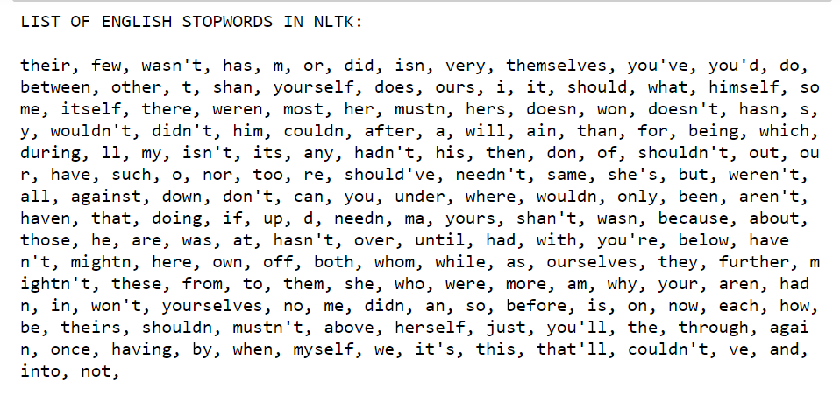
Input: “This is a sample sentence and we are going to remove the stopwords from this”
Output: [‘This’, ‘sample’, ‘sentence’, ‘going’, ‘remove’, ‘stopwords’]

- Stemming:
Stemming is the process of getting the root form of a word. Stem or root is the part to which inflectional affixes (-ed, -ize, -de, -s, etc.) are added. The stem of a word is created by removing the prefix or suffix of a word. So, stemming a word may not result in actual words.
Example:
books ---> book
looked ---> look
denied ---> deni
flies ---> fli
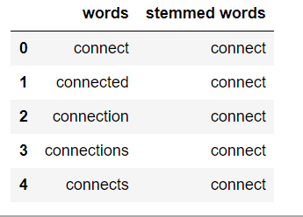
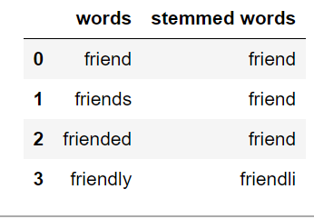

from nltk.stem.porter import PorterStemmer
from nltk.tokenize import word_tokenize
stemmer = PorterStemmer()

# stem words in the list of tokenized words
def stem_words(text):
word_tokens = word_tokenize(text)
stems = [stemmer.stem(word) for word in word_tokens]
return stems

text = 'data science uses scientific methods algorithms and many types of processes'
stem_words(text)

Input: ‘data science uses scientific methods algorithms and many types of processes’
Output: [‘data’, ‘scienc’, ‘use’, ‘scientif’, ‘method’, ‘algorithm’, ‘and’, ‘mani’, ‘type’, ‘of’, ‘process’]

- Lemmatization:
Lemmatization also converts a word to its root form. The only difference is that lemmatization ensures that the root word belongs to the language.

from nltk.stem import WordNetLemmatizer
from nltk.tokenize import word_tokenize
lemmatizer = WordNetLemmatizer()

# lemmatize string
def lemmatize_word(text):
word_tokens = word_tokenize(text)
# provide context i.e. part-of-speech
lemmas = [lemmatizer.lemmatize(word, pos ='v') for word in word_tokens]
return lemmas

text = 'data science uses scientific methods algorithms and many types of processes'
lemmatize_word(text)

Input: ‘data science uses scientific methods algorithms and many types of processes’
Output: [‘data’, ‘science’, ‘use’, ‘scientific’, ‘methods’, ‘algorithms’, ‘and’, ‘many’, ‘type’, ‘of’, ‘process’]

PROGRAM:
import pandas as pd
import numpy as np
import string
import seaborn as sns
import matplotlib.pyplot as plt
from nltk.corpus import stopwords
from sklearn.feature_extraction.text import CountVectorizer
from sklearn.feature_extraction.text import TfidfTransformer
from sklearn.model_selection import train_test_split
from sklearn.svm import SVC
from collections import Counter
from sklearn.metrics import classification_report,confusion_matrix
from sklearn.model_selection import GridSearchCV
%matplotlib inline

# Load data
data = pd.read_excel('data.xlsx')

# Rename names columns
data.columns = ['label', 'messages']
data["length"] = data["messages"].apply(len)
data.sort_values(by='length', ascending=False).head(10)
data.hist(column = 'length', by ='label',figsize=(12,4), bins = 5)
def transform_message(message):
message_not_punc = []
# Message without punctuation
for punctuation in message:
if punctuation not in string.punctuation:
message_not_punc.append(punctuation)

# Join words again to form the string.
message_not_punc = ''.join(message_not_punc)

# Remove any stopwords for message_not_punc, but first we should
# to transform this into the list.
message_clean = list(message_not_punc.split(" "))
while i <= len(message_clean):
for mess in message_clean:

if mess.lower() in stopwords.words('english'): message_clean.remove(mess)
i =i +1
return message_clean
vectorization = CountVectorizer(analyzer = transform_message )
X = vectorization.fit(data['messages'])
X_transform = X.transform([data['messages']])

tfidf_transformer = TfidfTransformer().fit(X_transform)
X_tfidf = tfidf_transformer.transform(X_transform)
print(X_tfidf.shape)
# Classification Model

X_train, X_test, y_train, y_test = train_test_split(X_tfidf, data['messages'], test_size=0.30,
random_state = 50)
clf = SVC(kernel='linear').fit(X_train, y_train)
# Test model

predictions = clf.predict(X_test)
print('predicted', predictions)
# Is our model reliable?

print (classification_report(y_test, predictions))
print(confusion_matrix(y_test,predictions))

OUTPUT:
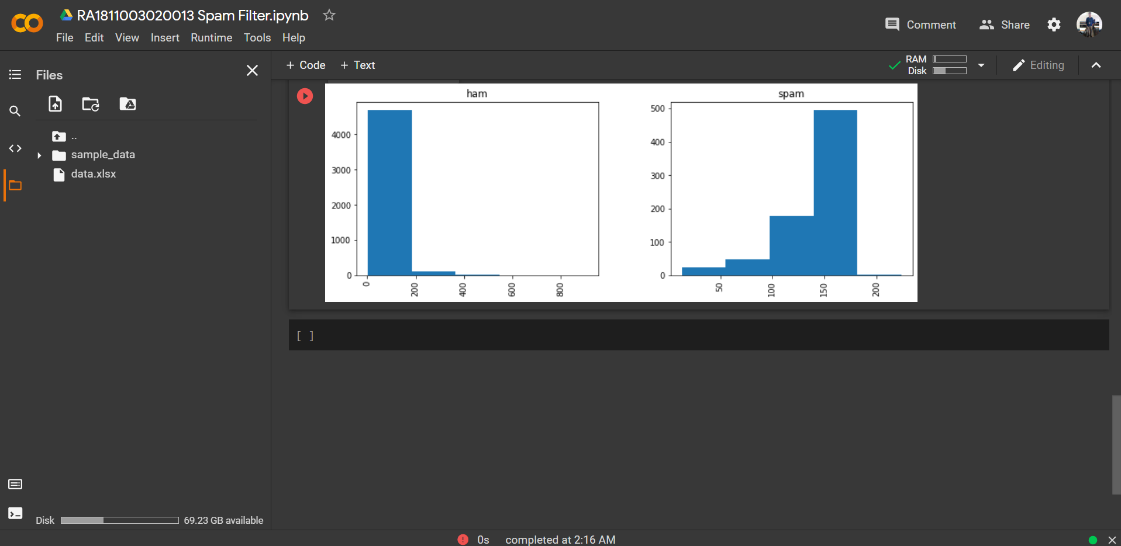

PROGRAM:
import argparse
import json

import cv2
import editdistance
from path import Path

from DataLoaderIAM import DataLoaderIAM, Batch
from Model import Model, DecoderType
from SamplePreprocessor import preprocess

class FilePaths:
"filenames and paths to data"
fnCharList = '../model/charList.txt'
fnSummary = '../model/summary.json'
fnInfer = '../data/test.png'
fnCorpus = '../data/corpus.txt'

def write_summary(charErrorRates, wordAccuracies):
with open(FilePaths.fnSummary, 'w') as f:
json.dump({'charErrorRates': charErrorRates, 'wordAccuracies': wordAccuracies}, f)

def train(model, loader):
"train NN"
epoch = 0

# number of training epochs since start
summaryCharErrorRates = []
summaryWordAccuracies = []
bestCharErrorRate = float('inf') # best valdiation character error rate
noImprovementSince = 0 # number of epochs no improvement of character error rate occured
earlyStopping = 25 # stop training after this number of epochs without improvement
while True:
epoch += 1
print('Epoch:', epoch)

# train
print('Train NN')
loader.trainSet()
while loader.hasNext():
iterInfo = loader.getIteratorInfo()
batch = loader.getNext()
loss = model.trainBatch(batch)

# validate
charErrorRate, wordAccuracy = validate(model, loader)
# write summary
summaryCharErrorRates.append(charErrorRate)
summaryWordAccuracies.append(wordAccuracy)
write_summary(summaryCharErrorRates, summaryWordAccuracies)
# if best validation accuracy so far, save model parameters
if charErrorRate < bestCharErrorRate:
print('Character error rate improved, save model')
bestCharErrorRate = charErrorRate
noImprovementSince = 0
model.save()
else:
print(f'Character error rate not improved, best so far: {charErrorRate * 100.0}%')
noImprovementSince += 1

# stop training if no more improvement in the last x epochs
if noImprovementSince >= earlyStopping:
print(f'No more improvement since {earlyStopping} epochs. Training stopped.')
break

def validate(model, loader):
"validate NN"
print('Validate NN')
loader.validationSet()
numCharErr = 0
numCharTotal = 0
numWordOK = 0
numWordTotal = 0

while loader.hasNext():
iterInfo = loader.getIteratorInfo()
print(f'Batch: {iterInfo[0]} / {iterInfo[1]}')
batch = loader.getNext()
(recognized, _) = model.inferBatch(batch)

print('Ground truth -> Recognized')
for i in range(len(recognized)):
numWordOK += 1 if batch.gtTexts[i] == recognized[i] else 0
numWordTotal += 1
dist = editdistance.eval(recognized[i], batch.gtTexts[i])
numCharErr += dist
numCharTotal += len(batch.gtTexts[i])
print('[OK]' if dist == 0 else '[ERR:%d]' % dist, '"' + batch.gtTexts[i] + '"', '->', '"' + recognized[i] + '"')

# print validation result
charErrorRate = numCharErr / numCharTotal
wordAccuracy = numWordOK / numWordTotal
print(f'Character error rate: {charErrorRate * 100.0}%. Word accuracy: {wordAccuracy * 100.0}%.')
return charErrorRate, wordAccuracy 1
def infer(model, fnImg):
"recognize text in image provided by file path"

img = preprocess(cv2.imread(fnImg, cv2.IMREAD_GRAYSCALE), Model.imgSize)
batch = Batch(None, [img])
(recognized, probability) = model.inferBatch(batch, True)
print(f'Recognized: "{recognized[0]}"')
print(f'Probability: {probability[0]}')

def main():
"main function"
parser = argparse.ArgumentParser()
parser.add_argument('--train', help='train the NN', action='store_true')
parser.add_argument('--validate', help='validate the NN', action='store_true')
parser.add_argument('--decoder', choices=['bestpath', 'beamsearch', 'wordbeamsearch'], default='bestpath',
help='CTC decoder')
parser.add_argument('--batch_size', help='batch size', type=int, default=100)
1parser.add_argument('--data_dir', help='directory containing IAM dataset', type=Path, required=False)
parser.add_argument('--fast', help='use lmdb to load images', action='store_true')
parser.add_argument('--dump', help='dump output of NN to CSV file(s)', action='store_true')
args = parser.parse_args()

# set chosen CTC decoder
if args.decoder == 'bestpath':
decoderType = DecoderType.BestPath
elif args.decoder == 'beamsearch':
decoderType = DecoderType.BeamSearch
elif args.decoder == 'wordbeamsearch':
decoderType = DecoderType.WordBeamSearch

# train or validate on IAM dataset
if args.train or args.validate:

# load training data, create TF model
loader = DataLoaderIAM(args.data_dir, args.batch_size, Model.imgSize, Model.maxTextLen, args.fast)

# save characters of model for inference mode
open(FilePaths.fnCharList, 'w').write(str().join(loader.charList))

# save words contained in dataset into file
open(FilePaths.fnCorpus, 'w').write(str(' ').join(loader.trainWords + loader.validationWords))

# execute training or validation
if args.train:
model = Model(loader.charList, decoderType)
train(model, loader)

elif args.validate:
model = Model(loader.charList, decoderType, mustRestore=True)
validate(model, loader)

# infer text on test image
else:
model = Model(open(FilePaths.fnCharList).read(), decoderType, mustRestore=True, dump=args.dump)
infer(model, FilePaths.fnInfer) 155

if name == ' main ':
main()

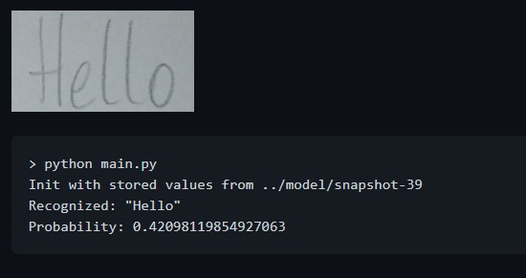
OUTPUT:

