Delivery Performance & Profitability Analysis
Late-Delivery Root Causes, Financial Impact and Predictive Modelling

1. Executive Summary
This report analyses the delivery operations of a global e-commerce company that manages end-to-end order fulfilment across multiple regions. The analysis covers 172,765 orders placed between January 2015 and January 2018. It identifies the root causes of chronic late deliveries, quantifies their financial impact, and sets out a data-driven framework for improvement.
The headline finding is that 54.71% of all orders are delivered late, putting $2.1M of profit at risk on delayed orders alone. Total profit across fulfilled orders reached $7.5M, so the late-delivery problem is both a significant financial drain and a major customer-experience risk. A Random Forest model identified at-risk orders with 74% accuracy before they became late.
54.71%  Orders delivered late | 45.29%  Delivered on time | $2.1M  Profit at risk | 74%  Model accuracy

2. Business Context & Objectives
The company operates a global e-commerce platform selling sporting goods, fitness equipment, outdoor gear, footwear and apparel across multiple international regions.

2.1 Core Business Problem
Actual shipping times frequently deviate from the scheduled delivery window. This erodes customer trust, reduces order profitability, and makes it impossible to give buyers reliable delivery commitments at the point of purchase.

2.2 Analytical Objectives
- Understand current delivery performance across all dimensions (region, shipping mode, time and customer segment).
- Quantify the financial impact of delays on order profitability.
- Identify the main operational bottlenecks driving late deliveries.
- Build a predictive model that flags high-risk orders before they ship.
- Deliver actionable recommendations to improve on-time delivery and profitability.

2.3 Key Findings Summary
Table 1. Summary of key findings
Key Finding | Metric
Overall late delivery rate | 54.71%
On-time delivery rate | 45.29%
Total orders analysed | 172,765
Total profit (profitable orders) | $7.5M
Profit at risk (delayed orders) | $2.1M
Predictive model accuracy (Random Forest) | 74%

3. Key Performance Indicators
The following KPIs were computed from the cleaned dataset to establish a performance baseline.
Table 2. Baseline delivery and profitability KPIs
Metric | Value
Total orders | 172,765
Late deliveries | 94,523
Late delivery rate | 54.71%
On-time delivery rate | 45.29%
Total profit (profitable orders) | $7.5M
Profit at risk (delayed orders) | $2.1M
90th percentile delay | 3 days
Average order profit | $22.03

3.1 Key Takeaways from the KPIs
Late delivery rate of 54.71%: More than half of all orders arrive late. This is not an edge case; it is the default experience for most customers.

$2.1M profit at risk: Delayed orders generated $2.1M in profit that remains under pressure if operations deteriorate further.

90th percentile delay of 3 days: Even the most extreme delays are contained within 3 days, which suggests the problem is systemic and process-driven rather than catastrophic.

4. Profitability Analysis

4.1 Profitability Distribution
Orders were classified into three profitability tiers based on profit per order. While 80.7% of orders are profitable, the 18.7% loss-making share is a meaningful drag and is disproportionately concentrated among delayed shipments.
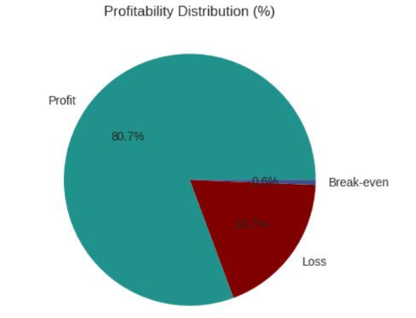
Figure 1. Distribution of orders by profitability tier.

4.2 Delay Distribution & Profit vs. Delay Days
The largest single cohort is orders delivered exactly 1 day late, at 31.0% of all orders. Orders delayed by 1–4 days together account for 54.7% of order volume, which matches the overall late delivery rate.
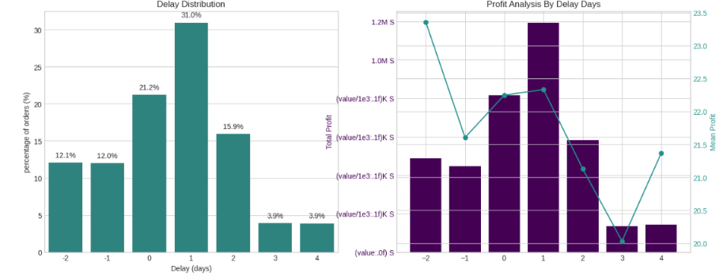
Figure 2. Delay distribution (left) and profit analysis by delay days (right).

Key observation: mean profit per order stays stable at roughly $21–$23 across all delay levels. The profitability problem is therefore driven by the volume of delayed orders, not by individual order economics. Improving overall throughput is the highest-leverage intervention.

5. Bottleneck Detection
Delay percentage was computed across six operational dimensions to show where the fulfilment process breaks down most severely.
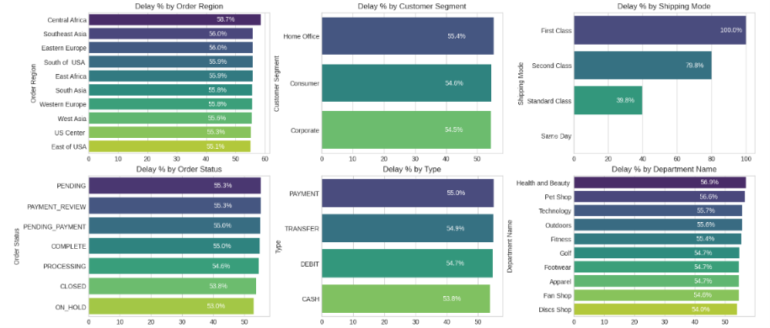
Figure 3. Late delivery percentage across six operational dimensions.

Shipping mode is the biggest lever. First Class has a 100% delay rate, Second Class 79.8%, Standard Class 39.8% and Same Day 0%. Mode assignment logic is the single most impactful variable to fix.

Regional spread is narrow (55–59%). Central Africa is highest at 58.7%, but all regions cluster within a few points. This rules out a localised logistics failure and points to a company-wide systemic issue.

Customer segments are nearly identical (54.5–55.4%). No segment receives preferential service; Consumer, Corporate and Home Office customers all experience the same broken delivery promise.

Health & Beauty (56.9%) and Pet Shop (56.6%) lead by department. These departments marginally outpace the others and warrant an inventory and carrier audit.

6. Root Cause Analysis
Central Africa was selected for deep-dive analysis as the highest-delay region (58.7%). Figure 4 ranks the top 10 driver factors by delay percentage within this region.
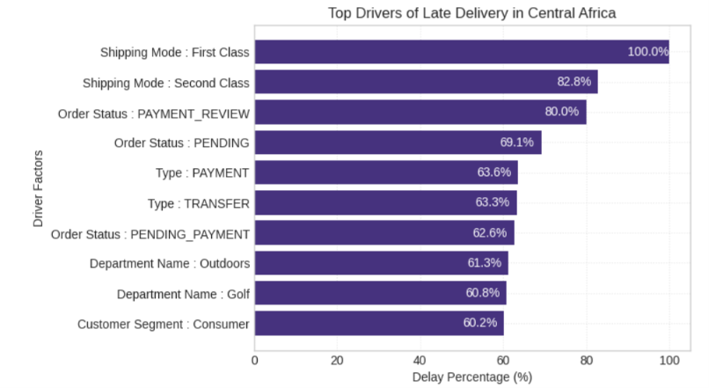
Figure 4. Top 10 drivers of late delivery in Central Africa.

7. Time-Based Delay Patterns
Three temporal dimensions were analysed: month of year, day of week and hour of day. Delay rates are relatively stable across all three (53–57%), but specific peaks highlight opportunities for targeted capacity planning.
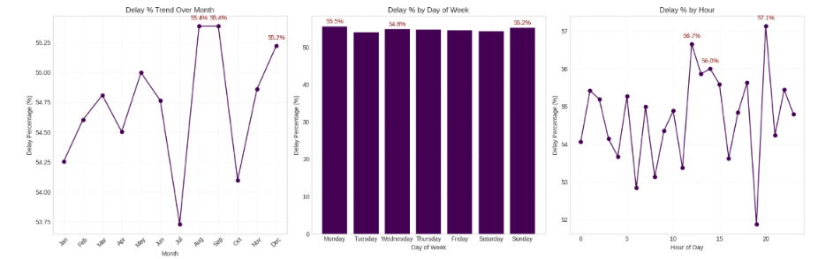
Figure 5. Late delivery percentage by month, day of week and hour of day.

Peak months are August, September (55.4%) and December (55.2%). These likely reflect mid-year promotions and the Q4 holiday surge overwhelming fulfilment capacity. July is a notable low point (about 53.75%), which confirms that seasonal variation is plannable.

Day-of-week variance is minimal. Monday (55.5%) and Sunday (55.2%) peak, but the spread across the week is under 1 percentage point, so day of week is not a meaningful operational lever.

Intra-day peaks occur at hours 21 (57.1%), 11 (56.7%) and 12 (56.0%). Late-evening orders have the highest delay rate, likely due to processing cut-off windows, while midday peaks suggest bottlenecks during high-volume hours.

8. Machine Learning Model Results
A supervised classification model was built to predict whether an order will be delivered late (Late_delivery_risk = 1). The pipeline used frequency encoding of categorical variables, a stratified train/test split, SMOTE oversampling to address class imbalance, and a Random Forest classifier.

8.1 Class Imbalance Handling (SMOTE)
Table 3. Training-set class distribution before and after SMOTE
Split | Class 0 (On-time) | Class 1 (Late)
Before SMOTE (train) | 59,030 | 79,182
After SMOTE (train) | 79,182 | 79,182

8.2 Random Forest Test-Set Performance
The model was evaluated on a held-out test set of 34,553 records.
Table 4. Random Forest classification metrics on the test set
Metric | Class 0 (On-time) | Class 1 (Late) | Overall (Weighted)
Precision | 0.68 | 0.78 | 0.74
Recall | 0.72 | 0.75 | 0.74
F1-score | 0.70 | 0.77 | 0.74
Accuracy | — | — | 0.74
Support | 14,758 | 19,795 | 34,553

74% overall accuracy: the model classifies nearly 3 in 4 orders correctly, a strong foundation for use as an order-level late-delivery alert system.

Higher precision on late orders (0.78): when the model predicts a late order it is right 78% of the time, enough to trigger targeted interventions without excessive false alarms.

Recall of 0.75 on late orders: the model captures 75% of actual late orders. The 25% miss rate is acceptable for a first-generation alert system and leaves room for improvement.

Class 0 is harder to predict (precision 0.68): on-time deliveries share many characteristics with late ones because delays are systemic, which makes them genuinely hard to separate.

9. Strategic Recommendations
Based on the findings above, the following prioritised actions are recommended.
1. Audit First Class and Second Class shipping capacity immediately. First Class has a 100% delay rate and Second Class 79.8%, which contradicts their premium promise. Conduct a carrier SLA audit and, until resolved, consider suspending First Class or repricing it to reflect actual performance.

2. Deploy the predictive alert system. The Random Forest model (74% accuracy, 78% precision on late orders) is ready for a production pilot. Integrate it into the order management system to flag high-risk orders at confirmation and trigger proactive customer communication and priority handling.

3. Resolve payment-processing bottlenecks. PAYMENT_REVIEW (55.3% overall; 80.0% in Central Africa) and PENDING_PAYMENT (55.0%) orders have elevated delay rates. Introduce automated escalation for payment reviews stalled beyond 2 hours.

4. Develop seasonal surge capacity plans. August, September and December are peak delay months. Build pre-season plans that include temporary logistics partnerships, inventory pre-positioning and adjusted delivery promise windows.

5. Default to Standard Class for eligible orders. Standard Class has a 39.8% delay rate, far better than First and Second Class. Revisit shipping-mode assignment logic, particularly in regions and departments where premium modes perform poorly.

6. Investigate high-delay departments in Central Africa. Outdoors (61.3%) and Golf (60.8%) show significantly elevated delay rates. Audit stock availability, pick-and-pack times and carrier assignment for these categories.

7. Reduce the loss-making order share (18.7%). Run a separate pricing and discount review, combined with the delay analysis, to test whether discounted orders are disproportionately late and compounding the margin problem.

