avMonitoring



Overview

avMonitoring is a availability monitoring system by provide a socket connection to the server and get a binary status; “online” and “offline”, and notify to system administrator when server or service fail by send an E-Mail, record to Google Calendar event sent Short Message Service (SMS) by Google Calendar or other SMS gateway. avMonitoring has report 2 type; status report for each servers per services and summary of downtime. each report can generate by specify date range and server name. The data store in database, can be used for another works.

Features

Easy to use, Easy to install
- Easy to use browser-based GUI.
- The system is running on Apache, PHP and MySQL.
- Working on Windows, Linux, Unix and Mac.

Easy Integration
- The data is stored into the database.
- The data can be used for another works.

Agent less Monitoring
- No need agent to target machine.
- Supports standards such as HTTP, SMTP, POP3, IMAP etc.
- Specify the server both the IP Address and FQDN.

Individual Notification
- Specify server administrator and alert individuals.
- Notification via email.
- Alerts via Google Calendar.
- Alerts via SMS, using Google Calendar or other SMS Gateway.

Summary Reports
- Reports can be created by the specified date and the server.
- Report the number of the stopping of servers and services.
- Reporting period of service outage.

Dashboard
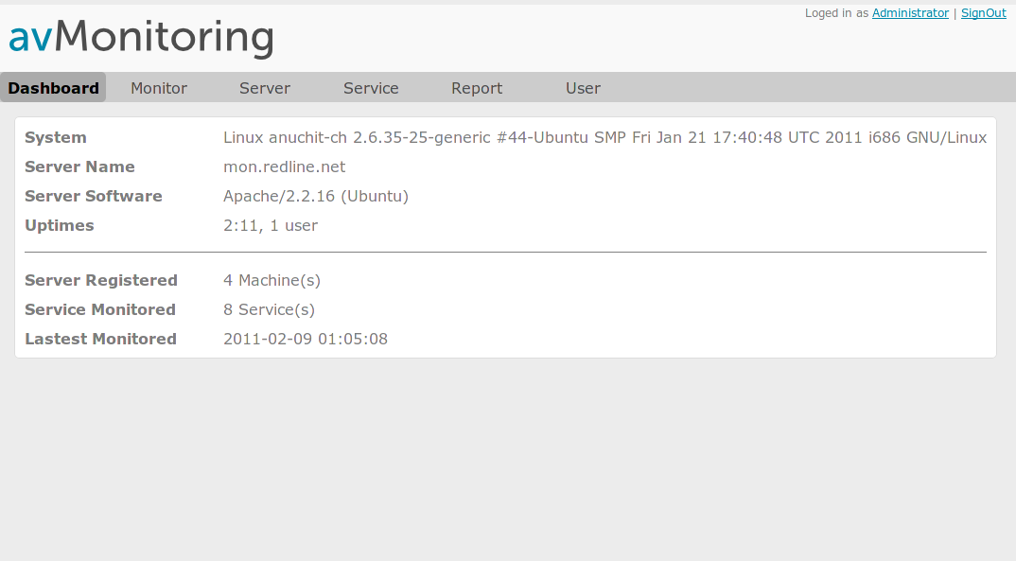
- System status, monitored server and services.
- Monitoring server status.
- Latest monitoring.

Monitoring
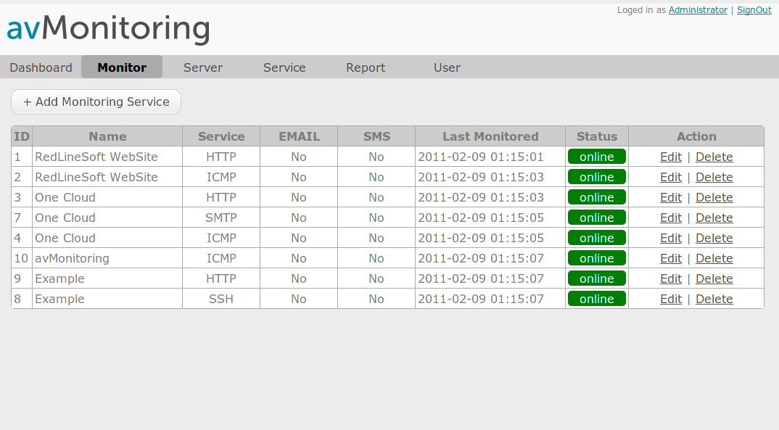
- Server / Service list and status.
- Notification type.
- Latest monitoring.

Server
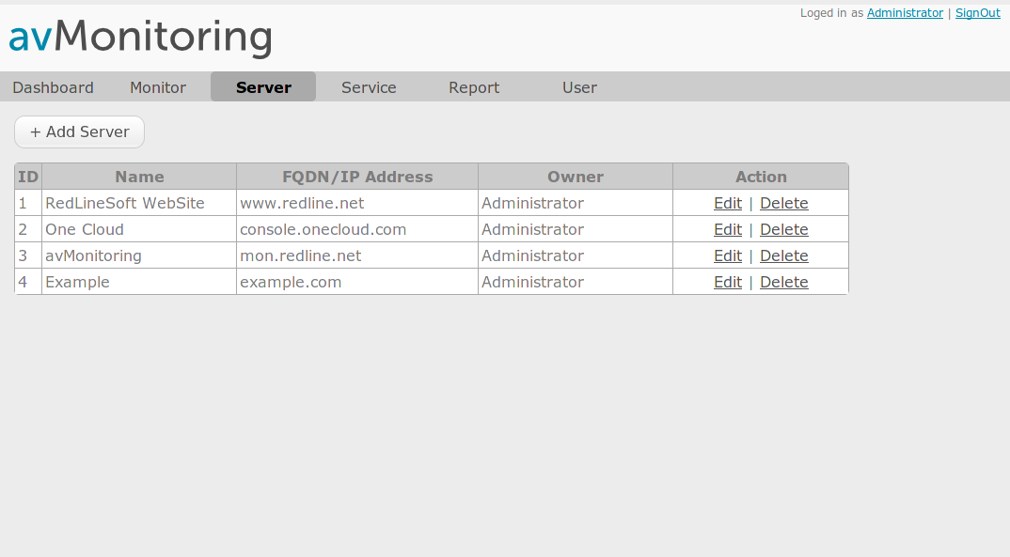
- Register server to monitor.
- Specify server's owner for notification.
- Support Windows, Linux, Unix, Mac server.

Service
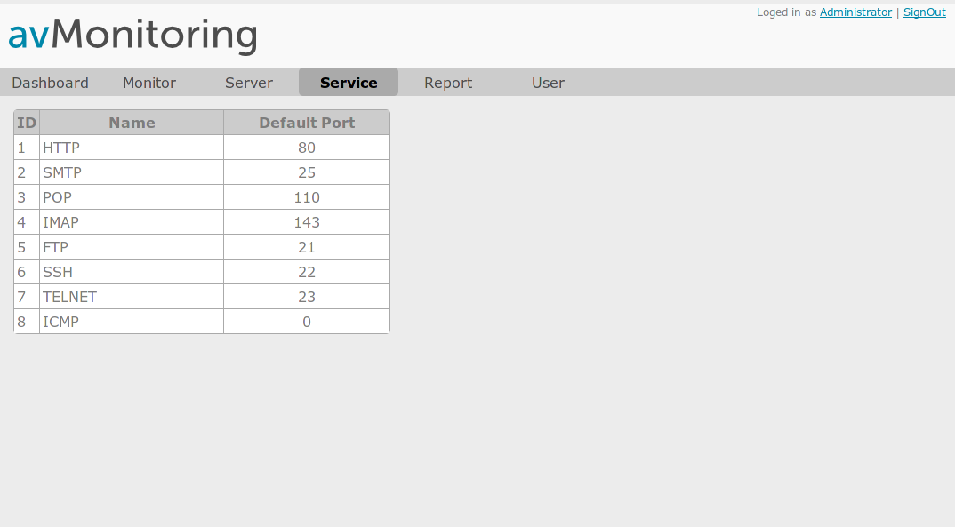
- Support standard port or specify the alternate port
- Support ICMP monitoring

Report
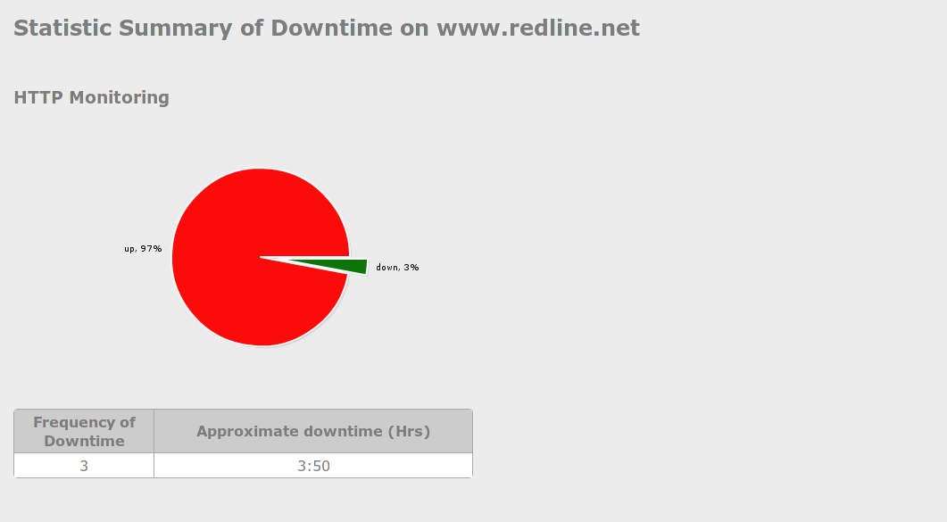
- Statistic Summary of server and services status.
- Summary frequency of downtime.
- Generate report form database.

Improve Service Availability
- Immediate notification of outages and performance-related issues significantly reduces the Mean Time to Repair (MTTR) for problems
- 24/7 proactive monitoring increases availability
and lowers IT operating costs by identifying
problems before they cause costly outages
- Rapid isolation of problems reduces the
troubleshooting time and related-expenses

