avMonitoring

User's Manual

Rev. 1.0

February 4, 2011

© Copyright 2011 RedLineSoft. All Rights Reserved.

Table of Contents
Chapter 1 : Overview 1
Chapter 2 : Installation 2
Installation Overview 2
Step 1 install LAMPP and MySQL server 2
Step 2 extract and configure management console 2
Step 3 config Apache default site 3
Step 4 check management console setup 4
Step 5 setup root's cron job 5
Chapter 3 : Monitor server 7
Update administrator information 10
Register Server 10
Register services to monitor 12
Report 13
User Management 15
Chapter 4 : Troubleshoot 17
Copyright and License i

Chapter 1 : Overview

avMonitoring is a availability monitoring system which concern only binary status 1 or 0, online or offline. The system can monitor services port number and record into log file, database and notify to the administrator via E-mail, Google calendar and short message system (SMS).

Report of the system has 2 type; The first is statistic summary of all status. The second is statistic summary of downtime. Each reports have flash animation graph and data table.

The system divide in 2 parts; the first is management console, web application using application server like Apache, PHP and MySQL. Management console is a user interface between the monitoring job, report and monitoring data. Administrator use the management console to configure the monitoring job, watch status, reports.

The second is monitoring script run by system schedule (cron) to check server services in monitoring job, record their status in to a log file, database and notified system administrator.

Chapter 2 : Installation

The system divide in 2 parts; management console and monitoring script, then the monitoring server must have LAMPP and PHP cli. We recommend to use Ubuntu 10.04 Long Term Support as a monitoring server.

Installation Overview

You must have a CD-ROM contain; application and manual in portable format. To install avMonitoring you should have a Ubuntu server which basic server installation (or include OpenSSH for remote configure), installation has 5 steps below

Step 1 install LAMPP and MySQL server

Install LAMP and PHPMyAdmin services for monitoring server.

$ sudo apt-get phpmyadmin mysql-server postfix php5-cli

The command above use meta package of phpmyadmin it 'll call the dependency of this package and install all necessary packages include PHPMyAdmin and MySQL server. Check Apache, MySQL and PHP status before install avMonitoring management console.

Step 2 extract and configure management console

avMonitoring management console is an archive file like avmonitoring_<version>.tar.gz . Extract into /var/www/ directory.

$ sudo tar xzf avmonitoring_<version>.tar.gz -C /var/www/

Edit the configuration file in /var/www/

$ sudo nano /var/www/config.php

Check the configuration below :

[…]

$dbhost="localhost";
$dbname="avmonitor_database";
$dbusername="database_user";
$dbpassword="database_password";

$url="http://monitor.redlinesoft.net";

[…]

$admin_name="Monitoring Administrator";
$admin_email="admin@monitor.redlinesoft.net";

$crontab_inteval=15;

[…]

replace bold value to your configuration, after that import pre monitoring data to your avMonitoring database.

$ mysql -u root -p avmonitor_database < /var/www/schema/schema.sql

Step 3 config Apache default site

After import pre monitoring data, now you can change DOCUMENT ROOT of Apache to the avMonitoring console application's location ; /var/www/www/. Edit your Apache default site like this

[…]

DocumentRoot /var/www/www

<Directory />
Options FollowSymLinks
AllowOverride None
</Directory>

<Directory /var/www/www/>
Options Indexes FollowSymLinks MultiViews
AllowOverride All
Order allow,deny
allow from all
</Directory>

[…]

Config 'php.ini' at /etc/php5/apache2/php.ini, change the directive to control display error equal Off

[…]

display_errors = Off

[…]

After update default site and PHP config, you MUST restart Apache service as following

# services apache2 restart

Step 4 check management console setup

Open your favorite web browser (FireFox 3.6.x above is recommend) goto your monitoring server e.g. http://monitor.redlinesoft.net, browser 'll redirect to sign-in page look like below

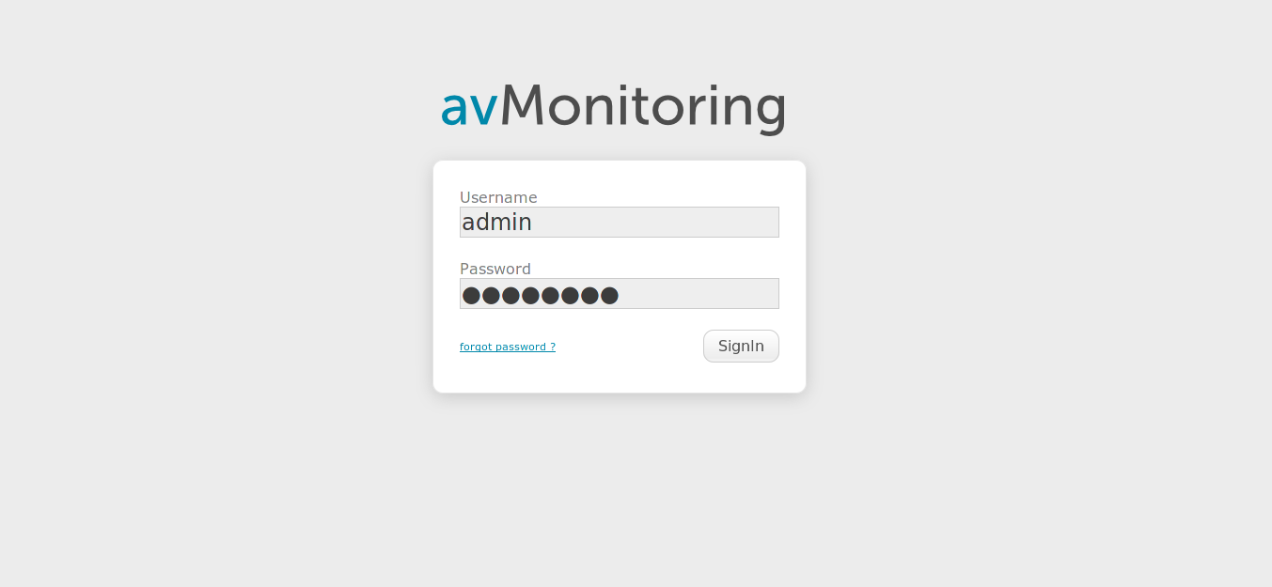Figure 1 : Sign In
Default administrator login is admin and password is adminadmin . DO NOT hurry sign in, you should config the cron job for monitoring script in the next step.

Step 5 setup root's cron job

Edit monitoring script in /var/www/www/script/avmonitor.cli.php then edit this file :

$ sudo nano /var/www/www/script/avmonitor.cli.php

update the following bold lines

[…]

$pwd="/var/www/www/"; // base path for cli script
$incattm="n"; // notify include all attempt

[…]

Update the avMonitoring directory is '/var/www/www/ ' (don't forget slash tail '/') and if you want to send notification in every interval of monitoring change 'n' to 'y', then setup root's cron job.

# crontab -e

add the following line to root's cron job

*/15 * * * * /usr/bin/php /var/www/www/script/avmonitor.cli.php

Check after 15 minutes, monitoring service's log of example.com 'll write in to /var/www/www/script/monitor.log .

Chapter 3 : Monitor server

After installation the management console, you can use your favortie web browser browse to avMonitoring server e.g. http://monitor.redlinesoft.net your browser will redirect to the sign-in page like figure 1 below

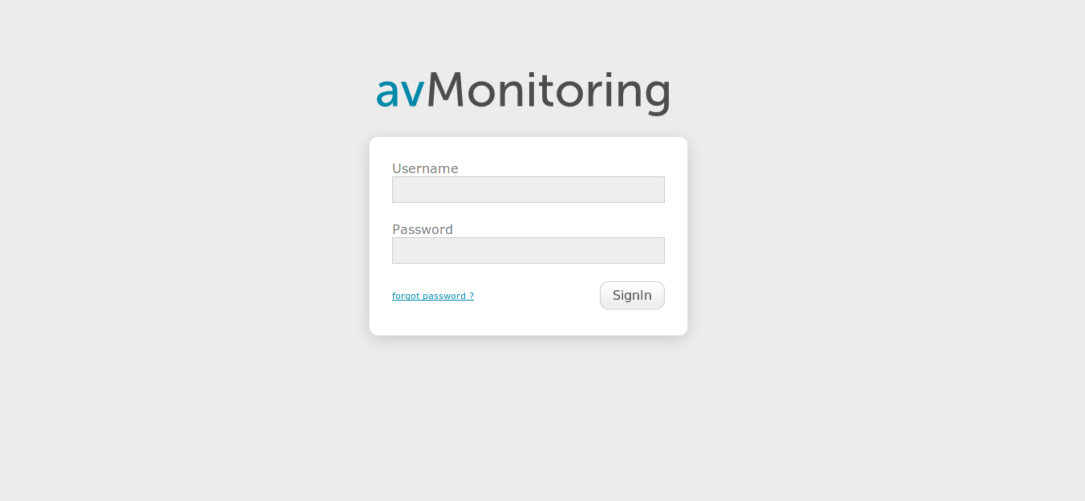Figure 1 : Sign In
Sign in with default administrator's username and password is admin and admiadmin .

Figure 2 : Sign In with default username and password
Click 'Sign In' button if username and password correct, your browser will redirect to 'Dashboard' page in figure 3

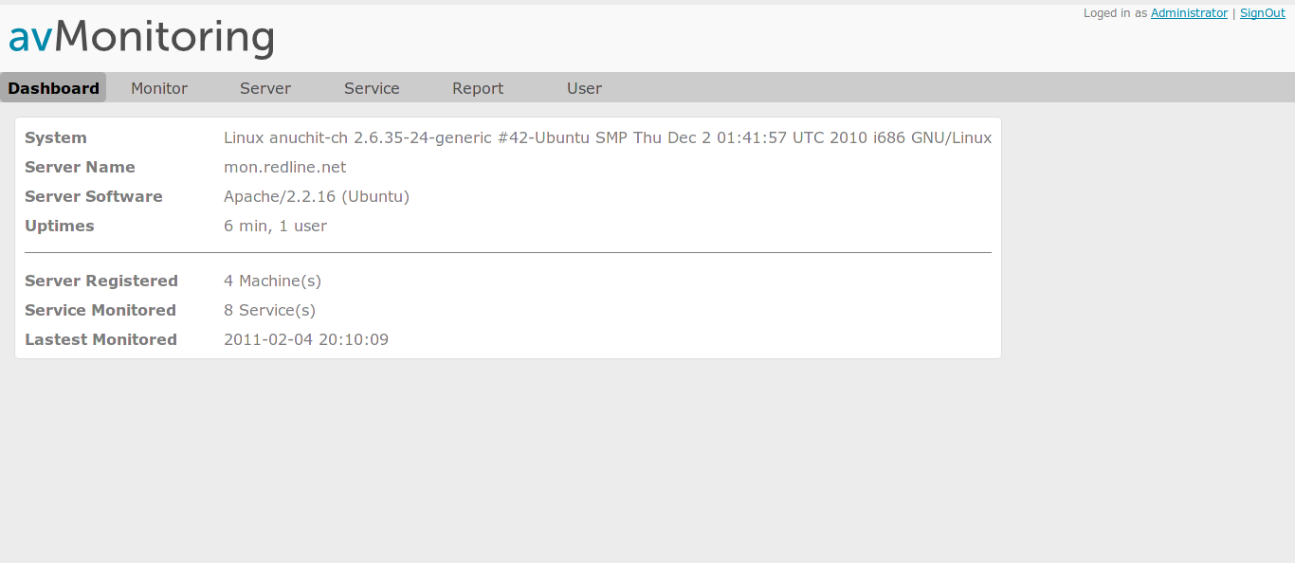Figure 3 : Dashboard
Dashboard has information about your monitoring server, number of service monitored, date-time in latest monitored and number of server registered.

Management console has 6 pages

- Dashboard – show information of monitoring server
- Monitor – show service monitoring and status
- Server – list of servers
- Service – list of standard services
- Report – statistic and summary report for each servers
- User – user management for management console

Update administrator information

Pre-configuration data has an example data for administrator account, you MUST change it first! Befor add any server and services to monitoring. Click 'preference' menu or your name; in this case is Administrator at the top right of Dashboard page. The page will change to preference page like figure

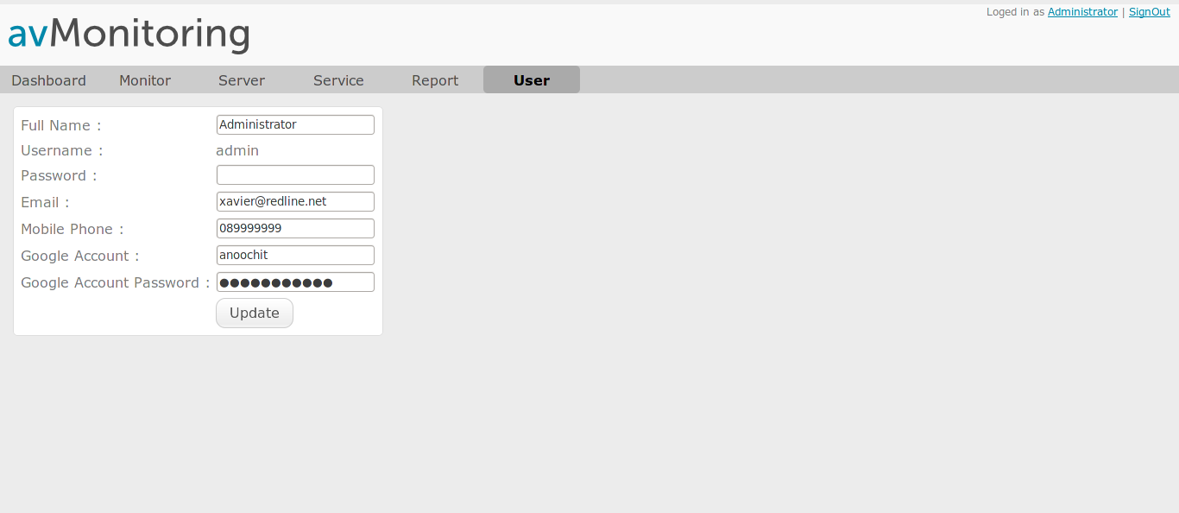Figure 4 : Preference page
Enter your information, change your password fill your mobile phone (if you want to use SMS gateway) or fill your Google Account and Password to use Google Calendar, you can use Google Calendar to sent SMS to your mobile (see troubleshoot)

Register Server

To monitor your server or any services on your server, you MUST register server to the system first. Click at 'Server' menu goto server page in figure 5
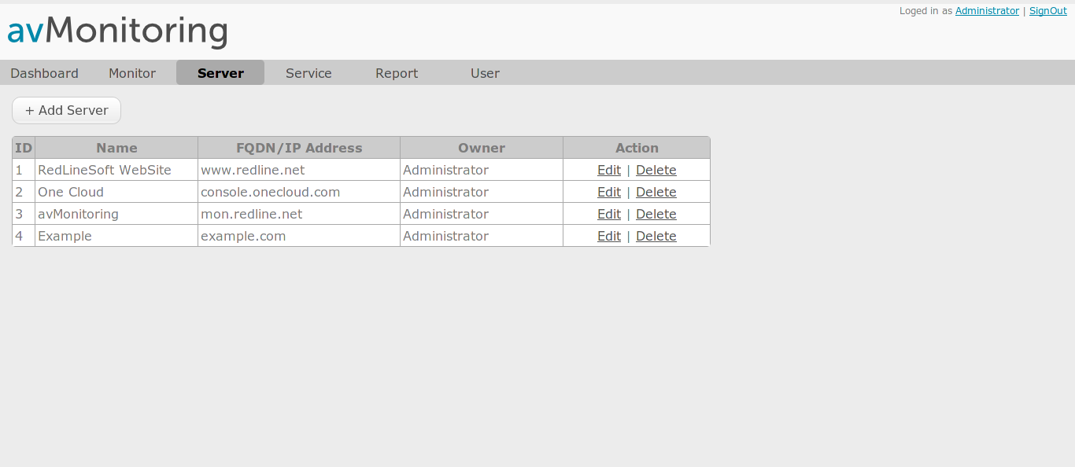Figure 5 : Server list

Click '+ Add Server' to register server to system. Enter server information in register form – figure 5

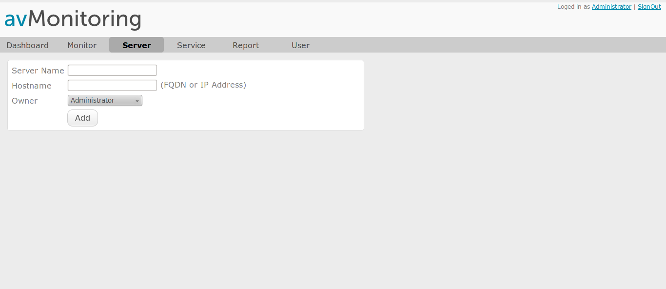Figure 6 : Server register form
Enter the server name and hostname (it should be IP Address or FQDN) e.g. console.onecloud.com or 61.7.253.222. choose the administrator of the server. Click 'Add' to register the server. Your server information will show in Server page like figure 4

Register services to monitor

avMonitoring can monitor your server via services like HTTP, SMTP, FTP or ICMP (ping) etc. then if you want to check your server status you should pick up some services to monitor. e.g. the server call 'console.onecloud.com' has web server to serve console services for cloud customer, mail server to sent e-mail to cloud member, these services should stay alive. From information above we choose HTTP, SMTP and ICMP services to monitor. Click 'Monitor' menu to go to Monitor page - figure 6

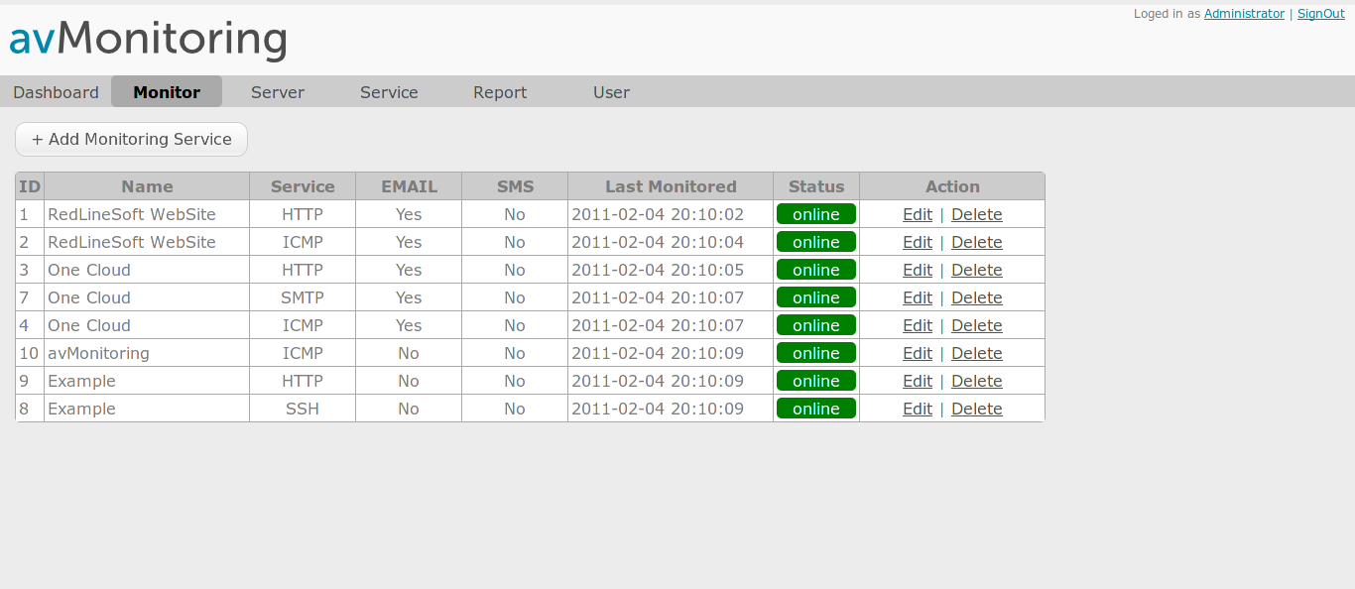Figure 7 : Monitor status list
Click '+ Add Monitoring Service' button then enter information for monitor – figure 7

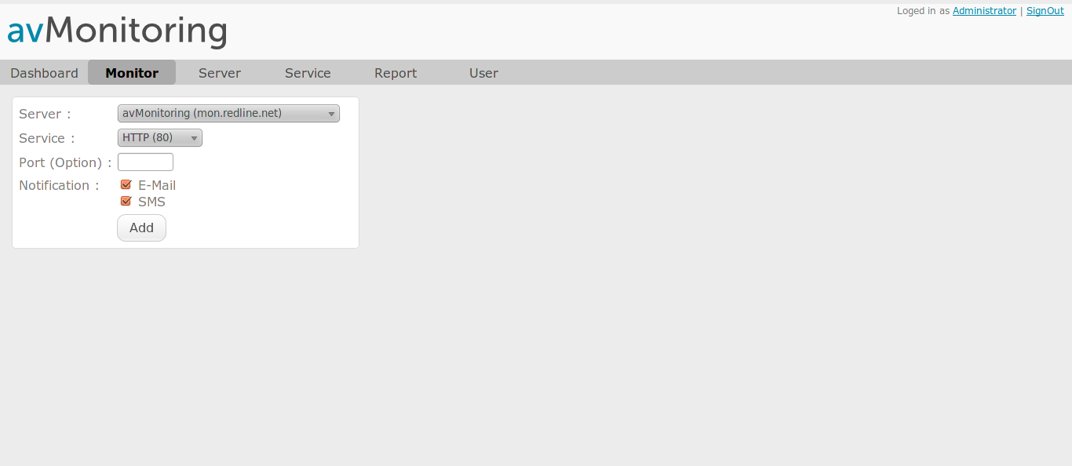Figure 8 : Add services monitoring
Choose server name and service, if your service use difference port number (not a default port number) you can enter services port number in 'Port (Option)' field, choose your notification methods; E-Mail or SMS. Then click 'Add' to add service monitoring. Go to Monitor page, your service status will be 'waiting' state (orange bar), after 15 minutes the monitoring script run and monitored status will show in Monitor page. If status is wrong see troubleshoot chapter.

Report

avMonitoring has 2 type of report; The first is statistic summary of all status. The second is statistic summary of downtime. Each reports have flash animation graph, data table and date range to generated report from any day, month or year. To generate report, click 'Report' menu to go to report page – figure 9

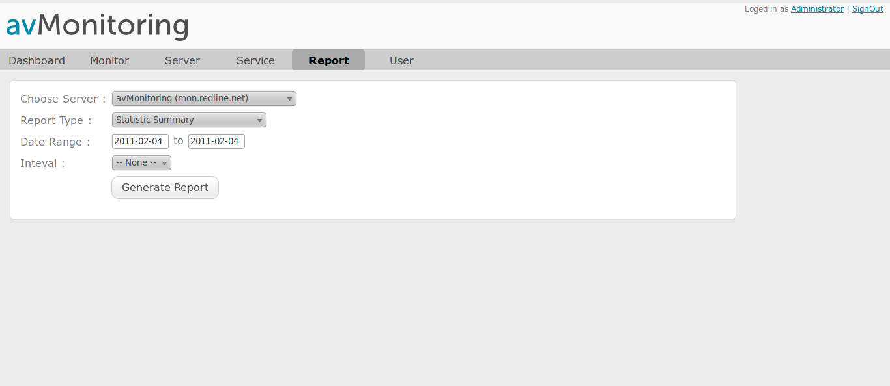Figure 9 : Report
Choose server, report type and date range the click 'Generate Report' button. The report will open in new windows (or next tab in FireFox). So you can generate another report by click Report tab and generate report again. Example report – figure 10, 11

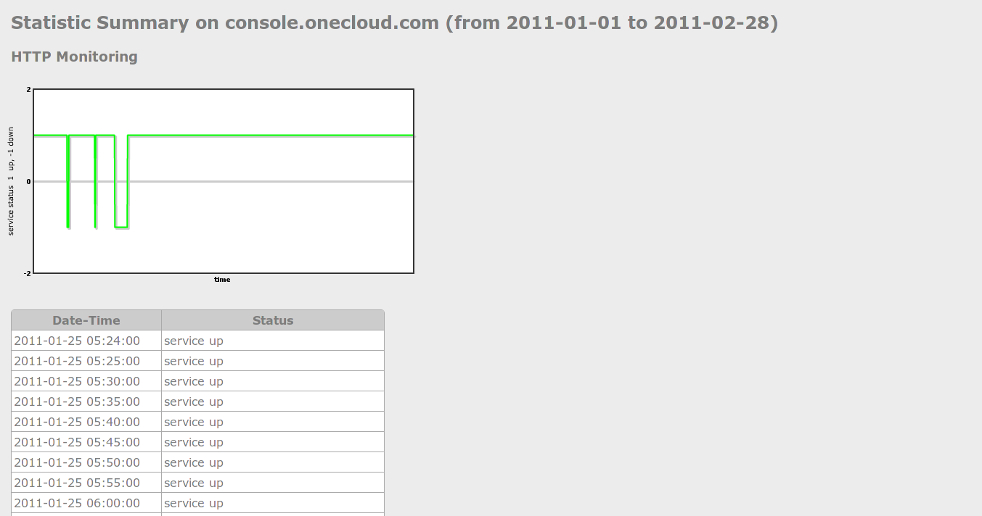Figure 10 : Statistic summary report

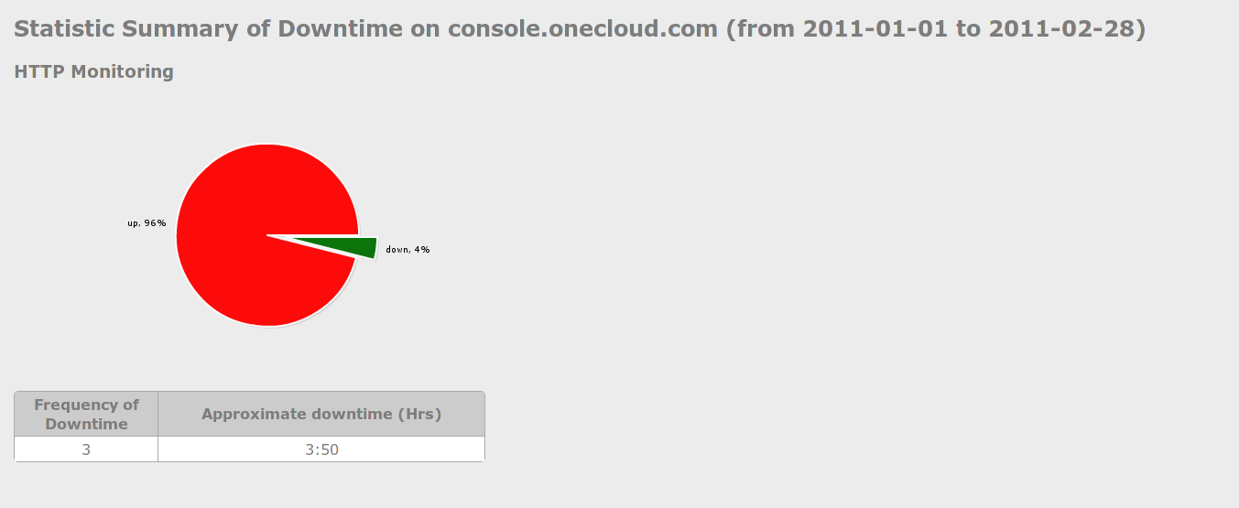Figure 11 : Statistic summary of downtime

User Management

avMonitoring allow you to add another administrator as user of the system. To add another administrator user, go to 'User' menu – figure 12

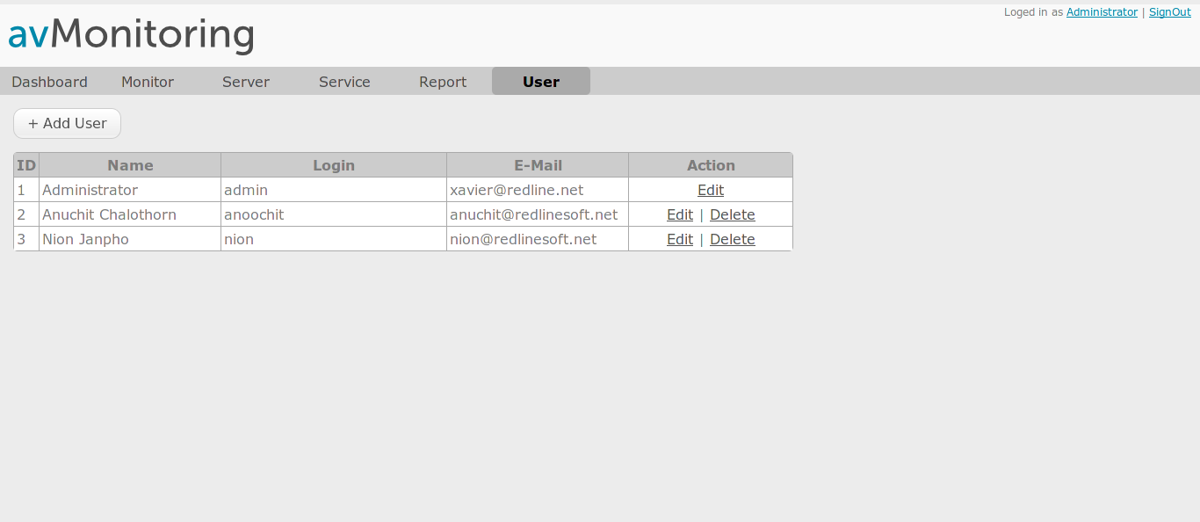Figure 12 : User list
Add new administrator click '+Add User' button, fill information in register form below – figure 13
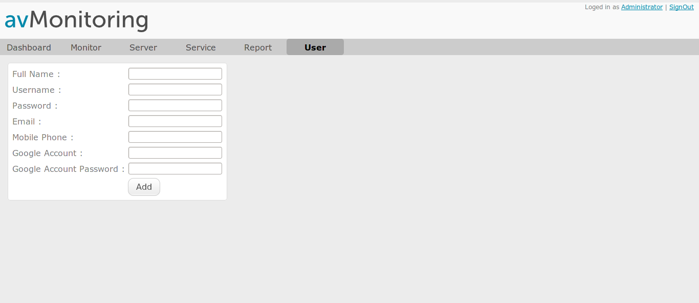Figure 13 : User register form
Click 'Add' button to add new administrator user.

Chapter 4 : Troubleshoot

avMonitoring has 2 parts; the first is management console and the second is monitoring script. Then you should identified exactly your problems.

No monitoring log in log file.
Check root's scheduler and error message in root's e-mail.

No monitoring data in database.
Check root's scheduler and error message in root's e-mail.

No SMS message from Google Calendar.
You should setup notification at your Google Calendar via SMS.

How to send SMS by using other SMS Gateway ?
You can change SMS script at avmonitor.cli.php .

No notification via E-Mail address.
Please check SMTP service in monitoring server.

Copyright and License

AV Monitoring is a availability monitoring system, which provide
an interval TCP socket check to the server for a binary status
“online” and “offline”, and alert report to system admin via E-Mail,
record to Google Calendar and sent SMS (with Google Calendar service). AV Monitoring provide 2 reports; status report for each servers each services and amount of downtime.

Copyright (C) 2011 RedlineSoft.

This program is free software: you can redistribute it and/or modify
it under the terms of the GNU General Public License as published by
the Free Software Foundation, either version 3 of the License, or
(at your option) any later version.

This program is distributed in the hope that it will be useful,
but WITHOUT ANY WARRANTY; without even the implied warranty of MERCHANTABILITY or FITNESS FOR A PARTICULAR PURPOSE. See the GNU General Public License for more details.
You should have received a copy of the GNU General Public License along with this program. If not, see <http://www.gnu.org/licenses/>.
GNU GENERAL PUBLIC LICENSE
Version 3, 29 June 2007

Copyright (C) 2007 Free Software Foundation, Inc. <http://fsf.org/>
Everyone is permitted to copy and distribute verbatim copies
of this license document, but changing it is not allowed.

Preamble

The GNU General Public License is a free, copyleft license for
software and other kinds of works.

The licenses for most software and other practical works are designed to take away your freedom to share and change the works. By contrast, the GNU General Public License is intended to guarantee your freedom to share and change all versions of a program--to make sure it remains free software for all its users. We, the Free Software Foundation, use the GNU General Public License for most of our software; it applies also to any other work released this way by its authors. You can apply it to
your programs, too.

When we speak of free software, we are referring to freedom, not price. Our General Public Licenses are designed to make sure that you
have the freedom to distribute copies of free software (and charge for
them if you wish), that you receive source code or can get it if you
want it, that you can change the software or use pieces of it in new
free programs, and that you know you can do these things.

To protect your rights, we need to prevent others from denying you these rights or asking you to surrender the rights. Therefore, you have
certain responsibilities if you distribute copies of the software, or if
you modify it: responsibilities to respect the freedom of others.

For example, if you distribute copies of such a program, whether gratis or for a fee, you must pass on to the recipients the same
freedoms that you received. You must make sure that they, too, receive
or can get the source code. And you must show them these terms so they
know their rights.

Developers that use the GNU GPL protect your rights with two steps: (1) assert copyright on the software, and (2) offer you this License
giving you legal permission to copy, distribute and/or modify it.

For the developers' and authors' protection, the GPL clearly explains that there is no warranty for this free software. For both users' and authors' sake, the GPL requires that modified versions be marked as
changed, so that their problems will not be attributed erroneously to
authors of previous versions.

Some devices are designed to deny users access to install or run
modified versions of the software inside them, although the manufacturer
can do so. This is fundamentally incompatible with the aim of
protecting users' freedom to change the software. The systematic
pattern of such abuse occurs in the area of products for individuals to
use, which is precisely where it is most unacceptable. Therefore, we
have designed this version of the GPL to prohibit the practice for those
products. If such problems arise substantially in other domains, we
stand ready to extend this provision to those domains in future versions
of the GPL, as needed to protect the freedom of users.

Finally, every program is threatened constantly by software patents. States should not allow patents to restrict development and use of
software on general-purpose computers, but in those that do, we wish to
avoid the special danger that patents applied to a free program could
make it effectively proprietary. To prevent this, the GPL assures that
patents cannot be used to render the program non-free.

The precise terms and conditions for copying, distribution and
modification follow.

TERMS AND CONDITIONS

0. Definitions.

"This License" refers to version 3 of the GNU General Public License.

"Copyright" also means copyright-like laws that apply to other kinds of works, such as semiconductor masks.

"The Program" refers to any copyrightable work licensed under this License. Each licensee is addressed as "you". "Licensees" and
"recipients" may be individuals or organizations.

To "modify" a work means to copy from or adapt all or part of the work in a fashion requiring copyright permission, other than the making of an
exact copy. The resulting work is called a "modified version" of the
earlier work or a work "based on" the earlier work.

A "covered work" means either the unmodified Program or a work based on the Program.

To "propagate" a work means to do anything with it that, without permission, would make you directly or secondarily liable for
infringement under applicable copyright law, except executing it on a
computer or modifying a private copy. Propagation includes copying,
distribution (with or without modification), making available to the
public, and in some countries other activities as well.

To "convey" a work means any kind of propagation that enables other parties to make or receive copies. Mere interaction with a user through a computer network, with no transfer of a copy, is not conveying.

An interactive user interface displays "Appropriate Legal Notices" to the extent that it includes a convenient and prominently visible
feature that (1) displays an appropriate copyright notice, and (2)
tells the user that there is no warranty for the work (except to the
extent that warranties are provided), that licensees may convey the
work under this License, and how to view a copy of this License. If
the interface presents a list of user commands or options, such as a
menu, a prominent item in the list meets this criterion.

1. Source Code.

The "source code" for a work means the preferred form of the work for making modifications to it. "Object code" means any non-source
form of a work.

A "Standard Interface" means an interface that either is an official standard defined by a recognized standards body, or, in the case of
interfaces specified for a particular programming language, one that
is widely used among developers working in that language.

The "System Libraries" of an executable work include anything, other than the work as a whole, that (a) is included in the normal form of packaging a Major Component, but which is not part of that Major
Component, and (b) serves only to enable use of the work with that
Major Component, or to implement a Standard Interface for which an
implementation is available to the public in source code form. A
"Major Component", in this context, means a major essential component
(kernel, window system, and so on) of the specific operating system
(if any) on which the executable work runs, or a compiler used to
produce the work, or an object code interpreter used to run it.

The "Corresponding Source" for a work in object code form means all the source code needed to generate, install, and (for an executable work) run the object code and to modify the work, including scripts to control those activities. However, it does not include the work's
System Libraries, or general-purpose tools or generally available free
programs which are used unmodified in performing those activities but
which are not part of the work. For example, Corresponding Source
includes interface definition files associated with source files for
the work, and the source code for shared libraries and dynamically
linked subprograms that the work is specifically designed to require,
such as by intimate data communication or control flow between those
subprograms and other parts of the work.

The Corresponding Source need not include anything that users
can regenerate automatically from other parts of the Corresponding
Source.

The Corresponding Source for a work in source code form is that same work.

2. Basic Permissions.

All rights granted under this License are granted for the term of
copyright on the Program, and are irrevocable provided the stated
conditions are met. This License explicitly affirms your unlimited
permission to run the unmodified Program. The output from running a
covered work is covered by this License only if the output, given its
content, constitutes a covered work. This License acknowledges your
rights of fair use or other equivalent, as provided by copyright law.

You may make, run and propagate covered works that you do not convey, without conditions so long as your license otherwise remains
in force. You may convey covered works to others for the sole purpose
of having them make modifications exclusively for you, or provide you
with facilities for running those works, provided that you comply with
the terms of this License in conveying all material for which you do
not control copyright. Those thus making or running the covered works
for you must do so exclusively on your behalf, under your direction
and control, on terms that prohibit them from making any copies of
your copyrighted material outside their relationship with you.

Conveying under any other circumstances is permitted solely under the conditions stated below. Sublicensing is not allowed; section 10
makes it unnecessary.

3. Protecting Users' Legal Rights From Anti-Circumvention Law.

No covered work shall be deemed part of an effective technological measure under any applicable law fulfilling obligations under article 11 of the WIPO copyright treaty adopted on 20 December 1996, or similar laws prohibiting or restricting circumvention of such
measures.

When you convey a covered work, you waive any legal power to forbid circumvention of technological measures to the extent such circumvention is effected by exercising rights under this License with respect to the covered work, and you disclaim any intention to limit operation or modification of the work as a means of enforcing, against the work's users, your or third parties' legal rights to forbid circumvention of
technological measures.

4. Conveying Verbatim Copies.

You may convey verbatim copies of the Program's source code as you receive it, in any medium, provided that you conspicuously and
appropriately publish on each copy an appropriate copyright notice;
keep intact all notices stating that this License and any non-permissive terms added in accord with section 7 apply to the code; keep intact all notices of the absence of any warranty; and give all recipients a copy of this License along with the Program.

You may charge any price or no price for each copy that you convey, and you may offer support or warranty protection for a fee.

5. Conveying Modified Source Versions.

You may convey a work based on the Program, or the modifications to produce it from the Program, in the form of source code under the terms of section 4, provided that you also meet all of these conditions:

a) The work must carry prominent notices stating that you modified it, and giving a relevant date.
b) The work must carry prominent notices stating that it is released under this License and any conditions added under section 7. This requirement modifies the requirement in section 4 to "keep intact all notices".
c) You must license the entire work, as a whole, under this License to anyone who comes into possession of a copy. This License will therefore apply, along with any applicable section 7 additional terms, to the whole of the work, and all its parts, regardless of how they are packaged. This License gives no permission to license the work in any other way, but it does not invalidate such permission if you have separately received it.
d) If the work has interactive user interfaces, each must display Appropriate Legal Notices; however, if the Program has interactive interfaces that do not display Appropriate Legal Notices, your work need not make them do so.

A compilation of a covered work with other separate and independent works, which are not by their nature extensions of the covered work, and which are not combined with it such as to form a larger program, in or on a volume of a storage or distribution medium, is called an "aggregate" if the compilation and its resulting copyright are not
used to limit the access or legal rights of the compilation's users
beyond what the individual works permit. Inclusion of a covered work
in an aggregate does not cause this License to apply to the other
parts of the aggregate.

6. Conveying Non-Source Forms.

You may convey a covered work in object code form under the terms of sections 4 and 5, provided that you also convey the
machine-readable Corresponding Source under the terms of this License,
in one of these ways:

a) Convey the object code in, or embodied in, a physical product (including a physical distribution medium), accompanied by the Corresponding Source fixed on a durable physical medium customarily used for software interchange.
b) Convey the object code in, or embodied in, a physical product (including a physical distribution medium), accompanied by a written offer, valid for at least three years and valid for as long as you offer spare parts or customer support for that product model, to give anyone who possesses the object code either (1) a copy of the Corresponding Source for all the software in the product that is covered by this License, on a durable physical medium customarily used for software interchange, for a price no more than your reasonable cost of physically performing this conveying of source, or (2) access to copy the Corresponding Source from a network server at no charge.
c) Convey individual copies of the object code with a copy of the written offer to provide the Corresponding Source. This alternative is allowed only occasionally and noncommercially, and only if you received the object code with such an offer, in accord with subsection 6b.
d) Convey the object code by offering access from a designated place (gratis or for a charge), and offer equivalent access to the Corresponding Source in the same way through the same place at no further charge. You need not require recipients to copy the Corresponding Source along with the object code. If the place to copy the object code is a network server, the Corresponding Source may be on a different server (operated by you or a third party) that supports equivalent copying facilities, provided you maintain clear directions next to the object code saying where to find the Corresponding Source. Regardless of what server hosts the Corresponding Source, you remain obligated to ensure that it is available for as long as needed to satisfy these requirements.
e) Convey the object code using peer-to-peer transmission, provided you inform other peers where the object code and Corresponding Source of the work are being offered to the general public at no charge under subsection 6d.
A separable portion of the object code, whose source code is excluded from the Corresponding Source as a System Library, need not be
included in conveying the object code work.

A "User Product" is either (1) a "consumer product", which means any tangible personal property which is normally used for personal, family, or household purposes, or (2) anything designed or sold for incorporation into a dwelling. In determining whether a product is a consumer product, doubtful cases shall be resolved in favor of coverage. For a particular product received by a particular user, "normally used" refers to a typical or common use of that class of product, regardless of the status of the particular user or of the way in which the particular user
actually uses, or expects or is expected to use, the product. A product
is a consumer product regardless of whether the product has substantial
commercial, industrial or non-consumer uses, unless such uses represent
the only significant mode of use of the product.

"Installation Information" for a User Product means any methods, procedures, authorization keys, or other information required to install and execute modified versions of a covered work in that User Product from a modified version of its Corresponding Source. The information must suffice to ensure that the continued functioning of the modified object code is in no case prevented or interfered with solely because modification has been made.

If you convey an object code work under this section in, or with, or specifically for use in, a User Product, and the conveying occurs as part of a transaction in which the right of possession and use of the
User Product is transferred to the recipient in perpetuity or for a
fixed term (regardless of how the transaction is characterized), the
Corresponding Source conveyed under this section must be accompanied
by the Installation Information. But this requirement does not apply
if neither you nor any third party retains the ability to install
modified object code on the User Product (for example, the work has
been installed in ROM).

The requirement to provide Installation Information does not include a requirement to continue to provide support service, warranty, or updates for a work that has been modified or installed by the recipient, or for the User Product in which it has been modified or installed. Access to a network may be denied when the modification itself materially and
adversely affects the operation of the network or violates the rules and
protocols for communication across the network.

Corresponding Source conveyed, and Installation Information provided, in accord with this section must be in a format that is publicly
documented (and with an implementation available to the public in
source code form), and must require no special password or key for
unpacking, reading or copying.

7. Additional Terms.

"Additional permissions" are terms that supplement the terms of this License by making exceptions from one or more of its conditions.
Additional permissions that are applicable to the entire Program shall
be treated as though they were included in this License, to the extent
that they are valid under applicable law. If additional permissions
apply only to part of the Program, that part may be used separately
under those permissions, but the entire Program remains governed by
this License without regard to the additional permissions.

When you convey a copy of a covered work, you may at your option remove any additional permissions from that copy, or from any part of it. (Additional permissions may be written to require their own
removal in certain cases when you modify the work.) You may place
additional permissions on material, added by you to a covered work,
for which you have or can give appropriate copyright permission.

Notwithstanding any other provision of this License, for material you add to a covered work, you may (if authorized by the copyright holders of that material) supplement the terms of this License with terms:

a) Disclaiming warranty or limiting liability differently from the
terms of sections 15 and 16 of this License; or

b) Requiring preservation of specified reasonable legal notices or author attributions in that material or in the Appropriate Legal Notices displayed by works containing it; or

c) Prohibiting misrepresentation of the origin of that material, or requiring that modified versions of such material be marked in reasonable ways as different from the original version; or

d) Limiting the use for publicity purposes of names of licensors or authors of the material; or

e) Declining to grant rights under trademark law for use of some trade names, trademarks, or service marks; or

f) Requiring indemnification of licensors and authors of that material by anyone who conveys the material (or modified versions of it) with contractual assumptions of liability to the recipient, for any liability that these contractual assumptions directly impose on those licensors and authors.

All other non-permissive additional terms are considered "further restrictions" within the meaning of section 10. If the Program as you received it, or any part of it, contains a notice stating that it is governed by this License along with a term that is a further restriction, you may remove that term. If a license document contains a further restriction but permits relicensing or conveying under this License, you may add to a covered work material governed by the terms of that license document, provided that the further restriction does not survive such relicensing or conveying.

If you add terms to a covered work in accord with this section, you must place, in the relevant source files, a statement of the additional terms that apply to those files, or a notice indicating where to find the applicable terms.

Additional terms, permissive or non-permissive, may be stated in the form of a separately written license, or stated as exceptions; the above requirements apply either way.

8. Termination.

You may not propagate or modify a covered work except as expressly provided under this License. Any attempt otherwise to propagate or modify it is void, and will automatically terminate your rights under this License (including any patent licenses granted under the third
paragraph of section 11).

However, if you cease all violation of this License, then your
license from a particular copyright holder is reinstated (a)
provisionally, unless and until the copyright holder explicitly and
finally terminates your license, and (b) permanently, if the copyright
holder fails to notify you of the violation by some reasonable means
prior to 60 days after the cessation.

Moreover, your license from a particular copyright holder is
reinstated permanently if the copyright holder notifies you of the
violation by some reasonable means, this is the first time you have
received notice of violation of this License (for any work) from that
copyright holder, and you cure the violation prior to 30 days after
your receipt of the notice.

Termination of your rights under this section does not terminate the licenses of parties who have received copies or rights from you under
this License. If your rights have been terminated and not permanently
reinstated, you do not qualify to receive new licenses for the same
material under section 10.

9. Acceptance Not Required for Having Copies.

You are not required to accept this License in order to receive or run a copy of the Program. Ancillary propagation of a covered work
occurring solely as a consequence of using peer-to-peer transmission
to receive a copy likewise does not require acceptance. However,
nothing other than this License grants you permission to propagate or
modify any covered work. These actions infringe copyright if you do
not accept this License. Therefore, by modifying or propagating a
covered work, you indicate your acceptance of this License to do so.

10. Automatic Licensing of Downstream Recipients.

Each time you convey a covered work, the recipient automatically receives a license from the original licensors, to run, modify and propagate that work, subject to this License. You are not responsible
for enforcing compliance by third parties with this License.

An "entity transaction" is a transaction transferring control of an organization, or substantially all assets of one, or subdividing an
organization, or merging organizations. If propagation of a covered
work results from an entity transaction, each party to that
transaction who receives a copy of the work also receives whatever
licenses to the work the party's predecessor in interest had or could
give under the previous paragraph, plus a right to possession of the
Corresponding Source of the work from the predecessor in interest, if
the predecessor has it or can get it with reasonable efforts.

You may not impose any further restrictions on the exercise of the rights granted or affirmed under this License. For example, you may
not impose a license fee, royalty, or other charge for exercise of
rights granted under this License, and you may not initiate litigation
(including a cross-claim or counterclaim in a lawsuit) alleging that
any patent claim is infringed by making, using, selling, offering for
sale, or importing the Program or any portion of it.

11. Patents.

A "contributor" is a copyright holder who authorizes use under this License of the Program or a work on which the Program is based. The
work thus licensed is called the contributor's "contributor version".

A contributor's "essential patent claims" are all patent claims
owned or controlled by the contributor, whether already acquired or
hereafter acquired, that would be infringed by some manner, permitted
by this License, of making, using, or selling its contributor version,
but do not include claims that would be infringed only as a
consequence of further modification of the contributor version. For
purposes of this definition, "control" includes the right to grant
patent sublicenses in a manner consistent with the requirements of
this License.

Each contributor grants you a non-exclusive, worldwide, royalty-free patent license under the contributor's essential patent claims, to make, use, sell, offer for sale, import and otherwise run, modify and
propagate the contents of its contributor version.

In the following three paragraphs, a "patent license" is any express agreement or commitment, however denominated, not to enforce a patent (such as an express permission to practice a patent or covenant not to sue for patent infringement). To "grant" such a patent license to a
party means to make such an agreement or commitment not to enforce a
patent against the party.

If you convey a covered work, knowingly relying on a patent license, and the Corresponding Source of the work is not available for anyone to copy, free of charge and under the terms of this License, through a publicly available network server or other readily accessible means,
then you must either (1) cause the Corresponding Source to be so
available, or (2) arrange to deprive yourself of the benefit of the
patent license for this particular work, or (3) arrange, in a manner
consistent with the requirements of this License, to extend the patent
license to downstream recipients. "Knowingly relying" means you have
actual knowledge that, but for the patent license, your conveying the
covered work in a country, or your recipient's use of the covered work
in a country, would infringe one or more identifiable patents in that
country that you have reason to believe are valid.

If, pursuant to or in connection with a single transaction or
arrangement, you convey, or propagate by procuring conveyance of, a
covered work, and grant a patent license to some of the parties
receiving the covered work authorizing them to use, propagate, modify
or convey a specific copy of the covered work, then the patent license
you grant is automatically extended to all recipients of the covered
work and works based on it.

A patent license is "discriminatory" if it does not include within
the scope of its coverage, prohibits the exercise of, or is conditioned on the non-exercise of one or more of the rights that are specifically granted under this License. You may not convey a covered work if you are a party to an arrangement with a third party that is in the business of distributing software, under which you make payment to the third party based on the extent of your activity of conveying the work, and under which the third party grants, to any of the parties who would receive the covered work from you, a discriminatory patent license (a) in connection with copies of the covered work conveyed by you (or copies made from those copies), or (b) primarily for and in connection with specific products or compilations that contain the covered work, unless you entered into that arrangement,
or that patent license was granted, prior to 28 March 2007.

Nothing in this License shall be construed as excluding or limiting any implied license or other defenses to infringement that may
otherwise be available to you under applicable patent law.

12. No Surrender of Others' Freedom.

If conditions are imposed on you (whether by court order, agreement or otherwise) that contradict the conditions of this License, they do not excuse you from the conditions of this License. If you cannot convey a covered work so as to satisfy simultaneously your obligations under this License and any other pertinent obligations, then as a consequence you may not convey it at all. For example, if you agree to terms that obligate you to collect a royalty for further conveying from those to whom you convey the Program, the only way you could satisfy both those terms and this License would be to refrain entirely from conveying the Program.

13. Use with the GNU Affero General Public License.

Notwithstanding any other provision of this License, you have
permission to link or combine any covered work with a work licensed
under version 3 of the GNU Affero General Public License into a single
combined work, and to convey the resulting work. The terms of this
License will continue to apply to the part which is the covered work,
but the special requirements of the GNU Affero General Public License,
section 13, concerning interaction through a network will apply to the
combination as such.

14. Revised Versions of this License.

The Free Software Foundation may publish revised and/or new versions of the GNU General Public License from time to time. Such new versions will be similar in spirit to the present version, but may differ in detail to address new problems or concerns.

Each version is given a distinguishing version number. If the
Program specifies that a certain numbered version of the GNU General
Public License "or any later version" applies to it, you have the option of following the terms and conditions either of that numbered version or of any later version published by the Free Software Foundation. If the Program does not specify a version number of the GNU General Public License, you may choose any version ever published by the Free Software Foundation.

If the Program specifies that a proxy can decide which future
versions of the GNU General Public License can be used, that proxy's
public statement of acceptance of a version permanently authorizes you
to choose that version for the Program.

Later license versions may give you additional or different
permissions. However, no additional obligations are imposed on any
author or copyright holder as a result of your choosing to follow a
later version.

15. Disclaimer of Warranty.

THERE IS NO WARRANTY FOR THE PROGRAM, TO THE EXTENT PERMITTED BY APPLICABLE LAW. EXCEPT WHEN OTHERWISE STATED IN WRITING THE COPYRIGHT HOLDERS AND/OR OTHER PARTIES PROVIDE THE PROGRAM "AS IS" WITHOUT WARRANTY OF ANY KIND, EITHER EXPRESSED OR IMPLIED, INCLUDING, BUT NOT LIMITED TO, THE IMPLIED WARRANTIES OF MERCHANTABILITY AND FITNESS FOR A PARTICULAR
PURPOSE. THE ENTIRE RISK AS TO THE QUALITY AND PERFORMANCE OF THE PROGRAM IS WITH YOU. SHOULD THE PROGRAM PROVE DEFECTIVE, YOU ASSUME THE COST OF
ALL NECESSARY SERVICING, REPAIR OR CORRECTION.

16. Limitation of Liability.

IN NO EVENT UNLESS REQUIRED BY APPLICABLE LAW OR AGREED TO IN WRITING WILL ANY COPYRIGHT HOLDER, OR ANY OTHER PARTY WHO MODIFIES AND/OR CONVEYS
THE PROGRAM AS PERMITTED ABOVE, BE LIABLE TO YOU FOR DAMAGES, INCLUDING ANY GENERAL, SPECIAL, INCIDENTAL OR CONSEQUENTIAL DAMAGES ARISING OUT OF THE
USE OR INABILITY TO USE THE PROGRAM (INCLUDING BUT NOT LIMITED TO LOSS OF DATA OR DATA BEING RENDERED INACCURATE OR LOSSES SUSTAINED BY YOU OR THIRD
PARTIES OR A FAILURE OF THE PROGRAM TO OPERATE WITH ANY OTHER PROGRAMS), EVEN IF SUCH HOLDER OR OTHER PARTY HAS BEEN ADVISED OF THE POSSIBILITY OF SUCH DAMAGES.

17. Interpretation of Sections 15 and 16.

If the disclaimer of warranty and limitation of liability provided
above cannot be given local legal effect according to their terms,
reviewing courts shall apply local law that most closely approximates
an absolute waiver of all civil liability in connection with the
Program, unless a warranty or assumption of liability accompanies a
copy of the Program in return for a fee.

END OF TERMS AND CONDITIONS

How to Apply These Terms to Your New Programs

If you develop a new program, and you want it to be of the greatest possible use to the public, the best way to achieve this is to make it free software which everyone can redistribute and change under these terms.

To do so, attach the following notices to the program. It is safest to attach them to the start of each source file to most effectively
state the exclusion of warranty; and each file should have at least
the "copyright" line and a pointer to where the full notice is found.

<one line to give the program's name and a brief idea of what it does.>
Copyright (C) <year> <name of author>

This program is free software: you can redistribute it and/or modify it under the terms of the GNU General Public License as published by the Free Software Foundation, either version 3 of the License, or (at your option) any later version.

This program is distributed in the hope that it will be useful, but WITHOUT ANY WARRANTY; without even the implied warranty of
MERCHANTABILITY or FITNESS FOR A PARTICULAR PURPOSE. See the GNU General Public License for more details.

You should have received a copy of the GNU General Public License
along with this program. If not, see <http://www.gnu.org/licenses/>.

Also add information on how to contact you by electronic and paper mail.

If the program does terminal interaction, make it output a short
notice like this when it starts in an interactive mode:

<program> Copyright (C) <year> <name of author>
This program comes with ABSOLUTELY NO WARRANTY; for details type `show w'. This is free software, and you are welcome to redistribute it under certain conditions; type `show c' for details.

The hypothetical commands `show w' and `show c' should show the appropriate parts of the General Public License. Of course, your program's commands might be different; for a GUI interface, you would use an "about box".

You should also get your employer (if you work as a programmer) or school, if any, to sign a "copyright disclaimer" for the program, if necessary. For more information on this, and how to apply and follow the GNU GPL, see <http://www.gnu.org/licenses/>.

The GNU General Public License does not permit incorporating your program into proprietary programs. If your program is a subroutine library, you may consider it more useful to permit linking proprietary applications with the library. If this is what you want to do, use the GNU Lesser General Public License instead of this License. But first, please read <http://www.gnu.org/philosophy/why-not-lgpl.html>.

