Software Requirement Specification
"Centralized Brainstorms"

Version 1.0

Anuchit Chalothorn
<anoochit@redlinesoft.net>

Revision
Version | Date | Author | Remark
1.0 | 30/12/08 | Anuchit Chalothorn | Initial version

Table of Content
Chapter 1: Introduction 4
Chapter 2: Overview 5
Chapter 3: Analysis 6
Chapter 4: Design 8

Chapter 1: Introduction
This document describe the centralized brainstorms system.

Chapter 2: Overview
The centralized brainstorms is the DIGG-like system which mean every member of this system can post their idea or any suggestions on any topic of interest. Each post item can give a score +1 or -1 to weight the post item position, if the item has more score than another it 'll list on top of another items. By this way we can check what is the idea is popular or what is the problem want to improve/fix.
It 's in the DIGG way, so we can use this way to make an easy brainstorms system. The brainstorms system is look like DIGG, but the system must organized each idea/problem by category or group. because the members 'll be easy to find their interested category and post a new one or give a score or post comment in the posted item.

Chapter 3: Analysis
The centralized brainstorms is DIGG-like so we can use DIGG as concept of the system. Centralized brainstorms must have the category for each items. Each item has title, name of the author, create date time and score equal 1 at the beginning so the another member can comment this item like a forum and give +1 or -1 for each item. The visitors can sign-up and sign-in to the system by using OpenID. The member has permission to manage this system this may be depend on permission table to manage any modules. For the short description above we can write in the software requirement specification as the following :

Functional
R1 : Category
R1.1 Category should contain the post items.
R1.2 Category compost of title, description.
R1.3 Manage the category by administrator or content manger.
R1.4 Each category must have syndicate (RSS or ATOM) provide lastest items (by entry) data.

R2 : Post Item
R2.1 Each item must have category.
R2.2 Each item compost of title, description, created date time, name of author.
R2.3 Each item has score begin at 1 (first post)
R2.4 Each Item can plus (+1) or minut ()-1 score by another member.
R2.5 Only 1 score (can be +1 or -1) per member for each item.
R2.6 Manage the post item by administrator, content manager and the owner of each item.
R2.7 Each item must have syndicate (RSS or ATOM) provide lastest comment data.

R3 : Member
R3.1 Visitor can sign-up as a new member of this system via OpenID service.
R3.2 Member can sign-in to the system via OpenID service.
R3.3 The Avatar of each member derived from Gravatar service.
R3.4 Member can manage the system depend on permission rule (administrator, content manager, member and visitor)
R3.5 The member compost of first name, last name, nickname and OpenID url.
R3.6 The OpenID service 'll be the authentication system when member sign-in.

Non-Functional
N1.1 May be use AJAX for give a score (+1,-1).
N1.2 Not store any user name and password, authentication from OpenID only.

Chapter 4: Design
This chapter separate in 3 parts: the system design, database design and virtual design.

System Design
Centralized brainstorms is web application which developed by any language; ASP, PHP, JSP, Ruby or Python. System design document will describe scope of this system. Centralized brainstorms is multi-tires application (include REST for authentication request and get personal information from OpenID) but it still use application server like Apache, J2EE, JBOSS, Mongrel and etc. The concept of this system isn't different from web application development and design.
The system should store data in (object) relational database system and support multiple database system; MySQL, PostgeSQL, Oracle or Microsoft SQL Server that mean you can change to any database with out change any code of program. The multi-language support is so important because it 'll be easy to understand when deployed in non-English locale.
Basic concept of multi-tires is the application connect or send request more than 3 level, so this application store data in RDBMS is 3 tiers but this system use REST request to OpenID, it is another tire then the application is multi-tiers levels. Look and feel or theme is gimmick member can change theme for their page.
The application should use template engine like PHPTemplate, Cheetah, Smarty and another when you use template engine, it easy to separate presentation level and business logic so you can manipulate data with the result from business logic by using template engine too.

Database Design

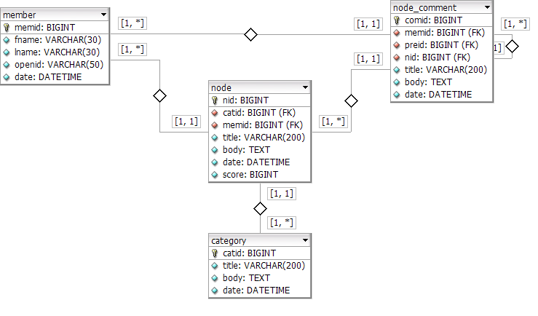
Database Schema

Virtual Design

