HAWKEYE LAB

Blue Team Detection &
Incident Response Report
Evidence-led defensive analysis of stealer.pcap

Report details | Value
Author | Giri Anoop
Programme | ElevanceSkills Cybersecurity Internship
Lab | CyberDefenders HawkEye
Evidence artifact | stealer.pcap
Primary tools | Wireshark, Kali Linux, md5sum, public IP geolocation lookup
Report status | Defensive analysis and proposed detection recommendations; no rule deployment claimed

Prepared from the completed lab investigation, source notes and supplied screenshots.

1. Executive Summary
The HawkEye packet capture provides network-level evidence of a Windows host, 10.4.10.132 (hostname Beijing-5cd1-PC in the investigation notes), resolving proforma-invoices.com, downloading tkraw_Protected99.exe over HTTP, making repeated public-IP lookup requests, and establishing recurring authenticated SMTP sessions to 23.229.162.69:587. The capture contains 4,003 packets over 01:03:41.
The extracted HTTP object was listed at approximately 2,025 kB. Its MD5, calculated on Kali Linux, is 71826ba081e303866ce2a2534491a2f7. SMTP traffic identifies Exim 4.91 and shows AUTH LOGIN followed by “235 Authentication succeeded”; the message uses sales.del@macwinlogistics.in as sender and recipient. The investigation notes report that the Base64-encoded message body was decoded and contained the label “HawkEye Keylogger – Reborn v9” and a password-log section. This report does not reproduce passwords or authentication values.
For defenders, the strongest opportunities are correlating DNS resolution with subsequent HTTP executable transfer, hunting for the file hash, alerting on workstations that initiate outbound SMTP, and detecting repeated external requests on a near-ten-minute cadence. These are proposed detections, not rules shown to be deployed or tested. The PCAP does not prove the executable ran or establish persistence, lateral movement, the original delivery mechanism, or command-and-control.
Key finding | Evidence status | Defensive significance
HTTP executable transfer | Observed in packet capture and HTTP object list | Hunt for the filename, URL, hash and similar transfers
Recurring SMTP to external host | Observed; destination port 587 | Investigate unauthorized mail submission from a workstation
SMTP authentication success | Observed in SMTP stream | Review mail logs, account ownership and authentication context
Credential-log content | Reported in source investigation notes | Treat as potential credential exposure; verify using decoded message safely
Execution / persistence / lateral movement | Not established by PCAP | Acquire endpoint and identity telemetry before concluding

2. Scope and Available Telemetry
This report is limited to the supplied stealer.pcap, the existing HawkEye investigation report/notes, the exported HTTP object and MD5 screenshot, endpoint statistics, and the screenshots supplied in this conversation. It documents what a Blue Team could detect and investigate from these artifacts, then recommends additional telemetry and controls.
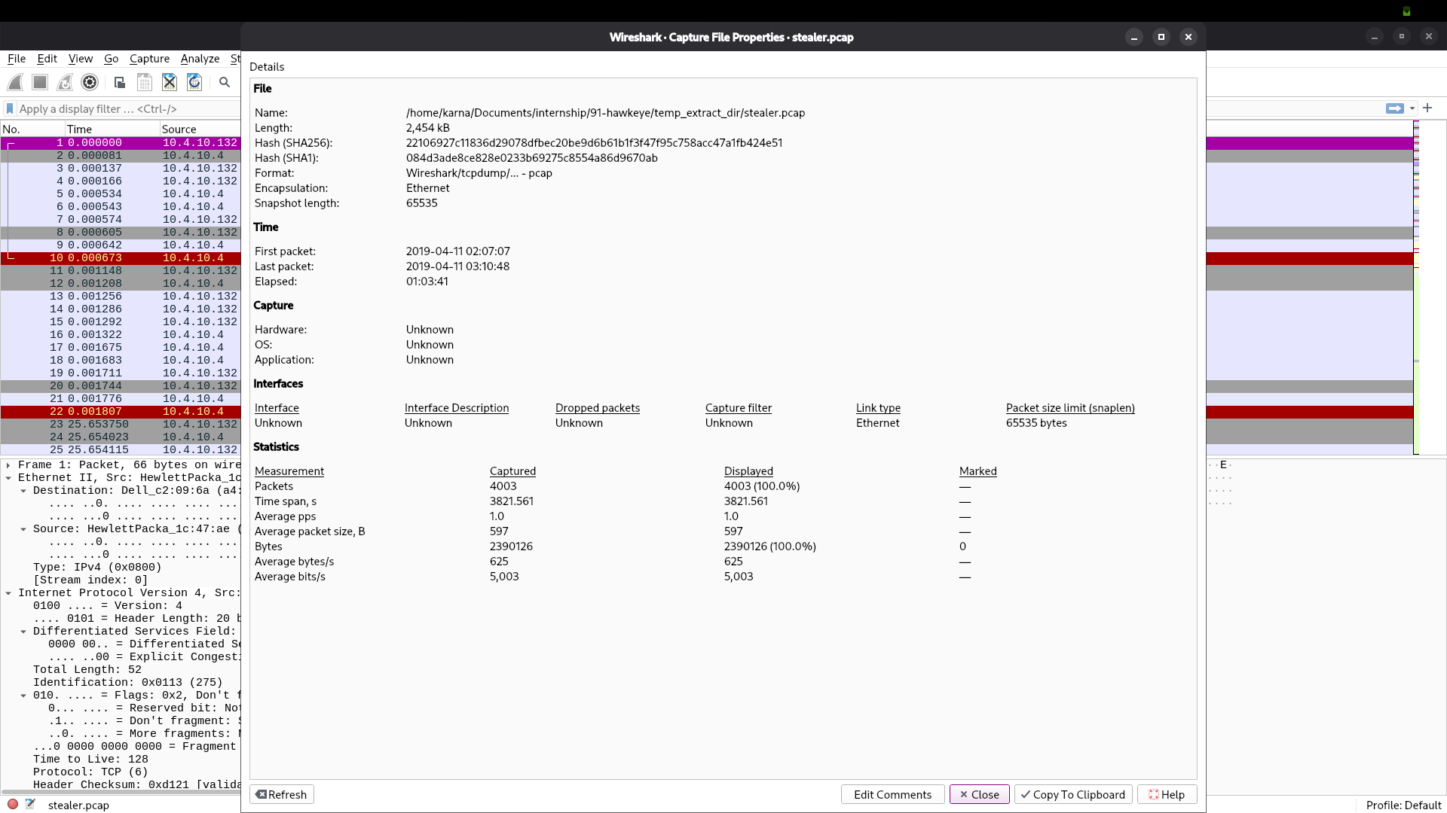
Figure 1. Wireshark Capture File Properties: 4,003 packets and a capture duration of 01:03:41.
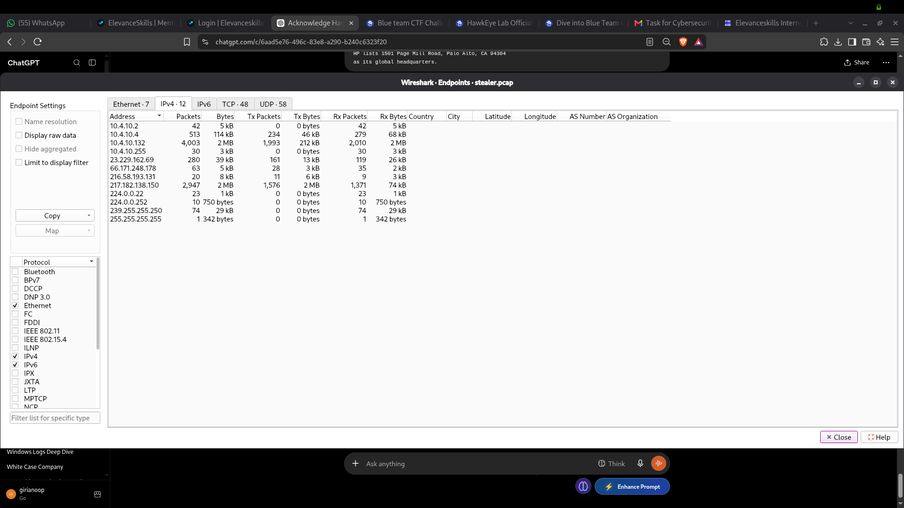
Figure 2. IPv4 endpoint statistics showing 10.4.10.132 and the external addresses involved in the capture.
Telemetry source | Available in this lab? | Value / limitation
Network packet capture | Yes | DNS, HTTP and SMTP exchanges visible where captured
HTTP object extraction and file hash | Yes | Executable object listed and MD5 recorded
DNS resolver logs | No separate logs supplied | DNS frames 204/206 are documented in investigation nwotes
Firewall / proxy logs | No | Would add connection decisions, URLs, users and bytes transferred
Endpoint EDR / process telemetry | No | Needed to establish file creation, execution, child processes and persistence
Identity and mail-gateway logs | No | Needed to validate account use, TLS status, message handling and mailbox delivery
Memory / disk forensic artifacts | No | No endpoint image or memory capture supplied

3. Initial Detection Opportunities
The evidence supports several practical detection opportunities. Each should be implemented only after confirming the organisation’s normal traffic patterns and available fields.
- Correlate a DNS query for proforma-invoices.com with a subsequent HTTP request to 217.182.138.150 and a response carrying executable content.
- Alert when a workstation downloads executable content over cleartext HTTP, especially from a domain not commonly used by that endpoint.
- Hunt endpoint and file repositories for MD5 71826ba081e303866ce2a2534491a2f7; hash matches require contextual triage rather than automatic attribution.
- Detect a non-mail-server workstation establishing outbound SMTP sessions to an external address on TCP/587.
- Correlate repeated HTTP GET / requests to 66.171.248.178 and SMTP sessions to 23.229.162.69 with approximately ten-minute recurrence.
- Review SMTP authentication-success events that are inconsistent with the source host, account, expected client or transport security policy.

4. DNS, HTTP, Executable Download and Hash Detection
The investigation notes record a DNS query for proforma-invoices.com at frame 204 and an answer resolving to 217.182.138.150 at frame 206. Frame 210 shows 10.4.10.132 requesting /proforma/tkraw_Protected99.exe, and frame 3155 is recorded as the HTTP 200 OK response with application/x-msdownload. The supplied screenshot below is an HTTP-filtered packet list, not a DNS query view.
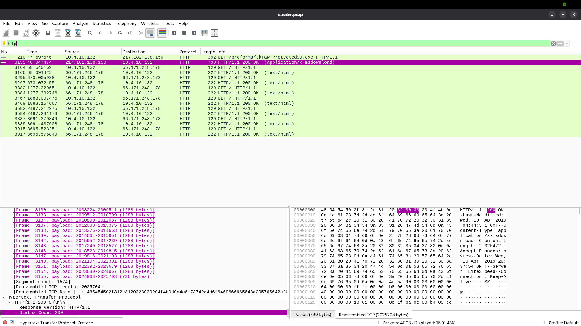
Figure 3. HTTP-filtered packet list showing the executable GET/response and repeated public-IP lookup requests; not DNS-query evidence.
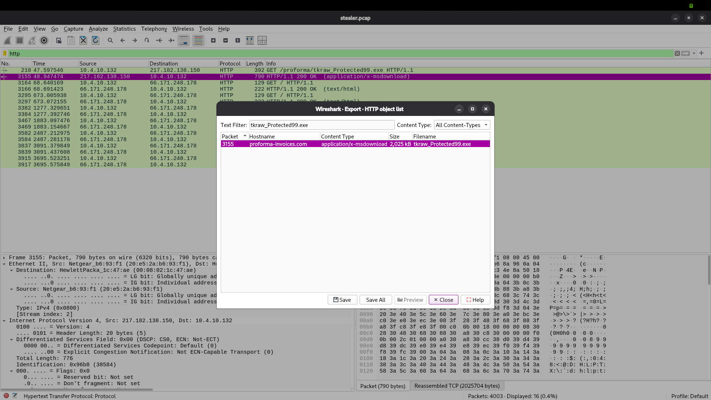
Figure 4. Wireshark Export Objects → HTTP lists tkraw_Protected99.exe under proforma-invoices.com, approximately 2,025 kB.
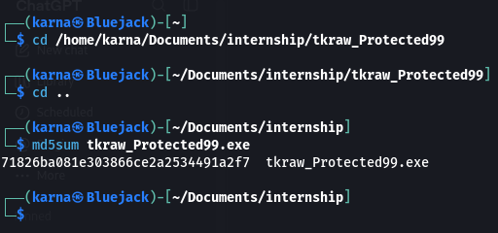
Figure 5. Kali Linux md5sum output for the extracted executable.
Attribute | Recorded value | Defensive use
Victim IP / hostname | 10.4.10.132 / Beijing-5cd1-PC | Scope endpoint searches and network log correlation
Domain | proforma-invoices.com | DNS, proxy, browser and resolver hunting
Resolved address | 217.182.138.150 | Network threat-hunt pivot; verify current relevance before blocking
HTTP path | /proforma/tkraw_Protected99.exe | Proxy and network IDS searches
File name | tkraw_Protected99.exe | Endpoint file inventory and EDR hunting
MD5 | 71826ba081e303866ce2a2534491a2f7 | Hash-based search; not a standalone verdict
Content type / size | application/x-msdownload / ~2,025 kB | HTTP response and file-transfer context

The filename and MIME type support classifying the transfer as executable content, but do not establish that the file ran or that its behaviour was independently confirmed. The malware family label in the investigation notes is based on decoded message content, not independent reverse engineering.

5. Repeated Outbound Connections and SMTP Authentication
The packet capture shows recurring SMTP sessions from 10.4.10.132 to 23.229.162.69 on TCP/587. The server banner identifies p3plcpnl0413.prod.phx3.secureserver.net and Exim 4.91. The SMTP conversation includes AUTH LOGIN, a server response of 235 Authentication succeeded, MAIL FROM and RCPT TO commands using sales.del@macwinlogistics.in, and a 250 Accepted response for the recipient.
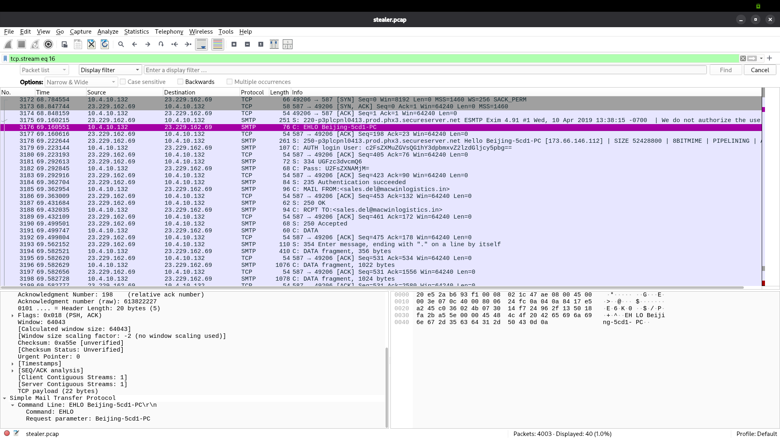
Figure 6. SMTP-filtered packet list showing recurring sessions and message-transfer activity.
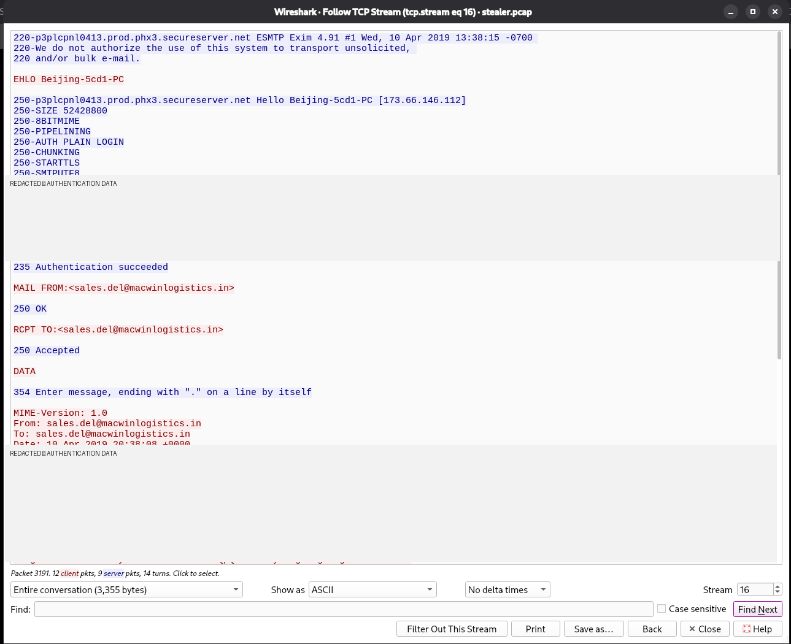
Figure 7. SMTP Follow TCP Stream with authentication values and message-body content redacted.
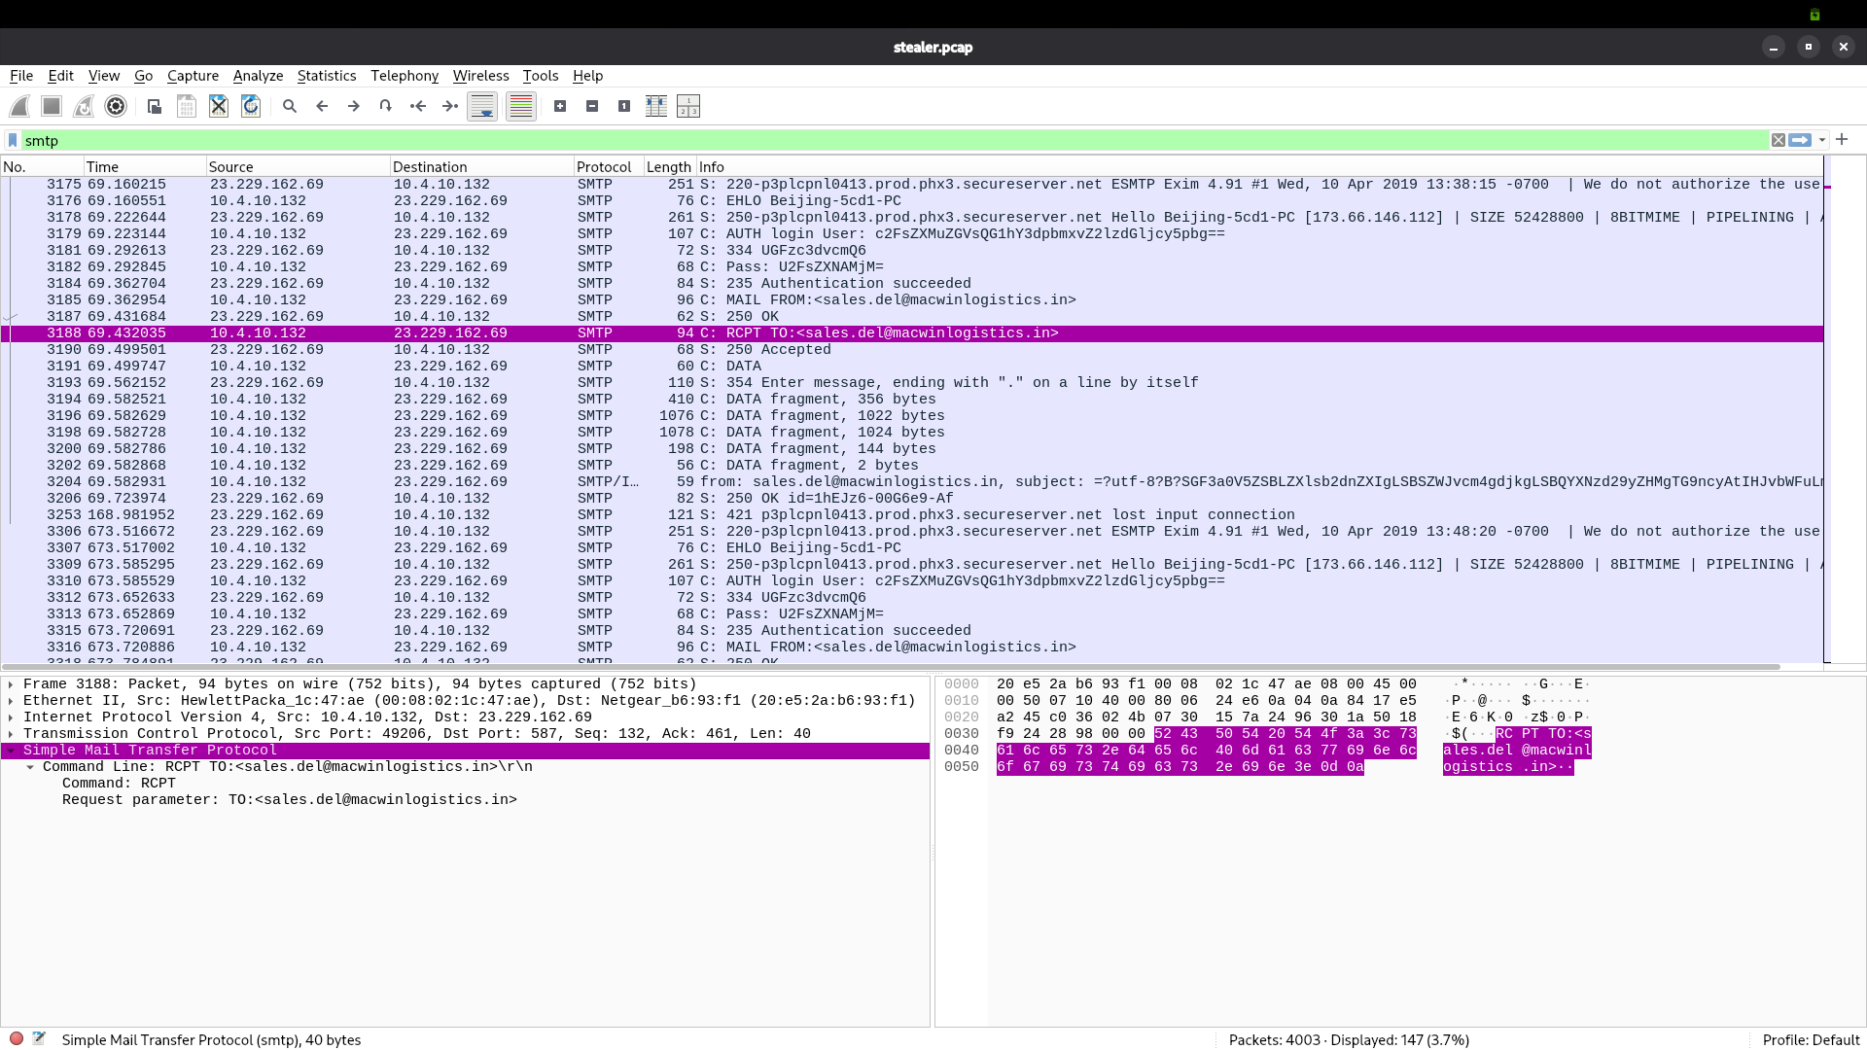
Figure 8. RCPT TO command and server response 250 Accepted.
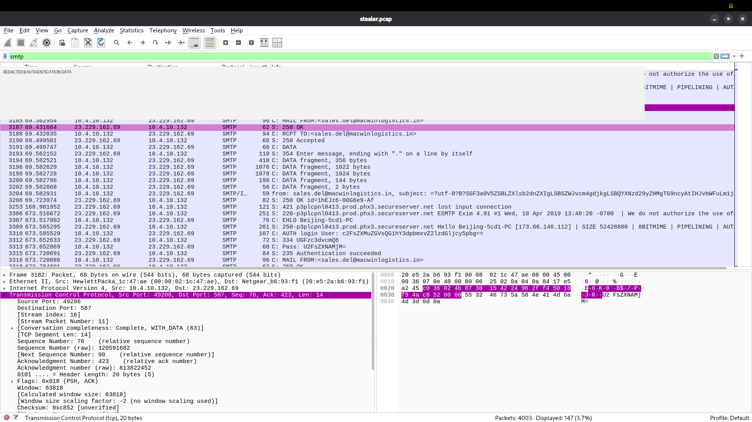
Figure 9. SMTP authentication sequence; authentication values are redacted.
The source notes report that the Base64-encoded body was decoded during the investigation and contained a “HawkEye Keylogger – Reborn v9” label and a password-log section. Base64 is encoding, not encryption. The screenshots of the SMTP exchange expose sensitive authentication material, so redacted versions are embedded here. The report does not decode or repeat those values.
The investigation notes identify repeated public-IP lookup requests to 66.171.248.178, associated with bot.whatismyipaddress.com, and a response value of 173.66.146.112. The request/response sequence and SMTP sessions recur at roughly ten-minute intervals. This cadence is a useful hunt pivot, but the PCAP does not prove which process or timer caused it.
Network indicator | Recorded observation | Blue Team follow-up
SMTP server | 23.229.162.69:587; Exim 4.91 | Review firewall, mail logs, account owner and allowed egress policy
SMTP mailbox | sales.del@macwinlogistics.in in sender/recipient fields | Verify ownership and legitimate usage; avoid assuming attribution
Public-IP lookup endpoint | 66.171.248.178; HTTP GET / requests | Search proxy logs for the host, cadence and other endpoints
Returned public IP | 173.66.146.112 | Context only; not an attacker identity
Cadence | Approximately ten minutes | Correlate time series across DNS, proxy, firewall and endpoint events

6. Relevant Data Sources for a Blue Team
Source | Fields / events to collect | What it can answer
DNS resolver | Timestamp, client IP, queried name, record type, answer, response code | Did the host resolve the domain before contacting the address?
Firewall / NetFlow | Source/destination IP and port, protocol, bytes, duration, action | Which external connections occurred, and how much data moved?
Proxy / web gateway | User/device, URL, method, status, MIME type, bytes, TLS details | Was the executable downloaded and was HTTP allowed by policy?
NIDS / network monitoring | DNS, HTTP headers, SMTP commands, TLS negotiation, periodicity | Can the network sequence and unusual protocol use be detected?
EDR / Windows telemetry | File creation, process creation, command line, hash, signer, network connections, persistence events | Did the executable run, what spawned it, and what changed on the endpoint?
Identity provider / AD | Authentication result, source host/IP, account, MFA, logon type, risk events | Was an account used from an unusual host or context?
Mail gateway / SMTP server | Authenticated identity, source IP, STARTTLS negotiation, sender/recipient, message ID, size, disposition | Was a message accepted, delivered, quarantined or rejected?
Forensic collection | Disk image, memory, browser/email artifacts, scheduled tasks and autoruns | Can delivery, execution, persistence and credential access be confirmed?

7. Investigation Workflow and Key Questions
1. Validate and preserve — Preserve the original PCAP and extracted object; record file hashes, collection source, timestamps and analyst actions. Work from copies.
2. Scope the endpoint — Search network, proxy, DNS, EDR and identity logs for 10.4.10.132 and Beijing-5cd1-PC before and after the capture window.
3. Confirm the download — Search for the domain, IP, URL path, filename and MD5. Determine whether the file was written to disk and whether it was executed.
4. Investigate SMTP activity — Search for outbound TCP/587, the server IP, Exim banner, account identity, AUTH success, TLS negotiation, message ID and message disposition.
5. Assess possible credential exposure — Preserve the message safely; restrict access to decoded credential material. Validate affected accounts through authorised identity/mail logs and rotate credentials if exposure is credible.
6. Expand scope — Search for other endpoints contacting the same domain/IP/hash, making similar public-IP requests or initiating periodic SMTP sessions.
7. Decide severity and response — Use endpoint execution evidence, account exposure, message content, scope and business context. Document confidence and unresolved questions.
Questions that remain open: What initiated the first URL request? Was the executable executed? Which process initiated the SMTP connection? Was STARTTLS negotiated at any point in the complete conversation? Which account authenticated, and was the message delivered? Did any other host or account show related activity?

8. Evidence-Supported Indicators of Compromise
Type | Indicator | Context / confidence
Internal host | 10.4.10.132 | Observed in the capture; hostname recorded as Beijing-5cd1-PC
Hostname | Beijing-5cd1-PC | Recorded in DHCP notes and SMTP EHLO
Domain | proforma-invoices.com | DNS/HTTP context recorded in investigation
Download path | /proforma/tkraw_Protected99.exe | HTTP GET at frame 210, response at frame 3155 in notes
File name | tkraw_Protected99.exe | Shown in HTTP object export
MD5 | 71826ba081e303866ce2a2534491a2f7 | Calculated from extracted object
Download IP | 217.182.138.150 | Observed HTTP peer; geolocation is approximate
Public-IP lookup IP | 66.171.248.178 | Repeated HTTP requests; associated with lookup service in notes
Returned public IP | 173.66.146.112 | Value recorded from lookup response and SMTP greeting
SMTP destination | 23.229.162.69:587 | Observed recurring SMTP connection
Mailbox address | sales.del@macwinlogistics.in | Observed in SMTP commands; handle as sensitive operational data

Treat these as lab-derived indicators, not timeless blocklist entries. Validate freshness, ownership and false-positive risk before blocking or distributing them. Defang domains and addresses when publishing outside a controlled incident channel.

9. Recommended Detection Logic and Alert Conditions
All rules below are proposed recommendations. The supplied evidence does not show that any rule was implemented, triggered in a SIEM, tested against a live event stream or validated.
Rule / status | Required telemetry and suggested condition | False positives / tuning
R1 — PROPOSED: DNS → executable download | DNS logs plus proxy/NIDS: same client queries proforma-invoices.com, then within 5 minutes connects to the returned IP and receives executable MIME type or requests a .exe path. Raise higher severity when multiple signals align. | Software deployment, legitimate installers and lab traffic. Maintain approved download sources; tune by device role and signer.
R2 — PROPOSED: Executable over cleartext HTTP | Proxy/NIDS: HTTP response MIME type application/x-msdownload or executable extension, especially from a workstation to an external host. Include URL, status, size and client. | Legacy internal tools and legitimate downloads. Prefer policy exceptions by approved source; avoid relying on extension alone.
R3 — PROPOSED: File-hash hunt | EDR/file inventory: exact MD5 71826ba081e303866ce2a2534491a2f7. Search historical telemetry and alert on matching file creation or execution. | MD5 collisions and hash reputation limitations; verify SHA-256, file provenance and endpoint context.
R4 — PROPOSED: Near-periodic outbound activity | Proxy/firewall/NetFlow: same host contacts a destination or URL at repeated intervals near 8–12 minutes for at least 3 cycles; correlate with outbound SMTP or other suspicious events. | Health checks, agents and scheduled jobs. Require repeated timing plus a risk signal; use a flexible interval.
R5 — PROPOSED: Workstation → Internet SMTP | Firewall/NetFlow: source device is not in approved mail-server group and initiates outbound TCP/25, 465 or 587 to an external destination. Escalate if paired with repeated sessions or unusual byte volume. | Approved mail clients, scanners and business apps. Use an asset role allowlist and approved relay architecture.
R6 — PROPOSED: SMTP AUTH without TLS | Mail gateway or protocol-aware sensor: AUTH succeeds before TLS negotiation, or policy-required TLS is absent. Alert on successful authentication from a workstation or unusual source. | Some telemetry may not expose TLS state; STARTTLS offer is not proof of negotiation. Confirm complete session and gateway configuration.
R7 — PROPOSED: Credential-log content in outbound mail | Mail gateway/DLP: outbound body or attachment contains high-confidence credential-dump markers, password-log headings, or many username/password-like pairs; combine with unusual sender, destination or workstation SMTP. | Security testing, password-manager exports and legitimate reports. Use DLP carefully, minimise stored secrets and restrict alert payload visibility.
R8 — PROPOSED: Suspicious SMTP account use | Identity/mail logs: successful SMTP AUTH from an unusual source, new geography/network, unapproved client, or non-mail-server workstation, particularly after repeated sessions. | Shared NAT, travel and service accounts. Baseline normal source hosts and investigate with account-owner confirmation.

Operationalisation: map each rule to the fields available in the chosen SIEM, document severity and owner, test against benign and controlled test events, measure false positives, and record the rule version and test evidence. No thresholds should be considered production-ready until tuned to local baselines.

10. Incident Response: Triage Through Recovery
Phase | Recommended actions | Evidence status
Triage | Validate indicators, establish the affected asset/user, preserve PCAP and extracted file, record hashes and timeline, and check whether endpoint execution is known. | Recommended; no response action is documented as performed.
Containment | If execution or credential compromise is credible, isolate the endpoint through EDR/network controls; block relevant destinations and restrict unauthorized outbound SMTP under change control. | Recommendation only; isolation/blocking was not shown in the evidence.
Credential response | Identify the authenticated SMTP account from authorised mail logs; revoke sessions and rotate credentials if exposure is confirmed or reasonably suspected. Review MFA and related sign-ins. | Recommendation only; account identity and credential rotation are not established.
Eradication | After evidence collection, remove malicious artifacts, investigate autoruns/tasks/services and browser/email delivery, patch the initial access route if found, and reimage if integrity cannot be trusted. | Not performed or verified in this PCAP-only lab.
Recovery | Restore from known-good state, reconnect with monitoring, validate endpoint health, review mail-flow policy and confirm that detections operate. | Recommendation only.
Lessons learned | Document timeline, scope, decisions, affected credentials, detection gaps, control changes, rule tuning and follow-up owners. | Recommended follow-up.

Do not delete the executable or modify the endpoint before preserving evidence if a real incident is being handled. Any containment decision should follow the organisation’s incident-response authority and business continuity requirements.

11. Mitigation and Hardening Recommendations
- Restrict outbound SMTP from user workstations to approved mail relays; block direct internet SMTP where business requirements allow.
- Enforce TLS for SMTP authentication and message submission, and alert on policy violations. Confirm actual TLS negotiation from complete gateway/session telemetry.
- Use web proxying and egress controls to restrict executable downloads over cleartext HTTP; prefer HTTPS and approved software distribution channels.
- Enable EDR detections for suspicious executable creation/execution, unsigned or untrusted binaries, credential-access behaviours and persistence changes.
- Centralise DNS, proxy, firewall, EDR, identity and mail logs with consistent timestamps and sufficient retention for cross-source correlation.
- Use application control, least privilege, patch management, email/web filtering and user reporting workflows to reduce the chance of initial compromise.
- Establish a safe process for handling suspected credential dumps: limit access, avoid copying secrets into tickets/reports, and rotate affected credentials when validated.
- Maintain a repeatable detection validation process with benign baselines, controlled test cases, expected results and documented tuning.

12. Visibility Gaps and Limitations
- The PCAP shows network activity but does not directly prove that tkraw_Protected99.exe executed.
- The initial delivery mechanism—such as email, browser download or another route—is not established.
- Persistence, privilege escalation, lateral movement and command-and-control are not demonstrated by the supplied capture.
- No endpoint process logs, EDR alerts, disk image, memory image, identity-provider records or mail-gateway logs were supplied.
- The decoded message-body summary and some details—DNS frames 204/206, DHCP hostname, User-Agent, LiteSpeed header and public-IP lookup response—are recorded in investigation notes; not all have dedicated screenshots in this evidence set.
- The SMTP screenshots originally exposed authentication values and encoded message content; redacted versions are embedded. This report does not reproduce or decode those secrets.
- IP geolocation is approximate and does not identify an attacker or prove physical location.
- The approximately ten-minute recurrence is an observed timing pattern; its cause and mechanism remain unconfirmed.

13. Conclusion
The HawkEye evidence gives defenders a coherent network-hunt starting point: a workstation resolved a domain associated with an executable transfer, downloaded tkraw_Protected99.exe over HTTP, repeatedly contacted a public-IP lookup endpoint, and established recurring authenticated SMTP sessions to an external server. The SMTP conversation accepted the recipient and proceeded to message transfer; the source notes report credential-log content in the decoded body.
The recommended defensive priorities are to correlate DNS and HTTP telemetry, hunt the file hash, investigate outbound SMTP from workstation assets, review authentication and TLS policy, and correlate near-periodic activity across network and endpoint sources. These controls remain proposed. Confirming execution, scope and credential impact requires endpoint, identity and mail-gateway evidence that is not present in the supplied PCAP.

14. Evidence References
Figure | Evidence file | Use in this report
1 | 01_capture_properties.png | Capture size, duration and packet count
2 | 04_ipv4_endpoints.png | Victim and external endpoint statistics
3 | 06_dns_query_204.png | HTTP request/response and repeated public-IP lookup traffic; not a DNS screenshot
4 | 09_HTTP_Export_Object_tkraw_Protected99.png | Executable object, host, content type, size and packet number
5 | 10_Malware_File_MD5_Hash.png | Extracted object MD5
6 | 05_SMTP_Exfiltration_Traffic.png | Recurring SMTP traffic
7 | 11_SMTP_Follow_TCP_Stream_REDACTED.png | SMTP banner and message flow; sensitive fields redacted
8 | 12_SMTP_RCPT_TO_Evidence.png | Recipient and 250 Accepted response
9 | 13_SMTP_Authentication_Evidence_REDACTED.png | Authentication sequence; values redacted

Factual basis: the completed HawkEye investigation report and source notes, together with the listed screenshots. Findings not directly shown in a screenshot are identified as investigation-note findings, not as independently proven by the image.
End of report.

