PURPLE TEAM
Attack & Defense
Handover Report
HawkEye Lab — PCAP-led investigation and defensive improvement plan

Report details | Value
Author | Giri Anoop
Programme | ElevanceSkills Cybersecurity Internship
Primary evidence | stealer.pcap
Capture size | 4,003 packets; 01:03:41 duration
Report purpose | Transfer observed network findings into detection, response and validation work

Handling note
This report contains investigation indicators and a defensive validation plan. Authentication values and decoded credentials are intentionally excluded. The report distinguishes packet-supported observations from hypotheses and proposed future tests.

1. Executive summary
The HawkEye Lab PCAP contains 4,003 packets across 01:03:41. The principal internal host is 10.4.10.132, identified in the capture as Beijing-5cd1-PC. The traffic includes a request for proforma-invoices.com, a response resolving that name to 217.182.138.150, and an HTTP request for tkraw_Protected99.exe. The file was extracted for identification and its recorded MD5 is 71826ba081e303866ce2a2534491a2f7.
The capture also shows repeated SMTP activity from the internal host to 23.229.162.69 on TCP/587. The server banner identifies Exim 4.91. The observed SMTP conversation includes successful authentication, message submission and acceptance for sales.del@macwinlogistics.in. Decoded message content is reported by the investigation notes to identify “HawkEye Keylogger – Reborn v9” and contain a password-log section. This supports a finding of suspicious outbound data transfer; it does not, by itself, prove that the downloaded executable was executed or establish the original delivery method.
The immediate defensive priorities are to preserve the PCAP and extracted file, search available proxy/DNS/endpoint/mail telemetry for the same indicators, review the affected host and account context, and develop detections that correlate download activity with repeated authenticated SMTP submissions. All detections in this report are proposals until implemented and validated in an authorised lab.
Assessment area | Current conclusion
Observed | HTTP executable request/response; DNS resolution; repeated public-IP lookup requests; SMTP sessions to TCP/587; SMTP authentication and accepted message submission.
Strong investigative lead | Potential credential or sensitive-data exfiltration via SMTP, based on the message content described in the investigation notes.
Not established | Original delivery mechanism, executable execution, persistence, lateral movement, and command-and-control.
Validation status | This document proposes detections and tests; it does not claim those detections have been built or tested.

2. Scope and methodology
Scope was limited to reviewing the supplied packet capture, the recorded investigation findings and the available evidence screenshots. The objective is to translate the observed behaviour into actionable defensive telemetry, detection logic, response steps and future validation cases.
- Reviewed capture metadata and Ethernet/IPv4 endpoint statistics in Wireshark.
- Reviewed the HTTP request and response associated with tkraw_Protected99.exe and the exported-object record.
- Recorded the extracted file MD5 as supplied by the investigation evidence.
- Reviewed SMTP sessions, server banner, authentication outcome, sender/recipient commands and repeated session timing.
- Used IP geolocation only as contextual enrichment; it is not proof of operator identity or physical location.
- Did not execute the executable, perform binary reverse engineering, collect endpoint memory, or establish host-side process and persistence evidence.
Evidence handling: preserve the original PCAP as read-only, compute and record hashes for working copies, keep extracted artefacts in a controlled analysis directory, and redact credentials or authentication material in any shared evidence.

3. Consolidated attack-chain timeline
Sequence / time reference | Observed event | Interpretation and confidence
Capture begins: 2019-04-11 02:07:07 (as displayed in capture properties) | Capture metadata records the first packet and a total duration of 01:03:41. | Directly observed metadata. Timestamp display/time-zone interpretation should be confirmed before correlating with other systems.
Packet 204–206 (investigation notes) | DNS query for proforma-invoices.com followed by a response resolving to 217.182.138.150. | Directly reported from packet analysis; supports domain-to-IP association within this capture.
Packet 210 | 10.4.10.132 requests /proforma/tkraw_Protected99.exe from 217.182.138.150 over HTTP. | Directly observed request. A request alone does not prove successful execution.
Packet 3155 | HTTP response/object is identified as application/x-msdownload; exported object is tkraw_Protected99.exe, about 2,025 kB. | Directly observed object evidence; extracted file MD5 recorded separately.
Repeated intervals | HTTP requests to a public-IP lookup service and SMTP sessions recur at approximately ten-minute intervals. | Pattern visible in the capture; timing should be confirmed against packet timestamps and session boundaries during further analysis.
SMTP stream around packets 3175 onward | SMTP banner identifies Exim 4.91; AUTH LOGIN exchange receives 235 Authentication succeeded; MAIL FROM and RCPT TO commands are accepted; DATA follows. | Directly observed SMTP protocol activity. Authentication values are sensitive and intentionally omitted.
SMTP message content | Investigation notes report decoded content identifying HawkEye Keylogger – Reborn v9 and a password-log section. | Content interpretation reported in the investigation notes; no credentials are reproduced here.

4. Attack-to-evidence-to-detection-to-response mapping
Observed behaviour | Evidence source | Proposed detection | Response / next collection
Domain resolution | DNS query/response noted at packets 204–206. | Alert when a host resolves a suspicious domain and subsequently requests a related executable over HTTP; enrich with DNS and proxy telemetry. | Collect DNS logs, resolver response, proxy logs and full URL/request metadata; assess domain reputation using approved sources.
Executable transfer | HTTP packet 210 and object record around packet 3155. | Correlate executable download from an uncommon external host with endpoint file creation or security-product alert. | Preserve file, hash it, quarantine through endpoint tooling if available, and collect endpoint process/file telemetry.
Repeated public-IP lookup | HTTP request/response series in the packet list. | Baseline public-IP lookup frequency; alert only when unusual repetition correlates with suspicious download or outbound transfer activity. | Confirm whether the service is expected; search other hosts and time periods.
Authenticated SMTP to external server | TCP/587 session to 23.229.162.69; Exim 4.91 banner; successful SMTP authentication. | Alert on endpoint-to-external SMTP submission where the destination is not an approved mail relay, especially when followed by message DATA. | Review firewall, proxy, mail and identity logs; identify process/user behind the connection; block or restrict egress only under incident authority.
Repeated outbound message submission | Repeated SMTP sessions approximately every ten minutes; accepted recipient command. | Detect periodic authenticated SMTP submissions from a workstation or server outside approved mail-client/relay patterns. | Preserve mail logs and message metadata; determine what data was transferred without circulating decoded secrets.
Potential credential-log transfer | Investigation notes describe decoded message content with a password-log section. | Use content-aware controls and endpoint detections for known credential-dumping/keylogging indicators where supported; avoid relying on a single string match. | Escalate as potential credential exposure; rotate affected credentials through the identity owner and review sign-in activity.

5. Red Team findings for Blue Team investigation
The Red Team handover should focus on what the PCAP makes observable, not on assumed actions that are absent from the evidence.
- Network indicators: victim 10.4.10.132; hostname Beijing-5cd1-PC; domain proforma-invoices.com; payload-host IP 217.182.138.150; SMTP destination 23.229.162.69:587.
- Transfer indicators: HTTP GET for /proforma/tkraw_Protected99.exe and an exported executable object identified in Wireshark.
- Potential exfiltration indicators: repeated authenticated SMTP sessions, accepted recipient command and message DATA transfers.
- Likely analyst questions: Which process initiated the connections? Was the file created or executed? Which user was logged on? Is the SMTP destination approved? What data was sent? Are similar patterns present elsewhere?
- Do not represent persistence, lateral movement, phishing delivery or command-and-control as confirmed. Those stages require endpoint, identity, mail, or additional network evidence.

6. Detection coverage matrix
Attack stage | Observed evidence | Proposed detection | Required telemetry | Response action | Validation status
Name resolution | Domain query/response recorded in notes. | Suspicious domain resolution followed by executable download. | DNS logs, proxy/HTTP logs, endpoint process/file events. | Investigate domain, host and subsequent connections. | Proposed; not tested
HTTP download | GET request and executable object in PCAP. | External executable download from uncommon domain/IP. | Proxy logs, firewall logs, EDR file and process telemetry. | Preserve artefact; isolate host if justified. | Proposed; not tested
File identity | MD5 recorded for extracted file. | Hash match in endpoint/file telemetry; use as one indicator only. | EDR/AV telemetry, file inventory, threat-intelligence platform. | Search fleet; quarantine confirmed matches. | Proposed; not tested
SMTP submission | TCP/587, Exim 4.91, successful authentication and DATA. | Unapproved SMTP destination plus successful submission from an endpoint. | Firewall, network flow, endpoint network connections, mail logs. | Validate business use; restrict egress under approved procedure. | Proposed; not tested
Periodic activity | Repeated SMTP and public-IP lookup requests at roughly ten-minute intervals. | Frequency/periodicity rule combined with destination and host context. | NetFlow/Zeek/proxy logs; timestamped SMTP metadata. | Hunt for recurrence and related hosts. | Proposed; not tested
Credential exposure | Investigation notes report password-log content in message body. | Correlate endpoint credential-theft signals with unusual outbound transfer. | EDR, Windows event logs, identity logs, mail/egress metadata. | Treat as potential exposure; rotate credentials and review sign-ins. | Proposed; not tested
Execution / persistence | Not proven by PCAP. | Endpoint rules for suspicious process execution, autoruns and persistence changes. | EDR, Sysmon, Windows Security logs, autorun/registry telemetry. | Collect triage package and investigate host state. | Not observed; future test
Lateral movement | No confirming evidence in this capture. | Rules for unusual remote logons, admin shares, remote services and cross-host authentication. | Windows Security logs, Sysmon, network telemetry, identity logs. | Scope affected identities and systems. | Not observed; future test

7. IOC handover
Type | Value | Context | Handling note
Internal host | 10.4.10.132 | Primary host in the capture; hostname Beijing-5cd1-PC. | Private IP; correlate with DHCP and asset inventory.
Hostname | Beijing-5cd1-PC | DHCP/SMTP HELO context reported in evidence. | Validate host identity from endpoint/DHCP records.
Domain | proforma-invoices.com | DNS query associated with the HTTP download. | Treat as an investigation indicator; validate in context.
Payload-host IP | 217.182.138.150 | HTTP source for tkraw_Protected99.exe; geolocation screenshot shows France/Roubaix and OVH SAS. | Geolocation is approximate and does not identify the attacker.
File | tkraw_Protected99.exe | Executable object exported from HTTP traffic. | Keep in a controlled analysis location; do not execute on a production host.
MD5 | 71826ba081e303866ce2a2534491a2f7 | Hash recorded from extracted file. | MD5 is useful for matching but is not a modern integrity guarantee; calculate SHA-256 for future handling.
SMTP destination | 23.229.162.69:587 | External SMTP server; banner identifies Exim 4.91. | Validate approved mail-relay status before blocking.
Mailbox | sales.del@macwinlogistics.in | Observed as sender and recipient in the SMTP conversation. | Handle as potentially sensitive evidence; do not infer account ownership from address alone.

8. Detection engineering improvements

8.1 Correlation logic to implement
- Download-to-egress correlation: within a defined window, correlate an external executable download with an outbound SMTP session from the same host. Use a configurable time window (for example, 30 minutes) and tune against baseline traffic.
- Unapproved SMTP submission: alert when an endpoint initiates TCP/587 to a destination not on the approved relay list and the session shows SMTP AUTH or message submission, where protocol parsing is available.
- Periodicity: calculate repeated connection intervals per source host and destination. Treat regularity as supporting context, not a standalone malicious verdict.
- Credential-exposure correlation: combine endpoint alerts for credential access or keylogging-like behaviour with unusual outbound data transfer. Avoid matching on sensitive content alone.
- Executable reputation: enrich file hashes with approved reputation sources and internal prevalence. Do not treat a hash-only match as conclusive without context.

8.2 Data quality and tuning
- Normalise timestamps to a documented time zone before cross-source correlation.
- Retain source host, destination, process/user, DNS answer, HTTP URI, file hash, SMTP authentication outcome and transfer volume where available.
- Create allowlists for authorised mail relays and approved administrative tools, with owner and expiry dates.
- Record alert rationale and linked evidence so an analyst can reproduce the finding.
- Track false positives and detection latency during validation; tune thresholds using benign baseline traffic.

9. Containment and remediation handover
Priority | Action | Owner / dependency | Completion evidence
P1 | Preserve the original PCAP, extracted executable and hash records; maintain access controls and chain-of-custody notes. | Incident handler / evidence custodian | Read-only original, hashes and evidence log.
P1 | Identify the asset and user behind 10.4.10.132 using DHCP, endpoint inventory and authentication records. | Endpoint / IT operations | Asset and user mapping with timestamps.
P1 | Review endpoint security telemetry for file creation, process execution, persistence and credential access around the capture window. | Endpoint detection / DFIR | Triage findings; explicitly state if telemetry is unavailable.
P1 | Review mail and network logs for the SMTP destination, authentication account, accepted message submissions and similar sessions. | Mail / network teams | Search results and scope assessment; no passwords copied into report.
P1 | If current exposure is confirmed, coordinate credential rotation, session revocation and sign-in review with identity owners. | Identity team / incident lead | Approved change record and post-change sign-in review.
P2 | Restrict workstation-originated SMTP submission to approved relays where operationally safe. | Network security / service owner | Firewall policy and exception review.
P2 | Search other hosts for the domain, IP, filename and hash; broaden the hunt to periodic SMTP behaviour. | SOC / threat hunting | Query, time range, result count and investigated hits.
P2 | Add the proposed correlation detections and validate with benign controlled artefacts. | Detection engineering | Rule version, test case, expected/actual result and tuning notes.

10. Visibility gaps and unconfirmed stages
- The PCAP does not prove the original delivery mechanism or that tkraw_Protected99.exe was executed.
- No endpoint process tree, Windows event logs, EDR timeline, memory image or persistence artefacts were in scope.
- No binary reverse engineering was performed; the malware-family label comes from the decoded message content described in the investigation notes.
- The capture alone cannot establish the identity or physical location of an attacker. IP geolocation is approximate context only.
- No confirmed lateral movement or command-and-control activity is established by the provided evidence.
- The packet capture does not independently identify the account owner or establish whether the mailbox was compromised.
- The exact payload contents and any credentials are deliberately not reproduced. If further analysis requires content review, handle it in a restricted evidence workspace.
- The capture's timestamps should be reconciled with source-system time zones and any available log timestamps before constructing a cross-system incident timeline.

11. Future Purple Team validation plan
Run these tests only in an authorised isolated lab. Use synthetic events, reserved test domains, dummy files and dummy accounts. Never use real credentials or send data to the external indicators listed in the PCAP.
Test | Controlled method | Expected telemetry / outcome | Pass criteria
T1 — DNS-to-download correlation | Use a lab DNS zone and benign text/binary test file hosted on an internal test web server; generate a lookup and download from a designated test host. | DNS and proxy/HTTP events share host and time context; correlation alert fires. | Alert includes host, domain, URL, time and evidence links; no production traffic required.
T2 — Unapproved SMTP policy | Send a harmless test message from a lab host to a local mail sink on TCP/587 using a dummy account, or simulate the flow in a replay dataset. | Network and mail telemetry show destination, session and submission; alert flags non-approved relay. | Alert fires for the test destination and remains quiet for an approved-relay baseline.
T3 — Periodic connection logic | Generate benign connections to a lab sink at a fixed interval, then at varied intervals. | Periodic pattern is scored with context; jittered benign traffic does not automatically become a high-confidence incident. | Rule documents threshold, time window and observed false-positive behaviour.
T4 — File hash matching | Create a harmless test file and compute SHA-256/MD5; ingest a synthetic file event with the known test hash. | File event is searchable and enrichment appears. | Analyst can trace the hash to the test artefact; no malicious executable is needed.
T5 — Endpoint visibility | Use benign administrative PowerShell or a harmless script that writes a marker file in a lab VM; collect approved process and script-block telemetry. | Process, user, command-line and relevant event records are collected. | Telemetry is complete enough to investigate who ran what and when; do not run credential theft.
T6 — Incident handover drill | Give a second analyst the synthetic alert, evidence links and IOC list without verbal context. | Analyst identifies observed facts, unknowns, required collections and containment decision. | Handover is reproducible and unknowns are not misreported as facts.

Record for every test: date/time and time zone, test host, rule version, event IDs or query IDs, expected result, actual result, screenshots/log extracts, false positives, and pass/fail rationale.

12. Prioritised recommendations
Rank | Recommendation | Reason
1 — Immediate | Preserve evidence and determine whether the host/account is still active or exposed. | Maintains investigative integrity and informs current risk.
2 — Immediate | Correlate endpoint, DNS, proxy, firewall, mail and identity telemetry for the capture window. | The PCAP provides network visibility but not host execution or account ownership.
3 — High | Review successful SMTP authentication and message-submission records; validate whether the destination was authorised. | The SMTP sequence is the clearest observed outbound-transfer lead.
4 — High | Develop and test download-to-SMTP and unapproved SMTP detections. | Cross-stage correlation is stronger than isolated indicator matching.
5 — High | Add endpoint visibility for file creation, process execution, PowerShell/script telemetry and persistence changes. | These sources can confirm or refute stages that the PCAP cannot establish.
6 — Medium | Add periodicity analytics and maintain documented mail-relay allowlists. | Improves detection quality while controlling false positives.
7 — Medium | Recalculate SHA-256 for the extracted artefact and document secure evidence storage. | Improves artefact integrity and future matching.
8 — Medium | Run the controlled validation plan and keep evidence for each pass/fail result. | Moves the handover from proposed coverage to demonstrated coverage.

13. Final handover checklist
- ☐ Original PCAP preserved and hash recorded.
- ☐ Extracted file stored in a controlled location; SHA-256 still to be calculated if not already recorded.
- ☐ IOC list transferred to SOC/DFIR with context and confidence noted.
- ☐ Endpoint, DNS, proxy, firewall, mail and identity log searches assigned.
- ☐ Authentication values and decoded credentials excluded from shared report.
- ☐ Detection rules clearly labelled proposed until implementation and validation are complete.
- ☐ Lab tests use benign artefacts, dummy accounts and authorised infrastructure only.
- ☐ Timeline time zone and cross-source clock differences checked before final incident chronology.
- ☐ Response owner and escalation path assigned for any confirmed current exposure.

14. Conclusion and evidence references
The strongest handover finding is a suspicious sequence linking domain resolution and an HTTP executable transfer with repeated authenticated SMTP submissions from the same internal host. The SMTP conversation and message-content interpretation justify further investigation for potential credential exposure. The capture does not establish execution, initial delivery, persistence, lateral movement or command-and-control. The next step is to corroborate the network evidence with endpoint, identity and mail records, then implement and validate the proposed detections in a controlled lab.
Evidence figures below are taken from the supplied screenshots. Authentication payloads and decoded credentials are not reproduced. If an image is missing from the supplied working files, the report marks that limitation rather than fabricating evidence.

Figure 1
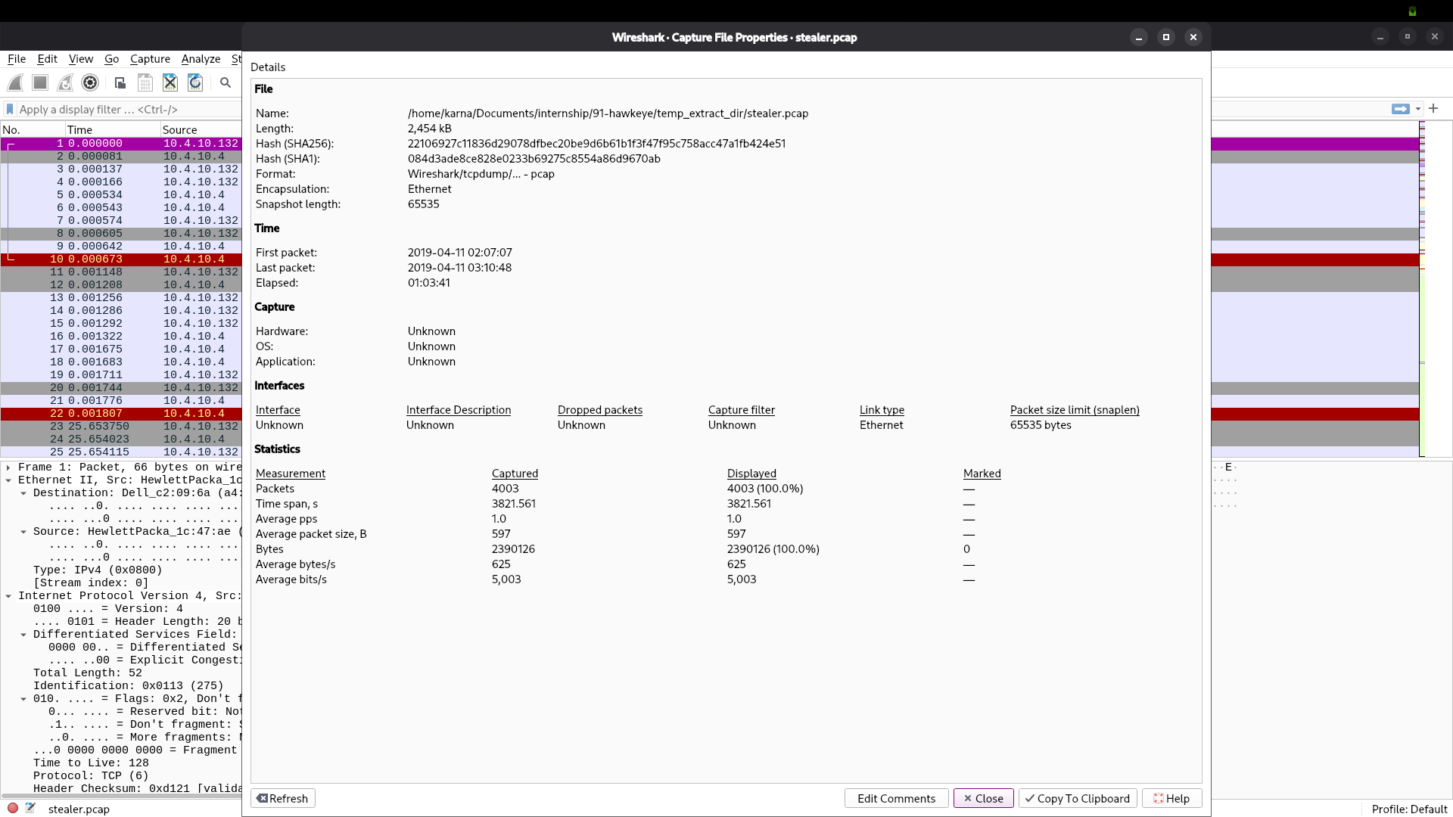
Figure 1. Wireshark capture properties: stealer.pcap, 4,003 packets, 01:03:41 duration.

Figure 2
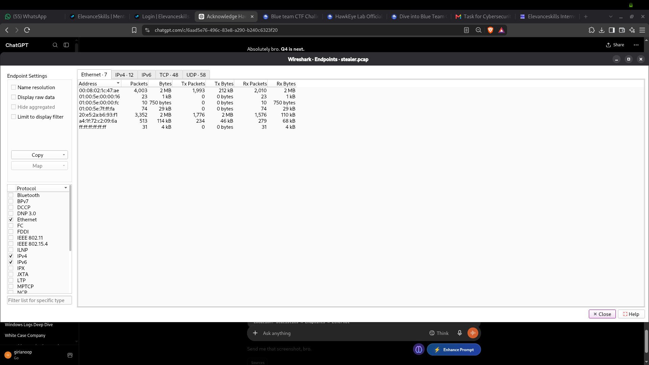
Figure 2. Ethernet endpoint statistics: primary MAC accounts for the capture traffic.

Figure 3
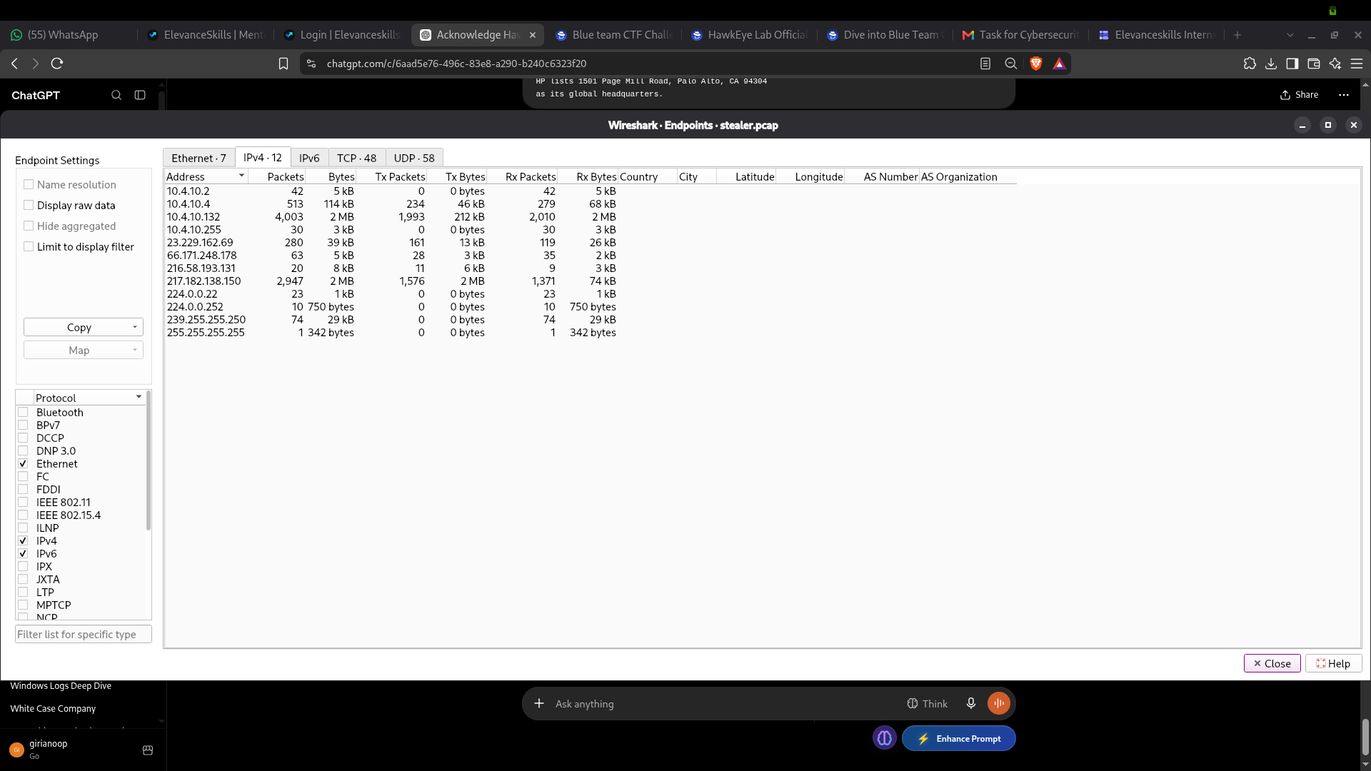
Figure 3. IPv4 endpoint statistics: internal host 10.4.10.132 and observed external endpoints.

Figure 4
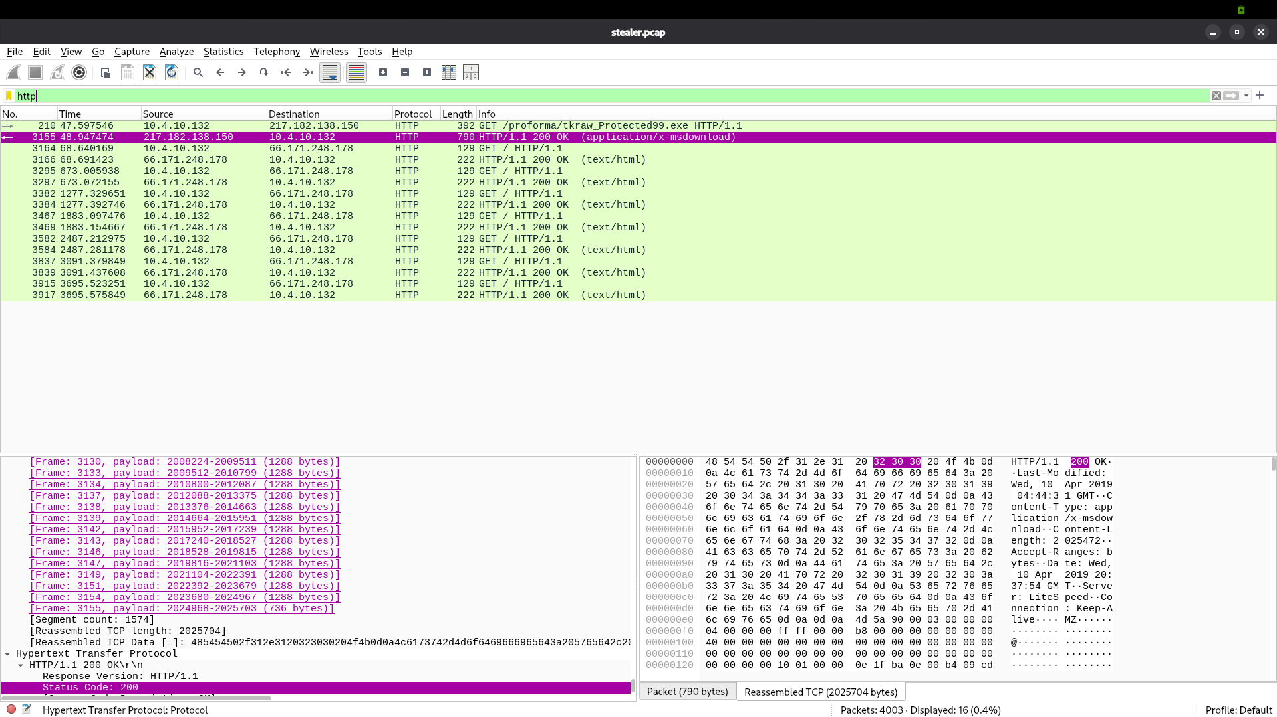
Figure 4. HTTP packet list showing the executable request/response and repeated public-IP lookup requests. This is not a DNS-query screenshot.

Figure 5
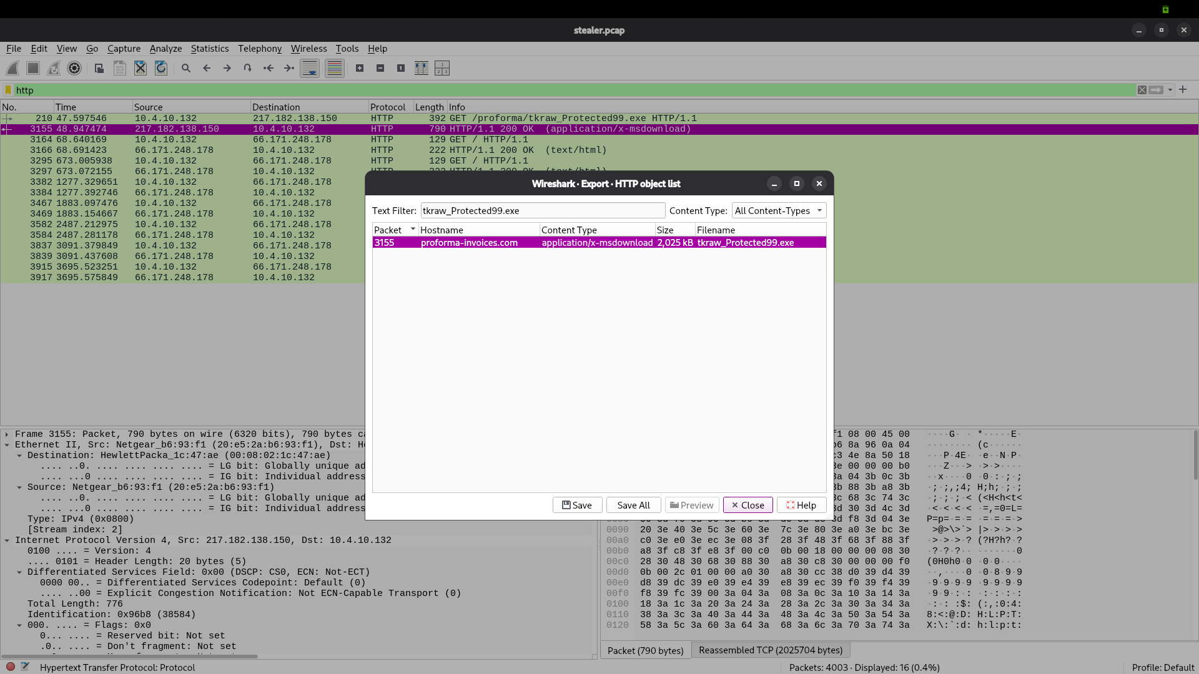
Figure 5. Wireshark HTTP object export listing tkraw_Protected99.exe.

Figure 6
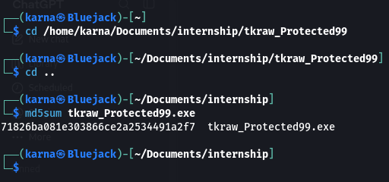
Figure 6. MD5 recorded for the extracted file: 71826ba081e303866ce2a2534491a2f7.

Figure 7
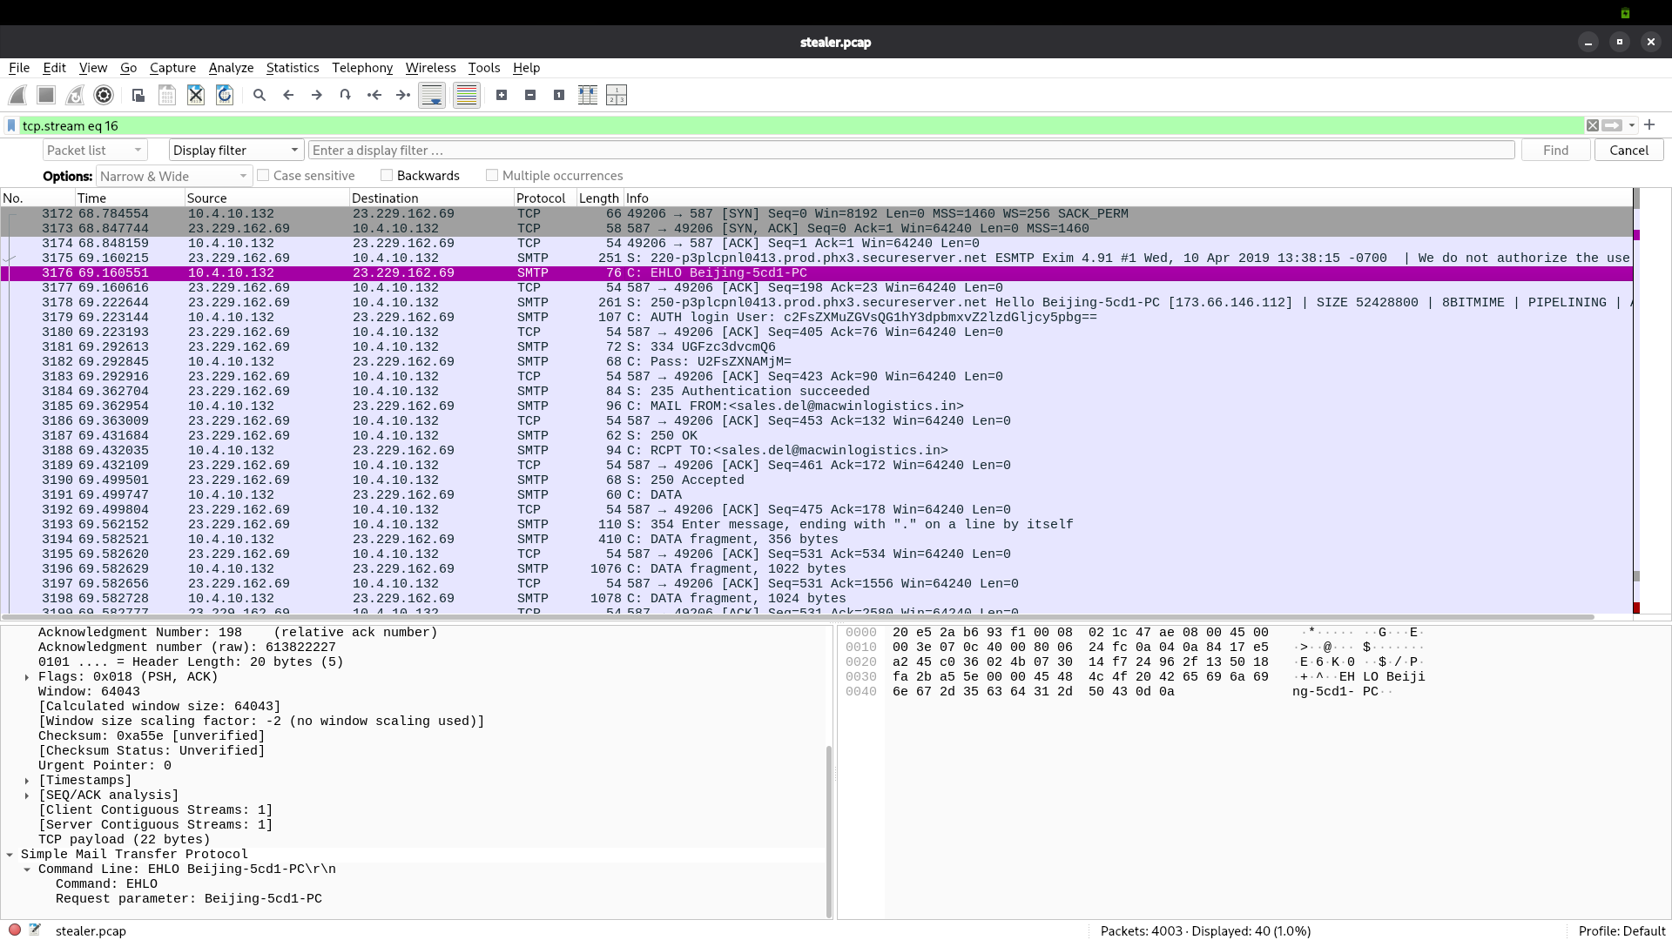
Figure 7. SMTP packet list showing recurring sessions and message-submission commands.

Figure 8
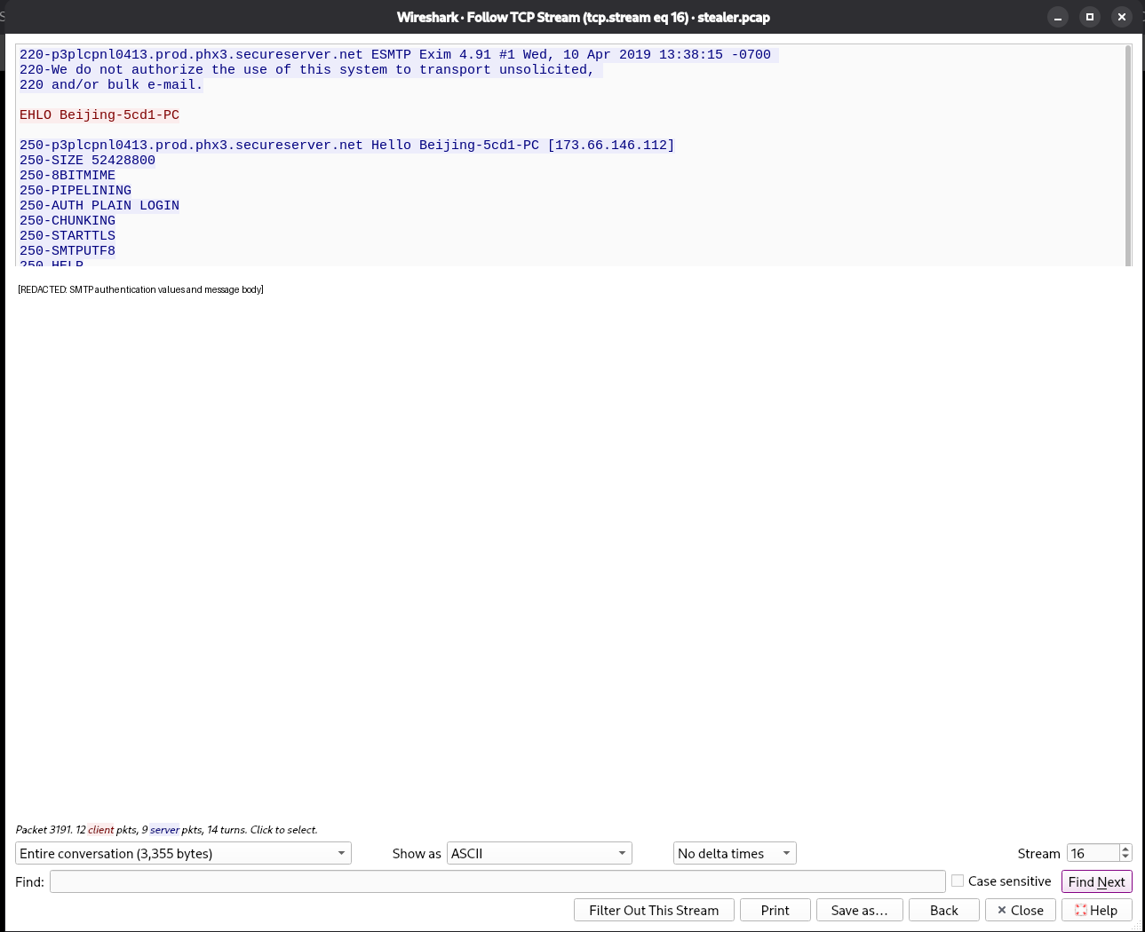
Figure 8. SMTP conversation showing Exim 4.91, successful authentication and message submission. Secrets and credentials are intentionally omitted from the report text.

Figure 9
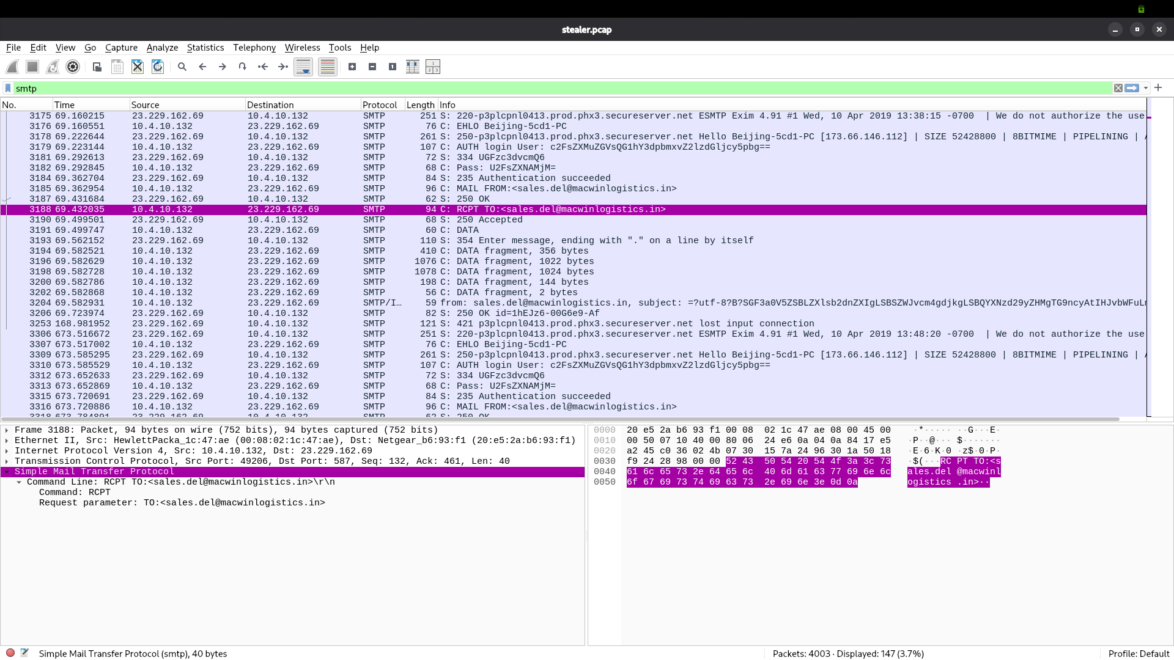
Figure 9. SMTP recipient command and server acceptance response.

Figure 10
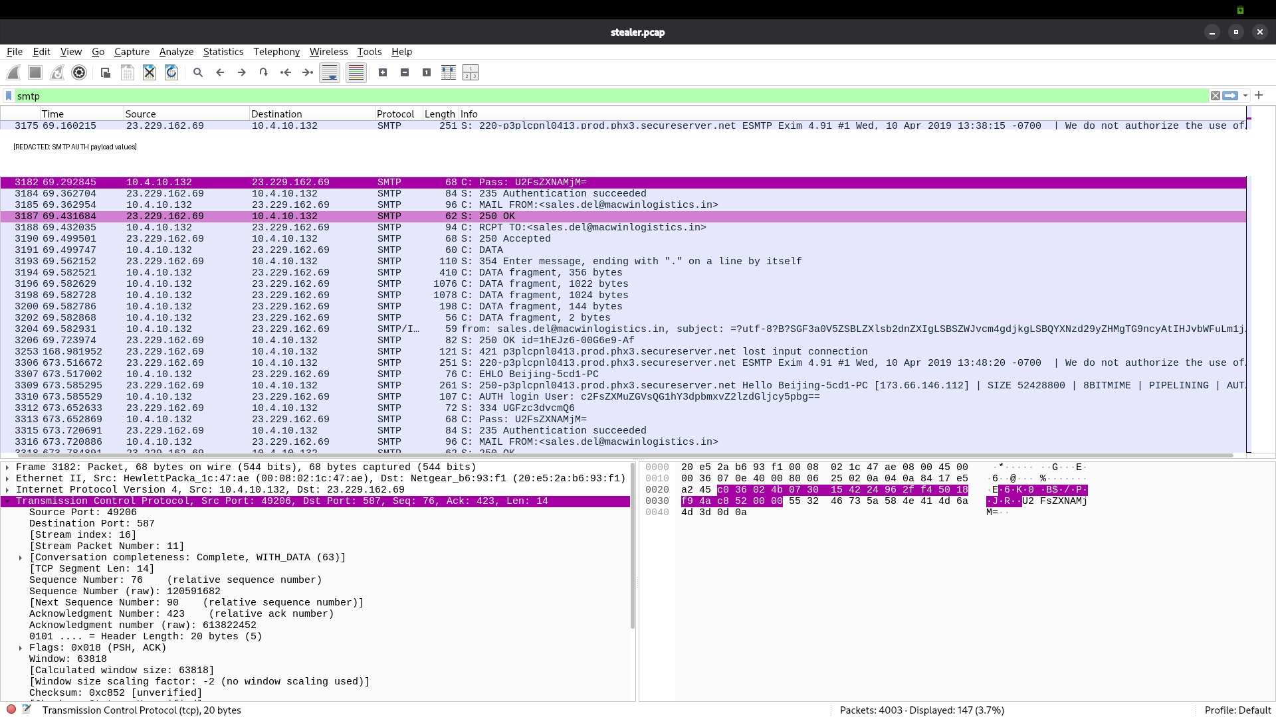
Figure 10. SMTP authentication sequence. The original screenshot contains authentication payload material; treat the image as restricted evidence and do not circulate it outside the authorised investigation team.

Figure 11
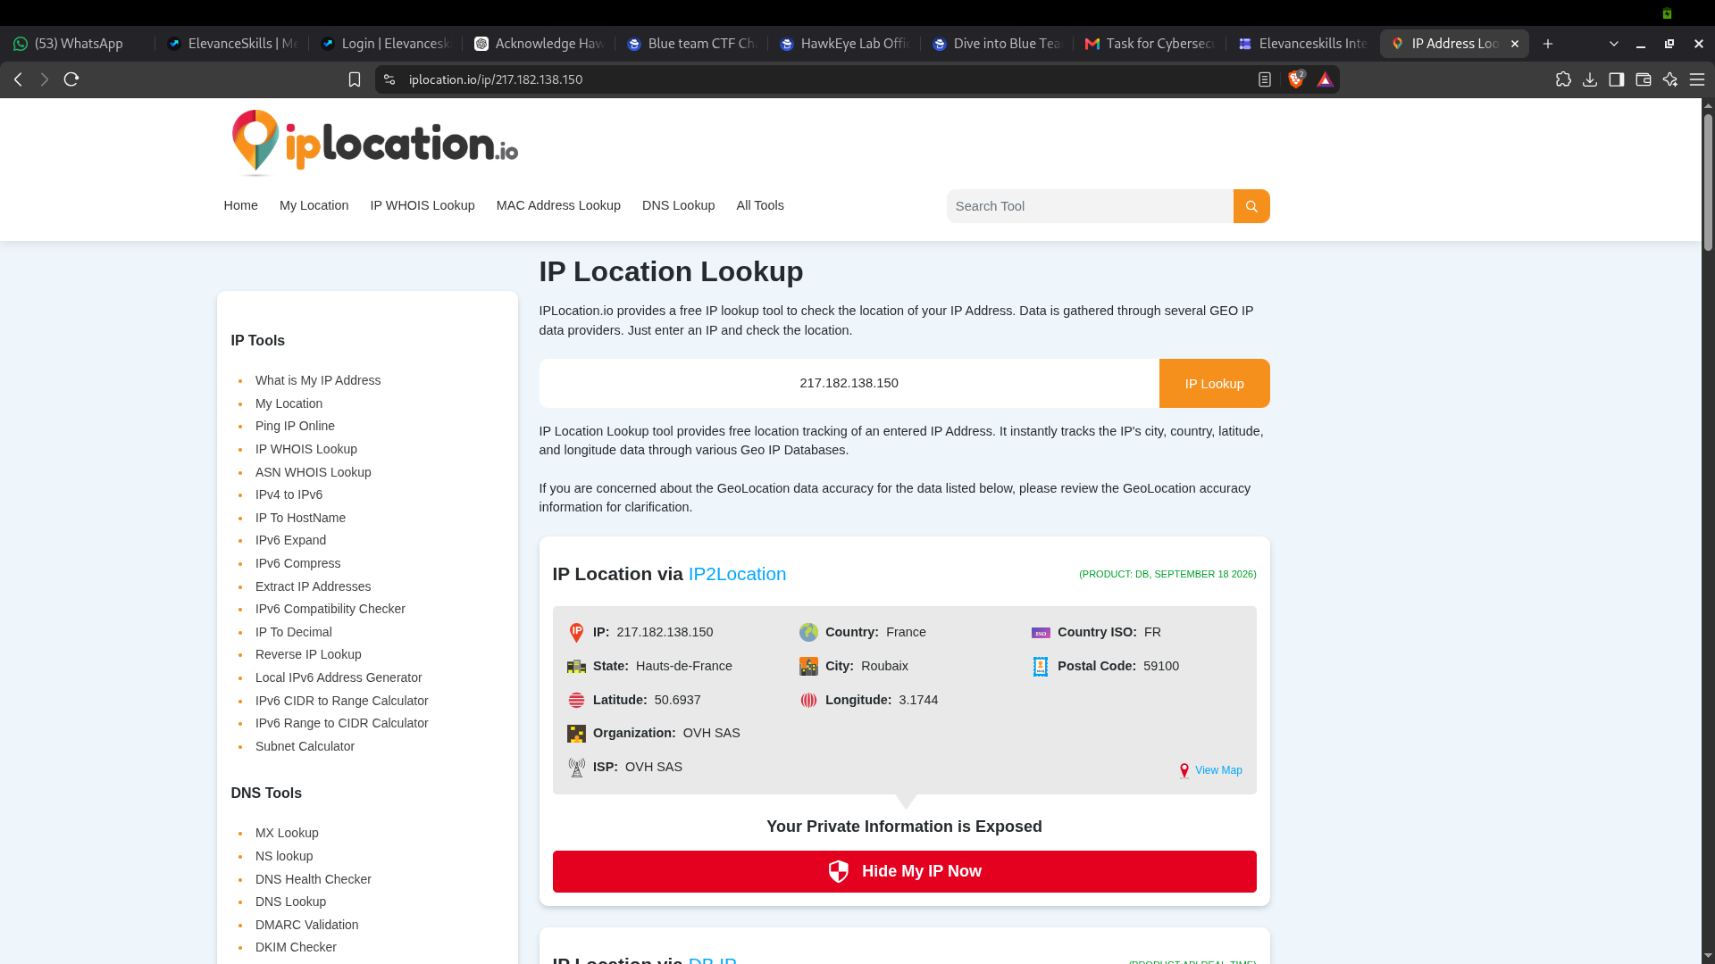
Figure 11. IP geolocation context for 217.182.138.150. Geolocation is approximate and does not establish attacker identity or physical location.

