HAWKEYE LAB

Red Team Assessment Report
Network-forensics reconstruction of the activity represented in stealer.pcap

Report details | Value
Author | Giri Anoop
Programme | ElevanceSkills Cybersecurity Internship
Lab | CyberDefenders HawkEye
Evidence artifact | stealer.pcap
Primary tools | Wireshark, Kali Linux, md5sum, IP geolocation lookup
Assessment perspective | Red Team — evidence-led attack-chain reconstruction

Prepared from the completed lab investigation and its recorded evidence.

1. Executive Summary
This report reconstructs the attack-like sequence visible in the CyberDefenders HawkEye packet capture from a Red Team assessment perspective. The PCAP contains 4,003 packets across 01:03:41. The central host is 10.4.10.132, identified in the investigation as Beijing-5cd1-PC. The observed sequence includes DNS resolution for proforma-invoices.com, an HTTP request for tkraw_Protected99.exe, repeated public-IP lookup requests, and recurring authenticated SMTP sessions to 23.229.162.69 on TCP port 587.
The executable was listed in Wireshark’s HTTP object export at approximately 2,025 kB. The extracted file’s MD5 was recorded as 71826ba081e303866ce2a2534491a2f7. The download server address 217.182.138.150 was geolocated by a public lookup service to Roubaix, France, with OVH SAS shown as the organisation/ISP. That location is approximate and does not identify an operator.
The SMTP traffic identifies Exim 4.91 and shows an authentication-success response, followed by a message from and to sales.del@macwinlogistics.in. The investigation notes report that the Base64-encoded message body, when decoded during the investigation, identified “HawkEye Keylogger – Reborn v9” and a password-log section. The report does not reproduce passwords or authentication values. Base64 is an encoding, not encryption.
The timing and order of events are consistent with an infostealer-style workflow, but the PCAP alone does not prove the executable was run, establish the delivery method, or demonstrate persistence, lateral movement, or command-and-control. Those points remain unconfirmed.
Assessment result | Status | Basis
HTTP transfer of executable | Directly observed | Frames 210 and 3155; HTTP object export screenshot
Repeated public-IP lookup traffic | Directly observed | HTTP request sequence beginning at frame 3164; response value recorded in notes
Authenticated SMTP submission | Directly observed | SMTP stream and packet list; AUTH success and message submission
Credential-log content | Reported in investigation notes | Decoded message content; sensitive values deliberately omitted
Executable execution / persistence | Not established | No endpoint or process telemetry in the PCAP

2. Scope, Tools and Evidence Sources
Scope was limited to analysis of the supplied stealer.pcap, extraction and hashing of the HTTP object, review of the relevant network conversations, and a public IP geolocation lookup. The report is a reconstruction of the lab evidence, not a claim that a real-world intrusion was independently validated.
Source / tool | Purpose | Evidence caveat
stealer.pcap | Network packet analysis and chronology | Does not provide endpoint process, file-system, or memory evidence
Wireshark | Capture properties, endpoints, DNS/HTTP/SMTP packet analysis, Export Objects and Follow TCP Stream | Packet-level conclusions depend on what the capture contains
Kali Linux / md5sum | MD5 hash of extracted executable | MD5 is an identification aid, not proof of maliciousness
IPLocation.io | Contextual geolocation for 217.182.138.150 | Geolocation can be approximate; it does not identify a person
Investigation notes | DNS frames 204/206, DHCP hostname, HTTP headers, lookup response, decoded email-body summary and timing | Some details have no dedicated screenshot among the supplied images

Evidence integrity and handling: screenshots are inserted near the finding they support. The screenshot originally named 06_dns_query_204.png is an HTTP packet-list view, not a DNS-query view; it is captioned accordingly. SMTP screenshots were sanitized before insertion so authentication values are not exposed.

3. Capture Baseline and Host Identification
Capture File Properties reports 4,003 captured and displayed packets, a duration of 01:03:41, and a first/last packet timestamp displayed in the local capture view. The investigation notes normalize the capture start to 2019-04-10 20:37:07 UTC and the end to 21:40:48 UTC. The properties screenshot displays 2019-04-11 02:07:07 through 03:10:48 in the local-time view; these are consistent with a timezone offset and the same elapsed duration.
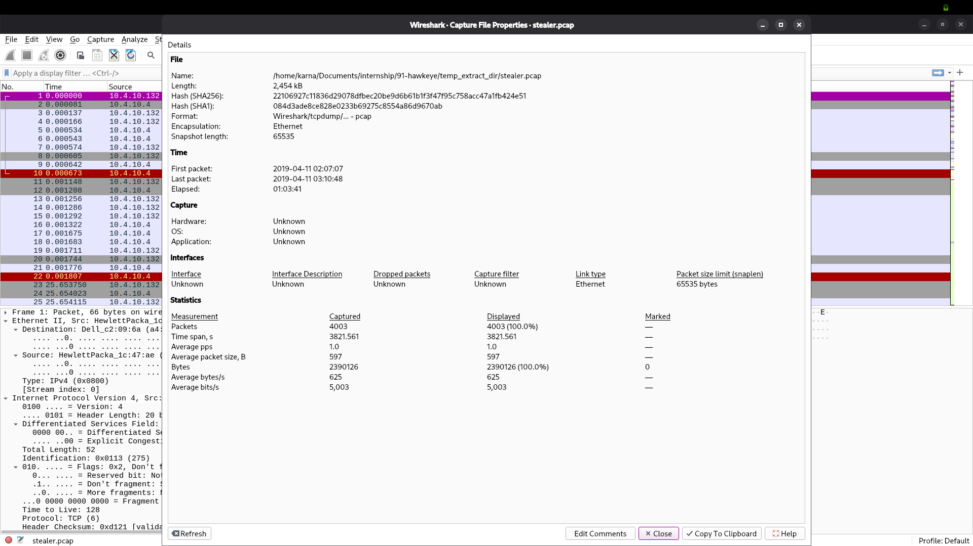
Figure 1. Wireshark Capture File Properties: 4,003 packets and elapsed time of 01:03:41.
Ethernet endpoint statistics show MAC address 00:08:02:1c:47:ae in all 4,003 packets, with 1,993 transmitted and 2,010 received. The investigation associates the OUI with Hewlett-Packard. The IPv4 endpoint view shows 10.4.10.132 in all 4,003 packets, with 2,947 packets involving 217.182.138.150 and 280 involving 23.229.162.69.
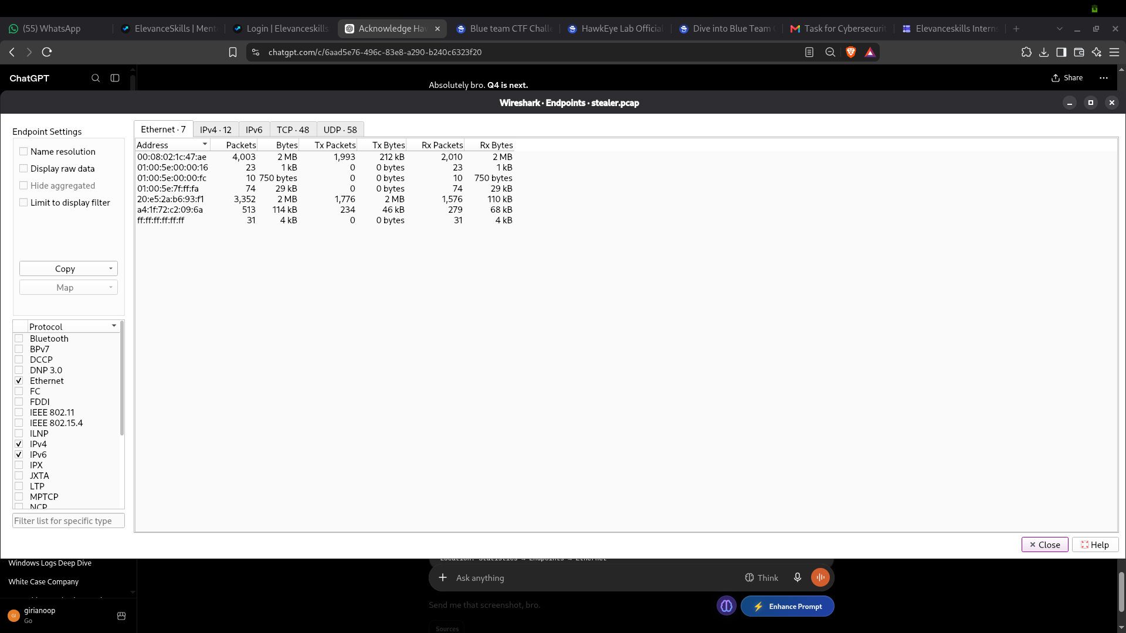
Figure 2. Ethernet endpoint statistics highlighting the most active MAC address.
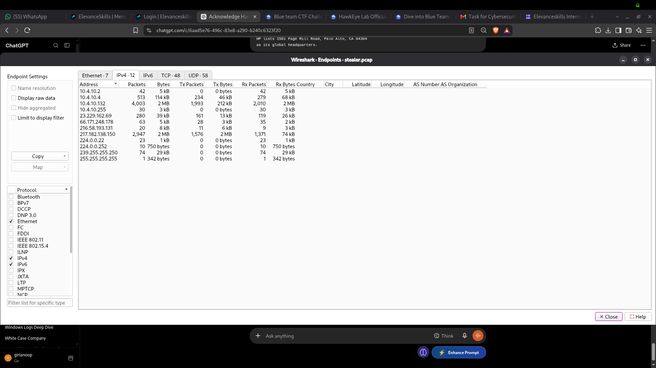
Figure 3. IPv4 endpoint statistics showing the victim and principal external addresses.
The DHCP Inform in frame 3263 is recorded in the notes as identifying the hostname Beijing-5cd1-PC for 10.4.10.132. The HTTP User-Agent in frame 210 contains Windows NT 6.1 and WOW64, which is consistent with a 64-bit Windows 7 environment. These host details are sourced from the investigation notes; the supplied endpoint screenshots do not themselves show the DHCP or User-Agent fields.

4. Attack-Chain Reconstruction
The following sequence is the strongest evidence-supported reconstruction. It is presented as a lab attack-chain hypothesis based on network observations, not as proof of every endpoint action.
Stage | Observed evidence | Red Team interpretation | Confidence
1. Name resolution | Frame 204 query for proforma-invoices.com; frame 206 answer 217.182.138.150 (notes) | The victim resolved the host later used for the executable download. | Directly recorded in notes
2. Executable transfer | Frame 210 GET /proforma/tkraw_Protected99.exe; frame 3155 HTTP 200 response | A Windows executable was transferred to the victim over HTTP. | Directly observed
3. External IP check | Frame 3164 onward: repeated GET / requests to 66.171.248.178; response value 173.66.146.112 recorded in notes | The host repeatedly queried a public-IP lookup service. | Directly observed / response body in notes
4. SMTP authentication | TCP connection to 23.229.162.69:587; AUTH LOGIN; server response 235 Authentication succeeded | The client authenticated to an external SMTP service. | Directly observed
5. Message submission | MAIL FROM and RCPT TO use sales.del@macwinlogistics.in; message body is Base64-encoded | A report-like message was submitted; investigation notes report a credential-log section. | Submission directly observed; content summary from notes
6. Repetition | Public-IP lookups and SMTP sessions recur at approximately ten-minute intervals | A recurring timer or scheduled behaviour is plausible, but the mechanism is not proven. | Pattern observed; cause inferred

5. DNS Resolution and HTTP Executable Delivery
The investigation notes record DNS query frame 204 for the A record of proforma-invoices.com and answer frame 206 resolving the name to 217.182.138.150, with 10.4.10.4 acting as the internal DNS server. The corresponding supplied screenshot is a packet-list view filtered to HTTP, not DNS, so it is not used as visual proof of frames 204/206.
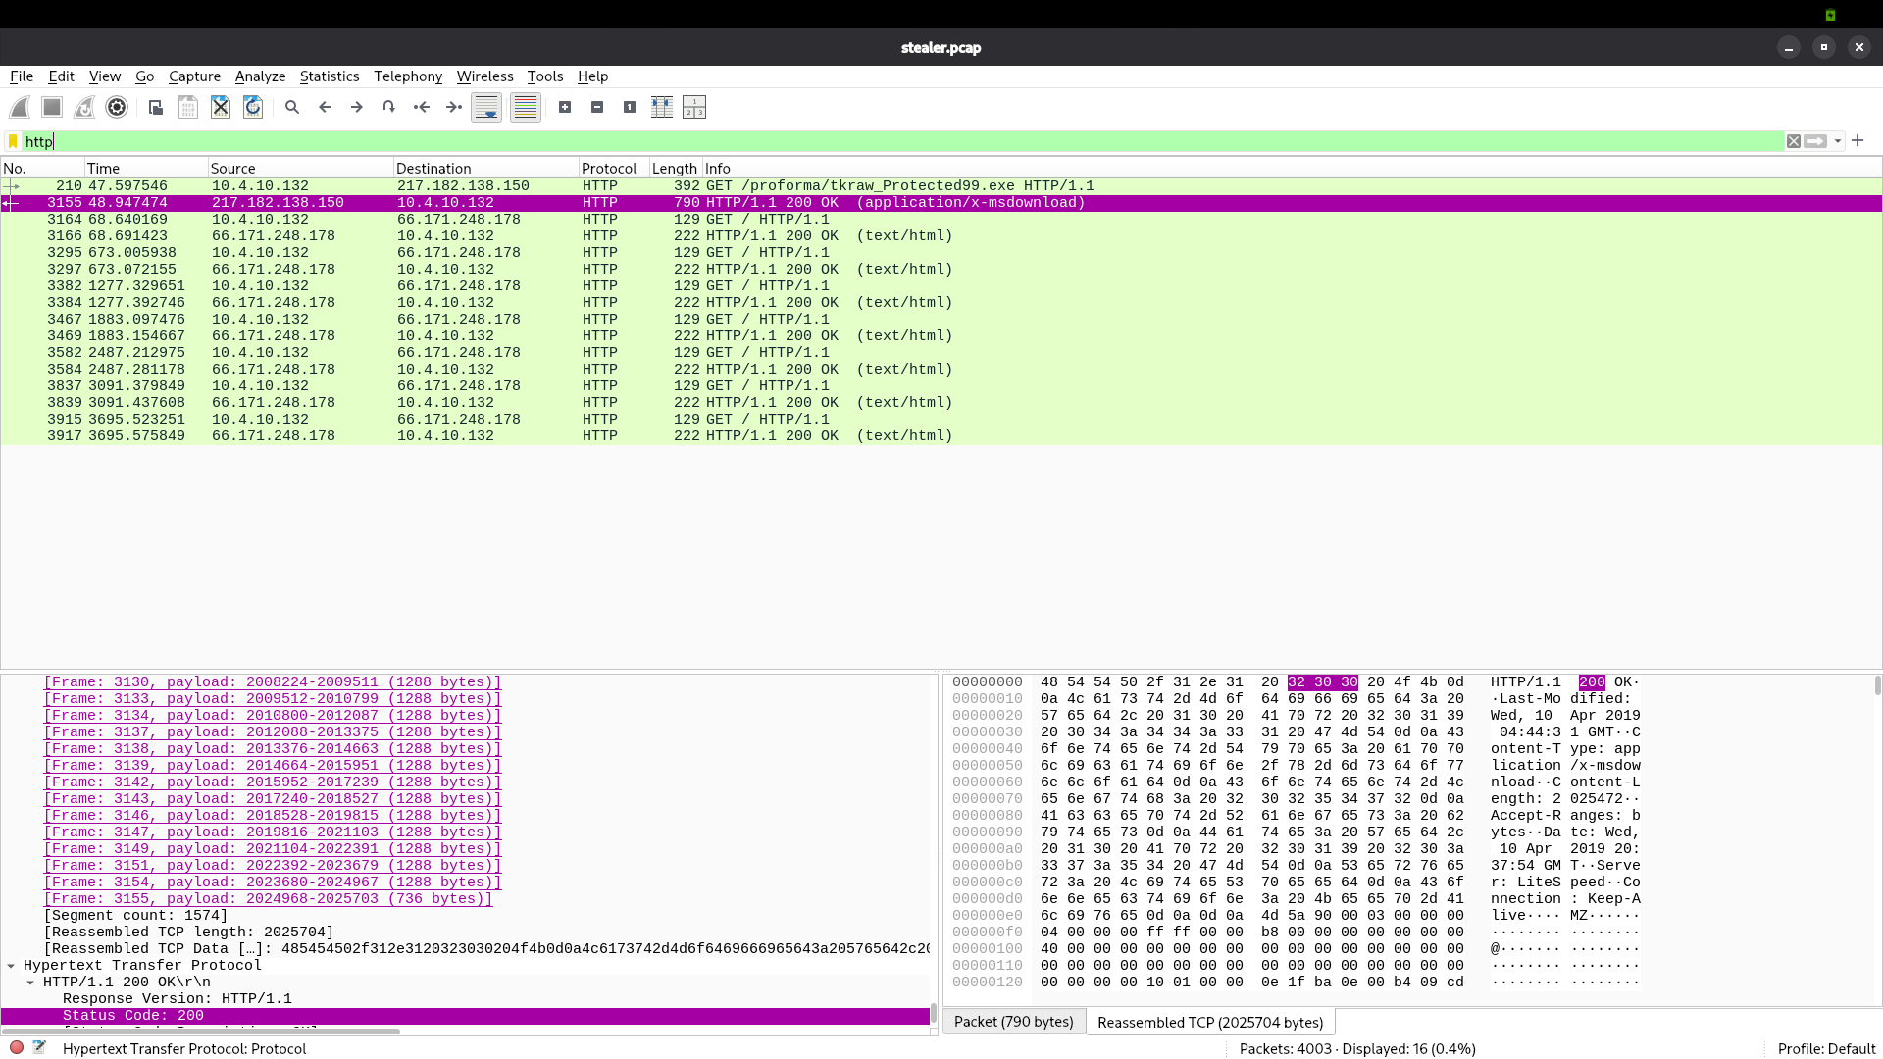
Figure 4. HTTP-filtered packet list showing the executable request/response and repeated public-IP lookup requests; this is not DNS-query evidence.
Frame 210 shows a GET request from 10.4.10.132 to 217.182.138.150 for /proforma/tkraw_Protected99.exe. Frame 3155 is recorded as the HTTP 200 OK response with content type application/x-msdownload. The investigation notes identify LiteSpeed in the Server header. The transfer is plain HTTP, so the request and response content were visible in the capture.
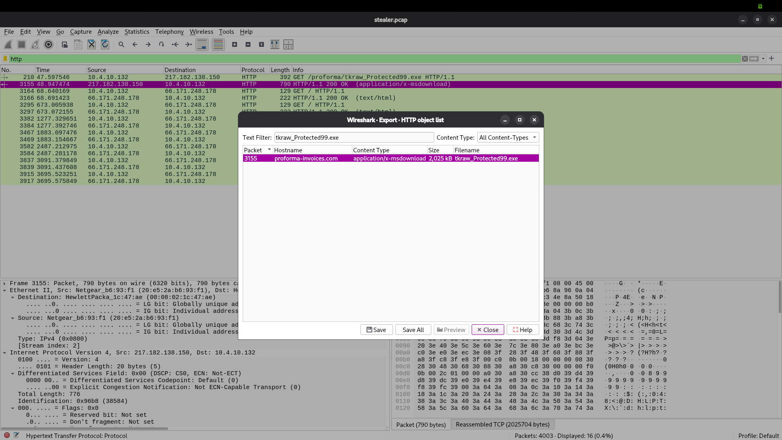
Figure 5. Wireshark Export Objects → HTTP lists tkraw_Protected99.exe, associated with proforma-invoices.com and packet 3155.
The filename and content type are consistent with a Windows executable, but filename and content type alone do not establish the program’s behaviour. The capture demonstrates a transfer; it does not show the user’s preceding activity, the original delivery vector, or execution of the file.

6. Extracted Executable and Hosting Infrastructure
Property | Recorded value | Interpretation / caveat
Filename | tkraw_Protected99.exe | Name shown in the HTTP object list
Approximate size | 2,025 kB | Size displayed in Wireshark Export Objects
Content type | application/x-msdownload | HTTP response metadata
MD5 | 71826ba081e303866ce2a2534491a2f7 | Hash calculated with md5sum after extraction
Download IP | 217.182.138.150 | Destination in HTTP request/response
Domain | proforma-invoices.com | DNS name recorded in notes and HTTP object list
Web server | LiteSpeed | Server header recorded in notes
Geolocation context | Roubaix, Hauts-de-France, France; OVH SAS | Public geolocation lookup; approximate only

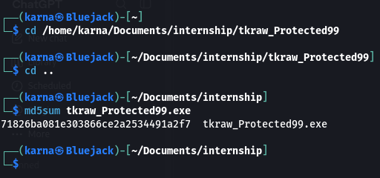
Figure 6. Kali Linux md5sum output for the extracted tkraw_Protected99.exe.
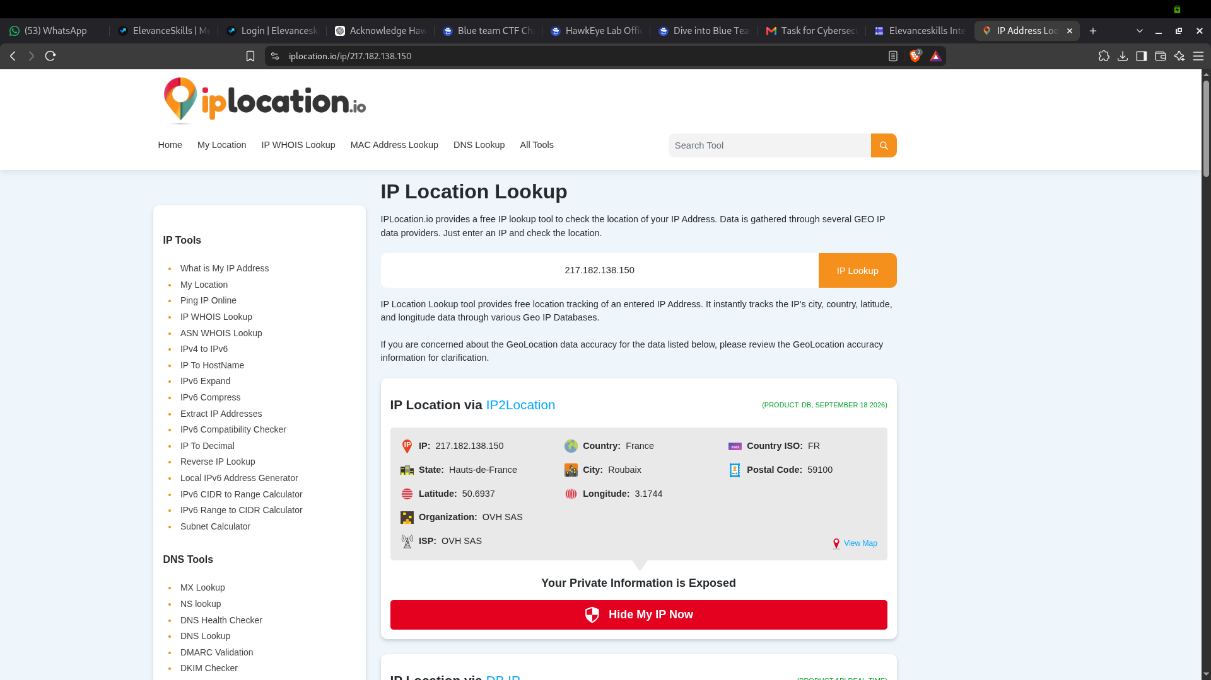
Figure 7. Public geolocation result for 217.182.138.150; location is approximate and is not attribution.
The malware label “HawkEye Keylogger – Reborn v9” is based on the decoded SMTP message content described in the investigation notes. The executable was not independently reverse engineered or sandboxed for this report. Therefore, the relationship between the downloaded file and the reported malware label is supported by the sequence and message content, but is not independently confirmed by binary analysis.

7. Post-Download Network Behaviour and Public-IP Lookups
The investigation notes identify frame 3164 as an HTTP GET / request to 66.171.248.178, associated with bot.whatismyipaddress.com, and frame 3166 as the 200 OK response. The returned public IP is recorded as 173.66.146.112. Similar requests recur in the capture at frames 3295, 3382, 3467, 3582, 3837 and 3915. The recorded intervals are approximately 604 seconds.
The SMTP server greeting also includes 173.66.146.112 alongside the client hostname. This is consistent with the public-IP lookup result, but does not by itself establish why the host checked its public address.
From a Red Team reconstruction perspective, recurring IP checks followed by recurring SMTP submissions are consistent with periodic reporting behaviour. The packet capture does not reveal the internal timer, process, or mechanism responsible.
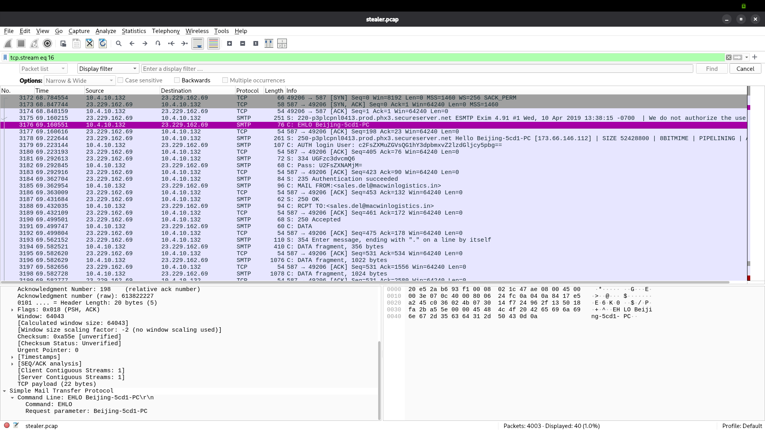
Figure 8. SMTP-filtered packet list showing repeated authenticated SMTP sessions and message-transfer activity.

8. Credential-Theft Indicators and SMTP Submission
The SMTP connection is from 10.4.10.132 to 23.229.162.69 on TCP port 587. The server banner identifies p3plcpnl0413.prod.phx3.secureserver.net and Exim 4.91. The session includes EHLO Beijing-5cd1-PC, AUTH LOGIN, a 334 challenge, and a 235 Authentication succeeded response. The server offered STARTTLS, but the observed client exchange proceeded without initiating TLS; consequently, authentication and message data are readable in this captured conversation.
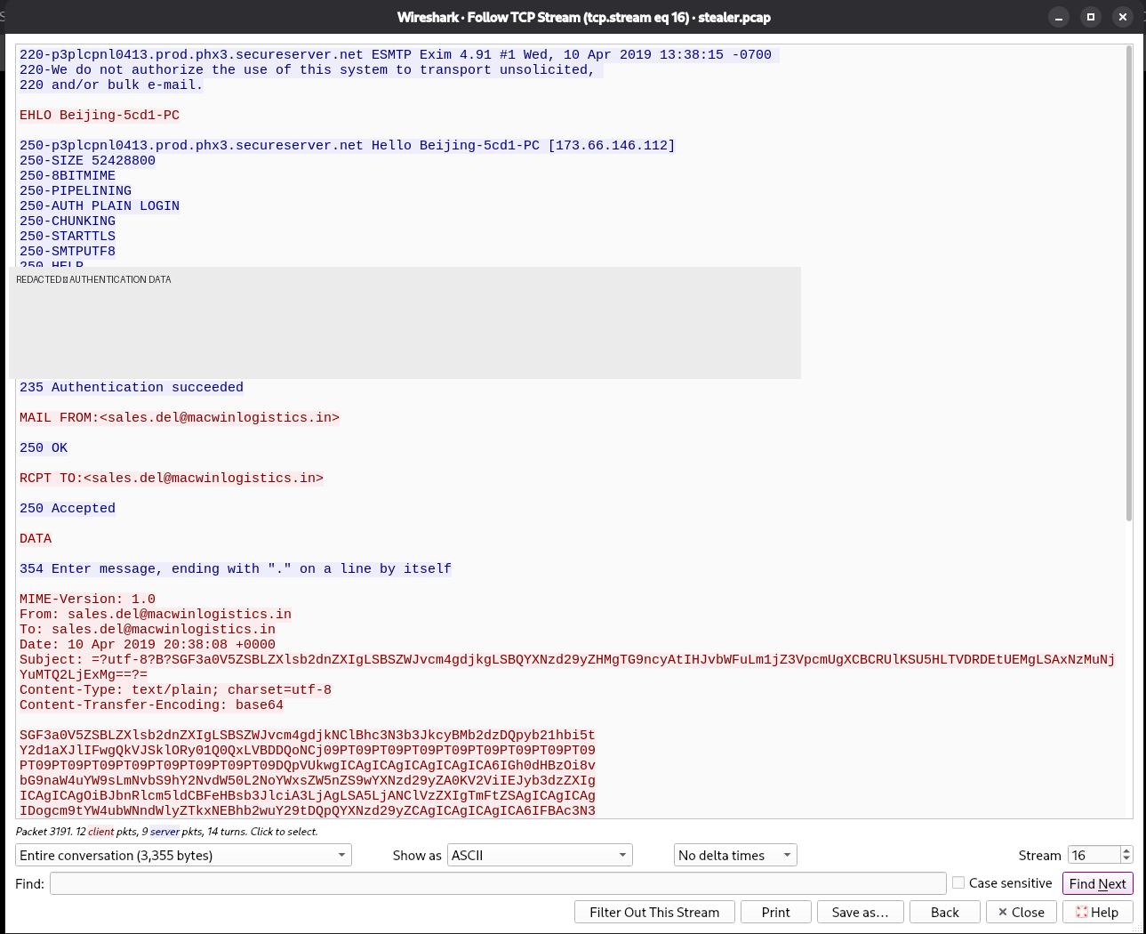
Figure 9. SMTP Follow TCP Stream showing the server banner and message flow. Authentication values are redacted.
The SMTP commands show MAIL FROM and RCPT TO using sales.del@macwinlogistics.in, followed by DATA. The server accepts the recipient with 250 Accepted and acknowledges message submission. The packet-level acceptance establishes that the SMTP server accepted the recipient and message content at the protocol level; it does not prove final mailbox delivery or that a human read it.
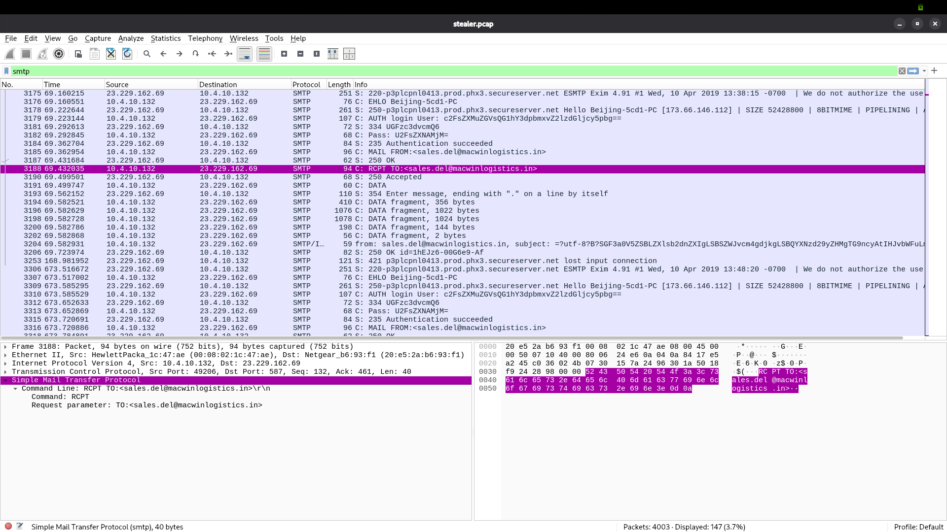
Figure 10. SMTP RCPT TO command and server response 250 Accepted. Authentication values are not reproduced.
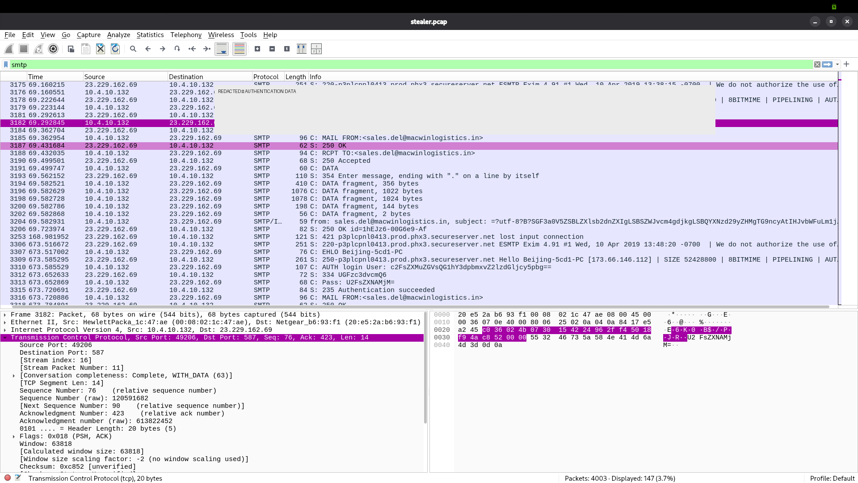
Figure 11. SMTP authentication sequence with authentication-value region redacted.
The investigation notes state that the Base64-encoded message body was decoded during analysis and identified “HawkEye Keylogger – Reborn v9” followed by a “Passwords Logs” section. The notes record a credential-log entry associated with roman.mcguire and BEIJING-5CD1-PC. Passwords and decoded authentication secrets are intentionally omitted. This content is a reported finding from the investigation notes; the supplied screenshots show the SMTP exchange but do not independently display the decoded message body.
The capture shows recurring SMTP sessions at approximately ten-minute intervals. The first server banner is timestamped 13:38:15 -0700 and a subsequent session banner is timestamped 13:48:20 -0700, which is consistent with the recurring cadence. Repetition supports a periodic-behaviour hypothesis, not proof of a specific malware timer.

9. Evidence-Backed MITRE ATT&CK Mapping
The mapping below is deliberately conservative. Techniques are included only where the observed network activity supports a meaningful association. A technique name or malware label in a message is not treated as proof that the underlying behaviour occurred.
Technique / ID | Relationship to evidence | Assessment
Ingress Tool Transfer — T1105 | Executable transferred over HTTP to the victim host (frames 210 and 3155). | Supported as a network transfer; the file’s execution is unconfirmed.
Exfiltration Over Web Service / Exfiltration Over Unencrypted/Obfuscated Non-C2 Protocol — candidate mapping only | SMTP message submission carries a Base64-encoded report-like body. Exact technique selection depends on how the exercise classifies the email service and payload. | Potential mapping; avoid claiming a definitive sub-technique without validating ATT&CK applicability.
Application Layer Protocol: SMTP — T1071.003 | SMTP used for message submission to an external server. | Protocol use is observed; malicious intent is inferred from context.
Unsecured Credentials: Credentials In Files / Credentials from Password Stores — not confirmed | Decoded message reportedly contains a password-log section. | Do not assign a credential-access technique from the PCAP alone; acquisition method is unknown.

Not mapped: phishing, user execution, persistence, privilege escalation, lateral movement, command-and-control, and keylogging. The capture does not directly establish these activities. The malware name suggests a keylogger family, but no keystroke capture or endpoint execution trace is available.

10. Indicators of Compromise
Type | Indicator | Context / handling note
Internal host | 10.4.10.132 | Victim host in the capture; hostname Beijing-5cd1-PC
Hostname | Beijing-5cd1-PC | Recorded in DHCP notes and SMTP EHLO
Domain | proforma-invoices.com | DNS query and HTTP object host
URL path | /proforma/tkraw_Protected99.exe | HTTP GET at frame 210
File | tkraw_Protected99.exe | HTTP object listed at packet 3155
MD5 | 71826ba081e303866ce2a2534491a2f7 | Hash of extracted object
Download IP | 217.182.138.150 | HTTP server; geolocation is approximate
Public-IP lookup endpoint | 66.171.248.178 | Repeated HTTP GET / requests; associated in notes with bot.whatismyipaddress.com
Returned public IP | 173.66.146.112 | Value recorded from lookup response and shown in SMTP greeting
SMTP server | 23.229.162.69:587 | Exim 4.91; recurring authenticated SMTP sessions
Mailbox identifier | sales.del@macwinlogistics.in | Observed in MAIL FROM and RCPT TO; treat as sensitive operational data

Handling note: defang domains, URLs and IP addresses before sharing the report publicly. The SMTP mailbox may be a lab indicator or a third-party account; do not assume ownership or attribution from the capture.

11. Attack-Chain Gaps and Limitations
- Initial delivery vector is unknown. The capture does not show an email, attachment, browser history, or user action that led to the URL.
- Execution is not proven. The file was downloaded, but there is no process-creation or endpoint telemetry showing it ran.
- Persistence, privilege escalation, lateral movement, and command-and-control are not demonstrated in this PCAP.
- Endpoint forensics, memory analysis, and reverse engineering were outside scope. The file’s behaviour and family identity were not independently validated through binary analysis.
- The reported credential-log content is based on the decoded message described in the investigation notes. Passwords and authentication values are excluded from this report.
- IP geolocation provides approximate network-location context only and does not establish an attacker’s physical location or identity.
- The repeated ten-minute cadence is an observed timing pattern; the mechanism and purpose behind it remain an inference.
- Several facts—DNS frames 204/206, DHCP frame 3263, User-Agent details, LiteSpeed header, lookup response body, and decoded message content—are recorded in the investigation notes without a dedicated supplied screenshot.

12. Red Team Assessment Conclusion
The evidence supports a concise network-level chain: 10.4.10.132 resolved proforma-invoices.com, requested tkraw_Protected99.exe from 217.182.138.150 over HTTP, repeatedly queried a public-IP lookup service, and submitted recurring authenticated SMTP messages to 23.229.162.69. The message used sales.del@macwinlogistics.in as both sender and recipient. The investigation notes report that the decoded body identified HawkEye Keylogger – Reborn v9 and contained a password-log section.
The strongest directly supported findings are the executable transfer, the extracted file hash, the repeated external lookup traffic, and the authenticated SMTP message-submission sequence. The interpretation that the file executed and produced the later traffic is plausible but remains an inference. Confirming that relationship would require endpoint telemetry, file analysis or sandboxing, none of which was part of this capture-only assessment.
From the Red Team perspective, the lab illustrates how an executable transfer over HTTP, repeated external lookups, and cleartext SMTP authentication/message submission can leave a connected sequence of network indicators. The reconstruction intentionally stops where the evidence stops.

13. Evidence and Figure References
Figure | Image / source | Finding supported
1 | 01_capture_properties.png | Packet count, elapsed duration, timestamps
2 | 02_ethernet_endpoints.png | Most active Ethernet MAC and packet counts
3 | 04_ipv4_endpoints.png | Victim and external IPv4 endpoint statistics
4 | 06_dns_query_204.png | HTTP packet list: executable request/response and public-IP lookup requests; not DNS evidence
5 | 09_HTTP_Export_Object_tkraw_Protected99.png | HTTP object name, host, content type, size and packet
6 | 10_Malware_File_MD5_Hash.png | Extracted executable MD5
7 | 07_Malware_Server_IP_Geolocation.png | Approximate geolocation for download IP
8 | 05_SMTP_Exfiltration_Traffic.png | Repeated SMTP traffic
9 | 11_SMTP_Follow_TCP_Stream_REDACTED.png | SMTP banner, authentication sequence and message flow; secrets redacted
10 | 12_SMTP_RCPT_TO_Evidence.png | Recipient command and 250 Accepted response
11 | 13_SMTP_Authentication_Evidence_REDACTED.png | Authentication sequence with values redacted

Source of factual findings: HawkEye_Lab_Investigation_Report.docx and the screenshots listed above. Where the source notes a finding without a dedicated screenshot, this report labels it as recorded in the investigation notes rather than implying that the image independently proves it.
End of report.

