TASK 2

Custom SIEM Correlation Rules
and Detection Testing
ElevanceSkills Cybersecurity Internship
Prepared by: Giri Anoop
Environment: Kali Linux, Elasticsearch 9.5.4 and Kibana 9.5.4
Date: 9 October 2026
Project scope
Implement and test custom correlation checks for credential stuffing, DNS tunnelling-like activity, and suspicious PowerShell execution, with alert records stored in Elasticsearch and reviewed through Kibana.

1. Introduction
The purpose of this task was to build and test custom SIEM detection logic for three security-relevant behaviours: repeated authentication failures across multiple accounts, unusual DNS query patterns, and suspicious PowerShell command indicators. The work reused the existing Elasticsearch and Kibana environment instead of creating a new stack.
Elasticsearch was used to store the test events and generated alert documents. Kibana Discover was used to inspect the alert records. A Python script evaluated the events against the defined conditions and wrote any triggered results to the task2-alerts index.

2. Objectives
- Reuse the existing ELK environment and avoid rebuilding the stack.
- Define practical detection conditions for the three required techniques.
- Generate controlled test telemetry and check whether each condition is met.
- Store the results as searchable alert documents in Elasticsearch.
- Review the alerts in Kibana and capture evidence for the report.

3. Environment and Implementation
The lab ran on Kali Linux with Docker-hosted Elasticsearch 9.5.4 and Kibana 9.5.4. Elasticsearch was reachable through its local HTTP API on port 9200, and Kibana's status endpoint reported that the service was available on port 5601.
Three dedicated Elasticsearch indices were used: task2-auth-events for authentication test events, task2-security-events for DNS and PowerShell test telemetry, and task2-alerts for the results produced by the correlation script. The task2-* data view in Kibana made the alert records available in Discover.
The implementation was a Python-based rule runner that queries recent events, evaluates the conditions described below, and stores alert documents in Elasticsearch. Kibana was used for visualisation and review. These are custom script-evaluated correlation checks; recurring, scheduled native Kibana Security detection rules were not configured as part of this work.

4. Correlation Rules

4.1 Credential Stuffing
Detection logic: group recent authentication-failure events by source IP. Trigger an alert when one IP has at least 8 failed attempts involving at least 5 distinct usernames within a five-minute window.
Test result: the controlled dataset contained 10 failed authentication events from 198.51.100.23 across 5 distinct usernames. The rule generated a high-severity alert.

4.2 DNS Tunnelling Suspicion
Detection logic: group recent DNS query events by source IP. Trigger a medium-severity alert when at least 10 DNS queries and at least 8 distinct queried names are observed within five minutes.
Test result: the controlled dataset contained 15 DNS queries from 192.0.2.45 across 15 distinct DNS names. The rule generated an alert. This pattern is treated as suspicious DNS activity, not proof that a DNS tunnel or data exfiltration actually occurred.

4.3 Suspicious PowerShell Execution
Detection logic: inspect PowerShell process command-line telemetry for indicators such as -EncodedCommand, DownloadString, Invoke-Expression, IEX, and FromBase64String. The test rule generates a high-severity alert when at least one matching event is found.
Test result: three simulated PowerShell events matched the configured indicators. The rule generated a high-severity alert. These indicators can occur in malicious activity, but they can also appear in legitimate administrative or testing activity and therefore need context.

5. Test Method and Results
Controlled synthetic events were inserted into the task-specific Elasticsearch indices. The rule runner evaluated the recent events, stored the resulting alerts in task2-alerts, and the stored documents were queried through the Elasticsearch API. Kibana Discover then displayed all three alert documents together.
Detection | Test observations | Threshold | Severity | Result
Credential stuffing | 10 failures; 5 usernames | ≥8 failures and ≥5 usernames / 5 min | High | Triggered
DNS tunnelling suspicion | 15 queries; 15 distinct names | ≥10 queries and ≥8 names / 5 min | Medium | Triggered
Suspicious PowerShell | 3 matching events | ≥1 matching command indicator | High | Triggered
The final Elasticsearch search returned three alert documents, one for each rule. The results were also visible in Kibana Discover using the query event_type: "correlation_alert".

6. Evidence
The screenshots below document the visible results and test outputs collected during the lab. They show the alert records and the individual rule-evaluation output.
Figure 1. All three correlation alerts in Kibana Discover.
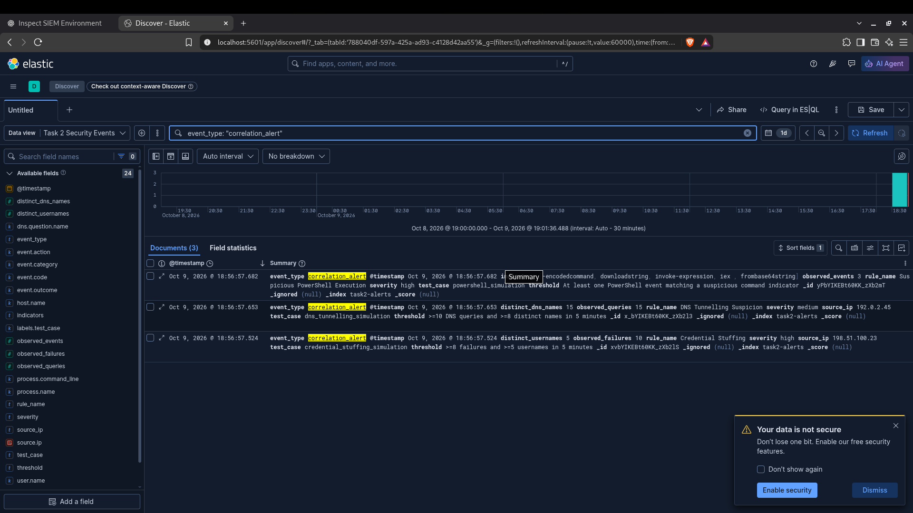

Figure 2. Combined test output showing all three rules and observed values.
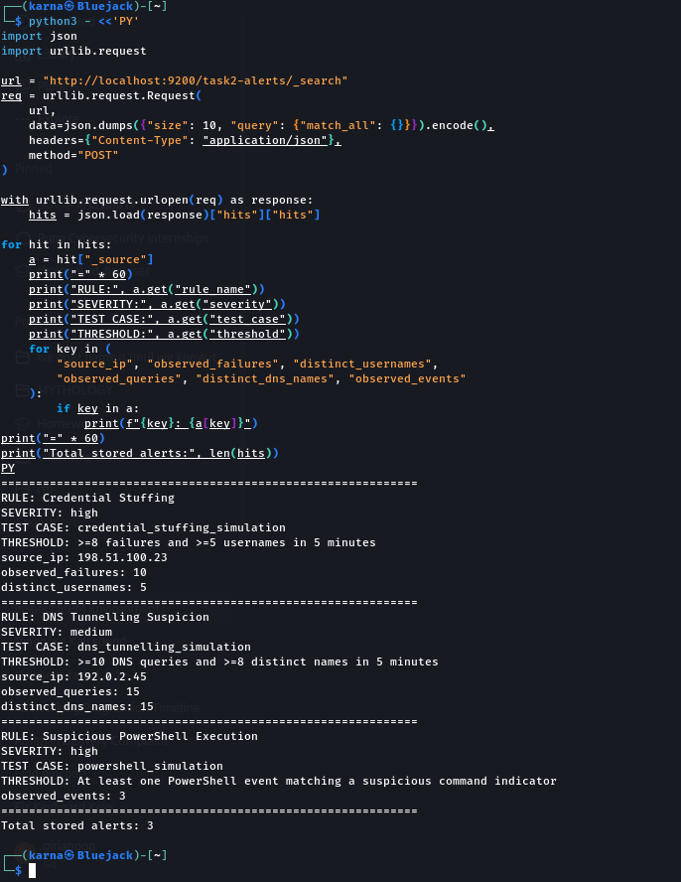

Figure 3. Credential-stuffing detection output.
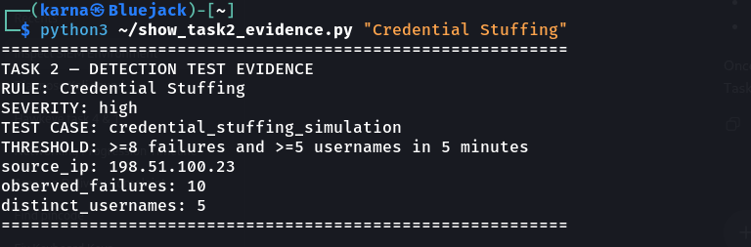

Figure 4. DNS tunnelling-suspicion detection output.
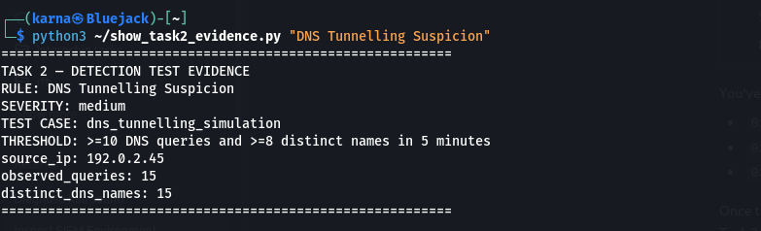

Figure 5. Suspicious PowerShell detection output.
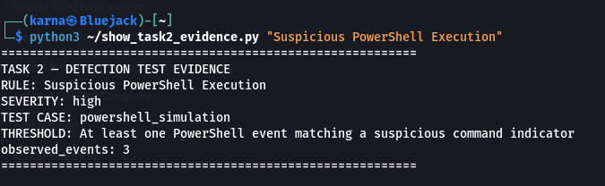

7. Limitations
- The test events were simulated and were not collected from a live attack or a production endpoint.
- The DNS condition identifies query volume and name diversity; it does not inspect payload content or confirm tunnelling.
- The PowerShell condition is indicator-based and can produce false positives; it does not prove successful exploitation.
- The correlation logic was run manually using a Python script. No recurring schedule or native Kibana Security detection rule was configured.
- The lab uses a local, security-disabled Elasticsearch endpoint; it is intended for controlled local testing, not production deployment.

8. Improvements and Next Steps
- Connect real authentication, DNS, and Windows PowerShell telemetry through an appropriate ingestion pipeline.
- Validate the rules against benign activity and more varied test cases to tune thresholds and reduce false positives.
- Configure scheduled detection using an appropriate SIEM rule engine if automatic recurring detection is required.
- Add alert context, timestamps, host identifiers, and response guidance to support investigation.
- Enable authentication, TLS, and appropriate access controls before exposing any SIEM services beyond the local lab.

9. Conclusion
The task produced and verified three custom correlation checks using the existing Elasticsearch and Kibana lab. The controlled tests triggered alerts for credential stuffing, DNS tunnelling-like activity, and suspicious PowerShell execution. All three alert documents were confirmed in Elasticsearch and displayed in Kibana Discover. The results demonstrate the rule logic on the test data; additional work would be needed to validate detection against live telemetry and to configure scheduled, automated execution.

