ELEVANCESKILLS
CYBERSECURITY INTERNSHIP
TASK 3
Simulating and Responding to a Multi-Stage APT Attack Using Open-Source SOC Tools
Technical Implementation, Detection Validation and Evidence Report
Report date: 14 October 2026
SIEM: Elasticsearch and Kibana
Environment: Microsoft Azure Ubuntu VM and Kali Linux
Additional evidence: E18 — Process Discovery Detection Verification
Final consolidated package: Pending generation and verification

1. Executive Summary
This project involved implementing and evaluating an open-source Security Information and Event Management (SIEM) workflow for investigating a multi-stage Advanced Persistent Threat (APT) scenario. Work included infrastructure validation, authentication-log collection, controlled telemetry generation, detection-rule development, query validation, event correlation, investigation documentation, incident-response procedures, Kibana dashboard development, and evidence preservation.
The original evidence package contains E01–E14 records, including infrastructure and SIEM health checks, authentication-log collection artifacts, six explicitly synthetic APT events, detection queries and tests, a correlation timeline, investigation and response documentation, dashboard evidence, and final validation records.
Additional work on 14 October 2026 evaluated process-discovery detection on the Azure Ubuntu VM. The benign command `sudo /usr/bin/ps -eo pid,ppid,user,comm --sort=pid` was executed, its sudo invocation was found in authentication logs, and the corresponding record was located in Elasticsearch. A Python query evaluation matched the process-discovery event and excluded tested `grep` and `ls` controls.
Query-based detection was validated within the tested scope. This does not establish a real compromise, and a live Kibana alert was not verified. The original ZIP was transferred to Kali Linux and its SHA-256 checksum and ZIP integrity were verified. The consolidated archive and updated evidence index remain pending.

2. Objectives
- Validate an open-source SIEM environment.
- Collect and search authentication-log telemetry.
- Represent an APT scenario using explicitly labelled synthetic events.
- Develop and test query-based detection logic.
- Correlate events and document investigation findings.
- Document response procedures and distinguish performed actions from proposed actions.
- Create a Kibana dashboard and validate evidence integrity.
- Add controlled process-discovery detection using genuine host telemetry.
- Consolidate evidence into a verifiable submission package.

3. Scope and Methodology
The methodology consisted of infrastructure checks, log collection, event indexing, query execution, positive and negative test evaluation, investigation documentation, dashboard validation, and evidence preservation.
Synthetic scenario data represents selected APT stages for controlled testing and does not prove that the represented attacks occurred. Genuine controlled host activity refers to the process-discovery command executed on the Azure VM and its sudo authentication-log record. This demonstrates an administrative command invocation, not malicious activity.
Query matches, detection candidates, and scripted validation results are not equivalent to confirmed incidents or automatically generated security alerts.

4. Lab Environment and SIEM Architecture
The lab used an Ubuntu 24.04 Azure VM, Docker, Elasticsearch 9.5.4, and Kibana 9.5.4. Kali Linux was used for local evidence handling and transfer verification. The `task3-auth-logs` index held authentication-log records, including the process-discovery sudo invocation. The `task3-apt-simulation` index held synthetic APT scenario data.
The original validation report recorded Elasticsearch HTTP 200 with green cluster status and one node, and Kibana HTTP 200 availability. The original Compose configuration disabled Elasticsearch and Kibana security, which is a lab limitation rather than a production-ready configuration.

5. Evidence E01–E04: Infrastructure, SIEM Health and Telemetry

E01 — Infrastructure Information
OS release, kernel, Docker container information, host environment and timestamps. Evidence: `evidence/01-infrastructure/`.

E02 — SIEM Health
Elasticsearch cluster health, index summary and replica settings. Evidence: `evidence/01-infrastructure/`.

E03 — Log Collector
Python authentication-log ingestion script and syntax-validation output. Evidence: `evidence/02-log-collection/`.

E04 — Authentication Telemetry
SSH authentication-log samples and controlled-test records. Evidence: `evidence/03-telemetry/`.

6. Evidence E05–E06: Synthetic APT Events and Initial Queries

E05 — Synthetic APT Scenario
Stage | Recorded ATT&CK mapping | Purpose
Initial access | T1078 | Represent valid-account access
Persistence | T1136 | Represent account creation
Privilege escalation | T1068 | Represent privilege escalation
Discovery | T1082 | Represent system information discovery
Lateral movement | T1021 | Represent remote-service movement
Exfiltration | T1041 | Represent attempted data transfer

These six events are synthetic test records. The simulated account-change event states no real privileges changed; the simulated data-transfer event does not represent an actual transfer. Evidence: `evidence/03-telemetry/synthetic-events.json`.

E06 — Invalid SSH Username Query
Elasticsearch query and output used to examine invalid SSH usernames. Evidence: `evidence/04-detection/invalid-ssh-user-query.json`.

7. Evidence E07–E08: Detection Rules and Test Validation

E07 — Detection Rules
Detection-rule definitions, query definitions and recorded outputs. Evidence: `evidence/07-detection/20261012T074102861963Z/`.

E08 — Positive and Negative Tests
- lab_user failed-login sequence followed by successful login.
- Negative sequence involving test_analyst.
- Simulated account-change indicator.
- Simulated data-transfer indicator.
The original test report recorded all four tests as passing. These results validate the tested cases, not a real APT campaign. Evidence: `evidence/08-detection-tests/20261012T074102861963Z/`.
The first terminal screenshot shows `verify_detection.py` reporting FOUND (2 records) for all six stages. The second shows eight high/critical detection-result entries from `run_detection_query.py`. These are script outputs for synthetic indicators, not proof of real attacks.
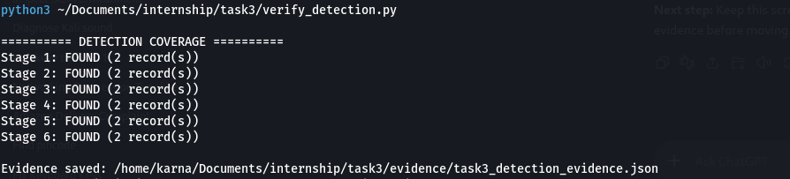
Figure 1. Detection coverage script output showing all six stages reported as FOUND (2 records each).
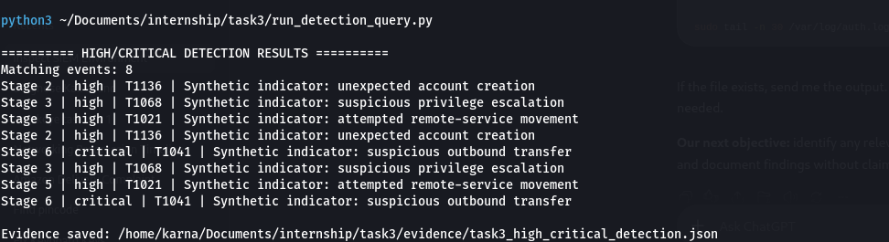
Figure 2. Query-driven high/critical detection output for synthetic APT indicators; these results do not prove real attacks.

8. Evidence E09–E11: Correlation, Investigation and Response

E09 — Correlation Timeline
Correlation timeline and text representation of synthetic APT events. Evidence: `evidence/09-correlation-timeline/20261012T074102861963Z/`.

E10 — Investigation Record
Structured investigation record and Markdown summary. Evidence: `evidence/10-investigation/20261012T074102861963Z/`.

E11 — Response Procedures
Response procedures and action-verification record. The original report states account disabling, IP blocking and host isolation were not performed. Evidence: `evidence/11-response/20261012T074102861963Z/`.

9. Evidence E12–E14: Dashboard, Validation and Original Submission

E12 — Kibana Dashboard
The dashboard “Task 3 — APT and Authentication Investigation” displays a six-document synthetic timeline, one account-change indicator, and one data-transfer indicator. The account-change message states no real privileges changed.
The original archive also contains dashboard/saved-search results and data-view API results. Evidence: `evidence/12-kibana-dashboard/20261012T074102861963Z/`.

E13 — End-to-End Validation
The original recheck recorded successful Elasticsearch health, Kibana availability, valid JSON for checked artifacts, and successful checks of six synthetic APT records. Earlier validation failures remain historical evidence. Location: `evidence/13-validation/20261012T074102861963Z/`.

E14 — Original Final Submission
The original archive contains a report, evidence index and package records; it has 42 entries and passed the ZIP integrity test.
Original archive: `task3-e07-e14-submission-20261012T074102861963Z.zip`
Original SHA-256: `62b2a5361d79e5a33cd9d60075fcdf7e8763595ef1aad092b7e06f7d919e8021`. This checksum applies only to the original archive.
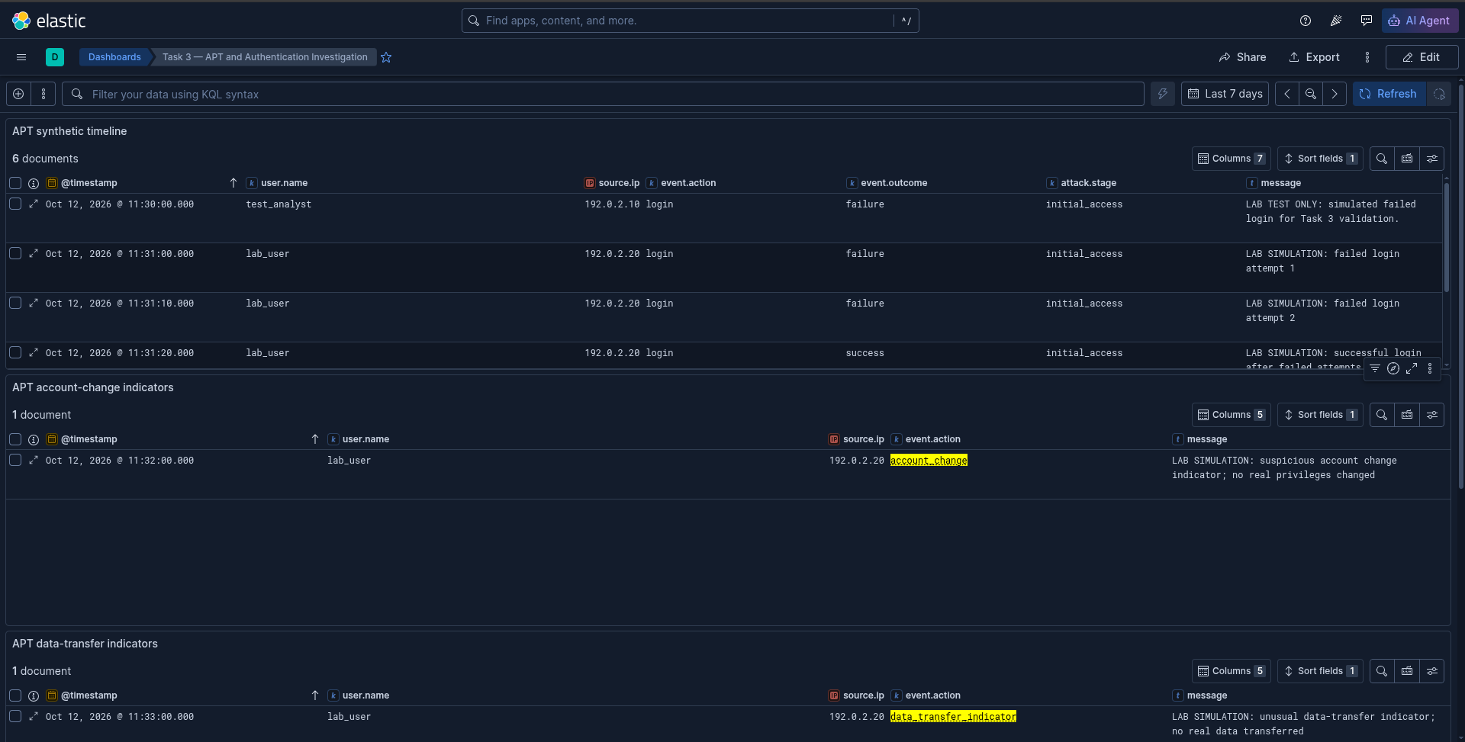
Figure 3. Kibana dashboard showing the synthetic APT timeline, account-change indicator, and data-transfer indicator.

10. Evidence E15–E17: Inventory Reconciliation Required
The original evidence index explicitly identifies E01–E14. The available inventory does not establish the exact identities, filenames, results or completion statuses of E15–E17. These identifiers must be reconciled against local evidence before the final index is published. No unsupported descriptions are assigned.

11. Evidence E18 — Process Discovery Detection Verification

11.1 Objective and Activity
Objective: evaluate whether a benign process-discovery command on the Azure Ubuntu VM could be found in authentication-log telemetry and identified by query-driven evaluation.
- Host: AegisGovern-VM
- Technique: MITRE ATT&CK T1057 — Process Discovery
- Command: sudo /usr/bin/ps -eo pid,ppid,user,comm --sort=pid
- Recorded time: 2026-10-14T13:42:10.504331Z

11.2 Evidence Collection
The command completed successfully. Its sudo invocation was found in `/var/log/auth.log`; ingestion reported zero indexing errors. Elasticsearch document counts were 163 before ingestion and 475 afterward; these are index counts, not process-discovery event counts. The event was located in `task3-auth-logs`.

11.3 Detection Rule and Results
Python evaluation rule: `T1057-SUDO-PROC-001`. It returned 54 source records, matched the known `ps` event, and excluded the tested `grep` and `ls` controls.
Verification | Recorded result
Known ps event matched | Yes
grep control present | Yes
ls control present | Yes
grep false positive | No
ls false positive | No
Query validation | PASS
Live Kibana alert verified | No

11.4 Principal Evidence Files
- 00-index-count-before.json; 01-process-discovery-output.txt; 02-matching-auth-records.txt; 03-ingestion-result.txt; 04-index-count-after.json.
- 04-process-event-query.json; 05-process-event-search.json; 06-t1057-candidate-rule.json; 07-t1057-detection-query.json.
- 08-negative-control-baseline-query.json; 09-negative-control-detection-query.json; 10-t1057-detection-result.json; 11-negative-control-baseline-result.json; 12-negative-control-detection-result.json.
- 17-command-records-query.json; 18-command-records-response.json; 19-detection-validation.json; 31-t1057-python-detection-result.json.
- 20-elasticsearch-info.json; 21-elasticsearch-license.json; 22-detection-privileges-response.json; 23-existing-rules-response.json.
- 30-phase5-detection-summary.md; 31-phase5-evidence-sha256.txt.
The file `15-t1057-refined-result.json` is zero bytes and is not valid JSON. It must not be cited as proof; preserve it or transparently exclude it from the clean package and document the handling.

11.5 Limitations and Conclusion
The Python evaluation is not a continuously running detection engine. A live Kibana alert was not verified; the detection API returned HTTP 500 because the Encrypted Saved Objects plugin lacked a configured encryption key. Elasticsearch and Kibana security were also disabled in the existing Compose configuration. The test demonstrates benign process enumeration, not a compromise, and telemetry records sudo command invocations rather than every process.
Conclusion: query-based detection validated within the tested scope; negative-control validation passed for the tested grep and ls controls; live Kibana alert not verified.

12. Screenshot Register
Figure | Description | Interpretation
Figure 1 | Task3_Detection_Coverage.png | Six detection-coverage checks for synthetic indicators.
Figure 2 | Task3_High_Critical_Detection.png | High/critical query output for synthetic indicators; not proof of real attacks.
Figure 3 | Pasted image.png | Kibana dashboard showing synthetic timeline, account-change and data-transfer panels.

The original archive also contains a dashboard screenshot. Check whether it duplicates Figure 3 before adding another copy.

13. Evidence Integrity and Transfer Verification
The original ZIP transferred from Azure to Kali had SHA-256 `62b2a5361d79e5a33cd9d60075fcdf7e8763595ef1aad092b7e06f7d919e8021`, matching the expected checksum. The ZIP test reported “No errors detected in compressed data.” The Process Discovery directory was transferred with 27 files, including the empty refined-result JSON artifact.
These checks establish the original archive’s integrity and the presence of transferred files. They do not validate every JSON file or independently prove every claimed activity.

14. Overall Findings
- Original SIEM environment and dashboard were available during recorded validation.
- Detection workflow was tested against six synthetic APT-stage events and four recorded scenarios.
- Dashboard visualized synthetic timeline, account-change and data-transfer indicators.
- Investigation and response procedures were documented; actions not performed remain identified.
- Genuine controlled process-discovery command was recorded and located in Elasticsearch.
- Query-driven Python evaluation matched the process-discovery event and excluded tested negative controls.
- Live Kibana alert was not verified.
- Original ZIP integrity and SHA-256 were verified after transfer to Kali.
- Consolidated report, updated evidence index and final ZIP remain to be generated and verified.

15. Limitations and Recommendations

Limitations
- APT-stage events are synthetic and do not demonstrate an actual compromise.
- Telemetry is limited to configured authentication-log collection.
- Query-driven detection is not a continuously running engine.
- Live Kibana alert was not verified.
- Elasticsearch and Kibana security were disabled in the Compose configuration.
- One Process Discovery JSON artifact is empty.
- E15–E17 require source-inventory reconciliation.
- The consolidated package has not been generated.

Recommendations
- Reconcile E15–E17 against the original local evidence.
- Preserve original ZIP and source Process Discovery files unchanged.
- Validate JSON files individually and document the empty artifact.
- Include the three screenshots where their original image files are available.
- Create an updated evidence index with relative paths and clear descriptions.
- Generate a new ZIP and checksum only after evidence reconciliation.
- Configure and validate live alerting separately if required, after reviewing security and resource implications.

16. Final Submission Status
Deliverable | Status
Original E01–E14 archive | Transferred and integrity verified
Process Discovery E18 evidence | Transferred; 27 files inventoried
Detection screenshots | Supplied; final package inclusion pending
Kibana dashboard screenshot | Present in original archive and supplied screenshot
Comprehensive report | Document generated; final review pending
E15–E17 reconciliation | Pending
Updated evidence index | Pending
Consolidated final ZIP | Pending
Final ZIP integrity and SHA-256 | Pending

Final Conclusion
The available artifacts document an implemented SIEM lab, synthetic APT detection tests, investigation and response documentation, a Kibana dashboard, and an additional controlled process-discovery evaluation. The strongest verified additional result is that the process-discovery command was captured in authentication logs, found in Elasticsearch, and matched by the query-based Python evaluation while the tested negative controls were excluded.
The report distinguishes simulated APT indicators from genuine controlled host activity and query validation from a live alert. The original archive has passed integrity verification; the consolidated final submission remains pending local packaging and final validation.
Report status: prepared for final evidence reconciliation and packaging. Final submission status: not complete until the consolidated ZIP, updated evidence index and final integrity verification are generated.

