HawkEye Lab Investigation
Red Team | Blue Team | Purple Team
Name: Giri Anoop
Internship Cybersecurity Assignment
ElevanceSkills – Task 1
Lab: CyberDefenders HawkEye (stealer.pcap)
Tools: Wireshark, Kali Linux, IPLocation.io
Date: 20 September 2026

1. Executive Summary
This document covers my analysis of the CyberDefenders HawkEye lab. The lab provides one packet capture, stealer.pcap, with 4,003 packets from a network in 10.4.10.0/24 spanning 1 hour 3 minutes 41 seconds. I analysed it with Wireshark and Kali Linux and wrote the results up from the three perspectives the internship task asks for: the Red Team view of the attack chain (Section 6), the Blue Team view of detection and investigation (Section 7), and a Purple Team handover that ties each attack step to a detection opportunity (Section 8).
The compromised host is 10.4.10.132 (Beijing-5cd1-PC, Windows 7 64-bit). It resolved proforma-invoices.com through the internal DNS server 10.4.10.4 and downloaded tkraw_Protected99.exe over HTTP from 217.182.138.150, a server in Roubaix, France (OVH SAS). After the download the host made two kinds of repeated outbound connection. It sent HTTP requests to a public IP lookup service, which returned 173.66.146.112 as the host’s public address, and it opened authenticated SMTP sessions to 23.229.162.69 (Exim 4.91) about every ten minutes. Each SMTP session carried an email from and to sales.del@macwinlogistics.in. The Base64 body of that email, once decoded, identifies the malware as HawkEye Keylogger – Reborn v9 and contains a log of stolen credentials.
The capture does not show how the user was led to the download, or what the executable did on the endpoint. Both are treated as unknown, and any statement about execution in this document is an inference from the network traffic.

2. Lab and Investigation Scope
The artifact is stealer.pcap (2,454 kB) from the CyberDefenders HawkEye lab. The work covered capture statistics, host identification, DNS, HTTP, the extracted executable, external IP lookups, and one repeating SMTP conversation. Endpoint forensics, memory analysis and reverse engineering of the executable were outside the scope of this exercise. The Red Team and Purple Team sections describe activity in the lab capture; they are not guidance for attacking a real environment.
Table 1. Key facts established from the capture.
Item | Finding
Capture | stealer.pcap, 4,003 packets, 2,454 kB (Figure A1)
First packet | 2019-04-10 20:37:07 UTC. Wireshark displays it as 2019-04-11 02:07:07 (Figure A1), a 5 h 30 min offset that comes from the local time zone of the analysis machine.
Duration | 01:03:41 (last packet at 21:40:48 UTC)
Network | 10.4.10.0/24. Active computers: 10.4.10.2, 10.4.10.4, 10.4.10.132. 10.4.10.255 is the broadcast address and is not counted.
Victim | 10.4.10.132, hostname Beijing-5cd1-PC
MAC address / NIC | 00:08:02:1c:47:ae, Hewlett-Packard (OUI 00:08:02)
Operating system | Windows NT 6.1 with WOW64 in the HTTP User-Agent: Windows 7, 64-bit
DNS server | 10.4.10.4
Victim public IP | 173.66.146.112

3. Tools Used
Table 2. Tools and what each was used for.
Tool | Use in this investigation
Wireshark | Capture File Properties and Statistics → Endpoints for the baseline. Display filters dhcp, dns, http, smtp, frame.number == 204, dns.qry.name == "proforma-invoices.com" and tcp.stream eq 16. File → Export Objects → HTTP to extract the executable. Follow TCP Stream to read the SMTP conversation.
Kali Linux | Terminal, used to calculate the MD5 hash of the extracted file with md5sum.
IPLocation.io | Location and ownership lookup for 217.182.138.150. A separate IP lookup gave the country of 23.229.162.69 (United States).
MAC/OUI lookup | Vendor of the NIC from the first three octets of 00:08:02:1c:47:ae.
Base64 decoding | Decoding the SMTP message body and the AUTH LOGIN values.

4. Evidence Handling / Investigation Methodology
All analysis was done on stealer.pcap in Wireshark. The executable was extracted with Export Objects → HTTP and hashed with md5sum in Kali. Screenshots were taken as each finding was confirmed and are listed in Section 11. Some are cropped to the relevant area for this document, and a caption says so where a long line is cut at the edge. The steps below follow the order I worked in.

4.1 Investigation steps

Step 1 – Baseline: size, time span and busiest hosts
I started with Capture File Properties and the Endpoints tables. The capture has 4,003 packets between 2019-04-10 20:37:07 UTC and 21:40:48 UTC (Figure A1). The Ethernet table shows 00:08:02:1c:47:ae in all 4,003 packets, with 1,993 sent and 2,010 received (Figure A2). Its OUI, 00:08:02, belongs to Hewlett-Packard. In the IPv4 table 10.4.10.132 also appears in all 4,003 packets, which fits a capture taken at that host (Figure A3). The other internal addresses are 10.4.10.2 and 10.4.10.4. The largest external endpoints are 217.182.138.150 (2,947 packets) and 23.229.162.69 (280 packets). The table also lists 66.171.248.178 (63 packets), which turned out to be the IP lookup service in Step 6, and 216.58.193.131 (20 packets), which I did not analyse.

Step 2 – Victim host and operating system
The DHCP Inform in frame 3263 gives the hostname Beijing-5cd1-PC for 10.4.10.132, and the same name is sent in the SMTP EHLO command later (Figure 5). The User-Agent in the HTTP request in frame 210 contains Windows NT 6.1 and WOW64, so the host is a 64-bit Windows 7 machine. The packet details in Figure 7 tie the MAC address to the IP: frame 3188 was sent from 00:08:02:1c:47:ae, source IP 10.4.10.132. The DHCP frame and the User-Agent values are recorded in my investigation notes.

Step 3 – DNS
Filtering on dns shows the victim sending its queries to 10.4.10.4 and receiving the answers from it, so 10.4.10.4 is the DNS server. Frame 204 is an A-record query for proforma-invoices.com and frame 206 returns 217.182.138.150. These values are recorded in my investigation notes.

Step 4 – HTTP download of the executable
Filtering on http shows the download and the traffic that follows it (Figure 1). Frame 210 is a GET for /proforma/tkraw_Protected99.exe sent from 10.4.10.132 to 217.182.138.150. Frame 3155 is the 200 OK response with content type application/x-msdownload. The list also contains a series of GET / requests to 66.171.248.178 starting at frame 3164, which are the IP lookups covered in Step 6.
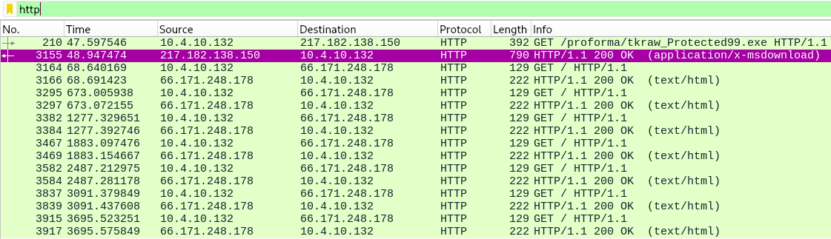
Figure 1. Wireshark http filter showing the download of tkraw_Protected99.exe (frames 210 and 3155) and the repeated GET / requests to 66.171.248.178. Cropped to the packet list.
Export Objects → HTTP lists one executable, tkraw_Protected99.exe (2,025 kB, application/x-msdownload), served from the hostname proforma-invoices.com in packet 3155 (Figure 2). I saved it from here for hashing. The Server header of that response identifies the web server as LiteSpeed (investigation notes).
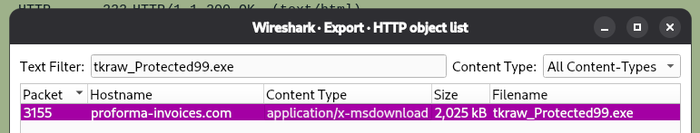
Figure 2. Wireshark HTTP object list showing tkraw_Protected99.exe from proforma-invoices.com, packet 3155. Cropped to the dialog.

Step 5 – File hash and server location
In Kali I ran md5sum tkraw_Protected99.exe on the extracted file. The MD5 is 71826ba081e303866ce2a2534491a2f7 (Figure 3).
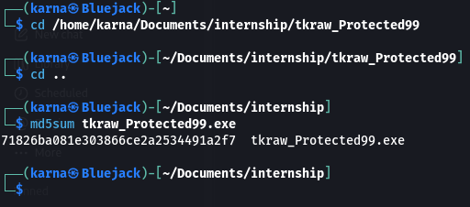
Figure 3. Kali terminal: md5sum of tkraw_Protected99.exe.
I then looked up 217.182.138.150 on IPLocation.io. The address belongs to OVH SAS and is geolocated to Roubaix, Hauts-de-France, France (Figure 4). Geolocation is approximate, so I used it as context and not as proof of where the operator sits.
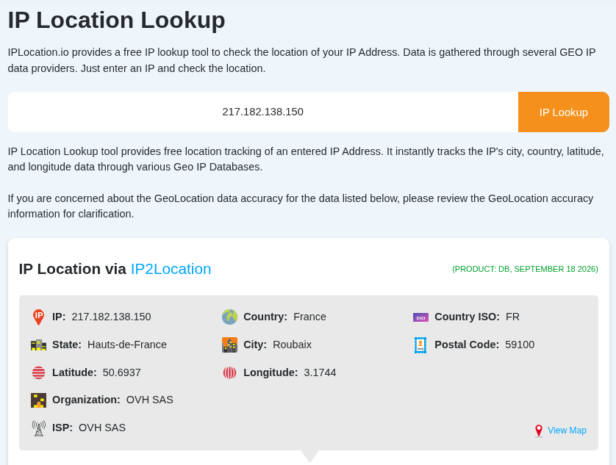
Figure 4. IPLocation.io result for 217.182.138.150: France, Hauts-de-France, Roubaix, OVH SAS. Cropped to the result panel.

Step 6 – Public IP lookups
In frame 3164 the host sends GET / to the lookup service (bot.whatismyipaddress.com, 66.171.248.178 in the capture) and frame 3166 returns 200 OK. The response body is 173.66.146.112 (investigation notes). The same request repeats about every 604 seconds: frames 3164, 3295, 3382, 3467, 3582, 3837 and 3915 in Figure 1, seven requests in total. The SMTP server’s greeting later lists 173.66.146.112 next to the client name (Figure 6), which agrees with the value returned by the lookup service.

Step 7 – SMTP traffic
Filtering on tcp.stream eq 16 isolates the first SMTP session (Figure 5). It is a TCP connection from 10.4.10.132 (source port 49206) to 23.229.162.69 on port 587. After the server banner and EHLO, the client sends AUTH login, receives the 334 challenge, sends a password line and gets 235 Authentication succeeded. MAIL FROM, RCPT TO and DATA follow.
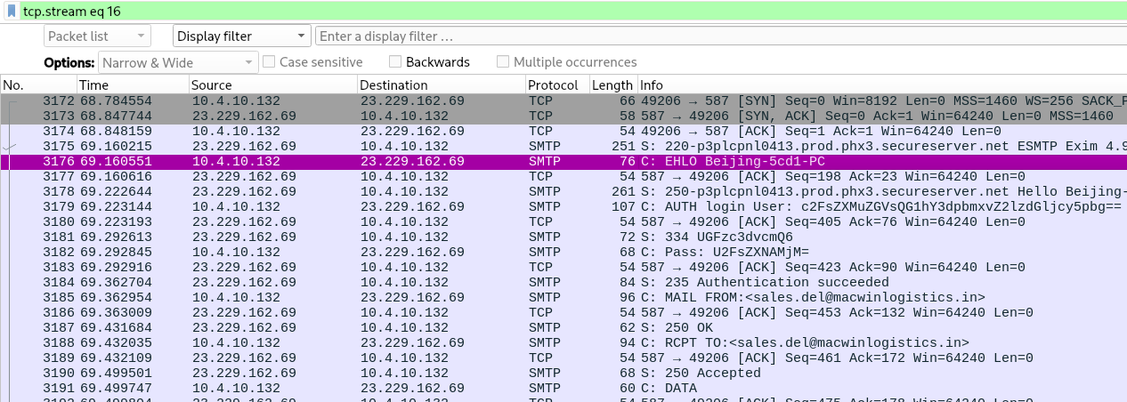
Figure 5. Wireshark tcp.stream eq 16: one SMTP session between 10.4.10.132 and 23.229.162.69 (port 587) from the TCP handshake to the DATA command. Cropped; long Info lines are cut at the right edge.
Follow TCP Stream shows the whole conversation (Figure 6).
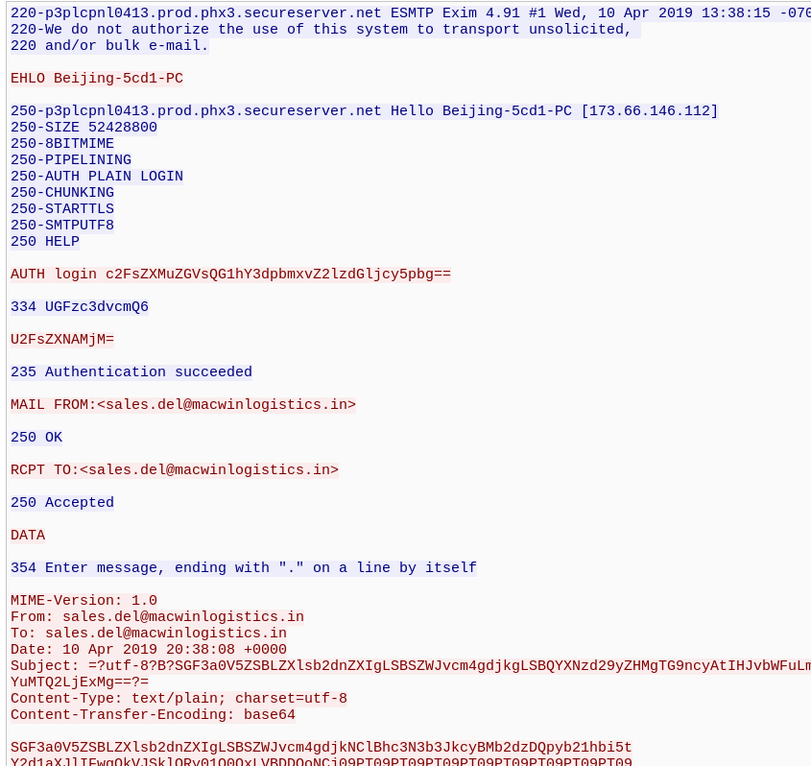
Figure 6. Follow TCP Stream (tcp.stream eq 16): banner, EHLO, AUTH login, MAIL FROM, RCPT TO, DATA and the start of the Base64 body. Cropped; the right edge of the long Subject line is cut.
The banner reads 220-p3plcpnl0413.prod.phx3.secureserver.net ESMTP Exim 4.91. The server offers AUTH PLAIN LOGIN and STARTTLS, and the client goes straight to AUTH without starting TLS, so the exchange is readable in the capture. The message headers show From and To as sales.del@macwinlogistics.in, Content-Type text/plain, and Content-Transfer-Encoding base64, followed by the Base64 body. Decoding that body gives HawkEye Keylogger - Reborn v9 followed by a Passwords Logs section (investigation notes; the decoded text is not shown in Figure 6).
The smtp filter (147 packets) shows the RCPT TO command in frame 3188 and the server’s 250 Accepted in frame 3190 (Figure 7). The packet details show frame 3188 leaving from 10.4.10.132 to 23.229.162.69 on port 587. The same view shows the message accepted with 250 OK (frame 3206), the server dropping the connection with a 421 in frame 3253, and a second session starting in frame 3306. The banner of the second session is timestamped 13:48:20 -0700, ten minutes after the first one at 13:38:15 -0700.
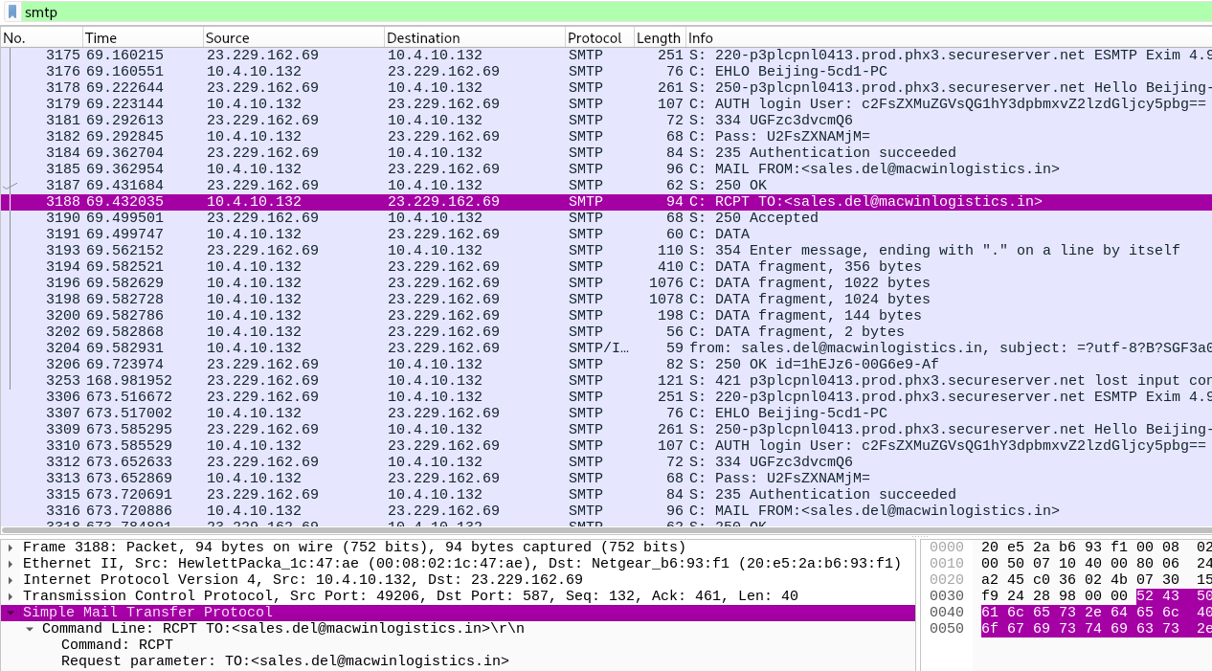
Figure 7. Wireshark smtp filter: RCPT TO:<sales.del@macwinlogistics.in> (frame 3188) with 250 Accepted (frame 3190), and a second SMTP session from frame 3306. Cropped; long Info lines are cut at the right edge.
Frames 3179 to 3184 carry the authentication (Figure 8). The client sends AUTH login with a Base64 username, the server answers 334, the client sends a Base64 password in frame 3182 (highlighted), and the server replies 235 Authentication succeeded. The Base64 username decodes to sales.del@macwinlogistics.in, the same mailbox used in MAIL FROM and RCPT TO. I have not reproduced the password value in this document.
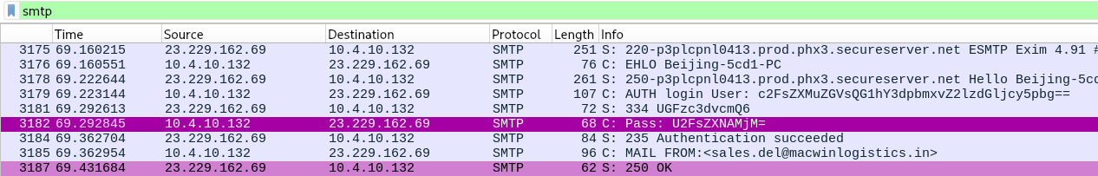
Figure 8. Wireshark smtp filter: AUTH login, 334 challenge, Base64 password line (frame 3182) and 235 Authentication succeeded. Cropped to the packet list.
The notes record these sessions repeating about every ten minutes. Figure 7 shows the first two, and the lookups in Figure 1 follow the same cadence.

5. Investigation Timeline
Relative times come from the Wireshark Time column. UTC is the first-packet time (20:37:07) plus the relative time, rounded to the minute.
Table 3. Chronology of the activity in stealer.pcap.
Rel. time (s) | UTC | Frame(s) | Event
0.000 | 20:37 | 1 | Capture starts.
– | – | 204, 206 | DNS A query for proforma-invoices.com from 10.4.10.132 to 10.4.10.4; answer 217.182.138.150 (investigation notes).
47.598 | 20:37 | 210 | HTTP GET /proforma/tkraw_Protected99.exe sent to 217.182.138.150 (Figure 1).
48.947 | 20:37 | 3155 | HTTP 200 OK, application/x-msdownload, web server LiteSpeed. Executable extracted from this object (Figure 2).
68.640 | 20:38 | 3164, 3166 | First public IP lookup (GET /) and 200 OK; body 173.66.146.112.
68.785 | 20:38 | 3172–3174 | TCP handshake from 10.4.10.132 to 23.229.162.69 port 587 (Figure 5).
69.160 | 20:38 | 3175–3176 | Banner ESMTP Exim 4.91; client sends EHLO Beijing-5cd1-PC.
69.223–69.363 | 20:38 | 3179–3184 | AUTH login, 334, password line, 235 Authentication succeeded (Figure 8).
69.363–69.500 | 20:38 | 3185–3190 | MAIL FROM and RCPT TO sales.del@macwinlogistics.in; 250 Accepted (Figure 7).
69.500–69.724 | 20:38 | 3191–3206 | DATA, 354, Base64 message body sent; 250 OK id=1hEJz6-006Ge9-Af.
168.982 | 20:39 | 3253 | Server sends 421 lost input connection.
– | – | 3263 | DHCP Inform from 10.4.10.132 with hostname Beijing-5cd1-PC (investigation notes).
673.006 | 20:48 | 3295 | Second public IP lookup.
673.517 | 20:48 | 3306–3316 | Second SMTP session: same EHLO, AUTH, 235 and MAIL FROM sequence; banner clock 13:48:20 -0700.
1277–3696 | 20:58–21:38 | 3382 … 3915 | Five more lookups at about 604-second intervals (frames 3382, 3467, 3582, 3837, 3915). SMTP sessions continue about every ten minutes (investigation notes).
3821.561 | 21:40 | – | End of capture (elapsed 01:03:41).

6. Report 1 – Red Team Perspective
This section describes the attack chain the capture represents, from the attacker’s side. It is an analysis of the lab scenario only.
Table 4. Attack chain as it appears in the capture.
Stage | What the capture shows | Evidence
Delivery context | Not visible. The URL is invoice-themed. | Frames 204–210
Executable delivery | Windows executable served over HTTP from 217.182.138.150. | Figures 1, 2, 3
Execution context | Not visible. Inferred from the traffic that follows. | –
Malware behaviour | Repeated public IP lookups about every 604 seconds. | Figure 1
Credential collection | Passwords Logs report from HawkEye Keylogger – Reborn v9. | Figure 6; investigation notes
Exfiltration | Authenticated SMTP to 23.229.162.69:587 about every ten minutes. | Figures 5–8

6.1 Delivery context
The capture does not show how the user came to request the URL. The domain name proforma-invoices.com and the /proforma/ path look like an invoice lure. That fits a phishing scenario, but it is my reading of the naming and not something the traffic proves.

6.2 Malicious executable delivery
The payload sits on a rented server at OVH SAS in Roubaix and is served over plain HTTP by LiteSpeed. The filename tkraw_Protected99.exe, the 2,025 kB size and the application/x-msdownload content type mark it as a Windows executable. Its MD5 is 71826ba081e303866ce2a2534491a2f7.

6.3 Victim interaction and execution
The GET request comes from 10.4.10.132 itself, so a user or process on that host started the download. The capture never shows the file being run. What it does show is new traffic from the same host after the download: lookups to an IP service and authenticated SMTP. That pattern fits an infostealer running on the machine, so I treat execution as inferred.

6.4 Malware behaviour
The host repeatedly asks a lookup service for its public IP, seven times in the capture at intervals of about 604 seconds. The SMTP sessions run on roughly the same ten-minute cadence, which suggests a fixed timer in the malware. The identification as HawkEye Keylogger – Reborn v9 comes from the decoded email, not from analysis of the executable. I did not tie tkraw_Protected99.exe to HawkEye by any other method, so that link rests on the order of events in the capture.

6.5 Credential collection
The decoded email body starts with HawkEye Keylogger - Reborn v9 and a Passwords Logs section, listed under the user and machine name roman.mcguire \ BEIJING-5CD1-PC. The entry I recorded is for https://www.bankofamerica.com/, taken from Chrome, with a username and password. The values are not reproduced here. This comes from my investigation notes; the decoded text is not in the screenshots. The capture does not show how the credentials were obtained, for example from the browser’s stored logins or by keystroke logging.

6.6 SMTP exfiltration
The malware authenticates to a mail server as sales.del@macwinlogistics.in with AUTH LOGIN and sends the report to the same address. Using one mailbox as sender, recipient and login means the operator only has to open that mailbox to read the stolen data. The server offered STARTTLS but the client did not use it, so the username, password and message body can be read from the capture. Whether the mailbox was set up by the attacker or belongs to a compromised account is not shown.

6.7 Attacker infrastructure
Table 5. External systems seen in the attack chain.
Role | Address | Details
Payload host | proforma-invoices.com / 217.182.138.150 | OVH SAS, Roubaix, Hauts-de-France, France. Web server LiteSpeed. Serves /proforma/tkraw_Protected99.exe.
Public IP lookup service | bot.whatismyipaddress.com / 66.171.248.178 | Third-party service contacted by the victim about every 604 seconds. Returned 173.66.146.112.
SMTP drop | 23.229.162.69, port 587 | United States. Exim 4.91. Banner host p3plcpnl0413.prod.phx3.secureserver.net.
Mailbox | sales.del@macwinlogistics.in | SMTP login, MAIL FROM and RCPT TO.

6.8 Techniques represented
Table 6. MITRE ATT&CK mapping supported by the evidence.
Technique | Observed behaviour | Evidence
T1105 Ingress Tool Transfer | Executable downloaded from an external server over HTTP. | Frames 210, 3155; Figures 1, 2, 3
T1016 System Network Configuration Discovery | Host asks an external service for its public IP, repeatedly. | Frames 3164, 3166 and later requests; Figure 1
T1555.003 Credentials from Web Browsers (possible) | Decoded report lists a Chrome entry with URL, username and password. The collection method is not shown. | Decoded body (investigation notes)
T1048.003 Exfiltration Over Unencrypted Non-C2 Protocol | Stolen data sent by SMTP to an external mail server in a readable session. | Figures 5–8
T1029 Scheduled Transfer | Sessions repeat about every ten minutes. | Figure 7; investigation notes
I did not map phishing or user execution (delivery and execution are not visible), persistence and command and control (no evidence in the capture), or keylogging (the malware name suggests it, but no keystroke capture is shown).

7. Report 2 – Blue Team Perspective
This section covers how an analyst would find and investigate the same activity, and which log sources would give the earliest signal.

7.1 Detection opportunities by data source
Table 7. Monitoring areas, what the capture shows, and how to detect it.
Area | Seen in the capture | Detection approach | Data source
DNS | 10.4.10.4 answered a query for proforma-invoices.com with 217.182.138.150 (frames 204, 206). | Log all queries. Flag domains first seen on the network, especially invoice or payment-themed names. Match against threat intelligence and sinkhole known-bad domains. | DNS server logs, DNS filtering
HTTP executable download | Workstation fetched an .exe from an external host over HTTP; application/x-msdownload; about 2 MB; hosting-provider IP (frames 210, 3155). | Alert on executable content types or MZ headers going to workstations, especially over HTTP or from uncategorised hosts. | Web proxy, IDS/NSM HTTP logs, firewall
File hash | MD5 71826ba081e303866ce2a2534491a2f7. | Check the hash in reputation services and search the estate for it. A reputation lookup is a recommended next step. | Threat intel, EDR, file inventory
Endpoint and network correlation | Network side gives 10.4.10.132, Beijing-5cd1-PC and a download at about 20:37 UTC. The user roman.mcguire appears in the decoded report. | On the endpoint, look for the file on disk, process creation from about 20:37 UTC, the parent process, its network connections and autostart entries. | EDR, Sysmon or Windows event logs (no endpoint data in this capture)
Repeated outbound connections | GET / to 66.171.248.178 about every 604 s (seven requests); SMTP sessions to 23.229.162.69 about every ten minutes. | Flag fixed-interval connections from one host to the same rarely used destination. Alert on workstations contacting IP-lookup services. | Firewall or proxy flow logs, Zeek/NSM
SMTP | Workstation to an external server on port 587 with AUTH login; sender equals recipient; Base64 text/plain body; no STARTTLS. | Alert when a non-mail-server host opens SMTP to the internet. Alert on cleartext AUTH. Watch for mail sent to the sender’s own address. | Firewall logs, NSM SMTP logs, mail gateway
Credential theft indicators | Decoded report lists the user, computer name and web credentials. | Inspect outbound mail content for password-log style text. Treat any listed credential as exposed. | DLP, mail gateway

7.2 Follow-up questions for the investigation
- How did the user reach proforma-invoices.com? Check proxy, browser and email logs on 10.4.10.132 before 20:37 UTC.
- Is tkraw_Protected99.exe still on the host, and was it run? Check EDR or Sysmon for the file and process activity.
- Did any other host contact 217.182.138.150 or 23.229.162.69? Search DNS, proxy and firewall logs.
- Has the sales.del@macwinlogistics.in mailbox been used from anywhere else? The credentials crossed the network in readable form.
The full list of indicators is in Section 9 and the control recommendations are in Section 10.

8. Report 3 – Purple Team Handover
The table links each stage of the activity to what it left behind, how it could have been detected, and what a response would involve.
Table 8. Attack activity, evidence, detection and response by stage.
Attack stage | Red Team activity | Evidence observed | Blue Team detection | Recommended response
1. Delivery and download | Victim retrieves tkraw_Protected99.exe over HTTP from proforma-invoices.com (217.182.138.150). | DNS query and answer (204, 206); GET (210); 200 OK x-msdownload (3155). Figures 1, 2. | New invoice-themed domain; .exe over HTTP; hash lookup. | Block domain and IP. Isolate the host. Recover the file. Check proxy and email logs for the source of the link.
2. Execution on host | Payload presumably runs on 10.4.10.132. | Not visible. Inferred from the traffic that follows. | EDR: new unsigned process from a download location; Sysmon process and network events. | Collect endpoint triage data. Look for the file and autostart entries. Rebuild the host if execution is confirmed.
3. Discovery | Malware asks a lookup service for the host’s public IP, repeatedly. | GET / to 66.171.248.178 (frames 3164, 3295, 3382, 3467, 3582, 3837, 3915). Figure 1. | Workstations querying IP-lookup sites, especially at fixed intervals. | Block the lookup service where not needed. Use it as a hunting pivot on other hosts.
4. Credential collection | HawkEye builds a Passwords Logs report with user, host and site credentials. | Decoded email body (investigation notes). Base64 body in Figure 6. | Endpoint access to browser credential stores; DLP on outbound mail. | Reset the credentials in the report. Enable MFA. Review those accounts for misuse.
5. Exfiltration over SMTP | Authenticated SMTP session to 23.229.162.69:587, mail from and to sales.del@macwinlogistics.in. | EHLO, AUTH, 235, MAIL FROM, RCPT TO, DATA. Figures 5–8. | Workstation-originated SMTP to the internet; egress on 25, 465 and 587 from non-mail hosts. | Block 23.229.162.69. Report the mailbox to its provider and rotate its credentials. Search for other hosts using the same destination.
6. Repeated exfiltration | Sessions repeat about every ten minutes. | Banners 13:38:15 and 13:48:20 -0700 (Figure 7); interval in investigation notes. | Periodicity rule on outbound connections; SMTP rate per host. | Contain the host quickly to stop further sends. Count how many reports were sent.

8.1 Handover notes
- The download and the SMTP session were both unencrypted, so a proxy or network sensor could have read them. The fixed ten-minute timing gives a second, independent signal.
- The capture has no endpoint telemetry and no delivery evidence. Stage 2 and the delivery vector need endpoint and email logs to close.
- Two follow-ups for a later exercise: confirm the link between the executable and HawkEye with a hash reputation lookup or sandbox run, and confirm whether the decoded report contains more than the one entry recorded here.

9. Indicators of Compromise (IoCs)
Values are shown as recorded. Defang domains, URLs and IP addresses before sharing this document outside the internship.
Table 9. Indicators observed in the capture.
Type | Value | Context
IPv4 | 217.182.138.150 | Payload host; resolved address of proforma-invoices.com (OVH SAS, France).
Domain | proforma-invoices.com | Queried in frame 204; hosts the executable.
URL path | /proforma/tkraw_Protected99.exe | HTTP GET in frame 210.
Filename | tkraw_Protected99.exe | Downloaded executable, 2,025 kB.
MD5 | 71826ba081e303866ce2a2534491a2f7 | Hash of the extracted executable.
IPv4 | 23.229.162.69 | SMTP server receiving the stolen data; port 587; Exim 4.91; United States.
Hostname | p3plcpnl0413.prod.phx3.secureserver.net | Host in the SMTP banner.
Email address | sales.del@macwinlogistics.in | SMTP login, MAIL FROM and RCPT TO.
Domain | macwinlogistics.in | Domain of the exfiltration mailbox.
Malware string | HawkEye Keylogger - Reborn v9 | Start of the decoded exfiltrated content.
IPv4 / domain | 66.171.248.178 / bot.whatismyipaddress.com | Public IP lookup service. Legitimate service; contextual indicator, useful for hunting.
IPv4 | 173.66.146.112 | Victim’s public IP. Contextual only.
IPv4 | 10.4.10.132 | Affected host.
Hostname | Beijing-5cd1-PC | Affected host.
MAC | 00:08:02:1c:47:ae | Affected host NIC (Hewlett-Packard OUI).
User | roman.mcguire | Account named in the decoded report.

10. Detection and Mitigation Recommendations
Table 10. Recommended controls and the lab finding behind each.
Area | Recommendation | Lab finding it addresses
Egress SMTP | Allow SMTP to the internet only from designated mail servers. Log and alert on any other source. | 10.4.10.132 connected directly to 23.229.162.69 on port 587.
Web filtering | Block or sandbox executable downloads from uncategorised or newly seen sites. Prefer HTTPS with inspection. | tkraw_Protected99.exe arrived over plain HTTP.
DNS | Centralise DNS query logs. Use a filtering or sinkhole service and alert on newly seen domains. | proforma-invoices.com resolved normally through 10.4.10.4.
Network detection | Add rules for fixed-interval connections and for workstations reaching IP-lookup sites. | Lookups every 604 s and SMTP about every ten minutes.
Endpoint | Deploy EDR with process and network telemetry. Restrict execution of downloaded executables. | Execution is not visible in the capture.
Mail and mailbox | Report the abused mailbox to its provider and rotate its credentials. On servers you control, require TLS before authentication. | AUTH login succeeded in cleartext although STARTTLS was offered.
Credentials | Reset passwords for accounts in the stolen log, enforce MFA and review those accounts for misuse. | The Passwords Logs report held web credentials.
Logging | Keep DNS, proxy, firewall egress, SMTP and endpoint process logs in one place with enough retention to look back. | Every stage above depends on one of these sources.
Threat intelligence | Add the indicators in Section 9 to blocklists and hunts. | Payload host, mail server and mailbox are all reusable indicators.

11. Evidence Index
Table 11. Screenshots used in this document.
Evidence ID | Filename | Tool | Investigation stage | What it demonstrates
E-01 (Fig. A1) | 01_capture_properties.png | Wireshark | Baseline | File name, 4,003 packets, first and last packet times, 01:03:41 elapsed.
E-02 (Fig. A2) | 02_ethernet_endpoints.png | Wireshark | Baseline | Ethernet endpoints; 00:08:02:1c:47:ae in 4,003 packets (Tx 1,993, Rx 2,010).
E-03 (Fig. A3) | 04_ipv4_endpoints.png | Wireshark | Baseline | IPv4 endpoints; 10.4.10.132 in 4,003 packets; external addresses and packet counts.
E-04 (Fig. 1) | 06_dns_query_204.png | Wireshark | HTTP download | HTTP filter: GET for the executable (210), 200 OK x-msdownload (3155), repeated GET / to 66.171.248.178.
E-05 (Fig. 2) | 09_HTTP_Export_Object_tkraw_Protected99.png | Wireshark | Payload extraction | HTTP object list: tkraw_Protected99.exe, proforma-invoices.com, packet 3155, 2,025 kB.
E-06 (Fig. 3) | 10_Malware_File_MD5_Hash.png | Kali terminal | File hashing | md5sum output: 71826ba081e303866ce2a2534491a2f7.
E-07 (Fig. 4) | 07_Malware_Server_IP_Geolocation.png | IPLocation.io | Infrastructure | 217.182.138.150: France, Hauts-de-France, Roubaix, OVH SAS.
E-08 (Fig. 5) | 05_SMTP_Exfiltration_Traffic.png | Wireshark | SMTP exfiltration | One SMTP session (tcp.stream eq 16): handshake to port 587, EHLO, AUTH, MAIL FROM, RCPT TO, DATA.
E-09 (Fig. 6) | 11_SMTP_Follow_TCP_Stream.png | Wireshark | SMTP exfiltration | Full conversation: Exim 4.91 banner, AUTH login, 235, headers, Base64 body.
E-10 (Fig. 7) | 12_SMTP_RCPT_TO_Evidence.png | Wireshark | SMTP exfiltration | RCPT TO and 250 Accepted (3188, 3190); MAC/IP of the sender; second session at 13:48:20 -0700.
E-11 (Fig. 8) | 13_SMTP_Authentication_Evidence.png | Wireshark | SMTP authentication | AUTH login, 334, password line (3182), 235 Authentication succeeded.

Some findings are recorded in the investigation notes without a dedicated screenshot: the DNS query and answer (frames 204 and 206), the DHCP Inform hostname (frame 3263), the User-Agent values in frame 210, the LiteSpeed Server header, the body of the lookup response (frame 3166), the NIC vendor lookup, the country of 23.229.162.69, the decoded content of the email body, and the ten-minute SMTP interval beyond the two sessions in Figure 7.

12. Conclusion
The capture shows a short, clear chain on one host. 10.4.10.132 downloaded tkraw_Protected99.exe from proforma-invoices.com over HTTP, then began polling a public IP service and sending authenticated SMTP mail to 23.229.162.69 about every ten minutes. The mail went from and to sales.del@macwinlogistics.in, and its decoded body identifies HawkEye Keylogger – Reborn v9 and lists stolen credentials.
The delivery method, the execution of the file and any persistence are not visible in the capture, and the link between the executable and HawkEye rests on the order of events. The download, the repeated lookups and the unencrypted SMTP session each give a defender a place to detect this activity, and Sections 8 and 10 set out how.

13. Appendix – Screenshots
The screenshots below support the baseline findings in Step 1. The screenshots for the later steps appear in Section 4.
Capture File Properties gives the file name (stealer.pcap), the packet count of 4,003, the first packet at 2019-04-11 02:07:07 (local time display), the last packet at 03:10:48 and the elapsed time of 01:03:41. This is the source of the packet count and duration used throughout the document.
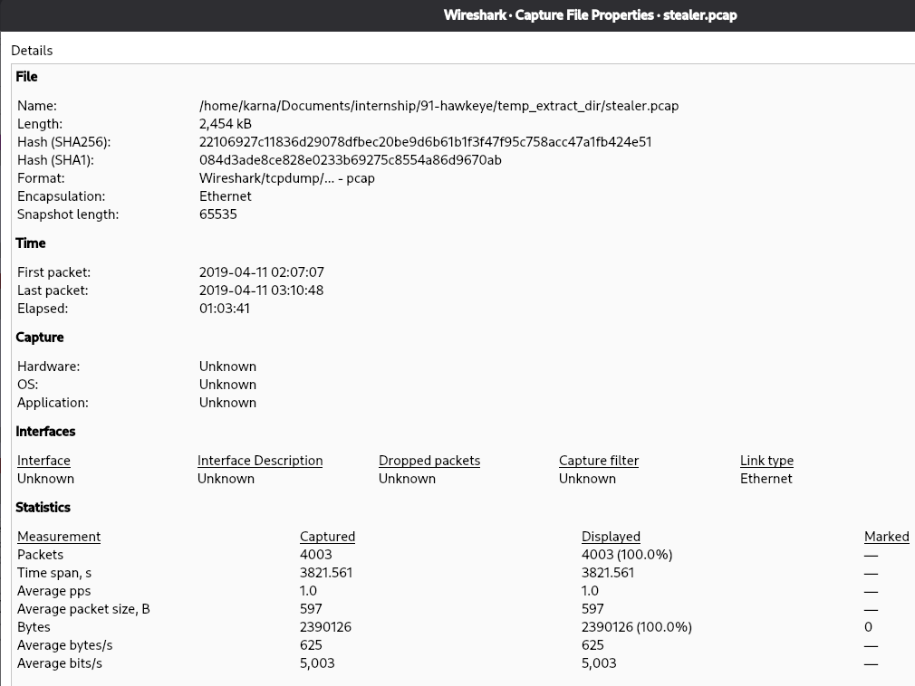
Figure A1. Wireshark Capture File Properties for stealer.pcap. Cropped to the dialog.
The Ethernet endpoints table lists seven endpoints. 00:08:02:1c:47:ae is the most active at link level with 4,003 packets, of which 1,993 were transmitted and 2,010 received.
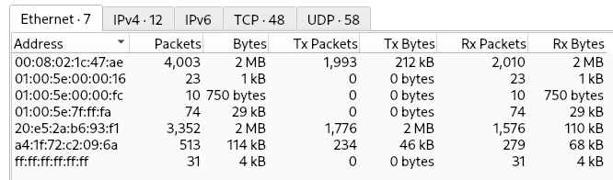
Figure A2. Wireshark Statistics → Endpoints, Ethernet tab. Cropped to the table.
The IPv4 endpoints table lists twelve addresses. 10.4.10.132 appears in all 4,003 packets, 217.182.138.150 in 2,947 and 23.229.162.69 in 280. The internal addresses 10.4.10.2, 10.4.10.4 and 10.4.10.132 are the three computers; 10.4.10.255 is the subnet broadcast address.
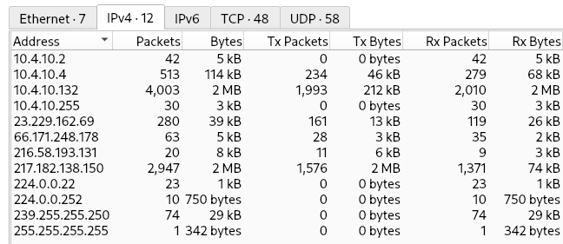
Figure A3. Wireshark Statistics → Endpoints, IPv4 tab. Cropped to the table.

