Task 6
Design and Implementation of a Custom SIEM Dashboard
ELK Stack (Elasticsearch, Kibana, Filebeat) — Kali Linux lab
Giri Anoop
Cybersecurity Internship — ElevanceSkills
Internship Task 6 Report
Date: 27 September 2026

1. Introduction
For Task 6, I designed and built a small custom SIEM dashboard capable of visualizing security-relevant events — authentication failures, privileged (sudo) activity, and file-transfer indicators. Since my laptop only has about 8 GB of RAM, I kept the stack lightweight and used Elasticsearch, Kibana, and Filebeat rather than a full SIEM platform or something like Security Onion, which would have been too heavy for the machine.
The setup pulls authentication events from /var/log/auth.log on my Kali machine, forwards them with Filebeat, indexes them in Elasticsearch, and visualizes the results in Kibana. I tested the pipeline with a set of controlled SSH and sudo activities that I generated myself, rather than a real attack.

2. Objective
- Build a lightweight SIEM pipeline using Filebeat, Elasticsearch, and Kibana.
- Collect host authentication telemetry from /var/log/auth.log.
- Index the collected events in Elasticsearch and confirm they arrive intact.
- Visualize SSH authentication failures and successes in Kibana.
- Monitor sudo/privileged activity.
- Extract source-IP information from SSH authentication-failure messages.
- Generate a controlled file-transfer event with SCP as a file-transfer/exfiltration indicator.
- Bring all of the above together into one dashboard.
- Capture evidence of the finished dashboard.

3. Lab Environment
Component | Configuration
Operating system | Kali GNU/Linux Rolling 2026.3
CPU | Intel Core i5-1235U
Memory | Approximately 8 GB RAM
Elasticsearch | 9.5.4 (Docker, single node)
Kibana | 9.5.4 (Docker)
Filebeat | 9.5.4 (installed directly on the Kali host)
Container platform | Docker
Primary log source | /var/log/auth.log

I left Logstash out on purpose. With only 8 GB of RAM, running Elasticsearch, Kibana, and Logstash together would have made the machine unusable, and for a single log source like auth.log, Filebeat shipping straight to Elasticsearch was enough.

4. SIEM Architecture
/var/log/auth.log → Filebeat 9.5.4 → Elasticsearch 9.5.4 → Kibana 9.5.4 → Custom SIEM Dashboard
Filebeat watches /var/log/auth.log, ships new lines to Elasticsearch, and the events land in the filebeat-9.5.4* index. In Kibana I built a data view called Task 6 - Auth Logs on top of that index to build the visualizations and the dashboard from.

5. Implementation

5.1 Elasticsearch
I ran Elasticsearch 9.5.4 as a single-node Docker container with the memory limited to about 1 GB, mainly to keep it from eating all the RAM on the host. It's exposed locally on port 9200 for single-node use.
After it came up, I checked the API and it reported version 9.5.4 correctly. Cluster health showed yellow, which is expected here — it's a single-node setup, so the one replica shard has nowhere else to go. That's a normal single-node condition, not something broken.

5.2 Kibana
Kibana 9.5.4 also runs in Docker, connected to the Elasticsearch container over the Docker elastic network. I capped it at about 1 GB of container memory and limited the Node.js heap to 768 MB, again to keep things from stalling out on the 8 GB host. I could reach it at localhost:5601 without issues.

5.3 Filebeat
Filebeat 9.5.4 is installed directly on the Kali host rather than in a container. I pointed its input at just one file:
/var/log/auth.log
I kept it to that single path on purpose — pulling in every log on the system would have added a lot of noise and used more resources than the host could really spare. filebeat test config and filebeat test output both passed, confirming the config was valid and that Filebeat could actually reach Elasticsearch.

6. Log Ingestion and Verification
Once the pipeline was running, I checked Elasticsearch directly rather than just trusting the Kibana UI. At the point I first verified it, the Filebeat index held approximately 1,893 documents, and a search for Failed password returned 6 matching events. Each document contained the original auth.log line plus the usual Filebeat metadata (host, agent info, and the /var/log/auth.log source path), which confirmed the events were real log lines that had made it all the way from the host file into Elasticsearch — not something typed into a dashboard by hand.
Note: the 6 events above were from an earlier verification pass. By the time I captured the final dashboard screenshots I had run a couple more rounds of controlled SSH tests, so the dashboard itself shows 9 failed-password events (Section 10, Figures 1–2) rather than 6. Both numbers are real; they just reflect two different points in the testing.

7. Controlled Security Testing
Everything the dashboard shows came from activity I actually ran on the lab machine — nothing was typed directly into Kibana or backfilled after the fact.

7.1 SSH Authentication Failure Test
I generated controlled failed SSH logins against the local SSH service — one round of three failed attempts from 127.0.0.1, plus an earlier round from 192.168.0.105 on a different day. Both sets show up in auth.log, get picked up by Filebeat, land in Elasticsearch, and show up in Kibana.
This is the kind of pattern — several failed logins for the same account in a short window — that would normally be treated as a potential brute-force indicator. I'm not calling it a confirmed brute-force attack, since I generated it myself for the test.

7.2 Successful Authentication Test
I also logged in successfully once, which produced an event along the lines of:
Accepted password for karna from 127.0.0.1
Having both failures and a success in the index let me build a success-vs-failure comparison in Kibana. A successful login right after several failures is a reasonable thing to flag for a closer look in a real environment, but on its own it doesn't prove anything malicious happened — it needs the surrounding context.

7.3 Source IP Analysis
auth.log's "Failed password" lines don't come indexed with the source IP as a separate field, so I built a Kibana runtime field, ssh_source_ip, that pulls the address out of messages matching a pattern like Failed password ... from <IP> port .... That field is what drives the Top SSH Source IPs table.
In the finished dashboard that table shows 127.0.0.1 with 9 hits and 192.168.0.105 with 3 (Figure 2). There's also a third row, user karna 127.0.0.1, with a count of 1 — that's not a real address, it's the runtime field grabbing a slightly different substring from one message than it did from the others. I left it in rather than quietly cleaning it up, since it's a genuine limitation of a quick regex-based field, not a real host.

7.4 Sudo Activity
I also pulled sudo-related lines out of auth.log and built Sudo Activity Over Time and Sudo Activity Count to keep an eye on privileged activity. Seeing sudo events in the index doesn't mean anything malicious happened — plenty of normal admin work shows up the same way. In a real deployment you'd want to know who ran the command, what the command was, and whether it fits the user's usual behaviour before treating it as suspicious.

7.5 Controlled SCP File-Transfer Test
For the file-transfer/exfiltration piece, I created a small test file:
/tmp/task6_exfil_test.txt — contents: Task 6 controlled transfer test
and copied it with SCP to 127.0.0.1:/tmp/task6_exfil_test_copy.txt. I hashed both copies with SHA-256 to make sure the transfer hadn't corrupted anything:
626c990967a3c149251c1bb34d2bd99c8a2f234e8f5a8eb875b7daed805c2f67
Both files matched. The SCP session shows up in auth.log as sudo and SSH authentication activity, which I turned into a Kibana visualization, Potential File Transfer / Exfiltration Indicators, built on an SCP-related query. It returns 3 matching records for this test (Figure 2).
This was a local copy to 127.0.0.1 — not data leaving the machine — so it's a stand-in for what a transfer indicator might look like, not evidence of real exfiltration. It also only looks at log lines that mention SCP; there's no packet capture or inspection of what was actually inside the transfer.

8. Kibana Visualizations
I ended up with seven saved Lens visualizations plus one saved Discover search, listed below in the order I built them. (While putting the evidence together I noticed a leftover duplicate, Sudo Activity Over Time_v2, sitting in the Visualize library from an earlier rebuild of that panel — visible in Figure 3. It's not used on the dashboard; the dashboard uses the original Sudo Activity Over Time.)
Visualization | Type | What it shows
SSH Authentication Failures Over Time | Lens, line chart | Controlled failed-password events plotted over time.
Sudo Activity Over Time | Lens, line chart | Sudo-related activity plotted over time.
Task 6 - SSH Authentication Failures | Saved Discover search | The raw authentication-failure documents behind the dashboard, for drilling into individual events.
SSH Authentication Failure Count | Lens, metric | Failed-authentication counts for the selected time buckets.
Top SSH Source IPs | Lens, table (uses ssh_source_ip) | Source-IP distribution for the controlled failed logins.
Authentication Success vs Failure | Lens | Compares successful and failed authentication events.
Sudo Activity Count | Lens, metric | A compact count of sudo-related events.
Potential File Transfer / Exfiltration Indicators | Lens, table | Count of SCP-related events matching the controlled transfer test.

The saved versions of these (plus a small leftover from one rebuild) are shown in Section 11.

9. Custom SIEM Dashboard
All of the visualizations above come together in one dashboard, Task 6 - Custom SIEM Security Dashboard, built on the Task 6 - Auth Logs data view over the filebeat-9.5.4* index. It gives a single view over SSH authentication failures, success-vs-failure activity, source IPs, sudo activity, and the controlled file-transfer indicator, alongside the raw documents behind the failure count.
Figure 1 is the dashboard as it looked once everything was finished. Reading it panel by panel: Sudo Activity Over Time (top left) trends sudo activity across the window; SSH Authentication Failures Over Time (top right) shows a single 3-event spike at 17:00 on 27 September; the Task 6 - SSH Authentication Failures discover panel lists 9 raw documents; and SSH Authentication Failure Count breaks those into three buckets of 3 events each (19:00 and 22:00 on 25 September, and 17:00 on 27 September) — three separate rounds of the controlled test, run on two different days.
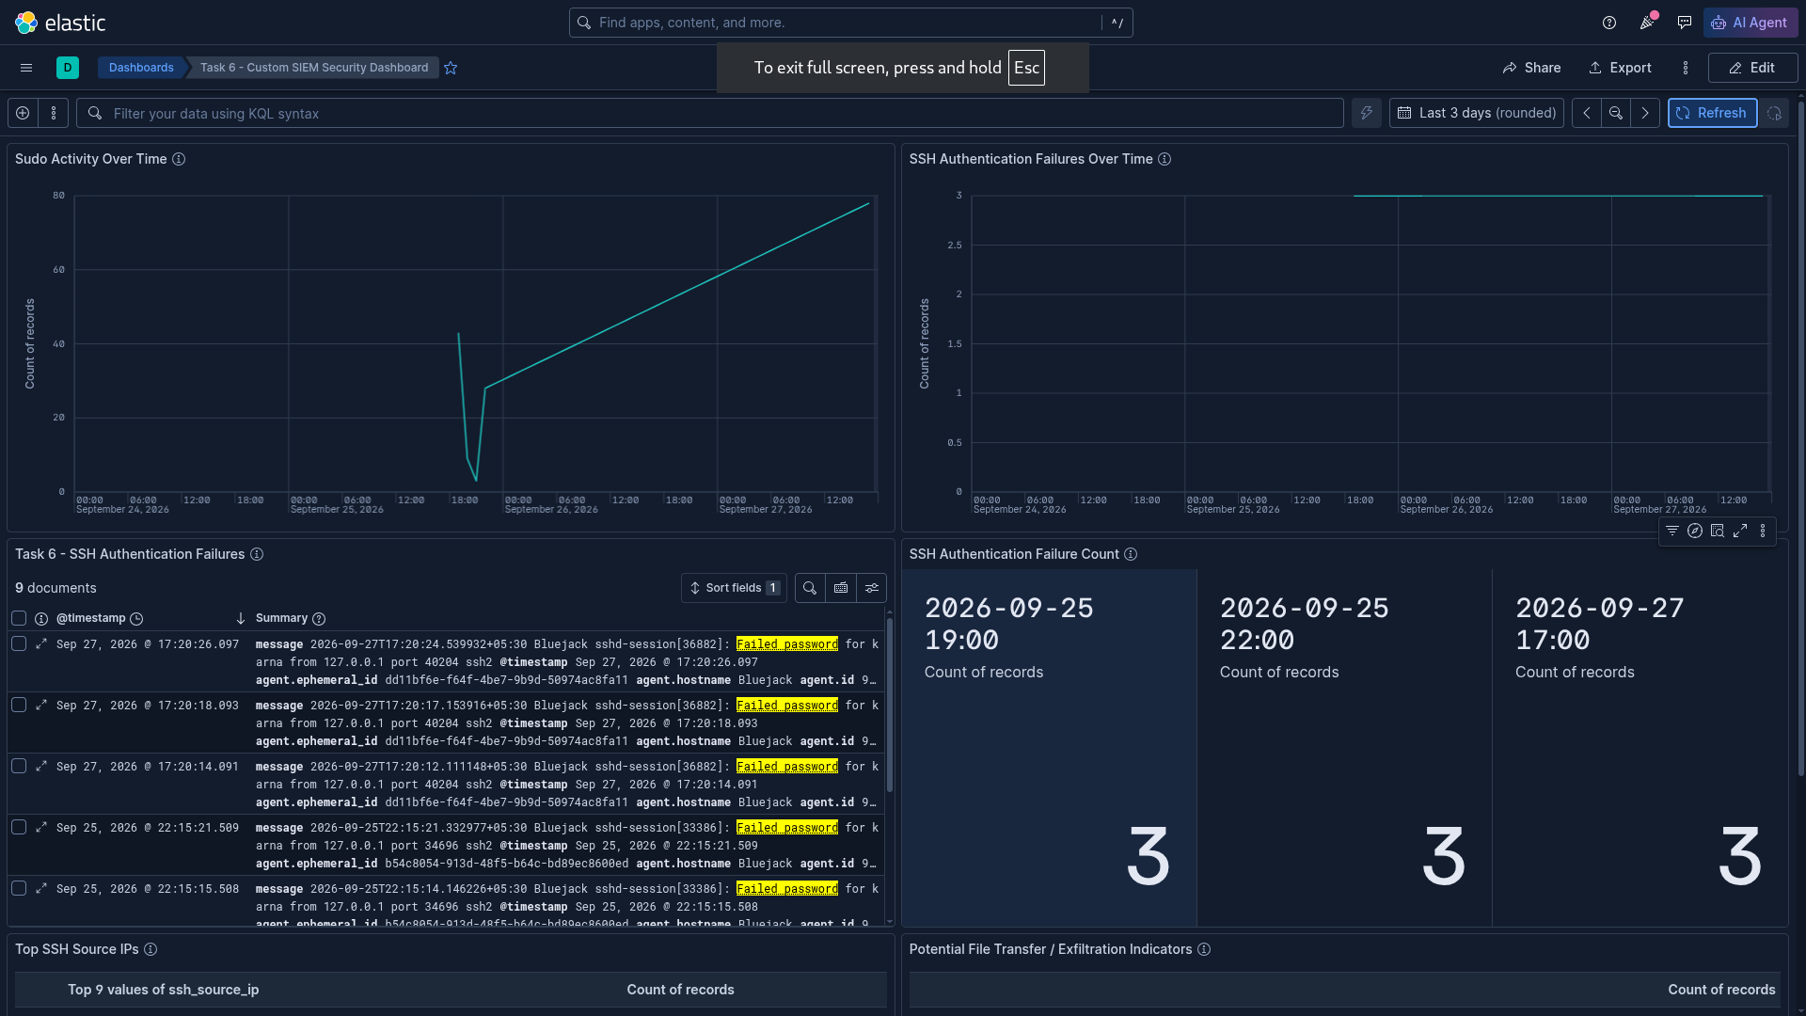
Figure 1 — Custom SIEM Security Dashboard — sudo activity, SSH authentication failures over time, the underlying failure documents, and the failure-count breakdown by time bucket.

10. Security Event Analysis
Scrolling further down the same dashboard brings up the source-IP and file-transfer panels.
Figure 2 shows the Top SSH Source IPs table — 127.0.0.1 with 9 events and 192.168.0.105 with 3, plus the one-off "user karna 127.0.0.1" extraction artifact described in Section 7.3 — next to Potential File Transfer / Exfiltration Indicators, which shows a single row with a count of 3, matching the controlled SCP test from Section 7.5.
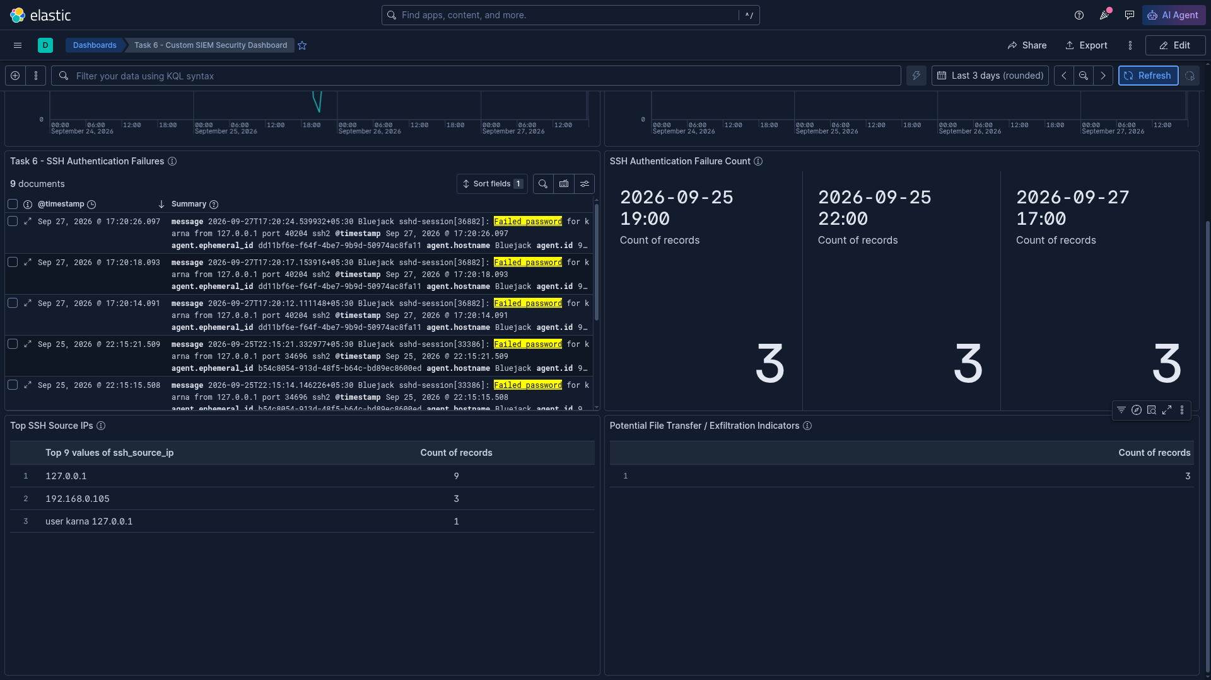
Figure 2 — Security event view — authentication-failure documents and counts, the Top SSH Source IPs table, and the Potential File Transfer / Exfiltration Indicators count.
Together these two views are what I'd actually use to investigate something: start from the failure count, check which source IP it's coming from, look at the raw documents for the specifics, and then check whether anything shows up on the file-transfer panel around the same time.

11. Visualization Library
For the record, here is what the saved visualizations looked like in the Kibana Visualize library when I pulled the evidence together, each with the short description I wrote for it at the time.
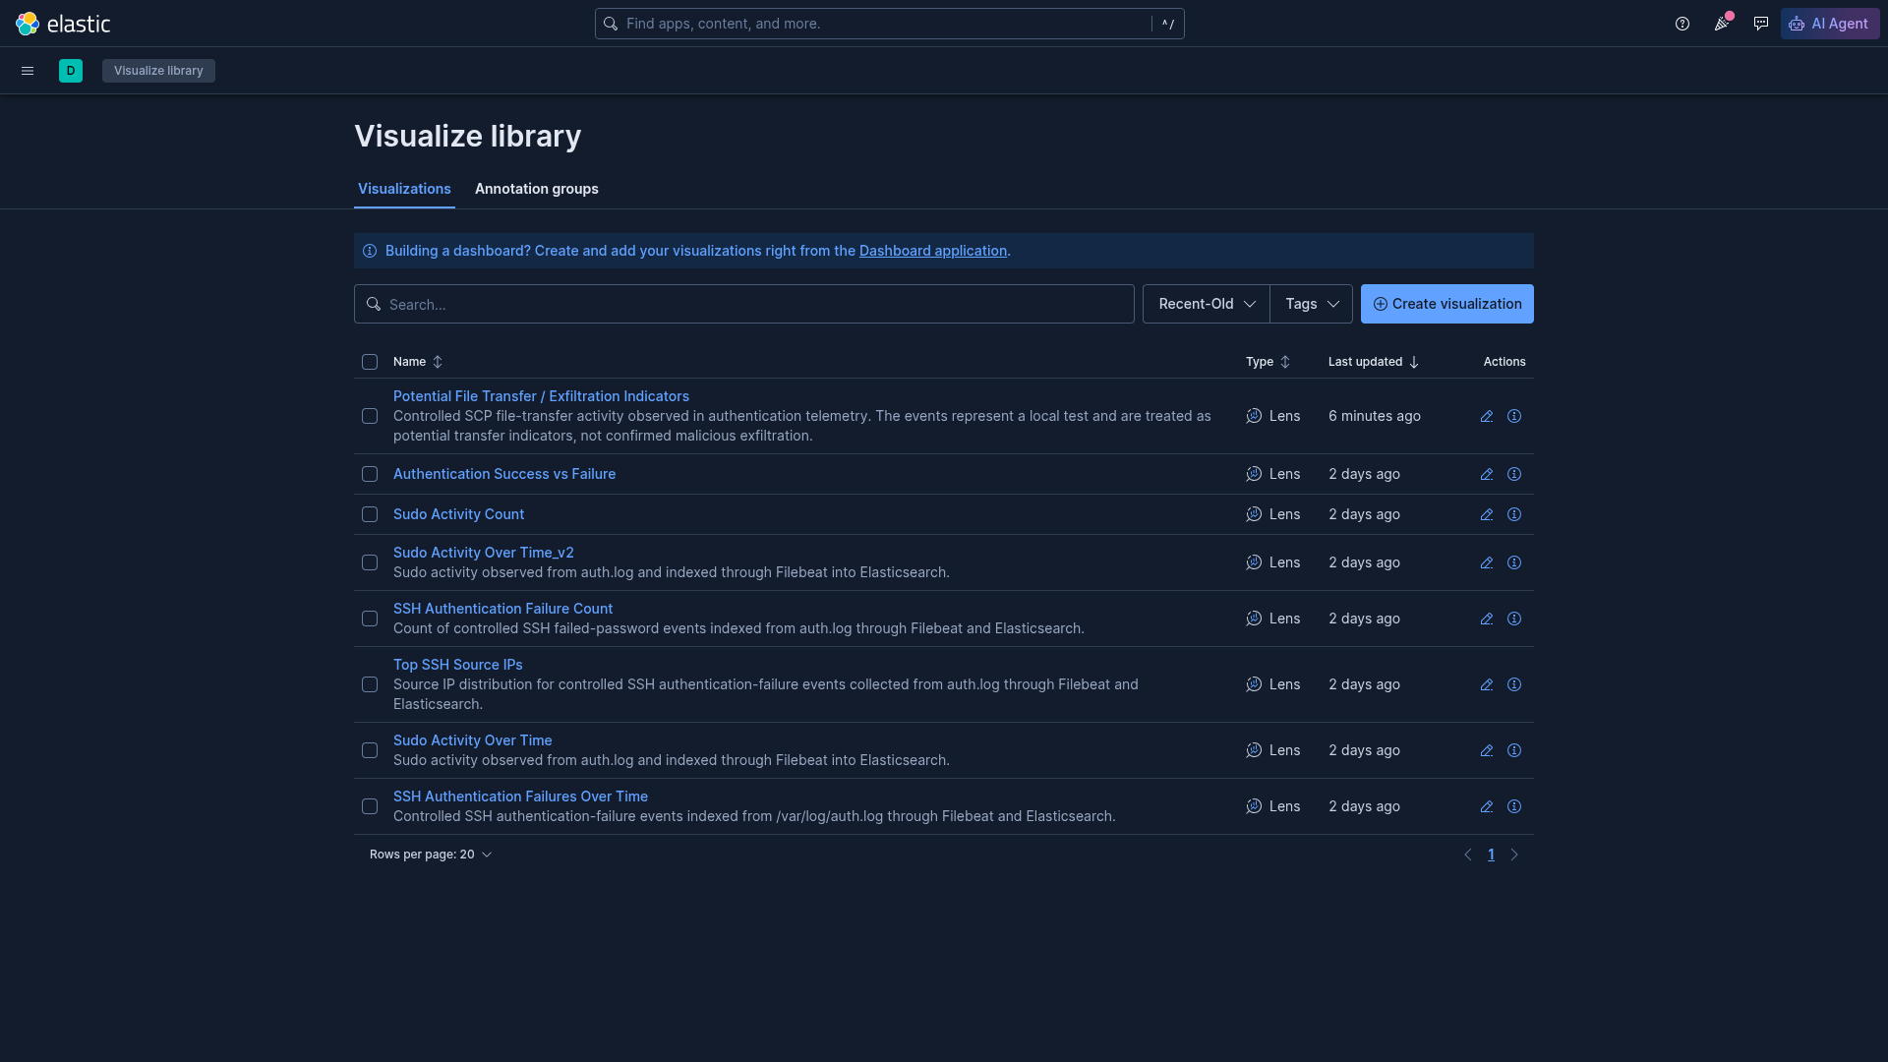
Figure 3 — Saved Kibana visualizations used to build the Task 6 dashboard. The Sudo Activity Over Time_v2 entry is a leftover from an earlier version of that panel and isn't used on the final dashboard.

12. Detection and Investigation Logic
The dashboard doesn't run any detection rules on its own — it's built for someone to look at and investigate from. The heuristics behind each panel are:
Pattern | What it can suggest
Repeated failed logins for the same account in a short window | A potential brute-force pattern worth a closer look.
A successful login right after several failures | Worth checking, since it can mean the attempts eventually succeeded — but it can also just be someone mistyping their own password.
Sudo activity outside of normal patterns | Worth reviewing against who the user is and what they normally do — sudo use by itself is routine.
SCP/file-transfer commands in the log | A transfer indicator to keep an eye on, not proof that anything left the network.

None of these are tuned thresholds or tested detection rules — they're just the reasoning I used while looking at the data, and the kind of thing a real SOC would refine with more data and more context.

13. Results
The pipeline works end to end: real activity on the host generates lines in auth.log, Filebeat ships them, Elasticsearch indexes them, and Kibana displays them. I could see my own controlled failed logins, my successful login, my sudo commands, and my SCP test all show up as searchable, visualized events, and the dashboard pulls all of that into one place.

14. Challenges and Troubleshooting

13.1 Limited RAM
8 GB doesn't leave much room once Elasticsearch and Kibana are both running. I dropped Logstash from the stack and capped both containers' memory (Elasticsearch ~1 GB, Kibana ~1 GB with a 768 MB Node heap) rather than let either one grab as much as it wanted.

13.2 Elasticsearch + Kibana running together
Even with the limits set, running both at once was noticeably heavy. Closing anything I didn't need helped — including, of all things, stopping the Hidamari animated-wallpaper app, which was quietly eating more CPU than I expected. After that the system felt a lot smoother.

13.3 Single-node cluster health
Elasticsearch reported yellow health the whole time, since a single node can't place a replica shard anywhere. I didn't try to fix this — it's the expected state for a one-node lab cluster, not a real problem.

13.4 The raw message field in Lens
The full message field was in the indexed documents and I could search it fine, but Kibana didn't expose it as a normal field I could drop into a Lens visualization. Rather than fight with that, I built the file-transfer indicator as a filtered query with a plain count, which is what's actually on the dashboard.

13.5 Leftover duplicate visualization
While rebuilding the sudo panel at one point I ended up with both Sudo Activity Over Time and Sudo Activity Over Time_v2 saved in the library (visible in Figure 3). The dashboard only uses the original one; the _v2 copy is just left over from that iteration and I didn't get around to deleting it before taking the evidence screenshots.

15. Limitations
- This is a single-host lab setup, not a distributed SIEM.
- Elasticsearch runs as a single node, so there's no real high availability here.
- /var/log/auth.log is the only telemetry source — there's no endpoint, network, or application-log coverage beyond it.
- All of the test data came from activity I generated myself; it isn't a stand-in for a real attacker's behaviour or volume.
- The ssh_source_ip runtime field is a simple pattern match and isn't fully clean — the stray "user karna 127.0.0.1" row in the source-IP table (Section 7.3) is a direct example of that.
- The file-transfer indicator is based on log entries mentioning SCP, not on packet capture or on inspecting what was actually inside the transfer.
- The SCP test was local (127.0.0.1), so it can't confirm anything about real exfiltration across a network.
- Everything here is query-based investigation support, not tuned or tested detection rules.
- The whole thing runs within the limits of an 8 GB laptop, which shaped several of the design choices above.

16. Learning Outcomes
This task was a good hands-on look at how a SIEM pipeline actually fits together, more than any of the reading I'd done on the topic. Specific things I got more comfortable with:
- setting up Filebeat to ship a single log file into Elasticsearch
- working with Elasticsearch indices and checking data landed correctly instead of just trusting the UI
- building Kibana data views and Lens visualizations from scratch
- writing a Kibana runtime field to pull a value out of unstructured log text
- reading auth.log well enough to tell authentication, session, and sudo lines apart
- generating controlled test activity instead of relying on made-up data
- working around resource limits on a normal laptop instead of a dedicated lab server
- writing this up in a way that's honest about what was and wasn't actually tested

17. Conclusion
Task 6 came together as a small but complete SIEM pipeline: auth.log events flow through Filebeat into Elasticsearch and get visualized in Kibana. Everything on the dashboard — the failure counts, the source IPs, the sudo activity, the file-transfer indicator — traces back to something I actually did on the lab machine, not made-up numbers, and I've tried to be upfront in this report about where the setup is rough around the edges (the stray source-IP row, the duplicate visualization, the single-node cluster) rather than smoothing those details over.
It's obviously not a production SIEM, and it wasn't meant to be one — inside the limits of an 8 GB laptop, it's a working example of how host telemetry can be collected, indexed, and turned into something a SOC analyst could actually look at.

