# NEST HACKATHON

# **ARCHITECTURE AND DESIGN DOCUMENT**

**Submitted By**

**CARBON TEAM**

**ANOOP P M**

**JOHN CHRISTO**

**MANU FASIL M**

# Abstract

This Application is used for transfer money from one account to another accounts using mt103 parse method. When the user send a transfer request this application convert into MT103 Message Then Convert to MX message.

Used Technologies

* Java 8
* Spring boot
* Docker
* Kafka
* Mysql
* Swagger

Used Tools

* Docker Desktop
* Mysql Workbench
* Jmeter
* Spring tool
* Postman

# ARCHITECTURE AND DESIGN

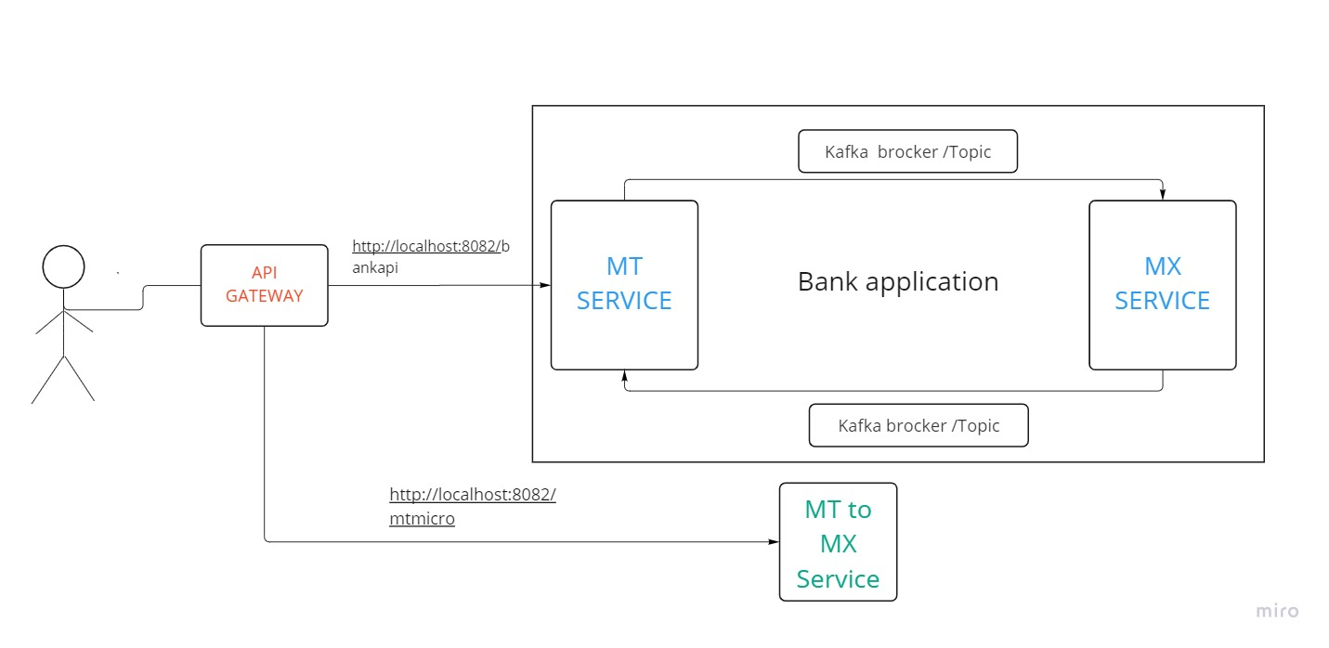

# API GATEWAY

This Service is provides a flexible way of routing requests based on a number of criteria, as well as focuses on cross-cutting concerns such as security, resiliency, and monitoring. Spring Cloud Gateway aims to provide a simple, yet effective way to route to APIs and provide cross cutting concerns to them such as: security, monitoring/metrics, and resiliency.

Here we used to route the 2 micro services.

# MT Service

This Service is used to convert User request to MT103 messages then This application produce message to a kafka topics(mtmessage).Also listening the kafka topic and Consume the messages and give a response to user .

* Also provide user registration for creating user account.
* Store Receiver account details.
* User Deposit
* Check user balance .

When we create account it is a zero balance account . All transactions are reflected through this given datas.

# MX Service

This service is used to convert MT103 message to MX message .Using kafka consume technology for listening messages then this converted XML message produce to a kafka topics(mx message).

# MT to MX Service .

This service is used to convert MT103 message to MX message Directly .Then give a response to user

# Project Setup

* Install Java 8
* Set up Kafka Using Docker ,Docker compose file attached in project folder
* Create Kafka topic

kafka-topics.sh --create --topic mtmessage --bootstrap-server localhost:9092

kafka-topics.sh --create --topic mxmessage --bootstrap-server localhost:9092

## Listen Kafka Messages

kafka-console-consumer.sh --topic mtmessage --from-beginning --bootstrap-server localhost:9092

{"SenderAccountnumber":"790773028412345","MTMessage":"{1:F01ENFEESS1A230000000000}{2:I103ENF43332XXXXN}{3:{121:724209c7-6d6e-4a68-becd-6c51bb0997bf}}{4:\r\n:20:REFERENCE\r\n:23B:CRED\r\n:32A:220829INR1\r\n:50A:/790773028412345\r\nSBI\r\n:59:/9539931867123\r\nSBI\r\n:71A:OUR\r\n-}","time":"2022-08-29T09:50:12.369307200Z"}

kafka-console-consumer.sh --topic mxmessage --from-beginning --bootstrap-server localhost:9092

{"MXmessage":"<message>\r\n<block1>\r\n\t<applicationId>F<\/applicationId>\r\n\t<serviceId>01<\/serviceId>\r\n\t<logicalTerminal>0000000000<\/logicalTerminal>\r\n<\/block1>\r\n<block2 type=\"input\">\r\n\t<messageType>103<\/messageType>\r\n\t<receiverAddress>N<\/receiverAddress>\r\n<\/block2>\r\n<block3>\r\n\t<tag>\r\n\t\t<name>121<\/name>\r\n\t\t<value>6e7e8273-8467-4b0b-8b3a-0bc9a1d356a5<\/value>\r\n\t<\/tag>\r\n<\/block3>\r\n<block4>\r\n\t<tag>\r\n\t\t<name>20<\/name>\r\n\t\t<value>REFERENCE<\/value>\r\n\t<\/tag>\r\n\t<tag>\r\n\t\t<name>23B<\/name>\r\n\t\t<value>CRED<\/value>\r\n\t<\/tag>\r\n\t<tag>\r\n\t\t<name>32A<\/name>\r\n\t\t<value>220829100<\/value>\r\n\t<\/tag>\r\n\t<tag>\r\n\t\t<name>50A<\/name>\r\n\t\t<value>/1720364789995554\r\nSBI<\/value>\r\n\t<\/tag>\r\n\t<tag>\r\n\t\t<name>59<\/name>\r\n\t\t<value>/11225546165621\r\nSBI<\/value>\r\n\t<\/tag>\r\n\t<tag>\r\n\t\t<name>71A<\/name>\r\n\t\t<value>OUR<\/value>\r\n\t<\/tag>\r\n<\/block4>\r\n<\/message>"}

* Install mysql and give password as root (password = root) and create Database mtbank(DB = mtbank)
* Then Run the 4 Spring boot applications using spring or other tools

# Hackathon API Request Examples

Make sure all four API are running successfully

1. Create User

URI = <http://localhost:8082/bankapi/usercreate> (post method)

Json Request body =

{

  "accountnumber": "1720364789995555",

  "username": "Ajay"

}

1. Create Receivers bank details

URI = http://localhost:8082/bankapi/addreceiveraccount (post method)

Json Request body =

{

  "accountnumber": "11225546165620",

  "bankName": "SBI",

  "ifsccode": "SBIN112445",

  "receivername": "Arshad"

}

1. User Deposit

URI = http://localhost:8082/bankapi/deposit (put method)

Json Request body =

{

  "accountnumber": "1720364789995555"

}

1. Transfer amount :this api take user data and create mt103 then send the mt103 message

URI = <http://localhost:8082/bankapi/transfermessage> (post method)

Json Request body =

{

  "accountnumber": "790773028412345",

  "address": "SBI",

  "amount": "100",

  "bankname": "SBI",

  "currency": "INR",

  "receiver": "ENF43332",

  "receiverAccountNo": "9539931867123",

  "refernce": "CRED",

  "sender": "ENFEESS123

}

Response

{

    "status": 200,

    "message": "Amount Transfered Successfully",

    "mtmessage": "{1:F01ENFEESS1A230000000000}{2:I103ENF43332XXXXN}{3:{121:eba1f58e-ad28-429d-b2ba-2576fa8e06fb}}{4:\r\n:20:ENF112344\r\n:23B:CRED\r\n:32A:220830INR1\r\n:50A:/1720364789995558\r\nSBI\r\n:59:/112255461656148\r\nSBI\r\n:71A:OUR\r\n-}",

    "mxmessage": "<?xml version=\"1.0\" encoding=\"UTF-8\" ?>\n<Document xmlns=\"urn:iso:std:iso:20022:tech:xsd:pacs.008.001.08\">\r\n    <FIToFICstmrCdtTrf>\r\n        <GrpHdr>\r\n            <MsgId>ENF112344</MsgId>\r\n            <CreDtTm>2022-08-30T17:32:16.773+05:30</CreDtTm>\r\n            <NbOfTxs>1</NbOfTxs>\r\n            <SttlmInf>\r\n                <SttlmMtd>INDA</SttlmMtd>\r\n                <SttlmAcct>\r\n                    <Id>\r\n                        <Othr>\r\n                            <Id>00010013800002001234</Id>\r\n                        </Othr>\r\n                    </Id>\r\n                </SttlmAcct>\r\n            </SttlmInf>\r\n            <InstgAgt>\r\n                <FinInstnId></FinInstnId>\r\n            </InstgAgt>\r\n            <InstdAgt>\r\n                <FinInstnId></FinInstnId>\r\n            </InstdAgt>\r\n        </GrpHdr>\r\n        <CdtTrfTxInf>\r\n            <PmtId>\r\n                <InstrId>ENF112344</InstrId>\r\n                <EndToEndId>ENF112344</EndToEndId>\r\n                <TxId>ENF112344</TxId>\r\n            </PmtId>\r\n            <IntrBkSttlmAmt Ccy=\"INR\">1</IntrBkSttlmAmt>\r\n            <IntrBkSttlmDt>2022-08-30</IntrBkSttlmDt>\r\n            <ChrgBr>DEBT</ChrgBr>\r\n            <Dbtr>\r\n                <Nm>JOE DOE</Nm>\r\n                <PstlAdr>\r\n                    <AdrLine>SBI</AdrLine>\r\n                </PstlAdr>\r\n            </Dbtr>\r\n            <DbtrAcct>\r\n                <Id>\r\n                    <Othr>\r\n                        <Id>1720364789995558</Id>\r\n                    </Othr>\r\n                </Id>\r\n            </DbtrAcct>\r\n            <DbtrAgt>\r\n                <FinInstnId>\r\n                    <BICFI>FOOENXM</BICFI>\r\n                </FinInstnId>\r\n            </DbtrAgt>\r\n            <CdtrAgt>\r\n                <FinInstnId>\r\n                    <BICFI>1720364789995558 SBI</BICFI>\r\n                </FinInstnId>\r\n            </CdtrAgt>\r\n            <Cdtr>\r\n                <Nm>TEST CORP</Nm>\r\n                <PstlAdr>\r\n                    <AdrLine>LAS SBI</AdrLine>\r\n                </PstlAdr>\r\n            </Cdtr>\r\n            <CdtrAcct>\r\n                <Id>\r\n                    <Othr>\r\n                        <Id>112255461656148</Id>\r\n                    </Othr>\r\n                </Id>\r\n            </CdtrAcct>\r\n        </CdtTrfTxInf>\r\n    </FIToFICstmrCdtTrf>\r\n</Document>\n XML : <message>\r\n<block1>\r\n\t<applicationId>F</applicationId>\r\n\t<serviceId>01</serviceId>\r\n\t<logicalTerminal>ENFEESS1A230</logicalTerminal>\r\n\t<sessionNumber>0000</sessionNumber>\r\n\t<sequenceNumber>00000</sequenceNumber>\r\n</block1>\r\n<block2 type=\"input\">\r\n\t<messageType>103</messageType>\r\n\t<receiverAddress>ENF43332XXXX</receiverAddress>\r\n\t<messagePriority>N</messagePriority>\r\n</block2>\r\n<block3>\r\n\t<tag>\r\n\t\t<name>121</name>\r\n\t\t<value>eba1f58e-ad28-429d-b2ba-2576fa8e06fb</value>\r\n\t</tag>\r\n</block3>\r\n<block4>\r\n\t<tag>\r\n\t\t<name>20</name>\r\n\t\t<value>ENF112344</value>\r\n\t</tag>\r\n\t<tag>\r\n\t\t<name>23B</name>\r\n\t\t<value>CRED</value>\r\n\t</tag>\r\n\t<tag>\r\n\t\t<name>32A</name>\r\n\t\t<value>220830INR1</value>\r\n\t</tag>\r\n\t<tag>\r\n\t\t<name>50A</name>\r\n\t\t<value>/1720364789995558\r\nSBI</value>\r\n\t</tag>\r\n\t<tag>\r\n\t\t<name>59</name>\r\n\t\t<value>/112255461656148\r\nSBI</value>\r\n\t</tag>\r\n\t<tag>\r\n\t\t<name>71A</name>\r\n\t\t<value>OUR</value>\r\n\t</tag>\r\n</block4>\r\n</message>"

}

1. User Balance

URI =http://localhost:8082/bankapi/userbalance (Get Method)

Json request body:

{

  "accountnumber": "1720364789995555"

}

1. Receiver Balance

URI =http://localhost:8082/bankapi/receiverbalance (Get Method)

Json request body:

{

  "accountnumber": "1244"

}

1. MT to MX Converter

URI = http://localhost:8082/mtmicro/mttovalue (Get Method)

Json request body: This message takes from given 103.txt file

{

    "message":"{1:F01BICFOOYYAXXX8683497519}{2:O1031535051028ESPBESMMAXXX54237522470510281535N}{3:{113:ROMF}{108:0510280182794665}{119:STP}}{4:\r\n:20:0061350113089908\r\n:13C:/RNCTIME/1534+0000\r\n:23B:CRED\r\n:23E:SDVA\r\n:32A:061028EUR100000,\r\n:33A:081029EUR120000,\r\n:33B:EUR100000,\r\n:50K:/12345678\r\nAGENTES DE BOLSA FOO AGENCIA\r\nAV XXXXX 123 BIS 9 PL\r\n12345 BARCELONA\r\n:52A:/2337\r\nFOOAESMMXXX\r\n:53A:FOOAESMMXXX\r\n:57A:BICFOOYYXXX\r\n:59:/ES0123456789012345671234\r\nFOO AGENTES DE BOLSA ASOC\r\n:71A:OUR\r\n:72:/BNF/TRANSF. BCO. FOO\r\n-}{5:{MAC:88B4F929}{CHK:22EF370A4073}}"

}

**Response**

"status": 200,

    "message": "<message>\r\n<block1>\r\n\t<applicationId>F</applicationId>\r\n\t<serviceId>01</serviceId>\r\n\t<logicalTerminal>BICFOOYYAXXX</logicalTerminal>\r\n\t<sessionNumber>8683</sessionNumber>\r\n\t<sequenceNumber>497519</sequenceNumber>\r\n</block1>\r\n<block2 type=\"output\">\r\n\t<messageType>103</messageType>\r\n\t<senderInputTime>1535</senderInputTime>\r\n\t<MIRDate>051028</MIRDate>\r\n\t<MIRLogicalTerminal>ESPBESMMAXXX</MIRLogicalTerminal>\r\n\t<MIRSessionNumber>5423</MIRSessionNumber>\r\n\t<MIRSequenceNumber>752247</MIRSequenceNumber>\r\n\t<receiverOutputDate>051028</receiverOutputDate>\r\n\t<receiverOutputTime>1535</receiverOutputTime>\r\n\t<messagePriority>N</messagePriority>\r\n</block2>\r\n<block3>\r\n\t<tag>\r\n\t\t<name>113</name>\r\n\t\t<value>ROMF</value>\r\n\t</tag>\r\n\t<tag>\r\n\t\t<name>108</name>\r\n\t\t<value>0510280182794665</value>\r\n\t</tag>\r\n\t<tag>\r\n\t\t<name>119</name>\r\n\t\t<value>STP</value>\r\n\t</tag>\r\n</block3>\r\n<block4>\r\n\t<tag>\r\n\t\t<name>20</name>\r\n\t\t<value>0061350113089908</value>\r\n\t</tag>\r\n\t<tag>\r\n\t\t<name>13C</name>\r\n\t\t<value>/RNCTIME/1534+0000</value>\r\n\t</tag>\r\n\t<tag>\r\n\t\t<name>23B</name>\r\n\t\t<value>CRED</value>\r\n\t</tag>\r\n\t<tag>\r\n\t\t<name>23E</name>\r\n\t\t<value>SDVA</value>\r\n\t</tag>\r\n\t<tag>\r\n\t\t<name>32A</name>\r\n\t\t<value>061028EUR100000,</value>\r\n\t</tag>\r\n\t<tag>\r\n\t\t<name>33A</name>\r\n\t\t<value>081029EUR120000,</value>\r\n\t</tag>\r\n\t<tag>\r\n\t\t<name>33B</name>\r\n\t\t<value>EUR100000,</value>\r\n\t</tag>\r\n\t<tag>\r\n\t\t<name>50K</name>\r\n\t\t<value>/12345678\r\nAGENTES DE BOLSA FOO AGENCIA\r\nAV XXXXX 123 BIS 9 PL\r\n12345 BARCELONA</value>\r\n\t</tag>\r\n\t<tag>\r\n\t\t<name>52A</name>\r\n\t\t<value>/2337\r\nFOOAESMMXXX</value>\r\n\t</tag>\r\n\t<tag>\r\n\t\t<name>53A</name>\r\n\t\t<value>FOOAESMMXXX</value>\r\n\t</tag>\r\n\t<tag>\r\n\t\t<name>57A</name>\r\n\t\t<value>BICFOOYYXXX</value>\r\n\t</tag>\r\n\t<tag>\r\n\t\t<name>59</name>\r\n\t\t<value>/ES0123456789012345671234\r\nFOO AGENTES DE BOLSA ASOC</value>\r\n\t</tag>\r\n\t<tag>\r\n\t\t<name>71A</name>\r\n\t\t<value>OUR</value>\r\n\t</tag>\r\n\t<tag>\r\n\t\t<name>72</name>\r\n\t\t<value>/BNF/TRANSF. BCO. FOO</value>\r\n\t</tag>\r\n</block4>\r\n<block5>\r\n\t<tag>\r\n\t\t<name>MAC</name>\r\n\t\t<value>88B4F929</value>\r\n\t</tag>\r\n\t<tag>\r\n\t\t<name>CHK</name>\r\n\t\t<value>22EF370A4073</value>\r\n\t</tag>\r\n</block5>\r\n</message>",

    "mxMessage": "<?xml version=\"1.0\" encoding=\"UTF-8\" ?>\n<Document xmlns=\"urn:iso:std:iso:20022:tech:xsd:pacs.008.001.08\">\r\n    <FIToFICstmrCdtTrf>\r\n        <GrpHdr>\r\n            <MsgId>0061350113089908</MsgId>\r\n            <CreDtTm>2022-08-30T17:34:52.522+05:30</CreDtTm>\r\n            <NbOfTxs>1</NbOfTxs>\r\n            <SttlmInf>\r\n                <SttlmMtd>INDA</SttlmMtd>\r\n                <SttlmAcct>\r\n                    <Id>\r\n                        <Othr>\r\n                            <Id>00010013800002001234</Id>\r\n                        </Othr>\r\n                    </Id>\r\n                </SttlmAcct>\r\n            </SttlmInf>\r\n            <InstgAgt>\r\n                <FinInstnId>\r\n                    <BICFI>FOOAESMMXXX</BICFI>\r\n                </FinInstnId>\r\n            </InstgAgt>\r\n            <InstdAgt>\r\n                <FinInstnId>\r\n                    <BICFI>BICFOOYYXXX</BICFI>\r\n                </FinInstnId>\r\n            </InstdAgt>\r\n        </GrpHdr>\r\n        <CdtTrfTxInf>\r\n            <PmtId>\r\n                <InstrId>0061350113089908</InstrId>\r\n                <EndToEndId>0061350113089908</EndToEndId>\r\n                <TxId>0061350113089908</TxId>\r\n            </PmtId>\r\n            <IntrBkSttlmAmt Ccy=\"EUR\">100</IntrBkSttlmAmt>\r\n            <IntrBkSttlmDt>2022-08-30</IntrBkSttlmDt>\r\n            <ChrgBr>DEBT</ChrgBr>\r\n            <Dbtr>\r\n                <Nm>JOE DOE</Nm>\r\n                <PstlAdr>\r\n                    <AdrLine>BARCELONA</AdrLine>\r\n                </PstlAdr>\r\n            </Dbtr>\r\n            <DbtrAcct>\r\n                <Id>\r\n                    <Othr>\r\n                        <Id>12345678</Id>\r\n                    </Othr>\r\n                </Id>\r\n            </DbtrAcct>\r\n            <DbtrAgt>\r\n                <FinInstnId>\r\n                    <BICFI>FOOAESMMXXX</BICFI>\r\n                </FinInstnId>\r\n            </DbtrAgt>\r\n            <CdtrAgt>\r\n                <FinInstnId>\r\n                    <BICFI>BICFOOYYXXX</BICFI>\r\n                </FinInstnId>\r\n            </CdtrAgt>\r\n            <Cdtr>\r\n                <Nm>TEST CORP</Nm>\r\n                <PstlAdr>\r\n                    <AdrLine>LAS ASOC</AdrLine>\r\n                </PstlAdr>\r\n            </Cdtr>\r\n            <CdtrAcct>\r\n                <Id>\r\n                    <Othr>\r\n                        <Id>ES0123456789012345671234</Id>\r\n                    </Othr>\r\n                </Id>\r\n            </CdtrAcct>\r\n        </CdtTrfTxInf>\r\n    </FIToFICstmrCdtTrf>\r\n</Document>\n"

}

# Project Performance Test

**Using JMETER**

Here we give 2 threads and 100 loops in one second ramp period so we get zero Error%.

When we give 10 thread with 50 loops the error percentage is 5% .

Here only showing our major rest api call for Transfer money .

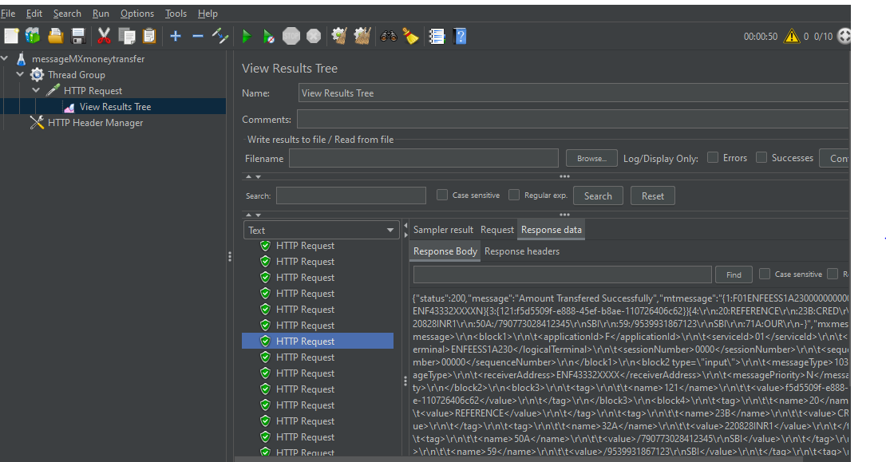

**AGGREGATE REPORT**

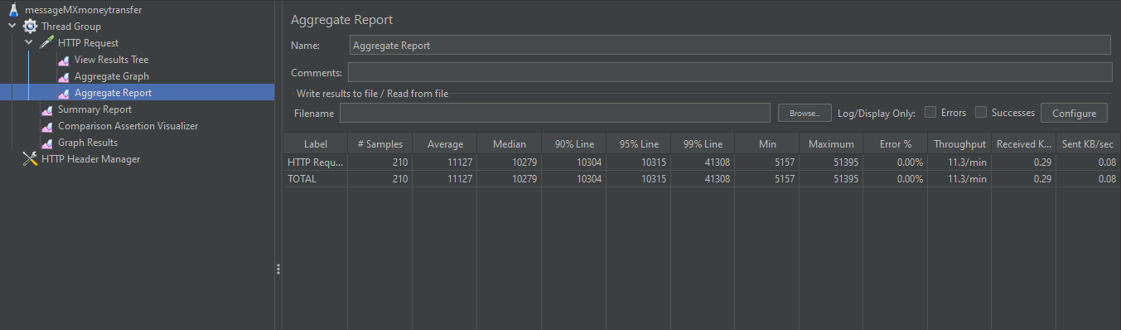

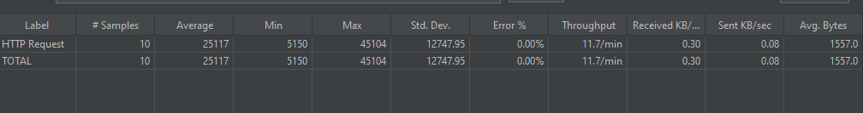

**AGGREGATE Summary**

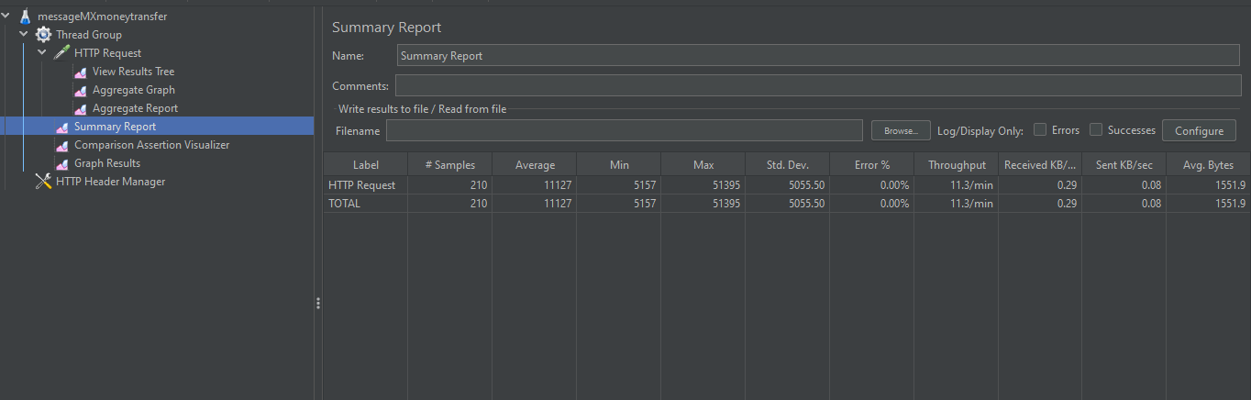

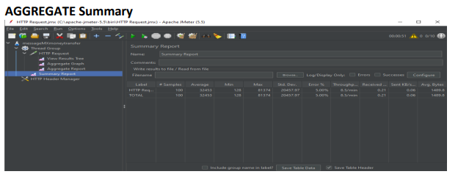

**AGGREGATE Graph**

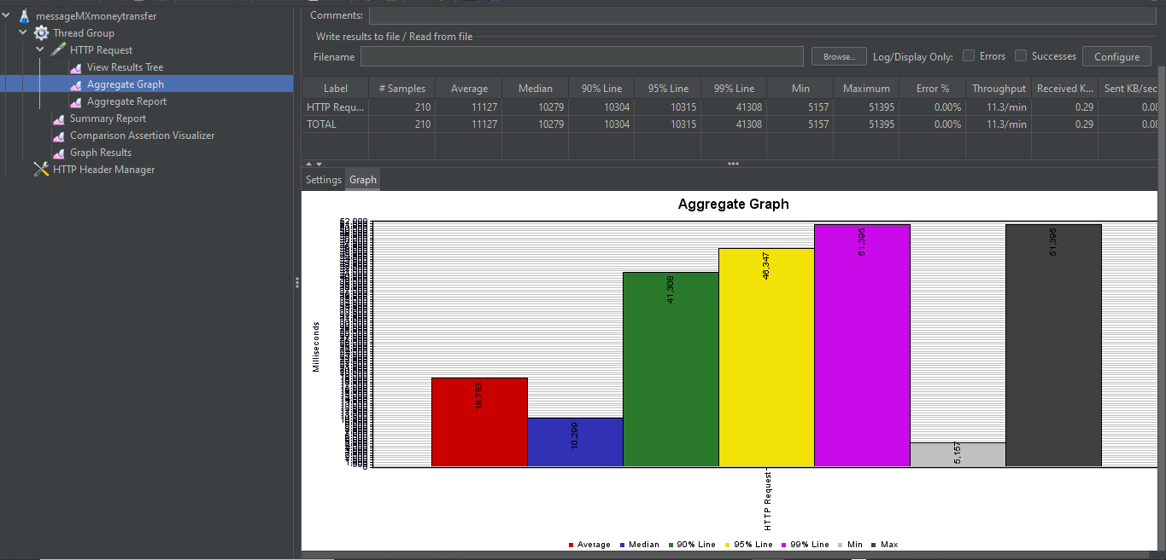

**GRAPH**

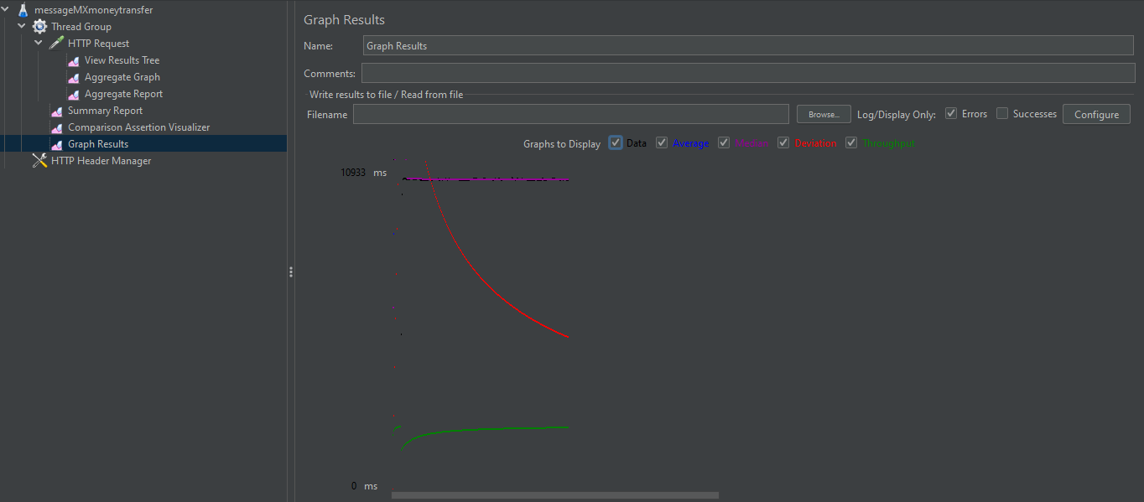

# JUNIT TESTING

Junit test for 7 modules

Here we created 8 Unit test cases for all rest api services . All service tests are passed .

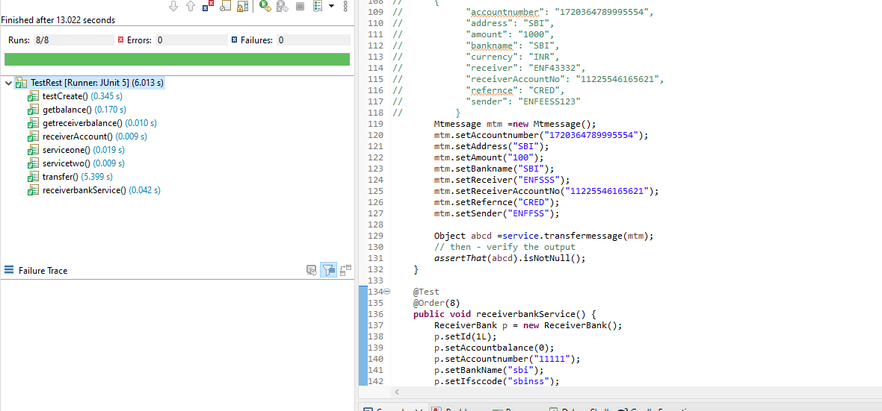

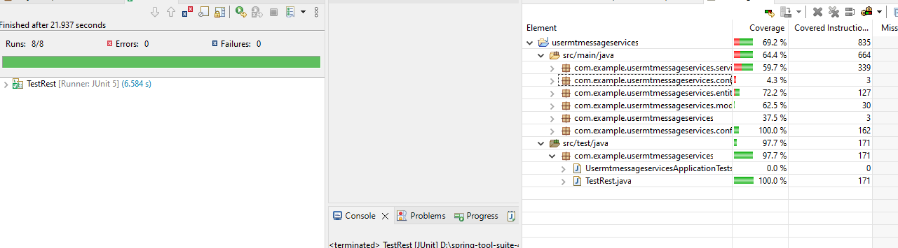

# SWAGGER IMPLIMENTATION

We use the swagger for the rest control testing and documentation.

