**Setting up application –**

1. ng-app

ng-app attribute in html or body or div tag indicates that the directives under this will have angular contents.

<html ng-app="app">

1. include the angular javascript file from google.

<script type="text/javascript" src=<https://ajax.googleapis.com/ajax/libs/angularjs/1.2.0/angular.min.js>> </script>

Here we are using the angular from google CDN but in real production version this should be coming from same server.

1. include the custom angular js file for your code.

<script type="text/javascript" src="app.js"></script>

In custom angular js file –

angular.module(‘app’, []);

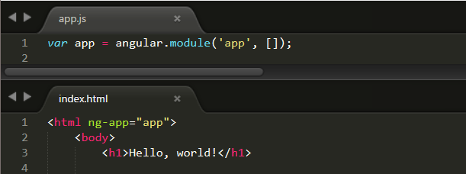

**Interpolation and Controller**

**Interpolation –**

To interpolate we should use ‘{{}}’. It evaluated whatever is inside the double curly braces.

Eg.

{{ val }}

{{ func() }}

**Controllers –**

Controller is used to operate some section of the views.

Way to declare controller in html is below

<html ng-app="app">

<body>

<h1>Hello, world!</h1>

<div ng-controller="MainController">

<p>interpolation – {{val}}</p>

</div> . . . </html>

There are three ways to declare controller:-

1. Global function –

We can create controller like global function. Like below –

angular.module(‘app’, []);

var MainController = function($scope){

$scope.val = “test123”

}

This is not a great way to do create controller. It is polluting the global namespace in javascript. We need to make controller as modular as possible.

1. Declare controller in entire application –

This is cleaner then declaring global function.

var app = angular.module(‘app’, []);

app.controller(‘mainController’, function($scope){

$scope.val = “test456”

})

1. Declare controller in a module and include in the application –

This is the preferred way of doing in production application

angular.module(‘app’, [‘controllers’]);

angular.module(‘controllers’, []).controller(‘mainController’, function($scope){

$scope.val = “test789”

})

**Built-in Directives –**

***ng-click:***

* It can be attached to any html element.
* Any time the element is clicked it kicks an event.

***ng-show & ng-hide –***

* It hides or shows an element where it is declared.
* Do not use functions in ng-show and ng-hide.
* Use state variable instead.

Examples of ng-click, ng-hide and ng-show –

Index.html

<div ng-controller="MainController">

{{val}}

<button ng-click="inc()" >Click me</button>

<h2 ng-show="isEven">even</h2>

<h2 ng-hide="isEven">odd</h2>

</div>

App.js

var app = angular.module('app', []);

app.controller('MainController', function($scope){

$scope.val = 1

$scope.isEven = false

$scope.inc = function(){

$scope.val += 1

$scope.isEven = $scope.val%2==0

}

})

Sdfasdfasdfsdaf

ghdfghgfh