**ASSIGNMENT1**

Problem Statement:

You work for Xyz Corporation, Your Corporation wants to launch a new web-based application using AWS virtual machines. Configure the resources accordingly for the tasks.

TASKS TO BE PERFORMED:

1. Create an instance in the US-East-1 (N.Virgina) region with an Ubuntu OS and install Nginx for making them web servers.

2. Change the default website with a page displaying the message: “Hello World”.

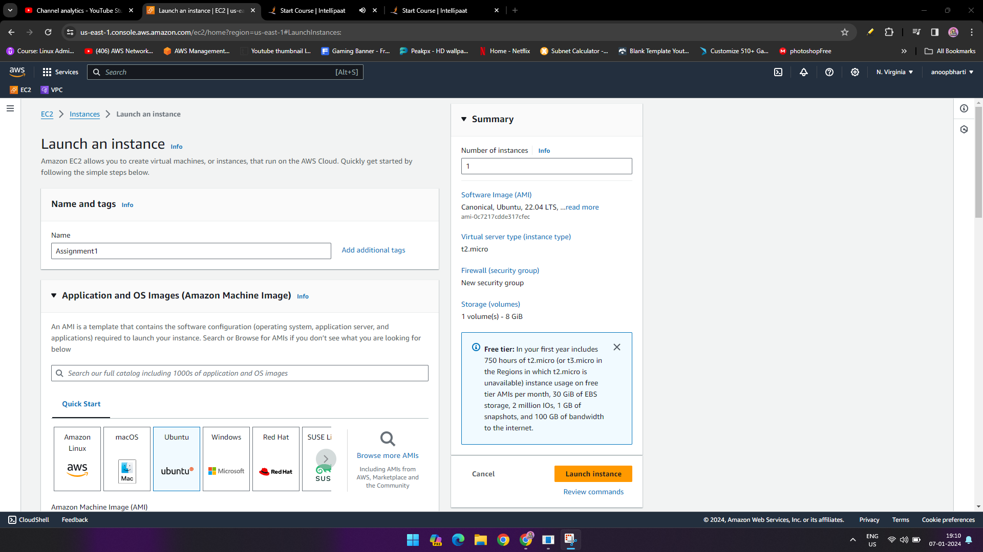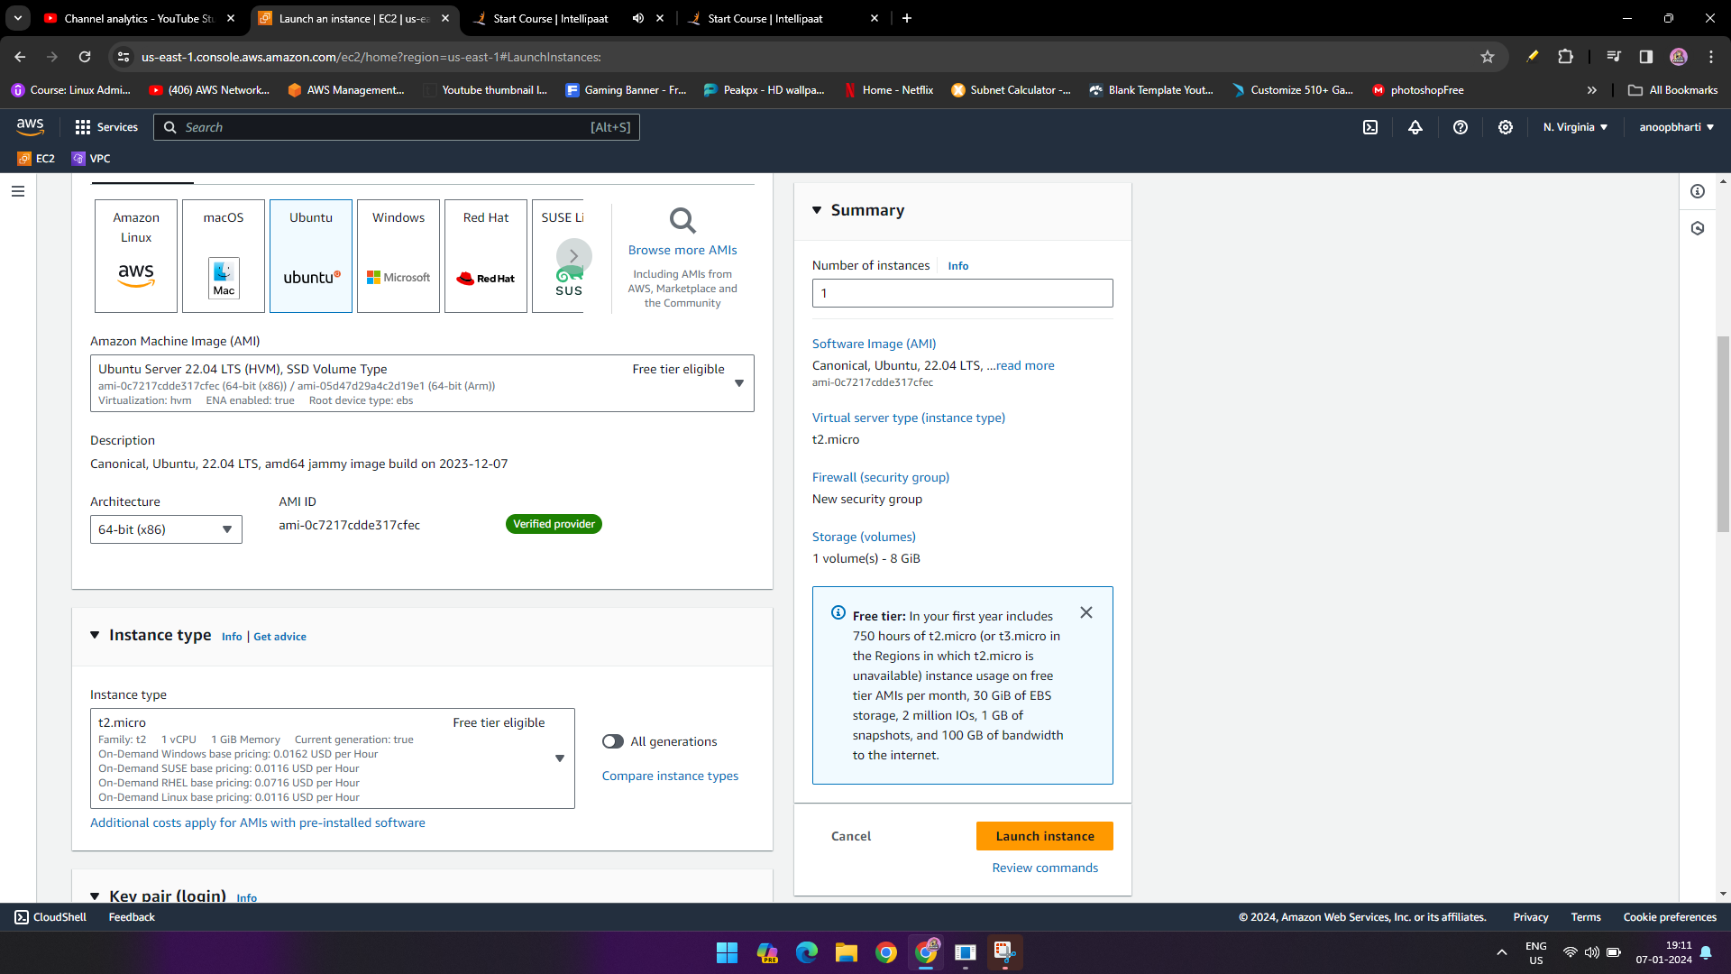

Click on “create new key pair”.

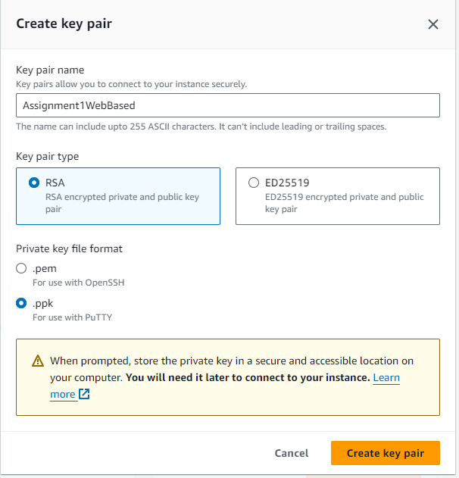

Network Section

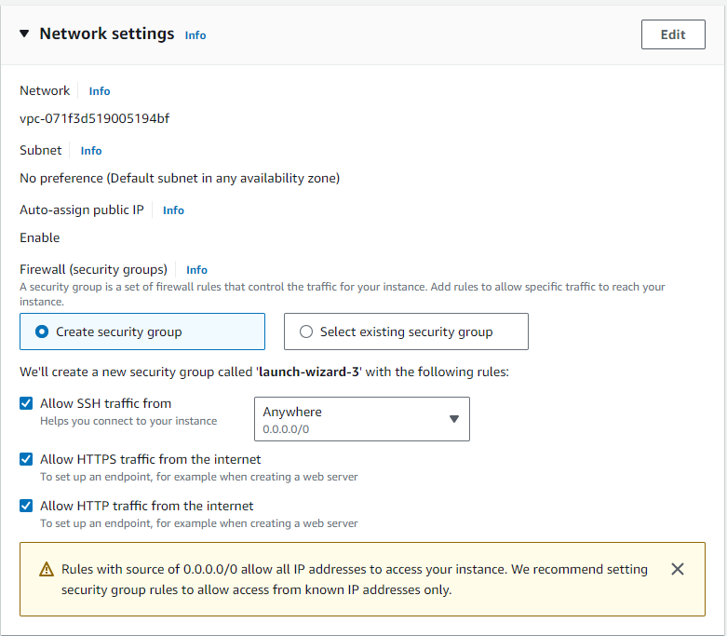

Click Launch Instance

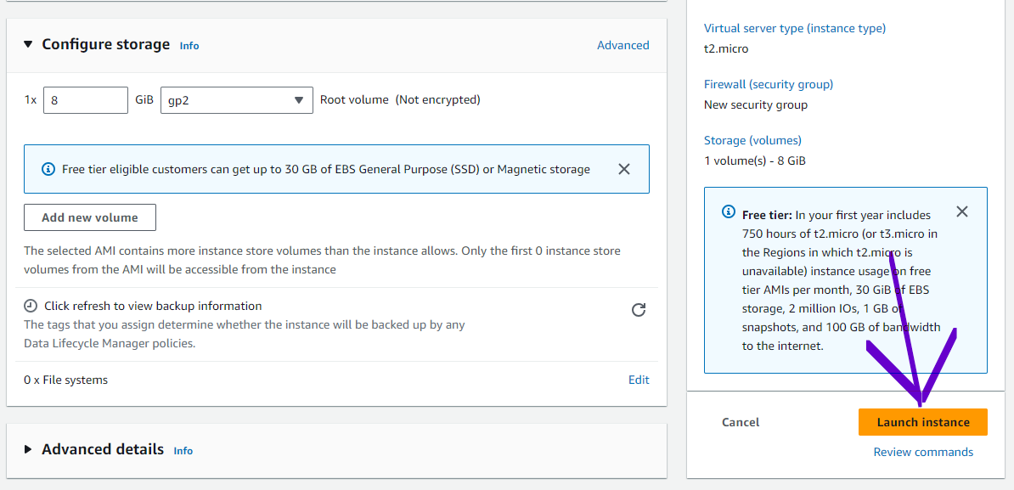

Select the instance and copy the Public Ip Adress and go to putty.

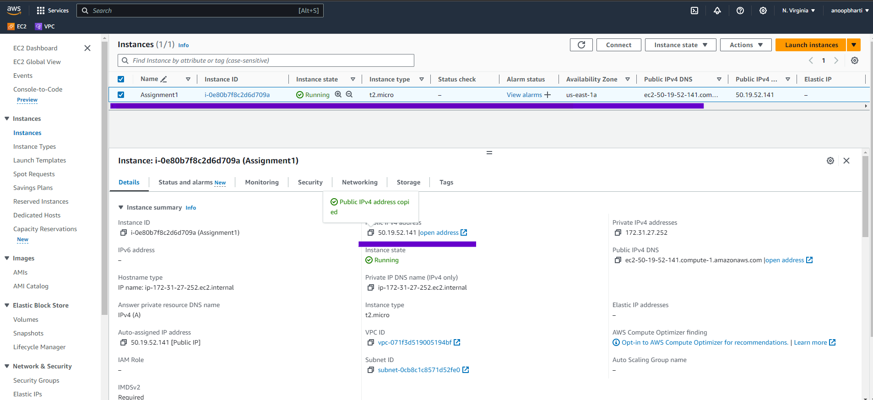

In Putty , paste your public IP address and go to left side option SSH then Auth the Credentials.

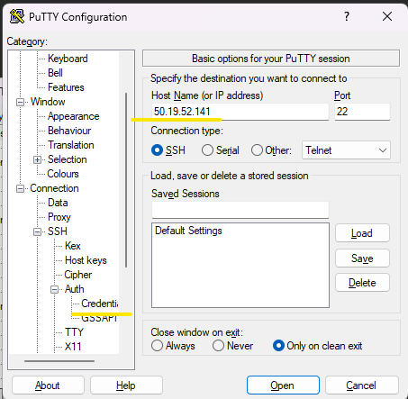

Then click on  **Credentials** and click on Browse ,and select your ppk file.

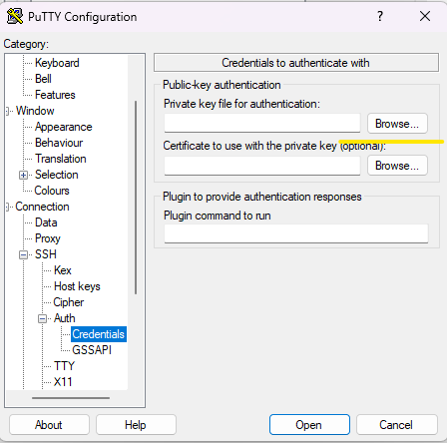

Then click on open 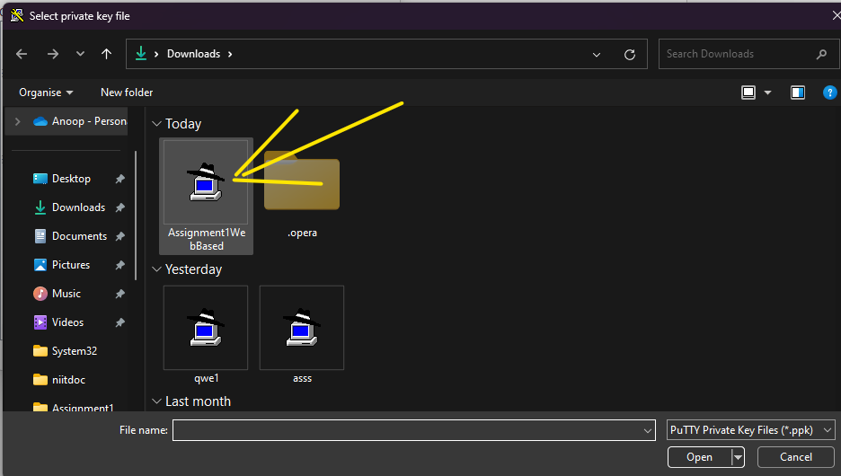

Then click on Accept

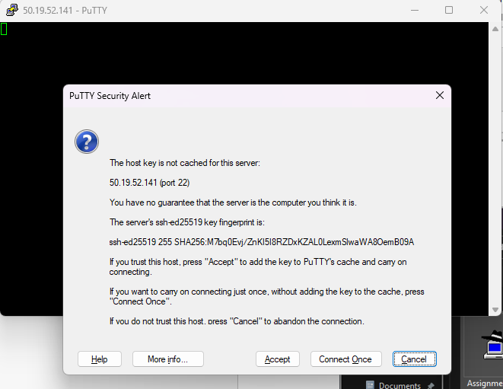

Then enter in **login as : Ubuntu**

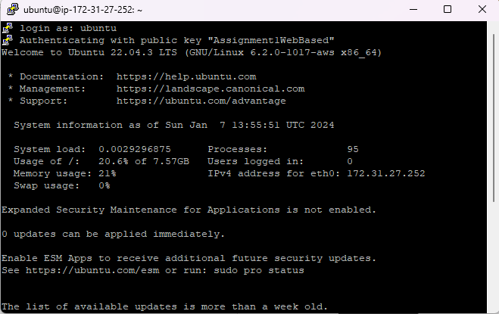

Then enter command **sudo apt-get update**

**Install nginx**

sudo apt-get install nginx –y

Then copy the Public IP address from Amazon machine and enter the IP address on Browser.

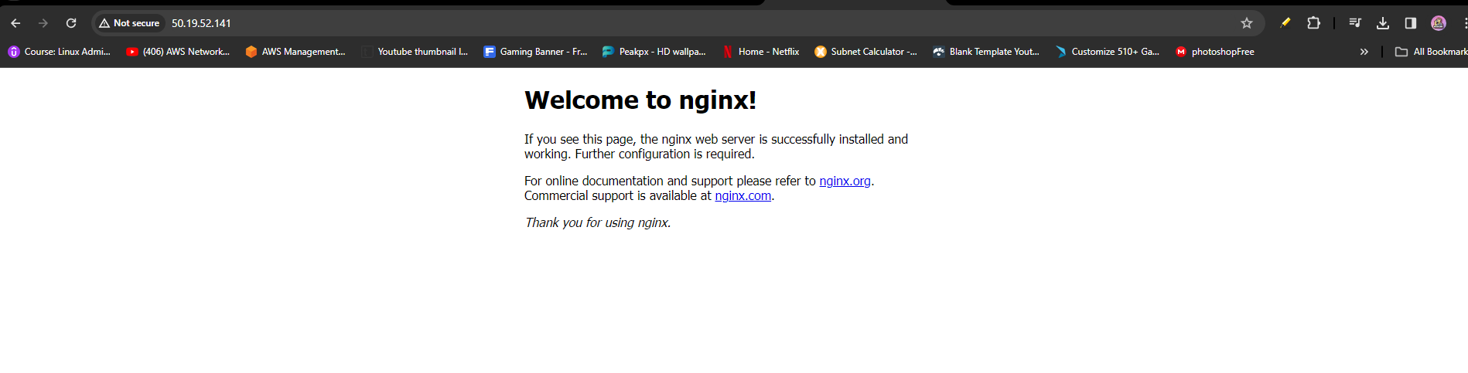

**NOW displaying the message: “Hello World”.**

1. go to terminal and type **cd /var/www/html , cd /var/www/html ,** it’s a store the all documents in **www.**
2. Delete the nginx

Command - sudo rm index.nginx-debian.html

1. Now create a Hello World message with nano command

Command – sudo nano index.html

Enter “HELLO WORLD”

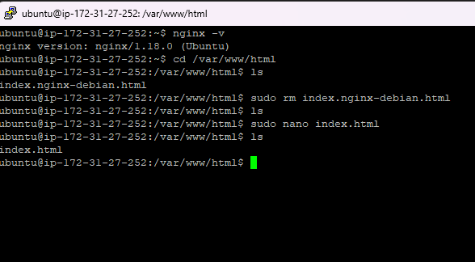

1. Copy the public IP address from Amazon Ubuntu instance and paste on browser .

**RESULT -**

