ANOOP R

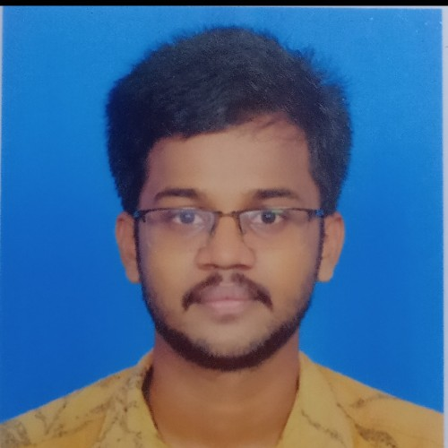@ [anooprkrishna2000@gmail.com](mailto:anooprkrishna2000@gmail.com)

O 6238134995

Krishna Vilasam Muttacaud, Muttacaud PO,,Trivandrum, kerala.







Objective

To work for an organization which provides me the opportunity to improve my skills and knowledge to grow along with the organisational objective.



Education

APJ Abdul Kalam Technological University, Kerala

2023

B. Tech in mechanical Engineering CGPA - 8.52



VPS HSS FOR BOYS VENGANOOR





2018

Plus Two 94.25



VPS HSS FOR BOYS VENGANOOR

2016

SSLC 10A+

Skills

CATIA

SOLIDWORKS





ANSYS (basics)

Projects



Design, Fabrication and testing of a variable pitch Darrieus type Vertical axis wind turbine for the







hamlets of communities residing along the long coastline of kerala and communities along the

hillocks

Vertical axis wind turbine working at low wind speeds for the domestic purpose . Blade designs are based on the Aerodynamic Principles.Design is a full scaled model, for the project purpose we scaled it to a laboratory model. We have fabricated and tested it.

Project Report Link:<https://drive.google.com/file/d/1gxN0Yu6Y2SdIWEYc0ujrUCxmfXYNueJI/view?usp=drivesdk>



Achievements & Awards

1. Participated in " Sustainability Hackathon (SUSTATHON) Challenge 2023" at Entrepreneurship

Development Institute of India (EDII), Ahmedabad, Gujarat. 2. Project paper presentation about the vertical axis wind turbine in The Institution of Engineers(India),Trivandrum.





1. Project paper presentation about the vertical axis wind turbine in The Institution of Engineers(India),Trivandrum.

AWARDS: "Academic Excellence Award" for scoring highest marks in the semester exams.



Languages

English( Read, Write, Speak - Advanced level) Hindi(Read, write, speak - intermediate level) Tamil( Speak)







Reference

S Chandrasekharan Nair - Retd. Head

Product Assurance,Aerospace Mechanisms Group,Vikram Sarabhai Space Centre(VSSC),Trivandrum.

[scnair00@gmail.com](mailto:scnair00@gmail.com) 9446967755







Strengths

Team work

Responsibility Adaptability Optimist





Dedicated



Certiﬁcates

1. Certiﬁcate of Participation in Grand Finale of Suatainabilty Hackathon Challenge 2023.
2. For Presenting a paper on Design, fabrication and testing of Variable Pitch Darrieus type vertical axis turbine at Institution of Engineers India, kerala state centre.



