Week 2:

1) Convert an RGB image to YUV and:
a)Revert it back to RGB
b)Quantize Y, U, V components differently and then revert it to RGB

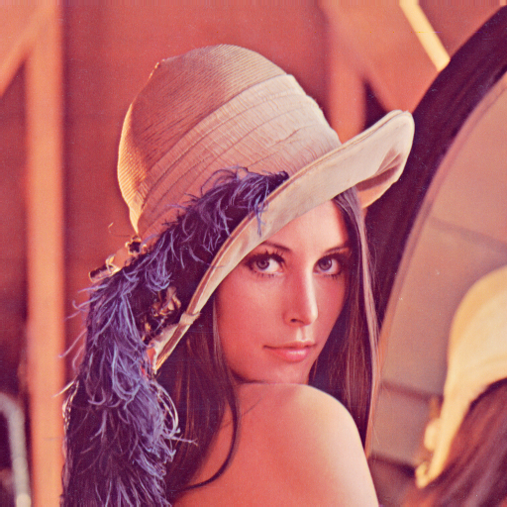
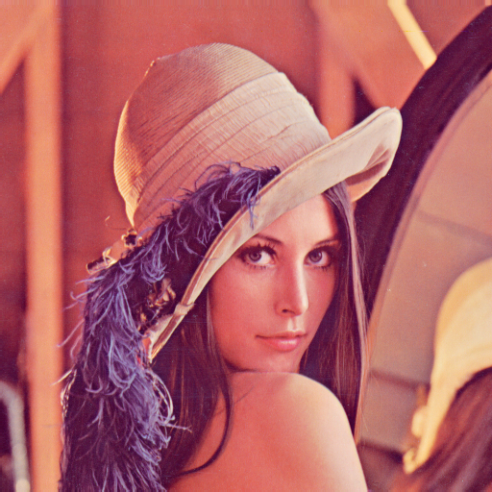

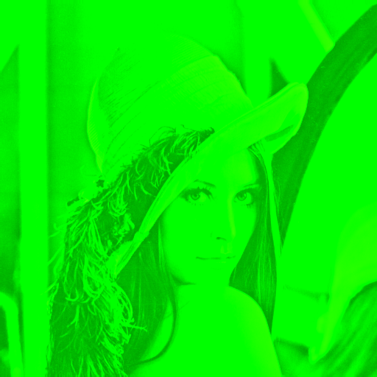

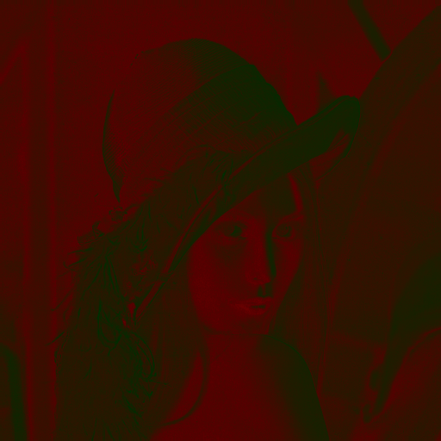
Original RGB Image Image converted from YUV to RGB

Y-Component U-Component V-Component

2) Write code to find PSNR between two images and:
a) Make two copies of an RGB image, edit one and the find the PSNR wrt the original.
b) Study the impact of quantization in the YUV space on PSNR and see how this does not correlate well with the visually perceived quality

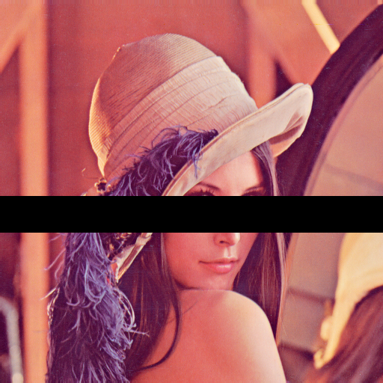

Original Image Edited Image

OBSERVATIONS:

Signal To Noise Ratio (with respect to the edited image): 15.51 db
Signal to Noise Ratio (after YUV conversion): 44.93 db

Effects of Quantization in Cb and Cr values:

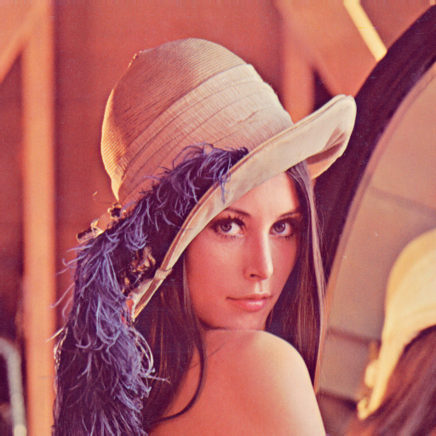
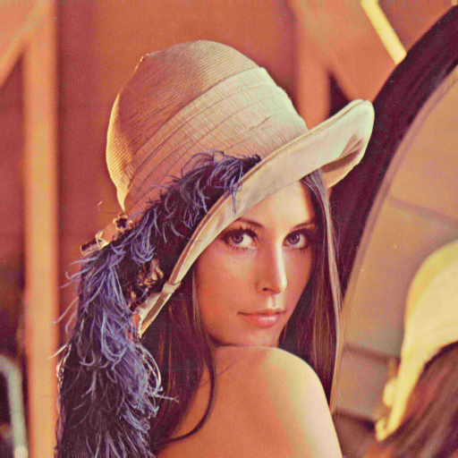
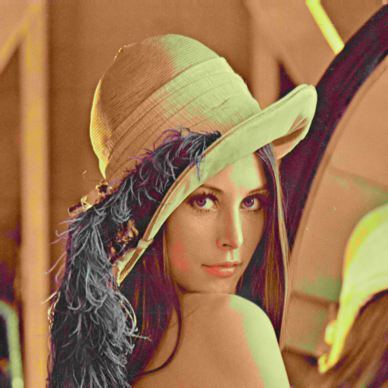

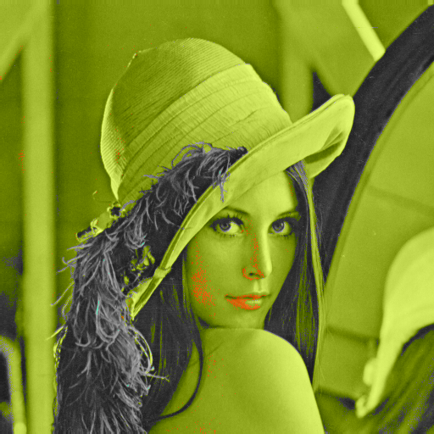
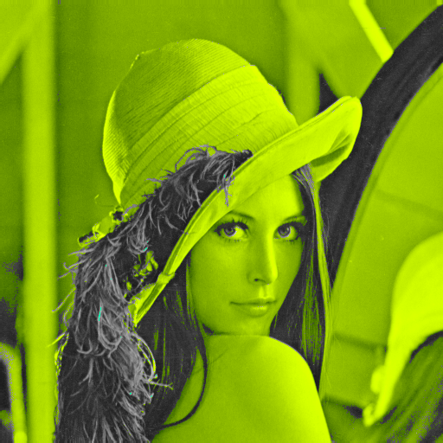
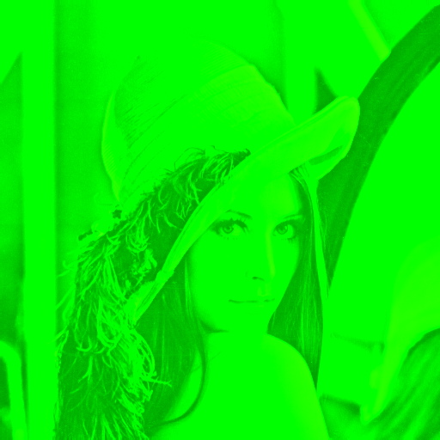
2-Bit Quantization 4-bit Quantization 5-Bit Quantization

6-Bit Quantization 7-Bit Quantization 8-Bit Quantization

Variation in SNR values for different Quantization Levels:

Level of Quantization | PSNR(in db)
0 | 44.93
1 | 41.48
2 | 36.66
3 | 31.31
4 | 25.62
5 | 19.80
6 | 12.73
7 | 10.39
8 | 4.69

WEEK 3

1) Implement a function to compute entropy of a color plane and also the image as a whole assuming the distribution of intensities represent the symbol probability of the source.
2)Implement down sampling if you haven’t done so in an earlier class. Study, record and submit the variation in compression, entropy and PSNR subsequent to the different compression tools you have implemented in this course.

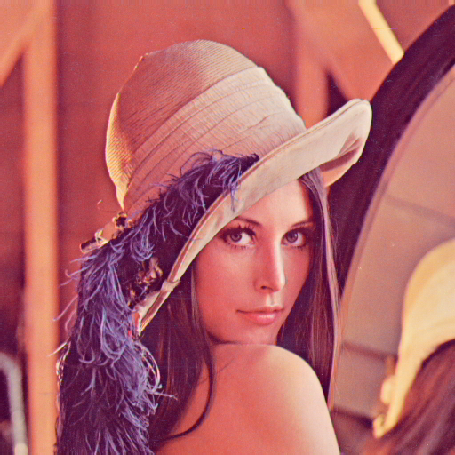

Original Bitmap image 4:1:1 Down Sampling(33.17db)

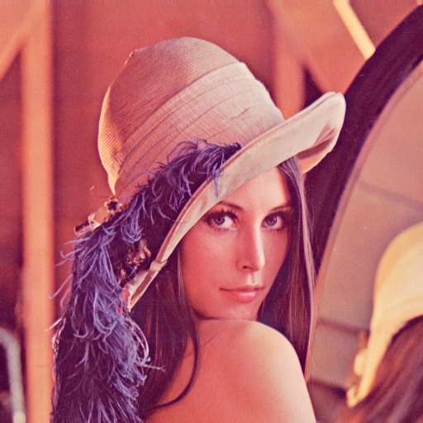
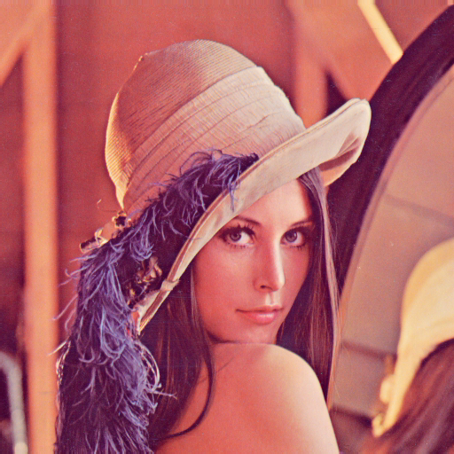

4:2:2 Down sampling(36.83 db) 4:2:0 Down sampling(34.52 db)

OBSERVATIONS:

Down sampling | R-Entropy | G_Entropy | B_Entropy | Image_entropy
4:4:4 | 7.25 | 7.59 | 6.97 | 7.75
4:1:1 | 7.25 | 7.58 | 6.99 | 7.71
4:2:2 | 7.25 | 7.58 | 6.98 | 7.72
4:2:0 | 7.25 | 7.58 | 6.98 | 7.71

Quantization | Y_Entropy | U_Entropy | V_Entropy | Image_Entropy
4:4:4 | 7.44 | 5.65 | 5.611 | 7.07
4:1:1 | 7.44 | 5.62 | 5.55 | 7.07
4:2:2 | 7.44 | 5.63 | 5.57 | 7.07
4:2:0 | 7.44 | 5.62 | 5.565 | 7.07
0 bit | 7.44 | 5.65 | 5.61 | 7.07
1 bit | 7.44 | 4.65 | 4.61 | 6.65
2 bit | 7.44 | 3.66 | 3.62 | 6.15
3 bit | 7.44 | 2.70 | 2.66 | 5.61
4 bit | 7.44 | 1.85 | 1.75 | 5.07
5 bit | 7.44 | 0.99 | 0.91 | 4.45
6 bit | 7.44 | 0.79 | 0.04 | 4.01
7 bit | 7.44 | 0.79 | 0.002 | 4.01
8 bit | 7.44 | 0 | 0 | 3.40

WEEK4

1) Apply DCT transform on the block in previous slide and verify results.
2) Apply DCT transform on different artificially created 8x8 blocks and examine the results.
3) Apply DCT transform on a few blocks in the Lena image that you choose at run time and examine the results. Do this on the RGB planes and also YUV planes.

****************** Activity 1: SAMPLE BLOCK ***************

48 39 40 68 60 38 50 121
149 82 79 101 113 106 27 62
58 63 77 69 124 107 74 125
80 97 74 54 59 71 91 66
18 34 33 46 64 61 32 37
149 108 80 106 116 61 73 92
211 233 159 88 107 158 161 109
212 104 40 44 71 136 113 66
******************** DCT matrix ***************************

699.25 43.18 55.25 72.11 24.00 -25.51 11.21 -4.14
-129.78 -71.50 -70.26 -73.35 59.43 -24.02 22.61 -2.05
85.71 30.32 61.78 44.87 14.84 17.35 15.51 -13.19
-40.81 10.17 -17.53 -55.81 30.50 -2.28 -21.00 -1.26
-157.50 -49.39 13.27 -1.78 -8.75 22.47 -8.47 -9.23
92.49 -9.03 45.72 -48.13 -58.51 -9.01 -28.54 10.38
-53.09 -62.97 -3.49 -19.62 56.09 -2.25 -3.28 11.91
-20.54 -55.90 -20.59 -18.19 -26.58 -27.07 8.47 0.31

*************************** Activity 2: RANDOM BLOCK ****************

9 129 120 60 1 90 130 21
4 81 25 131 31 129 90 45
14 143 118 68 100 60 148 148
89 147 7 18 127 144 51 136
25 73 99 79 13 131 100 69
62 28 51 145 7 141 93 73
37 61 141 137 121 42 37 112
39 44 130 17 91 83 55 18

****************************** DCT matrix ***************************

621.00 -66.19 -46.85 -44.23 -109.25 -14.38 -0.08 -59.42

16.08 -23.34 43.82 3.26 -78.22 -11.01 -81.21 -52.37

-56.10 51.03 -61.47 -38.81 -41.76 42.51 -0.32 53.03

-29.83 7.21 -20.21 -10.88 -29.46 111.28 24.81 -80.65
-34.75 32.44 36.70 59.48 -71.00 -44.89 24.58 35.64
60.48 21.50 29.75 -29.84 50.01 -80.61 -18.23 48.26
10.25 -10.27 35.68 -9.44 -51.16 32.13 -7.03 29.79
24.50 6.01 -11.64 -107.04 -42.27 13.41 -11.89 68.32
*********************** Activity 3: RGB Image Block *********************
Enter the starting row index and column index respectively: 2 2

58 58 62 59 56 54 72 63
57 66 65 62 61 60 70 68
63 57 65 62 61 63 67 71
64 60 64 62 64 66 75 62
63 61 57 67 61 61 66 74
62 59 61 70 62 64 64 79
61 59 67 60 64 66 60 74
66 71 70 63 57 70 62 80

****************************** DCT matrix ***************************

512.25 -18.62 12.90 -12.85 1.75 3.27 3.05 -0.50
-11.11 0.01 -2.63 2.27 -6.56 9.63 -11.78 9.03
-1.66 3.67 3.78 -6.54 -6.36 -4.80 3.01 0.35
-6.92 -3.51 -1.13 -2.52 6.96 2.36 -5.01 -1.27
-0.25 2.85 3.34 3.09 -4.25 3.85 -4.36 -0.44
-4.64 -0.42 -3.75 5.43 -2.37 3.98 2.93 7.65
1.23 -1.41 3.01 -2.35 4.26 2.85 2.72 -3.16
-4.75 -0.40 1.96 -1.29 4.64 -1.54 2.85 0.03

*********************** Activity 4: YUV Image Block *********************
Enter the starting row index and column index respectively: 2 2

157 160 158 160 160 157 155 159
157 157 157 161 160 158 160 157
155 157 157 158 159 158 158 157
156 157 160 160 159 157 157 160
157 159 160 156 159 160 157 156
158 160 157 160 157 159 158 154
159 159 161 159 161 158 161 160
156 157 156 159 158 157 159 158
****************************** DCT matrix ***************************

1265.38 -0.70 -4.83 -1.26 0.13 -0.69 -2.19 -0.01
-0.90 -0.05 -1.71 -0.87 1.94 -1.45 0.11 -0.79
0.90 -0.83 0.67 -0.38 2.57 0.34 -2.33 -0.49
1.76 4.15 0.08 1.28 -1.39 -1.24 0.38 -1.10
-1.38 0.26 0.37 -1.98 0.88 -2.50 1.88 -0.23
2.65 0.02 0.83 -3.20 1.77 -1.34 0.94 1.17
-4.03 1.21 -0.33 1.08 -0.66 -0.59 -0.92 -2.87
0.35 -0.24 0.59 0.94 -1.65 -2.30 1.27 2.11

