Introduction :
This problem is related for people who are looking at opening a new restaurant at a particular location.
We have selected NCR (Delhi, Noida or Gurugram) as ideal place. The ideal location needs to a place where there less or no similar restaurants. For a person who opens the new restaurant the main motive is that the area selected should have demand for the food and the competition should be less in the selected area. Another factor needs to consider is the restaurant type and available restaurant rating.
As Subway is a popular food chain so we are considering to open this type of restaurant.

Description of Data:
The data for the ideal location should provide the below information :
-- List of Subway restaurants
-- Distance of these restaurant from the ideal location
-- Other venues details like bus station, market, metro station etc as needed
-- Geodata (latitude and longitude)
-- The restaurants rating and type

Methodology:
-- Use of Foursquare data to get the restaurants and rating
-- Use of Geo Data to get the location coordinates
-- Look at the competition in the area and the rating
-- The analysis will lead us to making the conclusion and recommendation

The above information will help us to locate the ideal location for the new restaurant.

Result:
We considered Kalkaji, New Delhi as the area for the Subway. The result shows that there is already one similar restaurant in the area. The next we looked at the rating. It seems to be not very high.

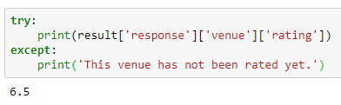

Conclusion:
The finding seems to meet our requirement. Firstly the competition is less. That is just one similar restaurant. Secondly the rating is not very high, so this gives a scope for new similar restaurant to open and show better standard so that its popularity plus is better then the existing competition.

