Marg AI 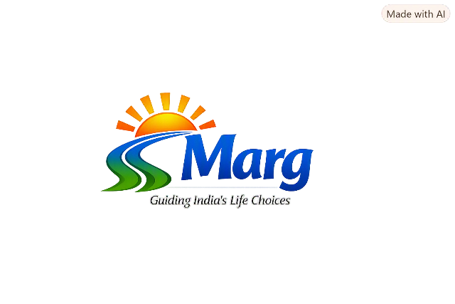
🏛️ Proposal: Life Choices Roadmap
Empowering Citizens to Make Informed Decisions Across Life Stages
1. Problem Statement
Citizens across different stages of life—students choosing education paths, young adults entering careers, families balancing responsibilities, and seniors planning retirement—often make decisions without structured guidance. This results in misaligned choices, underutilization of government schemes, increased stress, and weak intergenerational knowledge transfer.
Gap: Government services focus on transactions but lack decision-support frameworks that empower citizens to make informed, values-driven choices.
2. Context & Rationale
The government touches nearly every aspect of life—education, healthcare, employment, housing, welfare. Yet, citizens often struggle to connect these services to their personal decision-making. By introducing a roadmap, the government can shift from being a service provider to a decision enabler, strengthening citizen confidence and improving alignment with national development goals.
3. Citizen Journey Examples
- Student (Age 16): Chooses education stream confidently with roadmap prompts and scholarship info.
- Young Adult (Age 25): Balances higher studies vs. job using pros/cons matrix and Skill India programs.
- Senior Citizen (Age 68): Plans retirement with healthcare schemes and community engagement options.
4. Purpose
To support government and public-sector initiatives in education, employment, health, and social welfare by providing citizens with a clear, inclusive tool for navigating life transitions and opportunities.
5. Objectives
- Equip individuals with decision-making frameworks aligned with national development goals.
- Foster personal responsibility and informed citizenship.
- Integrate life-stage guidance into public education and community programs.
- Encourage intergenerational learning and mentorship.
6. Implementation Pathways
Initiative | Description | Lead Agency
Curriculum Integration | Embed roadmap principles into school/college life-skills modules | Ministry of Education
Community Workshops | Deliver sessions via local governance bodies & NGOs | Ministry of Social Justice & Empowerment
Digital Citizen Portal | Interactive roadmap on government websites/apps | Ministry of Electronics & IT
Awareness Campaigns | Promote lifelong decision-making literacy | Ministry of Information & Broadcasting
7. Expected Outcomes
- Improved citizen decision literacy and self-reliance.
- Enhanced alignment between personal choices and national priorities.
- Strengthened social cohesion and intergenerational understanding.
- Increased accessibility of life guidance tools for marginalized groups.
8. Impact Measurement
- Adoption: Number of schools/workshops using the roadmap.
- Engagement: Citizen usage on digital portal (monthly active users).
- Impact:
  - % increase in decision confidence (survey-based).
  - Alignment of career/education choices with national skill priorities.
  - Improved satisfaction scores in citizen feedback.
9. Risks & Mitigation
- Low Adoption: Citizens may not initially see value.
  - Mitigation: Partner with schools, NGOs, and awareness campaigns to build trust and visibility.
- Digital Divide: Rural or marginalized groups may lack access to online tools.
  - Mitigation: Provide printed versions and community workshops alongside digital platforms.
- Resistance to Change: Educators or officials may hesitate to adopt new frameworks.
  - Mitigation: Offer training sessions, pilot programs, and evidence of impact through early success stories.
- Overgeneralization: Citizens may feel the roadmap is too broad for individual needs.
  - Mitigation: Include reflective prompts and localized examples to personalize guidance.
10. Partnership Opportunities
To maximize reach and impact, the roadmap can be co-created and scaled through partnerships:
- NGOs & Civil Society: Deliver workshops in rural and underserved communities.
- Universities & Schools: Integrate roadmap into curricula and student counseling programs.
- Private Sector (CSR): Fund awareness campaigns, digital tools, and training modules.
- Technology Partners: Collaborate on building interactive digital platforms and mobile apps.
- International Agencies (UNESCO, UNICEF): Align with global lifelong learning and youth empowerment initiatives.
11. Next Steps
- Build MVP (digital + print roadmap).
- Pilot in select schools/community centers.
- Collect feedback → refine.
- Scale via national digital platforms.
12. Strategic Fit
This initiative directly supports:
- National Education Policy (NEP): Life-skills and holistic development.
- Skill India Mission: Career alignment and employability.
- Digital India: Citizen-centric digital services.
- Social Justice Goals: Inclusion of marginalized communities.
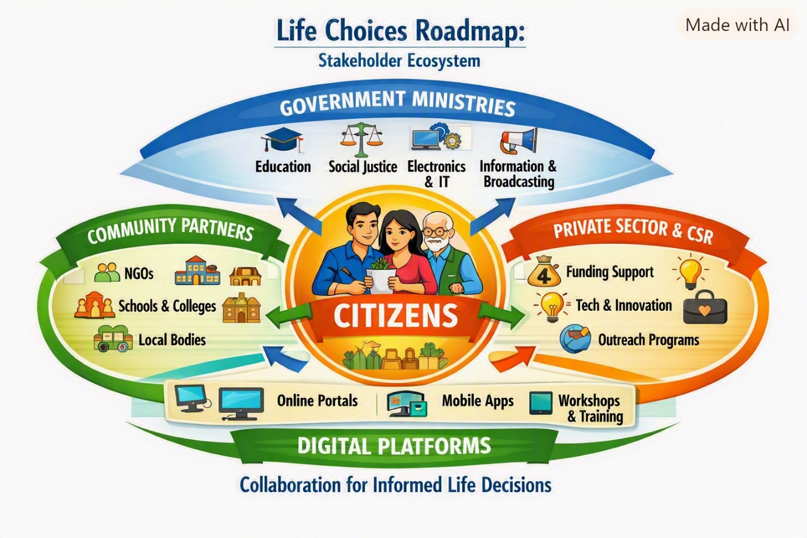
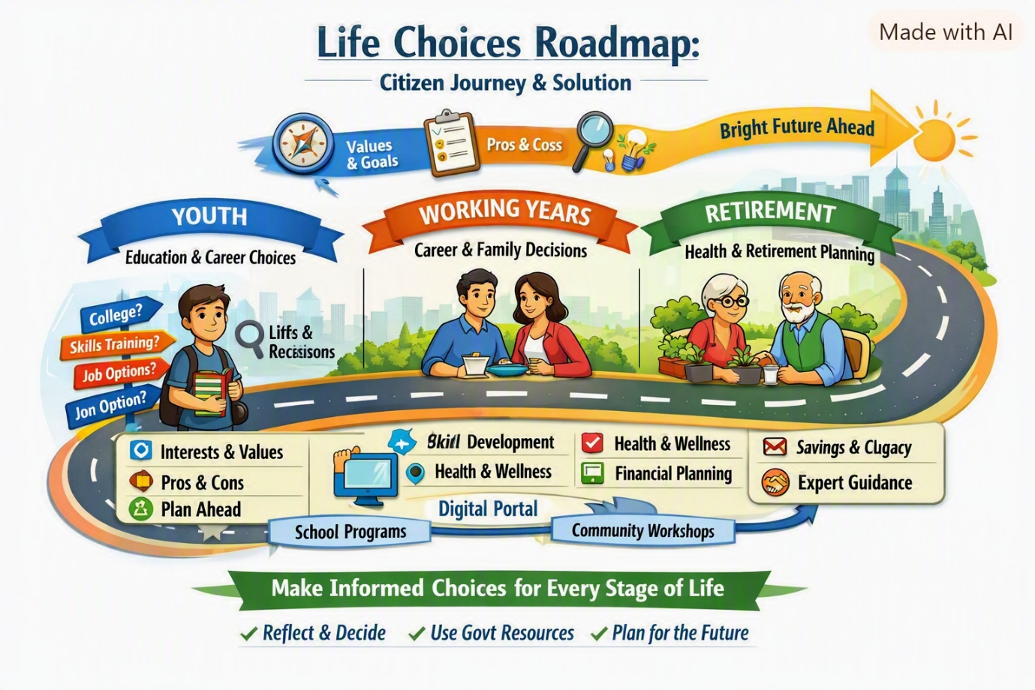

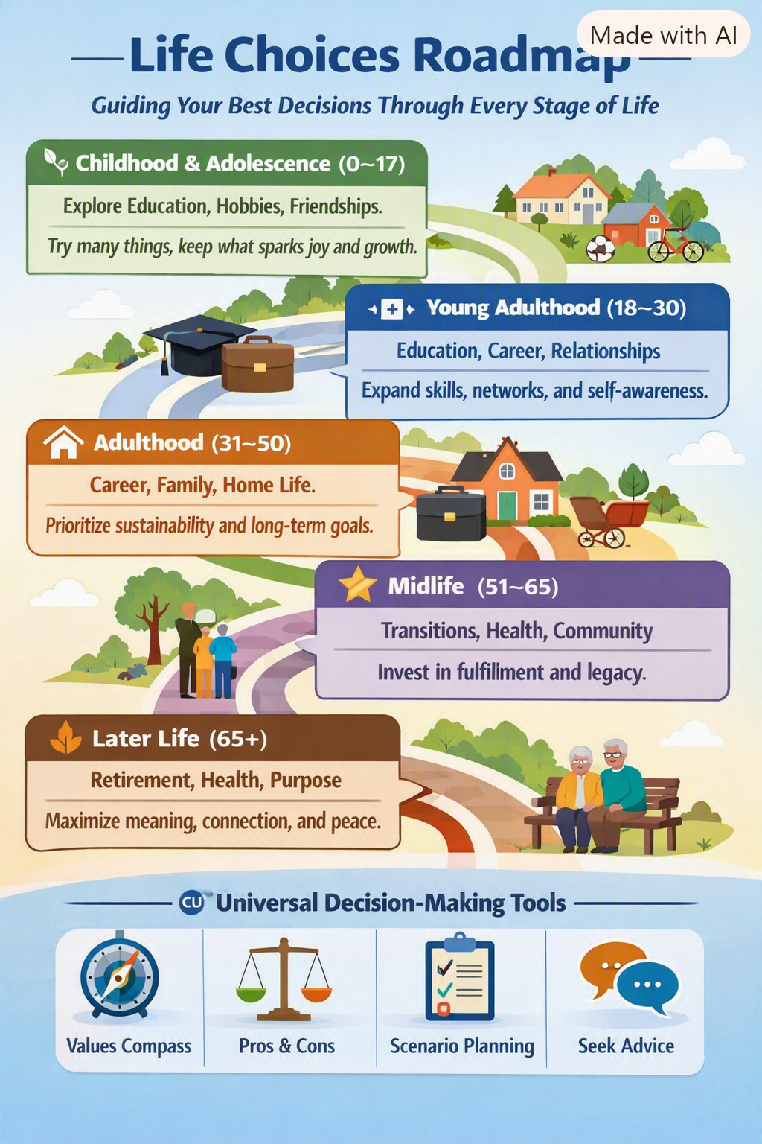
Nodes:
🧭 Central Node
- Citizens The core of the ecosystem — individuals across life stages (students, professionals, families, seniors). Role: Decision-makers and beneficiaries.
🏛️ Government Nodes
Ministry | Function
Ministry of Education | Curriculum integration, life-skills programs
Ministry of Social Justice & Empowerment | Community outreach, inclusion
Ministry of Electronics & IT | Digital platforms, citizen portals
Ministry of Information & Broadcasting | Awareness campaigns, media literacy
Local Government Bodies / Panchayats | On-ground implementation and feedback loops
🌱 Community Nodes
- Schools & Colleges – Deliver life-skills modules and workshops.
- NGOs & Civil Society Groups – Conduct outreach and mentoring.
- Community Centers – Host sessions for adults and seniors.
- Youth Clubs & Volunteer Networks – Peer-led engagement and awareness.
💼 Private Sector & CSR Nodes
- Corporate CSR Programs – Funding, awareness drives, and digital literacy initiatives.
- Technology Partners – Build interactive tools and mobile apps.
- Media & Communication Firms – Create campaigns and storytelling content.
- Financial Institutions – Support financial planning and savings education.
🌐 Digital Platform Nodes
- Government Portals – Centralized access to decision tools and schemes.
- Mobile Apps – Personalized guidance and progress tracking.
- Workshops & Webinars – Interactive learning experiences.
- Data & Analytics Systems – Measure citizen engagement and impact.
🧩 Support & Feedback Nodes
- Educators & Counselors – Provide personalized guidance.
- Policy Think Tanks – Evaluate outcomes and recommend improvements.
- Academic Institutions – Research and refine decision frameworks.
- Citizen Feedback Channels – Surveys, forums, and helplines.
🔄 Connecting Nodes (Flows)
- Information Flow: From ministries and partners to citizens.
- Feedback Flow: From citizens back to ministries and policy bodies.
- Resource Flow: Funding, training, and technology shared across nodes.

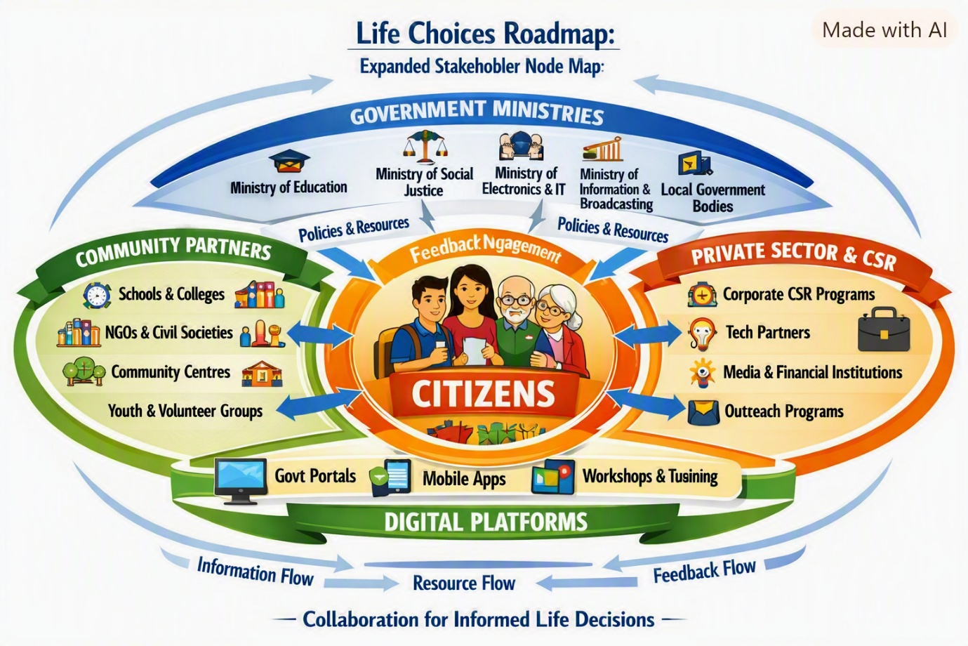
Personas
Persona | Profile | Needs | Pain Points | How the Roadmap Helps
🧑‍🎓 Student / Youth (Aarav, 16) | High school student exploring subjects and career paths | Guidance on choosing the right stream, understanding future opportunities, connecting education to real-world goals | Confusion about career options, lack of mentorship, limited awareness of scholarships | Offers reflection tools (interests, values, aptitude), connects to Skill India and education schemes, builds confidence
👩‍💼 Young Professional (Meera, 25) | Early-career professional balancing job growth and personal development | Clarity on career progression, skill enhancement, financial planning | Uncertainty about upskilling, work-life balance, long-term goals | Provides decision frameworks for career vs. higher education, connects to skill programs, promotes holistic planning
👨‍👩‍👧 Mid-Life Adult (Rajesh, 40) | Working parent managing family, career, and finances | Support in balancing priorities, planning for children’s education, securing future stability | Stress from multitasking, limited time for self-development, unclear access to welfare schemes | Encourages structured life planning, highlights relevant government benefits, promotes mental and financial well-being
👵 Senior Citizen (Leela, 68) | Retired teacher seeking purposeful engagement and health security | Opportunities for social contribution, healthcare access, emotional fulfillment | Isolation, lack of awareness about senior welfare programs, limited digital literacy | Connects to community volunteering, healthcare schemes, and digital literacy workshops
🧑‍🏫 Educator / Counselor (Dr. Nair, 50) | School counselor guiding students and families | Structured tools to teach decision-making and life skills | Fragmented resources, lack of standardized frameworks | Provides ready-to-use modules, visual aids, and digital tools for life-skills education

