Attendata

Anoop Manikanta S

anoop.manikanta.21@gmail.com

# Instructions

Download ‘Attendata.exe’ from the repository. Then follow the steps below to run the program.

**Step 1:** Make sure that the chat settings in zoom is set as shown below.

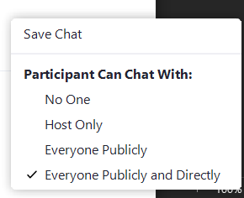

Figure

**Step 2:** After the participants have entered the requested key in the chat, click on save chat which is highlighted below.

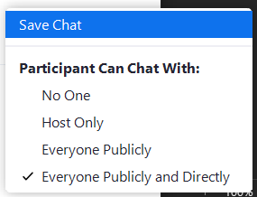

Figure

**Step 3:** Click on the file to start and wait for 10 seconds for it to load.

**Step 4:** Enter the zoom meeting id without any spaces as shown below.

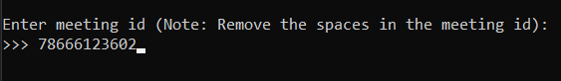

Figure

**Step 5:** Enter the path of zoom folder where the chats are stored. Please make sure that the input is right as it will be taken only once.

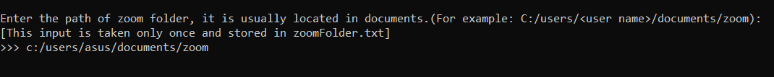

Figure

**Step 6:** Enter the secret key given to the students.



Figure

**Step 7:** Enter the path of the excel sheet to mark the attendance.



Figure

**Note:** To avoid crashing of the application, please make sure that the excel sheet is closed. To ensure proper output, the excel sheet must be in the following format. Also, note that the zoom participants must have ‘id’ or ‘name’ in their zoom’s username.

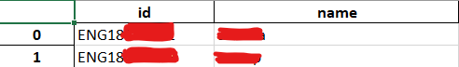

Figure

**Step 8:** The output will be reflected in the excel sheet with column name as current date.

**\*\*\*\***