Q3]

When initialized to InitParams2, MATLAB throws an error. The immediate cause of error is extremely small or sparsely populated co_variance matrices.

What this means is that the when we optimize Likelihood function, it settles down to a local minima between two gaussians instead of the maxima.

To illustrate

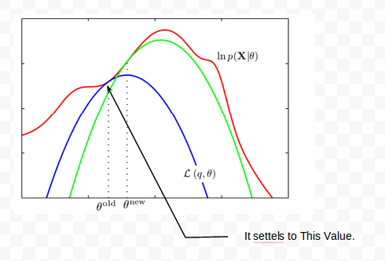

This can be technically quoted from wikipedia.com as follows
“the maximum likelihood estimate lies on the boundary of the set of possible parameters, or (if the boundary is not, strictly speaking, allowed) the likelihood gets larger and larger as the parameter approaches the boundary. Standard asymptotic theory needs the assumption that the true parameter value lies away from the boundary. If we have enough data, the maximum likelihood estimate will keep away from the boundary too. But with smaller samples, the estimate can lie on the boundary. In such cases, the asymptotic theory clearly does not give a practically useful approximation”

